A Project Report on

**TYPE ME**

Submitted as a mini project

**By**

**PALAVARAPU DEEPAK**

**H.NO-160115733152**

**SAGI NITISH VARMA**

**H.NO-160115733167**

Under the guidance of

**G.VIVEK**

Asstt.professor

**Department of Computer science and Engineering**

**Chaitanya Bhararathi Institute of Technology**

**Gandipet , Hyderabad-50075**

**CERTIFICATE**

This is to certify that the project work entitled **“TYPE ME”** is a bonafied work carried out by **PALAVARAPU DEEPAK**(160115733152) & **SAGI NITISH VARMA(**160115733167)under our guidance and supervision.

The results embodied in this report have not been submitted to any other university or institute for the award of any degree or diploma.

Internal Guide Head of department **G.Vivek Dr.Y.Rama Devi**  asst.profeesor professor and Head of Department of CSE Department of CSE

**DECLARATION**

This is to certify that the work reported in the present project entitled **“TYPE ME"** is a record of work done by me in the Department of Computer Science and Engineering, Chaitanya Bharathi Institute of Technology, Osmania University. The reports are based on the project work done entirely by me and not copied from any other source.

PALAVARAPU DEEPAK

SAGI NITISH VARMA

**ACKNOWLEDGEMENTS**

I would like to express my deep felt appreciation and gratitude to G.**Vivek** , Asst.Professor, Department of CSE, my project guide, for her skillful guidance, constant supervision, timely suggestion, keen interest and encouragement in completing the individual seminar within the stipulated time.

I am honoured to express my profound sense of gratitude to **Dr.Y.Rama Devi**, Head of Department, CSE, who has served as a host of valuable corrections and for providing me time and amenities to complete this project.

I gratefully express my thanks to **Dr.ChennaKeshava Rao**, Principal of our college and the management of **CHAITANYA BHARATHI INSTITUTE OF TECHNOLOGY** for providing excellent academic and learning environment in the college.

I wish to express my heartfelt gratitude to the **Members of Staff** and all others who helped me in bringing up my project. I would also like to thank the **Lab assistants and Programmers** for helping me through my project.

PALAVARAPU DEEPAK

SAGI NITISH VARMA

**ABSTRACT**

**ABSTRACT OF THE MINI PROJECT**

**TITLE OF THE PROJECT:TYPE ME**

**DEVELOPMENT TOOL:C++**

**DATABASE:C++**

**ROLL NO.S:160115733152,160115733167**

**BRANCH:CSE-3**

**NAME:P.DEEPAK,NITISH VERMA**

**BODY:**

Typing is the basic command to run a computer and your speed plays a vital role while working in computer to save time.The project is to enhance the typing speed of the user.This project is developed using c++ and compiled using GNU GCC complier.

**FEATURES:**

* this project provides certain name as user by default and there is also a facility to create a new user too.you can enter your name as user.
* you can view typing speed,accuracy using record option.
* you can view the entire statistics.
* if you want to terminate the program you can select exit option at any time.

**FUNCTIONS:**

the inbuilt are:

* stdio.h
* stdlib.h
* string.h
* time.h
* conio.h

when the user starts the game by selecting his lesson from the menu he will be provided with some letters randomly in a regular time interval.If he passes that level he'll move on to the next level and the time interval is changed.If he completes all the levels the he will win the game.

**LIST OF FIGURES**

**FIGURE FIG NO**.

Program execution flow 1.1

Output screens

**TABLE OF CONTENTS**

**Name of the topic Page No**

Certificate i

Declaration ii

Acknowledgements iii

Abstract iv

List of figures v

**Chapter 1.Introduction**

**Chapter 2.Existing system**

**Chapter 3.implementation**

**Chapter 4.output screens**

**Chapter 5.Conclusion**

**CHAPTER 1**

**INTRODUCTION**

**Type me is a game that improves your typing speed, accuracy and quality, no matter what your prior typing experience is. It is a system of training based upon how your hand works, and the kinds of movements and sequences of key presses needed to train the movement of each finger.**

**CHAPTER 2**

**EXISTING SYSTEM**

We are all know that this game is already exist which is working very well,but what my idea is ,we can develop this game without using graphics also.It mainly focuses on the typing accuracy and speed of the user.

**CHAPTER 3**

**IMPLEMENTATION**

To start enjoying the game you need to register.If you are already an existing user please login.Enter the appropriate key to register or login.press enter to start enjoying the game.Now type the paragraph which is shown above.Basing on your accuracy and speed you will get the result.if your score meets the requirements you will be promoted to the next level.At any stage you may come out of the game.

The given figure 1.1 shows how my program execution

**COVER PAGE**

**REGISTRATION PAGE**

else if the registration is successful

**LOGIN PAGE**

if successful else again goes to login page

**HOME PAGE**

**LEVEL-1**

**if your score meets the requirements**

**else try again.**

**LEVEL-2**

**If your score meets the requirements**

**else try again.**

**LEVEL-3**

**If your score meets the requirements**

**else try again.**

**congrats you have passed all the levels.**

**Thanks for typing me.**

**FIGURE 1.1 program execution flow**

**CHAPTER 4**

**OUTPUT SCREENS**

**COVER PAGE:**

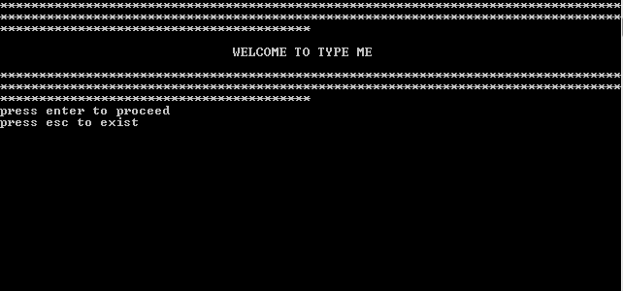

**figure 1.2**

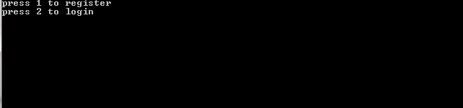

**figure 1.3**

**Figure 1.4** Registration page

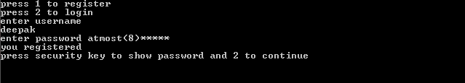

**Figure 1.5** login page

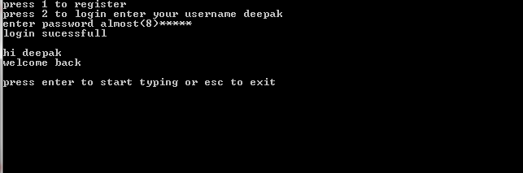

**Figure 1.6** Home page

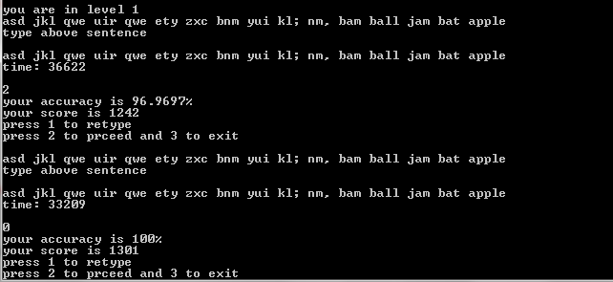

**using backspace:**

**Figure 1.7**

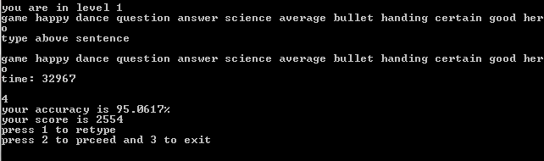

**without using backspace:**

**Figure 1.8**

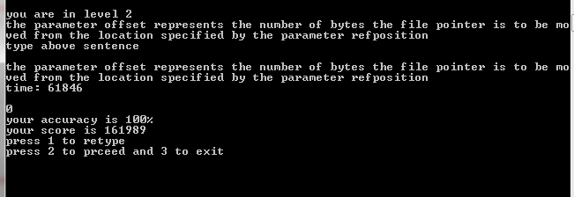

This is how my project “TYPE ME” works without using any graphics.

**CHAPTER 5**

**CONCLUSION**

By the end of my project ,I have learned how to handle the cursor on console window with different special functions using C++ .