|  |
| --- |
| video ID |
| uploader |
| Age |
| category |
| Length |
| Views |
| Rate |
| Ratings |
| comments |
| related Ids |

CREATE EXTERNAL TABLE YOUTUBE (video_ID STRING, uploader STRING, age int, category string, length int, views bigint, rate int, ratings int, comments int, related_id string)

ROW FORMAT DELIMITED

FIELDS TERMINATED BY ‘\t’

LOCATION ‘/home/training/’;

**Find out the top 5 categories in which the most number of videos are uploaded.**

Select category, count(category) as cnt from youtube group by category order by cnt desc;

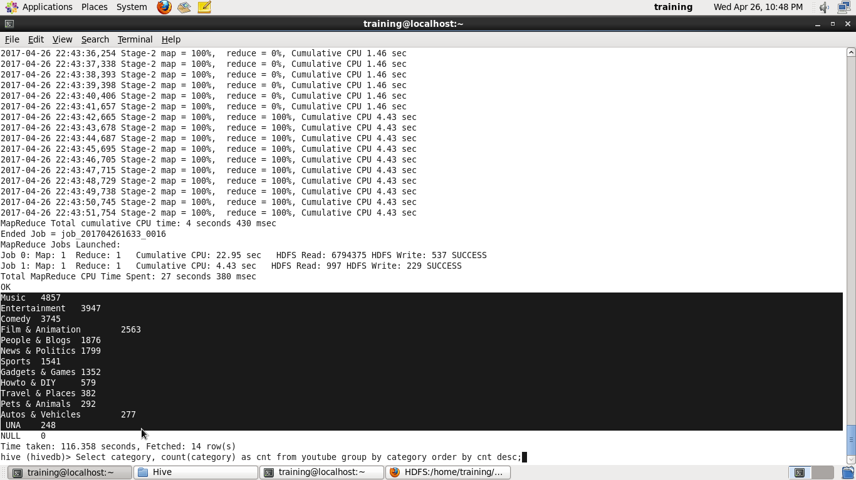

Find top 10 rated videos

Select category, rate, count(rate) as r, ratings, count(ratings) as s group by rate, ratings order by r desc;

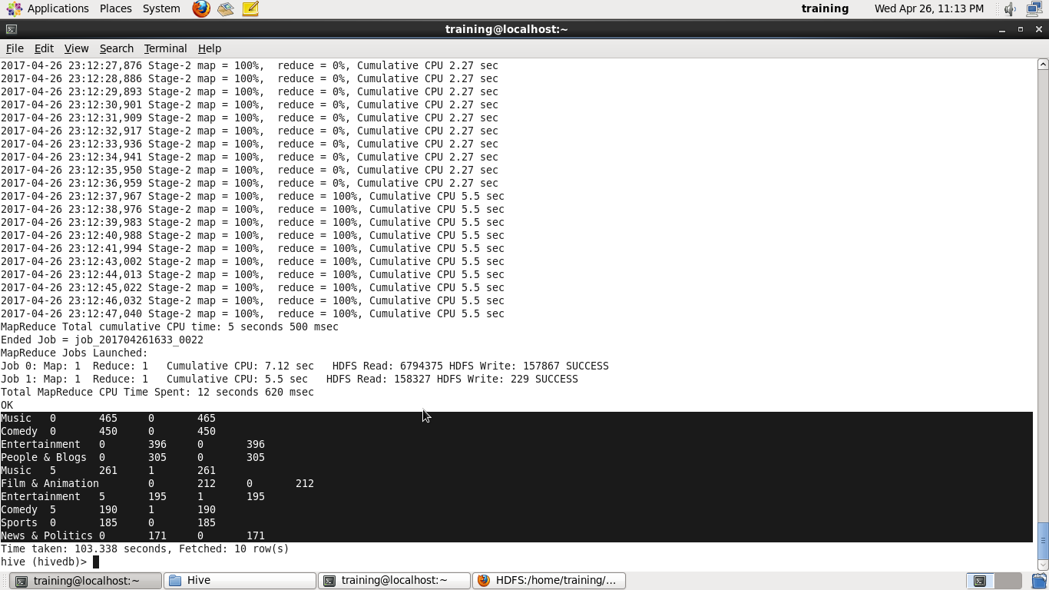

Find top 10 most viewed videos

Select video_id,category, max(views) as mx from youtube group by category order by mx desc limit 10;

HSoVKUVOnfQ Music 6193057

h0zAlXr1UOs Comedy 5826923

LB84A3zcmVo People & Blogs 4866739

hr23tpWX8lM News & Politics 4706030

6D9p-wmtIJc Comedy 4292706

8uwuLxrv8jY Entertainment 4226517

NINJQ5LRh-0 Music 3794886

FLn45-7Pn2Y Music 3604114

55YYaJIrmzo Film & Animation 3356163

eiiU-Fky18s Music 3269875

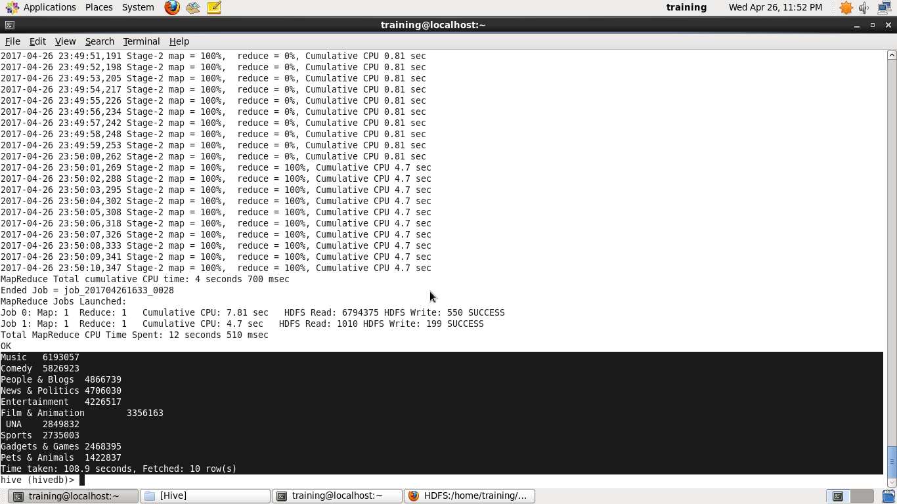

Find top 10 rated videos in each category

