### Acknowledgement

We take this opportunity to thank all those who have contributed their support in preparing this seminar. Firstly, we would like to express our deep sense of gratitude towards ROFEL BBA and BCA College, Vapi.

Providing us this opportunity to implement our skills in making **Presentations/Project** on a topic in our fifth semester course curriculum.

I would not miss the opportunity to thank my guide **ASST PROF TANVI RANA** who has always been providing continuous guidance & support and always been a stepping stone in completing this seminar.

I am also very thankful to Principal Dr. P.H.Ved of our college for their keen interest and for providing all facilities in our project work.

Last but not least, we are also grateful to our parents and friends whose continuous support has always boosted our moral towards working on this seminar.

o

### objective

# The Two Website Goals That Are Key to (Effective) Ecommerce Growth

Discover the only two ecommerce goals that matter and how to use them to outperform the competition.

What are your ecommerce website goals?

At The Good, we’ve found our clients often know exactly *what* they want to see happen – but they’re short on *why* their bucket list is a good idea.

Maybe the CEO is adamant about the site delivering pop-ups with special promotions, the CMO wants testimonials on every product page, and the website design objectives from the creative team stress upgrading the site with higher-quality images.

All are valid concerns, but they’re like the hunter who hears a noise in the brush and starts haphazardly firing off shots: not only is that strategy unlikely to result in fresh game on the table, it’s downright dangerous.

Here are the most important things to know about ecommerce website goals:

* **Most goals are based on opinion, not on research.** That new pop-up may please the CEO, but it could drive potential customers away.
* **There are really only two ecommerce website goals that really matter.** Neither gives a hoot for what your design team thinks.

You’re here to learn how to get better results for your company’s ecommerce efforts. Our desire is to help you do that.

If we could show you how to stop relying on opinions, get more sales, and boost ROI… would you be interested?

That’s exactly what this article is about:

We’re going to reveal the only two ecommerce goals that matter and show you how to apply them to get an upper hand on the competition.

|  |  |  |
| --- | --- | --- |
| SR.NO | INDEX | PG.NO |
| 1 | INTRODUCTION |  |
| 2 | OBJECTIVE |  |
| 3 | SYSTEM FLOW CHART |  |
| 4 | DFD |  |
| 5 | DATABASE |  |
| 6 | PROJECT SCREEN SHOT |  |
| 7 | REFERENCE |  |

***INTRODUCTION***

“Service Provider” is being launched because a need of local service provider vendor to get client easily and customer will also get find them easily Through this website customer can register them to book Service Provider According to their service Requirement . After that customer get service of particular provider at door.

Multiple Provider make available themselves on this website in different categories of service. In this website customer book them on the basis of their experience or according there city .

In this website admin can manage all users like Provider and Customer. Provider and Customer can register them and then Provider can receive request of customer and accept and reject them After accept of request by provider then booking id generated and then customer and provider can see contact and address of each other.

Admin can view each joining request of Provider and approved and block them also. Admin can Also view contact us query of customer and Provider and reply them through mail . admin also approved feedback to display on client site

Main purpose of this Website is centralize and organize Local Service Provider vendors make them directly intraction With Customers. On just reasonable Visiting Charge By Website

In future we can add features like payment gateways. In feedback we can give ratings.

For future enhancement we can update it by adding more and more services And Service Providers.

***Project Profile***

|  |  |
| --- | --- |
| * **Project done by:** | Vansh Nimish Rana |
| * **Project Title:** | **“smartport”** |
| * **Project Type:** | E-Commerce |
| * **College Guide Name:** | Asst prof Tanvi Rana |
| * **Hardware Configuration:** | Device name DESKTOP-S7EQMQM  Processor 11th Gen Intel(R) Core(TM) i5-1135G7 @ 2.40GHz 2.42 GHz  Installed RAM 8.00 GB (7.73 GB usable) |
| * **Software Configuration:** | Mozilla Firefox |
| * **Operating System:** | Windows 11 |
| * **Platform :** | Xamp Server |
| * **Project Technology:** | PHP7 |
| * **Front End:** | PHP7 |
| * **Back End:** | PHPMyAdmin(MySQLI) |
| * **Feature:** | Add to cart  Signin or signout  Display product by brand and category |

**DEVELOPMENT ENVIORMENT DEVLOPMENT TOOLS**

**HARDWARE CONFIGURATION:-**

PROCESSOR : 11th Gen Intel(R) Core(TM) i5-1135G7 @ 2.40GHz 2.42 GHz

HARD DISK : 1 tb

RAM : 8GB

**SOFTWARE CONFIGURATION:-**

OPERATING SYSTEM : Windows 11 .

FRONT-END : PHP7

BACK-END : PHP MySQLI

HELP TOOL : VS Code ,Xampserver

Programing languages : Php7,MYSQLI,Ajax,Javascript,Jquery.

**PROGRAMING LANGAUGES**

PHP is platform independent application made it can be run on way operation system such as windows10 , xp ,UNIX.

**What is PHP7?**

PHP 7 is a major release of PHP programming language and is touted to be a revolution in the way web applications can be developed and delivered for mobile to enterprises and the cloud. This release is considered to be the most important change for PHP after the release of PHP 5 in 2004.

* PHP Stands for PHP : Hypertext Pre-processor
* PHP is a server-side scripting language , like ASP PHP scripts are excuted on the server
* PHP supports many databases (MySQLI,Informix, Oracle ,Sybase, solid ,PostrageSQL ,Genric ODBC,etc.)
* PHP is an open source software
* PHP is free to download and use

**What is PHP File?**

* PHP files can contain text, HTML tags and scripts
* PHP files are returned to the browser as plain HTMl
* PHP files have a file extension of “.php”,”.php3”,or “.phtml”.

**Why php?**

* PHP runs on different platform (Windows, Linux, Unix, etc.)
* PHP is compatible with almost all servers used today(Apache, IIs ,etc.)
* PHP is free to download from the official PHP resource: [www.php.net](http://www.php.net)
* PHP is easy to learn and runs efficiently on the server side.

**XAMPP**

**What is XAMPP and functionality?**

XAMPP is a free and open-source cross-platform web server solution stack package developed by Apache Friends,consisting mainly of the Apache HTTP Server, MariaDB database, and interpreters for scripts written in the PHP and Perl programming languages. Since most actual web server deployments use the same components as XAMPP, it makes transitioning from a local test server to a live server possible.

XAMPP's ease of deployment means a WAMP or LAMP stack can be installed quickly and simply on an operating system by a developer, with the advantage that common add-in applications such as WordPress and Joomla! can also be installed with similar ease using Bitnami.

**Usage**

The most obvious characteristic of XAMPP is the ease at which a WAMP webserver stack can be deployed and instantiated. Later some common packaged applications that could be easily installed were provided by Bitnami.

Officially, XAMPP's designers intended it for use only as a development tool, to allow website designers and programmers to test their work on their own computers without any access to the Internet. To make this as easy as possible, many important security features are disabled by default. XAMPP has the ability to serve web pages on the World Wide Web.A special tool is provided to password-protect the most important parts of the package.

XAMPP also provides support for creating and manipulating databases in MariaDB and SQLite among others.

Once XAMPP is installed, it is possible to treat a localhost like a remote host by connecting using an FTP client. Using a program like FileZilla has many advantages when installing a content management system (CMS) like Joom

**PHPMYADMIN**

**What is phpMyAdmin?**

Php My Admin is a free software tool written in PHP, intended to handle the administration of MySQLI over the worldwide web.

Php my admin supports a wide range of operations with MySQlI. The most frequently used operations are supported by the user interface (managing database, tables, fields, relation indexes, users, permission,TRRIGER etc.)

While you still have the ability to directly execute any SQL statement.

**MYSQLI**

The MySQLi Extension (MySQL Improved) is a relational database driver used in the PHP scripting language to provide an interface with MySQL databases.

There are three main API options when considering connecting to a MySQL database server:

* PHP's MySQL Extension
* PHP's MySQLi Extension
* PHP Data Objects (PDO)

The PHP code consists of a core, with optional extensions to the core functionality. PHP's MySQL-related extensions, such as the MySQLi extension, and the MySQL extension, are implemented using the PHP extension framework. An extension typically exposes an API to the PHP developer, to allow its facilities to be used programmatically. However, some extensions which use the PHP extension framework do not expose an API to the PHP developer.

The PDO MySQL driver extension, for example, does not expose an API to the PHP developer, but provides an interface to the PDO layer above it.

MySQLi is an improved version of the older PHP MySQL driver, offering various benefits.

The authors of the PHP scripting language recommend using MySQLi when dealing with MySQL server versions 4.1.3 and newer (takes advantage of new function)

**Javascript**

Javascript is a dynamic computer programming language. It is lightweight and most commonly used as a part of web pages, whose implementations allow client-side script to interact with the user and make dynamic pages. It is an interpreted programming language with object-oriented capabilities.

JavaScript was first known as LiveScript, but Netscape changed its name to JavaScript, possibly because of the excitement being generated by Java. JavaScript made its first appearance in Netscape 2.0 in 1995 with the name LiveScript. The general-purpose core of the language has been embedded in

Netscape, Internet Explorer, and other web browsers.

**The ECMA-262 Specification defined a standard version of the core JavaScript language.**

* JavaScript is a lightweight, interpreted programming language.
* Designed for creating network-centric applications.
* Complementary to and integrated with Java.
* Complementary to and integrated with HTML.
* Open and cross-platform

**System Flow Chart**

Admin Sitemap

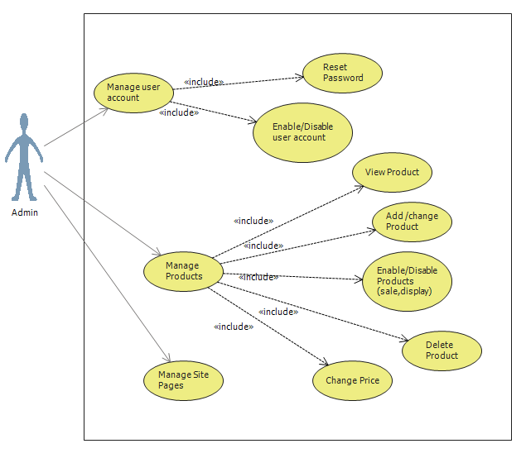

**Admin Process:**

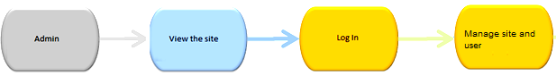

Admin manage the site pages, user accounts and products. Update the details of the different category of product. Admin can add, edit the product detail, activate, deactivate the product and block and unblock the user

User Sitemap

User management use case shows that only registered user can buy products, update profile. Non registered user can only browse the products but cannot buy anything

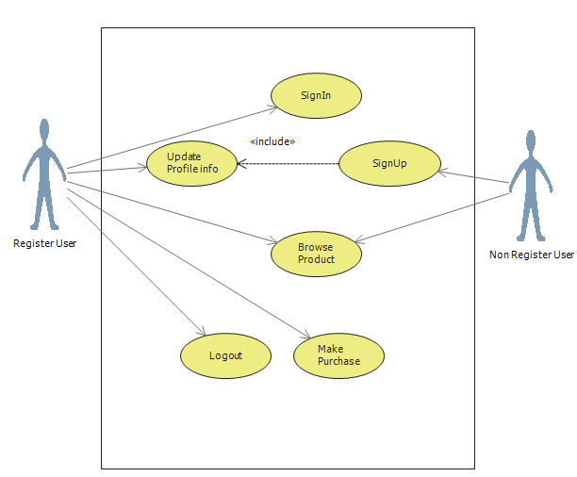

**Sign In Process**

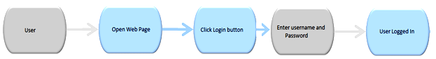

**Sign Up Process**

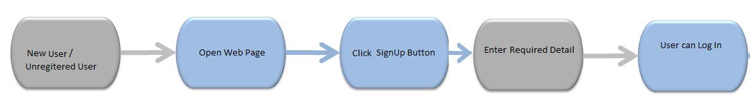

**Flowchart**

Activity diagrams represent workflows in a graphical way. They can be used to describe business workflow or the operational workflow of any component in a system. Sometimes activity diagrams are used as an alternative to State machine diagrams

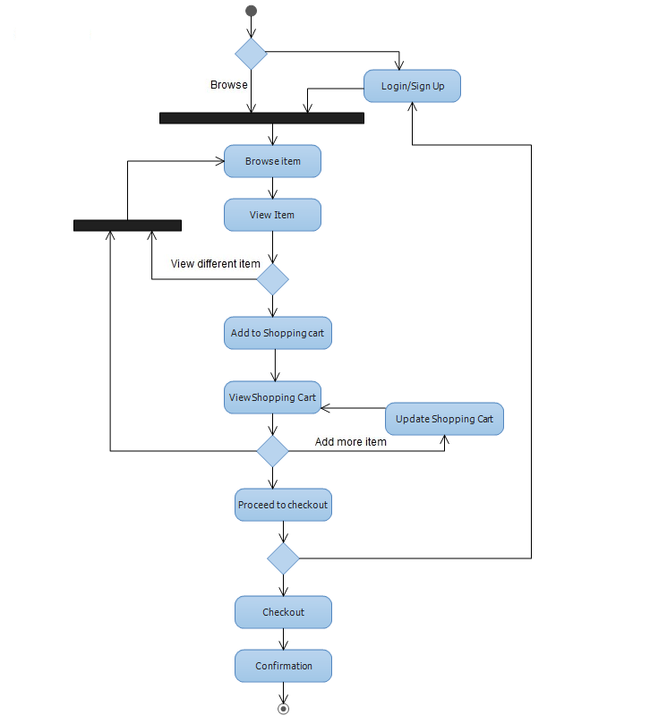

**Data Flow Diagram**

**Registration DFD**

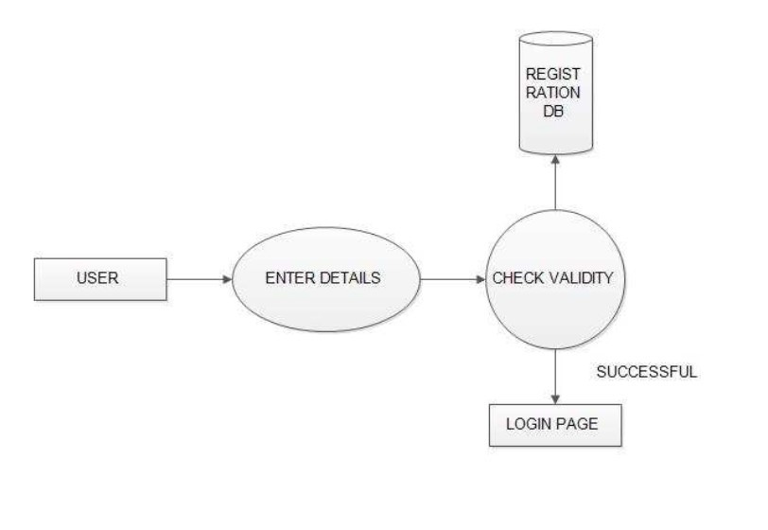

**Admin DFD**

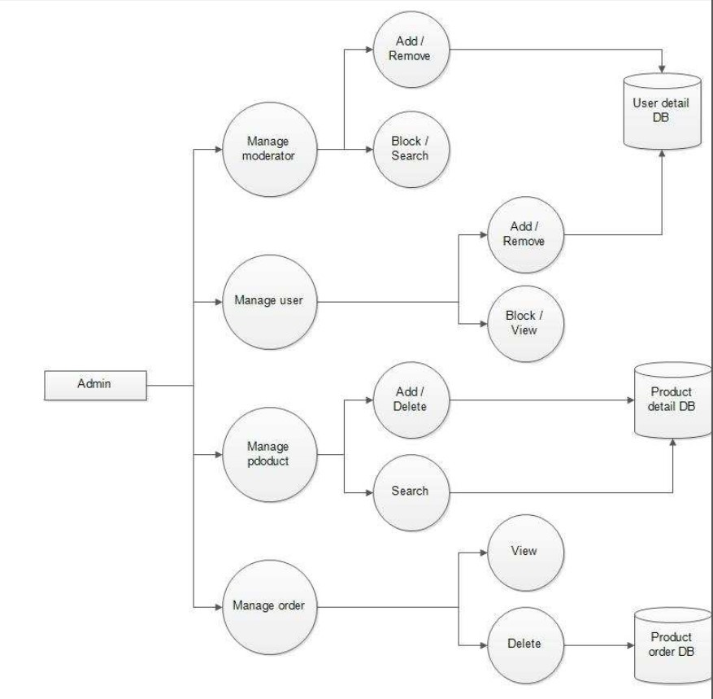

**Login DFD**

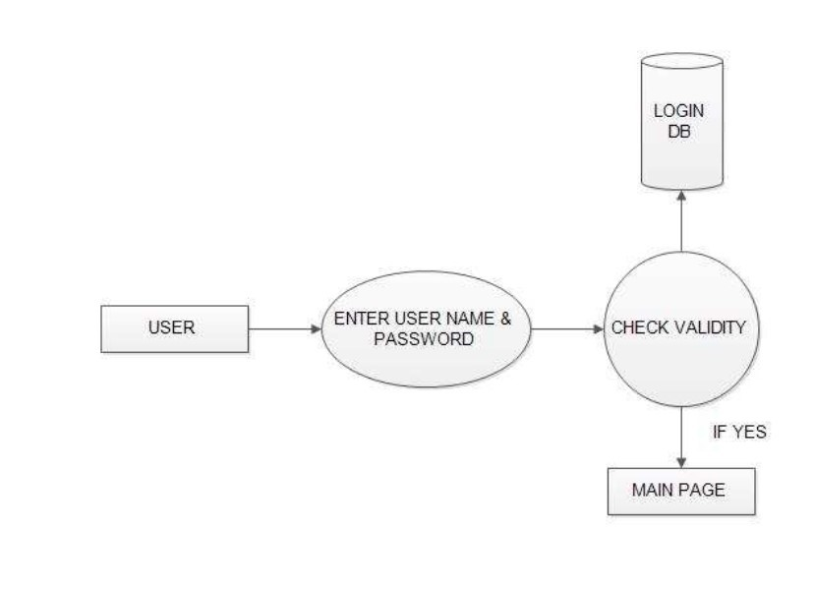

**Project Screen Shot**

HOME SECTION

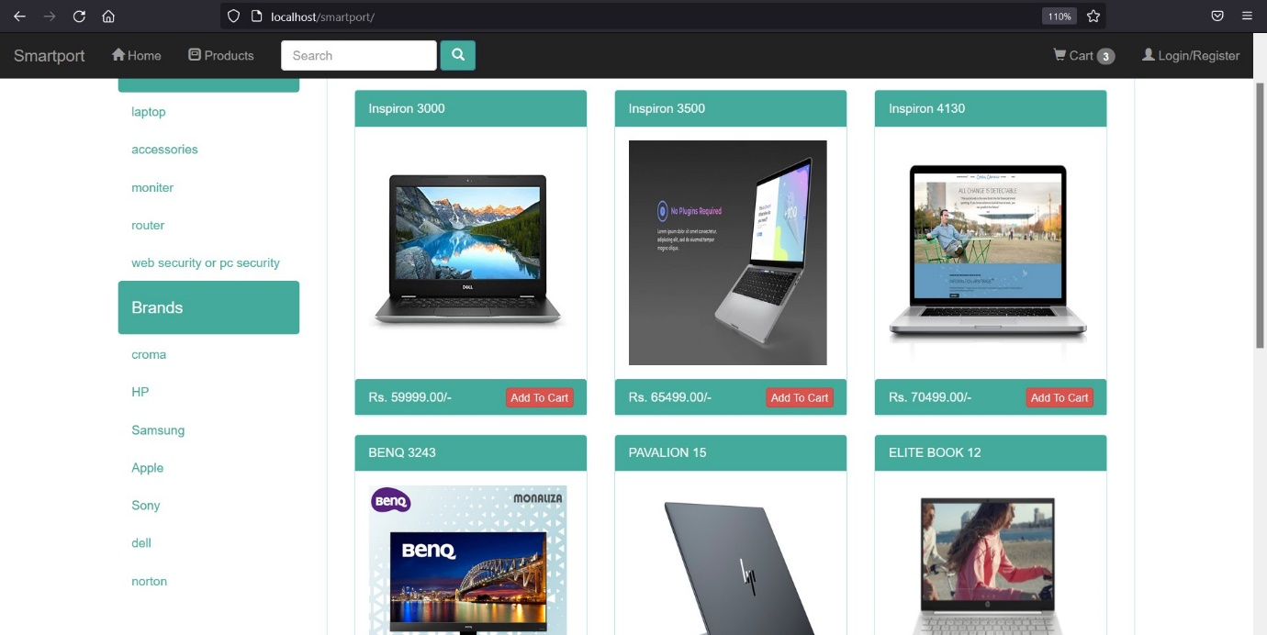

CART SECTION

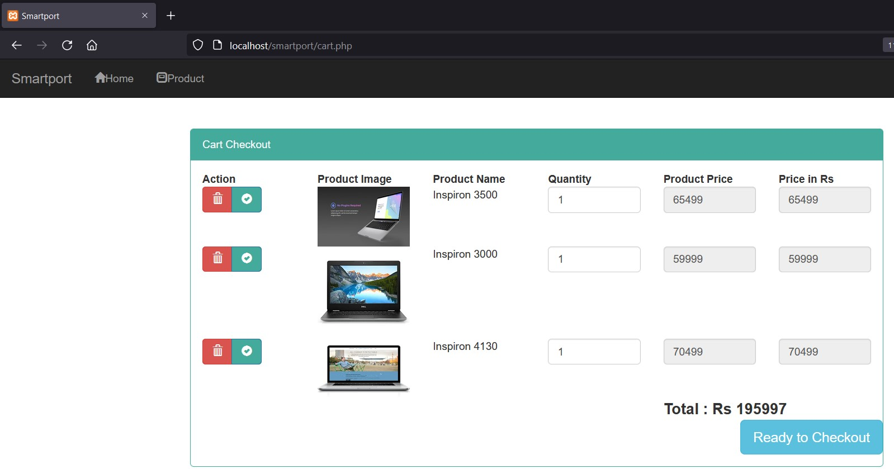

PRODUCT CATEGORY

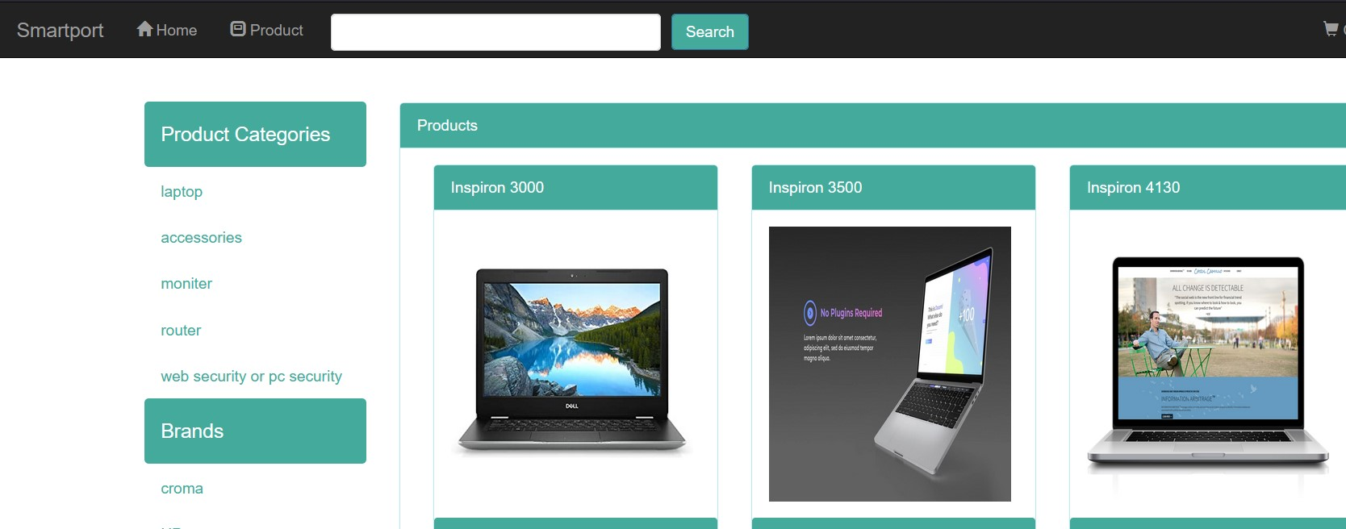

SEARCH BY BRAND

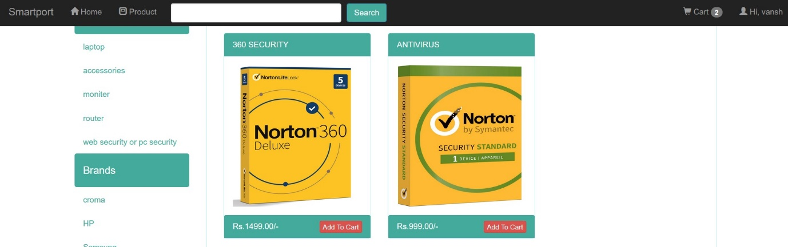

INSERT,UPDATE,DELETE BY ADMIN PANEL

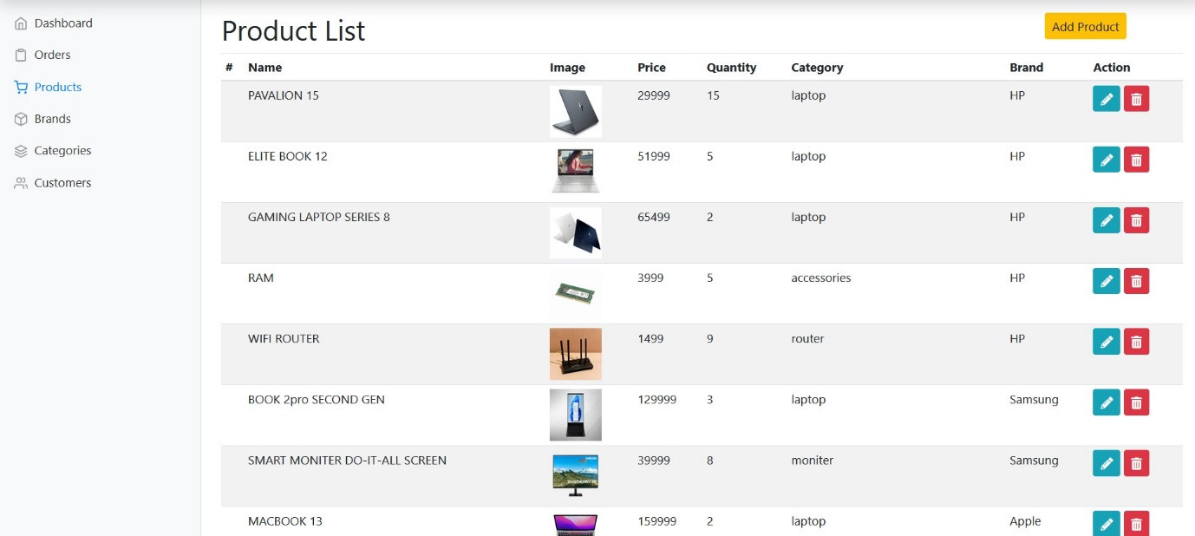

**MANAGE BRAND ALSO**

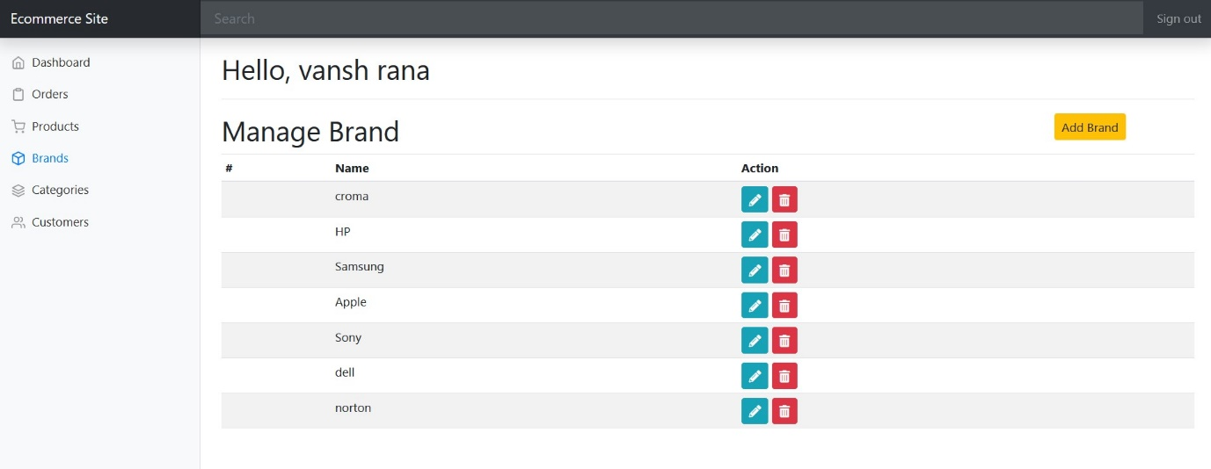

**MANAGE CATEGORY**

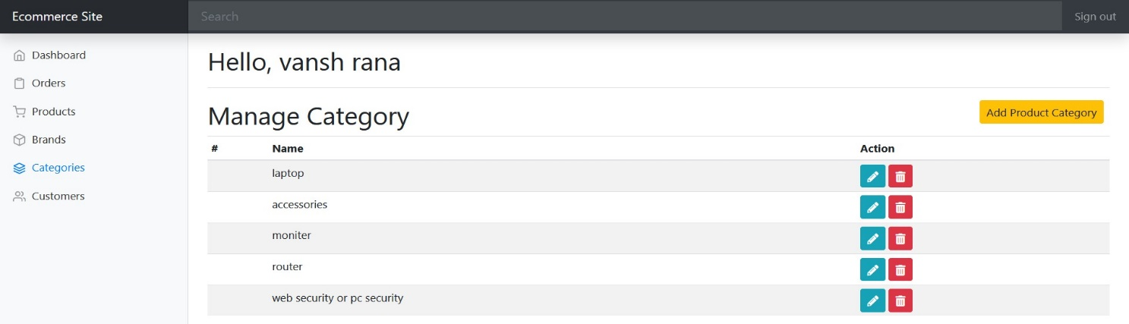

**WE CAN SEE CUSTOMER ALSO**

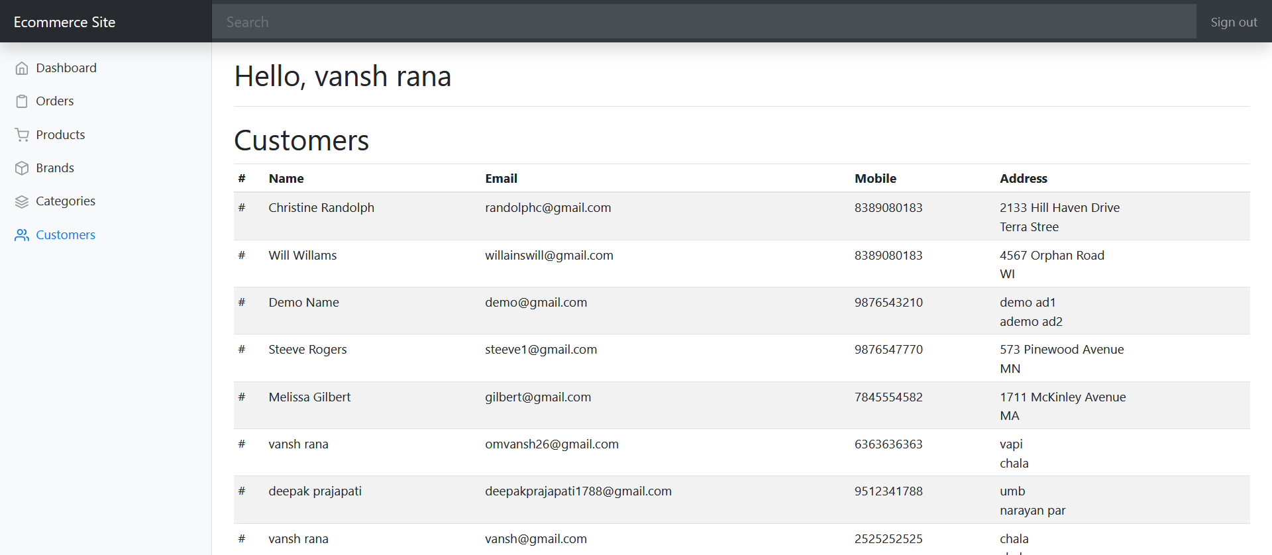

**REGISTRATION FORM**

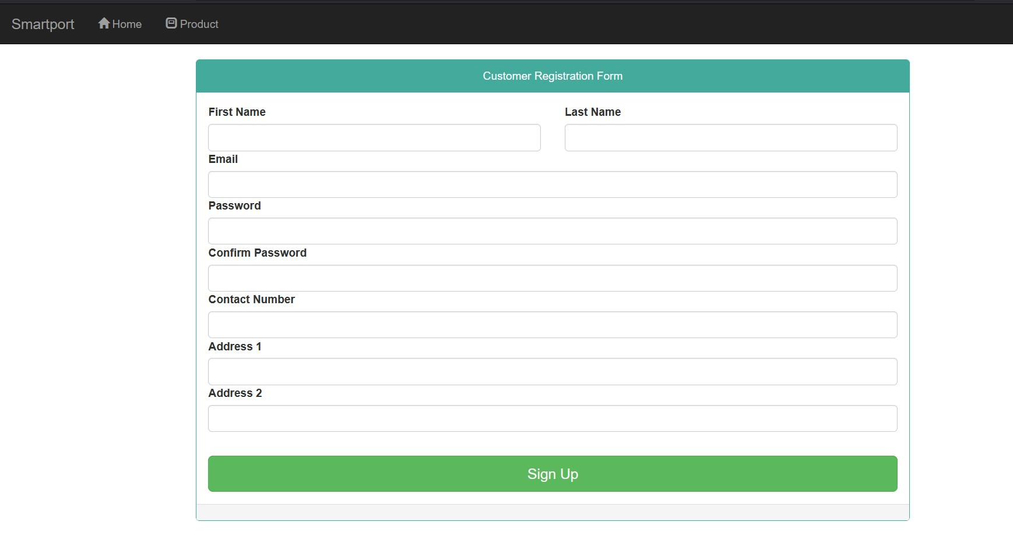

**LOGIN FORM**

