**Task 1: Get to Know Your Company**

1. What are the total numbers of:
   1. Bike stations?

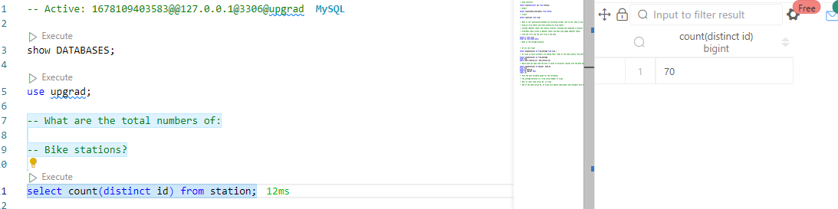

* 1. Bikes?

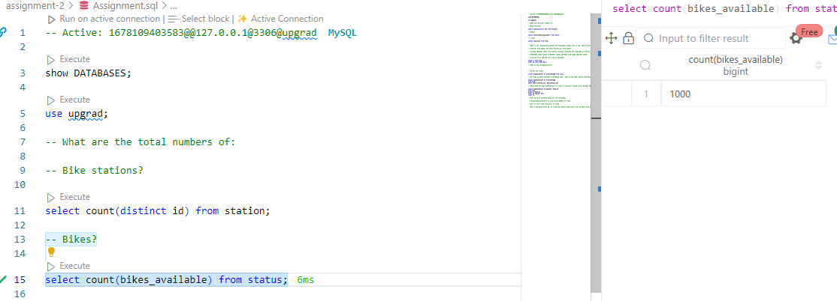

* 1. Trips?

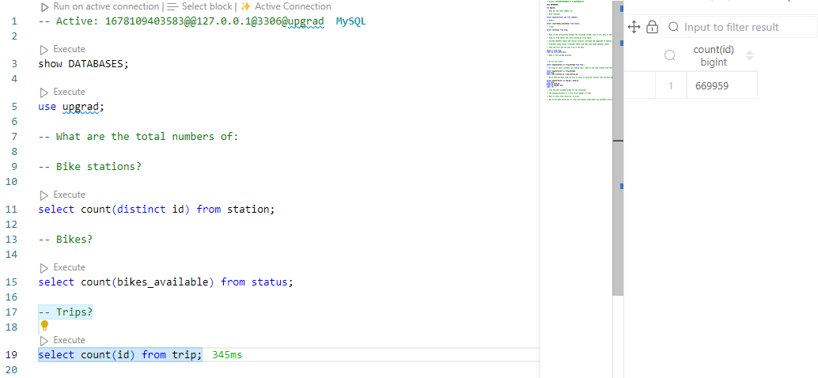

1. Construct a geographical plot to show the location of each bike station using the latitude and longitude provided under the Station table.

<https://public.tableau.com/app/profile/deepak.raghavendra4815/viz/2-BikeStationLocations/2-BikeStationLocation?publish=yes>

1. What is the relationship between the following columns (one to one, many to one, many to many)?
   1. bike_id (Trip table) and start_station_id (Trip table)

one to one – One bike can exist in one station id at any point of time.

* 1. pincode (Weather table) and station location (latitude and longitude in Station table)

one to many. One pincode can have many stations.

* 1. 8/29/2013 (date column in Weather table) and mean wind speed (Weather table)

One to many.

1. Find the first and the last trip in the data.

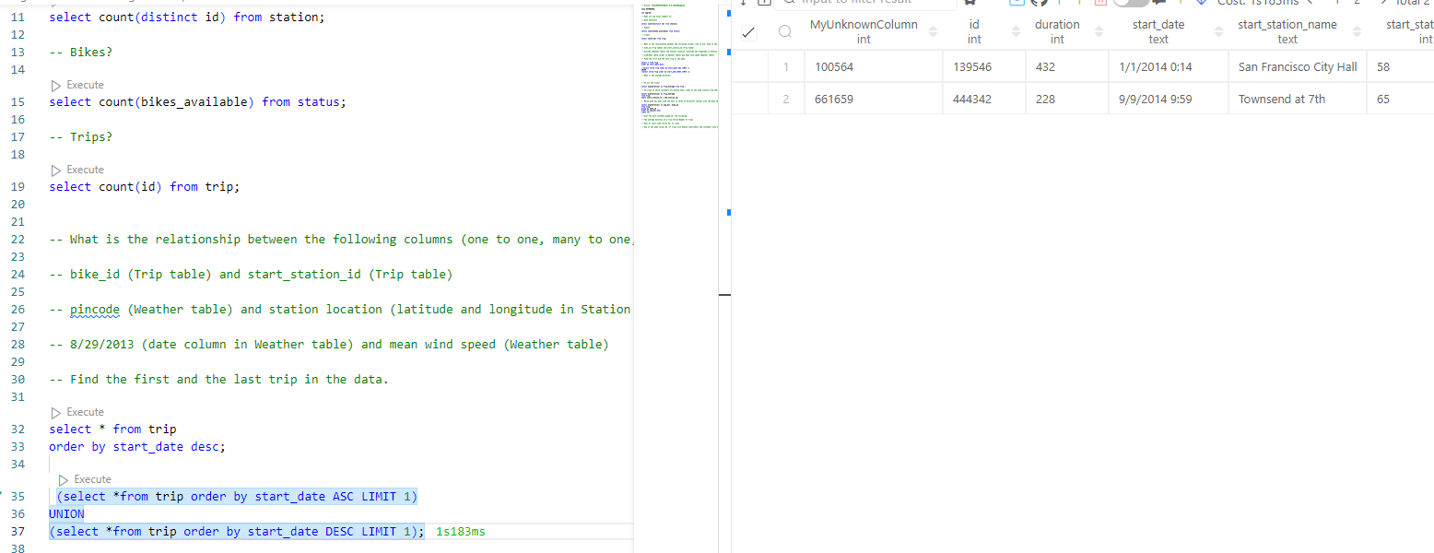

1. What is the average duration:
   1. Of all the trips?

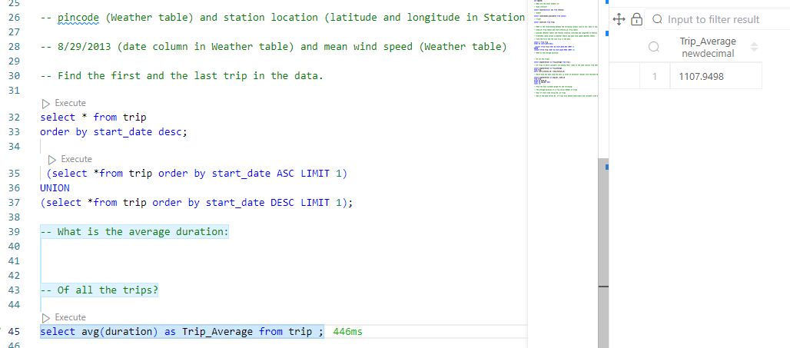

* 1. Of trips on which customers are ending their rides at the same station from where they started?

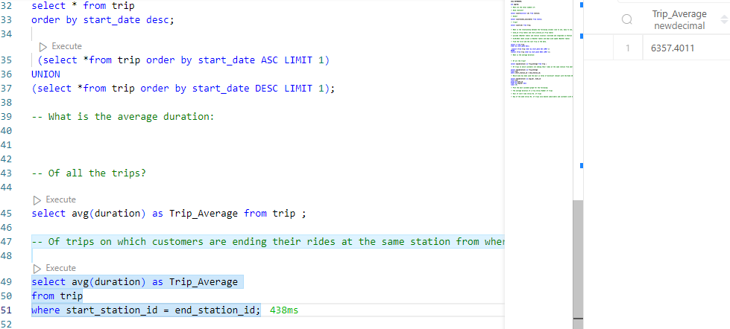

1. Which bike has been used the most in terms of duration? (Answer with the Bike ID)

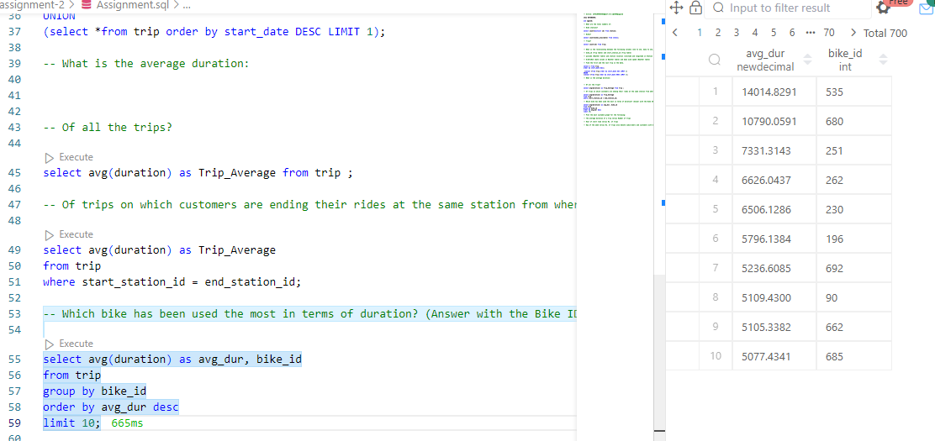

1. Plot the most suitable graph for the following:
   1. The average duration of a trip versus Number of trips
   2. Hour of start time versus No. of trips

<https://public.tableau.com/app/profile/deepak.raghavendra4815/viz/7-2-HourofstarttimeversusNo_oftrips/HourofstarttimeversusNo_oftrips?publish=yes>

* 1. Day of the week versus No. of trips also denote subscribers and customers with different colors.

<https://public.tableau.com/app/profile/deepak.raghavendra4815/viz/7-3-DayoftheweekversusNo_oftrips/DayoftheweekversusNo_oftrips?publish=yes>