A meadow should be capable of spawning a logically unlimited number of antfarms.

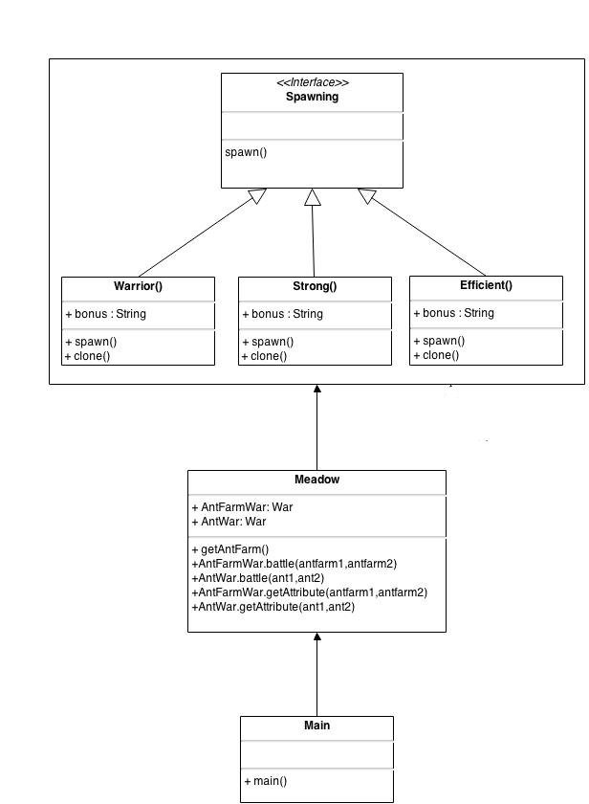
Fig : Factory Method

Why Factory method to create AntFarm?
Ans : I treating each antfarm as separate object and this pattern provides one of the best ways to create an object.

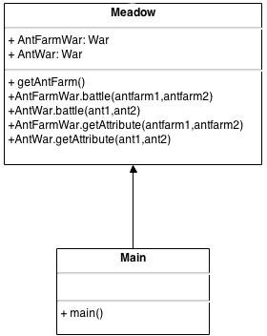

Fig : Singleton Pattern.

Why Singleton ?
Ans : Meadow class and object hav access to all other classes , interfaces and objects . Meadow has single object which no need to delete .

An antfarm should have rooms for spawning more ants.

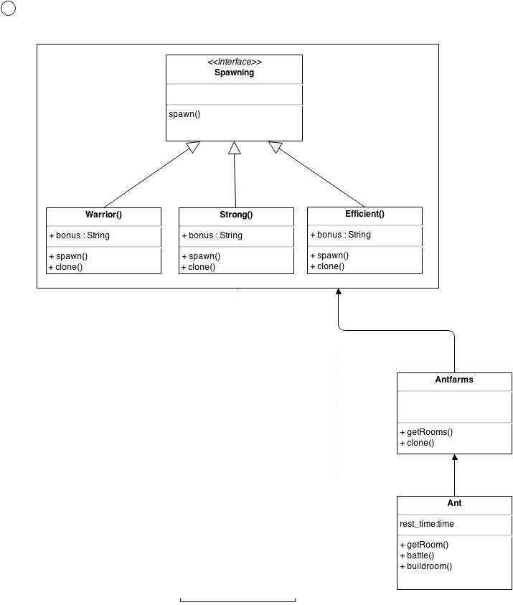
Fig : Prototype Pattern

Why Prototype Pattern?
Ans : Ant farm spawning a new ants which have similar attributes of existing ants so we copying the the current object to create new object i.e cloning.

- Ants should be able to battle other ants. When they do, the loser of the battle should die (it's antfarm can no longer command it), and the winner of the battle should get the attributes of the ant.
- If a member of an ant colony kills the queen of another colony, the killer's queen should assume control of the dead queen's population of ants.

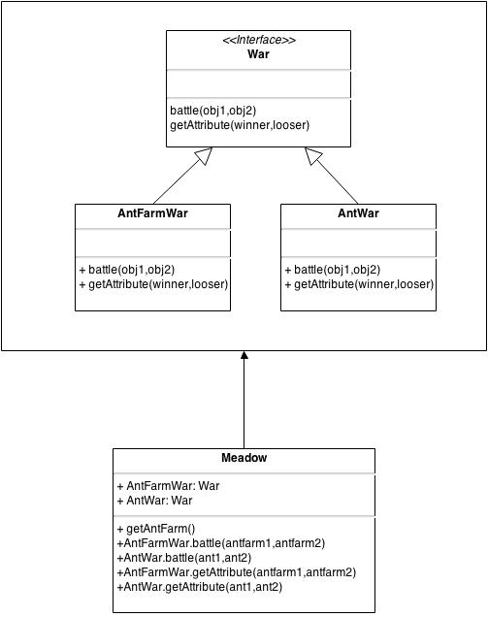
Fig: Facade Pattern

Why Facade Pattern ?
Want to hide the complexities of war and get attributes from the user.

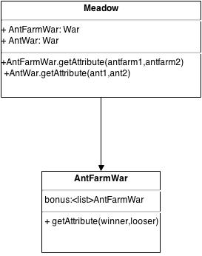

Fig: Composite Pattern

Why Composite Pattern?
In war/battle , one AntFarm win and one loose , both are objects we need to copy or add the attributes of looser object to the winner object .

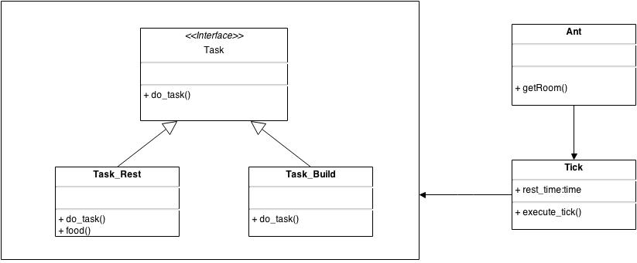
Fig: Stratergy Pattern
Why Stratergy Pattern ?
The behaviour of the ants can be changed at runtime

