Functionalities
- University/College provides varies courses.
- Professor can teach online or upload video.
- Professor can set assignment.
- Student can enroll to courses.
- Student can attend classes.
- Student can upload assignment and watch online video.
- Student can appear for exam and get the results.

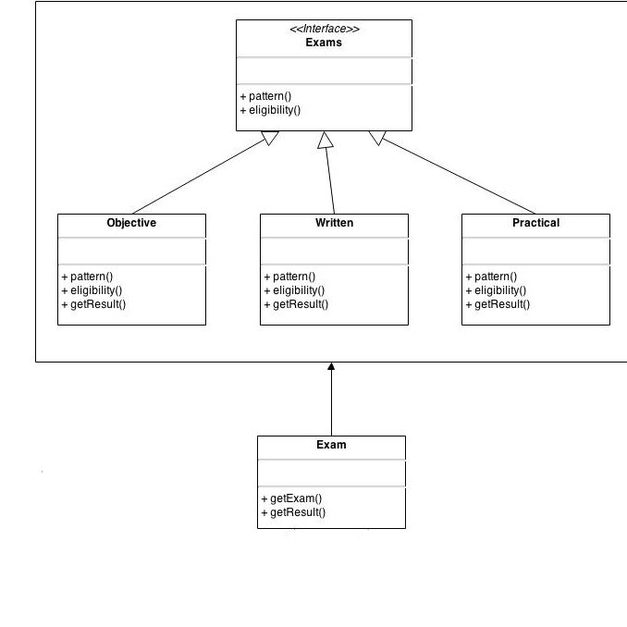
Fig : Factory Pattern

why this pattern ?
This type of design pattern comes under creational pattern as this pattern provides one of the best ways to create an object.

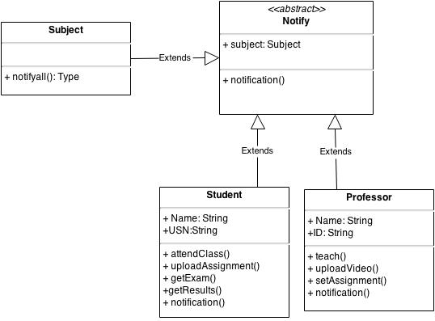
Fig: Observer Pattern

why this pattern ?
This type of design pattern provides one of the best ways to notify all the users of the system.

Class Diagram

