Pivoting Table:

Step1 :
I created view fro one assessment which consist the columns as below

User Question User_Answer
user1 abc ? xyz
user2 abc ? xyz

Query to create view
CREATE VIEW pivot AS SELECT u.name AS user ,q.question AS question , o.option AS Answer
From Assessments a, Exam e, Options o, Questions q, Users u,Answers an
WHERE a.id= e.Assmt_id and q.id=an.Ques_id and o.id = an.Opt_id and u.id=e.User_id and e.id=an.Exam_id and a.id =4;

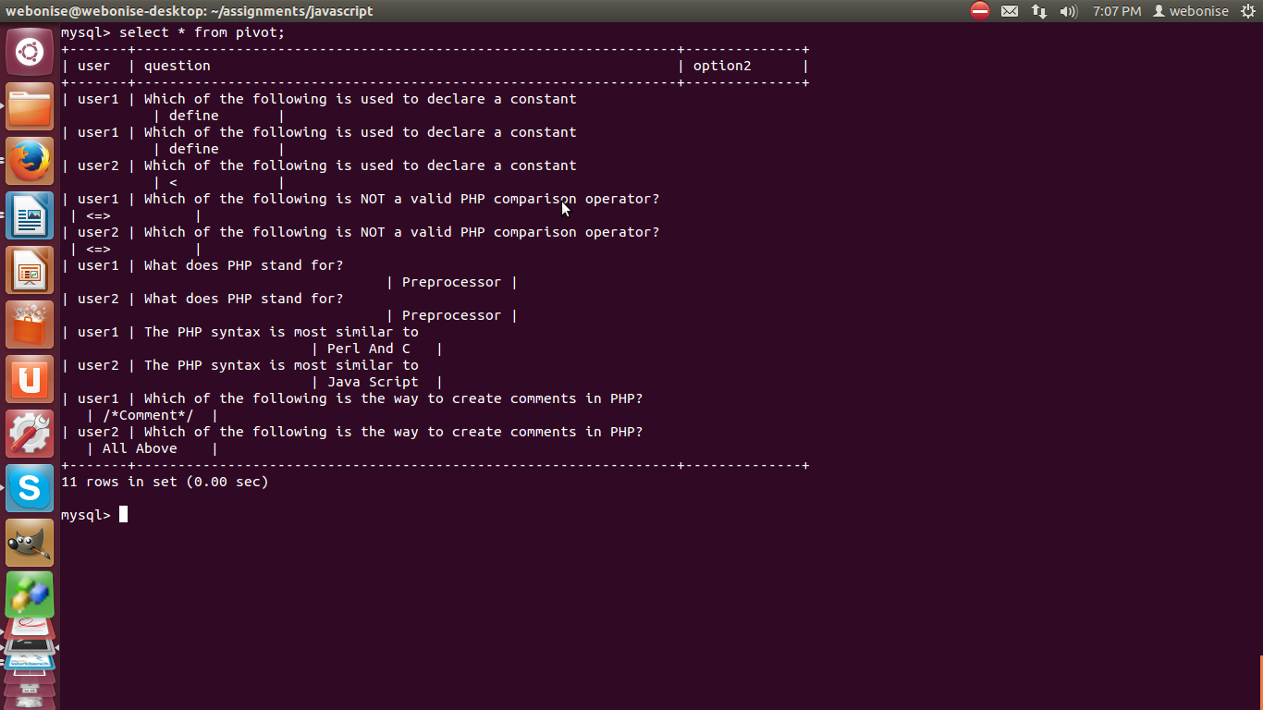

Stored Procedure
DELIMITER $$

CREATE DEFINER=`root`@`localhost` PROCEDURE `user_report`()
BEGIN
SET @sql = NULL;

SELECT GROUP_CONCAT(DISTINCT
CONCAT('MAX(CASE WHEN question = ''', question,
''' THEN option2 END) `', question, '`'))
INTO @sql
FROM pivot;

SET @sql = CONCAT('SELECT user, ', @sql, '
FROM pivot
GROUP BY user');

PREPARE stmt FROM @sql;
EXECUTE stmt;
DEALLOCATE PREPARE stmt;
END

Output

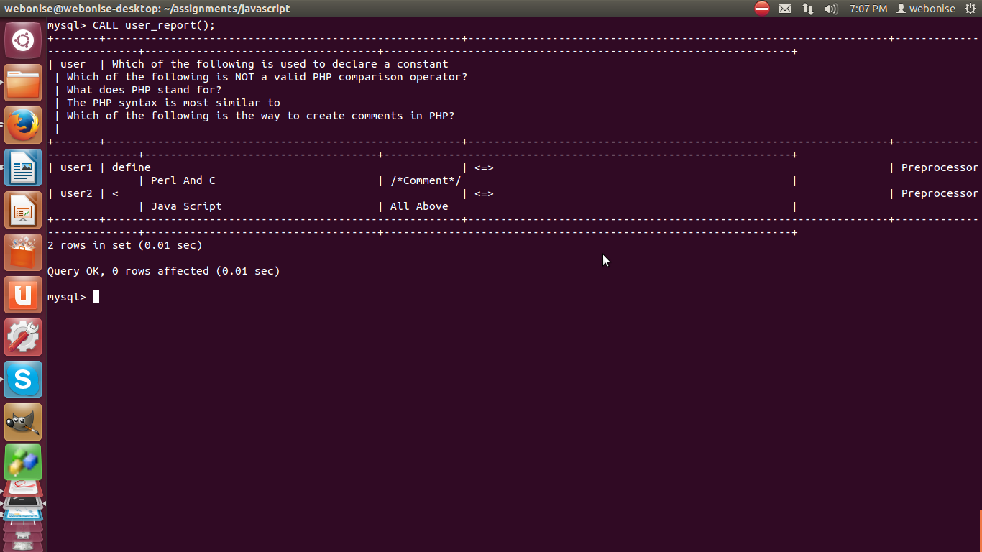

Output 2:

Questions are large so I have taken Question_id

