**Assignment 2**

Ans 3).

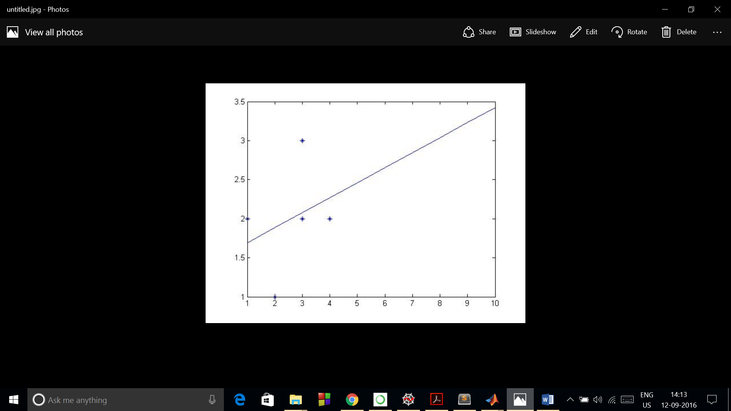

Ans 4).

A).

lin.txt:

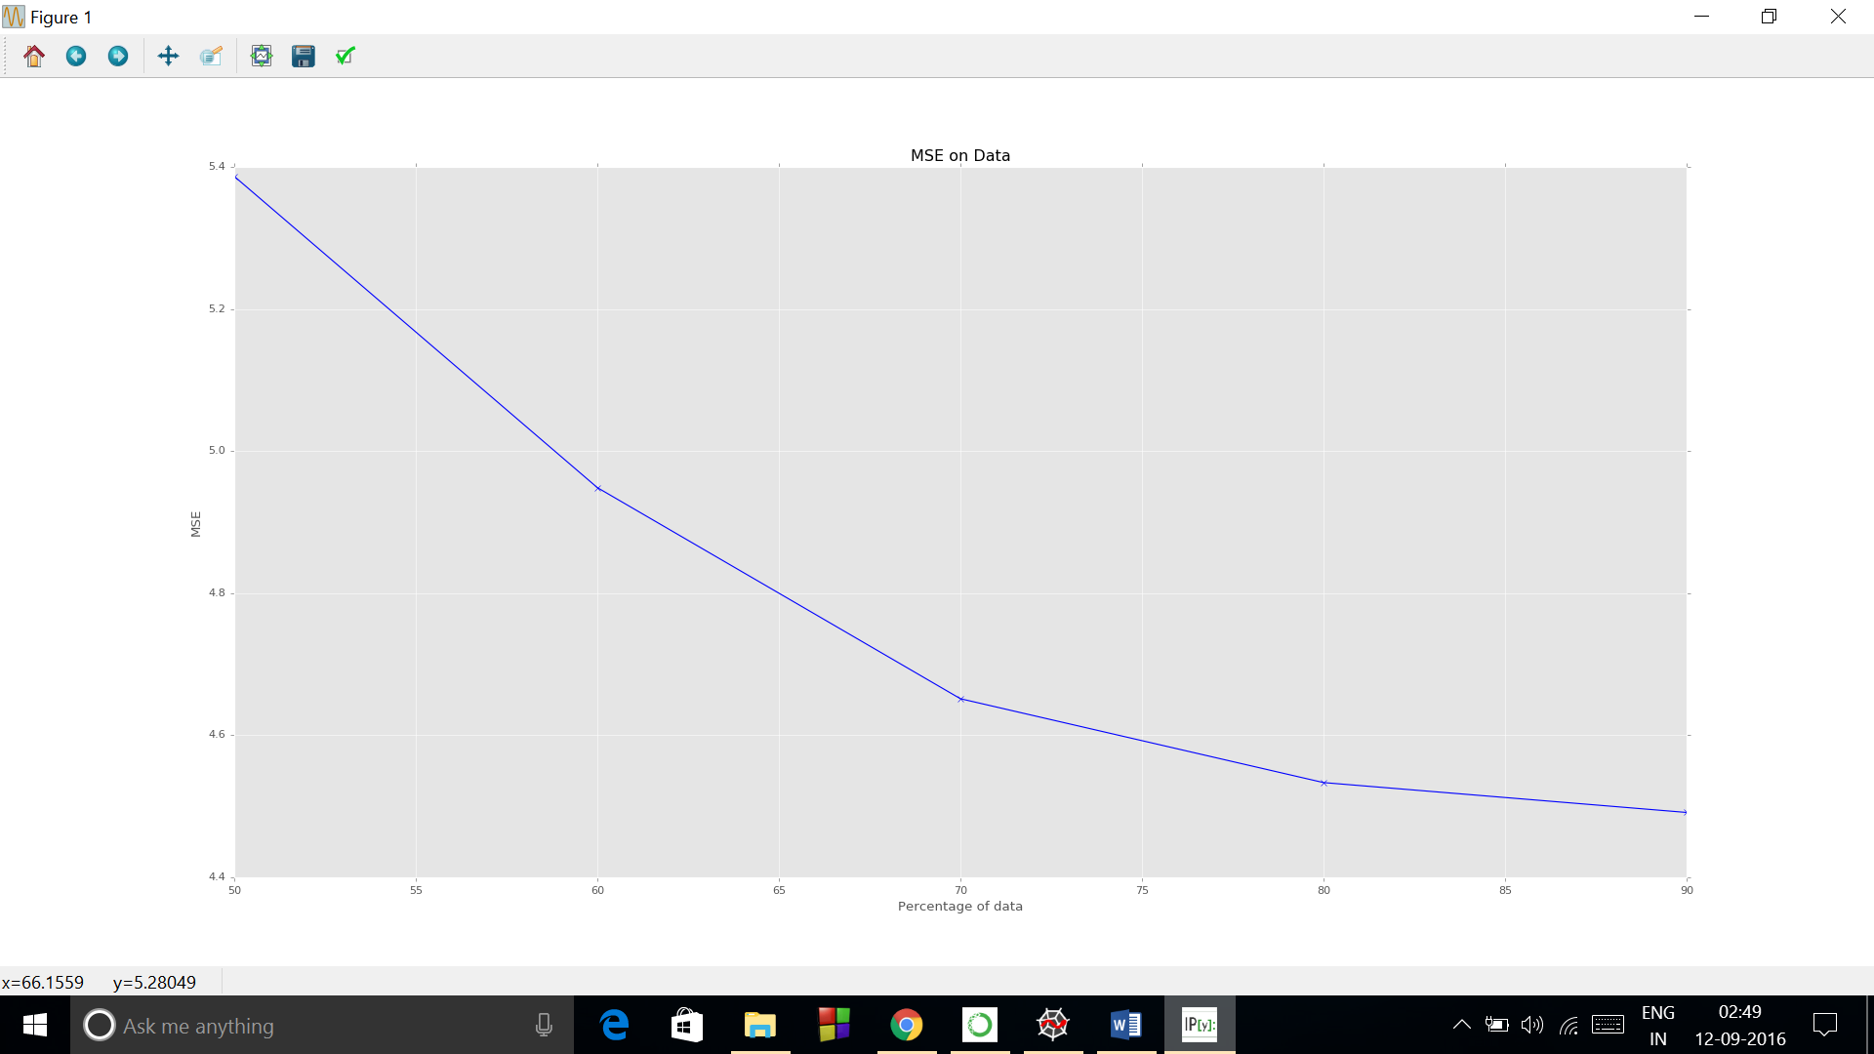

Final_parameters:

[[-3.83246815]

[ 1.20054998]]

Sph.txt:

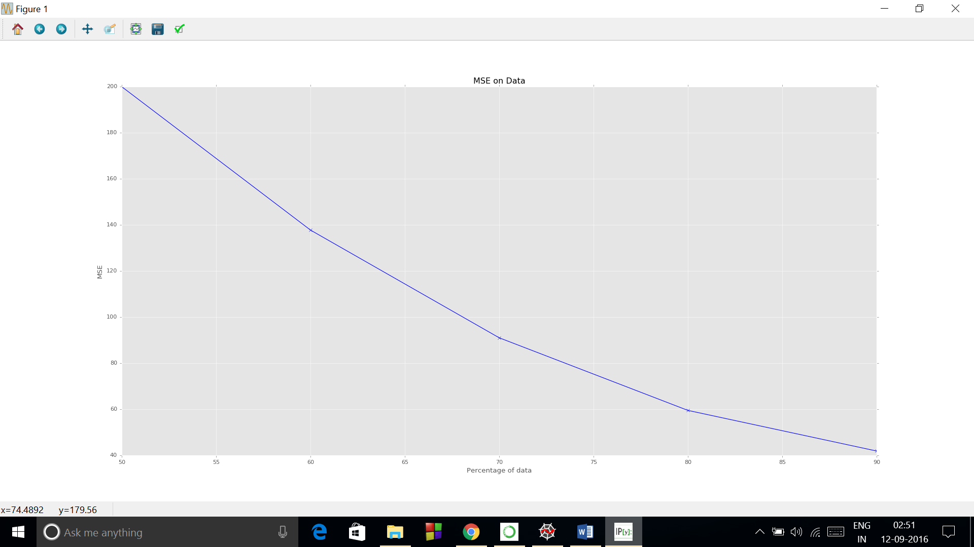

Final_parameters:

[[-12.28637391]

[ 0.95160029]]

B). lin.txt

Polynomial:

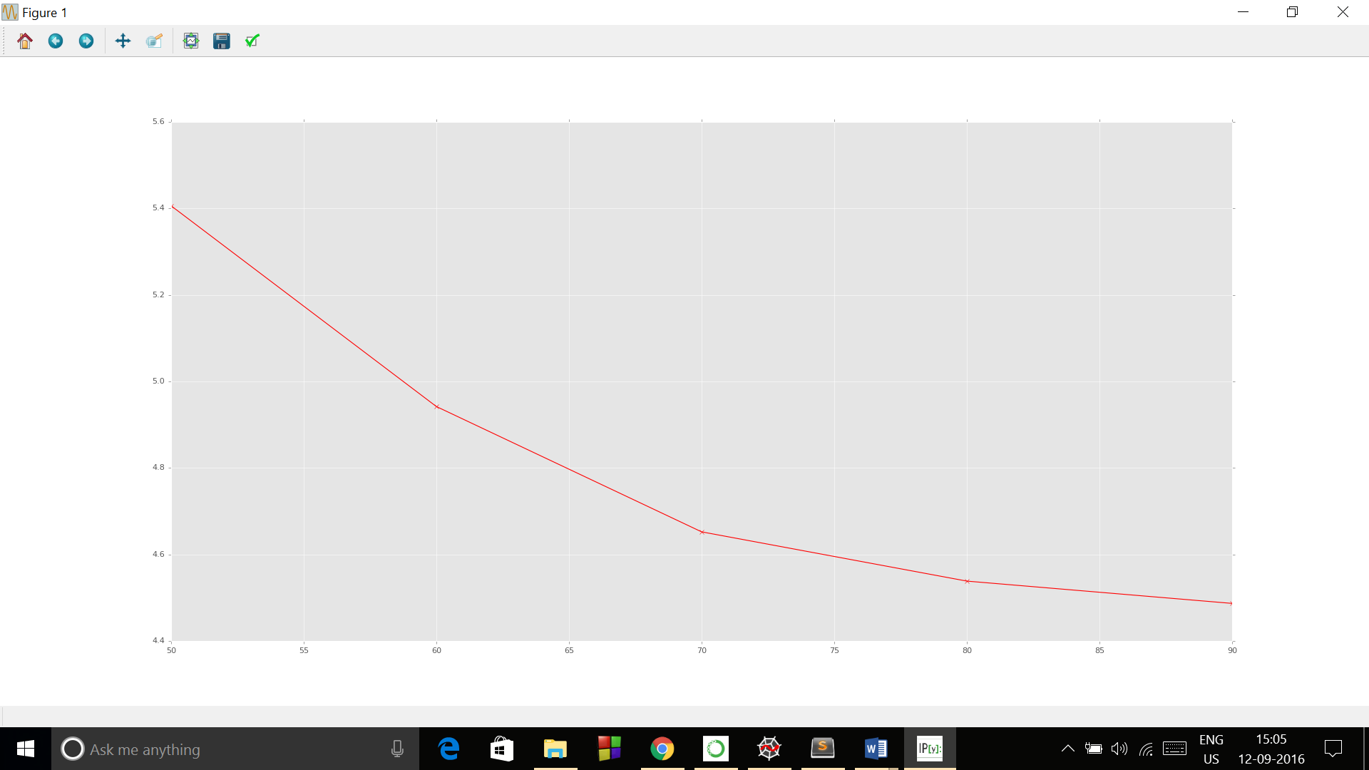

Final_parameters:

[[ -6.64533714e+00]

[ 2.05992598e+00]

[ -7.60642322e-02]

[ 1.98547372e-03]]

Gaussian:

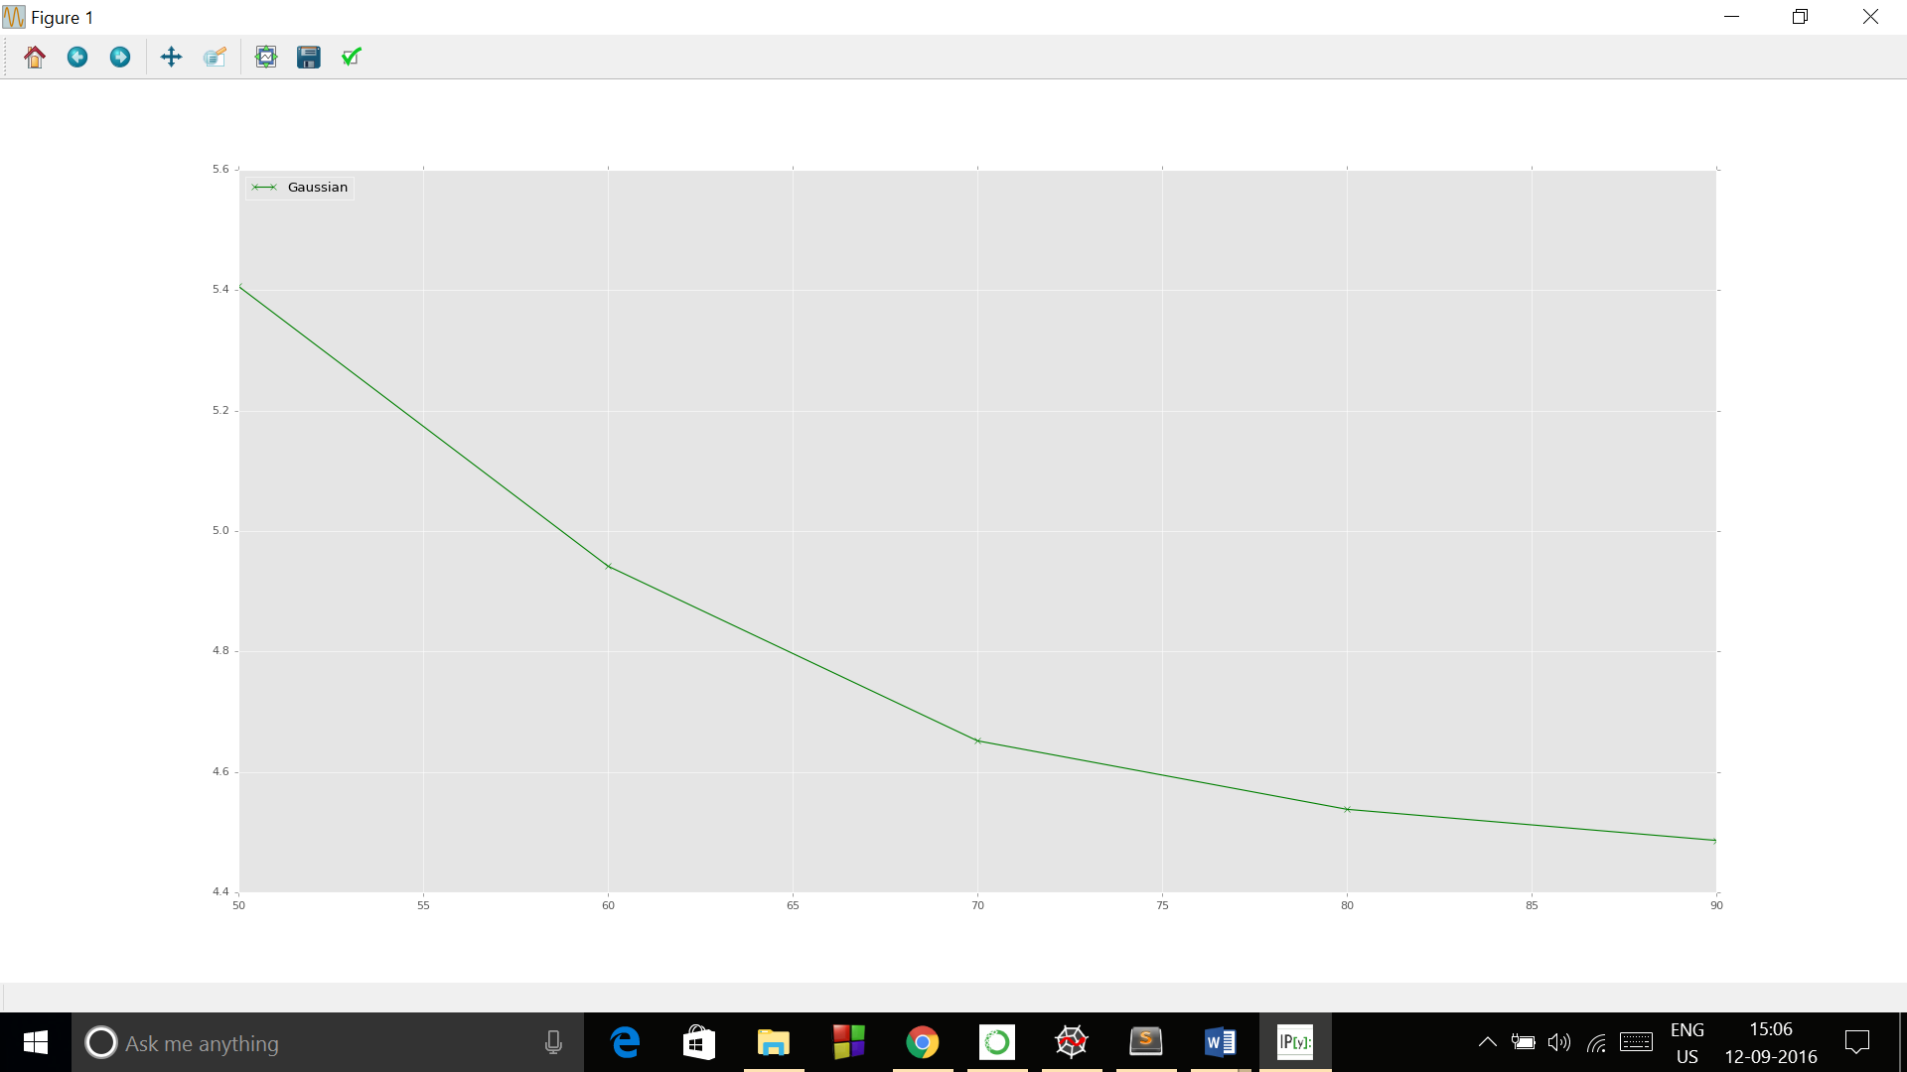

Final_parameters:

[[ -6.76938133]

[ 148.45639756]

[ -567.14117141]

[ 1915.29457624]]

All the three in same plot:

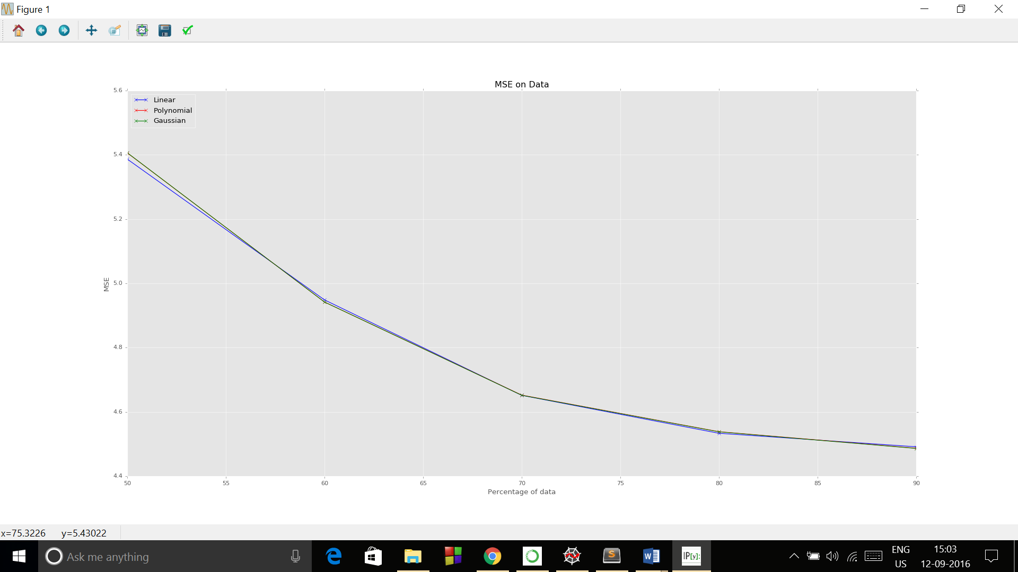

sph.txt:

Polynomial:

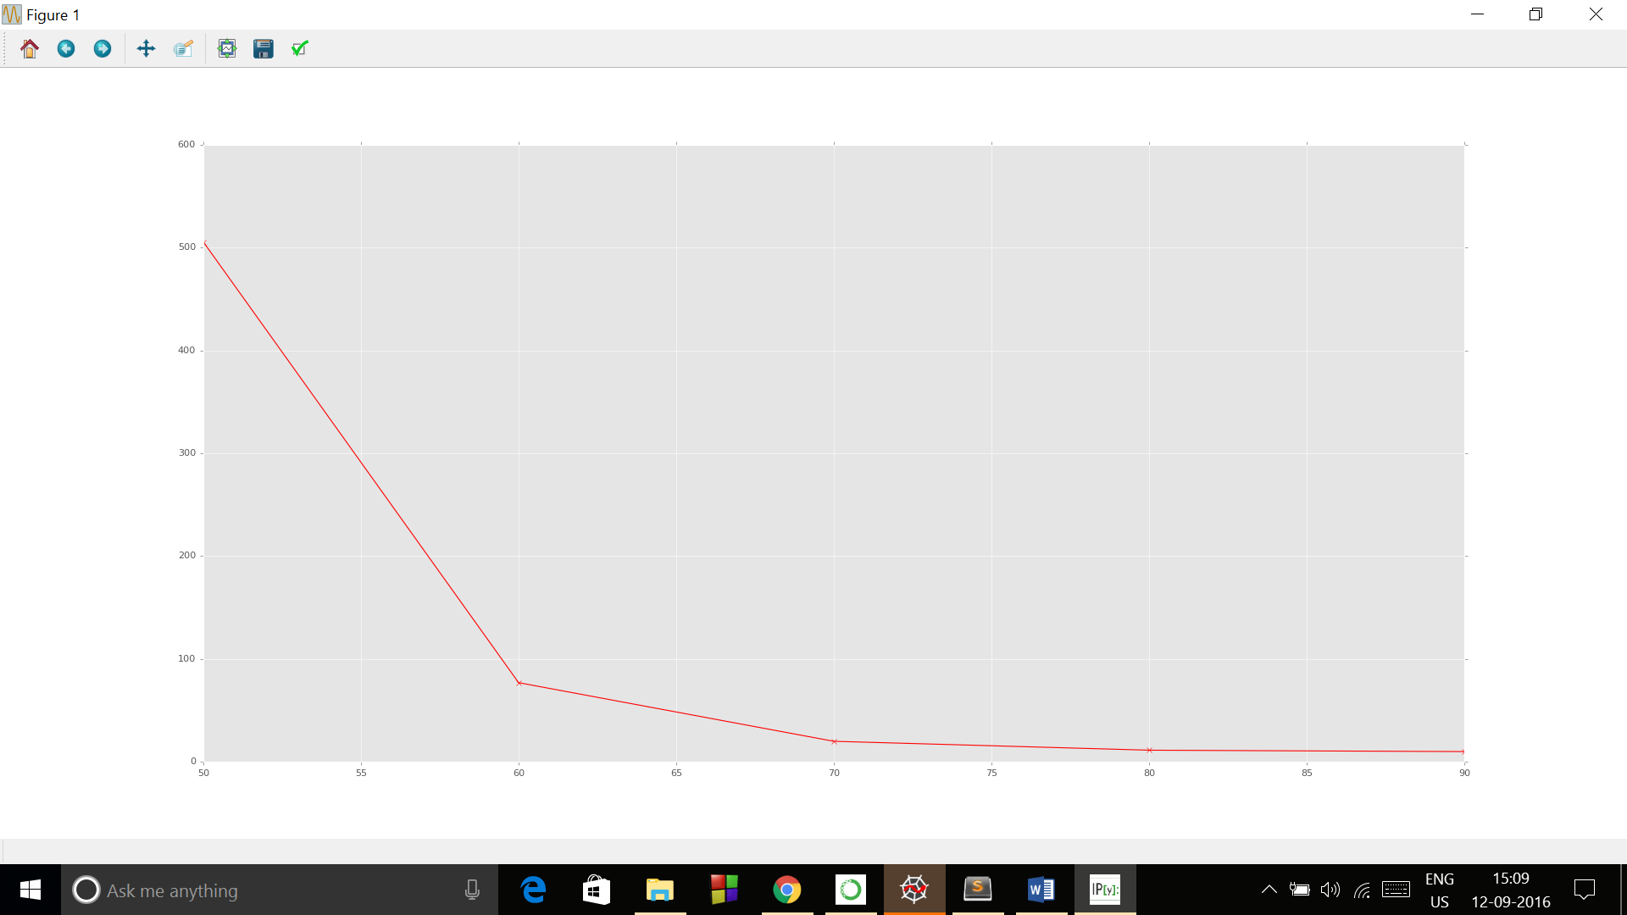

Final_parameters:

[[ 9.53078664e-01]

[ 1.56195472e-01]

[ 6.69055133e-03]

[ 2.50877482e-05]]

Gaussian:

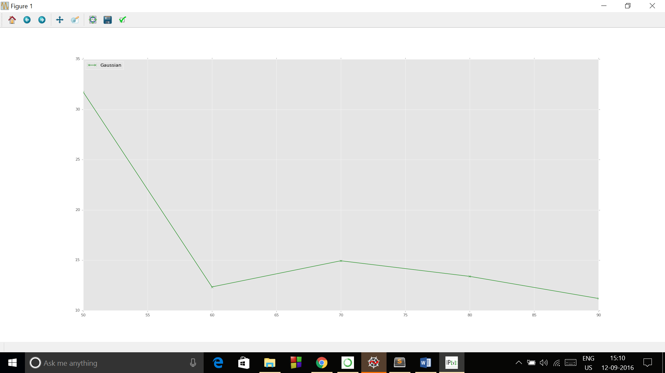

Final_parameters:

[[ -1.61926295]

[ 48.13812614]

[-120.94531105]

[ 319.61259127]]

All the three in same plot:

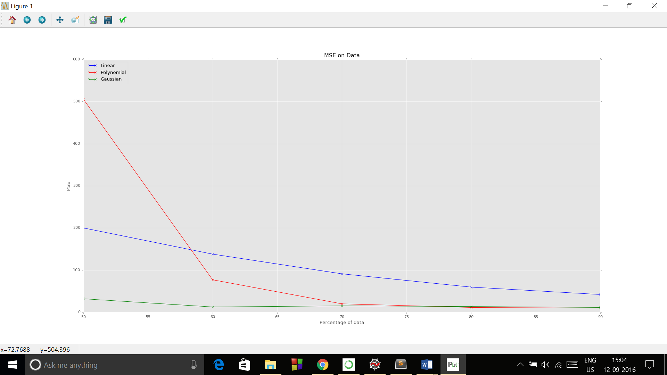

C).

lin.txt:

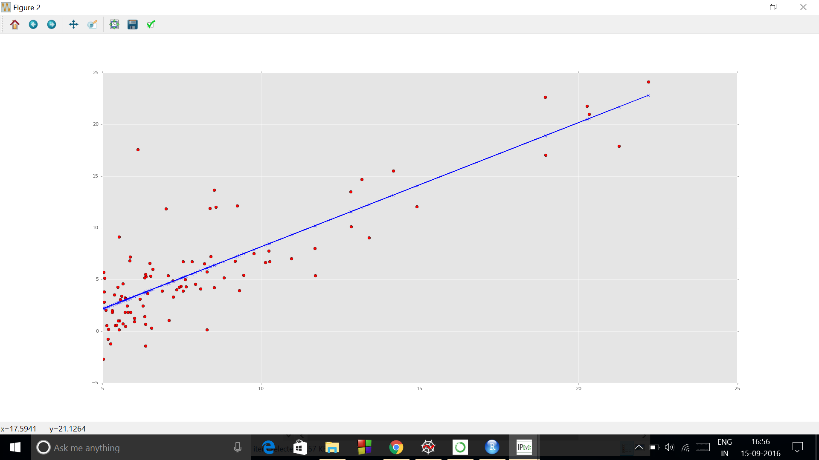

Fit of data

Using linear kernel:

Cost after training from 50%, 60%, 70%, 80%, 90% of data respectively:

[[ 5.38669943]

[ 4.94857837]

[ 4.65143337]

[ 4.53341478]

[ 4.49135934]]

Final_parameters:

[[-3.77399579]

[ 1.19872364]]

For polynomial kernel I have used 3 degree of polynomial for polynomial kernel. I have used 3 as degree of polynomial.

Cost after training from 50%, 60%, 70%, 80%, 90% of data respectively:

[[ 5.40603452]

[ 4.94200299]

[ 4.65225806]

[ 4.53839634]

[ 4.48682286]]

Final_parameters:

[[ -6.64533714e+00]

[ 2.05992598e+00]

[ -7.60642322e-02]

[ 1.98547372e-03]]

For Gaussian kernel:

Cost after training from 50%, 60%, 70%, 80%, 90% of data respectively:

[[ 5.40655131]

[ 4.94186324]

[ 4.65169658]

[ 4.53792331]

[ 4.48622959]]

Final_parameters:

[[ -6.76938133]

[ 148.45639756]

[ -567.14117141]

[ 1915.29457624]]

So, we observe that Gaussian and Polynomial gives approx the same result but Gaussian kernel is little better.

sph.txt:

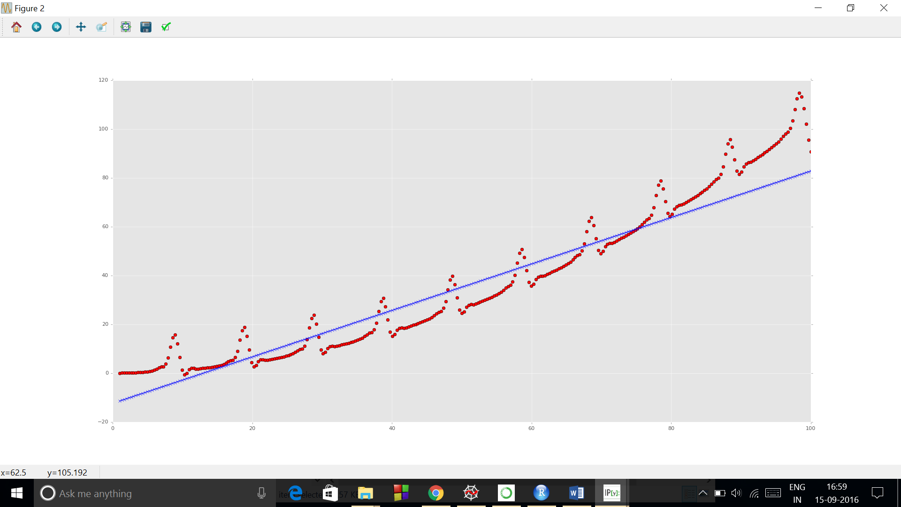

Fit of data

Using linear kernel:

Cost after training from 50%, 60%, 70%, 80%, 90% of data respectively:

[[ 199.95745047]

[ 137.75402046]

[ 91.0131034 ]

[ 59.49966616]

[ 41.87986043]]

Final_parameters:

[[-12.28637391]

[ 0.95160029]]

Polynomial kernel:

For polynomial kernel I have used 3 degree of polynomial for polynomial kernel. I have used 3 as degree of polynomial.

Cost after training from 50%, 60%, 70%, 80%, 90% of data respectively:

[[ 505.53585954]

[ 76.83831084]

[ 19.80531261]

[ 11.15582704]

[ 9.79429605]]

Final_parameters:

[[ 9.53078664e-01]

[ 1.56195472e-01]

[ 6.69055133e-03]

[ 2.50877482e-05]]

Gaussian kernel:

Cost after training from 50%, 60%, 70%, 80%, 90% of data respectively:

[[ 31.73330215]

[ 12.34528619]

[ 14.94332305]

[ 13.39268413]

[ 11.19358357]]

Final_parameters:

[[ -1.61926295]

[ 48.13812614]

[-120.94531105]

[ 319.61259127]]

So, we observe that polynomial kernel gives best result.

D).

lin.txt

So I have chosen delta value = 0.1 which best fit the data.

Cost after training from 50%, 60%, 70%, 80%, 90% of data respectively:

[[ 5.39196127]

[ 4.94951354]

[ 4.65529283]

[ 4.53530362]

[ 4.49195672]]

Final_parameters:

[[-3.75206566]

[ 1.19657154]]

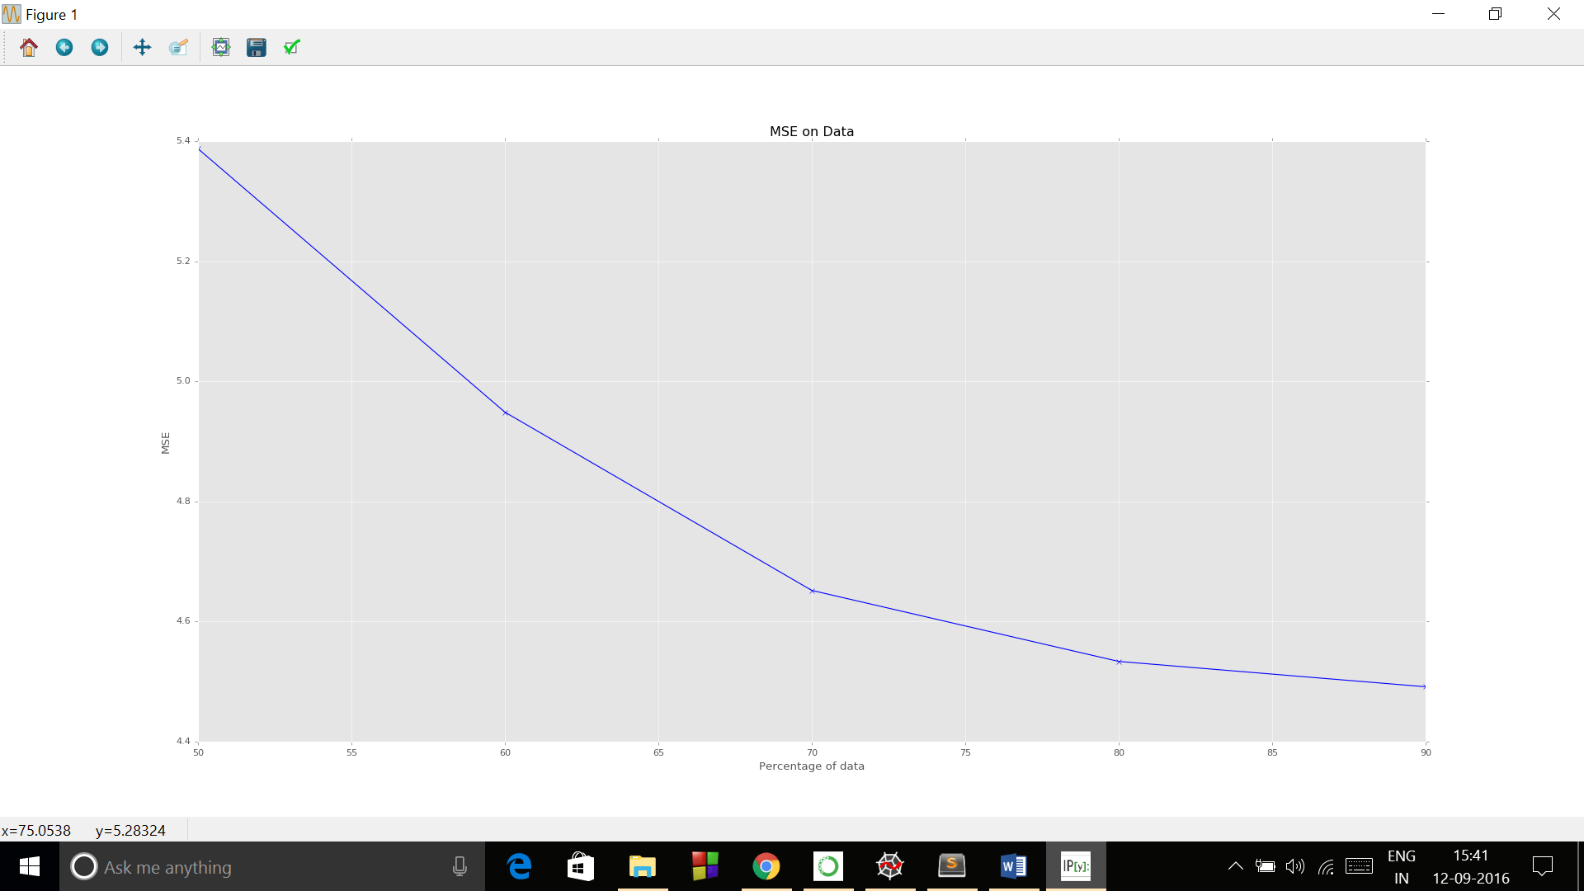

For higher delta we see there is underfit and cost tends to increase. For smaller delta we see there is overfit. So best fit is when delta = 0.1.

Higher delta:

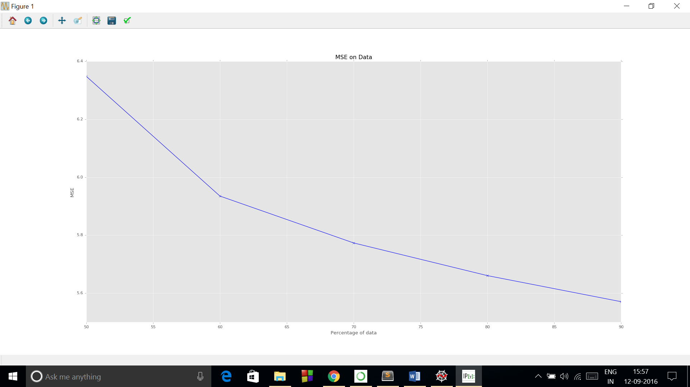

Lower delta:

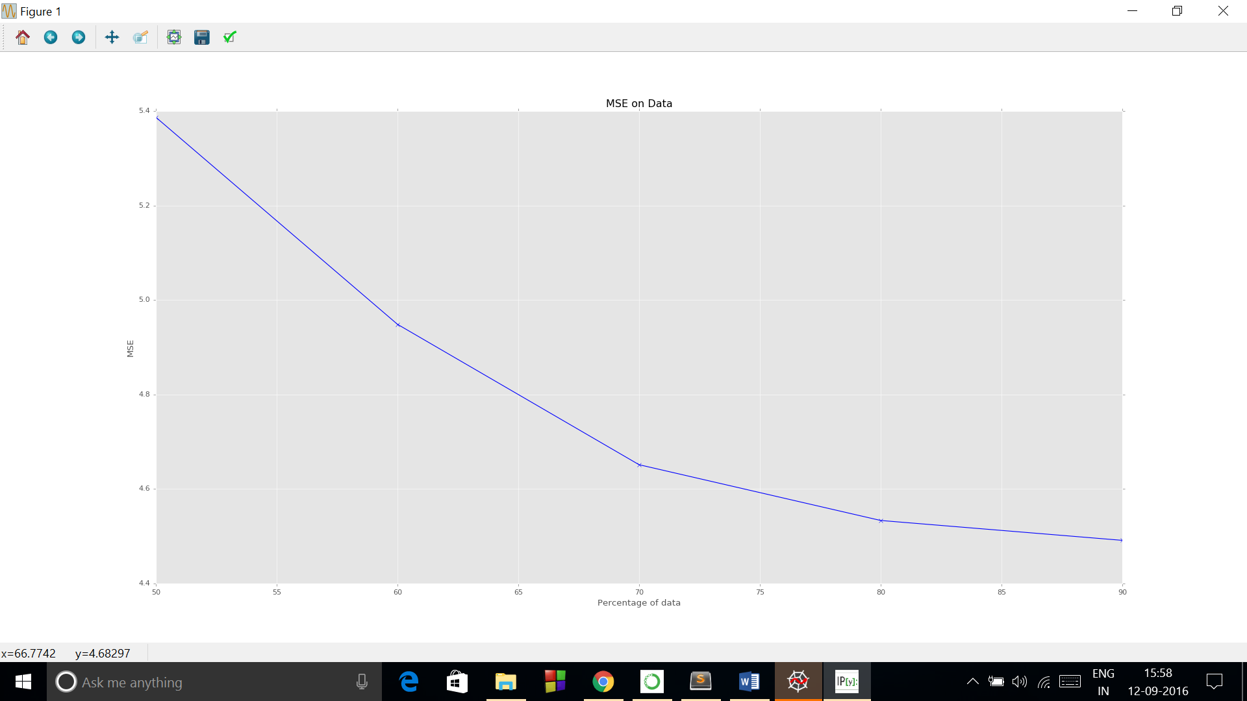

sph.txt

So I have chosen delta value = 0.1 which best fit the data.

Cost after training from 50%, 60%, 70%, 80%, 90% of data respectively:

[[ 199.97210943]

[ 137.76523603]

[ 91.02075088]

[ 59.50416632]

[ 41.88180253]]

Final_parameters:

[[-12.28450012]

[ 0.95156913]]

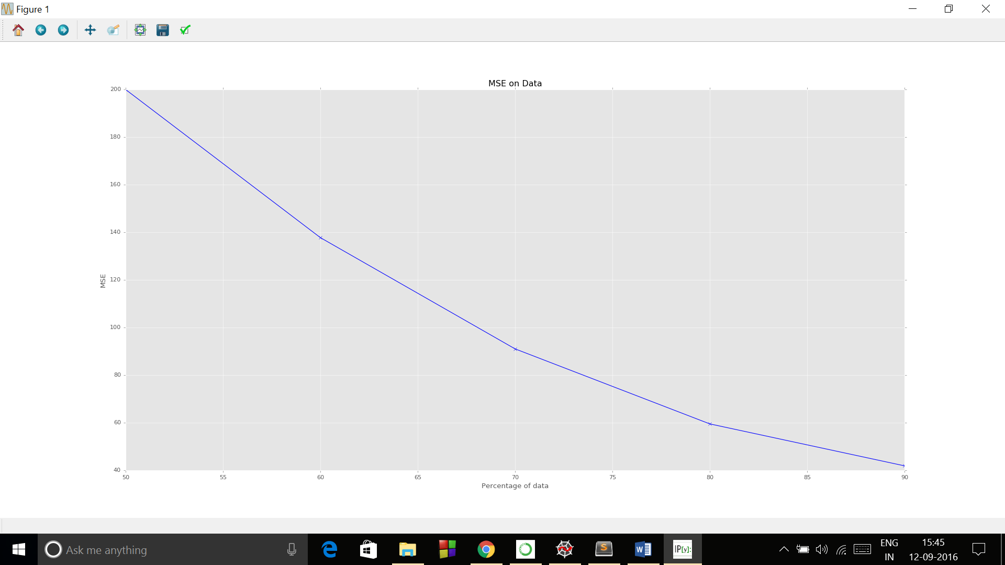

For higher delta we see there is underfit and cost tends to increase. For smaller delta we see there is overfit. So best fit is when delta = 0.1.

Higher delta:

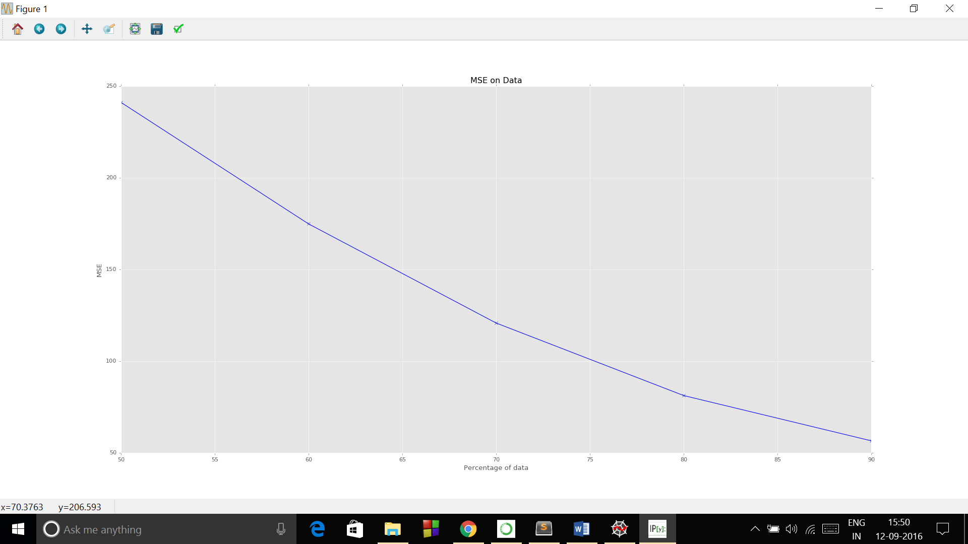

Lower delta:

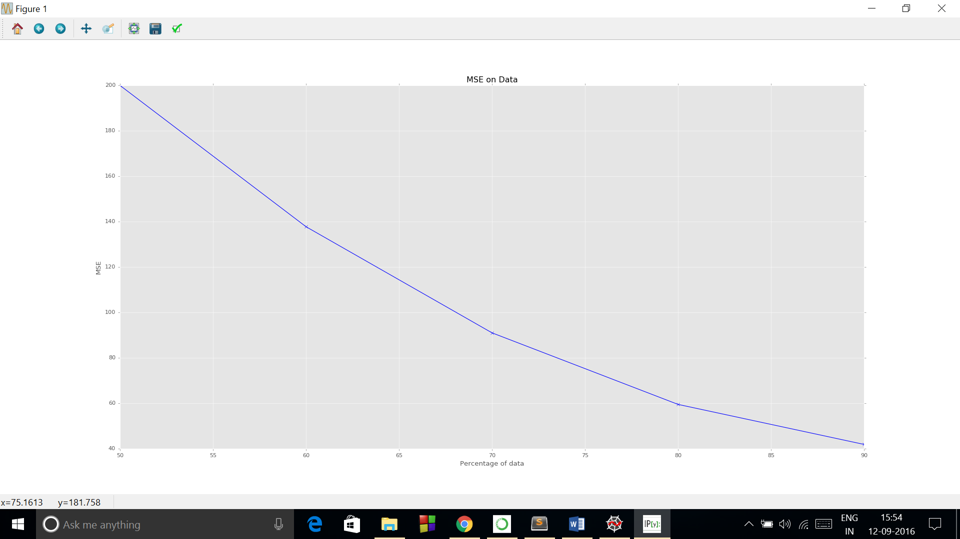

E).

lin.txt:

Here Gaussian kernel best fits the data.

Mean of test error: 5.1995724247

Std of test error: 7.04496308348

Final_parameters:

[[-3.83246815]

[ 1.20054998]]

In polynomial kernel:

Mean of test error: 5.39951571657

Std of test error: 7.1130080247

Cost after training from 50%, 60%, 70%, 80%, 90% of data respectively:

[[ 5.40603452]

[ 4.94200299]

[ 4.65225806]

[ 4.53839634]

[ 4.48682286]]

Final_parameters:

[[ -6.14572078e+00]

[ 1.90253007e+00]

[ -6.29580484e-02]

[ 1.66455547e-03]]

In gaussian kernel:

Mean of test error: 5.1995724247

Std of test error: 7.04496308348

Final_parameters:

[[-3.83246815]

[ 1.20054998]]

Gaussian kernel:

Mean of test error: 5.39951572216

Std of test error: 7.11300801726

Cost after training from 50%, 60%, 70%, 80%, 90% of data respectively:

[[ 5.40603453]

[ 4.94200298]

[ 4.65225806]

[ 4.53839634]

[ 4.48682286]]

Final_parameters:

[[ -6.14572186e+00]

[ 4.25418732e+04]

[ -4.45180885e+07]

[ 4.55857861e+10]]

sph.txt:

Linear kernel:

Mean of test error: 59.3670985994

Std of test error: 60.0409736531

Final_parameters:

[[-12.28637391]

[ 0.95160029]]

Polynomial kernel:

Mean of test error: 9.9456586336

Std of test error: 2.25962634043

Final_parameters:

[[ 9.53078664e-01]

[ 1.56195472e-01]

[ 6.69055133e-03]

[ 2.50877482e-05]]

Gaussian kernel:

Mean of test error: 9.51229639628

Std of test error: 2.85368891888

Cost after training from 50%, 60%, 70%, 80%, 90% of data respectively:

[[ 1191.53659013]

[ 1191.53659013]

[ 1191.53659013]

[ 1191.53659013]

[ 1191.53659013]]

Final_parameters:

[[-11.56634391]

[ 33.73033725]

[-42.4021767 ]

[ 20.44410388]]

Gaussian best fits the data.

seeds_dataset:

Linear kernel:

Mean of test error: 0.105967843521

Std of test error: 0.0936895203577

Final_parameters:

[[ 58.15571646]

[ 1.5159037 ]

[ -3.24367246]

[-37.0137699 ]

[ -2.22050422]

[ 0.53613228]

[ 0.09044132]

[ 2.06137804]]

Polynomial kernel:

Mean of test error: 0.136326537046

Std of test error: 0.134521301659

Final_parameters:

[[ -2.74009149e+03]

[ -1.74283436e+01]

[ 1.08236571e+02]

[ 7.35407329e+03]

[ 1.12032342e+02]

[ 2.32108330e+01]

[ -3.49986287e-02]

[ -5.14571746e+01]

[ 1.05563069e+00]

[ -7.07170994e+00]

[ -8.41305474e+03]

[ -2.02615733e+01]

[ -7.19929263e+00]

[ 2.94550796e-02]

[ 1.03051807e+01]

[ -2.08170449e-02]

[ 1.53162730e-01]

[ 3.20492691e+03]

[ 1.19676985e+00]

[ 7.35165526e-01]

[ -2.15122002e-03]

[ -6.58783659e-01]]

Gaussian kernel:

Mean of test error: 0.783990542683

Std of test error: 1.20034810607

Cost after training from 50%, 60%, 70%, 80%, 90% of data respectively:

[[ 0.50007586]

[ 3.64380383]

[ 7.07654658]

[ 0.39981445]

[ 2.37352994]]

Final_parameters:

[[ 5.58072774e+02]

[ 6.22697250e+03]

[ -5.15041472e+03]

[ -3.65435969e+03]

[ 7.76485260e+03]

[ 5.46122472e+02]

[ -9.03337136e+03]

[ -1.23236996e+05]

[ 7.65343937e+05]

[ 5.20006827e+07]

[ 7.92194599e+05]

[ 1.64125827e+05]

[ -2.47475775e+02]

[ -3.63857666e+05]

[ 7.46445905e+07]

[ -5.00037572e+08]

[ -5.94887370e+11]

[ -1.43272299e+09]

[ -5.09062877e+08]

[ 2.08316803e+06]

[ 7.28680722e+08]

[ -1.80280545e+10]

[ 1.32641961e+11]

[ 2.77552244e+15]

[ 1.03644080e+12]

[ 6.36674049e+11]

[ -1.86300256e+09]

[ -5.70523958e+11]]

Gaussian best fits the data.

iris_data:

Linear kernel:

Mean of test error: 0.0293738811041

Std of test error: 0.0216304028656

Cost after training from 50%, 60%, 70%, 80%, 90% of data respectively:

[[ 0.06833199]

[ 0.07141878]

[ 0.04195914]

[ 0.02690352]

[ 0.02357895]]

Final_parameters:

[[ 1.84623117]

[ 0.10719925]

[ 0.0405839 ]

[-0.24900758]

[-0.53588614]]

Polynomial kernel:

Mean of test error: 0.0259139955207

Std of test error: 0.0210187146341

Cost after training from 50%, 60%, 70%, 80%, 90% of data respectively:

[[ 0.59421357]

[ 0.45453488]

[ 0.0361531 ]

[ 0.02104076]

[ 0.01763312]]

Final_parameters:

[[ 4.41174419]

[-2.08477766]

[ 0.49892123]

[ 0.37373 ]

[ 0.45208169]

[ 0.32005398]

[ 0.07679573]

[-0.13660148]

[-0.88507123]

[-0.01453659]

[-0.02727833]

[ 0.007773 ]

[ 0.21404562]]

Gaussian kernel:

Mean of test error: 0.28711981094

Std of test error: 0.221978202994

Cost after training from 50%, 60%, 70%, 80%, 90% of data respectively:

[[ 0.26105358]

[ 2.11999115]

[ 0.99831511]

[ 4.20717824]

[ 1.30839136]]

Final_parameters:

[[ 3.49521822e+01]

[ 2.62084823e+01]

[ -9.36280719e+01]

[ 4.40188608e+01]

[ -1.01883828e+04]

[ -3.00628285e+04]

[ -1.39544375e+04]

[ -1.86382009e+04]

[ 3.12879530e+07]

[ 7.80375423e+07]

[ 1.96034997e+07]

[ 1.94934873e+08]

[ -3.36969610e+10]

[ -7.79288458e+10]

[ 3.68764271e+08]

[ -5.36742256e+11]]

Gaussian kernel best fits the data.

AirQualityUCI.txt

Linear kernel:

Mean of test error: 3.49144588364

Std of test error: 1.69059979269

Cost after training from 50%, 60%, 70%, 80%, 90% of data respectively:

[[ 5.25162289]

[ 5.45141356]

[ 3.80324406]

[ 3.18256931]

[ 2.6113028 ]]

Final_parameters:

[[ 8.77141483e+00]

[ -1.49533794e-01]

[ -3.32211416e-04]

[ -2.60470687e-03]

[ -3.64992750e-01]

[ 1.21093288e-02]

[ 2.19197695e-03]

[ 1.44242206e-03]

[ -2.59719811e-04]

[ 4.64696646e-03]

[ -2.73366327e-03]

[ -3.42181780e-01]

[ 1.40081888e+01]]

Polynomial kernel:

Mean of test error: 0.134104566275

Std of test error: 0.0749423458273

Cost after training from 50%, 60%, 70%, 80%, 90% of data respectively:

[[ 0.16947999]

[ 0.16749253]

[ 0.10308494]

[ 0.09859191]

[ 0.09095416]]

Final_parameters:

[[ 1.26817448e+01]

[ -1.29600690e-01]

[ 1.17822999e-02]

[ 1.03917328e-03]

[ 1.73619593e+00]

[ 3.47491062e-02]

[ -2.49897205e-03]

[ -6.94256775e-04]

[ 1.26387517e-02]

[ 3.54049109e-03]

[ -1.03562716e-03]

[ -1.34301069e+00]

[ 5.41226703e+01]

[ 3.57253268e-02]

[ -8.22732747e-06]

[ -2.37608422e-06]

[ -5.32577981e-02]

[ -8.06825338e-05]

[ 2.51132436e-06]

[ -2.18352196e-08]

[ -6.22135937e-05]

[ -2.75120260e-06]

[ 7.32657181e-07]

[ 1.60755155e-02]

[ -2.68262197e+01]

[ -2.50745417e-03]

[ 1.82874532e-09]

[ 1.36408355e-09]

[ 1.29388862e-04]

[ 3.64173678e-08]

[ -8.56695195e-10]

[ 1.00934075e-10]

[ 1.18861917e-07]

[ 5.76153087e-10]

[ -1.40590917e-10]

[ -7.72689071e-05]

[ 5.44496777e+00]]

Gaussian kernel:

Mean of test error: 1494.27159262

Std of test error: 3278.22616039

Cost after training from 50%, 60%, 70%, 80%, 90% of data respectively:

[[ 1422.35207022]

[ 3694.72197059]

[ 857.90387968]

[ 244.80427764]

[ 511.50427454]]

Final_parameters:

[[ 4.27067423e+05]

[ 2.54412939e+04]

[ -3.17463621e+04]

[ 3.59795029e+06]

[ -1.16895660e+05]

[ -8.07879490e+03]

[ 2.62986238e+03]

[ -4.10748809e+06]

[ 1.80125762e+04]

[ -4.29467829e+03]

[ -9.75134168e+05]

[ 1.17256407e+06]

[ -8.30061876e+02]

[ 1.46987635e+02]

[ 5.59331808e+00]

[ 1.17477691e+04]

[ 1.31242327e+02]

[ -2.26127121e+01]

[ 6.21320689e+00]

[ 9.22137683e+01]

[ 1.32412238e+02]

[ -1.80362924e+01]

[ -9.51712765e+03]

[ 3.80148366e+05]

[ 2.57682000e+06]

[ 1.65876855e+04]

[ -2.25138760e+04]

[ -8.64148562e+05]

[ -8.62369468e+04]

[ -5.39903819e+03]

[ 1.73303479e+03]

[ -2.90824163e+06]

[ 1.14896058e+04]

[ -2.84096807e+03]

[ 4.51964249e+05]

[ -1.87188383e+09]

[ -1.95883893e+09]

[ 7.17631232e+03]

[ -1.28349859e+03]

[ 3.35486425e+07]

[ 1.19190893e+04]

[ -2.15459078e+03]

[ 7.91645699e+02]

[ 2.03955453e+04]

[ 5.86504655e+03]

[ -1.09965193e+03]

[ -6.73351677e+07]

[ 4.63378844e+12]]

Gaussian kernel gives best result.

Reference:

For Gaussian kernel implementation I took help from:

http://www.csie.ntu.edu.tw/~cjlin/talks/kuleuven_svm.pdf