The given stacked bar chart shows accidents due to the vehicle distribution

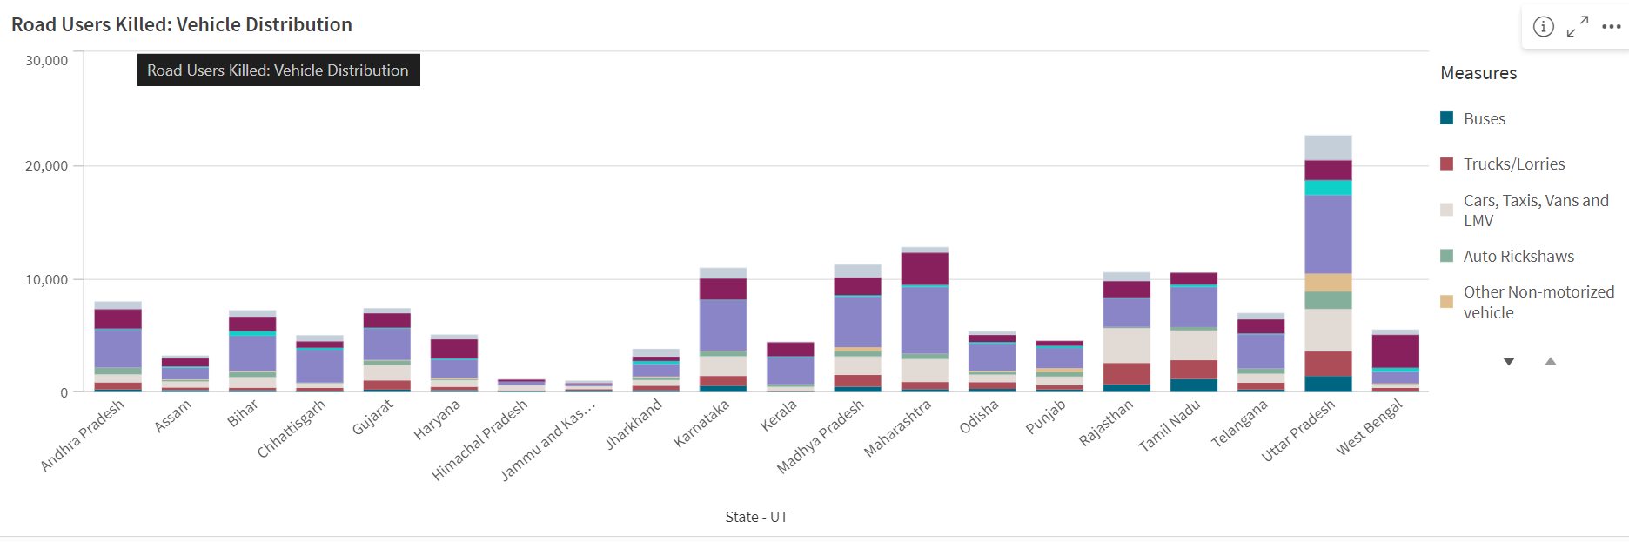

This scatter plot shows the positive realtion using avg number of accidents in all state

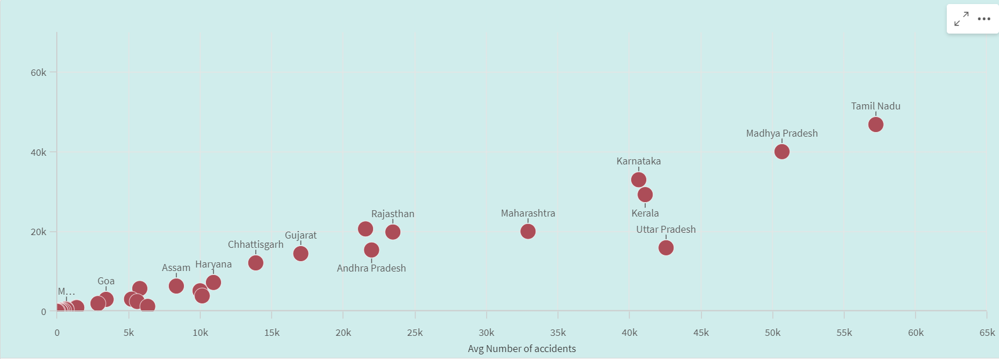

This map visualization show maximum number of male and female killed in which state

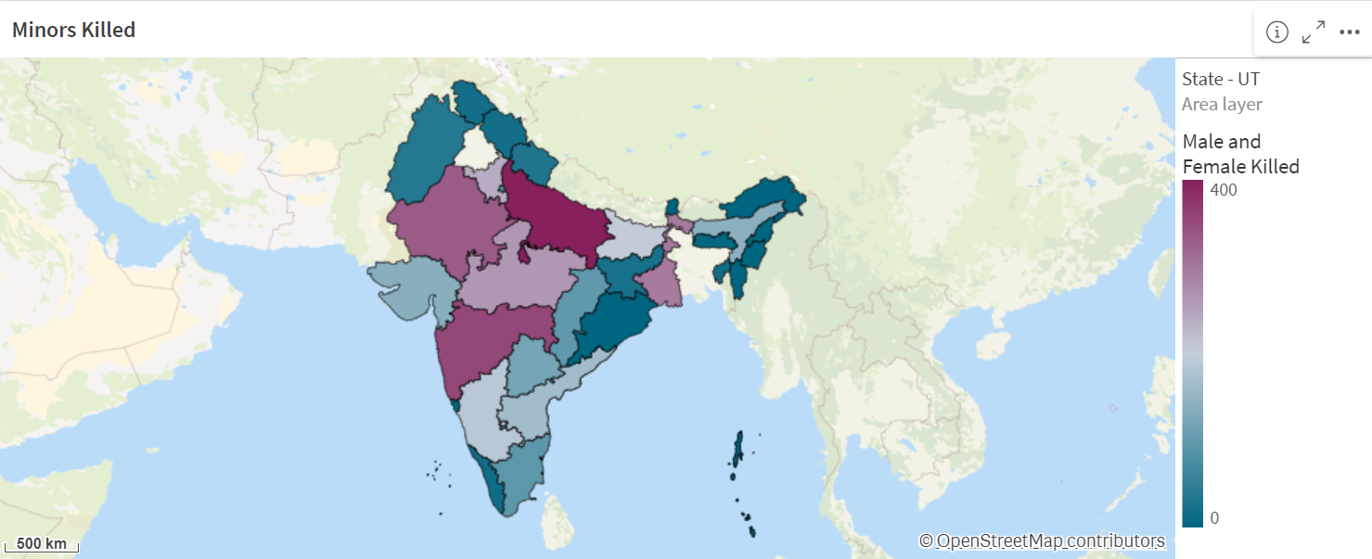

This is the dashboard which uses tree chart which shows the number of accidents in all states and by using KPI’s it shoes the person killed and greviously injured persons

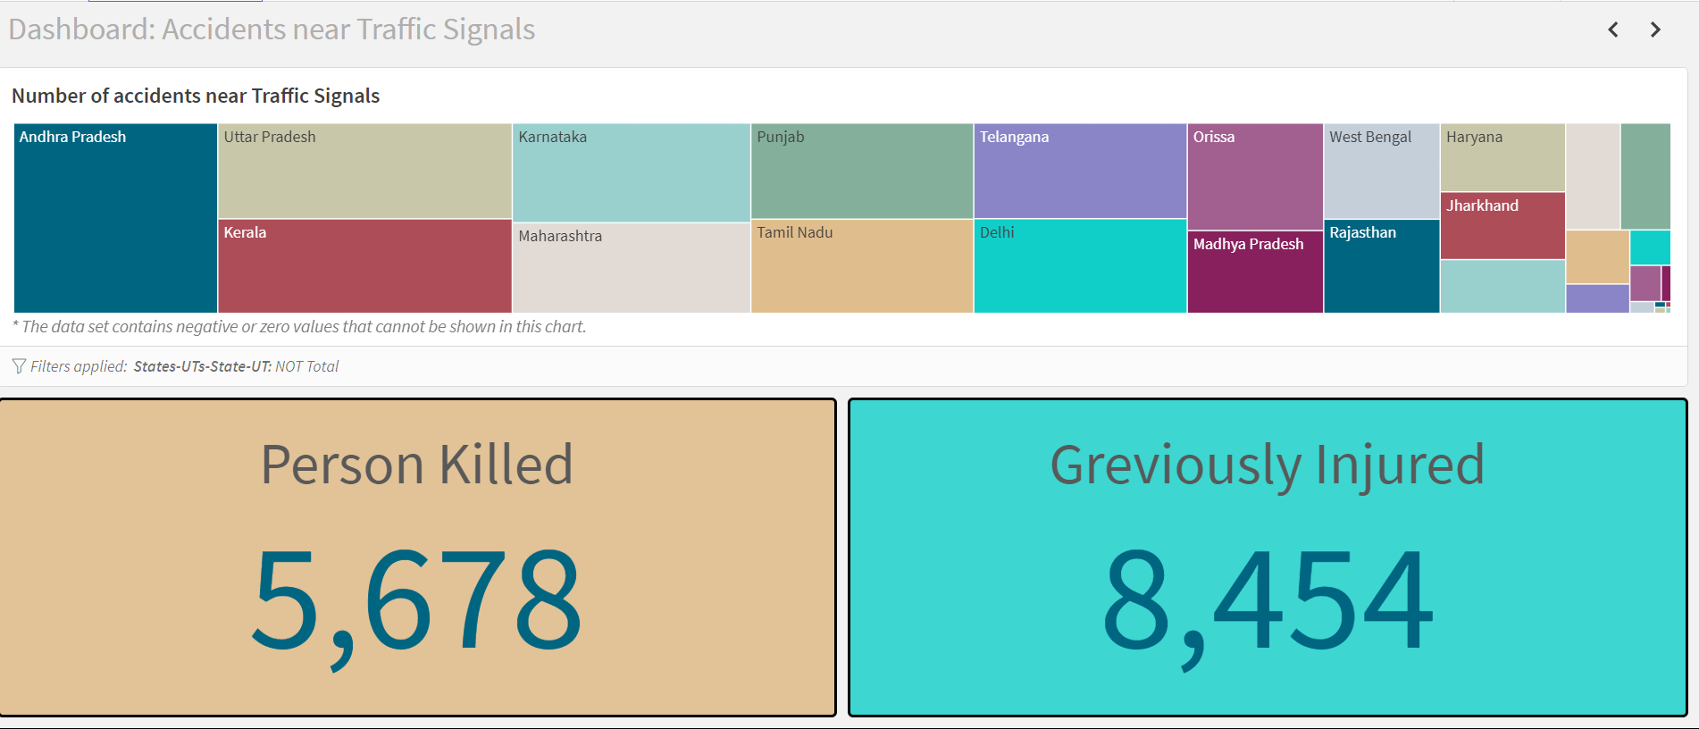

This is the dashboard which uses tree chart which shows the number of accidents in all states in police controlled area and by using KPI’s it shows the number of accidents, person killed and greviously injured persons

