Screenshots showing files and user IDs are not present for all 4 members of the team

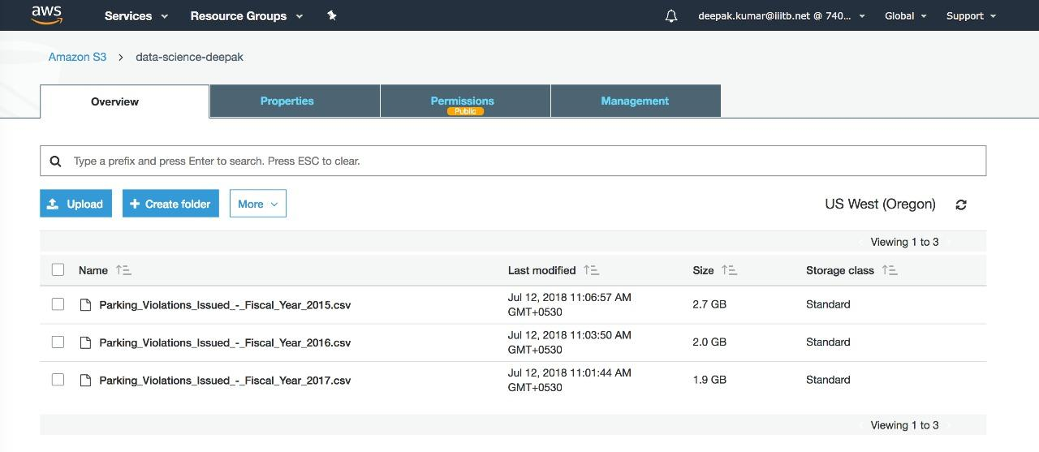

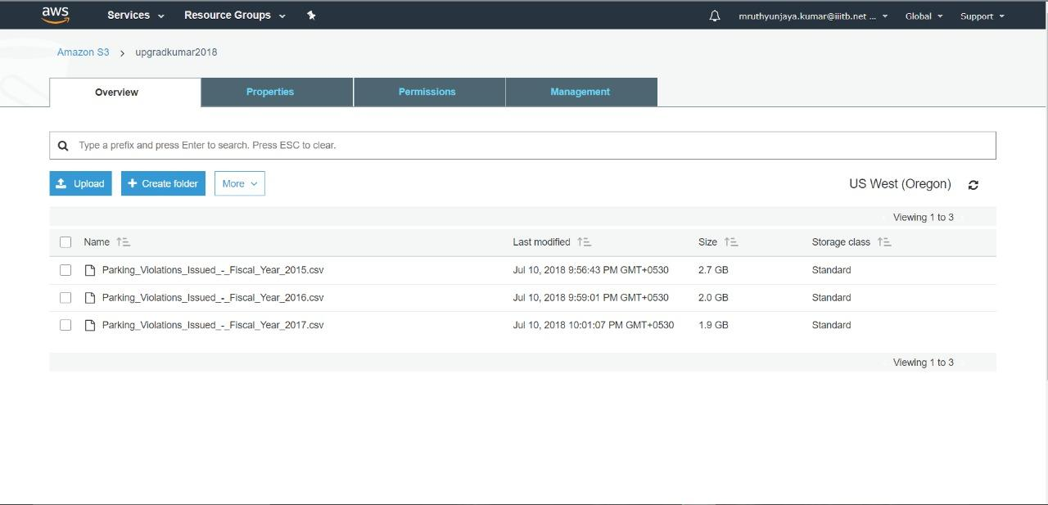

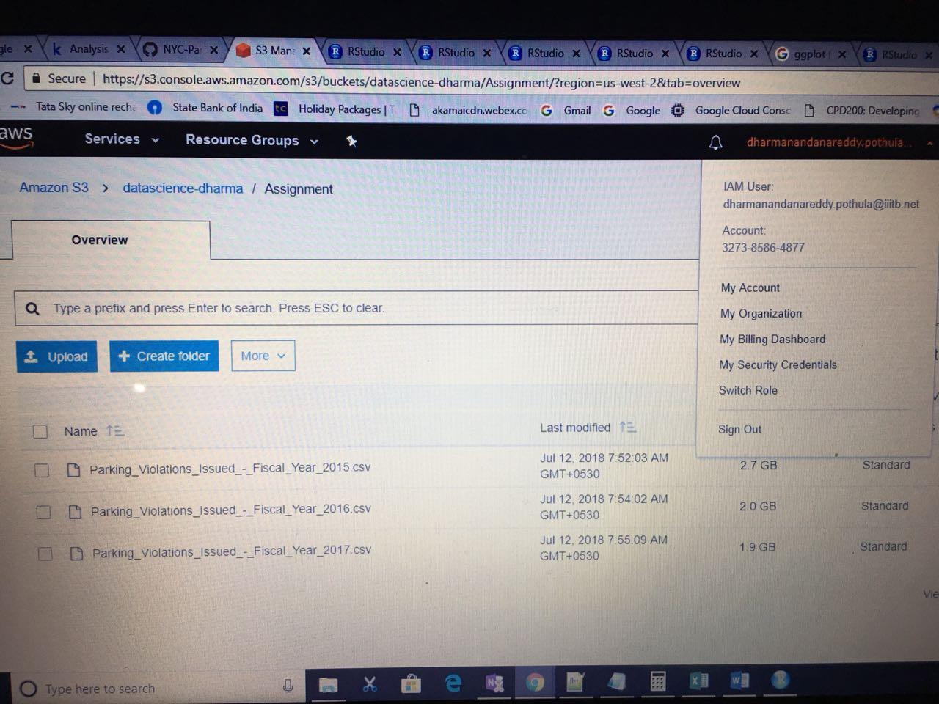

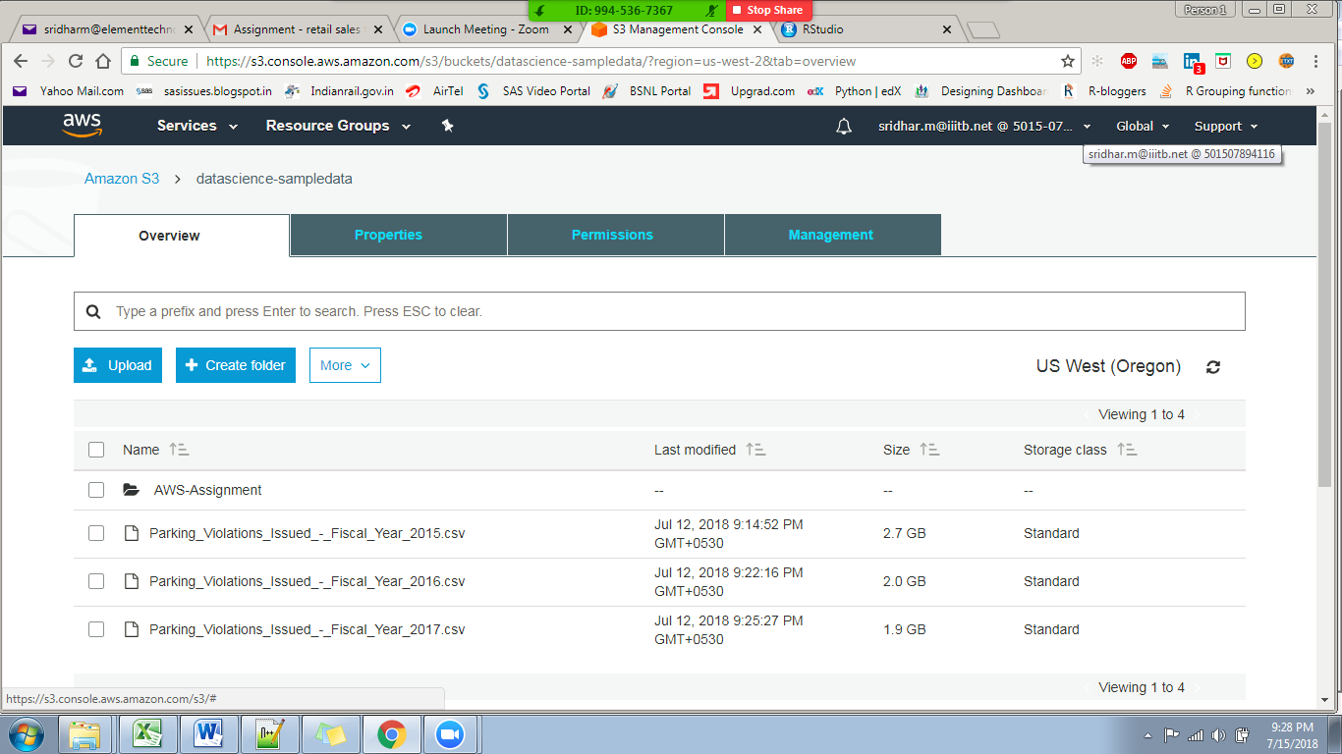

Examine the data.

1. Find total number of tickets for each year.

2015: 10951257 (51 columns)

2016: 10626899 (51 Columns)

2017: 10803028

2.Find out how many unique states the cars which got parking tickets came from.

2015: 68 (99 excluded)

2016: 68 (99 excluded)

2017: 67

1. Some parking tickets don’t have addresses on them, which is cause for concern. Find out how many such tickets there are.

2015: 5463

2016: 8274

2017: 4009

Aggregation tasks

1. How often does each violation code occur? (frequency of violation codes - find the top 5)

2015

#ViolationCode count

#1 21 171.41712

#2 38 151.20845

#3 14 105.55103

#4 36 86.93733

#5 37 85.19155

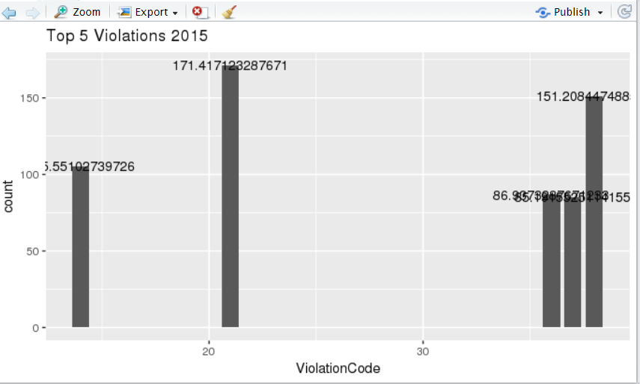

2016

#ViolationCode count

# 21 174.83870

# 38 130.55890

# 14 99.95594

# 36 143.09498

# 37 78.38014

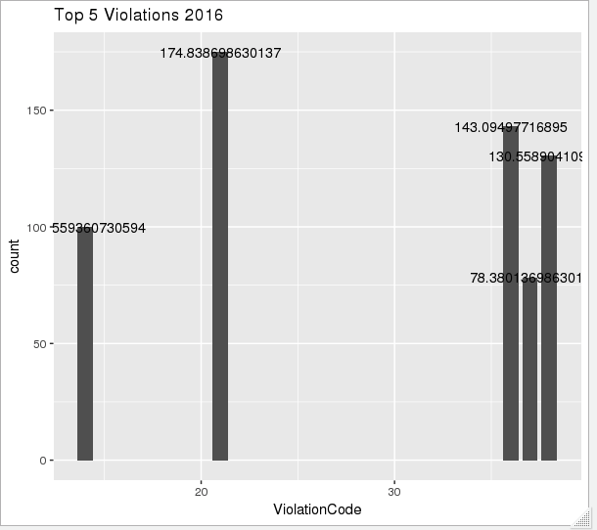

2017

# ViolationCode count

#1 21 174.49635

#2 36 159.88744

#3 38 121.26758

#4 14 101.99749

#5 20 70.61564

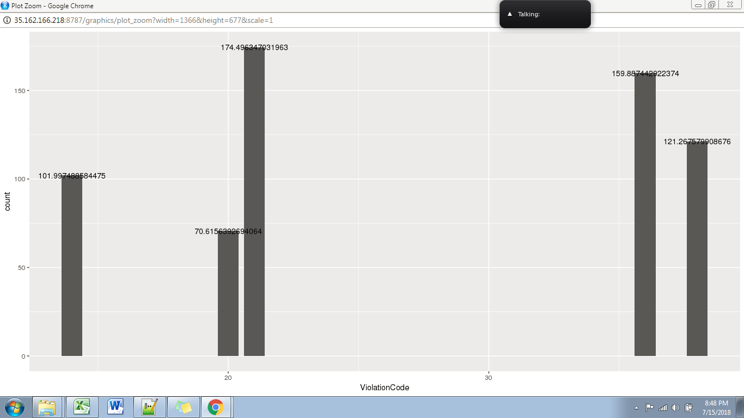

1. How often does each vehicle body type get a parking ticket? How about the vehicle make? (find the top 5 for both)

2015

VehicleBodyType count

1 SUBN 394.05970

2 4DSD 354.16781

3 VAN 183.24521

4 DELV 95.94087

5 SDN 51.82557

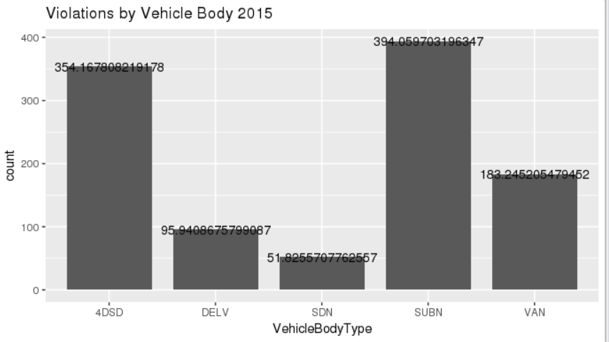

2016

#VehicleBodyType count

#1 SUBN 395.66632

#2 4DSD 341.56473

#3 VAN 173.32226

#4 DELV 86.21941

#5 SDN 48.40674

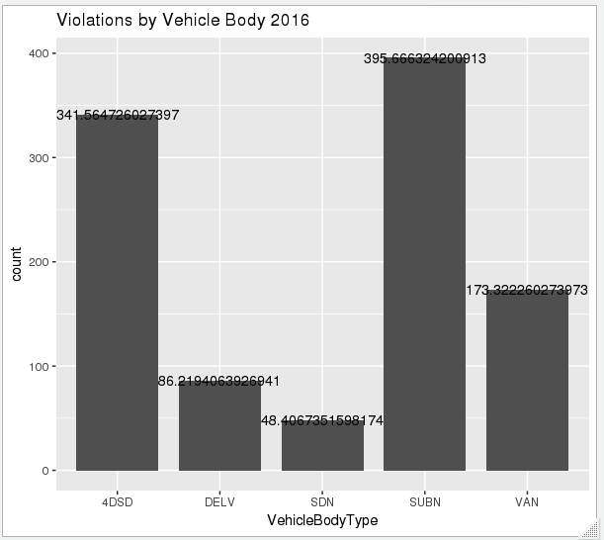

2017

# VehicleBodyType count

#1 SUBN 424.63493

#2 4DSD 351.82877

#3 VAN 161.18379

#4 DELV 78.46233

#5 SDN 50.02180

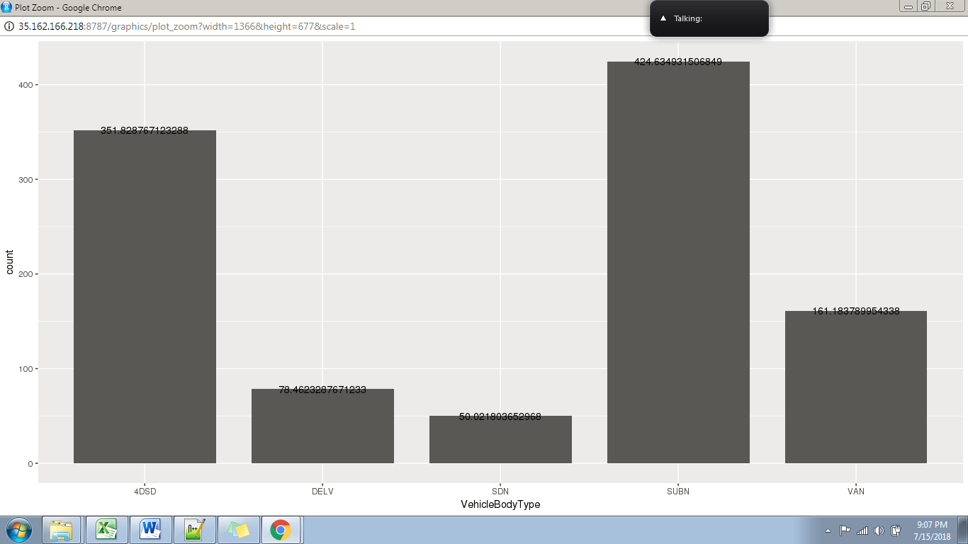

Vehicle Make Violations

2015 (Ford)

VehicleMake count

1 FORD 161.7926

2 TOYOT 128.2561

3 HONDA 116.2156

4 NISSA 95.6129

5 CHEVR 95.4782

2016

#VehicleMake count

#1 FORD 151.22991

#2 TOYOT 131.82534

#3 HONDA 115.76187

#4 NISSA 95.30057

#5 CHEVR 86.71952

2017

# VehicleMake count

#1 FORD 146.22808

#2 TOYOT 138.29349

#3 HONDA 123.20068

#4 NISSA 104.86187

#5 CHEVR 81.58162

1. A precinct is a police station that has a certain zone of the city under its command. Find the (5 highest) frequencies of:
2. Violating Precincts (this is the precinct of the zone where the violation occurred)
3. Issuing Precincts (this is the precinct that issued the ticket)

2015

#ViolationPrecinct count

#1 0 1633006

#2 19 559716

#3 18 400887

#4 14 384596

#5 1 307808

#IssuerPrecinct count

#1 0 1834343

#2 19 544946

#3 18 391501

#4 14 369725

#5 1 298594

2016

#ViolationPrecinct count

#1 0 1868655

#2 19 554465

#3 18 331704

#4 14 324467

#5 1 303850

#IssuerPrecinct count

#1 0 1834343

#2 19 544946

#3 18 391501

#4 14 369725

#5 1 298594

2017

# ViolationPrecinct count

#1 0 2072400

#2 19 535671

#3 14 352450

#4 1 331810

#5 18 306920

# IssuerPrecinct count

#1 0 2388479

#2 19 521513

#3 14 344977

#4 1 321170

#5 18 296553

-------------------------------

# [1] 3206545

-------------------------------

#ViolationCode count

#1 36 1400614

#2 7 516389

#3 21 326255

# [1] 3206545

# [1] 2914991

# ViolationCode count

#1 36 1400614

#2 7 516388

#3 14 154780

1. Find the violation code frequency across 3 precincts which have issued the most number of tickets - do these precinct zones have an exceptionally high frequency of certain violation codes? Are these codes common across precincts?

**2015**

#ViolationPrecinct count

#1 0 1619126

#2 25 9

#3 18 3

#4 104 3

#5 7 2

#6 106 2

#7 14 2

#8 26 1

#9 44 1

#10 122 1

#11 47 1

#12 1 1

#13 13 1

#14 48 1

#15 41 1

#16 33 1

#17 10 1

#18 77 1

#19 102 1

#20 50 1

#21 113 1

#22 121 1

#23 75 1

#24 71 1

#25 123 1

#26 901 1

#27 66 1

**2016**

#ViolationPrecinct count

#1 0 1619126

#2 25 9

#3 18 3

#4 104 3

#5 7 2

#6 106 2

#7 14 2

#8 26 1

#9 44 1

#10 122 1

#11 47 1

#12 1 1

#13 13 1

#14 48 1

#15 41 1

#16 33 1

#17 10 1

#18 77 1

#19 102 1

#20 50 1

#21 113 1

#22 121 1

#23 75 1

#24 71 1

#25 123 1

#26 901 1

#27 66 1

**2017**

# [1] 2062664

# ViolationPrecinct count

#1 0 2062644

#2 13 5

#3 7 3

#4 1 2

#5 78 2

#6 14 2

#7 34 1

#8 6 1

#9 17 1

#10 84 1

#11 70 1

#12 10 1

1. You’d want to find out the properties of parking violations across different times of the day:

* The Violation Time field is specified in a strange format. Find a way to make this into a time attribute that you can use to divide into groups.
* Find a way to deal with missing values, if any.
* Divide 24 hours into 6 equal discrete bins of time. The intervals you choose are at your discretion. For each of these groups, find the 3 most commonly occurring violations
* Now, try another direction. For the 3 most commonly occurring violation codes, find the most common times of day (in terms of the bins from the previous part)

2015

#bin_number ViolationCode count

#1 1 21 63574

#2 1 40 36490

#3 1 78 34842

#1 2 14 134458

#2 2 21 106858

#3 2 40 91344

#bin_number ViolationCode count

#1 3 21 1192163

#2 3 38 449070

#3 3 36 360365

#bin_number ViolationCode count

#1 4 38 432287

#2 4 37 324905

#3 4 36 220663

#1 5 38 241327

#2 5 37 175802

#3 5 7 168888

#bin_number ViolationCode count

#1 6 38 198472

#2 6 21 130164

#3 6 7 124456

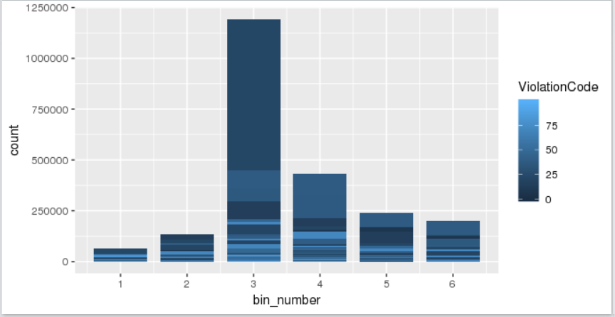

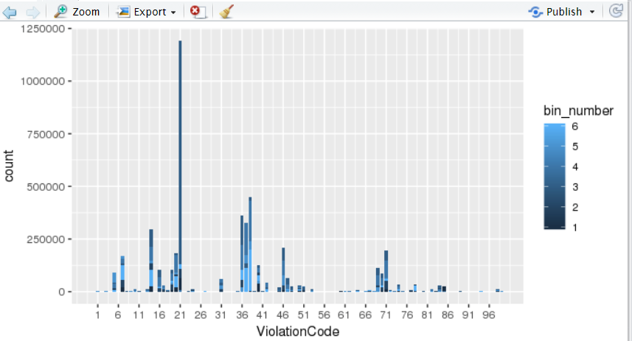

2016

bin_number ViolationCode count

         1            21                63574

         1            40                36490

         1            78                34842

         1            14                26545

         1            85                24865

          2            14               134458

          2            21               106858

          2            40                91344

          2            20                81103

          2            36                56550

          3            21               1192163

          3            38               449070

          3            36               360365

          3            14               297711

          3            46               210978

          4            38               432287

          4            37               324905

          4            36               220663

          4            14               211833

          4            20               171943

          5            38                 241327

          5            37               175802

          5             7                  168888

          5            14               148538

          5             5               89709

          6            38               198472

          6            21               130164

          6             7                 124456

          6            37               112638

          6            14                 105542

bin_number ViolationCode  count

         3            36                 360365

         4            36                 220663

         6            36                 102881

bin_number ViolationCode  count

          3            38                449070

          4            38                432287

          5            38                241327

bin_number ViolationCode   count

         3            21                 1192163

         6            21                 130164

         2            21                 106858

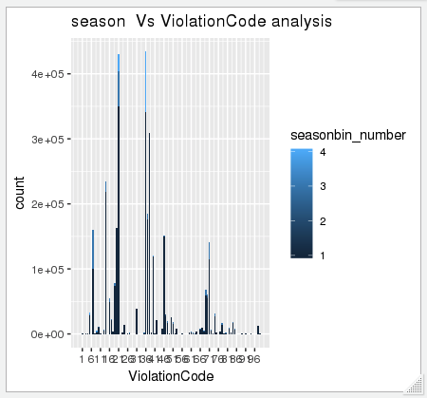

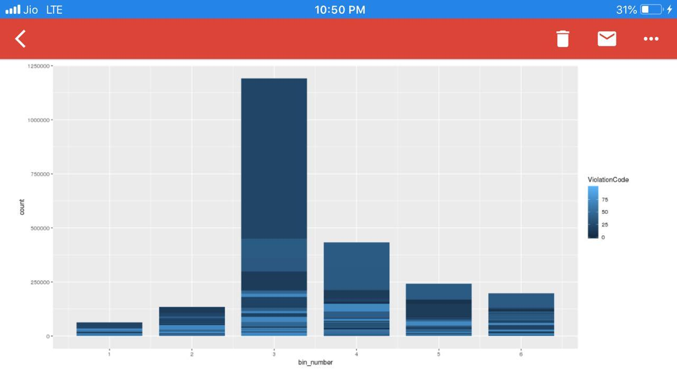

2017

# bin_number ViolationCode count

#1 3 21 1182689

#2 3 36 751422

#3 4 36 376961

#4 4 38 356354

#5 3 38 346518

#6 3 14 274288

# [1] 572 3

#bin_number ViolationCode count

#1 1 21 73160

#2 1 40 45960

#3 1 14 29311

# bin_number ViolationCode count

#1 2 14 141276

#2 2 21 119469

#3 2 40 112186

#bin_number ViolationCode count

#1 3 21 1182689

#2 3 36 751422

#3 3 38 346518

#bin_number ViolationCode count

#1 4 36 376961

#2 4 38 356354

#3 4 37 265869

#bin_number ViolationCode count

#1 5 38 203232

#2 5 37 145784

#3 5 14 144749

#bin_number ViolationCode count

#1 6 36 211434

#2 6 38 153537

#3 6 21 144082

# bin_number ViolationCode count

#1 4 38 356354

#2 3 38 346518

#3 5 38 203232

#bin_number ViolationCode count

#1 3 21 1182689

#2 6 21 144082

#3 2 21 119469

#bin_number ViolationCode count

#1 3 36 751422

#2 4 36 376961

#3 6 36 211434

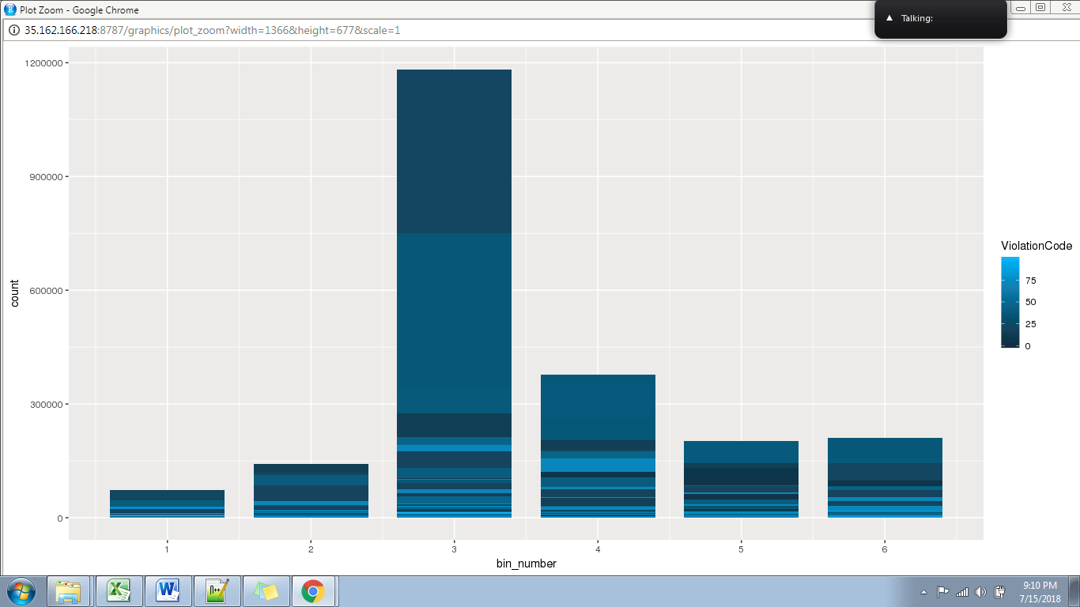

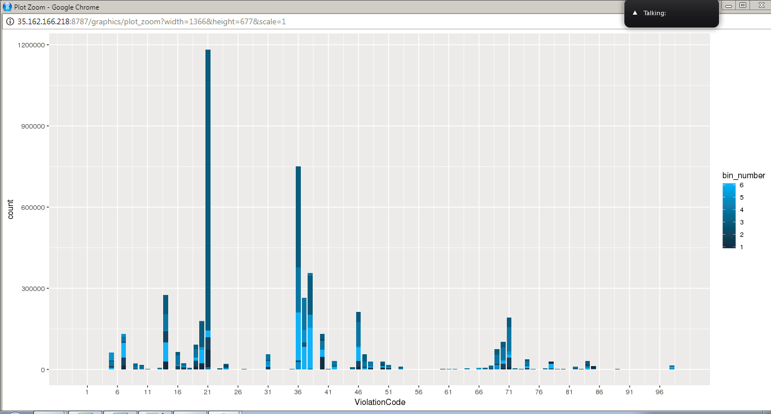

1. Let’s try and find some seasonality in this data

* First, divide the year into some number of seasons, and find frequencies of tickets for each season.
* Then, find the 3 most common violations for each of these season

2015

#seasonbin_number ViolationCode count

#1 1 38 336762

#2 1 21 281600

#3 1 14 220029

#seasonbin_number ViolationCode count

#1 2 21 471580

#2 2 38 346719

#3 2 14 262595

#seasonbin_number ViolationCode count

#1 3 21 397871

#2 3 38 348466

#3 3 14 234606

#seasonbin_number ViolationCode count

#1 4 21 350563

#2 4 38 292639

#3 4 14 207397

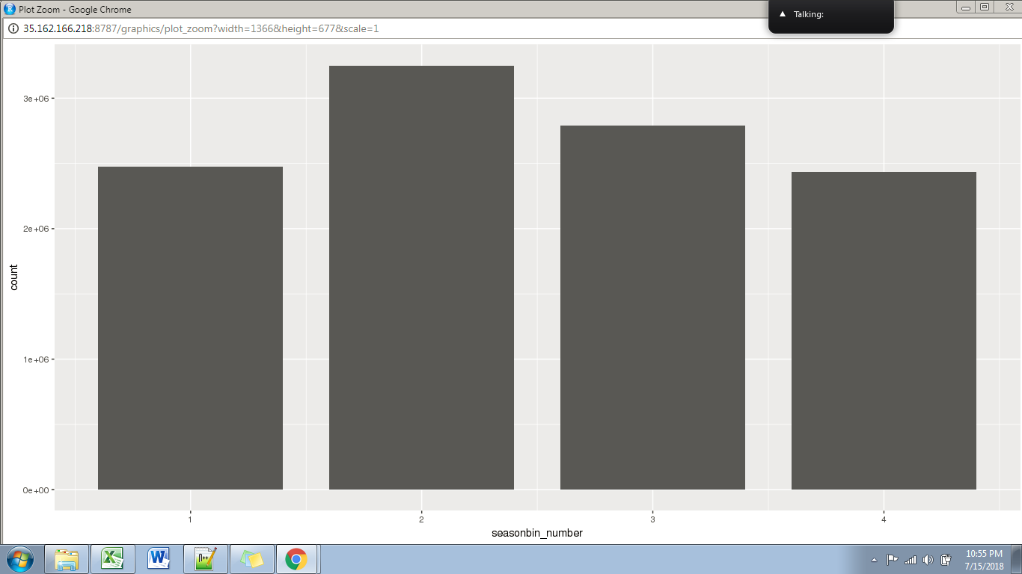

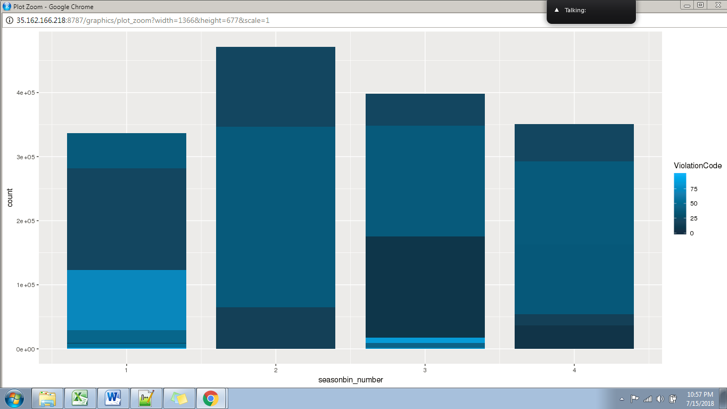

2016

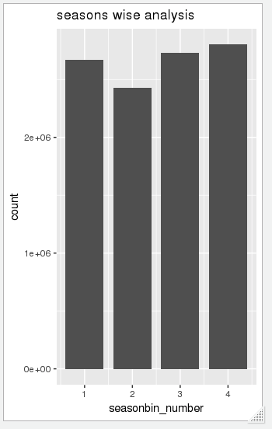

2017

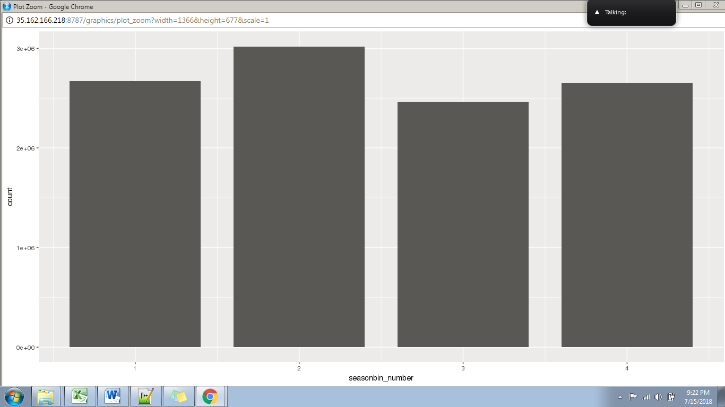

7 The fines collected from all the parking violation constitute a revenue source for the NYC police department. Let’s take an example of estimating that for the 3 most commonly occurring codes.

* Find total occurrences of the 3 most common violation codes
* Then, search the internet for NYC parking violation code fines. You will find a website (on the nyc.gov URL) that lists these fines. They’re divided into two categories, one for the highest-density locations of the city, the other for the rest of the city. For simplicity, take an average of the two.
* Using this information, find the total amount collected for all of the fines. State the code which has the highest total collection.
* What can you intuitively infer from these findings?

2015

#ViolationCode count fine

#1 21 1501614 75080700

#2 38 1324586 66229300

#3 14 924627 106332105

2016

#ViolationCode count fine

#1 21 1531587 76579350

#2 36 1253512 62675600

#3 38 1143696 131525040

2017

#ViolationCode count fine

#1 21 1528588 76429400

#2 36 1400614 70030700

#3 38 1062304 122164960