**CHATTING APPLICATION**A  
PROJECT REPORT  
*Submitted in partial fulfillment of the requirement for the award of  
Certificate of***INDUSTRIAL TRAINING**

Submitted to  
**GRRAS SOLUTIONS PVT. LTD.**

Submitted by

Deepak Sharma

Under the Supervision of

**(Mr. Sanjay Rathore)**Guide Name

**TABLE OF CONTENTS**

1. INTRODUCTION  
2. SCOPE & OBJECTIVE  
4. FEASIBILITY   
5. REQUIREMENT SPECIFICATION  
7. DESCRIPTION OF MODULES  
8. DATABASE  
9. STEPS TO USE THE WEB APPLICATION  
11. FUTURE SCOPE OF PROJECT

**INTRODUCTION**

* Chatting is a very common activity performed by people on daily basis .
* Today, people prefer chatting more than voice calling or video calling.
* From one chatting platform to another, from Facebook to Instagram and from Instagram to Whatsapp, people keep on moving.
* Chatting applications have been helping out introvert people for years.
* You don’t have to call and listen to those one minute of caller tune just for a 30 seconds of talk.
* Chatting took over the world because of how many thing you can, do with it, sending emojis, gifs, sharing photos, etc.
* This chatting application is built so that random people on the internet can find each other, know each other through this.
* This chatting application is built on very powerful technology stack, the MEAN stack, giving the web app high performance and developers, high productivity.

**SCOPE AND OBJECTIVE**

* This Chat application is supposed to connect random strangers of the internet through it.
* Giving user the ability to join random groups.
* Create a Groups.
* Chat, Share pictures, etc
* Users can use matchmaking features to connect to people who are alike.
* Different sets of APIs, and features to make chatting more entertaining.

**FEASIBILITY**

**Economical Feasibility**

Web based chat application uses less storage than most of the apps. Chatting saves time and time is money. In terms of development, all the technology used are open source and developers. Doesn’t need highly trained developers to make such applications.

**Technical Feasibility**

The proposed system is highly feasible in terms of technology. Built on modern JavaScript technology stack, the MEAN stack, it provides high productivity to the developers. With just JavaScript the developers can build both the Front End and the Back End. Angular is used to make Single page application, which gives the user app like feeling. It makes the end product highly maintainable, scalable and gives high performance. Node.Js used in back end is faster than a lot of other languages as it is single thread based and asynchronous.

**Operational Feasibility**

The proposed system is highly user friendly and is much easily able to interact with the system. Therefore the users will readily accept the system for Chatting.

**REQUIREMENT SPECIFICATION**

**Developer Requirements**

Minimum Hardware Requirements

* Processor:- Pentium II or higher
* RAM: - 3GB or higher
* Hard disk: - 10GB minimum

Software Requirements

* Operating system: Window 7, Mac OSX 10.5 or higher.
* Tool Used: Visual Studio Code.
* Front End Languages: HTML, CSS, JS, TypeScript, Angular(Framework).
* Backend End Languages: Node.JS, JS, Express.JS(Framework).
* Database: MongoDB.

**DESCRIPTION OF MODULES**

* Login/sign-up: User can make an account here or login to an already existing account.
* Set profile: Here the user can set there profile up.
* Joining Groups: User can Join a chat room.
* Creating Rooms: User can create there on chat room either public or private.
* Making Friends: User can add other users to their friend list.
* Match making : Users are matched according to their personal interests.

**DATABASE**

USERS

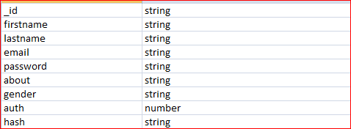

GROUPS

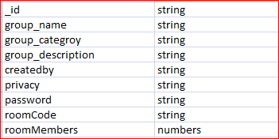

**STEPS TO USE THE APPLICATION**

STEP-1

We see this home page on opening the website.

The menu contains: Home, Contact, About us, Login and Sign-up.

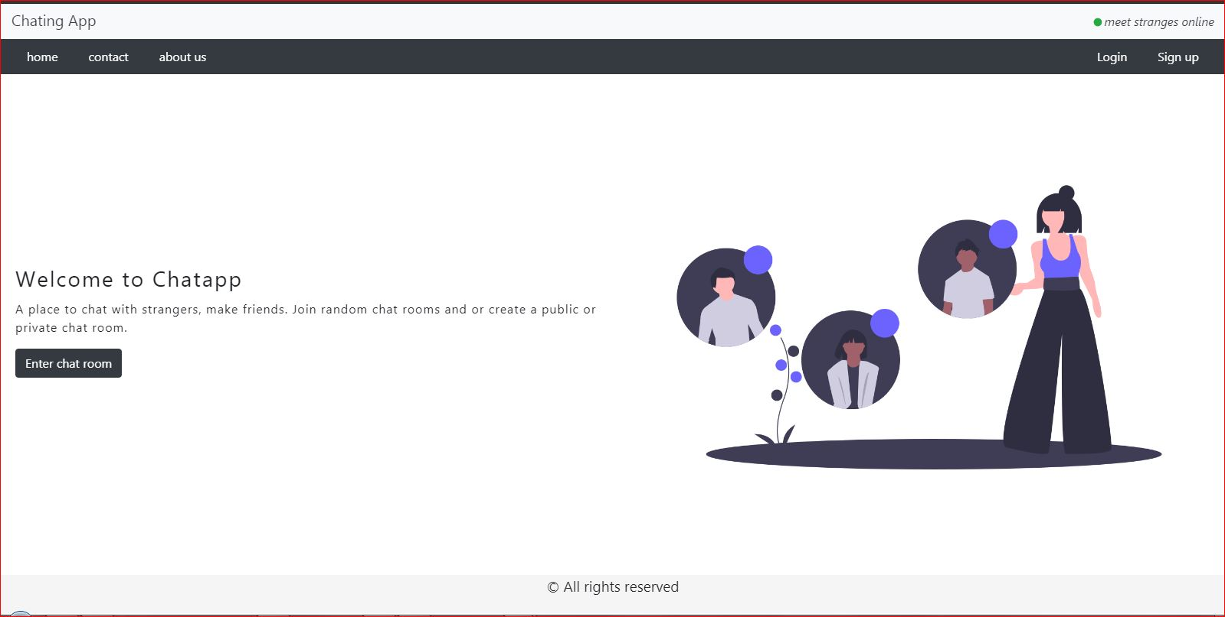

STEP-2: REGISTERING AN ACCOUNT

Click on sign up: fill the details and click on sign-up button. A link will be sent to you email to verify your email. Click on that link to activate your account.

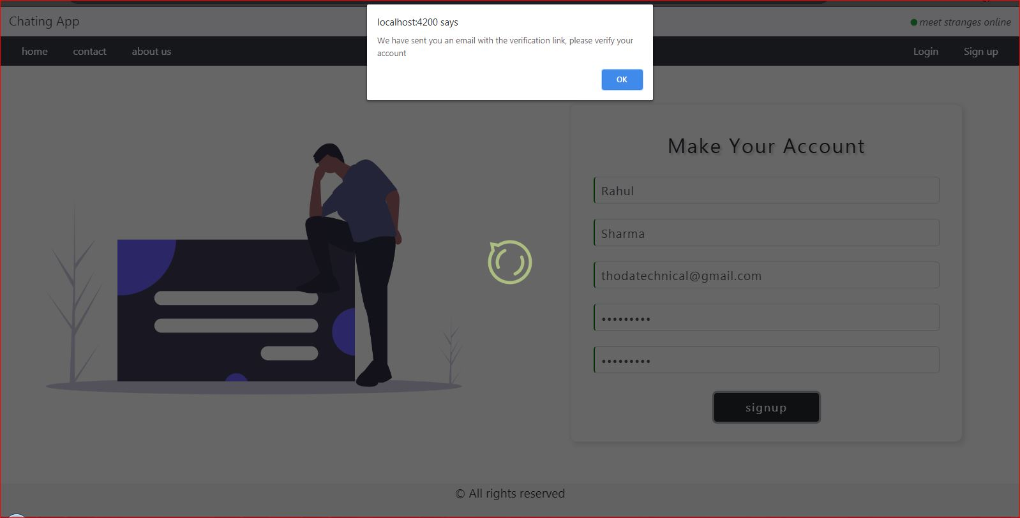

STEP-3: LOGIN

You can login to your account after verifying your account.

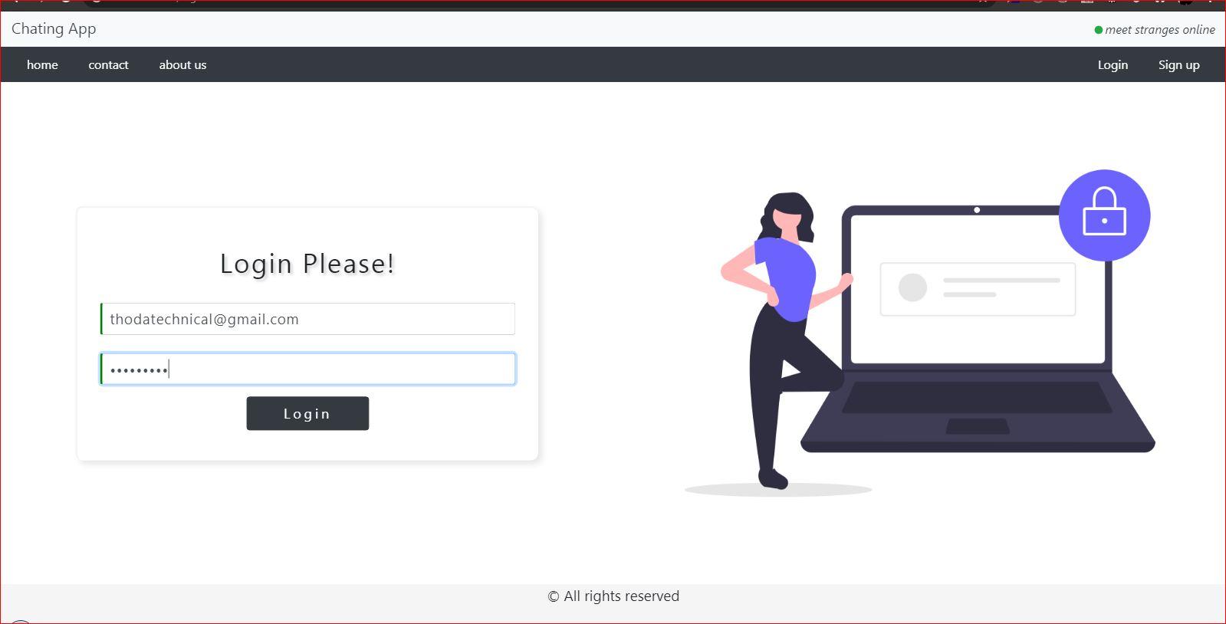

STEP-4: SETTING UP YOUR PROFILE

You can fill up your profile details in here and add a profile picture and save it .

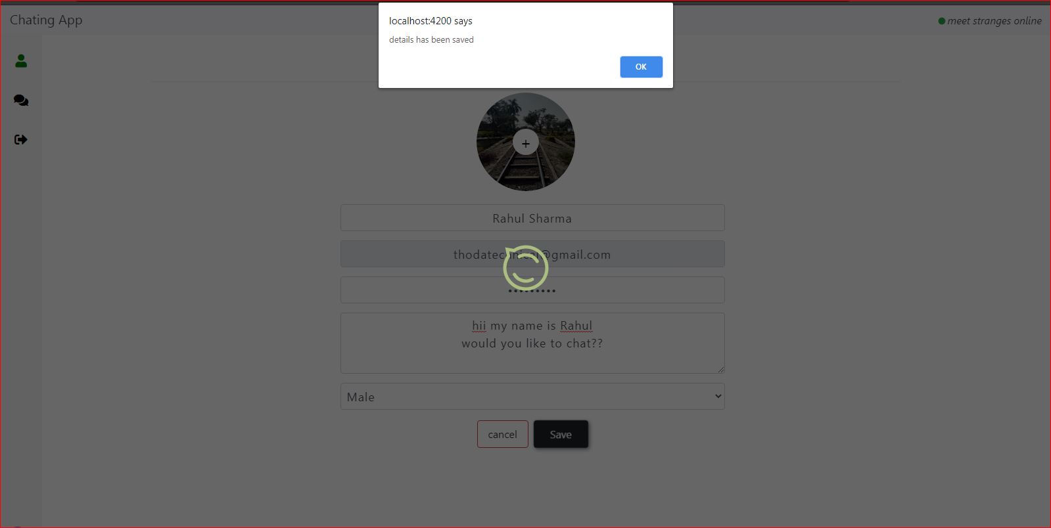

STEP-5: JOIN A ROOM

Join a random room or create a room or join specific room .

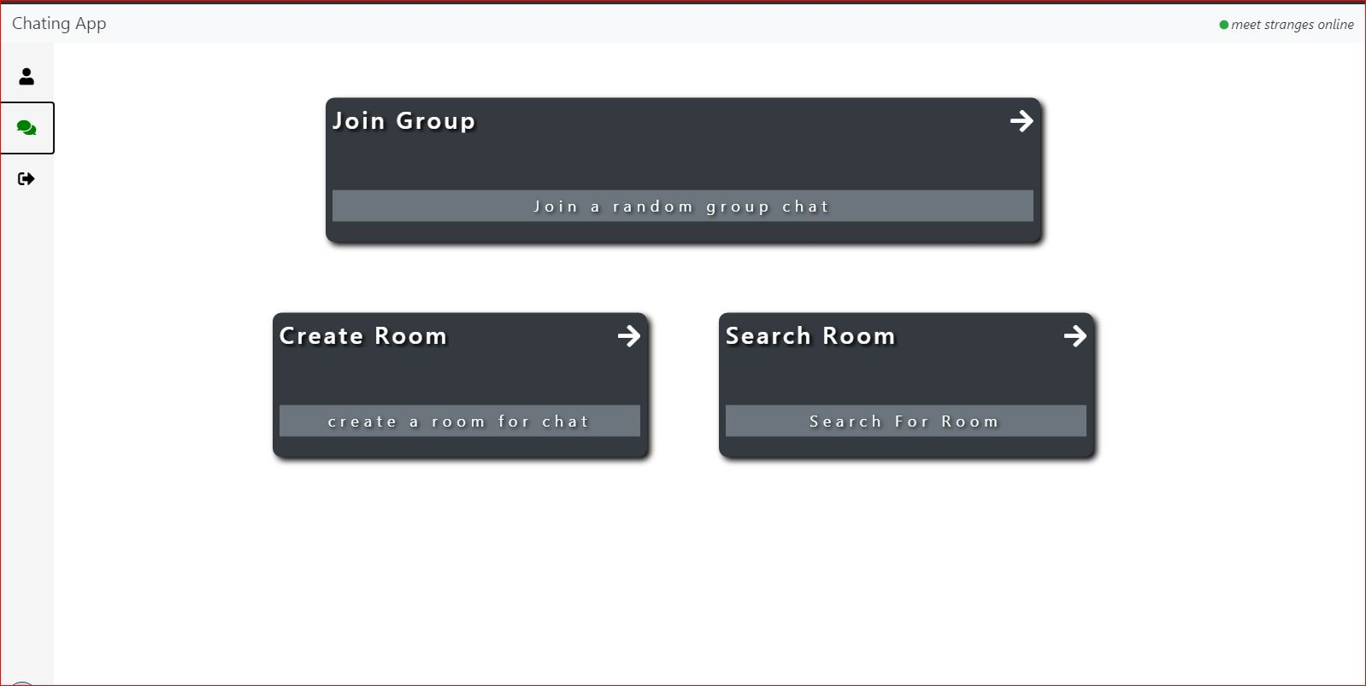

STEP-6: CHAT

After entering the chat room you can chat with other users.

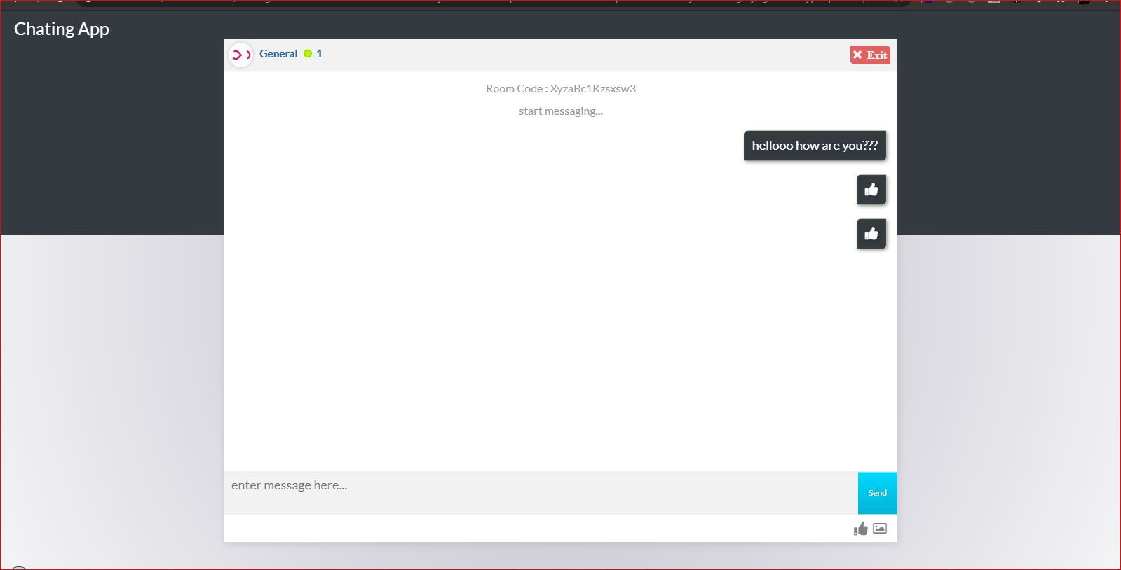

**FUTURE SCOPE**

* People can add each other to their friend list.
* People can post stories.
* New APIs to be included.
* Features that leading to some competition between the chatting parties to be implemented.
* More efficient matchmaking of users