DATA UNDERSTANDING
--1. Find total number of transactions.
select COUNT(*) as transactions
FROM sale;
Output:
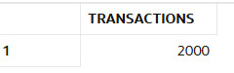

--2. Find total revenue generated.
select sum(amount)as total_revenue
from sale;
Output:
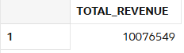

--3. Find total unique customers.
SELECT COUNT(DISTINCT customer_id) AS unique_customers
FROM sales
Output:
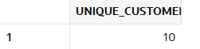

--4. Find average order value.
select avg(amount)as order_value
from sale;
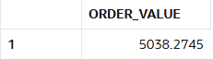

--5. Find total quantity sold.
select sum(quantity) as total_quantity
from sale;
Output:
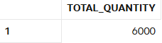
--7. Find minimum and maximum sale amount.
SELECT MIN(amount) AS min_sale, MAX(amount) AS max_sale
FROM sale;
Output:
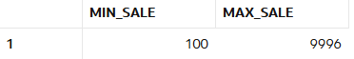
--8. Find average discount given.
select avg(discount) as avg_discount
from sale;
Output:
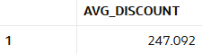
--9. Find total sales per store.
select store_id,sum(amount)as total_sale
from sale
group by store_id;
Output:
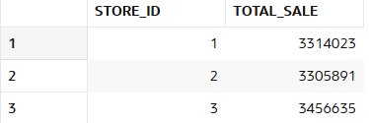

--9. Find total sales per category.
select p.category,sum(s.amount)as total_sales
from sale s left join product p
on s.product_id=p.product_id
group by p.category;
Output:
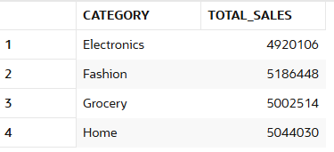

--10. Find number of transactions per day.
select sale_date , count(*) as transactions_per_day
from sale
group by sale_date
order by sale_date desc;
Output:
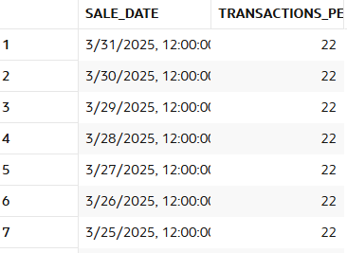
Data Cleaning
--11.Replace NULL discount with 0.
update sale
set discount =0
where discount is null;
Output:
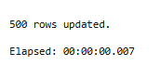
--12. Find number of NULL discounts.
SELECT COUNT(*) AS null_discount_count
FROM sale
WHERE discount IS NULL;
Output:
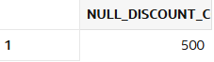
--13. Calculate net revenue (amount - discount).
SELECT sale_id,amount,discount,
(amount - discount) AS net_revenue
FROM sale;
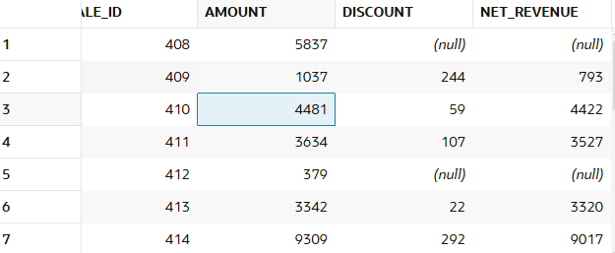

--14. Replace NULL quantity with 1.
UPDATE sale
SET quantity = 1
WHERE quantity IS NULL;
Output:
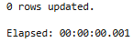
--15. Identify rows where amount is NULL.
select *
from sale
where amount is null;
Output:
--16. Use COALESCE to handle multiple NULL columns.
SELECT sale_id,
COALESCE(amount, 0) AS amount,
COALESCE(discount, 0) AS discount,
COALESCE(quantity, 1) AS quantity
FROM sale;
Output:
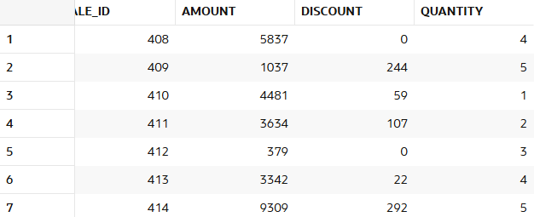

--17. Create a cleaned column for revenue.
SELECT sale_id,amount,discount,
(COALESCE(amount,0) - COALESCE(discount,0)) AS cleaned_revenue
FROM sale;
Output:
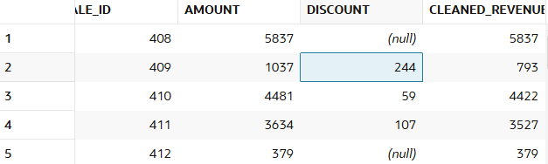

--18. Check percentage of missing data.
select count(*)as total_rows,
sum(case when amount is null then 1 else 0 end)as null_amount,
sum(case when amount is null then 1 else 0 end)*100/count(*)as percent
from sale;
Output:
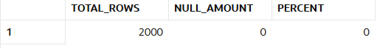

--19. Flag rows with missing values.
SELECT sale_id,
case when amount IS NULL OR discount IS NULL OR quantity IS NULL
THEN 'Missing'
ELSE 'Complete'
END AS data_flag
FROM sale;
Output:

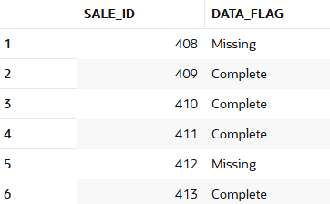

--20. Prepare dataset for analysis.
SELECT sale_id,customer_id,product_id,store_id,sale_date,
COALESCE(amount, 0) AS amount,
COALESCE(discount, 0) AS discount,
COALESCE(quantity, 1) AS quantity,
(COALESCE(amount,0) - COALESCE(discount,0)) AS net_revenue
FROM sale;
Output:
--Here I cleaned the messy data using coalesce and removed the null values and added a new net_revenue column with a clean dataset.
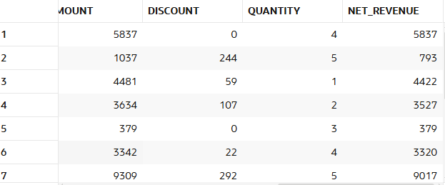

Filtering (WHERE)
--21. Find sales in last 30 days.
select *
from sale
where sale_date >= sysdate - 30;
Output:
--21. Find sales above 5000.
select *
from sale
where amount>5000;
Output:
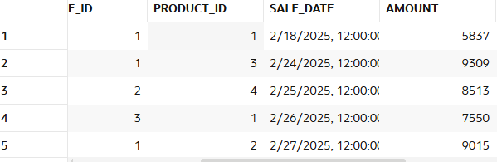
--23. Find sales between 1000 and 5000.
select *
from sale
where amount between 1000 and 5000;
Output:
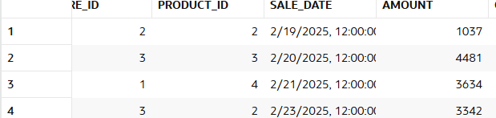

--24. Find sales from CMR store.
select S.AMOUNT,s1.STORE_NAME
from sale S LEFT JOIN stores s1
on s.store_id=s1.store_id
where s1.store_name='CMR';
Output:
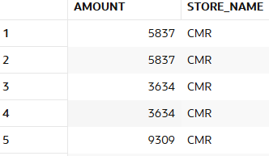
--25. Find Electronics category sales.
select p.CATEGORY,s.amount
from sale s LEFT join product p
on s.product_id=p.product_id
where p.category='Electronics';
Output:
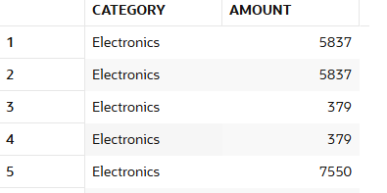
--26. Find sales excluding Grocery category.
SELECT p.CATEGORY , amount
FROM sale s
JOIN product p
ON s.product_id = p.product_id WHERE p.category != 'Grocery';
Output:
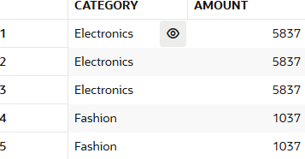
--27. Find customers from specific store.
SELECT DISTINCT c.customer_name,st.STORE_NAME
FROM customer c
JOIN sale s ON c.customer_id = s.customer_id
JOIN stores st ON s.store_id = st.store_id
WHERE st.store_name = 'CMR';
Output:
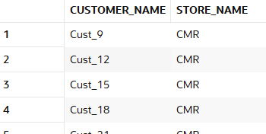
--28. Find high discount transactions.
select discount as high_discount
from sale
where discount>30;
Output:
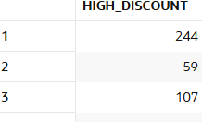
--29. Find low quantity sales.
select *
from sale
where quantity<2;
Output:
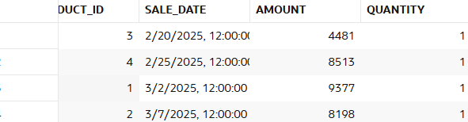

--30. Find recent transactions.
SELECT *
FROM sales
WHERE sale_date >= SYSDATE - 7;
Output:

Aggregation (GROUP BY)
--31. Revenue per store.
select s1.store_name,sum(s.amount)as Revenue
from sale s left join stores s1
on s.store_id=s1.store_id
GROUP by store_name;
Output:
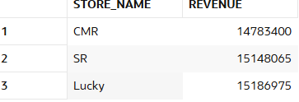
--32. Revenue per category.
SELECT p.category,sum(s.amount)as Revenue
from sale s left join product P
on p.product_id=s.product_id
group by p.category;
Output:
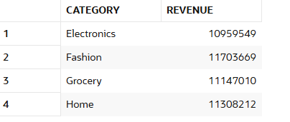

--33. Revenue per customer.
select c.customer_name,sum(s.amount)as Revenue
from sale s left join customer c
on c.customer_id=s.customer_id
group by c.customer_name;
Output:
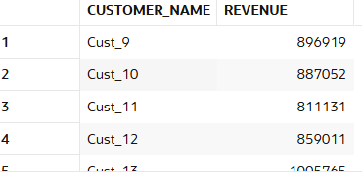

--34. Monthly revenue.
SELECT TO_CHAR(sale_date, 'YYYY-MM') AS month,SUM(amount) AS total_revenue
FROM sale
GROUP BY TO_CHAR(sale_date, 'YYYY-MM')
ORDER BY month;
Output:
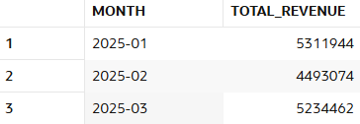
--35. Daily revenue.
select to_char(sale_date)as daily,sum(amount)as revenue
from SALE
group by to_char(sale_date);
Output:
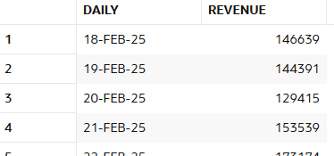
--36. Average sales per store.
select s1.store_name,avg(s.amount)
from sale s left join stores s1
on s.STORE_ID=s1.STORE_ID
group by s1.STORE_NAME;
Output:
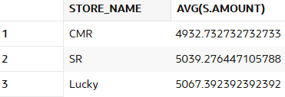

--37. Total quantity per category.
select p.category,sum(s.quantity)
from product p left join sale s
on p.product_id=s.PRODUCT_ID
group by p.category;
Output:
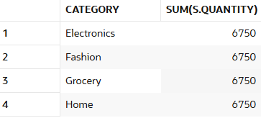

--38. Total discount per store.
select s1.store_name,sum(s.discount)as total_dis
from sale s left join stores s1
on s.STORE_ID=s1.STORE_ID
group by s1.STORE_NAME;
Output:
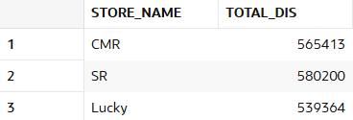

--39. Customer-wise total spending.
SELECT customer_id,SUM(amount) AS total_spending
FROM sale
GROUP BY customer_id;
Output:
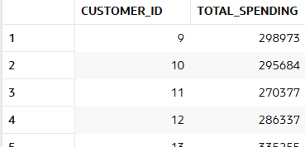

--40. Store-wise transaction count.
SELECT store_id,COUNT(amount) AS transaction_count
FROM sale
GROUP BY store_id;
Output:
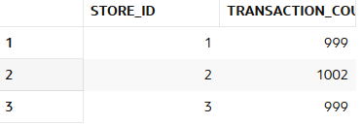

HAVING
--41. Customers with revenue > 20000.
SELECT customer_id,SUM(amount) AS total_revenue
FROM sale
GROUP BY customer_id
HAVING SUM(amount) > 20000;
Output:
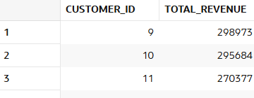
--42. Stores with revenue > 100000.
select store_id,sum(amount) as revenue
from sale
group by STORE_ID
having sum(amount)>100000;
Output:
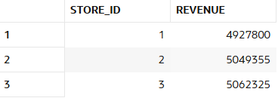
--43. Categories with avg sales > 3000.
select p.category,avg(s.amount)as avg_sales
from sale s left join product P
on p.product_id=s.PRODUCT_ID
group BY P.CATEGORY
HAVING avg(s.amount)>3000;

Output:
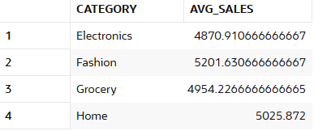
--44. Customers with more than 5 transactions.
select customer_id,count(amount)
from sale
group by customer_id
having count(amount)>5;
Output:
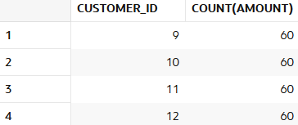
--45. Stores with high discount usage.
SELECT store_id,SUM(discount) AS total_discount
FROM sale
GROUP BY store_id
HAVING SUM(discount) > 5000;
Output:
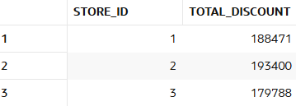

--46. Categories with low performance.

SELECT p.category,AVG(s.amount) AS avg_sales
FROM sale s left join product p
on p.product_id=s.PRODUCT_ID
GROUP BY p.category
HAVING AVG(s.amount) < 2000;
Output:
--47. Customers with high avg order value.
SELECT customer_id,AVG(amount) AS avg_order_value
FROM sale
GROUP BY customer_id
HAVING AVG(amount) > 5000;
Output:
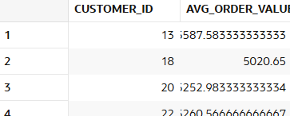

--48. Find top 5 customers using HAVING.
select customer_id as top_5_cust,sum(amount)
from sale
group by CUSTOMER_ID
having sum(amount) is not NULL
order by sum(amount)desc
fetch first 5 rows only;

OUTPUT:
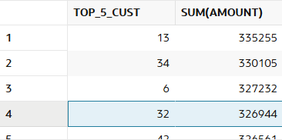
--49. Stores with max transactions.
SELECT store_id,COUNT(*) AS transaction_count
FROM sale
GROUP BY store_id
ORDER BY transaction_count DESC;
OUTPUT:
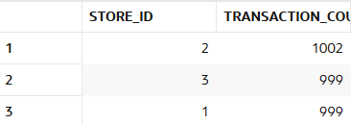

--50. Categories with high growth.
SELECT p.category, SUM(amount) revenue
FROM sale s
JOIN products p ON s.product_id=p.product_id
GROUP BY p.category
HAVING SUM(amount)>500000;
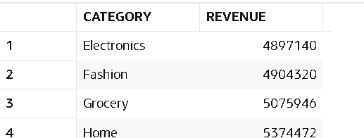

CASE WHEN
-- 51. Classify customers as High/Medium/Low spenders.
SELECT customer_id,
CASE
WHEN SUM(amount)>50000 THEN 'High'
WHEN SUM(amount)>20000 THEN 'Medium'
ELSE 'Low'
END spender_type
FROM sale
GROUP BY customer_id;
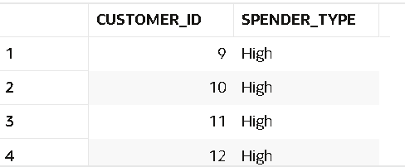

-- 52. Classify transactions as Big/Small.
SELECT sale_id,
CASE WHEN amount>5000 THEN 'Big' ELSE 'Small' END txn_type
FROM sale;
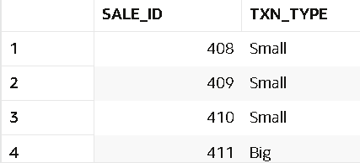

-- 53. Create discount flag.
SELECT sale_id,
CASE WHEN NVL(discount,0)>0 THEN 'Discounted'
ELSE 'No Discount' END flag
FROM sale;
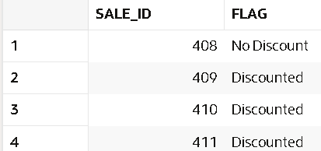

-- 54. Segment stores based on revenue.
SELECT store_id,
CASE
WHEN SUM(amount)>300000 THEN 'Top Store'
ELSE 'Regular'
END store_segment
FROM sale
GROUP BY store_id;
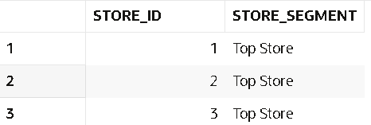

-- 55. Categorize customers based on frequency.
SELECT customer_id,
CASE
WHEN COUNT(*)>30 THEN 'Frequent'
ELSE 'Occasional'
END frequency
FROM sale
GROUP BY customer_id;
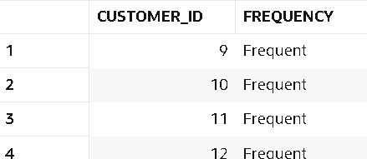

-- 56. Create sales buckets.
SELECT sale_id,
CASE
WHEN amount<1000 THEN 'Low'
WHEN amount<5000 THEN 'Medium'
ELSE 'High'
END bucket
FROM sale;
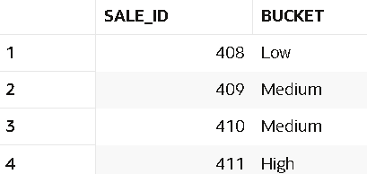

-- 57. Identify premium customers.
SELECT customer_id
FROM sale
GROUP BY customer_id
HAVING SUM(amount)>60000;
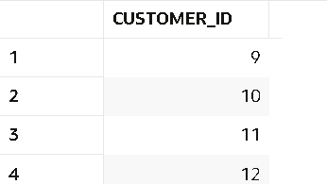
-- 58. Mark high-value transactions.
SELECT sale_id,
CASE WHEN amount>8000 THEN 'High Value' END label
FROM sale;
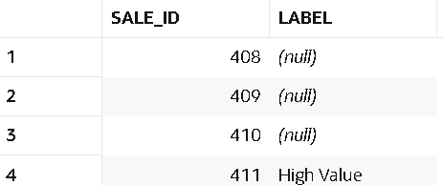

-- 59. Classify categories based on performance.
SELECT p.category,
CASE
WHEN AVG(amount)>4000 THEN 'Good'
ELSE 'Average'
END performance
FROM sale s
JOIN products p ON s.product_id=p.product_id
GROUP BY p.category;
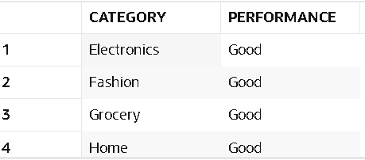

-- 60. Create custom labels for reporting.
SELECT sale_id,
'TXN-'||sale_id AS report_label
FROM sale;
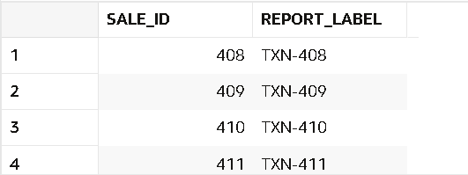

JOINS
-- 61. Join sales with customers table.
SELECT s.*, c.customer_name
FROM sale s
JOIN customer c ON s.customer_id=c.customer_id;
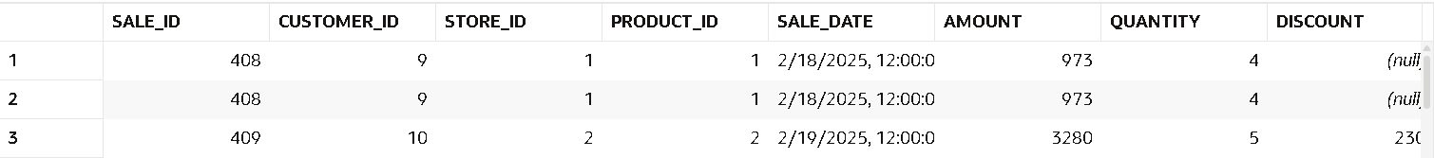

-- 62. Join sales with stores table.
SELECT s.*, st.store_name
FROM sale s
JOIN stores st ON s.store_id=st.store_id;
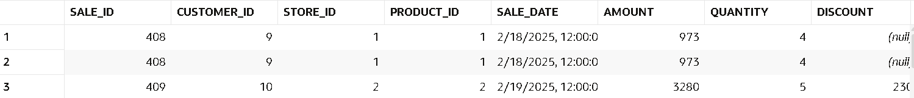

-- 63. Join sales with products table.
SELECT s.*, p.category
FROM sale s
JOIN product p ON s.product_id=p.product_id;
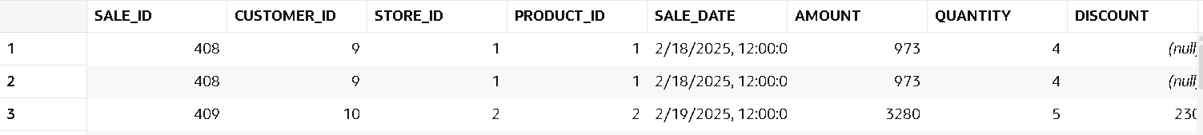

-- 64. Find customer name with store name and sales.
SELECT c.customer_name, st.store_name, s.amount
FROM sale s
JOIN customer c ON s.customer_id=c.customer_id
JOIN stores st ON s.store_id=st.store_id;
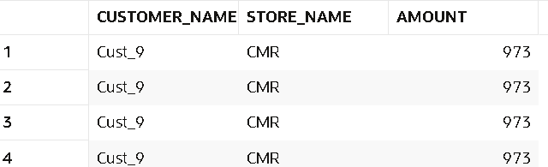

-- 65. Find category-wise revenue using joins.
SELECT p.category, SUM(s.amount)
FROM sale s
JOIN product p ON s.product_id=p.product_id
GROUP BY p.category;
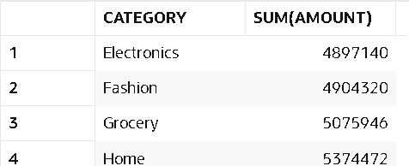

-- 66. Find store-wise customer count.
SELECT store_id, COUNT(DISTINCT customer_id)
FROM sale
GROUP BY store_id;
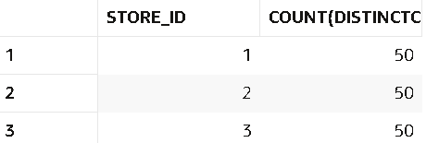
-- 67. Find top product per store.
SELECT *
FROM (
SELECT store_id, product_id,
RANK() OVER(PARTITION BY store_id ORDER BY SUM(amount) DESC) rnk
FROM sale
GROUP BY store_id, product_id
)
WHERE rnk=1;
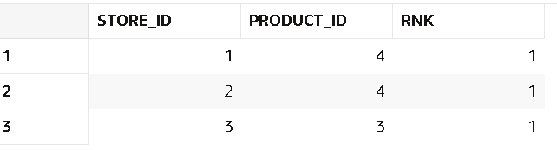

-- 68. Find customers who purchased from multiple stores.
SELECT customer_id
FROM sale
GROUP BY customer_id
HAVING COUNT(DISTINCT store_id)>1;
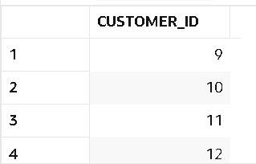

-- 69. Find sales with product category.
SELECT s.sale_id, p.category, s.amount
FROM sale s
JOIN product p ON s.product_id=p.product_id;
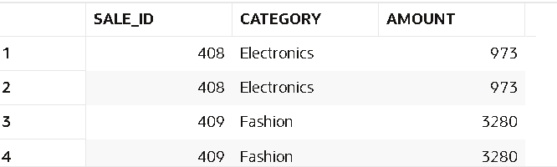

-- 70. Find revenue per customer per store.
SELECT customer_id, store_id, SUM(amount)
FROM sale
GROUP BY customer_id, store_id;
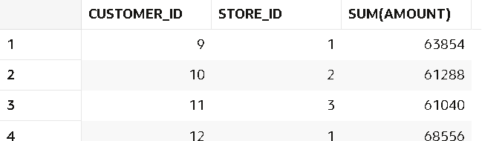

-- 71. Find customers with no transactions (LEFT JOIN).
SELECT c.customer_id
FROM customer c
LEFT JOIN sale s
ON c.customer_id=s.customer_id
WHERE s.amount IS NULL;
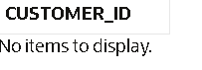

-- 72. Find missing product mappings.
SELECT s.* FROM sale s
LEFT JOIN product p
ON s.product_id=p.product_id
WHERE p.product_id IS NULL;

-- 73. Find store performance using joins.
SELECT st.store_name, SUM(amount)
FROM sale s
JOIN stores st ON s.store_id=st.store_id
GROUP BY st.store_name;
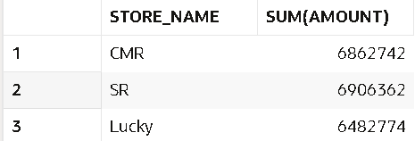

-- 74. Find cross-category purchases.
SELECT customer_id
FROM sale s
JOIN product p ON s.product_id=p.product_id
GROUP BY customer_id
HAVING COUNT(DISTINCT p.category)>1;
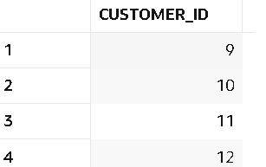

-- 75. Find total revenue using joins.
SELECT SUM(s.amount) AS total_revenue
FROM sale s JOIN product p
ON s.product_id = p.product_id;
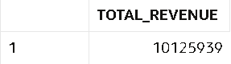

WINDOW FUNCTIONS
-- 76. Calculate total spend per customer using window function.
SELECT sale_id,
SUM(amount) OVER(PARTITION BY customer_id) total_spend
FROM sale;
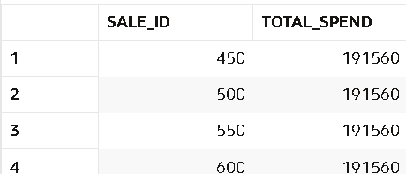

-- 77. Rank customers by revenue.
SELECT customer_id,
RANK() OVER(ORDER BY SUM(amount) DESC) rnk
FROM sale
GROUP BY customer_id;
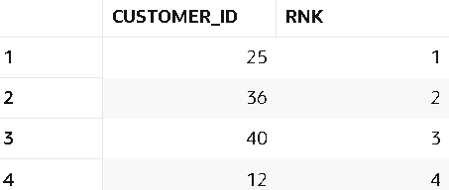

-- 78. Find top customer per store.
SELECT * FROM (
SELECT store_id, customer_id,
RANK() OVER(PARTITION BY store_id ORDER BY SUM(amount) DESC) rnk
FROM sale
GROUP BY store_id, customer_id)
WHERE rnk=1;
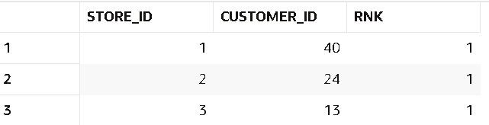

-- 79. Calculate running total of sales.
SELECT sale_date,
SUM(amount) OVER(ORDER BY sale_date) running_total
FROM sale;
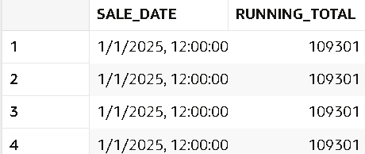

-- 80. Find previous sale using LAG.
SELECT sale_id,amount,
LAG(amount) OVER(ORDER BY sale_date) prev_sale
FROM sale;
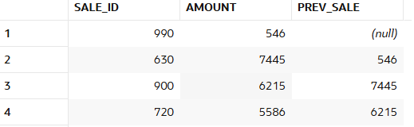

-- 81. Find next sale using LEAD.
SELECT sale_id,amount,
LEAD(amount) OVER(ORDER BY sale_date) next_sale
FROM sale;
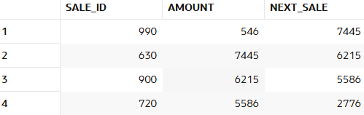
-- 82. Calculate sales growth.
SELECT sale_id,amount,
amount - LAG(amount) OVER(ORDER BY sale_date) growth
FROM sale;
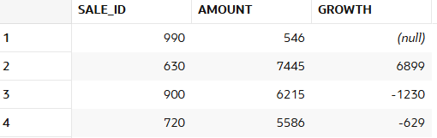

-- 83. Find difference between transactions.
SELECT sale_id,
sale_date - LAG(sale_date) OVER(ORDER BY sale_date) diff_days
FROM sale;
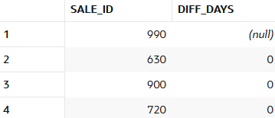
-- 84. Calculate cumulative revenue.
SELECT sale_date,amount,
SUM(amount) OVER(ORDER BY sale_date
ROWS BETWEEN UNBOUNDED PRECEDING AND CURRENT ROW)
FROM sale;
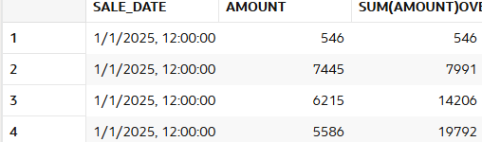

-- 85. Find moving average of sales.
SELECT sale_date,amount,
AVG(amount) OVER(ORDER BY sale_date
ROWS BETWEEN 2 PRECEDING AND CURRENT ROW)
FROM sale;
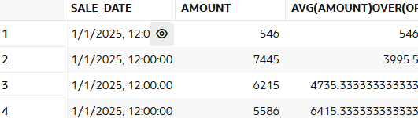
-- 86. Rank stores by revenue.
SELECT store_id,amount,
RANK() OVER(ORDER BY SUM(amount) DESC)
FROM sale
GROUP BY store_id,amount;
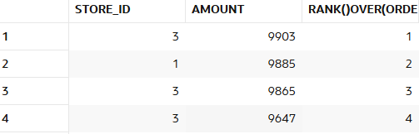

-- 87. Find second highest sale.
SELECT * FROM (
SELECT amount,
DENSE_RANK() OVER(ORDER BY amount DESC) rnk
FROM sale)
WHERE rnk=2;
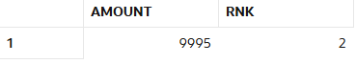

-- 88. Partition data by store and analyze.
SELECT store_id,
AVG(amount) OVER(PARTITION BY store_id order by amount)
FROM sale;
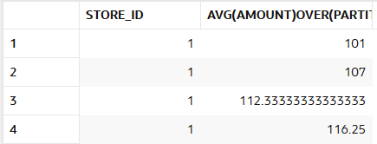

-- 89. Find customer ranking per store.
SELECT store_id, customer_id,
RANK() OVER(PARTITION BY store_id ORDER BY SUM(amount) DESC)
FROM sale
GROUP BY store_id, customer_id;
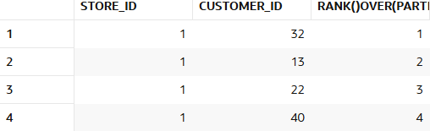

-- 90. Calculate frequency using window.
SELECT sale_id,
COUNT(*) OVER(PARTITION BY customer_id) frequency
FROM sale;
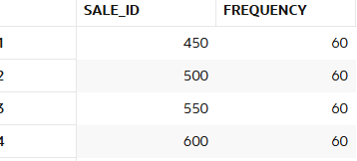

NTILE / Segmentation

-- 91. Divide customers into 4 segments.
SELECT customer_id,
NTILE(4) OVER(ORDER BY SUM(amount) DESC) AS segment
FROM sale
GROUP BY customer_id;
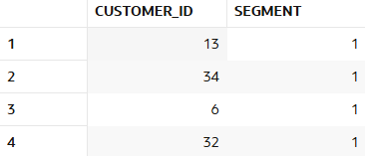
-- 92. Identify top 25% customers.
SELECT * FROM ( SELECT customer_id,
NTILE(4) OVER(ORDER BY SUM(amount) DESC) seg
FROM sale
GROUP BY customer_id)
WHERE seg = 1;
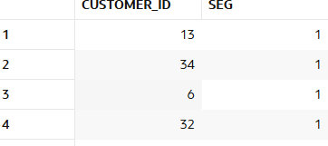

-- 93. Identify bottom 25% customers.
SELECT * FROM (
SELECT * FROM (SELECT customer_id,
NTILE(4) OVER(ORDER BY SUM(amount) DESC) seg
FROM sale
GROUP BY customer_id)
WHERE seg = 4;
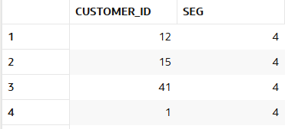

-- 94. Segment stores into 3 groups.
SELECT store_id,
NTILE(3) OVER(ORDER BY SUM(amount) DESC) store_group
FROM sale
GROUP BY store_id;
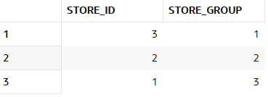

-- 95. Create quartiles based on revenue.
SELECT customer_id,
SUM(amount) revenue,
NTILE(4) OVER(ORDER BY SUM(amount)) quartile
FROM sale
GROUP BY customer_id;
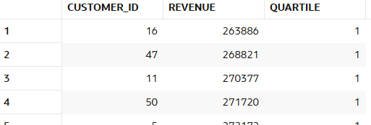

-- 96. Segment customers per store.
SELECT store_id,
customer_id,
NTILE(3) OVER(PARTITION BY store_id ORDER BY SUM(amount) DESC) segment
FROM sale
GROUP BY store_id, customer_id;
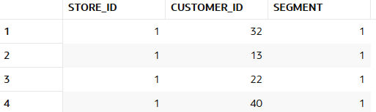

-- 97. Identify premium segment.
-- 97. Identify premium segment.
SELECT * FROM (
SELECT customer_id,
NTILE(4) OVER(ORDER BY SUM(amount) DESC) seg
FROM sale

GROUP BY customer_id
)
WHERE seg = 1;

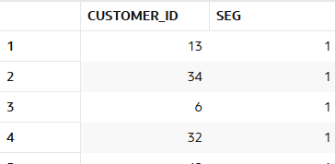

-- 98. Find mid-level customers.
SELECT * FROM (
SELECT customer_id,
NTILE(4) OVER(ORDER BY SUM(amount) DESC) seg
FROM sale

GROUP BY customer_id
)
WHERE seg in (2,3);

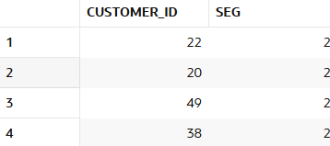

-- 99. Analyze bucket distribution.
SELECT bucket, COUNT(*)
FROM (
SELECT NTILE(5) OVER(ORDER BY amount) bucket
FROM sales
)
GROUP BY bucket;
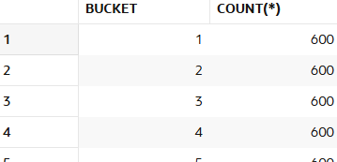

-- 100. Create marketing segments.
SELECT customer_id,nt,
CASE
WHEN nt = 1 THEN 'VIP'
WHEN nt = 2 THEN 'Loyal'
WHEN nt = 3 THEN 'Casual'
ELSE 'Low Value'
END marketing_segment
FROM (
SELECT customer_id,
NTILE(4) OVER(ORDER BY SUM(amount) DESC) nt
FROM sale
GROUP BY customer_id
);

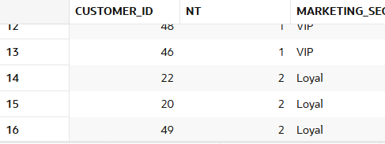

FIRST_VALUE / LAST_VALUE
-- 101. Find highest sale.
SELECT MAX(amount) AS highest_sale
FROM sale;
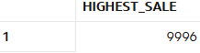

-- 102. Find lowest sale.
SELECT MIN(amount) AS lowest_sale
FROM sale;
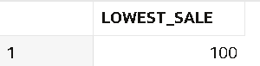

-- 103. Compare each sale with highest.
SELECT sale_id,
amount,
FIRST_VALUE(amount) OVER(ORDER BY amount DESC) highest_sale
FROM sale;
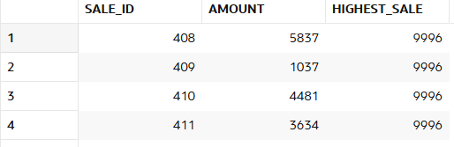

-- 104. Compare each sale with lowest.
SELECT sale_id,
amount,
FIRST_VALUE(amount) OVER(ORDER BY amount) lowest_sale
FROM sale;
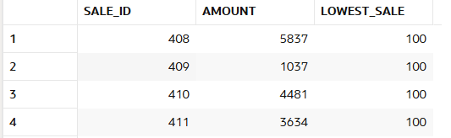

-- 105. Find highest sale per store.
SELECT store_id,
sale_id,
FIRST_VALUE(amount)
OVER(PARTITION BY store_id ORDER BY amount DESC) highest_store_sale
FROM sale;
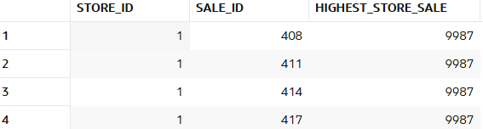

-- 106. Find lowest sale per store.
SELECT store_id,
sale_id,
FIRST_VALUE(amount)
OVER(PARTITION BY store_id ORDER BY amount) lowest_store_sale
FROM sale;
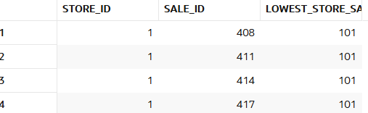

-- 107. Compare category performance.
SELECT p.category,
amount,
FIRST_VALUE(amount)
OVER(PARTITION BY p.category ORDER BY amount DESC) best_category_sale
FROM sale s
JOIN product p ON s.product_id=p.product_id;
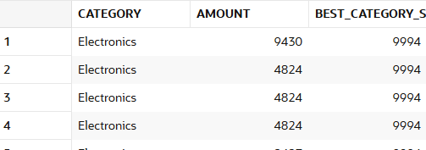

-- 108. Find best customer per store.
SELECT * FROM (
SELECT store_id,
customer_id,
SUM(amount),
RANK() OVER(PARTITION BY store_id ORDER BY SUM(amount) DESC) rnk
FROM sale
GROUP BY store_id, customer_id
)
WHERE rnk=1;
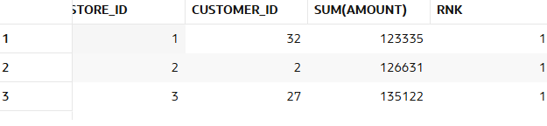

-- 109. Find worst performing category.
SELECT * FROM (
SELECT p.category,
SUM(amount) revenue,
RANK() OVER(ORDER BY SUM(amount)) rnk
FROM sale s
JOIN products p ON s.product_id=p.product_id
GROUP BY p.category
)
WHERE rnk=1;
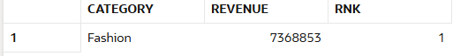

-- 110. Analyze gap between best and worst.
SELECT
MAX(amount) - MIN(amount) AS performance_gap
FROM sale;
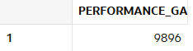
Date Analysis
-- 111. Find daily sales.
SELECT sale_date,
SUM(amount) daily_sales
FROM sale
GROUP BY sale_date
ORDER BY sale_date;
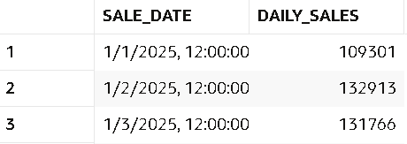

-- 112. Find monthly sales.
SELECT TO_CHAR(sale_date,'YYYY-MM') month,
SUM(amount) monthly_sales
FROM sale
GROUP BY TO_CHAR(sale_date,'YYYY-MM')
ORDER BY month;
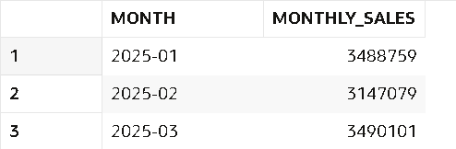

-- 113. Find weekend sales.
SELECT * FROM sale
WHERE TO_CHAR(sale_date,'DY')
IN ('SAT','SUN');
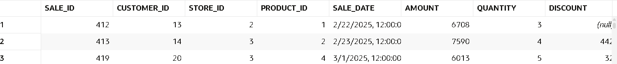

-- 114. Find first sale date.
SELECT MIN(sale_date) first_sale
FROM sale;
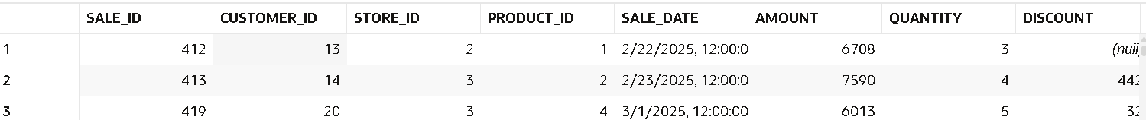

-- 115. Find last sale date.
SELECT MAX(sale_date) last_sale
FROM sale;
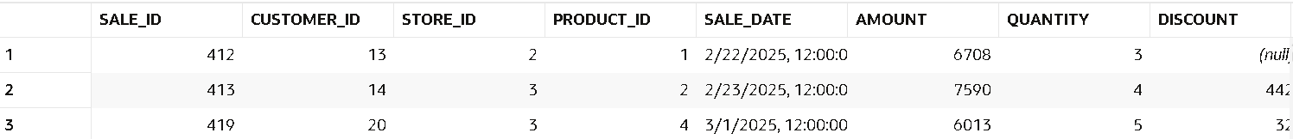

-- 116. Find sales in specific month.
SELECT * FROM sale
WHERE TO_CHAR(sale_date,'YYYY-MM')='2025-01';
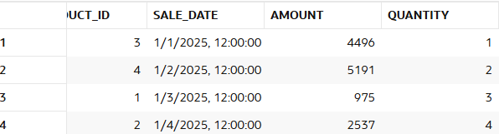
-- 117. Find sales growth month-wise
SELECT month,
sales,
sales - LAG(sales) OVER(ORDER BY month) growth
FROM (
SELECT TO_CHAR(sale_date,'YYYY-MM') month,
SUM(amount) sales
FROM sale
GROUP BY TO_CHAR(sale_date,'YYYY-MM')
);
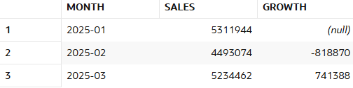

-- 118. Find inactive customers (30 days).
SELECT customer_id,sale_date
FROM sale
GROUP BY customer_id,sale_date
HAVING MAX(sale_date) < SYSDATE-30;

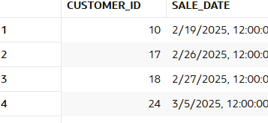

-- 119. Find repeat customers.
SELECT customer_id
FROM sale
GROUP BY customer_id
HAVING COUNT(*) > 1;
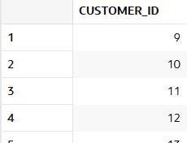
-- 120. Find sales trend.
SELECT month,total_sales,
CASE WHEN total_sales > LAG(total_sales) OVER (ORDER BY month) THEN 'Increase'
WHEN total_sales < LAG(total_sales) OVER (ORDER BY month) THEN 'Decrease'
ELSE 'No Change'
END AS trend
FROM (SELECT TO_CHAR(sale_date, 'YYYY-MM') AS month,
SUM(amount) AS total_sales
FROM sale
GROUP BY TO_CHAR(sale_date, 'YYYY-MM')
);
