DATA UNDERSTANDING
--1. Find total number of transactions.
select COUNT(*) as transactions
FROM sale;
Output:
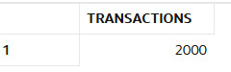

--2. Find total revenue generated.
select sum(amount)as total_revenue
from sale;
Output:
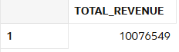

--3. Find total unique customers.
SELECT COUNT(DISTINCT customer_id) AS unique_customers
FROM sales
Output:
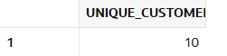

--4. Find average order value.
select avg(amount)as order_value
from sale;
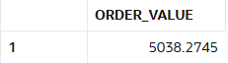

--5. Find total quantity sold.
select sum(quantity) as total_quantity
from sale;
Output:
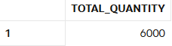
--7. Find minimum and maximum sale amount.
SELECT MIN(amount) AS min_sale, MAX(amount) AS max_sale
FROM sale;
Output:
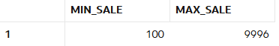
--8. Find average discount given.
select avg(discount) as avg_discount
from sale;
Output:
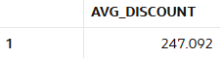
--9. Find total sales per store.
select store_id,sum(amount)as total_sale
from sale
group by store_id;
Output:
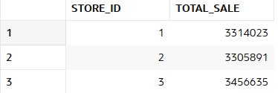

--9. Find total sales per category.
select p.category,sum(s.amount)as total_sales
from sale s left join product p
on s.product_id=p.product_id
group by p.category;
Output:
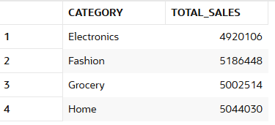

--10. Find number of transactions per day.
select sale_date , count(*) as transactions_per_day
from sale
group by sale_date
order by sale_date desc;
Output:
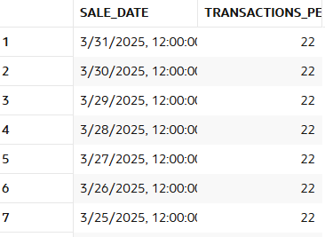
Data Cleaning
--11.Replace NULL discount with 0.
update sale
set discount =0
where discount is null;
Output:
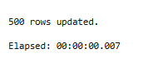
--12. Find number of NULL discounts.
SELECT COUNT(*) AS null_discount_count
FROM sale
WHERE discount IS NULL;
Output:
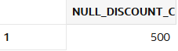
--13. Calculate net revenue (amount - discount).
SELECT sale_id,amount,discount,
(amount - discount) AS net_revenue
FROM sale;
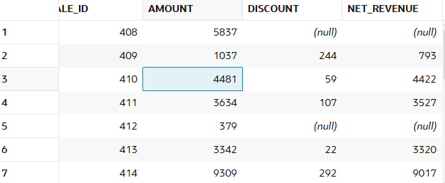

--14. Replace NULL quantity with 1.
UPDATE sale
SET quantity = 1
WHERE quantity IS NULL;
Output:
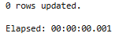
--15. Identify rows where amount is NULL.
select *
from sale
where amount is null;
Output:
--16. Use COALESCE to handle multiple NULL columns.
SELECT sale_id,
COALESCE(amount, 0) AS amount,
COALESCE(discount, 0) AS discount,
COALESCE(quantity, 1) AS quantity
FROM sale;
Output:
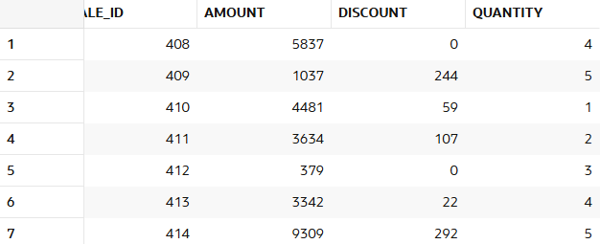

--17. Create a cleaned column for revenue.
SELECT sale_id,amount,discount,
(COALESCE(amount,0) - COALESCE(discount,0)) AS cleaned_revenue
FROM sale;
Output:
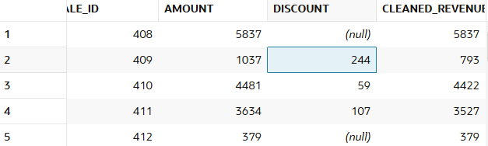

--18. Check percentage of missing data.
select count(*)as total_rows,
sum(case when amount is null then 1 else 0 end)as null_amount,
sum(case when amount is null then 1 else 0 end)*100/count(*)as percent
from sale;
Output:
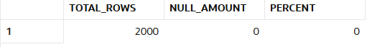

--19. Flag rows with missing values.
SELECT sale_id,
case when amount IS NULL OR discount IS NULL OR quantity IS NULL
THEN 'Missing'
ELSE 'Complete'
END AS data_flag
FROM sale;
Output:

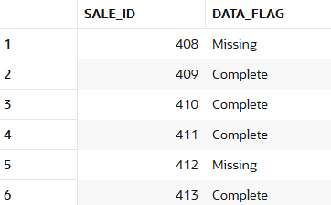

--20. Prepare dataset for analysis.
SELECT sale_id,customer_id,product_id,store_id,sale_date,
COALESCE(amount, 0) AS amount,
COALESCE(discount, 0) AS discount,
COALESCE(quantity, 1) AS quantity,
(COALESCE(amount,0) - COALESCE(discount,0)) AS net_revenue
FROM sale;
Output:
--Here I cleaned the messy data using coalesce and removed the null values and added a new net_revenue column with a clean dataset.
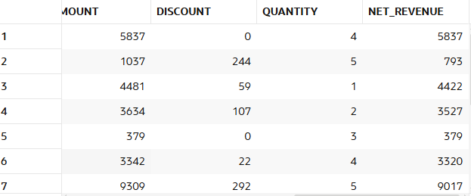

Filtering (WHERE)
--21. Find sales in last 30 days.
select *
from sale
where sale_date >= sysdate - 30;
Output:
--21. Find sales above 5000.
select *
from sale
where amount>5000;
Output:
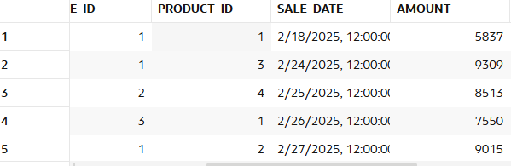
--23. Find sales between 1000 and 5000.
select *
from sale
where amount between 1000 and 5000;
Output:
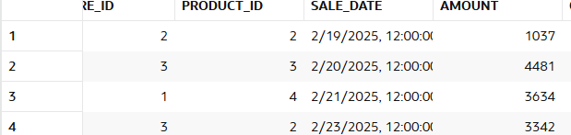

--24. Find sales from CMR store.
select S.AMOUNT,s1.STORE_NAME
from sale S LEFT JOIN stores s1
on s.store_id=s1.store_id
where s1.store_name='CMR';
Output:
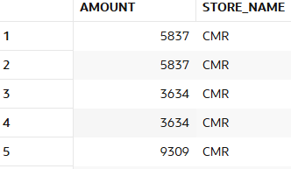
--25. Find Electronics category sales.
select p.CATEGORY,s.amount
from sale s LEFT join product p
on s.product_id=p.product_id
where p.category='Electronics';
Output:
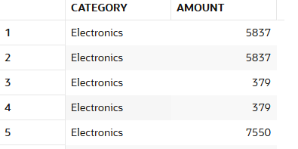
--26. Find sales excluding Grocery category.
SELECT p.CATEGORY , amount
FROM sale s
JOIN product p
ON s.product_id = p.product_id WHERE p.category != 'Grocery';
Output:
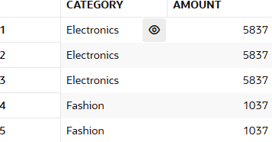
--27. Find customers from specific store.

Find high discount transactions.
Find low quantity sales.
Find recent transactions.

