**SOFTWARE ENGINEERING**

**“NITK WEBSITE”**

SYSNOPSIS

SUBMITTED IN PARTIAL FULFILMENT OF THE

REQUIREMENTS FOR THE DEGREE OF

MASTER OF COMPUTER APPLICATIONS



DEPARTMENT OF MACS

**NATIONAL INSTITUTE OF TECHNOLOGY KARNATAKA**

SURATHKAL, MANGALORE - 575025

OCTOBER 2018

**SUBMITTED BY: SUBMITTED TO:**

AVINASH KUMAR GUPTA

(174CA020)

DEEPAK KUMAR

(174CA024)

KHAGAPATI BAGH

(174CA032 )

SONALI MAHAJAN

(174CA073)

Mrs. SAHANA BHATT

**ABSTRACT**

The National Institute of Technology Karnataka (NITK), Surathkal has established itself as one of the top technological institutions in India and richly deserved recognition as an Institute of National Importance under the NIT Act 2007.Accreditation of all our academic programs by NBA; many with highest rating, recognition as a QIP Center, initiation and operationalization of MoUs with several national and international institutions, more competitive student admissions and improved performance of students in examinations are achievements that bear testimony to our commitment to maintain quality in all processes and systems.

Now we taking that to the great extant by shifting our website to the new framework which is the combination of both laravel and the ruby on rails the backend is completely on ruby on rails and the front end is on larval php .

As old website contain lot of unnecessary things which are not required so we making it complete dynamic so that the user which is not familiar with website can use it easily .It consists new department template ,Iris integration where faculty can change the database by logging in ruby on rails and shift the data on the front end according to his requirements by giving the page name and we also included dynamic url and dynamic menu bar the faculty can add new menu options in menu bar without going in source code and each user created on the iris it automatically create an account on the nitk_website .

**CONTENTS**

1. Introduction
2. System Analysis and Design
3. Requirements
   1. Hardware Requirements
   2. Software Requirements
4. References

**INTRODUCTION**

We using the concept of model ,view ,controller for both ruby on rails and php laravel.

A Rails Model is a Ruby class that can add database records (think of whole rows in an Excel table), find particular data you're looking for, update that data, or remove data.

Rails let's you know that you need to create the view file for each new method. Each method you define in the controller needs to have a corresponding erb file, with the same name as the method, to display the data that the method is collecting.

The Rails controller is the logical center of your application. It coordinates the interaction between the user, the views, and the model. The controller is also a home to a number of important ancillary services. It is responsible for routing external requests to internal actions.

We have single data base shared by the two different framework one is php and other is ruby one rails we using rails as for backend and php as for front end from the rails authorised user can login change the database according to the permission given him and those changes will reflect on the front end

In our new website the main thing we using is iris integration where all the data come from the iris if any user update his data then it will automatically update on the nitk_website also.for that we creating an api which is responsible for fetching

Data from the iris end, the another thing we covering here is dynamic property where trying to shift each thing dynamically.

So that the person not familiar with the backend can also do the changes without going in backend. New templates where chosen for the department as well faculty, profile page of faculty are more attractive then the previous ones it contain multiple template and user can chose any of them and use it.

**ANALYSIS & DESIGN**

We are using the MVC structure for our website in both the Ruby on Rails and Laravel. These framework provide an efficient way to develop websites. this framework favors convention over configuration, which makes the web development more agile. Additionally, these conventions make the web applications more maintainable as well.

Ruby on Rails / Laravel architecture has the following features:

* Model-View-Controller architecture.
* Representational State Transfer (REST) for web services.
* Supports the major databases (MySQL, Oracle, MS SQL Server, PostgreSQL, IBM DB2, and more).
* Open-source server side scripting language.
* Convention over configuration
* Scripts generators to automate tasks.
* Use of YAML machine, which is a human-readable data serialization format.

The above-described features are distributed in the following Rails/laravel’ components and the Fig.(a) shows the interaction between some of these components:

* Action Mailer
* Action Pack
  + Action Controller
  + Action Dispatcher
  + Action View
* Active Model
* Active Record
* Active Resource
* Active Support

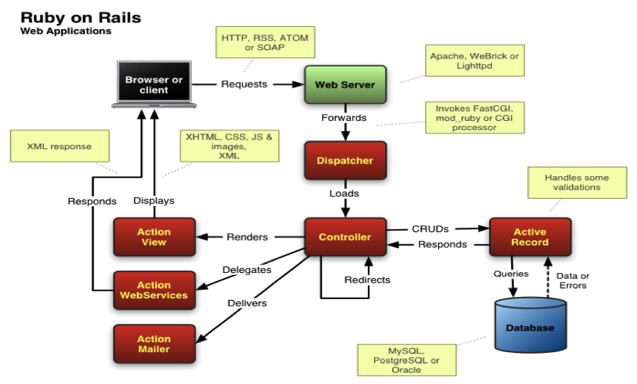

Fig:(a)

**MINIMUM REQUIREMENTS**

The minimum system requirements for running Information Filtering System:

* OS: Windows 7 / UNIX based system
* Memory: 2GB RAM
* Browser support: Yes
* Processor: Intel or AMD Processors (more the cores and speed of processor faster the character recognition)

Technologies on which these website is integrated:

* Ruby on Rails
* Laravel

**REFERENCES**

1. https://rubyonrails.org/
2. https://en.wikipedia.org/wiki/Ruby_on_Rails
3. https://github.com/rails/rails
4. https://www.tutorialspoint.com/ruby-on-rails/rails-introduction.htm
5. https://stackoverflow.com/
6. https://rubygems.org/gems/rails/versions/4.2.6
7. https://adrianmejia.com/blog/2011/08/11/ruby-on-rails-architectural-design/
8. https://www.slideshare.net/inqbation/laravel-restful-api-and-angularjs