Automated Home Waste Separator

Student: 1st Deepak Shivani
Electronics and Instrumentation Engineering
Dayananda Sagar College Of Engineering(V.T.U)
Bangalore, Karnataka
deepak21nov@gmail.com

Student : 2nd Narayani Tyagi
Electronics and Instrumentation Engineering
Dayananda Sagar College Of Engineering(V.T.U)
Bangalore, Karnataka
line 5: email address
Professor: Sushma T. Gowda
Electronics and Instrumentation Engineering
Dayananda Sagar College Of Engineering(V.T.U)
Bangalore, Karnataka
line 5: email address
Student : 3rd Abhishek Gaurav
Electronics and Instrumentation Engineering
Dayananda Sagar College Of Engineering(V.T.U)
Bangalore, Karnataka
line 5: email address

Abstract— Nowadays disposing garbage in landfills, barren lands and seas has become a huge cause for concern in the world. It can be considered as the main reason for land pollution. An extensive amount of waste that is generated is disposed by ways which have an unpropitious effect on the environment. Currently there is no system for separation of dry, wet and metallic wastes at a household level.
We have thus proposed an “Automatic Household Waste Separator” that aims at Segregating the waste at the disposal level itself. It is designed to sort the waste into metallic waste, biodegradable or kitchen waste, glass & plastic, thereby making waste management more effective. We have developed a mechanized system by embedding Arduino Uno R3 with different sensors and motors. The primary function of the system is to detect the type of waste with the help of the sensors installed such as inductive proximity sensor and capacitive sensors (moisture) and then by using the servo motor and DC motor to transfer the waste to the respective waste bin.
Keywords— Arduino, Waste Management, Servo Motor, Inductive Proximity Sensor, Capacitive Sensors, IR sensor, DC motor, Waste Separation.

Introduction
Technology is growing at an unimaginable rate! There are new products, facilities, and luxury elements that are developed every day. But the dark side is that this boon has always been accompanied by a tremendous production of waste. Currently there is no system of separation of dry, wet and metallic wastes at a household level. An astounding 0.1 million tons of waste is generated each day in India. Sadly, only 5% of this colossal amount of waste is recycled. One possible solution for this problem could be segregating the waste at the disposal level itself. In India, the collection, transportation and disposal of garbage are unscientific and chaotic. Uncontrolled dumping of waste on outskirts of towns and cities has created overflowing landfills which are not only impossible to reclaim because of the haphazard manner of dumping but also has serious environmental implication in terms of ground water pollution and contribution to Global warming .This has been found to reduce the average life span of the manual segregators.
The Philosophy of “Waste Management Hierarchy” [1] has been adopted by most industrialized nations as the menu for developing Municipal Solid Waste management strategies. Every city is grappling with the menace of escalating amounts of waste.
The situation calls for an efficient system that can sort waste at the primary stage thus making waste management more efficacious and fruitful. Mechanizing such a system is of paramount importance. We have thus come up with an Automatic home waste separator that categorizes the waste as wet, dry or metal. This will not only help in dealing with the situation in a clever manner but will also improve the economy of our country.
The objectives of this project are:
- Design and develop an engineering solution for proper sorting and separation of basic household garbage.
- To promote waste reduction, recycling and reuse and recovery; and create public awareness on the waste management and recycling industry as well as environmental and industry concerns.
- To advance the scientific, technical and practical aspects of waste management and recycling.

Block diagram & working

Block Diagram

The block diagram shown below is for the working prototype of Automated Home-Waste separator. The working is explained in the next section.
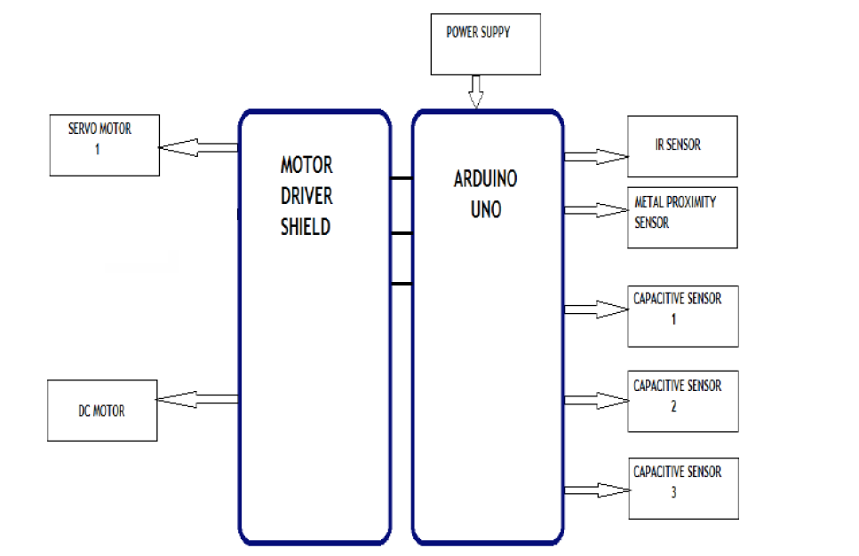
Figure 1. Block Diagram of Automated Home Waste Separator (AHWS)

Working

The waste input is detected by the IR sensor. The next section is capacitive moisture sensing module which works on the principle of capacitance, i.e. the change in dielectric of the sensor surrounding is used to detect whether to classify the waste as dry or wet. If the waste detected is wet (this is done by comparing the sensed values with a reference set of values) in nature, ex. Fruit peels, vegetable peels, leftover food etc. then the disc supported by a DC motor rotates in clockwise direction till the respective ‘wet’ bin comes under the flap, and then it stops. The flap then opens and the wet waste gets dumped in its respective bin. In case the waste detected is dry, the waste is further examined by the inductive metal proximity sensor. If the waste is found to be metallic, by comparing the analog value received by the sensor to some standard values, the flap opens and the metallic waste, ex. Tin cans, metallic bottles etc., will fall into its respective metal bin. If the waste is not metallic in nature, ex. ,plastic, glass, paper, cardboard etc. , the DC motor rotates the disk in anti-clockwise direction. Then the flap opens and the dry waste falls into its respective bin[ 10]. The flap motion is controlled by a servo motor that can rotate the flap in outward and inward direction to open or close it respectively.
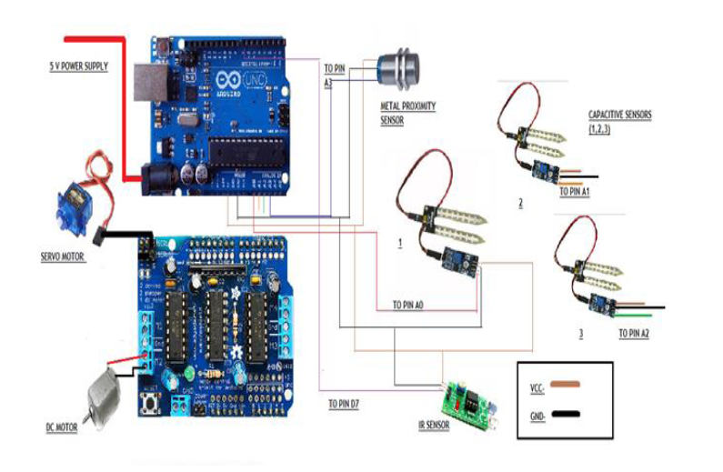
Figure 2. Circuit Diagram of AHWS

Arduino uno r3
The Arduino Uno is a microcontroller board based on the ATmega328 (datasheet). It has 14 digital input/output pins (of which 6 can be used as PWM outputs), 6 analog inputs, a 16 MHz ceramic resonator, a USB connection, a power jack, an ICSP header, and a reset button. It contains everything needed to support the microcontroller; simply connect it to a computer with a USB cable or power it with a AC-to-DC adapter or battery to get started.
The Uno differs from all preceding boards in that it does not use the FTDI USB-to-serial driver chip. Instead, it features the Atmega16U2 (Atmega8U2 up to version R2) programmed as a USB-to-serial converter. Revision 2 of the Uno board has a resistor pulling the 8U2 HWB line to ground, making it easier to put into DFU mode. Revision 3 of the board has the following new features:

1. Pin out: added SDA and SCL pins that are near to the AREF pin and two other new pins placed near to the RESET pin, the IOREF that allow the shields to adapt to the voltage provided from the board. In future, shields will be compatible both with the board that use the AVR, which operate with 5V and with the Arduino Due that operate with 3.3V. The second one is a not connected pin that is reserved for future purposes.
2. Stronger RESET circuit.
3. Atmega 16U2 replace the 8U2.

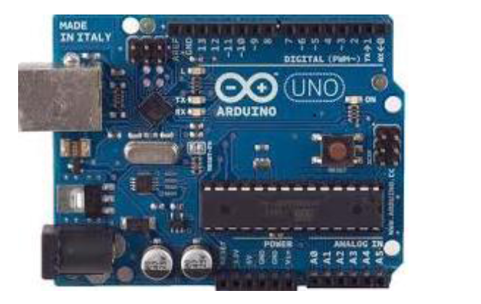
Figure 3. Arduino Uno R3

Table 1. Arduino Specifications
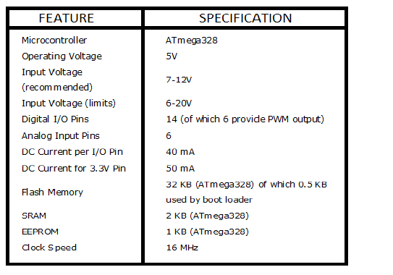

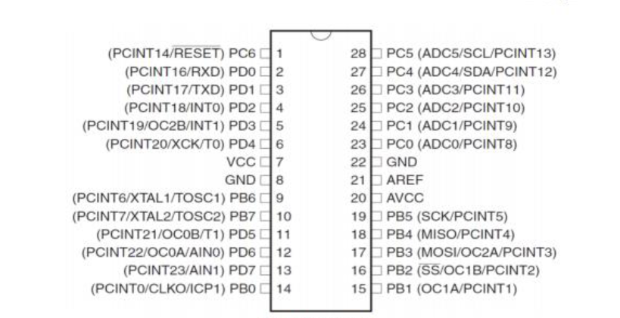
Figure 4. Pin Diagram of Atmega328

Arduino Motor Shield
The Arduino Motor Shield is based on the L298 (datasheet), which is a dual full-bridge driver designed to drive inductive loads such as relays, solenoids, DC and stepping motors. It lets you drive two DC motors with your Arduino board, controlling the speed and direction of each one independently. You can also measure the motor current absorption of each motor, among other features.

ir sensor

The IR Sensor-Single is a general purpose proximity sensor. Here we use it for collision detection. The module consists of a IR emitter and IR receiver pair. The high precision IR receiver always detects an IR signal. The module consists of 358 comparator IC. The output of sensor is high whenever it IR frequency and low otherwise. The on-board LED indicator helps user to check status of the sensor without using any additional hardware. The power consumption of this module is low. It gives a digital output.[10].

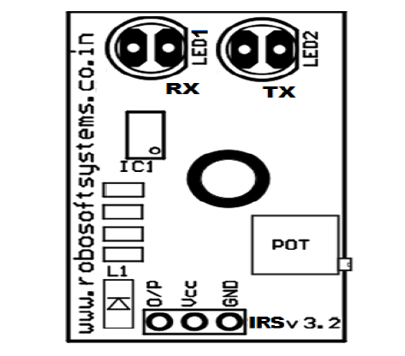
Figure 5. IR Sensor

The sensitivity of the IR Sensor is tuned using the potentiometer. The potentiometer is tunable in both the directions. Initially tune the potentiometer in clockwise direction such that the Indicator LED starts glowing. Once that is achieved, turn the potentiometer just enough in anti-clockwise direction to turn off the Indicator LED. At this point the sensitivity of the receiver is maximum. Thus, its sensing distance is maximum at this point. If the sensing distance (i.e., Sensitivity) of the receiver is needed to be reduced, then one can tune the potentiometer in the anti-clockwise direction from this point.

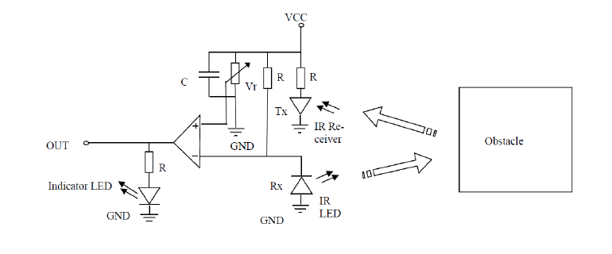
Figure 6. Schematic of IR Sensor

Table 2. Maximum Ratings of IR sensor
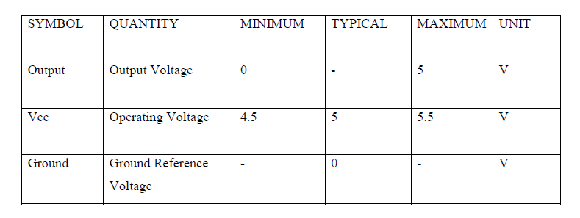

Inductive proximity sensor
An inductive proximity sensor is solely for the detection of metal objects. Here we are using a 3-wire type, NO or NC output, PNP or NPN. It basically comprises an oscillator whose windings constitute the sensing face. An alternating magnetic field is generated in front of these windings [10]. Inductive proximity sensors enable the detection, without physical contact, of metal objects. Their range of applications is very extensive and includes monitoring the position of machine parts (cams, end stops, etc.) and counting the presence of metal objects, etc. All inductive proximity sensors incorporate an output state LED indicator [6] Osiconcept sensors are fitted with a green LED that indicates “Power on” and also assists the user during setting-up (teach mode).
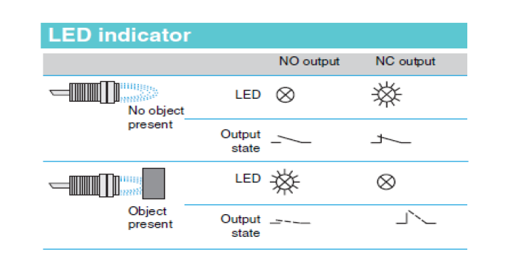
Figure 7. Inductive proximity Sensor LED Indicator

Capacitive moisture sensors
Moisture module is most sensitive to the ambient humidity is generally used to detect the moisture content of the soil. We are using this phenomenon to sense the change in moisture content of various types of wastes such as cardboard, paper, plastic, or wet kitchen waste.
Module in the ambient moisture less than a set threshold value when the DO port output high, when the ambient moisture exceeds the threshold value is set, the module D0 output low. Small plates digital outputs D0 can be directly connected with the microcontroller, to detect high and low, and thus to detect different waste’s moisture content Small plates analog output AO and AD module connected through the AD converter, you can get more accurate values of ambient moisture.

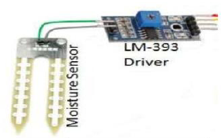
Figure 8. Moisture Sensor with LM-393

Consider the table shown below. These values were referenced and cross referenced and we deduced that a similar table could be produces for different wastes (dry and wet) with a similar value range

.
Table 3. Capacitive Value Ranges for Waste
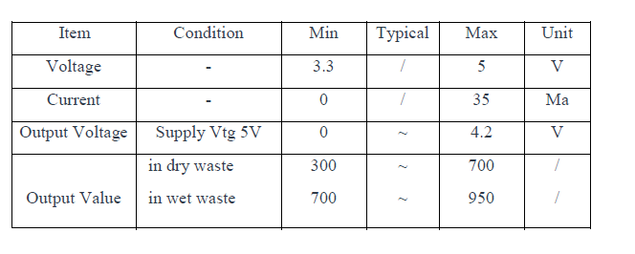

LM-393 is used along with the capacitance moisture sensor for providing comparative values to the Arduino board. The LM393 series are dual independent precision voltage comparators capable of single or split supply operation. These devices are designed to permit a common mode range−to−ground level with single supply operation. Input offset voltage specifications as low as 2.0 mV make this device an excellent selection for many applications in consumer, automotive, and industrial electronics.

Servo motor
The servo motor is actually an assembly of three parts: a normal DC motor, a gear reduction unit and a position-sensing device. The function of the servo is to apply power drive to its DC motor until its shaft turns to the expected position. It uses the position-sensing device to determine the rotational position of the shaft, so that it knows which way the motor must turn to move the shaft to the commanded position. The shaft typically does not rotate freely round and round like a DC motor, but rather can only turn around 200 degrees or so back and forth [10].

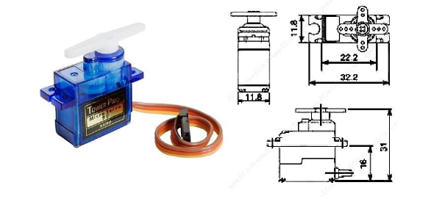
Figure 8. Servo Motor

Specifications of servo motor being used: Weight: 9 g,
Dimension: 22.2 x 11.8 x 31 mm approx., Stall torque: 1.8 kgf.cm, Operating speed: 0.1 s/60 degree, Operating voltage: 4.8 V (~5V), Dead band width: 10 μs, Temperature range: 0 ºC – 55 ºC
In order to control a Servo Motor, you need to use a technique called Pulse Width Modulation or PWM. In PWM technique, you will be sending a pulse of variable width and the position of the Servo Motor’s shaft will be set by the width or length of the Pulse. The frequency of the PWM Signal is a fixed value and is dependent on the type of the Servo Motor. In our case, both SG90 and MG90S Servo Motors have a PWM Frequency of 50Hz. At 50Hz i.e. a period of 20ms, the minimum pulse width is 1ms and the maximum pulse width is 2ms. Most servo motors can have a sweep area of 180 degrees i.e. 90 degrees on either side of the neutral position.
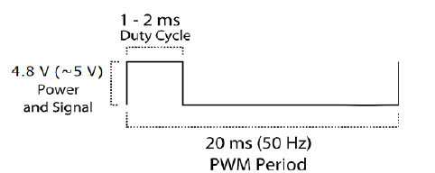
When the pulse width of the PWM Signal is 1ms, the position of the servo is all the way to the LEFT. The Duty Cycle of this position is (1ms/20ms) x 100 = 5%. Similarly, for pulse widths of 1.5ms and 2ms, the position of the servo is MIDDLE (with duty cycle of 7.5%) and far RIGHT (with duty cycle of 10%).

DC MOTOR

A DC motor is any of a class of electrical machines that converts direct current electrical power into mechanical power. The most common types rely on the forces produced by magnetic fields. Nearly all types of DC motors have some internal mechanism, either electromechanical or electronic, to periodically change the direction of current flow in part of the motor. Most types produce rotary motion; a linear motor directly produces force and motion in a straight line [10].
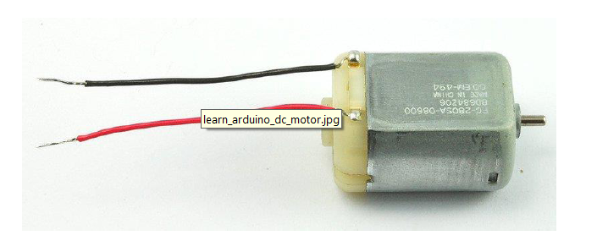Figure 9. 6V DC Motor

Results

IR Sensor Interfacing
The IR Sensor is interfaced with the Arduino Uno R3 board as shown in the figure above. The sensor gets it power input from thee VCC pin of the Arduino board and the output pin is connected to the digital pin 7 of the Arduino board. Whereas there is no waste in the proximity of the IR sensor, the LED of the sensor is in OFF state and the digital pin 7 of the Arduino board remains low as shown in fig. Whereas when a waste substance is brought in proximity of the IR sensor, the LED of the sensor is turned ON and the digital pin 7 of the Arduino board remains high as shown in figure.
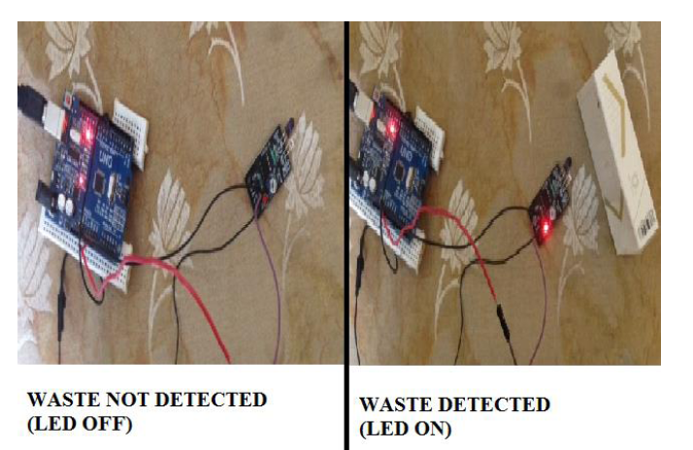Figure 10. IR Sensor Interfacing

Inductive Proximity Sensor interfacing
The Metal proximity sensor is interfaced with the Arduino Uno R3 board as shown in the figure above. The sensor gets it power input from thee VCC pin of the Arduino board and the output pin is connected to the analog pin 3 of the Arduino board. When there is no metal in the proximity of the metal proximity sensor, the LED of the sensor is in OFF state and the analog pin 3 of the Arduino board remains low as shown in figure. Whereas when a metallic substance is brought in proximity of the metal proximity sensor, the LED of the sensor is turned ON and the analog pin 3 of the Arduino board remains high as shown in figure.
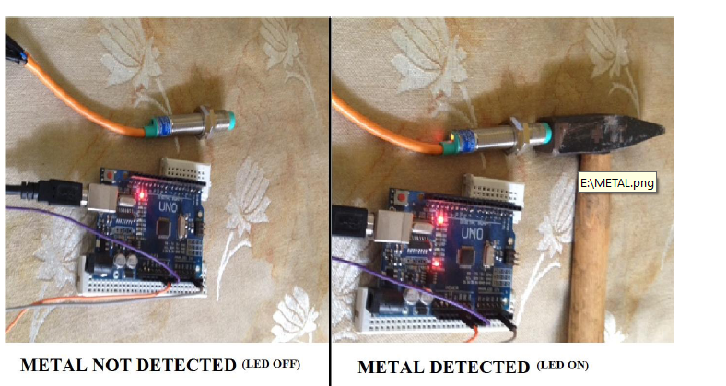Figure 11. Inductive Proximity Sensor Interfacing

Capacitive Moisture Sensor Interfacing
The Capacitive moisture sensors are interfaced with the Arduino Uno R3 board as shown in the figure above. The sensors gets it power input from thee VCC pin of the Arduino board and the output pin is connected to the analog pin 0, analog pin 1 and analog pin 2 of the Arduino board respectively. When dry waste is in the proximity of the capacitive moisture sensor, only 1 LED of the sensor is in ON state as shown in Figure. Whereas when a wet waste is brought in proximity of the capacitive moisture sensor, both the LED’s of the sensor are turned ON as shown in Figure
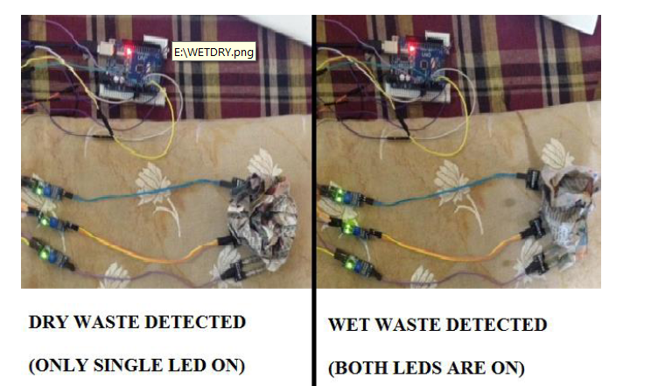Figure 12. Capacitive Sensor Interfacing

Output Display (Serial Monitor)
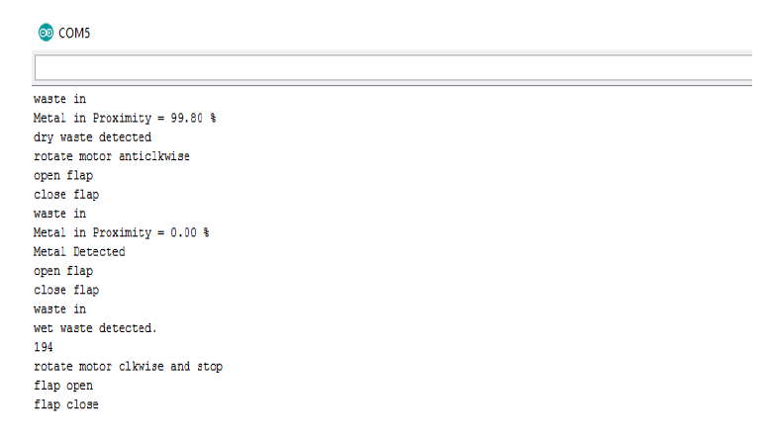

CONCLUSION
In order to solve the growing problem of increasing waste disposal and land pollution, our team proposed a solution that could reduce this at the domestic level in the form of automated home-waste separator. Our prototype of this Automated Home-Waste Separator has been successfully implemented for the separation of waste into metallic, dry and wet waste at a domestic level by using techniques such as metal proximity detection, capacitance modules and the ordered use of motors. However, it can face problem in classifying old dried biodegradable waste into wet waste due to lowered dielectric constant. Noise can be eliminated in the sensing module to increase accuracy and overall efficiency. The system can segregate only one type of waste at a time with an assigned priority for wet, metal and dry waste. Thus, improvements can be made to segregate mixed type of waste by the use of buffer spaces, claw machines, integration of electromagnets etc. Since, the time for sensing metal objects is low the entire sensing module can be placed along a single platform where the object is stable to ensure better outcome. This system can be integrated and brought to market level using higher end sensors, conveyor belts, more sensitive capacitive modules and more advanced segregation techniques. Such a device could be useful in public places such as parks, bus stands, railways, institutions etc.
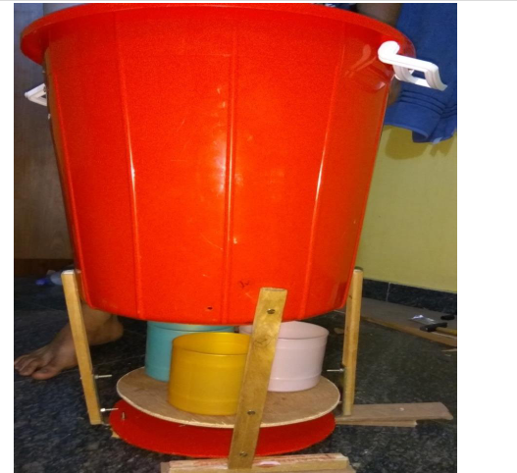Figure 13. Device Prototype

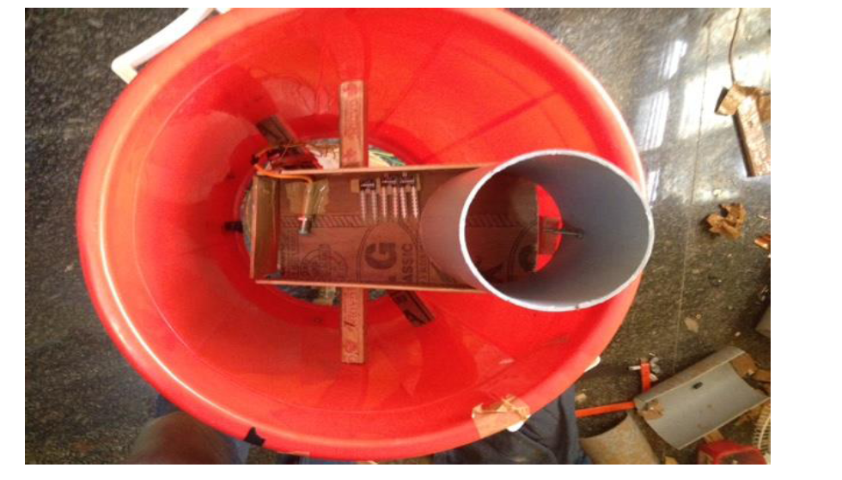Figure 14. Top View of Device

Acknowledgment
It is with great satisfaction and euphoria that we are submitting our project report on “Automated Home Waste Separator”. We express our warm thanks to our Professor Mrs. SUSHMA T., Dept. of Electronics and Instrumentation Engineering for skillful guidance, constant supervision, timely suggestion and constructive criticism in successful completion of our project in time. We are also thankful to all the staff members of Electronic and Instrumentation Engineering Department, who have rendered their whole hearted support at all times for successful completion of our project. Also, thanking Visvesvaraya Technological University and Dayananda Sagar College of Engineering without which we would not have achieved the success. Finally we convey our gratitude to all those who have been kind enough to offer their advice and provide assistance when needed which has led to the successful completion of our project.

References

[1] Daniel Hoornweg et al., “WHAT A WASTE A Global Review of Solid Waste Management”, Urban Development & Local Government Unit World Bank, Washington, DC.No.15, Mar. 2012.
[2] Nishigandha Kothari, ”Waste to Wealth”, NSWAI, New Delhi, Jul. 2013

[3] Claudine Capel, “INNOVATIONS IN WASTE”, Waste-management-world, Volume 11, Issue 2, Mar 2010.

[4] J.S. Bajaj, “Urban Solid Waste management in India“, Planning Commission Government of India, NEW DELHI, 1995

[5] Claudine Capel, “WASTE SORTING - A LOOK AT THE SEPARATION AND SORTING TECHNIQUES IN TODAY’S EUROPEAN MARKET” Waste-management-world, Volume 9, Issue 4, Jul 2008.

[6] LDC1000 Inductance to Digital Converter, Texas instruments, Dallas, TX, Sept 2013

[7] MSP430x2xx Family User's Guide, Texas instruments, Dallas, TX, Dec 2004–Revised Jul 2013

[8] “Relative Dielectric constant ℇr(dk value) of liquids and solid materials”, Endress Hauser, Weil am Rhein, Baden-Württemberg, 2000

[9] M.S. Venkatesh et al., “An Overview of Microwave Processing and Dielectric Properties of Agri-food Materials”, Biosystems Engineering (2004) 88 (1)

[10] Automated Waste Segregator, Amrutha Chandramohan, Joyal Mendonca, Nikhil Ravi Shankar, Nikhil U Baheti, Nitin Kumar Krishnan,Suma M S

[11] De Feo, G.; Napoli, R.M.A. New and old paradigms on production and management of municipal solid waste. In Proceedings of Sardinia 2005, Tenth International Waste Management and Landfill Symposium, Cagliari, Italy, 3–7 October 2005; CISA: Cagliari, Italy, 2005.

[12] Ayres, R.U; Simonis, U.E. Industrial Metabolism: Restructuring for Sustainable Development, 1st ed.; United Nations University Press: Tokyo, Japan, 1994.

[13] Fischer-Kowalski, M.; Haberl, H. Metabolism and colonization. Modes of production and the physical exchange between societies and nature. Innov. Soc. Sci. Res. 2003, 6, 415-442.

[14] Bovea, M.D.; Ibáñez-Forés, V.; Gallardo, A.; Colomer-Mendoza, F.J. Environmental assessment of alternative municipal solid waste management strategies. A Spanish case study. Waste Manage. 2010, (in press).

[15] Seadon, J.K. Integrated waste management—looking beyond the solid waste horizon. Waste Manage. 2006, 26, 1327-1336.

[16] Choe, C.; Fraser, I. An Economic Analysis of Household Waste Management. J. Environ. Econ. Manag. 1999

