**CHAPTER 1**

**INTRODUCTION**

Technology is growing at an unimaginable rate! There are new products, facilities, and luxury elements that are developed every day. But the dark side is that this boon has always been accompanied by a tremendous production of waste.

The Philosophy of “Waste Management Hierarchy” [1] has been adopted by most industrialized nations as the menu for developing Municipal Solid Waste management strategies. Every city is grappling with the menace of escalating amounts of waste.

The situation calls for an efficient system that can sort waste at the primary stage thus making waste management more efficacious and fruitful. Mechanizing such a system is of paramount importance. We have thus come up with an Automatic home waste separator that categorizes the waste as wet, dry or metal. This will not only help in dealing with the situation in a clever manner but will also improve the economy of our country.

The objectives of this project are:

1. Design and develop an engineering solution for proper sorting and separation of basic household garbage.
2. To promote waste reduction, recycling and reuse and recovery; and create public awareness on the waste management and recycling industry as well as environmental and industry concerns.
3. To advance the scientific, technical and practical aspects of waste management and recycling.

We sincerely hope that our project helps in fulfilling the motto of “Swacchh Bharat Abhiyaan”.

**1.1HISTORY OF WASTE MANAGEMENT**

Waste management is all the activities and actions required to manage waste from its inception to its final disposal. This includes amongst other things, collection, transport, treatment and disposal of [waste](https://en.wikipedia.org/wiki/Waste) together with monitoring and regulation. It also encompasses the legal and regulatory framework that relates to waste management encompassing guidance on recycling etc. Waste management is intended to reduce adverse effects of waste on [health](https://en.wikipedia.org/wiki/Health), the [environment](https://en.wikipedia.org/wiki/Environment_(biophysical)) or [aesthetics](https://en.wikipedia.org/wiki/Aesthetics).

Throughout most of history, the amount of [waste](https://en.wikipedia.org/wiki/Waste) generated by humans was insignificant due to low [population density](https://en.wikipedia.org/wiki/Population_density) and low societal levels of the exploitation of [natural resources](https://en.wikipedia.org/wiki/Natural_resources). Common waste produced during pre-modern times was mainly ashes and human [biodegradable waste](https://en.wikipedia.org/wiki/Biodegradable_waste), and these were released back into the ground locally, with minimum [environmental impact](https://en.wikipedia.org/wiki/Environmental_degradation). Tools made out of [wood](https://en.wikipedia.org/wiki/Wood) or [metal](https://en.wikipedia.org/wiki/Metal) were generally reused or passed down through the generations.

However, some civilizations do seem to have been more profligate in their waste output than others. In particular, the [Maya](https://en.wikipedia.org/wiki/Maya_civilization) of [Central America](https://en.wikipedia.org/wiki/Central_America) had a fixed monthly ritual, in which the people of the village would gather together and burn their rubbish in large dumps. Following the onset of [industrialisation](https://en.wikipedia.org/wiki/Industrial_revolution) and the sustained urban growth of large population centres the build-up of waste in the cities caused a rapid deterioration in levels of [sanitation](https://en.wikipedia.org/wiki/Sanitation) and the general quality of urban life. The streets became choked with filth due to the lack of waste clearance regulations.

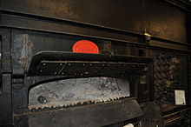

Fig 1.1: Manlove,Alliott & Co. Ltd. 1894 “destructor” furnace.

The dramatic increase in waste for disposal led to the creation of the first [incineration](https://en.wikipedia.org/wiki/Incineration) plants, or, as they were then called, "destructors".

**CHAPTER 2**

**WASTE DISPOSAL METHODS**

There are many different types of waste disposal schemes being used in today’s world. They have been evolved from old traditions or might have been invented as a result of necessity. The principles that almost all these techniques follow have been described below.

**2.1 Central Principles of Waste Management**

There are a number of [concepts about waste management](https://en.wikipedia.org/wiki/Waste_management_concepts) which vary in their usage between countries or regions. Some of the most general, widely used concepts include:

### 2.1.1 Waste hierarchy

The [waste hierarchy](https://en.wikipedia.org/wiki/Waste_hierarchy)[2][3] refers to the "3 Rs" [reduce](https://en.wikipedia.org/wiki/Reduce_(waste)), [reuse](https://en.wikipedia.org/wiki/Reuse) and [recycle](https://en.wikipedia.org/wiki/Recycling), which classify waste management strategies according to their desirability in terms of [waste minimisation](https://en.wikipedia.org/wiki/Waste_minimisation).

[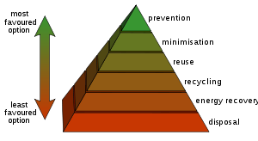](https://en.wikipedia.org/wiki/File:Waste_hierarchy.svg)

Fig 2.1: Waste hierarchy

The waste hierarchy remains the cornerstone of most waste minimisation strategies. The aim of the waste hierarchy is to extract the maximum practical benefits from products and to generate the minimum amount of waste; see: [resource recovery](https://en.wikipedia.org/wiki/Resource_recovery). The waste hierarchy is represented as a pyramid because the basic premise is for policy to take action first and prevent the generation of waste. The next step or preferred action is to reduce the generation of waste i.e. by re-use. The next is recycling which would include composting. Following this step is material recovery and [waste-to-energy](https://en.wikipedia.org/wiki/Waste-to-energy). Energy can be recovered from processes i.e. landfill and combustion, at this level of the hierarchy. The final action is disposal, in landfills or through incineration without energy recovery. This last step is the final resort for waste which has not been prevented, diverted or recovered. The waste hierarchy represents the progression of a product or material through the sequential stages of the pyramid of waste management. The hierarchy represents the latter parts of the life-cycle for each product.

### 2.1.2 Life-cycle of a Product

The life-cycle begins with design, then proceeds through manufacture, distribution, use and then follows through the waste hierarchy's stages of reuse, recovery, recycling and disposal. Each of the above stages of the life-cycle offers opportunities for policy intervention, to rethink the need for the product, to redesign to minimize waste potential, to extend its use. The key behind the life-cycle of a product is to optimize the use of the world's limited resources by avoiding the unnecessary generation of waste.

### 2.1.3 Resource efficiency

[Resource efficiency](https://en.wikipedia.org/wiki/Resource_efficiency) reflects the understanding that current, global, economic growth and development can not be sustained with the current production and consumption patterns. Globally, we are extracting more resources to produce goods than the planet can replenish.[11] Resource efficiency is the reduction of the environmental impact from the production and consumption of these goods, from final raw material extraction to last use and disposal. This process of resource efficiency can address [sustainability](https://en.wikipedia.org/wiki/Sustainability).

### 2.1.4 Polluter pays principle

The [Polluter pays principle](https://en.wikipedia.org/wiki/Polluter_pays_principle) is a principle where the polluting party pays for the impact caused to the environment. With respect to waste management, this generally refers to the requirement for a waste generator to pay for appropriate disposal of the unrecoverable material

**2.2 Disposal Solutions**

**2.2.1 Landfills**

A landfill site (also known as a tip, dump, rubbish dump, garbage dump or dumping ground and historically as a [midden](https://en.wikipedia.org/wiki/Midden)[11]) is a site for the disposal of [waste](https://en.wikipedia.org/wiki/Waste) materials by burial and is the oldest form of [waste treatment](https://en.wikipedia.org/wiki/List_of_solid_waste_treatment_technologies) (although the burial part is modern; historically, refuse was just left in piles or thrown into pits). Historically, landfills have been the most common method of organized [waste disposal](https://en.wikipedia.org/wiki/Waste_disposal) and remain so in many places around the world.

Some landfills are also used for waste management purposes, such as the temporary storage, consolidation and transfer, or processing of waste material (sorting, treatment, or recycling).[11]. A landfill also may refer to ground that has been filled in with [rocks](https://en.wikipedia.org/wiki/Rock_(geology)) instead of waste materials, so that it can be used for a specific purpose, such as for building houses. Unless they are stabilized, these areas may experience severe shaking or [liquefaction](https://en.wikipedia.org/wiki/Earthquake_liquefaction) of the ground during a large [earthquake](https://en.wikipedia.org/wiki/Earthquake).

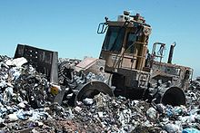

Fig2.2: A landfill site

**2.2.2 Incineration**

Incineration is a disposal method in which solid organic wastes are subjected to combustion so as to convert them into residue and gaseous products. This method is useful for disposal of residue of both solid waste management and solid residue from waste water management. This process reduces the volumes of solid waste to 20 to 30 percent of the original volume. Incineration and other high temperature waste treatment systems are sometimes described as "[thermal treatment](https://en.wikipedia.org/wiki/Thermal_treatment)". Incinerators convert waste materials into [heat](https://en.wikipedia.org/wiki/Heat), [gas](https://en.wikipedia.org/wiki/Gas), [steam](https://en.wikipedia.org/wiki/Steam), and [ash](https://en.wikipedia.org/wiki/Incineration#Solid_outputs).

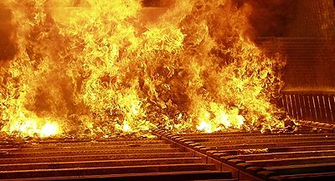

Fig2.3: Furnace of a moving grate incinerator

Incineration is carried out both on a small scale by individuals and on a large scale by industry. It is used to dispose of solid, liquid and gaseous waste. It is recognized as a practical method of disposing of certain [hazardous waste](https://en.wikipedia.org/wiki/Hazardous_waste) materials (such as biological [medical waste](https://en.wikipedia.org/wiki/Medical_waste)). Incineration is a controversial method of waste disposal, due to issues such as emission of gaseous [pollutants](https://en.wikipedia.org/wiki/Pollutants).

**2.2.3 Recycling and Reuse**

Recycling is a [resource recovery](https://en.wikipedia.org/wiki/Resource_recovery) practice that refers to the collection and reuse of waste materials such as empty beverage containers. The materials from which the items are made can be reprocessed into new products. Material for recycling may be collected separately from general waste using dedicated bins and collection vehicles, a procedure called [kerbside collection](https://en.wikipedia.org/wiki/Kerbside_collection). In some communities, the owner of the waste is required to separate the materials into different bins (e.g. for paper, plastics, metals) prior to its collection. In other communities, all recyclable materials are placed in a single bin for collection, and the sorting is handled later at a central facility. The latter method is known as “[single-stream recycling](https://en.wikipedia.org/wiki/Single-stream_recycling).” [11]

The most common consumer products recycled include [aluminium](https://en.wikipedia.org/wiki/Aluminium) such as beverages cans, [copper](https://en.wikipedia.org/wiki/Copper) such as wire, [steel](https://en.wikipedia.org/wiki/Steel) from food and aerosol cans, old steel furnishings or equipment, rubber [tyres](https://en.wikipedia.org/wiki/Tire), [polyethylene](https://en.wikipedia.org/wiki/HDPE) and [PET](https://en.wikipedia.org/wiki/Recycling_of_PET_Bottles) bottles, [glass](https://en.wikipedia.org/wiki/Glass) bottles and jars, [paperboard](https://en.wikipedia.org/wiki/Paperboard) [cartons](https://en.wikipedia.org/wiki/Carton), [newspapers](https://en.wikipedia.org/wiki/Newspapers), magazines and light paper, and [corrugated fiber board](https://en.wikipedia.org/wiki/Corrugated_fiberboard) boxes.

[PVC](https://en.wikipedia.org/wiki/Polyvinyl_chloride), [LDPE](https://en.wikipedia.org/wiki/LDPE), [PP](https://en.wikipedia.org/wiki/Polypropylene), and [PS](https://en.wikipedia.org/wiki/Polystyrene) (see [resin identification code](https://en.wikipedia.org/wiki/Resin_identification_code)) are also recyclable. These items are usually composed of a single type of material, making them relatively easy to recycle into new products. The recycling of complex products (such as computers and electronic equipment) is more difficult, due to the additional dismantling and separation required.



Fig2.4: The international recycling logo

The symbol shown above is the international ‘3R’ logo that represents Reduce, Recycling & Reusing. It is the standard way of representing recycling for sustainable development.

**CHAPTER 3**

**DESIGN AND IMPLEMENTATION**

**3.1 BLOCK DIAGRAM**

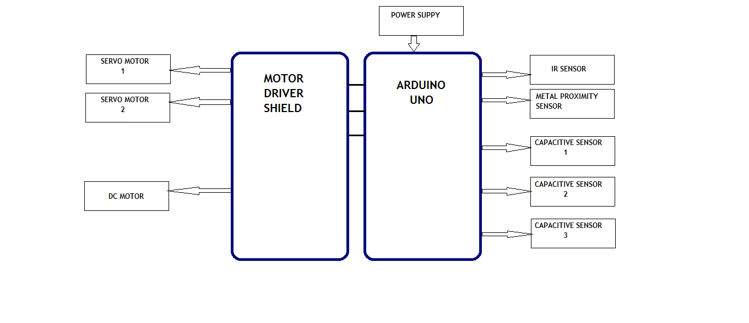The block diagram shown below is for the working prototype of Automated Home-Waste separator. The working is explained in the next section.

Fig3.1 Block Diagram of automated household waste separator

**3.2 WORKING**

The waste input is detected by the IR sensor. The next section is capacitive moisture sensing module which works on the principle of capacitance, i.e. change in dielectric of the surrounding ambient is used to detect whether and classify the waste as dry or wet. If the waste detected is wet (this is done by comparing the sensed values with a reference set of values) in nature, ex. Fruit peels, vegetable peels, leftover food etc. then the disc supported by a DC motor rotates in clockwise direction till the respective ‘wet’ bin comes under the flap, and then it stops. The flap then opens and the wet waste gets dumped in its respective bin. In case the waste detected is dry, the waste is further examined by the inductive metal proximity sensor. If the waste is found to be metallic, by comparing the analog value received by the sensor to some standard values, the flap opens and the metallic waste, ex. Tin cans, metallic bottles etc., will fall into its respective metal bin. If the waste is not metallic in nature, ex. ,plastic, glass, paper, cardboard etc. , the DC motor rotates the disk in anti-clockwise direction. Then the flap opens and the dry waste falls into its respective bin[ 10]. The flap motion is controlled by a servo motor that can rotate the flap in outward and inward direction to open or close it respectively.

**3.3 CIRCUIT DIAGRAM**

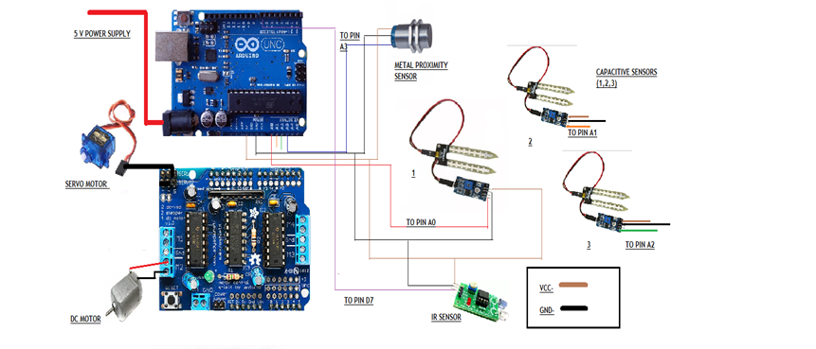

Fig3.2 Circuit Diagram of automated household waste separator

The figure given above shows the circuit diagram and shows how the sensors the connected to their respective pins in the arduino and the motor shield. The description of pin connections is explained in the next section.

**3.4 PIN CONNECTIONS**

1. IR sensor: Digital pin 7 – IR sensor is used to sense the presence of waste
2. Capacitive sensor 1: Analog pin 0
3. Capacitive sensor 2: Analog pin 1 These sensors are used to determine
4. Capacitive sensor 3: Analog pin 2 whether the waste is dry or wet
5. Metal proximity sensor: Analog pin 3 – checks if waste is metallic
6. Servo motors: S1- pin 10 [through motor driver shield] – for moving the flap
7. DC Motor: M2 [through motor driver shield] –for moving the rotating disc
8. VCC
9. GND

**CHAPTER 4**

**ARDUINO AND MOTOR SHIELD**

**4.1 ARDUINO UNO**

**4.1.1 OVERVIEW**

The Arduino Uno is a microcontroller board based on the ATmega328 (datasheet). It has 14 digital input/output pins (of which 6 can be used as PWM outputs), 6 analog inputs, a 16 MHz ceramic resonator, a USB connection, a power jack, an ICSP header, and a reset button. It contains everything needed to support the microcontroller; simply connect it to a computer with a USB cable or power it with a AC-to-DC adapter or battery to get started.

The Uno differs from all preceding boards in that it does not use the FTDI USB-to-serial driver chip. Instead, it features the Atmega16U2 (Atmega8U2 up to version R2) programmed as a USB-to-serial converter. Revision 2 of the Uno board has a resistor pulling the 8U2 HWB line to ground, making it easier to put into DFU mode. Revision 3 of the board has the following new features:

1. Pinout: added SDA and SCL pins that are near to the AREF pin and two other new pins placed near to the RESET pin, the IOREF that allow the shields to adapt to the voltage provided from the board. In future, shields will be compatible both with the board that use the AVR, which operate with 5V and with the Arduino Due that operate with 3.3V. The second one is a not connected pin, that is reserved for future purposes.
2. Stronger RESET circuit.
3. Atmega 16U2 replace the 8U2.

"Uno" means one in Italian and is named to mark the upcoming release of Arduino 1.0. The Uno and version 1.0 will be the reference versions of Arduino, moving forward. The Uno is the latest in a series of USB Arduino boards, and the reference model for the Arduino platform.

**4.1.2 Features**

1. High Performance, Low Power AVR® 8-Bit Microcontroller
2. Advanced RISC Architecture
   * 131 Powerful Instructions
   * Most Single Clock Cycle Execution
   * 32 x 8 General Purpose Working Registers
   * Fully Static Operation
   * Up to 20 MIPS Throughput at 20 MHz
   * On-chip 2-cycle Multiplier
3. High Endurance Non-volatile Memory Segments
   * 4/8/16/32K Bytes of In-System Self-Programmable Flash progam memory (ATmega48PA/88PA/168PA/328P)
   * 256/512/512/1K Bytes EEPROM (ATmega48PA/88PA/168PA/328P)
   * 512/1K/1K/2K Bytes Internal SRAM (ATmega48PA/88PA/168PA/328P)
   * Write/Erase Cycles: 10,000 Flash/100,000 EEPROM
   * Data retention: 20 years at 85°C/100 years at 25°C(1)
   * Optional Boot Code Section with Independent Lock Bits In-System Programming by On-chip Boot Program True Read-While-Write Operation
   * Programming Lock for Software Security
4. Peripheral Features
   * Two 8-bit Timer/Counters with Separate Prescaler and Compare Mode
   * One 16-bit Timer/Counter with Separate Prescaler, Compare Mode, and Capture Mode
   * Real Time Counter with Separate Oscillator
   * Six PWM Channels
   * 8-channel 10-bit ADC in TQFP and QFN/MLF package Temperature Measurement
   * 6-channel 10-bit ADC in PDIP Package Temperature Measurement
   * Programmable Serial USART
   * Master/Slave SPI Serial Interface
   * Byte-oriented 2-wire Serial Interface (Philips I2 C compatible)
   * Programmable Watchdog Timer with Separate On-chip Oscillator
   * On-chip Analog Comparator
   * Interrupt and Wake-up on Pin Change
5. Special Microcontroller Features
   * Power-on Reset and Programmable Brown-out Detection
   * Internal Calibrated Oscillator
   * External and Internal Interrupt Sources
   * Six Sleep Modes: Idle, ADC Noise Reduction, Power-save, Power-down, Standby, and Extended Standby
6. I/O and Packages
   * 23 Programmable I/O Lines
   * 28-pin PDIP, 32-lead TQFP, 28-pad QFN/MLF and 32-pad QFN/MLF
7. Operating Voltage:
   * 1.8 - 5.5V for ATmega48PA/88PA/168PA/328P
8. Temperature Range:
   * -40°C to 85°C
9. Speed Grade:
   * 0 - 20 MHz @ 1.8 - 5.5V
10. Low Power Consumption at 1 MHz, 1.8V, 25°C for ATmega48PA/88PA/168PA/328P:
    * Active Mode: 0.2 mA
    * Power-down Mode: 0.1 µA
    * Power-save Mode: 0.75 µA (Including 32 kHz RTC)

**4.1.3 Schematic & Reference Design**

The Arduino reference design can use an Atmega8, 168, or 328, Current models use an ATmega328, but an Atmega8 is shown in the schematic for reference. The pin configuration is identical on all three processors.

**4.1.3.1 Power**

The Arduino Uno can be powered via the USB connection or with an external power supply. The power source is selected automatically. External (non-USB) power can come either from an AC-to-DC adapter (wall-wart) or battery. The adapter can be connected by plugging a 2.1mm center-positive plug into the board's power jack. Leads from a battery can be inserted in the Gnd and Vin pin headers of the POWER connector. The board can operate on an external supply of 6 to 20 volts. If supplied with less than 7V, however, the 5V pin may supply less than five volts and the board may be unstable. If using more than 12V, the voltage regulator may overheat and damage the board. The recommended range is 7 to 12 volts.

The power pins are as follows:

1. VIN. The input voltage to the Arduino board when it's using an external power source (as opposed to 5 volts from the USB connection or other regulated power source). You can supply voltage through this pin, or, if supplying voltage via the power jack, access it through this pin.
2. 5V.This pin outputs a regulated 5V from the regulator on the board. The board can be supplied with power either from the DC power jack (7 - 12V), the USB connector (5V), or the VIN pin of the board (7-12V). Supplying voltage via the 5V or 3.3V pins bypasses the regulator, and can damage your board. We don't advise it.
3. 3V3. A 3.3 volt supply generated by the on-board regulator. Maximum current draw is 50 mA.
4. GND. Ground pins.

**4.1.3.2 Memory**

The ATmega328 has 32 KB (with 0.5 KB used for the bootloader). It also has 2 KB of SRAM and 1 KB of EEPROM (which can be read and written with the EEPROM library).

**4.1.3.3 Input and Output**

Each of the 14 digital pins on the Uno can be used as an input or output, using pinMode(), digitalWrite(), and digitalRead() functions. They operate at 5 volts. Each pin can provide or receive a maximum of 40 mA and has an internal pull-up resistor (disconnected by default) of 20-50 kOhms. In addition, some pins have specialized functions:

1. Serial: 0 (RX) and 1 (TX). Used to receive (RX) and transmit (TX) TTL serial data. These pins are connected to the corresponding pins of the ATmega8U2 USB-to-TTL Serial chip.
2. External Interrupts: 2 and 3. These pins can be configured to trigger an interrupt on a low value, a rising or falling edge, or a change in value. See the attachInterrupt() function for details.
3. PWM: 3, 5, 6, 9, 10, and 11. Provide 8-bit PWM output with the analogWrite() function.
4. SPI: 10 (SS), 11 (MOSI), 12 (MISO), 13 (SCK). These pins support SPI communication using the SPI library.
5. LED: 13. There is a built-in LED connected to digital pin 13. When the pin is HIGH value, the LED is on, when the pin is LOW, it's off.

The Uno has 6 analog inputs, labelled A0 through A5, each of which provide 10 bits of resolution (i.e. 1024 different values). By default they measure from ground to 5 volts, though is it possible to change the upper end of their range using the AREF pin and the analogReference() function. Additionally, some pins have specialized functionality:

1. TWI: A4 or SDA pin and A5 or SCL pin. Support TWI communication using the Wire library.

There are a couple of other pins on the board:

1. AREF. Reference voltage for the analog inputs. Used with analogReference().
2. Reset. Bring this line LOW to reset the microcontroller. Typically used to add a reset button to shields which block the one on the board.

**4.1.4 COMMUNICATION**

The Arduino Uno has a number of facilities for communicating with a computer, another Arduino, or other microcontrollers. The ATmega328 provides UART TTL (5V) serial communication, which is available on digital pins 0 (RX) and 1 (TX). An ATmega16U2 on the board channels this serial communication over USB and appears as a virtual com port to software on the computer. The '16U2 firmware uses the standard USB COM drivers, and no external driver is needed. However, on Windows, a .inf file is required. The Arduino software includes a serial monitor which allows simple textual data to be sent to and from the Arduino board. The RX and TX LEDs on the board will flash when data is being transmitted via the USB-to-serial chip and USB connection to the computer (but not for serial communication on pins 0 and 1).

A SoftwareSerial library allows for serial communication on any of the Uno's digital pins. The ATmega328 also supports I2C (TWI) and SPI communication. The Arduino software includes a Wire library to simplify use of the I2C bus; see the documentation for details. For SPI communication, use the SPI library.

**4.1.5 PROGRAMMING**

The Arduino Uno can be programmed with the Arduino software (download). Select "Arduino Uno from the **Tools > Board** menu (according to the microcontroller on your board). For details, see the reference and tutorials.

The ATmega328 on the Arduino Uno comes preburned with a bootloader that allows you to upload new code to it without the use of an external hardware programmer. It communicates using the original STK500 protocol (reference, C header files).

You can also bypass the bootloader and program the microcontroller through the ICSP (In-Circuit Serial Programming) header; see these instructions for details.

The ATmega16U2 (or 8U2 in the rev1 and rev2 boards) firmware source code is available The ATmega16U2/8U2 is loaded with a DFU bootloader, which can be activated by:

1. On Rev1 boards: connecting the solder jumper on the back of the board (near the map of Italy) and then resetting the 8U2.
2. On Rev2 or later boards: there is a resistor that pulling the 8U2/16U2 HWB line to ground, making it easier to put into DFU mode.

You can then use Atmel's FLIP software (Windows) or the DFU programmer (Mac OS X and Linux) to load a new firmware. Or you can use the ISP header with an external programmer (overwriting the DFU bootloader).

**4.1.6 AUTOMATIC (SOFTWARE) RESET**

Rather than requiring a physical press of the reset button before an upload, the Arduino Uno is designed in a way that allows it to be reset by software running on a connected computer. One of the hardware flow control lines (DTR) of the ATmega8U2/16U2 is connected to the reset line of the ATmega328 via a 100 nanofarad capacitor. When this line is asserted (taken low), the reset line drops long enough to reset the chip. The Arduino software uses this capability to allow you to upload code by simply pressing the upload button in the Arduino environment. This means that the bootloader can have a shorter timeout, as the lowering of DTR can be well-coordinated with the start of the upload.

This setup has other implications. When the Uno is connected to either a computer running Mac OS X or Linux, it resets each time a connection is made to it from software (via USB). For the following half-second or so, the bootloader is running on the Uno. While it is programmed to ignore malformed data (i.e. anything besides an upload of new code), it will intercept the first few bytes of data sent to the board after a connection is opened. If a sketch running on the board receives one-time configuration or other data when it first starts, make sure that the software with which it communicates waits a second after opening the connection and before sending this data.

The Uno contains a trace that can be cut to disable the auto-reset. The pads on either side of the trace can be soldered together to re-enable it. It's labeled "RESET-EN". You may also be able to disable the auto-reset by connecting a 110 ohm resistor from 5V to the reset line; see this forum thread for details.

**4.1.7 USB OVERCURRENT PROTECTION**

The Arduino Uno has a resettable polyfuse that protects your computer's USB ports from shorts and overcurrent. Although most computers provide their own internal protection, the fuse provides an extra layer of protection. If more than 500 mA is applied to the USB port, the fuse will automatically break the connection until the short or overload is removed.

**4.1.8 PHYSICAL CHARACTERISTICS**

The maximum length and width of the Uno PCB are 2.7 and 2.1 inches respectively, with the USB connector and power jack extending beyond the former dimension. Four screw holes allow the board to be attached to a surface or case. Note that the distance between digital pins 7 and 8 is 160 mil (0.16"), not an even multiple of the 100 mil spacing of the other pins.

The diagram shown below is the pin diagram of AT mega 328-

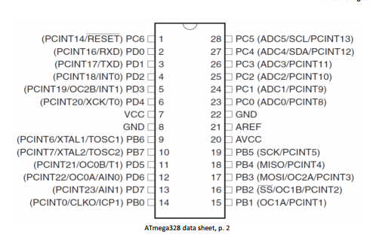

Fig4.1 Pin Diagram of ATmega328

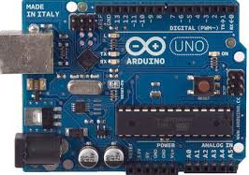

Fig4.2 An Arduino board.

**4.2 ARDUINO MOTOR SHIELD**

**4.2.1 Overview**

The Arduino Motor Shield is based on the L298 ([datasheet](http://www.st.com/web/en/catalog/sense_power/FM142/CL851/SC1790/SS1555/PF63147)), which is a dual full-bridge driver designed to drive inductive loads such as relays, solenoids, DC and stepping motors. It lets you drive two DC motors with your Arduino board, controlling the speed and direction of each one independently. You can also measure the motor current absorption of each motor, among other features. The shield is TinkerKit compatible, which means you can quickly create projects by plugging TinkerKit modules to the board.

### 4.2.2 Summary

|  |  |
| --- | --- |
| Operating Voltage | 5V to 12V |
| Motor controller | L298P, Drives 2 DC motors or 1 stepper motor |
| Max current | 2A per channel or 4A max (with external power supply) |
| Current sensing | 1.65V/A |
| Free running stop and brake function |  |

### 4.2.3 Schematic & Reference Design

### 5.2.3.1 Power

The Arduino Motor Shield must be powered only by an external power supply. Because the L298 IC mounted on the shield has two separate power connections, one for the logic and one for the motor supply driver. The required motor current often exceeds the maximum USB current rating.

External (non-USB) power can come either from an AC-to-DC adapter (wall-wart) or battery. The adapter can be connected by plugging a 2.1mm center-positive plug into the Arduino's board power jack on which the motor shield is mounted or by connecting the wires that lead the power supply to the Vin and GND screw terminals, taking care to respect the polarities.

To avoid possible damage to the Arduino board on which the shield is mounted, we reccomend using an external power supply that provides a voltage between 7 and 12V. If your motor require more than 9V we recommend that you separate the power lines of the shield and the Arduino board on which the shield is mounted. This is possible by cutting the "Vin Connect" jumper placed on the back side of the shield. The absolute limit for the Vin at the screw terminals is 18V.

The power pins are as follows:

1. **Vin** on the screw terminal block, is the input voltage to the motor connected to the shield. External power supplies connected to this pin also provide power to the Arduino board on which is mounted. By cutting the "Vin Connect" jumper you make this a dedicated power line for the motor.
2. **GND** Ground on the screw terminal block.

The shield can supply 2 amperes per channel, for a total of 4 amperes maximum.

### 4.2.3.2 Input and Output

This shield has two separate channels, called A and B, that each use 4 of the Arduino pins to drive or sense the motor. In total there are 8 pins in use on this shield. You can use each channel separately to drive two DC motors or combine them to drive one bipolar stepper motor.The shield's pins, divided by channel are shown in the table below:

|  |  |  |
| --- | --- | --- |
| **Function** | **pins per Ch. A** | **pins per Ch. B** |
| Direction | D12 | D13 |
| PWM | D3 | D11 |
| Brake | D9 | D8 |
| Current Sensing | A0 | A1 |

If you don't need the Brake and the Current Sensing and you also need more pins for your application you can disable this features by cutting the respective jumpers on the back side of the shield.

The additional sockets on the shield are described as follow:

1. **Screw terminal** to connect the motors and their power supply.
2. **2** TinkerKit **connectors** for two Analog Inputs (in white), connected to A2 and A3.
3. **2** TinkerKit **connectors** for two Aanlog Outputs (in orange in the middle), connected to PWM outputs on pins D5 and D6.
4. **2** TinkerKit **connectors** for the TWI interface (in white with 4 pins), one for input and the other one for output.

### 4.2.3.3 Motors connections

**Brushed DC motor**. You can drive two Brushed DC motors by connecting the two wires of each one in the (+) and (-) screw terminals for each channel A and B. In this way you can control its direction by setting HIGH or LOW the **DIR A** and**DIR B** pins, you can control the speed by varying the **PWM A** and **PWM B** duty cycle values. The **Brake A** and **Brake B** pins, if set HIGH, will effectively brake the DC motors rather than let them slow down by cutting the power. You can measure the current going through the DC motor by reading the SNS0 and SNS1 pins. On each channel will be a voltage proportional to the measured current, which can be read as a normal analog input, through the function analogRead() on the analog input A0 and A1. For your convenience it is calibrated to be 3.3V when the channel is delivering its maximum possible current, that is 2A.

### 4.2.4 Physical Characteristics

The maximum length and width of the Motor Shield PCB are 2.7 and 2.1 inches respectively. Four screw holes allow the board to be attached to a surface or case. Note that the distance between digital pins 7 and 8 is 160 mil (0.16"), not an even multiple of the 100 mil spacing of the other pins.

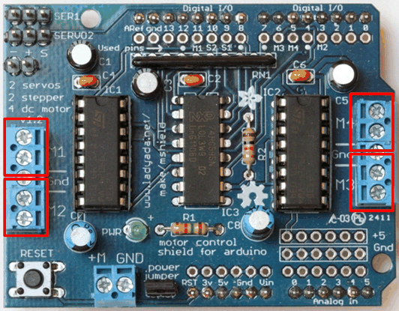

Fig4.3 A Motor Driver Shield.

**CHAPTER 5**

**COMPONENTS USED**

List of all the components used in building the Automated home-waste separator is given below with some general specifications:-

|  |  |  |
| --- | --- | --- |
| **SENSORS AND ACTUATORS USED** | **SPECIFICATIONS** | **COSTING(IN RS)** |
| IR SENSOR | RANGE: 1-5cm  I/P VTG: 5V  DIGITAL O/P | 50 |
| METAL PROXIMITY SENSOR | RANGE: 1-3cm  I/P VTG: 5V  ANALOG OUTPUT | 370 |
| CAPACITIVE SENSING MODULE | I/P VTG: 5V  ANALOG O/P | 390 |
| SERVO MOTORS | I/P VTG: 5V  360° ROTATION  LOADCAPACITY: UPTO 1KG. | 350 |
| DC MOTOR | I/P VTG: 12V  RPM: 300 | 150 |

**5.1 IR SENSOR**

**5.1.1General Description**

The IR Sensor-Single is a general purpose proximity sensor. Here we use it for collision detection. The module consists of a IR emitter and IR receiver pair. The high precision IR receiver always detects an IR signal. The module consists of 358 comparator IC. The output of sensor is high whenever it IR frequency and low otherwise. The on-board LED indicator helps user to check status of the sensor without using any additional hardware. The power consumption of this module is low. It gives a digital output.[10]



Fig5.1 Top view of IR sensor module

**5.1.2 Pin Configuration**

The figure is a top view of the IR Sensor module. The following table gives its pin description:

|  |  |  |
| --- | --- | --- |
| Pin No. | Connection | Description |
| 1. | Output | Digital output(high or low) |
| 2. | VCC | Connected to circuit supply |
| 3. | Ground | Connected to circuit ground |

**5.1.3 Schematic diagram**

The schematic diagram for an IR sensor is shown below:

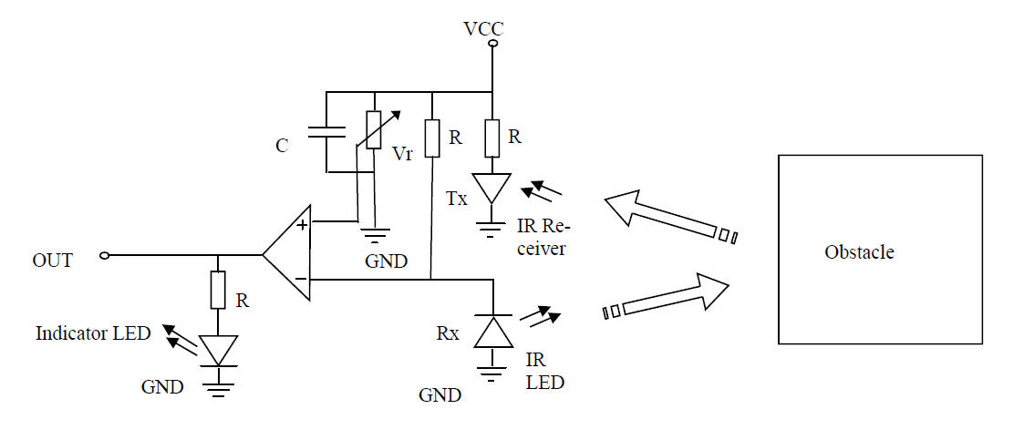

Fig5.2 Schematic of IR sensor

**5.1.4 Overview of schematic**

The sensitivity of the IR Sensor is tuned using the potentiometer. The potentiometer is tuneable in both the directions. Initially tune the potentiometer in clockwise direction such that the Indicator LED starts glowing. Once that is achieved, turn the potentiometer just enough in anti-clockwise direction to turn off the Indicator LED. At this point the sensitivity of the receiver is maximum. Thus, its sensing distance is maximum at this point. If the sensing distance (i.e., Sensitivity) of the receiver is needed to be reduced, then one can tune the potentiometer in the anti-clockwise direction from this point.

Further, if the orientation of both Tx and Rx LED’s is parallel to each other, such that both are facing outwards, then their sensitivity is maximum. If they are moved away from each other, such that they are inclined to each other at their soldered end, then their sensitivity reduces.

Tuned sensitivity of the sensors is limited to the surroundings. Once tuned for a particular surrounding, they will work perfectly until the IR illumination conditions of that region nearly constant. For example, if the potentiometer is tuned inside room/building for maximum sensitivity and then taken out in open sunlight, it will require retuning, since sun’s rays also contain Infrared (IR) frequencies, thus acting as a IR source (transmitter). This will disturb the receiver’s sensing capacity. Hence it needs to be returned to work perfectly in the new surroundings.

The output of IR receiver goes low when it receives IR signal. Hence the output pin is normally low because, though the IR LED is continuously transmitting, due to no obstacle, nothing is reflected back to the IR receiver. The indication LED is off. When an obstacle is encountered, the output of IR receiver goes low, IR signal is reflected from the obstacle surface. This drives the output of the comparator low. This output is connected to the cathode of the LED, which then turns ON.

**5.1.5 Maximum Ratings**

|  |  |  |  |  |  |
| --- | --- | --- | --- | --- | --- |
| SYMBOL | QUANTITY | MINIMUM | TYPICAL | MAXIMUM | UNIT |
| Output | Output Voltage | 0 | - | 5 | V |
| Vcc | Operating Voltage | 4.5 | 5 | 5.5 | V |
| Ground | Ground Reference  Voltage | - | 0 | - | V |

**5.1.6 Pin Out Dimensions**

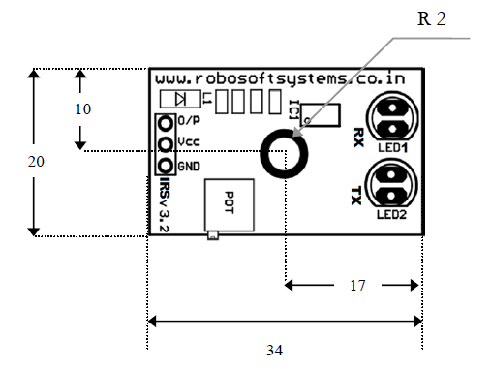

Fig5.3 Pin out dimensions

**Note** :All dimension in mm

Error of ±5% is subjected because of component soldering

**5.2 METAL PROXIMITY SENSOR**

**5.2.1 Operating Principle**

An inductive proximity sensor is solely for the detection of metal objects. It basically comprises an oscillator whose windings constitute the sensing face. An alternating magnetic field is generated in front of these windings.[10]

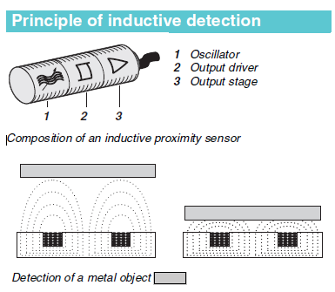

Fig5.4 Principle of Inductive Detection

**5.2.2 Inductive proximity detection**

Inductive proximity sensors enable the detection, without physical contact, of metal objects. Their range of applications is very extensive and includes:

1. Monitoring the position of machine parts (cams, end stops, etc.),
2. Counting the presence of metal objects, etc.

Advantages of inductive detection:

1. No physical contact with the object to be detected, thus avoiding wear and enabling detection of fragile objects, freshly painted objects, etc.
2. High operating rates. Fast response.
3. Excellent resistance to industrial environments (robust products, fully encapsulated in resin).
4. Solid-state technology: no moving parts, therefore service life of sensor not related to number of operating cycles.

**5.2.3 Osiconcept**

Osiconcept sensors are suitable for all metal environments (flush mountable or non flush mountable) since they ensure a maximum sensing distance, even if there is a metal background. Precise detection of the position of the object can be obtained using the teach mode.

Other advantages of Osiconcept:

1. Increased performance:
   * sensing distance guaranteed and optimized irrespective of the mounting configuration, the object, the environment or the background,
   * suitable for all metal environments.
2. Simplified use provided by:
   * the Osiconcept technology associated with the availability of the flattest, most compact sensors on the market ensuring that the sensor is fully built into the machine, thereby limiting risks of mechanical damage,
   * mechanical adjustments being eliminated through the use of the teach mode.
3. Lower costs due to:
   * adjustment times and complex supports being eliminated,
   * the elimination of flush mountable and non flush mountable versions which halves the number of references,
   * much easier and much quicker product selection.

**5.2.4 Output LED**

All inductive proximity sensors incorporate an output state LED indicator.[6]

Osiconcept sensors are fitted with a green LED that indicates “Power on” and also assists the user during setting-up (teach mode).

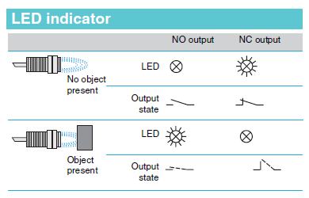

Fig5.5 LED Indicator

**5.2.5 Definitions**

The standard IEC 60947-5-2 defines various sensing distances, such as:

1. Nominal sensing distance (Sn):

The rated operating distance for which the sensor is designed. It does not take into account any variations (manufacturing tolerances, temperature, voltage).

2.Real sensing distance (Sr):

The real sensing distance is measured at the rated voltage (Un) and the rated ambient temperature (Tn). It must be between 90% and 110% of the nominal sensing distance (Sn): 0.9 Sn ≤ Sr ≤ 1.1 Sn.

3. Usable sensing distance (Su):

The usable sensing distance is measured at the limits of the permissible variations in the ambient temperature (Ta) and the supply voltage (Ub). It must be between 90% and 110% of the real sensing distance: 0.9 Sr ≤ Su ≤ 1.1 Sr.

4. Assured sensing distance (Sa):

This is the operating zone of the sensor. The assured operating distance is between 0 and 81% of the nominal sensing distance (Sn): 0 ≤Sa ≤ 0.9 x 0.9 x Sn

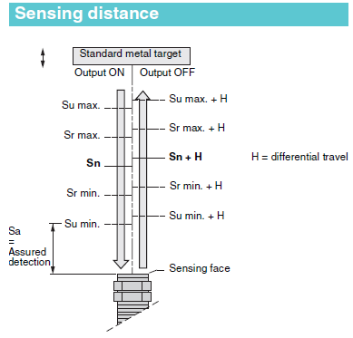

Fig 5.6 Sensing Distance

**5.2.6 Detection zone and precision adjustment zone**

By using sensitivity adjustment in teach mode, **Osi**concept proximity sensors enable the position of an object to be detected as it approaches from the front or side. The teach mode can be used when the object is located in the zone known as the “precision adjustment zone”. When the object approaches from the front, the detection zone of the object ranges from the stored position down to zero.

The diagram depicting the object detection zone is shown below-

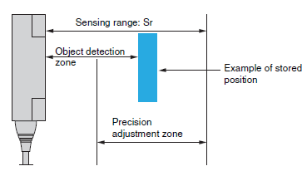

Fig 5.7 Object Detection Zone

**5.2.7 Operating zone**

The operating zone relates to the area in front of the sensing face in which the detection of a metal object is certain. The values stated in the characteristics relating to the various types of sensor are for steel objects of a size equal to the sensing face of the sensor. For objects of a different nature (smaller than the sensing face of the sensor, other metals, etc.), it is necessary to apply a correction coefficient.

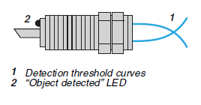

Fig 5.8 Operating Zone

**5.2.8. Types**

Here we are using a 3-wire type , NO or NC output, PNP or NPN

* Specific aspects

These sensors comprise 2 wires for the d.c. supply and a 3rd wire for the output signal,

- PNP type: switching the positive side to the load,

- NPN type: switching the negative side to the load.

* Advantages

-Protection against supply reverse polarity,

- Protection against overload and short-circuit,

- No residual current, low voltage drop.

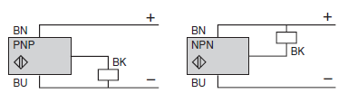

Fig5.9 3-Wire type

Some of the other commonly used types are:

1. 2-wire type c, non polarised NO or NC output

* Specific aspects:

These sensors are wired in series with the load to be switched. As a consequence, they are subject to:

- a residual current in the open state (current flowing through the sensor in the “open” state),

- a voltage drop in the closed state (voltage drop across the sensor’s terminals in the “closed” state).

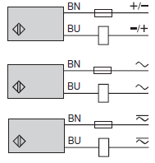

Fig 5.10 2-Wire type

* Advantages

- Only 2 leads to be wired: these sensors can be wired in series in the same way as mechanical limit switches,

- They can be connected to either positive (PNP) or negative (NPN) logic PLC inputs,

- No risk of incorrect connections.

* Operating precautions

- Check the possible effects of residual current and voltage drop on the actuator or input connected,

- For sensors that do not have overload and short-circuit protection (a.c. or a.c./d.c. symbol), it is essential to connect a 0.4 A “quick-blow” fuse in series with the load.

2.4-wire type, complementary outputs NO and NC outputs, PNP or NPN

* Advantages

- Protection against supply reverse polarity (+/-).

- Protection against overload and short-circuit.

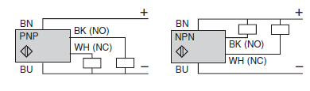

Fig 5.11 4-Wire type

**5.3 CAPACITIVE SENSORS**

**5.3.1 What is capacitance?**

Capacitance is the ability of a body to store an electrical charge. A material with a large capacitance holds more electric charge at a given voltage, than one with low capacitance. Any object that can be electrically charged exhibits capacitance, however the concept is particularly important for understanding the operations of the capacitor, one of the three fundamental electronic components (along with resistors and inductors). The SI unit of capacitance is the farad (symbol: F), named after the English physicist Michael Faraday. A 1 farad capacitor, when charged with 1 coulomb of electrical charge, has a potential difference of 1 volt between its plates.

**5.3.2 What is a capacitor?**

A common form is a parallel-plate [capacitor](https://en.wikipedia.org/wiki/Capacitor) [8][9], which consists of two conductive plates insulated from each other, usually sandwiching a [dielectric](https://en.wikipedia.org/wiki/Dielectric) material. In a parallel plate capacitor, capacitance is directly proportional to the surface area of the conductor plates and inversely proportional to the separation distance between the plates. If the charges on the plates are +*q* and −*q*, and *V* gives the [voltage](https://en.wikipedia.org/wiki/Voltage) between the plates, then the capacitance *C* is given by

{\displaystyle C={\frac {q}{V}}.}

which gives the voltage/[current](https://en.wikipedia.org/wiki/Electric_current) relationship



The energy stored in a capacitor is found by integrating the work *W*:{\displaystyle I(t)=C{\frac {\mathrm {d} V(t)}{\mathrm {d} t}}.}



**5.3.3 Capacitive Moisture Sensor**

Technologies commonly used to indirectly measure volumetric water content include:

1. Frequency Domain Reflectometry (FDR): The dielectric constant of a certain volume element around the sensor is obtained by measuring the operating frequency of an oscillating circuit.
2. Time Domain Transmission (TDT) and Time Domain Reflectometry (TDR): The dielectric constant of a certain volume element around the sensor is obtained by measuring the speed of propagation along a buried transmission line.
3. Neutron moisture gauges: The moderator properties of water for neutrons are utilized to estimate soil moisture content between a source and detector probe.
4. Galvanic cell: The amount of water present can be determined based on the voltage the soil produces because water acts as an electrolyte and produces electricity. The technology behind this concept is the galvanic cell.

Here for constructing the capacitive module we have used a basic moisture sensor.

**5.3.3.1 Moisture Sensor**

There are two types of moisture sensors:

1. Frequency Domain Sensor: it has an oscillating circuit. It measures the water content by measuring the dielectric constant, which determines the velocity of an electromagnetic wave or pulse through the ambient. When the ambient’s water content increases, the dielectric also increases which can be used to estimate how much water the ambient holds.

2. Neutron Moisture Gauge: it utilizes the moderator properties of water for neutrons. The principle is that fast neutrons are emitted from decaying radioactive source, and when they collide with particles having the same mass as a neutron(i.e. protons H+), they slow down dramatically. Because the main source of hydrogen is water, measuring the density of slowed down neutrons around the probe can estimate the volume fraction of water content the ambient holds

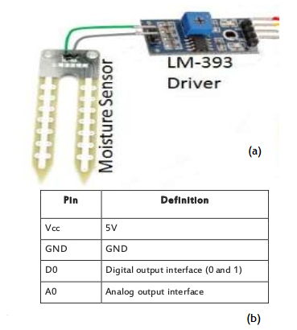

Fig 6.12 (a )Moisture sensor with LM-393

(b) pin description

**5.3.4. Relevance of moisture sensor in capacitive module**

1. Moisture module is most sensitive to the ambient humidity is generally used to detect the moisture content of the soil.
2. We are using this phenomenon to sense the change in moisture content of various types of wastes such as cardboard, paper, plastic, or wet kitchen waste.
3. Module in the ambient moisture less than a set threshold value when the DO port output high, when the ambient moisture exceeds the threshold value is set, the module D0 output low.
4. Small plates digital outputs D0 can be directly connected with the microcontroller, to detect high and low, and thus to detect different waste’s moisture content;
5. Small plates analog output AO and AD module connected through the AD converter, you can get more accurate values of ambient moisture.

Table 5.1 Capacitive value ranges for soil

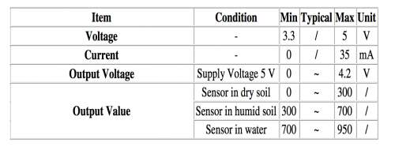

Consider the table shown above. These values were referenced and cross referenced and we deduced that a similar table could be produces for different wastes (dry and wet) with a similar value range.

Table 5.2 Capacitive value ranges for waste

|  |  |  |  |  |  |
| --- | --- | --- | --- | --- | --- |
| Item | Condition | Min | Typical | Max | Unit |
| Voltage | - | 3.3 | / | 5 | V |
| Current | - | 0 | / | 35 | Ma |
| Output Voltage | Supply Vtg 5V | 0 | ~ | 4.2 | V |
| Output Value | in dry waste  in wet waste | 300  700 | ~  ~ | 700  950 | /  / |

**5.3.5 LM-393**

LM-393 is used along with the capacitance moisture sensor for providing comparative values to the arduino board.

**Low Offset Voltage Dual Comparators**

The LM393 series are dual independent precision voltage comparators capable of single or split supply operation. These devices are designed to permit a common mode range−to−ground level with single supply operation. Input offset voltage specifications as low as 2.0 mV make this device an excellent selection for many applications in consumer, automotive, and industrial electronics.

Features:

* 1. Wide Single−Supply Range: 2.0 Vdc to 36 Vdc
  2. Split−Supply Range: ±1.0 Vdc to ±18 Vdc
  3. Very Low Current Drain Independent of Supply Voltage: 0.4 mA
  4. Low Input Bias Current: 25 nA • Low Input Offset Current: 5.0 nA
  5. Low Input Offset Voltage: 5.0 mV (max) LM293/393
  6. Input Common Mode Range to Ground Level
  7. Differential Input Voltage Range Equal to Power Supply Voltage
  8. Output Voltage Compatible with DTL, ECL, TTL, MOS, and CMOS Logic Levels
  9. ESD Clamps on the Inputs Increase the Ruggedness of the Device without Affecting Performance
  10. NCV Prefix for Automotive and Other Applications Requiring Unique Site and Control Change Requirements; AEC−Q100 Qualified and PPAP Capable
  11. These Devices are Pb−Free, Halogen Free/BFR Free and are RoHS Compliant.

The pin connections of the IC are shown below

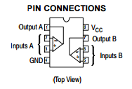

Fig 5.15 Pin Connections For LM-393

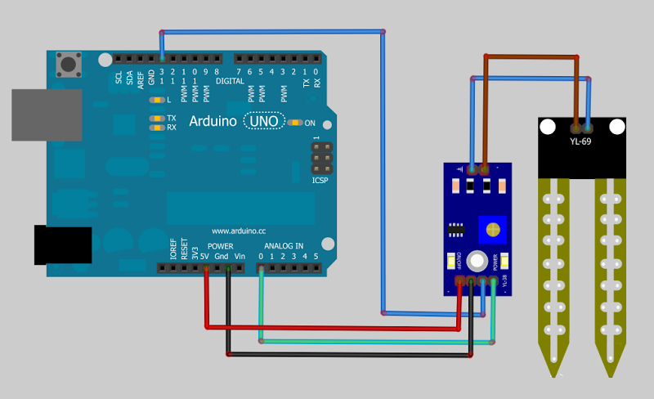 Fig 5.16 Connection of capacitive sensor to arduino board along with LM-393

**5.4 SERVO MOTOR**

The servo motor is actually an assembly of three parts: a normal DC motor, a gear reduction unit and a position-sensing device.

The function of the servo is to apply power drive to its DC motor until its shaft turns to the expected position. It uses the position-sensing device to determine the rotational position of the shaft, so that it knows which way the motor must turn to move the shaft to the commanded position.

The shaft typically does not rotate freely round and round like a DC motor, but rather can only turn around 200 degrees or so back and forth.[10]



Fig 5.17 Servo motor

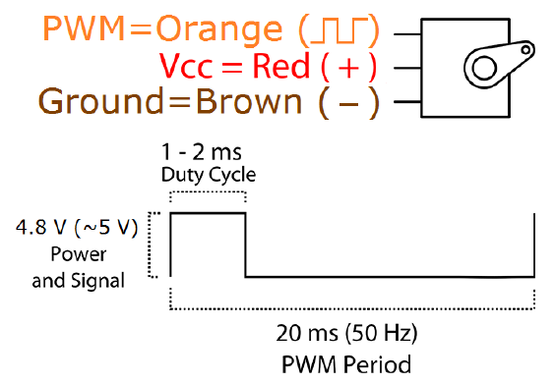

Fig 5.18 Connections of servo motor

Specifications of servo motor being used:

* 1. Weight: 9 g
  2. Dimension: 22.2 x 11.8 x 31 mm approx.
  3. Stall torque: 1.8 kgf·cm
  4. Operating speed: 0.1 s/60 degree
  5. Operating voltage: 4.8 V (~5V)
  6. Dead band width: 10 μs
  7. Temperature range: 0 ºC – 55 ºC

**5.5 DC MOTOR**

A **DC motor** is any of a class of electrical machines that converts direct current electrical power into mechanical power. The most common types rely on the forces produced by magnetic fields. Nearly all types of DC motors have some internal mechanism, either electromechanical or electronic, to periodically change the direction of current flow in part of the motor. Most types produce rotary motion; a linear motor directly produces force and motion in a straight line.[10]

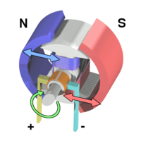

Fig 5.19 Workings of a brushed electric motor with a two-pole rotor (armature) and permanent magnet stator. "N" and "S" designate polarities on the inside axis faces of the [magnets](https://en.wikipedia.org/wiki/Magnet); the outside faces have opposite polarities. The **+** and **-** signs show where the DC current is applied to the [commutator](https://en.wikipedia.org/wiki/Commutator_(electric)) which supplies current to the [armature](https://en.wikipedia.org/wiki/Armature_(electrical_engineering)) coils

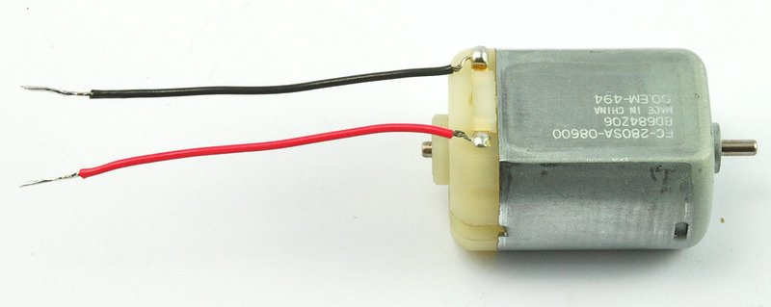

Fig 5.20 6V dc motor

DC motor 6/9V

Item Specification

Rated Voltage 6V DC

No load speed 12000±15%rpm

No load current ≤280mA

Operating voltage 1.5-6.5V DC

Starting Torque ≥250g.cm(according to ourself developed blade)

Starting current ≤5A

Insulation Resistance above 10Ω between the case and the terminal

Rotation Direction CW:[+]terminal connected to the positive power

supply, [-]terminal connected to negative

power,clockwise is deemed by the direction of the

output shaft

shaft gap 0.05-0.35mm

**CHAPTER 6**

**ALGORITHM, FLOWCHART AND PROGRAM LAYOUT**

**6.1 ALGORITHM**

The algorithm followed in the construction of program logic is:

**Step 1:** Start

**Step 2**: Waste input detected by IR sensor.

**Step 3**: Waste input to Capacitive moisture sensor module for checking whether the waste is dry or wet.

**Step 4**: If the waste is wet, the DC motor rotates the disk clockwise. Flap opens and the waste gets dumped into its respective bin.

**Step 5**:.If the waste detected is dry, it is sent to inductive metal proximity sensor for checking whether it is metal or not.

**Step 6**: If it is a metallic waste, the flap opens and the metal waste falls into its respective bin.

**Step 7**: If the dry waste is not metal, The DC motor rotates the disk in anti-clockwise direction, and the flap opens. The dry waste gets dumped into its respective bin.

**Step 8**: Once the process is complete, goto **step 2**.

**Step 9**: End of algorithm.

**6.2 FLOWCHART**

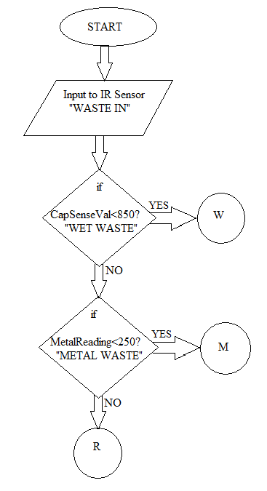

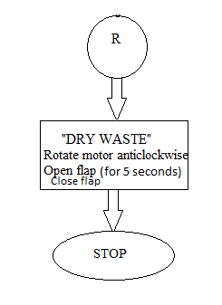

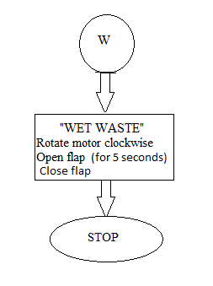

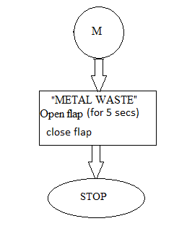

**6.3 PROGRAM LAYOUT**

#include<header file>

#include<header file>

Global variable declaration/initialization;

Function declaration;

void setup()

{

Statements;

}

void loop()

{

Statements;

}

Where setup() is the preparation, and loop() is the execution.

**CHAPTER 7**

**INTERFACING OF COMPONENTS WITH ARDUINO**

**7.1 IR Sensor Interfacing:**

The figures shown below show the interfacing of the IR sensor with the arduino board.

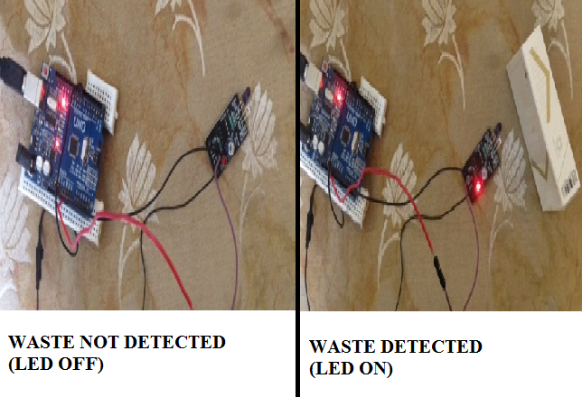

Fig 7.1: a) IR Sensor “OFF” when waste not detected

b) IR Sensor “ON” when waste detected.

The IR Sensor is interfaced with the Arduino Uno R3 board as shown in the figure above. The sensor gets it power input from thee Vcc pin of the arduino board and the output pin is connected to the digital pin 7 of the arduino board. When there is no waste in the proximity of the IR sensor, the LED of the sensor is in OFF state and the digital pin 7 of the arduino board remains low as shown in fig 7.1(a). Whereas when a waste substance is brought in proximity of the IR sensor, the LED of the sensor is turned ON and the digital pin 7 of the arduino board remains high as shown in fig 7.1(b).

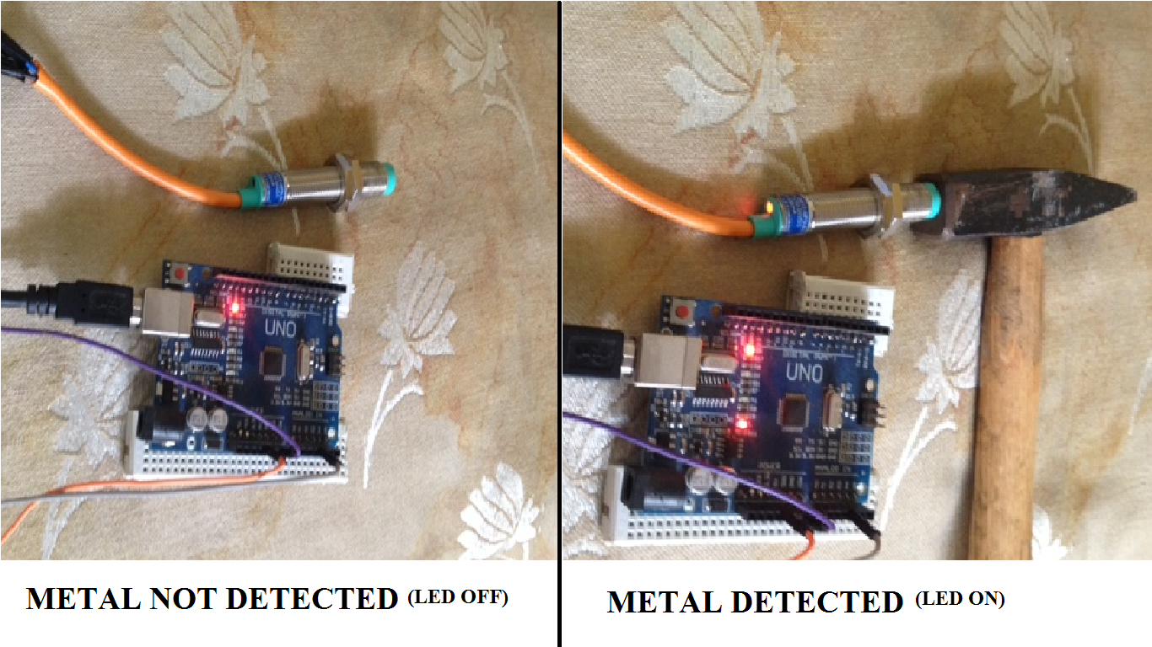**7.2 Interfacing Inductive Proximity Sensor**

Fig 7.2: a) Metal proximity sensor OFF when no metal in proximity.

b) Metal proximity sensor ON when metallic element in proximity.

The Metal proximity sensor is interfaced with the Arduino Uno R3 board as shown in the figure above. The sensor gets it power input from thee Vcc pin of the arduino board and the output pin is connected to the analog pin 3 of the arduino board. When there is no metal in the proximity of the metal proximity sensor, the LED of the sensor is in OFF state and the analog pin 3 of the arduino board remains low as shown in fig 7.1(a). Whereas when a metallic substance is brought in proximity of the metal proximity sensor, the LED of the sensor is turned ON and the analog pin 3 of the arduino board remains high as shown in fig 7.1(b).

**7.3 Interfacing Capacitive moisture Sensor**

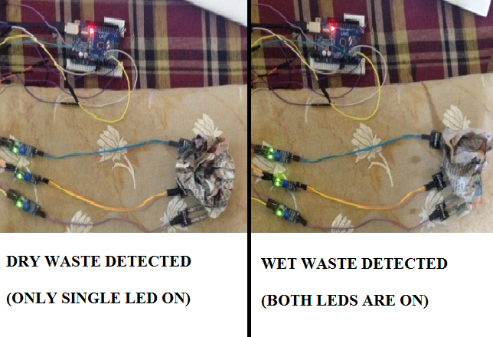

Fig 7.3: a) Capacitive moisture sensor with single LED ON when dry waste in proximity.

b) Capacitive moisture sensor with 2 LED’s ON when wet waste in proximity.

The Capacitive moisture sensors are interfaced with the Arduino Uno R3 board as shown in the figure above. The sensors gets it power input from thee Vcc pin of the arduino board and the output pin is connected to the analog pin 0, analog pin 1 and analog pin 2 of the arduino board respectively. When dry waste is in the proximity of the capacitive moisture sensor, only 1 LED of the sensor is in ON state as shown in Fig 7.3(a). Whereas when a wet waste is brought in proximity of the capacitive moisture sensor, both the LED’s of the sensor are turned ON as shown in Fig 7.3(b).

**7.4 OUTPUT DISPLAY**

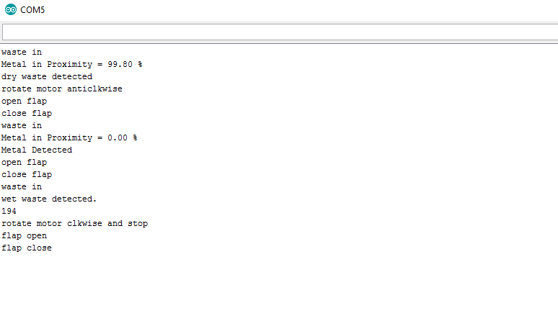

Fig 7.4 Serial Monitor Screenshot

The figure shown above shows how serial monitor in cases where the device was tested for dry waste, metallic waste and wet waste.

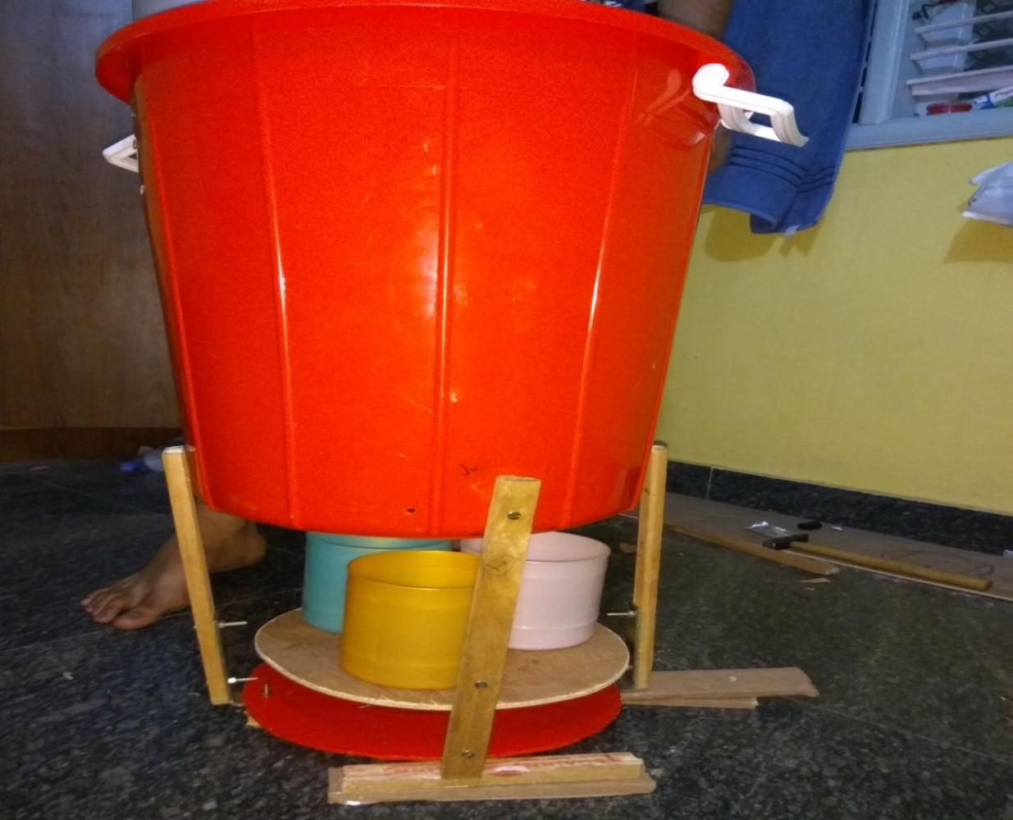**7.5 DEVICE PROTOTYPE**

Fig 7.5(a): Front view of the device

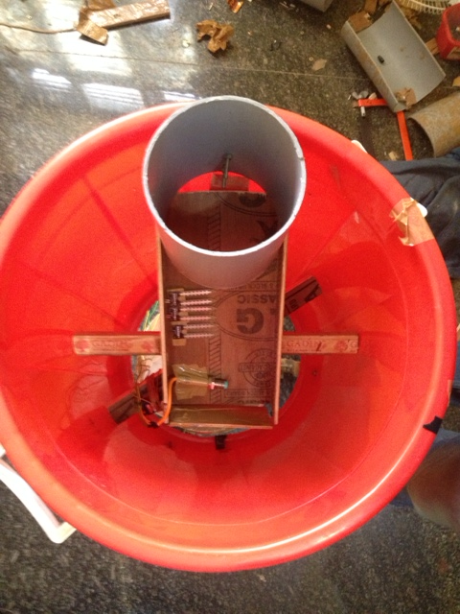

Fig 7.5(b): Top view of the device

**CHAPTER 8**

**APPLICATIONS AND FUTURE SCOPE**

**8.1 ADVANTAGES**

1. Simplifies the recycling process:

-By using the automated waste separator, we can separate waste into dry waste and metallic waste that can be further used as recyclable material such as paper, plastic, glass, metal cans and sheets, etc.

1. Biodegradable waste can be separated from no-biodegradable waste due to which dumping becomes easier.

-Wet waste such as fruit peels, vegetable peels, used tea leaves, left-over food, etc. Waste can be separated at the basic level by using the automated home-waste separator, which are biodegradable in nature.

- If this waste is put in a mud pit, then this biodegradable waste can be composted and used as manure.

1. Can be used efficiently in public places such as college/office campuses, hotels, railway stations, etc.

-The automated home waste separator is compact in nature and can be installed in places where the production of waste is very frequent. It is very advantageous to separate our waste at the basic household level.

1. Economical landfill use.[11]

-The use of automated home waste separator leads to the reduction of the landfill masses that are nowadays being generated or increased due to excess waste production.

1. Reduces land pollution

-By the use of the automated home waste separator there is a huge reduction in the land pollution and it also reduces the sources of land pollution which are mostly generated at the basic level .

6. Enables reuse of certain materials.

-Using automated home waste separator, certain materials can be obtained

which are still not degraded i.e. are in ample condition and can be reused again.

**8.2 LIMITATIONS**

1. Bulky in nature so it could pose a problem in limited spaces.

-The automated Home waste separator can be sometimes not enough to fit in certain places due to its bulky and complex size. It requires a considerable amount of space for installation.

1. In case of complex waste for example left over food thrown away in a plastic bag, it would be difficult for the device to judge the true nature of the waste since it cannot separate them.
2. Size of the waste must be less than or equal to the dimension of the opening.

-Due to the circular opening of the automated home waste separator the waste size must be according to the size of the opening so as to pass through the passage easily without any obstructions.

.

1. Sanitary waste and medical waste cannot be segregated by the proposed system as there are certain rules and regulations specified by government to be followed for their segregation.
2. It only separates one waste at a time.

-It is one of the major limitations of automated home waste separator, as it can separate only one kind of the waste at a time. With the help of different segregation techniques this can limitation can be overcome.

1. It cannot differentiate between different grades of plastics and glasses.

-The segregation between different grades or classes of plastics and glasses is not possible as it requires a very advanced technique to separate them due to their rare intrinsic physical and chemical property.

**8.3 APPLICATIONS**

1. It can be used in societies, offices, institutions and household areas.
2. It can be used at the places where events and functions on large scales are held, such as, hotels and banquet halls etc.
3. It can be used at airports and railway stations on a large scale.
4. It can be installed in transportations such as railways, flights and ships.

**8.4 FUTURE SCOPE**

1. Can be made to distinguish between different grades of glass and plastic which would enhance the recycling process and provide more efficiency
2. It can be made into a mobile unit which could be controlled with the help of an application or even navigational control
3. Inlet section can be incorporated with a crusher mechanism to reduce the size of the incoming waste.
4. Provisions can be made for on spot decomposition of wet waste.
5. GSM contraption to intimate to the nearest industry to use the metals collected.

**CONCLUSION**

In order to solve the growing problem of increasing waste disposal and land pollution, our team proposed a solution that could reduce this at the domestic level in the form of Automated home-waste separator. Our prototype of this Automated Home-Waste Separator has been successfully implemented for the separation of waste into metallic, dry and wet waste at a domestic level by using techniques such as metal proximity detection, capacitance modules and the ordered use of motors. However, it can face problem in classifying old dried biodegradable waste into wet waste due to lowered dielectric constant. Noise can be eliminated in the sensing module to increase accuracy and overall efficiency. The system can segregate only one type of waste at a time with an assigned priority for wet, metal and dry waste.

Thus, improvements can be made to segregate mixed type of waste by the use of buffer spaces, claw machines, integration of electromagnets etc. Since, the time for sensing metal objects is low the entire sensing module can be placed along a single platform where the object is stable to ensure better result.

This system can be integrated and brought to market level using higher end sensors, conveyor belts, more sensitive capacitive modules and more advanced segregation techniques. Such a device could be useful in public places such as parks, bus stands, railways, institutions etc.

**REFRENCES**

[1] Daniel Hoornweg et al., “WHAT A WASTE A Global Review of Solid Waste Management”, Urban Development & Local Government Unit World Bank, Washington, DC., No.15, Mar. 2012.

[2] Nishigandha Kothari ,”Waste to Wealth”, NSWAI, New Delhi, Jul. 2013

[3] Claudine Capel, “INNOVATIONS IN WASTE”, Waste-management-world, Volume 11, Issue 2, Mar 2010.

[4] J.S. Bajaj, “Urban Solid Waste management in India“, Planning Commission Government of India, NEW DELHI,1995

[5] Claudine Capel, “WASTE SORTING - A LOOK AT THE SEPARATION AND SORTING TECHNIQUES IN TODAY’S EUROPEAN MARKET ”, Waste-management-world, Volume 9, Issue 4, Jul 2008.

[6] LDC1000 Inductance to Digital Converter, Texas instruments, Dallas, TX,Sept 2013

[7] MSP430x2xx Family User's Guide, Texas instruments, Dallas, Tx, Dec 2004–Revised Jul 2013

[8] “Relative Dielectric constant ℇr(dk value) of liquids and solid materials”, Endress Hauser, Weil am Rhein, Baden-Württemberg, 2000

[9] M.S. Venkatesh et al., “An Overview of Microwave Processing and Dielectric Properties of Agri-food Materials”, Biosystems Engineering (2004) 88 (1)

[10] Automated Waste Segregator, Amrutha Chandramohan, Joyal Mendonca, Nikhil Ravi Shankar, Nikhil U Baheti, Nitin Kumar Krishnan,Suma M S

[11] De Feo, G.; Napoli, R.M.A. New and old paradigms on production and management of municipal solid waste. In Proceedings of Sardinia 2005, Tenth International Waste Management and Landfill Symposium, Cagliari, Italy, 3–7 October 2005; CISA: Cagliari, Italy, 2005.

[12] Ayres, R.U; Simonis, U.E. Industrial Metabolism: Restructuring for Sustainable Development, 1st ed.; United Nations University Press: Tokyo, Japan, 1994.

[13] Fischer-Kowalski, M.; Haberl, H. Metabolism and colonisation. Modes of production and the physical exchange between societes and nature. Innov. Soc. Sci. Res. 2003, 6, 415-442.

[14] Zamorano, M.; Molero, E.; Grindlay, A.; Rodríguez, M.L.; Hurtado, A.; Calvo, F.J. A planning scenario for the application of geographical information systems in municipal waste collection: A case of Churriana de la Vega (Granada, Spain). Resour. Conserv. Recy. 2009, 54, 123-133.

[15] Bovea, M.D.; Ibáñez-Forés, V.; Gallardo, A.; Colomer-Mendoza, F.J. Environmental assessment of alternative municipal solid waste management strategies. A Spanish case study. Waste Manage. 2010, (in press).

[16] Seadon, J.K. Integrated waste management—Looking beyond the solid waste horizon. Waste Manage. 2006, 26, 1327-1336.

[17] Hong, S. The effects of unit pricing system upon household solid waste management: The Korean experience. J. Environ. Manage. 1999, 57, 1-10.

[18] Choe, C.; Fraser, I. An Economic Analysis of Household Waste Management. J. Environ. Econ. Manag. 1999