DEVOPS

**Simple Fibonacci Number Calculation webpage using LAMP stack in VirtualBox**

**INTRODUCTION:**

This project involves creating a Fibonacci Number Calculation webpage using PHP on a LAMP stack (Linux, Apache, MySQL, PHP). The tool allows users to input a number, and it will display the Fibonacci sequence up to that number. This project provides an interactive way to learn and apply web development concepts, running on a virtual machine set up in VirtualBox. It serves as a simple yet effective tool for both learning and practical use, helping users understand the concept of Fibonacci numbers in a fun and engaging way.

**PROCEDURE:**

**STEP 1: Create a New Virtual Machine in VirtualBox**

* Open Oracle VirtualBox and click on the "New" button to create a virtual machine.
* Name and OS Type: Name your VM (e.g., "ubuntu1"), set the type to Linux, and choose the version as Ubuntu (64-bit).
* Load the respective ISO Image

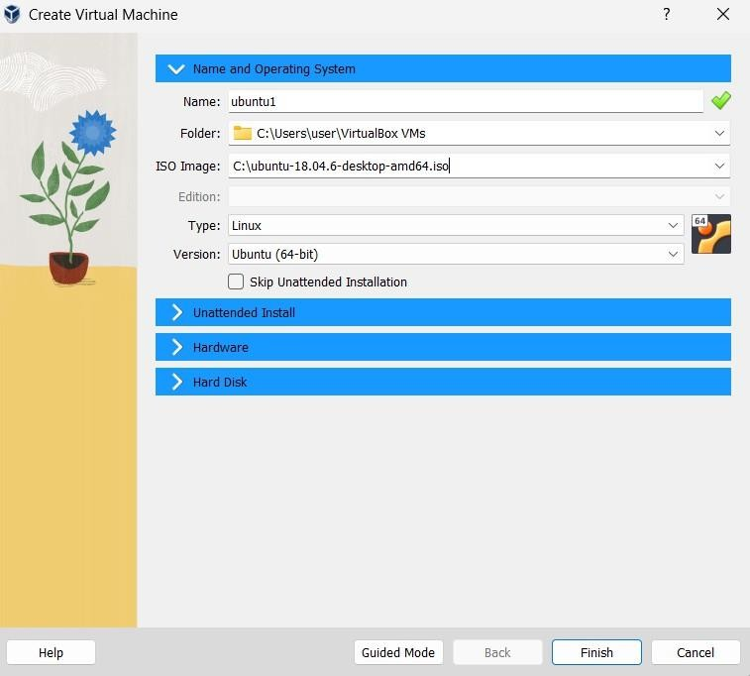

* Allocate at least 2 GB (2048 MB) of RAM to ensure smooth operation.

You can adjust this value based on your host machine's capacity.

* Assign at least 1 CPU core, though 2 or more are recommended for better performance.

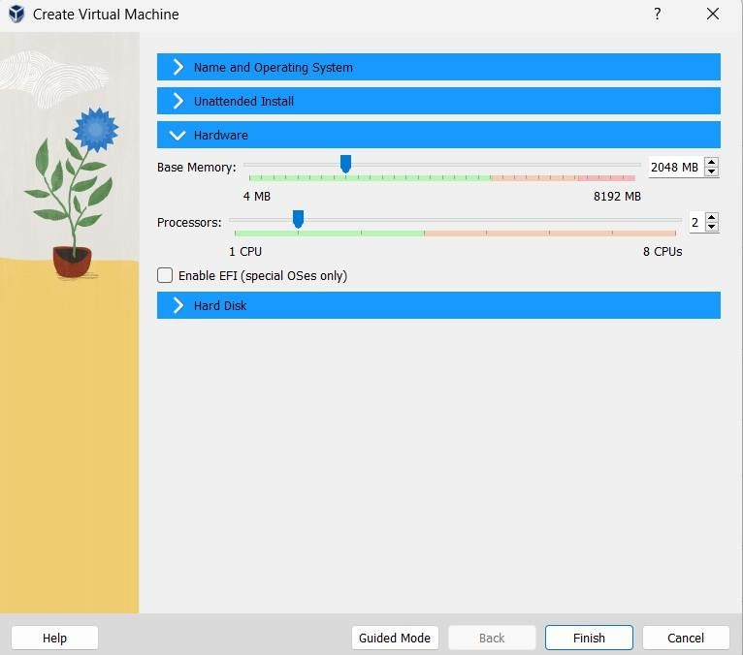

* Finally click on finish and install

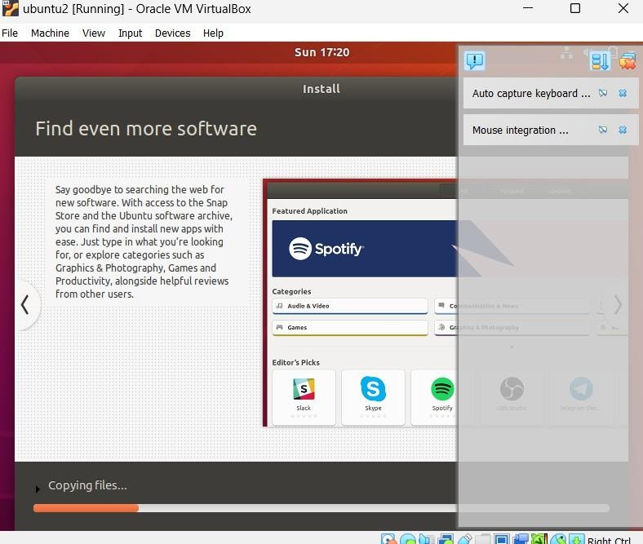

**STEP2:Log In to Ubuntu**

* Start your virtual machine in VirtualBox.
* Log in using the credentials (username and password) you created during the installation process.

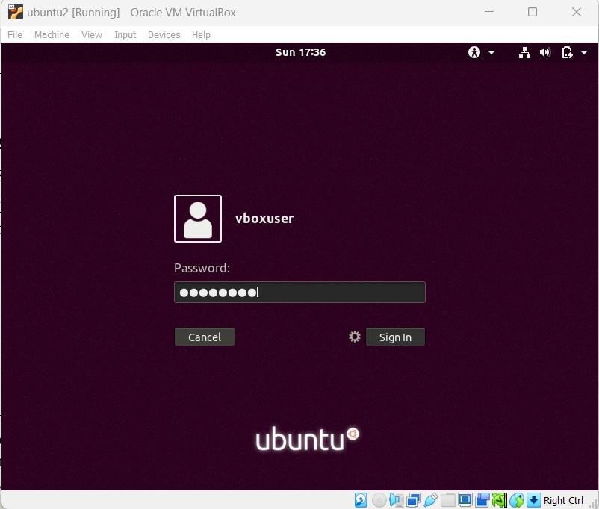

**STEP3:SWITCH TO ROOT**

* You can log in as the root user by switching to it in the terminal
* Use the correct password

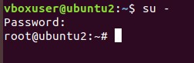

**STEP4:Update and Upgrade the System**

* **sudo apt update:** Updates the list of available packages.
* **sudo apt upgrade:** Installs the latest updates for all installed packages.**Update in progress**

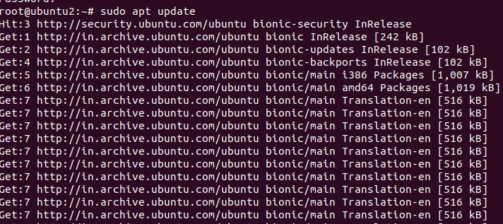

**Upgrade**

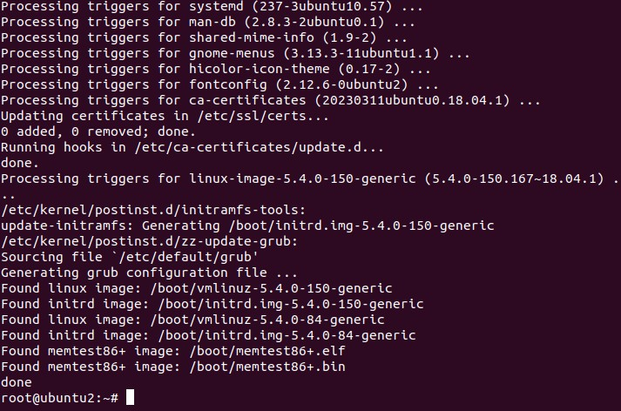

**STEP 5: Install Apache (web server):**

* sudo apt install apache2
* to check the version of apache2 use apache2 -v

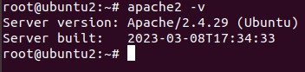

* to check the successful insatllation of apache open firefox and type localhost.The below page will be loaded

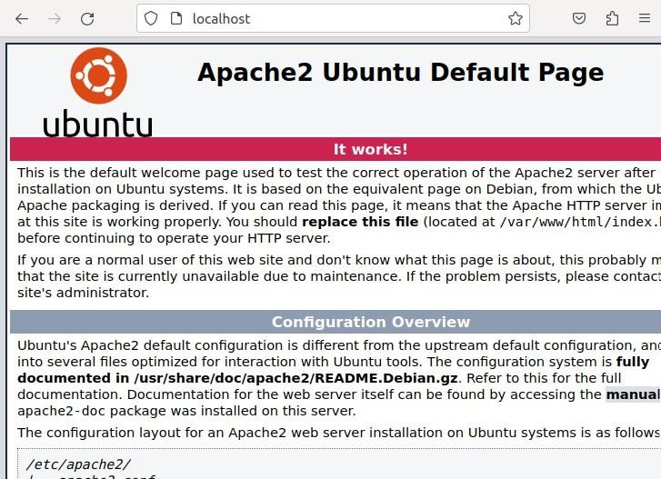

**STEP 7: Install MySQL (database server):** sudo apt install mysql-server

**STEP 8:Install PHP and required extensions:** sudo apt install php libapache2-mod-php php-mysql

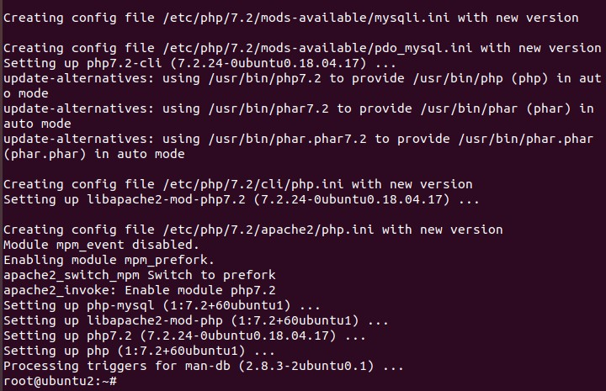

* to check the version oh php use php -v

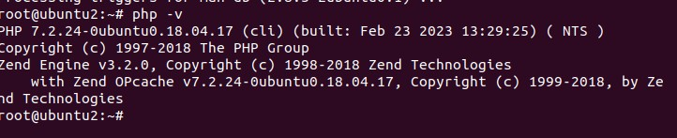

**STEP 9:Check if Apache is running:**

sudosystemctl status apache2

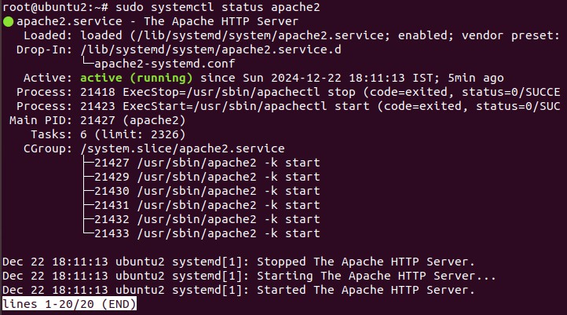

**STEP 10:Restart Apache:**

* sudosystemctl restart apache2

**STEP 11: To view network configuration details:**

* If ifconfig is not installed, you can install it with **sudo apt install net-tools**
* To view network configuration details: **ifconfig**

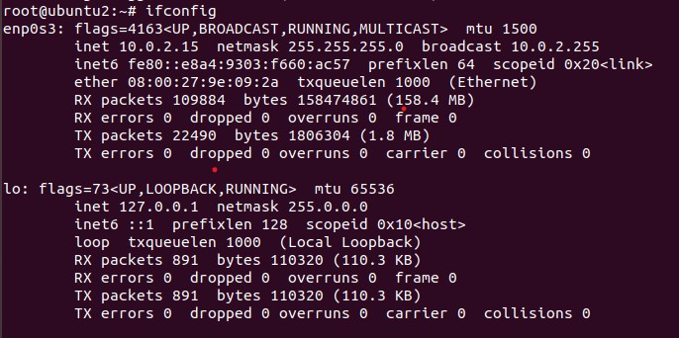

**STEP 12: Test PHP by creating a test file:**

* sudo vi /var/www/html/info.php

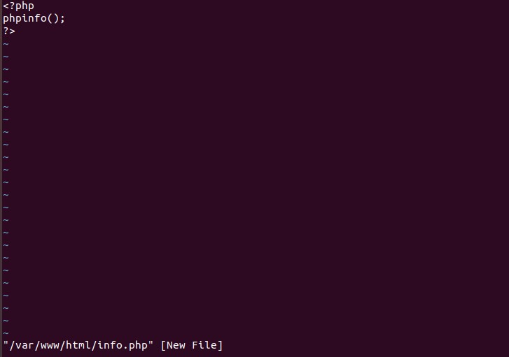

* To run the code in vi editor press esc key then :andwq ●Open a browser on your host machine and navigate to:
* http://<guest_IP>/info.php
* Use your system’s ip address instead of guest_ip
* You will the following screen as output

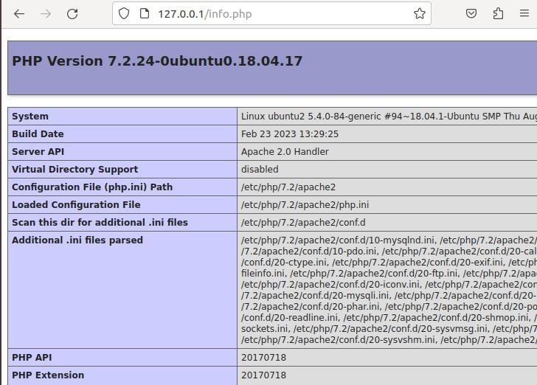

**STEP 13:Creating the Simple Interest Calculator Webpage**

* Create a new PHP file:
* sudo vi /var/www/html/leaf_not.php
* Type the code in this file

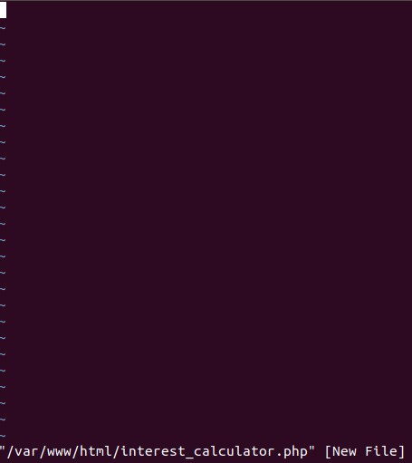

**CODE:**

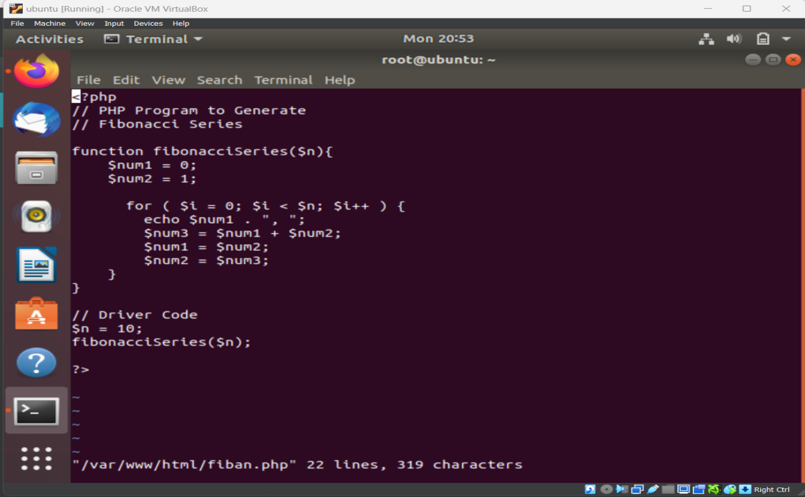

**OUTPUT:**

