

**BHARATI VIDYAPEETH’S**

**INSTITUTE OF COMPUTER APPLICATIONS & MANAGEMENT**

(Affiliated to Guru Gobind Singh Indraprastha University, Approved by AICTE, New Delhi)

**Object-Oriented Software Engineering**

**(MCA-164)**

**Practical File**

**Submitted To: Submitted By:**

Dr. Ritika Wason Deepak

(Enrolment No. -04335304421

(Associate Professor) MCA 2nd SEM SEC II

| AP1 | Create a Use Case Diagram for a Digital Sound Recorder with the following main features:   * The recorder stores up to 10 messages * Each message is max. 2 minutes long * The user can record message * Recording of a message ends after 2 minutes or when the user stops recording * Recording destroys the original message at chosen slot * Sufficient level of battery is checked before recording message * Message of a given slot can be replayed * Sufficient level of battery is checked before replaying message * Messages can be locked/unlocked * Locked messages cannot be deleted or over-written by recording to the same slot * User uses LCD display and buttons to interact with recorder |
| --- | --- |
| AP2 | Formulate use case descriptions for 5 major use cases identified in the digital sound recorder |
| AP3 | As the head of Information Technology at Acme Airlines, you are tasked with building a new booking system to replace the existing system. Acme needs a new system to allow employees to book ticket electronically and check the status of the booked tickets.  The new system will be state of the art and will have a Windows-based desktop interface to allow employees to enter booking details and view employee details. The system will run on individual employee desktops throughout the entire company. For reasons of security and auditing, employees can access only their data. The employees would only be able to view their information, and for any changes they would have to send an  E-Mail to the administrator. Administrator would only have the right to make any changes in the records.  For the cost being a factor Acme wants to use their old server with the existing database. The system will retain information on all employees in the company.  The administrator maintains employee information. He is responsible for adding new employees, deleting employees and changing all employee information such as name, address, and paycheck generation, as well as running administrative reports |
| AP4 | 1. Consider the following use-case of a travel agency.  Use-Case Name: Ticket Purchasing  Description:  1. The use-case begins when the customer calls the travel agency to ask it to issue a ticket that (s)he has booked.  2. The travel agency operator asks the customer to give his/her booking number.  3. The customer gives the booking number.  4. The operator types in the booking number and the flight reservation system displays the details of the reservation made.  5. The operator asks the customer to confirm the details of the reservation made.  5. The customer confirms the reservation made.  6. The operator asks the customer for a credit card number.  7. The customer gives his/her credit card number.  8. The operator types in the customer's credit card number and when the system confirms that the credit card transaction has been authorised (s)he asks the system to print the tickets, the details of the flights, and an invoice.  9. When the system confirms that the requested items have been printed, the operator informs the customer that the tickets have been issued.   Think of at least two alternative courses of events for this use-case. Describe the alternative courses as separate use-cases. Modify the description of the original use-case to make evident where exactly these alternative use-cases may be called and under which conditions. Create a use-case diagram to illustrate the relationships between the alternative use-cases and the use-case given. |
| BP1 | Create a Class Diagram for a Digital Sound Recorder with the following main features:   * The recorder stores up to 10 messages * Each message is max. 2 minutes long * The user can record message * Recording of a message ends after 2 minutes or when the user stops recording * Recording destroys the original message at chosen slot * Sufficient level of battery is checked before recording message * Message of a given slot can be replayed * Sufficient level of battery is checked before replaying message * Messages can be locked/unlocked * Locked messages cannot be deleted or over-written by recording to the same slot * User uses LCD display and buttons to interact with r |
| BP2 | Forward engineer the model obtained in BP1 to automatically generate equivalent Java stub Code? |

AP1**: Create a Use Case Diagram for a Digital Sound Recorder with the following main features:**

* **The recorder stores up to 10 messages**
* **Each message is max. 2 minutes long**
* **The user can record message**
* **Recording of a message ends after 2 minutes or when the user stops recording**
* **Recording destroys the original message at chosen slot**
* **Sufficient level of battery is checked before recording message**
* **Message of a given slot can be replayed**
* **Sufficient level of battery is checked before replaying message**
* **Messages can be locked/unlocked**
* **Locked messages cannot be deleted or over-written by recording to the same slot**
* **User uses LCD display and buttons to interact with recorder**

USE CASE DIAGRAM

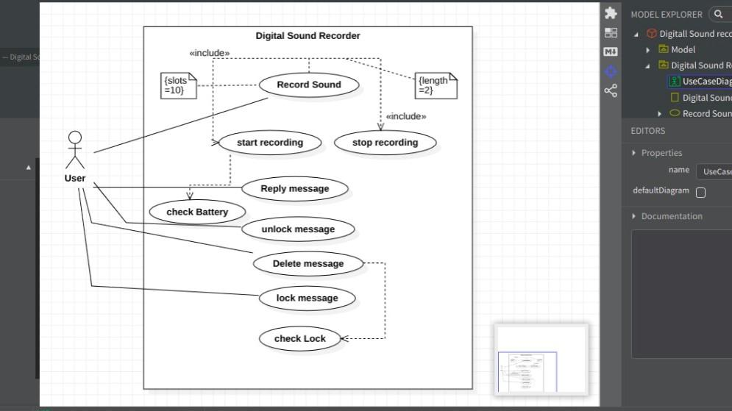

AP2 **: Formulate use case descriptions for 5 major use cases identified in the digital sound recorder.**

**ANSWER:**

**AP3:** As the head of Information Technology at Acme Airlines, you are tasked with building a new booking system to r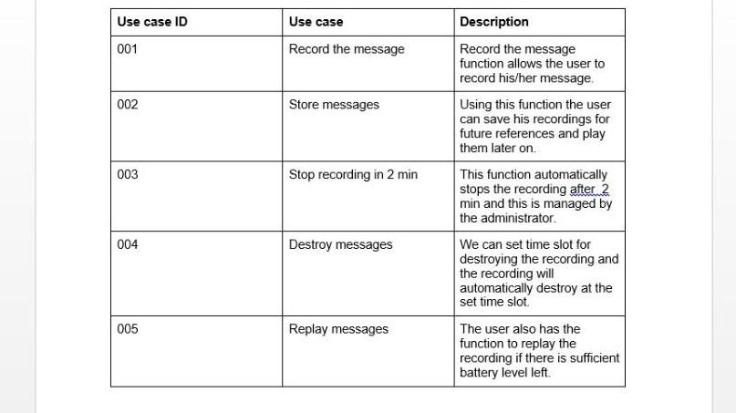eplace the existing system. Acme needs a new system to allow employees to book ticket electronically and check the status of the booked tickets.

The new system will be state of the art and will have a Windows-based desktop interface to allow employees to enter booking details and view employee details. The system will run on individual employee desktops throughout the entire company. For reasons of security and auditing, employees can access only their data. The employees would only be able to view their information, and for any changes they would have to send an

E-Mail to the administrator. Administrator would only have the right to make any changes in the records.

For the cost being a factor Acme wants to use their old server with the existing database. The system will retain information on all employees in the company.

The administrator maintains employee information. He is responsible for adding new employees, deleting employees and changing all employee information such as name, address, and paycheck generation, as well as running administrative reports

USE CASE DIAGRAM:

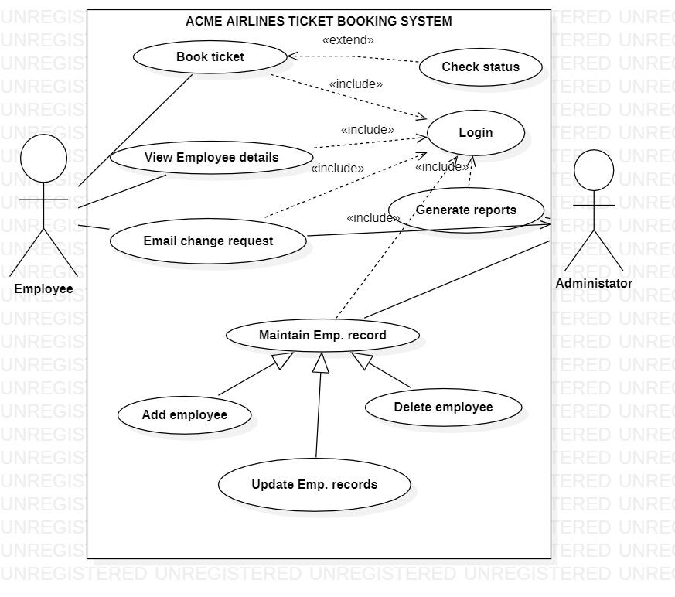

**AP4** 1.Consider the following use-case of a travel agency.   
Use-Case Name: Ticket Purchasing   
Description:   
1. The use-case begins when the customer calls the travel agency to ask it to issue a ticket that (s)he has booked.   
2. The travel agency operator asks the customer to give his/her booking number.   
3. The customer gives the booking number.   
4. The operator types in the booking number and the flight reservation system displays the details of the reservation made.   
5. The operator asks the customer to confirm the details of the reservation made.   
5. The customer confirms the reservation made.   
6. The operator asks the customer for a credit card number.   
7. The customer gives his/her credit card number.   
8. The operator types in the customer's credit card number and when the system confirms that the credit card transaction has been authorised (s)he asks the system to print the tickets, the details of the flights, and an invoice.   
9. When the system confirms that the requested items have been printed, the operator informs the customer that the tickets have been issued.   
  
Think of at least two alternative courses of events for this use-case. Describe the alternative courses as separate use-cases. Modify the description of the original use-case to make evident where exactly these alternative use-cases may be called and under which conditions. Create a use-case diagram to illustrate the relationships between the alternative use-cases and the use-case given.

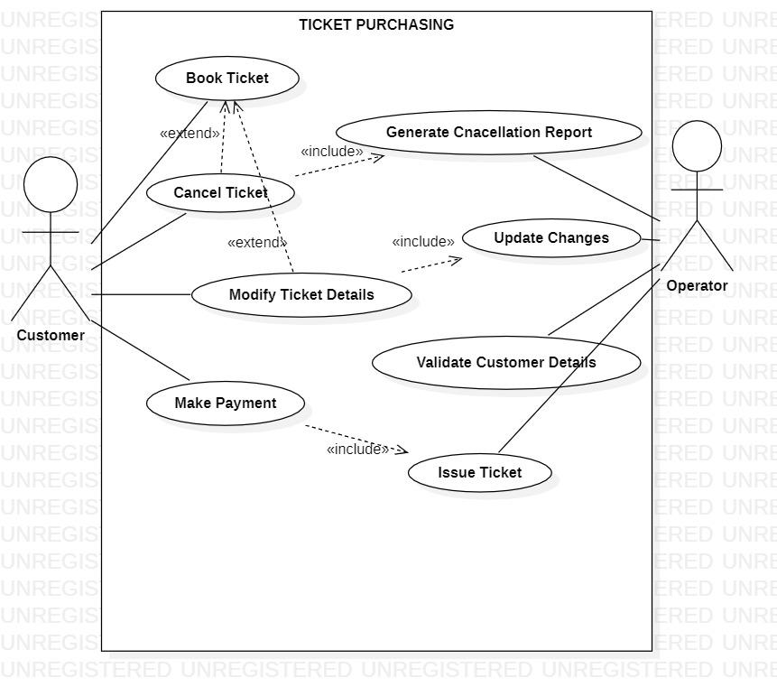

BP1.

Create a Class Diagram for a Digital Sound Recorder with the following main features:

* The recorder stores up to 10 messages
* Each message is max. 2 minutes long
* The user can record message
* Recording of a message ends after 2 minutes or when the user stops recording
* Recording destroys the original message at chosen slot
* Sufficient level of battery is checked before recording message
* Message of a given slot can be replayed
* Sufficient level of battery is checked before replaying message
* Messages can be locked/unlocked
* Locked messages cannot be deleted or over-written by recording to the same slot
* User uses LCD display and buttons to interact with r

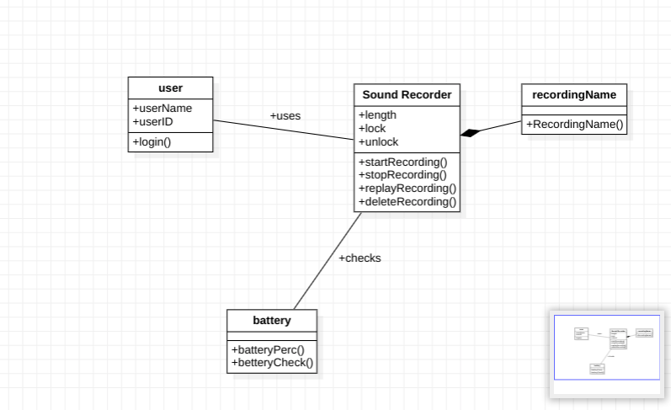

BP2.

Forward engineer the model obtained in BP1 to automatically generate equivalent Java stub Code?

user

import java.util.*;

/**

*

*/

public class user {

/**

* Default constructor

*/

public user() {

}

/**

*

*/

public void userName;

/**

*

*/

public void userID;

/**

*

*/

public void login() {

// TODO implement here

}

}

sound REcorder

import java.util.*;

/**

*

*/

public class Sound Recorder {

/**

* Default constructor

*/

public Sound Recorder() {

}

/**

*

*/

public void length;

/**

*

*/

public void lock;

/**

*

*/

public void unlock;

/**

*

*/

public void startRecording() {

// TODO implement here

}

/**

*

*/

public void stopRecording() {

// TODO implement here

}

/**

*

*/

public void replayRecording() {

// TODO implement here

}

/**

*

*/

public void deleteRecording() {

// TODO implement here

}

}

Recording name

import java.util.*;

/**

*

*/

public class recordingName {

/**

* Default constructor

*/

public recordingName() {

}

/**

*

*/

public void RecordingName() {

// TODO implement here

}

}

battery

import java.util.*;

/**

*

*/

public class battery {

/**

* Default constructor

*/

public battery() {

}

/**

*

*/

public void batteryPerc() {

// TODO implement here

}

/**

*

*/

public void betteryCheck() {

// TODO implement here

}

}