Supplemental Information

idPAD: Paper Analytical Device for Presumptive Identification of Illicit Drugs

Table of Contents
S1. idPAD Spotting Guide 2
S2. Blinded Study Sample Preparation 3
S3. Sample Application 10
S4. Light Box 10
S5. idPAD Blinded Study Reader 11
S6. Grading of Blinded Samples 12
S7. Blinded Study idPAD Images 19
S8. T-Testing of Lanes A-C Inverted Blue Color Intensity 49
S9. Heroin Standard idPAD 50
S10. Additional Color Bar Codes 50
S11. Characteristic Curves of Blinded Samples 52
S12. Grading of Adulterant, Cutting Agent and Drug Samples 54
S13. Adulterant, Cutting Agent, and Drug idPAD Images 56
S14. Stability Testing 68

S1. idPAD Spotting Guide
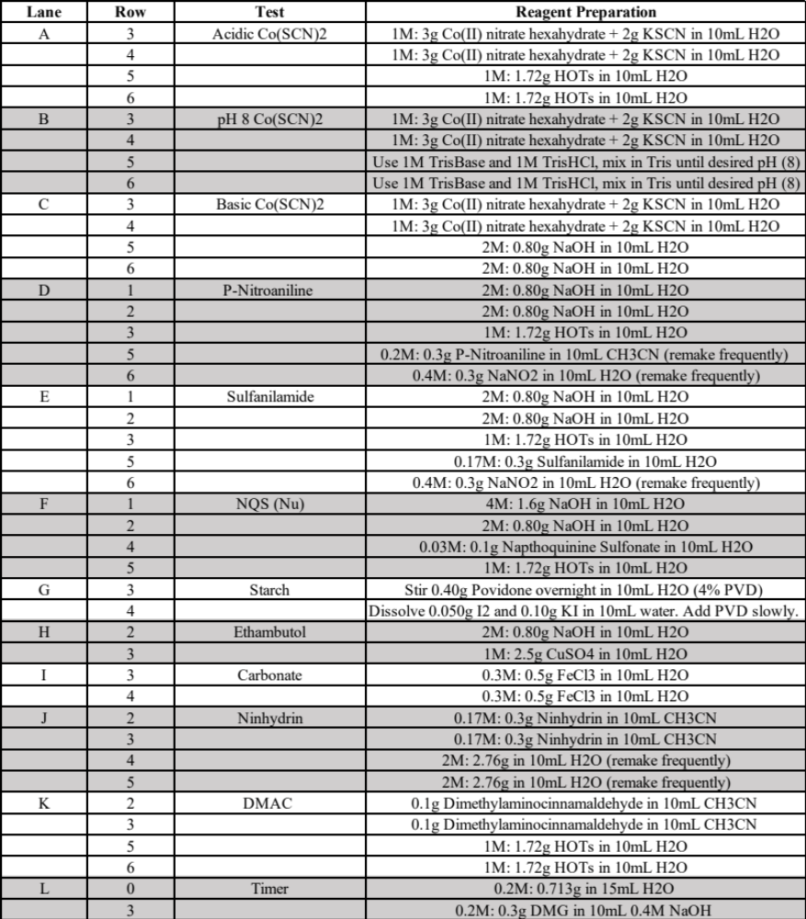

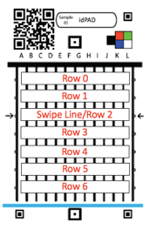

S2. Blinded Study Sample Preparation

Identity of street samples was confirmed with FTIR and in some cases, GC-MS. FTIR samples were ground with FTIR-grade KBr powder purchased from Alfa Aesar, 30 Bond Street, Ward Hill, MA 01835. Samples submitted for GC-MS were diluted in sufficient amount of a mixture of dichloromethane:methanol:n-propanol (8:1:1) all ASC-grade, filtered into ThermoScientific 12 x 32 mm (1.8 ml) clear glass vials with screw-top T/RR septa lids and injected with an auto sampler. The instrument is an Agilent 7890 with a 30-m Rxi-5MS column using Hydrogen as a carrier gas with a LECO Pegasus BT Time-of-Flight mass spectrometer detector.

FTIR scans of the compounds used in the blinded sample study can be found below. These scans were completed in accordance with the Berrien County Crime Lab procedures and identified using their stored and shared libraries.

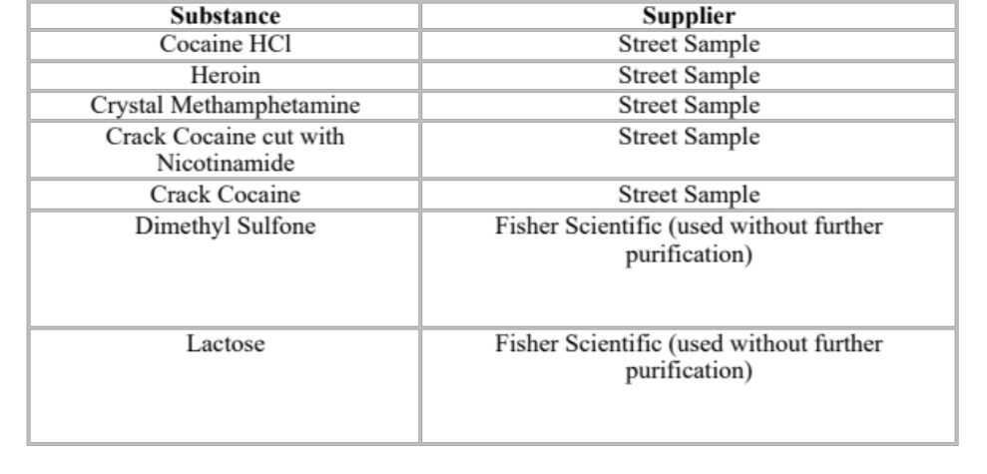

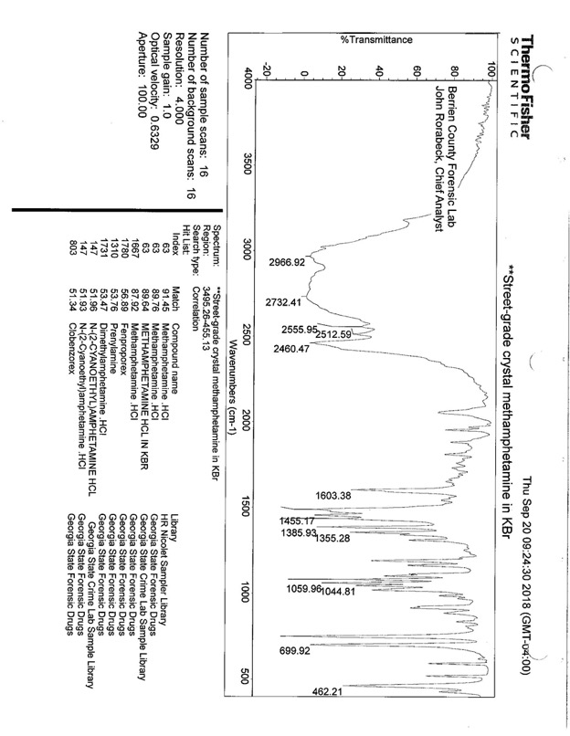
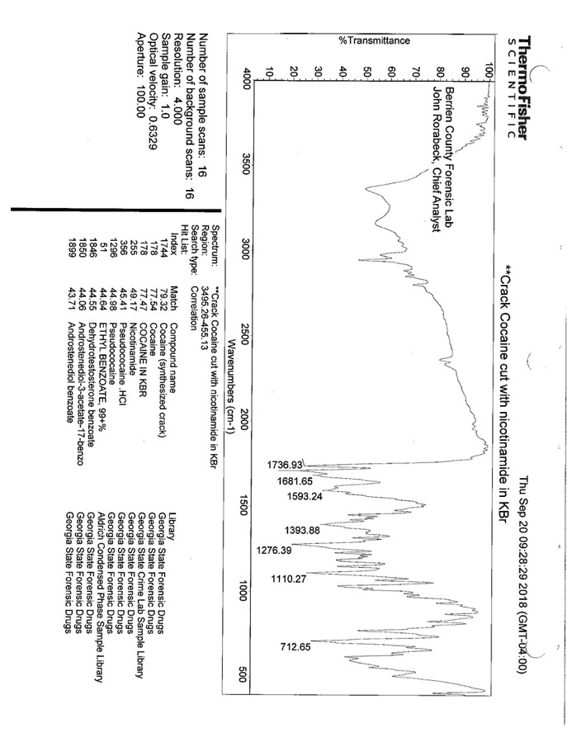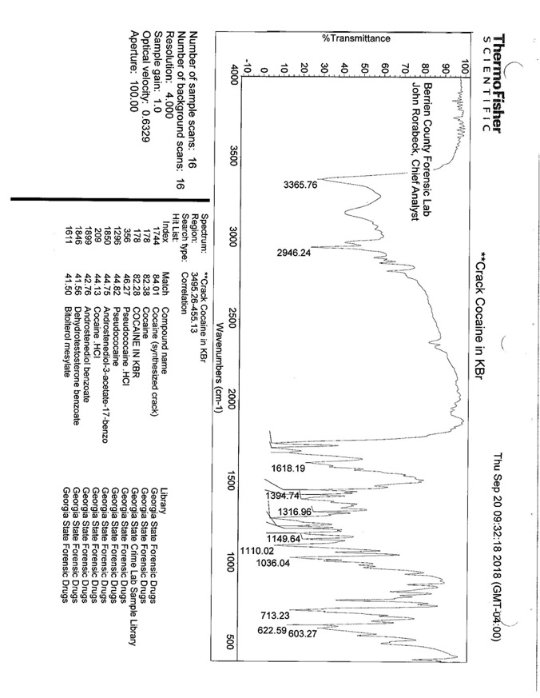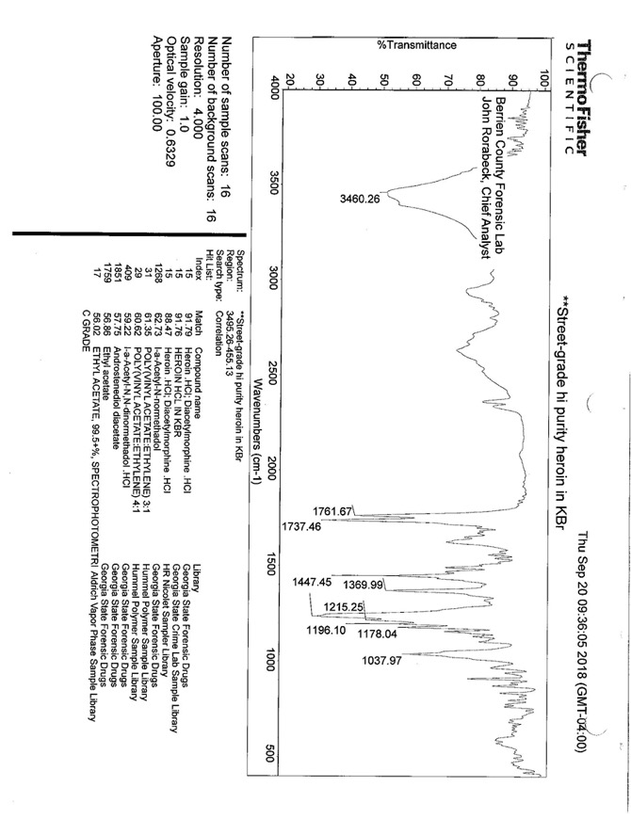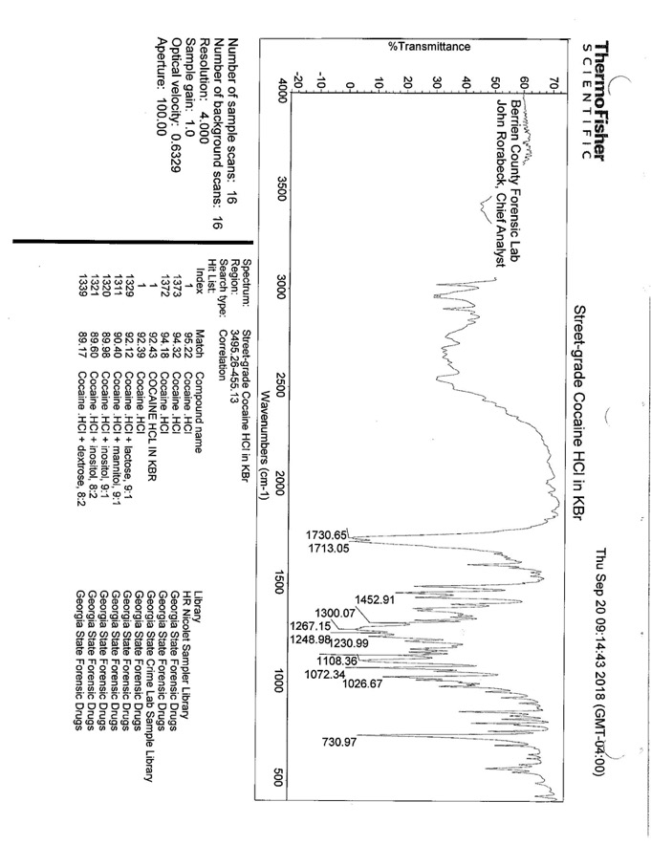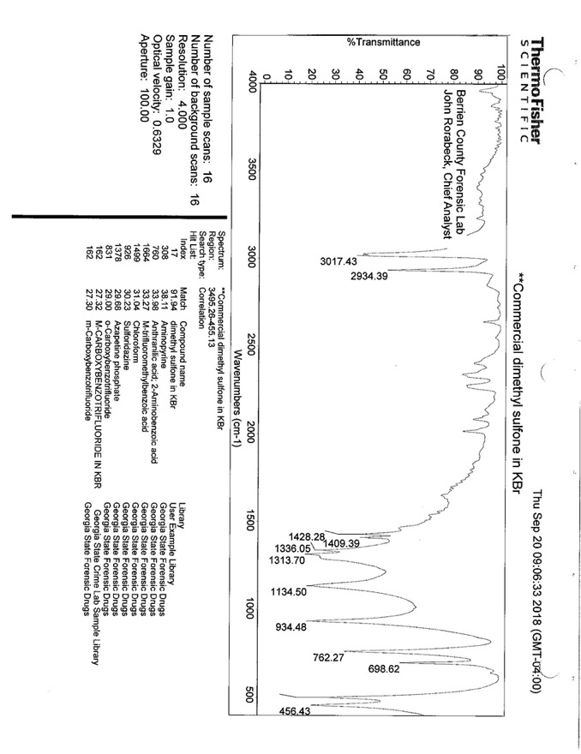

S3. Sample Application

Solid sample is applied to the idPAD using a bamboo stir stick. Multiple “swiping” passes across the 12 lanes are made to evenly distribute solid. 10-40mg of solid is recommended depending on the physical characteristics of the powder. The main source of color variability appears to be the reagent application process as these devices are made by hand. If the same volume of liquid reagent is not applied at the exact sample spot of each lane across the card, slight variability can be observed. This is most noticeable when the same reagents are stamped across all 12 lanes but is negligible on idPADs. It should also be noted that the idPAD is not quantitative and serves as a field presumptive test where additional lab analysis would be needed.

A subset of idPAD images is included below where all 12 lanes are of the same color test. As one can see, the color produced is quite consistent.
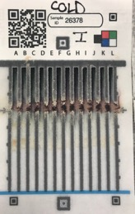
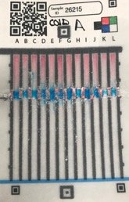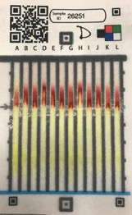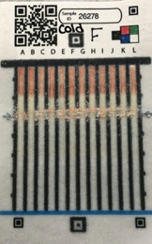

S4. Light Box

A lightbox has been fashioned out of a plastic “ammunition box” in which a hole has been cut in the top and LED strip tape applied inside.
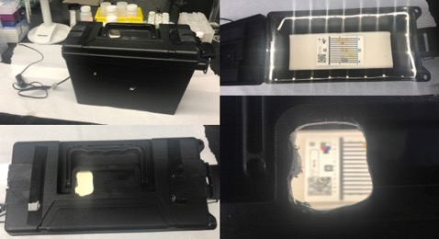

S5. idPAD Blinded Study Reader
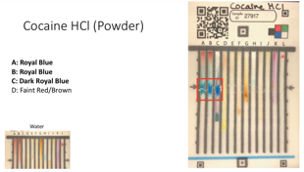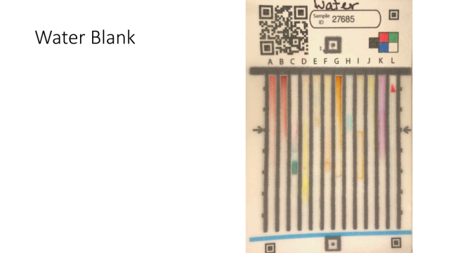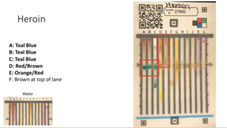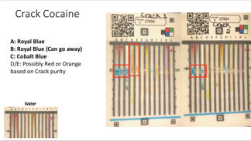
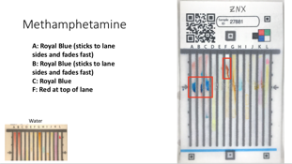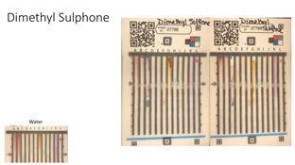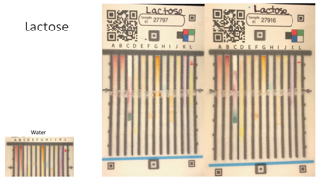

S6. Grading of Blinded Samples

Sample Code | Drug | Drug Concentration (by Mass) | Cutting Agent (concentration by mass) | Analyst 1 | Analyst 2 | Analyst 3
435 | None | 0% | Lactose (100%) | Lactose | Lactose | Lactose
658 | Cocaine HCl | 25% | Lactose (75%) | Cocaine | Cocaine | Cocaine
672 | Methamphetamine | 25% | Dimethyl Sulfone (75%) | Meth | Meth | Meth
736 | None | 0% | Dimethyl Sulfone (100%) | DMS | DMS | Lactose
986 | Cocaine HCl | 50% | Lactose (50%) | Cocaine | Cocaine | Cocaine
24B | Methamphetamine | 100% | None | Meth | Meth | Meth
2BQ | Crack Cocaine 2 | 100% | None | Crack | Crack | Cocaine
2DJ | Heroin | 100% | None | Heroin | Heroin | Heroin
2HQ | Methamphetamine | 100% | None | Meth | Meth | Meth
2K5 | None | 0% | Lactose (100%) | Lactose | Lactose | Lactose
2N4 | None | 0% | Lactose (100%) | Lactose | Lactose | Lactose
2TN | Heroin | 100% | None | Heroin | Heroin | Heroin
2WN | Methamphetamine | 100% | None | Meth | Meth | Meth
33P | None | 0% | Lactose (100%) | Lactose | Lactose | Lactose
34E | None | 0% | Lactose (100%) | Lactose | Lactose | Lactose
34W | Crack Cocaine 1 | 100% | Cut with Nicotinamide | Cocaine | Cocaine | Crack
3FS | Methamphetamine | 50% | Dimethyl Sulfone (50%) | Meth | Meth | Meth
3GM | Heroin | 25% | Lactose (75%) | Heroin | Crack | Heroin
3LS | Methamphetamine | 50% | Dimethyl Sulfone (50%) | Meth | Meth | Meth
3PV | Methamphetamine | 100% | None | Meth | Meth | Meth
3R9 | Cocaine HCl | 100% | None | Cocaine | Cocaine | Cocaine
3U4 | Cocaine HCl | 100% | None | Cocaine | Cocaine | Cocaine
44U | Crack Cocaine 1 | 100% | Cut with Nicotinamide | Cocaine | Crack | Crack
44Y | Heroin | 50% | Lactose (50%) | Heroin | Heroin | Heroin
4AZ | Methamphetamine | 50% | Dimethyl Sulfone (50%) | Meth | Meth | Meth
4D9 | Cocaine HCl | 50% | Lactose (50%) | Cocaine | Cocaine | Cocaine
4J9 | None | 0% | Lactose (100%) | Lactose | Lactose | Lactose
4KH | Crack Cocaine 2 | 100% | None | Crack | Crack | Crack
4RD | Cocaine HCl | 100% | None | Cocaine | Cocaine | Cocaine
4TL | Crack Cocaine 2 | 100% | None | Crack | Crack | Cocaine
4TT | Methamphetamine | 100% | None | Meth | Meth | Meth
4V8 | Methamphetamine | 100% | None | Meth | Crack | Meth
4VC | Heroin | 50% | Lactose (50%) | Heroin | Heroin | Heroin
4VQ | Methamphetamine | 50% | Dimethyl Sulfone (50%) | Meth | Meth | Meth
4WZ | None | 0% | Dimethyl Sulfone (100%) | DMS | DMS | DMS
52M | Cocaine HCl | 25% | Lactose (75%) | Cocaine | Cocaine | Cocaine
57H | None | 0% | Dimethyl Sulfone (100%) | Lactose | Lactose | Lactose
5BS | None | 0% | Lactose (100%) | Lactose | Lactose | Lactose
5C6 | Heroin | 100% | None | Heroin | Heroin | Heroin
5ET | Cocaine HCl | 25% | Lactose (75%) | Cocaine | Crack | Cocaine
5HD | None | 0% | Lactose (100%) | Lactose | Lactose | Lactose
5JK | Cocaine HCl | 100% | None | Cocaine | Cocaine | Crack
5PX | Heroin | 100% | None | Heroin | Heroin | Heroin
5SP | Heroin | 25% | Lactose (75%) | Heroin | Heroin | Heroin
5UJ | Methamphetamine | 50% | Dimethyl Sulfone (50%) | Meth | Meth | Meth
5Y7 | None | 0% | Lactose (100%) | Lactose | Lactose | Lactose
67U | None | 0% | Dimethyl Sulfone (100%) | DMS | Lactose | Lactose
6CA | Crack Cocaine 1 | 100% | Cut with Nicotinamide | Crack | Cocaine | Crack
6JZ | Heroin | 50% | Lactose (50%) | Heroin | Heroin | Heroin
6RL | Heroin | 100% | None | Heroin | Heroin | Heroin
6SC | Methamphetamine | 25% | Dimethyl Sulfone (75%) | Meth | Meth | Meth
6SN | Methamphetamine | 50% | Dimethyl Sulfone (50%) | Meth | Meth | Meth
7KK | Heroin | 25% | Lactose (75%) | Heroin | Heroin | Heroin
7LK | Heroin | 25% | Lactose (75%) | Heroin | Heroin | Heroin
7NA | Crack Cocaine 1 | 100% | Cut with Nicotinamide | Crack | Crack | Crack
7QD | Crack Cocaine 2 | 100% | None | Crack | Crack | Cocaine
7W4 | Cocaine HCl | 50% | Lactose (50%) | Cocaine | Cocaine | Cocaine
8F4 | Methamphetamine | 50% | Dimethyl Sulfone (50%) | Meth | Cocaine | Meth
8HJ | Crack Cocaine 1 | 100% | Cut with Nicotinamide | Cocaine | Crack | Crack
8KJ | Crack Cocaine 1 | 100% | Cut with Nicotinamide | Cocaine | Heroin | Crack
8RX | Cocaine HCl | 50% | Lactose (50%) | Cocaine | Cocaine | Cocaine
97U | Cocaine HCl | 50% | Lactose (50%) | Cocaine | Cocaine | Cocaine
98N | Methamphetamine | 50% | Dimethyl Sulfone (50%) | Meth | Meth | Meth
9C9 | Methamphetamine | 25% | Dimethyl Sulfone (75%) | DMS | Meth | Cocaine
9EH | Crack Cocaine 2 | 100% | None | Crack | Crack | Cocaine
9JF | Cocaine HCl | 50% | Lactose (50%) | Cocaine | Cocaine | Cocaine
9N4 | None | 0% | Dimethyl Sulfone (100%) | DMS | DMS | DMS
9P5 | Methamphetamine | 50% | Dimethyl Sulfone (50%) | Meth | Meth | Meth
9WN | Heroin | 50% | Lactose (50%) | Heroin | Crack | Heroin
9XP | Crack Cocaine 2 | 100% | None | Crack | Crack | Cocaine
A7Z | Cocaine HCl | 25% | Lactose (75%) | Cocaine | Cocaine | Cocaine
ADJ | Heroin | 100% | None | Heroin | Heroin | Heroin
ARA | None | 0% | Dimethyl Sulfone (100%) | Lactose | Lactose | Lactose
AT8 | Methamphetamine | 100% | None | Meth | Meth | Meth
AUM | None | 0% | Dimethyl Sulfone (100%) | DMS | DMS | Lactose
B3F | Heroin | 25% | Lactose (75%) | Heroin | Crack | Heroin
B68 | None | 0% | Lactose (100%) | Lactose | Lactose | Lactose
BB9 | None | 0% | Lactose (100%) | Lactose | Lactose | Lactose
BDB | Methamphetamine | 25% | Dimethyl Sulfone (75%) | Meth | Meth | Meth
BKZ | Cocaine HCl | 25% | Lactose (75%) | Cocaine | Cocaine | Cocaine
BLK | Crack Cocaine 1 | 100% | Cut with Nicotinamide | Crack | Crack | Crack
BNG | Crack Cocaine 2 | 100% | None | Crack | Crack | Cocaine
BQ6 | Heroin | 25% | Lactose (75%) | Heroin | Heroin | Heroin
BZ9 | Cocaine HCl | 25% | Lactose (75%) | Cocaine | Cocaine | Cocaine
C8V | Heroin | 50% | Lactose (50%) | Heroin | Heroin | Heroin
C97 | Heroin | 50% | Lactose (50%) | Heroin | Heroin | Heroin
CNF | Methamphetamine | 25% | Dimethyl Sulfone (75%) | Meth | Meth | Meth
CQK | Methamphetamine | 50% | Dimethyl Sulfone (50%) | Meth | Meth | Meth
CQL | Methamphetamine | 25% | Dimethyl Sulfone (75%) | Meth | Crack | Meth
CS9 | None | 0% | Lactose (100%) | Lactose | Lactose | Lactose
CSE | Methamphetamine | 25% | Dimethyl Sulfone (75%) | DMS | Crack | Cocaine
CUM | Crack Cocaine 2 | 100% | None | Crack | Crack | Cocaine
D2P | Heroin | 50% | Lactose (50%) | Heroin | Heroin | Heroin
D4G | Cocaine HCl | 25% | Lactose (75%) | Cocaine | Cocaine | Cocaine
D8H | Methamphetamine | 50% | Dimethyl Sulfone (50%) | Meth | Meth | Meth
DGU | None | 0% | Lactose (100%) | Lactose | Lactose | Lactose
DNZ | Heroin | 50% | Lactose (50%) | Heroin | Heroin | Heroin
DPP | Cocaine HCl | 25% | Lactose (75%) | Cocaine | Cocaine | Cocaine
DQ7 | Cocaine HCl | 100% | None | Cocaine | Cocaine | Cocaine
DSW | Cocaine HCl | 100% | None | Cocaine | Cocaine | Cocaine
DU9 | Methamphetamine | 100% | None | Meth | Meth | Meth
DUG | None | 0% | Lactose (100%) | Lactose | Lactose | Lactose
DZB | Cocaine HCl | 50% | Lactose (50%) | Cocaine | Cocaine | Cocaine
E5F | None | 0% | Lactose (100%) | Lactose | Lactose | Lactose
E6Y | None | 0% | Lactose (100%) | Lactose | Lactose | Lactose
EF8 | None | 0% | Lactose (100%) | Lactose | Lactose | Lactose
EHN | Methamphetamine | 25% | Dimethyl Sulfone (75%) | Meth | Meth | Meth
EL5 | None | 0% | Lactose (100%) | Lactose | Lactose | Lactose
ELJ | Methamphetamine | 25% | Dimethyl Sulfone (75%) | Meth | Meth | Meth
ERK | Heroin | 25% | Lactose (75%) | Heroin | Heroin | Heroin
EUJ | Heroin | 100% | None | Heroin | Heroin | Heroin
EYH | None | 0% | Lactose (100%) | DMS | DMS | DMS
F2Q | Cocaine HCl | 100% | None | Cocaine | Cocaine | Crack
F4X | Crack Cocaine 1 | 100% | Cut with Nicotinamide | Crack | Crack | Crack
FCJ | None | 0% | Lactose (100%) | Lactose | Lactose | Lactose
FDB | Methamphetamine | 100% | None | Meth | Meth | Meth
FF7 | Heroin | 25% | Lactose (75%) | DMS | DMS | DMS
FGB | None | 0% | Dimethyl Sulphone (100%) | Lactose | Lactose | Lactose
FJJ | Heroin | 25% | Lactose (75%) | Heroin | Heroin | Heroin
FRL | Cocaine HCl | 50% | Lactose (50%) | Cocaine | Cocaine | Cocaine
FRX | Heroin | 25% | Lactose (75%) | Heroin | Heroin | Heroin
FV6 | Cocaine HCl | 100% | None | Cocaine | Cocaine | Cocaine
FW7 | Crack Cocaine 2 | 100% | None | Crack | Crack | Cocaine
FWC | Crack Cocaine 1 | 100% | Cut with Nicotinamide | Crack | Crack | Crack
G35 | None | 0% | Lactose (100%) | Lactose | Lactose | Lactose
G6Z | Crack Cocaine 2 | 100% | None | Crack | Crack | Cocaine
GCT | Methamphetamine | 25% | Dimethyl Sulfone (75%) | Meth | Meth | Meth
GGD | Cocaine HCl | 50% | Lactose (50%) | Cocaine | Cocaine | Cocaine
GKC | None | 0% | Dimethyl Sulfone (100%) | DMS | DMS | Lactose
GLK | Crack Cocaine 2 | 100% | None | Crack | Crack | Crack
GLV | Heroin | 25% | Lactose (75%) | Heroin | Heroin | Heroin
GPN | Methamphetamine | 100% | None | Meth | Meth | Meth
GTQ | Methamphetamine | 25% | Dimethyl Sulfone (75%) | Meth | Meth | Meth
GX3 | Cocaine HCl | 25% | Lactose (75%) | Cocaine | Cocaine | Cocaine
H2C | Crack Cocaine 1 | 100% | Cut with Nicotinamide | Crack | Crack | Crack
H4Y | Heroin | 50% | Lactose (50%) | Heroin | Heroin | Heroin
H8G | Methamphetamine | 100% | None | Meth | Meth | Meth
HDH | Methamphetamine | 100% | None | Meth | Meth | Meth
HH9 | None | 0% | Lactose (100%) | Lactose | Lactose | Lactose
HJJ | Heroin | 100% | None | Heroin | Heroin | Heroin
J43 | Heroin | 100% | None | Heroin | Heroin | Heroin
J95 | Crack Cocaine 1 | 100% | Cut with Nicotinamide | Crack | Cocaine | Crack
JAY | Methamphetamine | 25% | Dimethyl Sulfone (75%) | Meth | Meth | Meth
JEM | None | 0% | Lactose (100%) | Lactose | Lactose | Lactose
JG2 | None | 0% | Lactose (100%) | DMS | Lactose | Lactose
JHJ | None | 0% | Dimethyl Sulfone (100%) | DMS | Lactose | Lactose
JKL | None | 0% | Dimethyl Sulfone (100%) | Lactose | Lactose | Lactose
JTB | Heroin | 25% | Lactose (75%) | Heroin | Crack | Heroin
K67 | Cocaine HCl | 25% | Lactose (75%) | Cocaine | Cocaine | Cocaine
K8L | Cocaine HCl | 50% | Lactose (50%) | Cocaine | Cocaine | Cocaine
K8S | Methamphetamine | 50% | Dimethyl Sulfone (50%) | Meth | Meth | Meth
K96 | Heroin | 50% | Lactose (50%) | Heroin | Heroin | Heroin
KFW | None | 0% | Lactose (100%) | Lactose | Lactose | Lactose
KNX | Methamphetamine | 100% | None | Meth | Meth | Meth
KPX | Heroin | 25% | Lactose (75%) | Heroin | Heroin | Heroin
KQD | Cocaine HCl | 25% | Lactose (75%) | Cocaine | Cocaine | Cocaine
KSP | Cocaine HCl | 100% | None | Cocaine | Cocaine | Crack
L3T | Heroin | 50% | Lactose (50%) | Heroin | Crack | Heroin
L4A | None | 0% | Lactose (100%) | Lactose | Lactose | Lactose
LBN | Methamphetamine | 50% | Dimethyl Sulfone (50%) | Meth | Meth | Meth
LGY | Cocaine HCl | 25% | Lactose (75%) | Cocaine | Cocaine | Cocaine
LKL | Heroin | 50% | Lactose (50%) | Heroin | Heroin | Heroin
LTF | Methamphetamine | 25% | Dimethyl Sulfone (75%) | Meth | Meth | Meth
LUL | Cocaine HCl | 50% | Lactose (50%) | Crack | Cocaine | Crack
LVA | Cocaine HCl | 100% | None | Cocaine | Cocaine | Cocaine
LWK | Cocaine HCl | 100% | None | Cocaine | Heroin | Cocaine
M6P | Cocaine HCl | 100% | None | Cocaine | Cocaine | Cocaine
MAD | Heroin | 25% | Lactose (75%) | Heroin | Heroin | Heroin
MB5 | Methamphetamine | 50% | Dimethyl Sulfone (50%) | Meth | Meth | Meth
MBA | None | 0% | Lactose (100%) | Lactose | DMS | Lactose
MCP | None | 0% | Lactose (100%) | Lactose | Lactose | Lactose
MGF | Crack Cocaine 2 | 100% | None | Crack | Cocaine | Cocaine
MJ4 | Cocaine HCl | 25% | Lactose (75%) | Cocaine | Cocaine | Cocaine
MTJ | Heroin | 25% | Lactose (75%) | Heroin | Heroin | Heroin
MUB | Heroin | 50% | Lactose (50%) | Heroin | Heroin | Heroin
N2D | Heroin | 100% | None | Heroin | Heroin | Heroin
NA4 | None | 0% | Lactose (100%) | Lactose | Lactose | Lactose
NBR | None | 0% | Dimethyl Sulfone (100%) | DMS | DMS | DMS
NV3 | Heroin | 25% | Lactose (75%) | Heroin | Heroin | Heroin
NVV | Cocaine HCl | 100% | None | Cocaine | Cocaine | Cocaine
OOO | Cocaine HCl | 25% | Lactose (75%) | Cocaine | Cocaine | Cocaine
P3H | Cocaine HCl | 100% | None | Cocaine | Cocaine | Cocaine
P5D | Methamphetamine | 50% | Dimethyl Sulfone (50%) | Meth | Meth | Meth
P5R | Heroin | 50% | Lactose (50%) | Heroin | Heroin | Heroin
P6V | None | 0% | Dimethyl Sulfone (100%) | Lactose | Lactose | Lactose
P8S | Cocaine HCl | 25% | Lactose (75%) | Cocaine | Cocaine | Cocaine
PE6 | Heroin | 100% | None | Heroin | Heroin | Heroin
PJW | None | 0% | Lactose (100%) | Lactose | Lactose | Lactose
PNN | Crack Cocaine 2 | 100% | None | Crack | Crack | Crack
PPV | Methamphetamine | 100% | None | Meth | Meth | Meth
PUH | Heroin | 50% | Lactose (50%) | Heroin | Heroin | Heroin
PZT | None | 0% | Lactose (100%) | Lactose | Lactose | Lactose
Q69 | Crack Cocaine 2 | 100% | None | Crack | Crack | Cocaine
Q6B | Crack Cocaine 1 | 100% | Cut with Nicotinamide | Crack | Crack | Crack
QAE | Cocaine HCl | 100% | None | Cocaine | Cocaine | Cocaine
QFH | Heroin | 25% | Lactose (75%) | Heroin | Heroin | Heroin
QMR | Crack Cocaine 2 | 100% | None | Crack | Crack | Cocaine
QPZ | Heroin | 50% | Lactose (50%) | Heroin | Heroin | Heroin
QTE | Methamphetamine | 25% | Dimethyl Sulfone (75%) | DMS | Meth | DMS
QUC | Crack Cocaine 2 | 100% | None | Crack | Crack | Cocaine
QVC | Methamphetamine | 50% | Dimethyl Sulfone (50%) | Meth | Meth | Meth
R66 | Heroin | 50% | Lactose (50%) | Heroin | Heroin | Heroin
RKD | Methamphetamine | 25% | Dimethyl Sulfone (75%) | Meth | Meth | Meth
RNR | None | 0% | Lactose (100%) | DMS | Lactose | Lactose
RPX | Heroin | 25% | Lactose (75%) | Heroin | Crack | Heroin
RW8 | Heroin | 50% | Lactose (50%) | Heroin | Heroin | Heroin
S6H | Methamphetamine | 100% | None | Crack | Meth | Meth
SEB | Cocaine HCl | 100% | None | Cocaine | Cocaine | Cocaine
SFR | Cocaine HCl | 100% | None | Cocaine | Cocaine | Cocaine
SRG | Cocaine HCl | 50% | Lactose (50%) | Cocaine | Cocaine | Crack
SSB | Crack Cocaine 1 | 100% | Cut with Nicotinamide | Crack | Cocaine | Crack
SWR | Cocaine HCl | 25% | Lactose (75%) | Cocaine | Cocaine | Cocaine
T2K | None | 0% | Lactose (100%) | Lactose | Lactose | Lactose
TGP | None | 0% | Lactose (100%) | Lactose | Lactose | Lactose
TNL | Crack Cocaine 1 | 100% | Cut with Nicotinamide | Cocaine | Crack | Crack
TTQ | Methamphetamine | 100% | None | Meth | Meth | Meth
TU4 | None | 0% | Dimethyl Sulfone (100%) | Lactose | Lactose | Lactose
UEX | Crack Cocaine 2 | 100% | None | Crack | Crack | Cocaine
UFL | Heroin | 100% | None | Heroin | Heroin | Heroin
UJ5 | None | 0% | Lactose (100%) | Lactose | Lactose | Lactose
UJG | Heroin | 100% | None | Heroin | Heroin | Heroin
ULN | Methamphetamine | 100% | None | Meth | Meth | Meth
UM8 | Crack Cocaine 2 | 100% | None | Crack | Heroin | Cocaine
UNE | Crack Cocaine 2 | 100% | None | Crack | Crack | Crack
UR9 | Methamphetamine | 50% | Dimethyl Sulfone (50%) | Meth | Meth | Meth
URU | Heroin | 25% | Lactose (75%) | Heroin | Crack | Heroin
UZW | None | 0% | Lactose (100%) | Lactose | Lactose | DMS
V25 | Cocaine HCl | 100% | None | Cocaine | Cocaine | Cocaine
V9G | None | 0% | Dimethyl Sulfone (100%) | DMS | Lactose | DMS
VC3 | None | 0% | Lactose (100%) | Lactose | Lactose | Lactose
VEL | Methamphetamine | 50% | Dimethyl Sulfone (50%) | Meth | Meth | Meth
VKM | Methamphetamine | 50% | Dimethyl Sulfone (50%) | Meth | Meth | Meth
VKR | Heroin | 50% | Lactose (50%) | Heroin | Heroin | Heroin
VQS | Crack Cocaine 1 | 100% | Cut with Nicotinamide | Crack | Crack | Crack
VU6 | Methamphetamine | 50% | Dimethyl Sulfone (50%) | Meth | Meth | Meth
VXT | Crack Cocaine 1 | 100% | Cut with Nicotinamide | Cocaine | Cocaine | Crack
VYN | Crack Cocaine 1 | 100% | Cut with Nicotinamide | Crack | Crack | Crack
W48 | Cocaine HCl | 50% | Lactose (50%) | Cocaine | Cocaine | Cocaine
W9F | Cocaine HCl | 50% | Lactose (50%) | Cocaine | Cocaine | Cocaine
WA9 | Crack Cocaine 1 | 100% | Cut with Nicotinamide | Crack | Crack | Crack
WAN | Heroin | 100% | None | Heroin | Heroin | Heroin
WHH | Crack Cocaine 2 | 100% | None | Crack | Crack | Crack
WL7 | Cocaine HCl | 25% | Lactose (75%) | Cocaine | Cocaine | Crack
WNL | Heroin | 25% | Lactose (75%) | Heroin | Heroin | Heroin
WPG | Methamphetamine | 100% | None | Meth | Cocaine | Meth
WRB | Methamphetamine | 100% | None | Meth | Meth | Meth
WTZ | Cocaine HCl | 50% | Lactose (50%) | Cocaine | Cocaine | Cocaine
WVF | Heroin | 50% | Lactose (50%) | Heroin | Heroin | Heroin
WWB | Methamphetamine | 25% | Dimethyl Sulfone (75%) | Meth | Meth | Meth
X8B | None | 0% | Dimethyl Sulfone (100%) | DMS | DMS | Lactose
X93 | Heroin | 100% | None | Heroin | Heroin | Heroin
XAH | Crack Cocaine 1 | 100% | Cut with Nicotinamide | Crack | Crack | Crack
XBH | None | 0% | Lactose (100%) | DMS | Lactose | Lactose
XBZ | Methamphetamine | 25% | Dimethyl Sulfone (75%) | Meth | Meth | Meth
XDX | Cocaine HCl | 25% | Lactose (75%) | Cocaine | Cocaine | Cocaine
XET | Cocaine HCl | 25% | Lactose (75%) | Cocaine | Cocaine | Cocaine
XHM | Cocaine HCl | 50% | Lactose (50%) | Cocaine | Cocaine | Cocaine
XRP | Cocaine HCl | 100% | None | Cocaine | Cocaine | Cocaine
XS9 | Cocaine HCl | 50% | Lactose (50%) | Cocaine | Cocaine | Cocaine
XSQ | Cocaine HCl | 100% | None | Cocaine | Cocaine | Cocaine
XVT | None | 0% | Dimethyl Sulfone (100%) | Lactose | DMS | Lactose
XWN | Methamphetamine | 25% | Dimethyl Sulfone (75%) | Meth | Meth | Meth
Y6J | None | 0% | Lactose (100%) | Lactose | Lactose | Lactose
YCR | Heroin | 100% | None | Heroin | Heroin | Heroin
YG4 | Heroin | 100% | None | Heroin | Heroin | Heroin
YL7 | Cocaine HCl | 50% | Lactose (50%) | Cocaine | Cocaine | Cocaine
YTB | Crack Cocaine 1 | 100% | Cut with Nicotinamide | Cocaine | Crack | Crack
YUD | None | 0% | Lactose (100%) | Lactose | Lactose | Lactose
Z5B | Heroin | 100% | None | Heroin | Crack | Heroin
Z8J | None | 0% | Dimethyl Sulfone (100%) | DMS | DMS | DMS
ZHM | Heroin | 100% | None | Heroin | Heroin | Heroin
ZJS | Cocaine HCl | 50% | Lactose (50%) | Cocaine | Cocaine | Cocaine
ZKS | Cocaine HCl | 25% | Lactose (75%) | Cocaine | Cocaine | Cocaine
ZNX | Methamphetamine | 100% | None | Meth | Meth | Meth
ZR4 | Heroin | 100% | None | Heroin | Heroin | Heroin
ZS2 | None | 0% | Dimethyl Sulfone (100%) | DMS | Lactose | Lactose
ZSC | Methamphetamine | 25% | Dimethyl Sulfone (75%) | Meth | Meth | Meth
ZZ4 | Cocaine HCl | 50% | Lactose (50%) | Cocaine | Cocaine | Cocaine

S7. Blinded Study idPAD Images

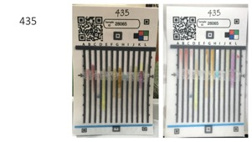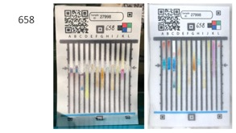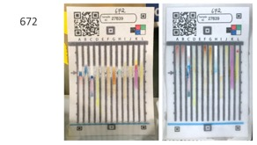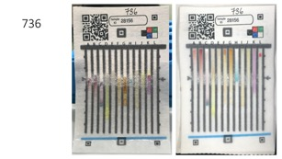
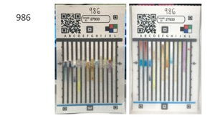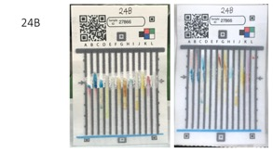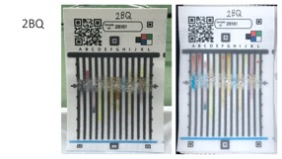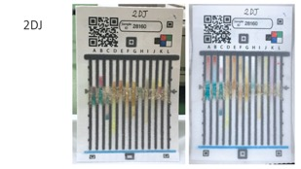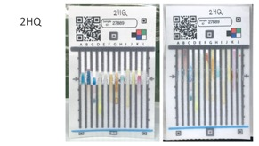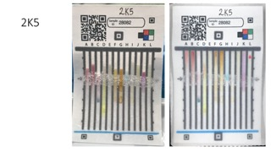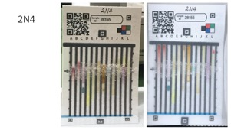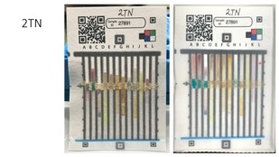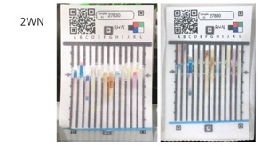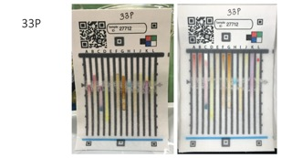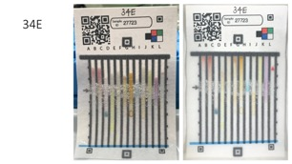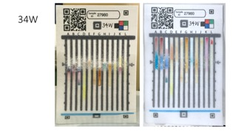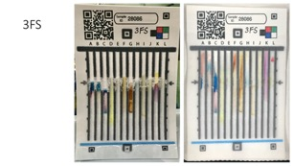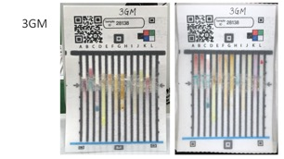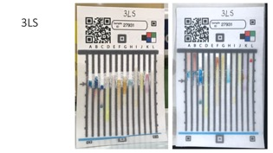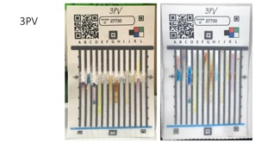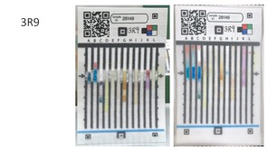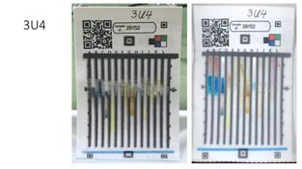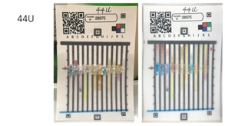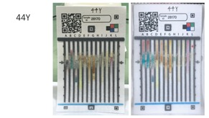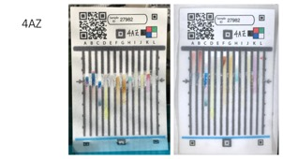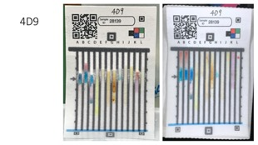
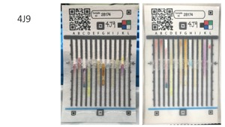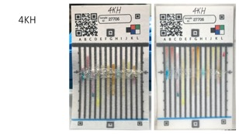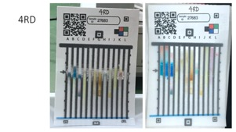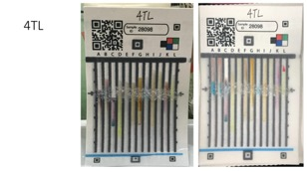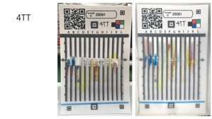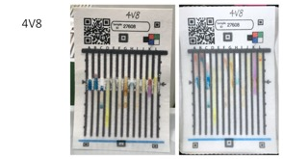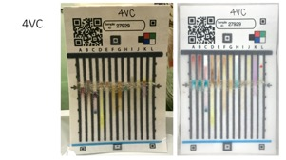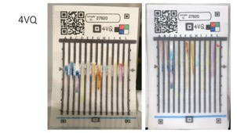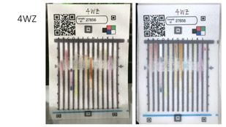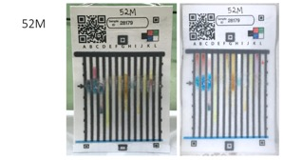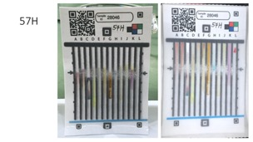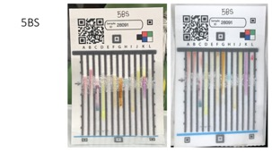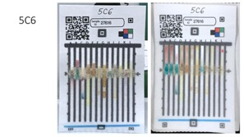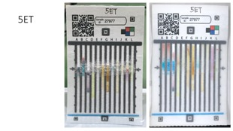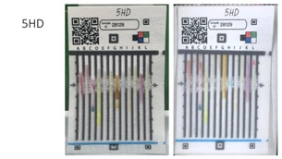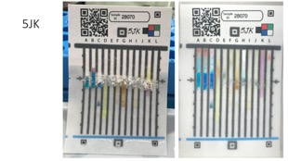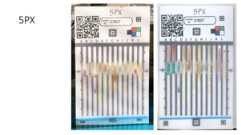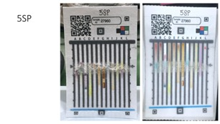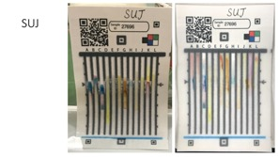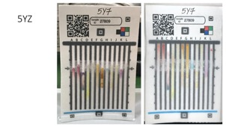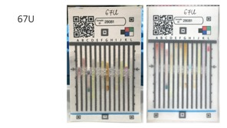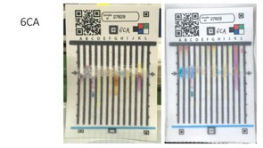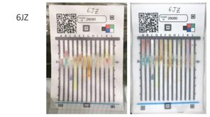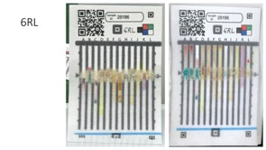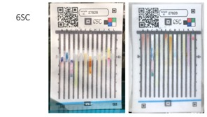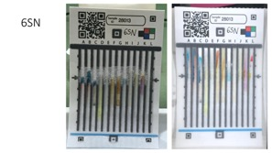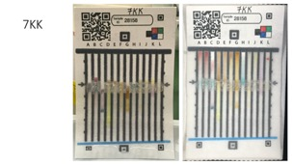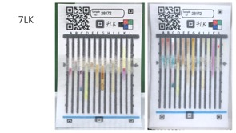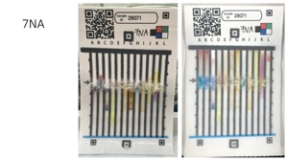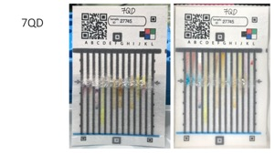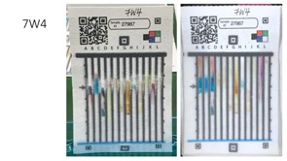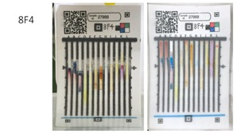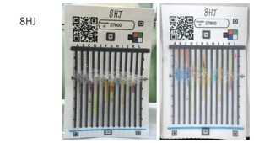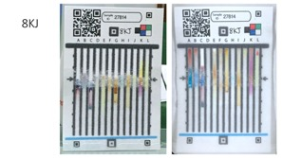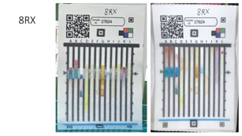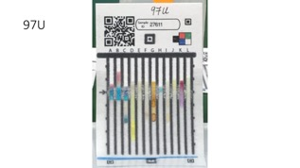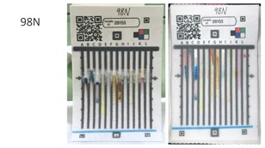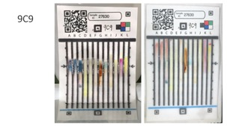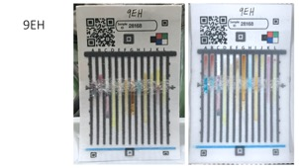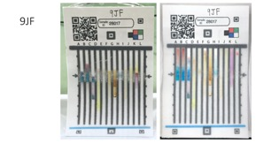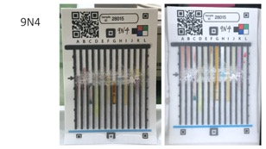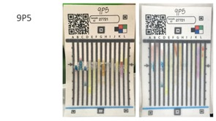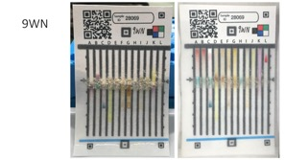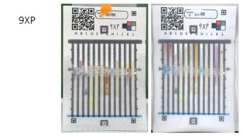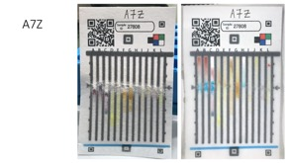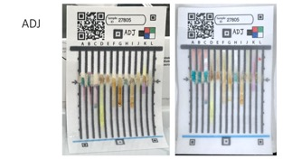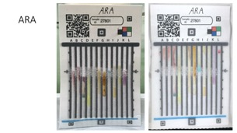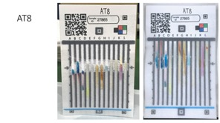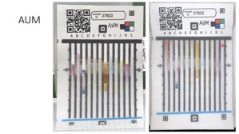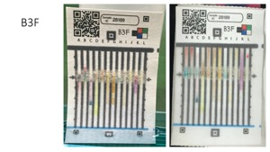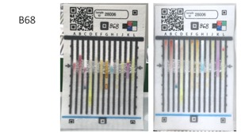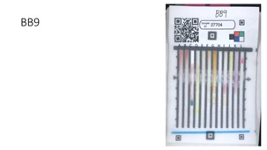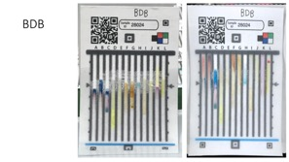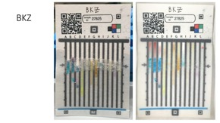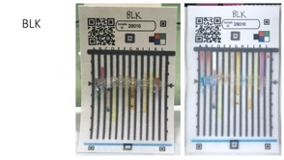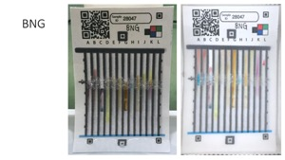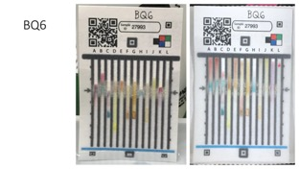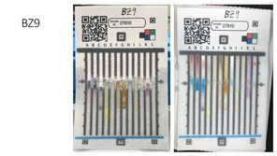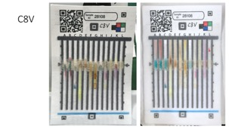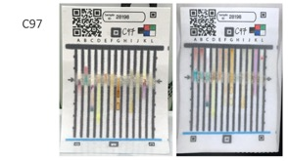
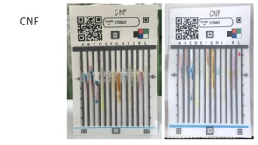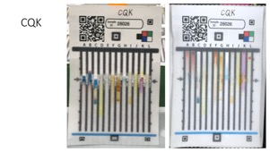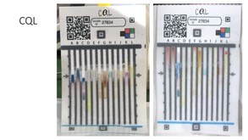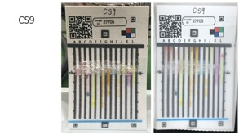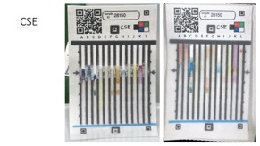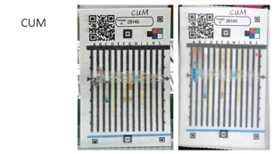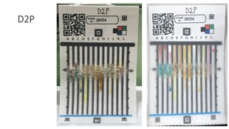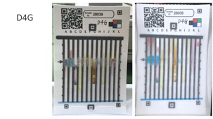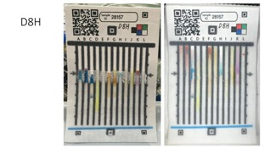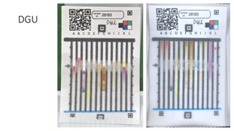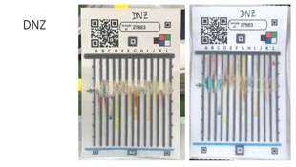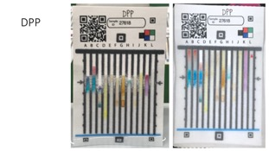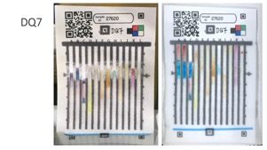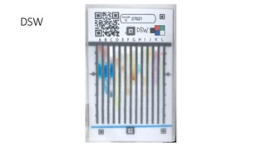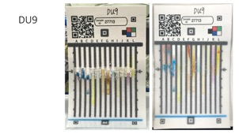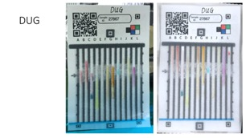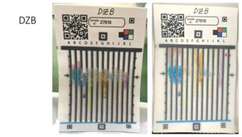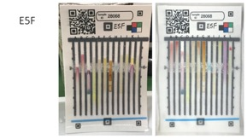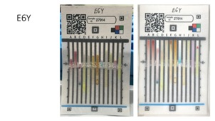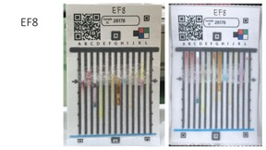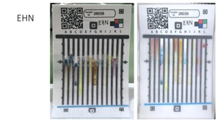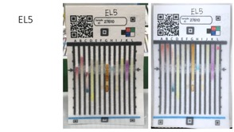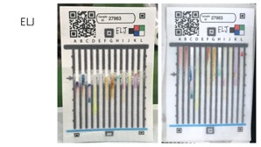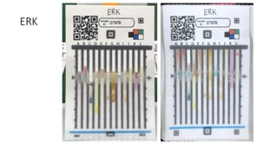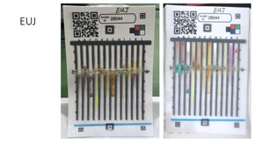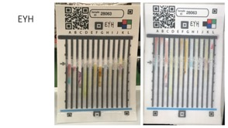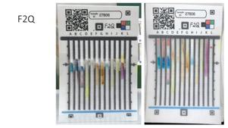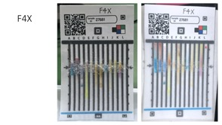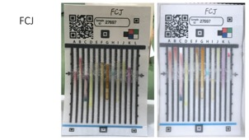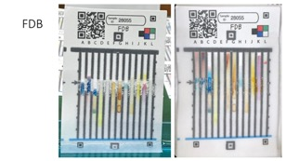
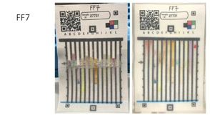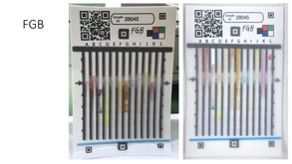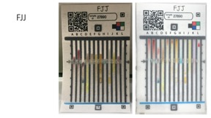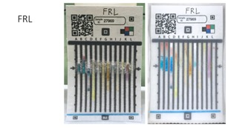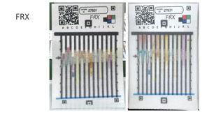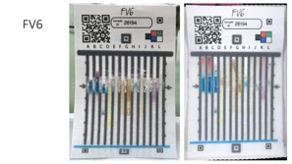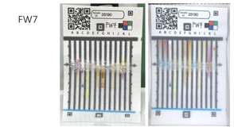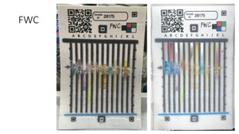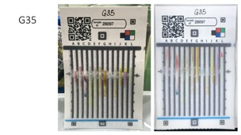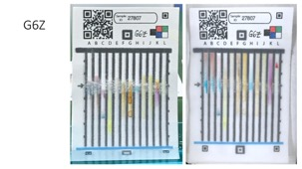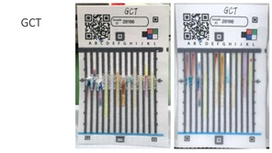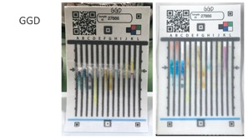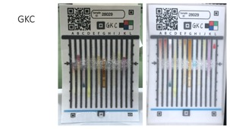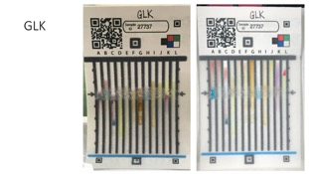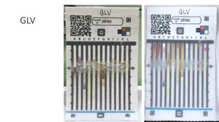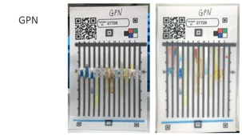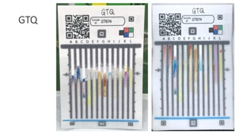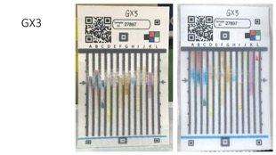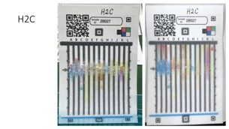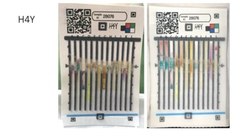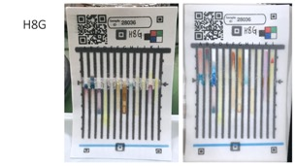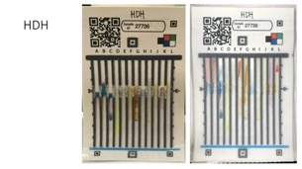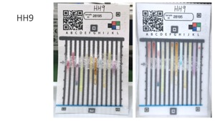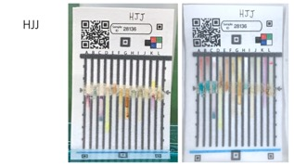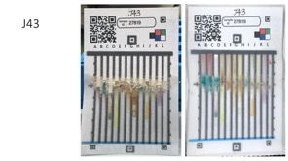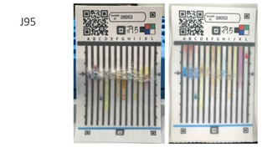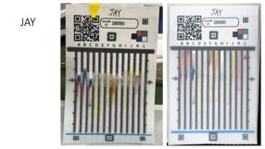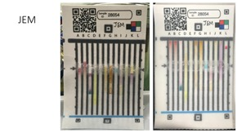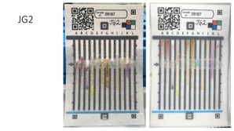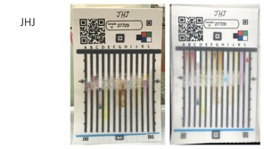

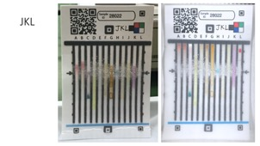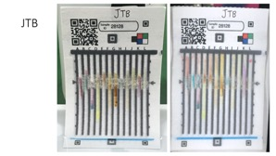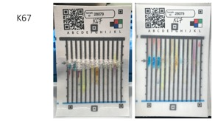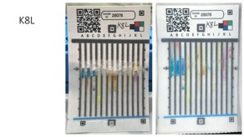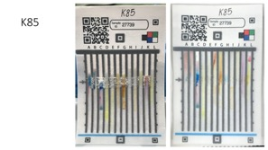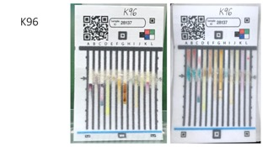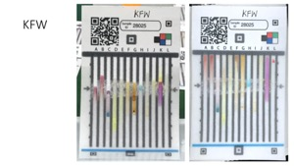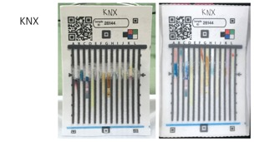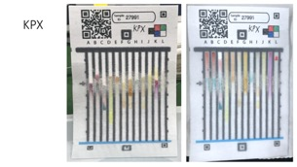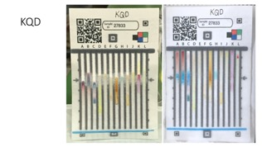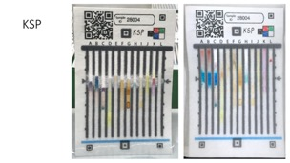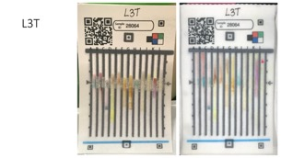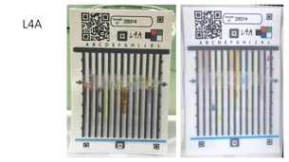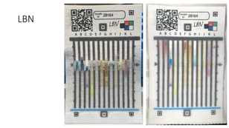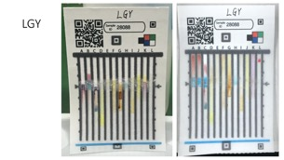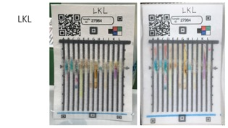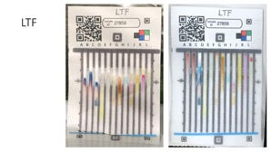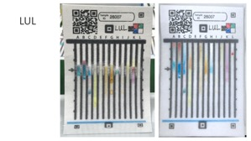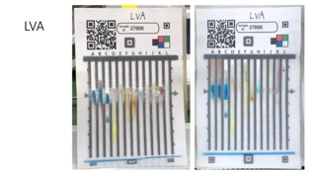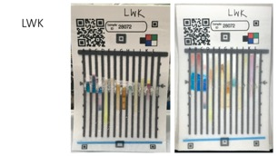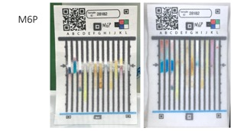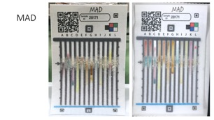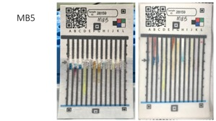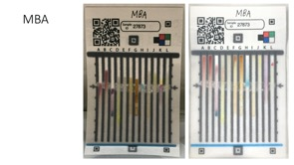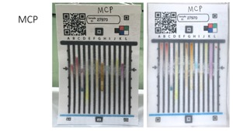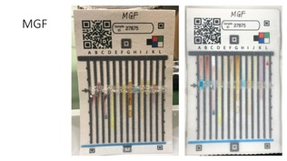

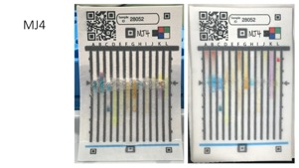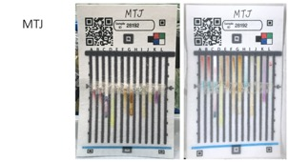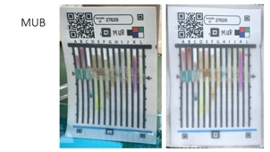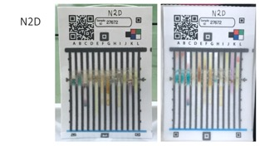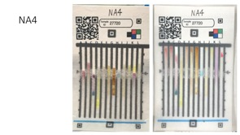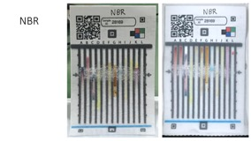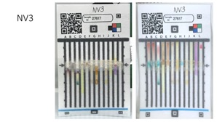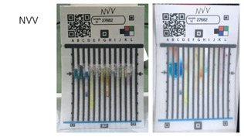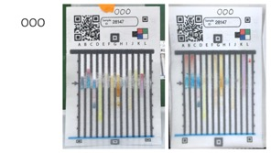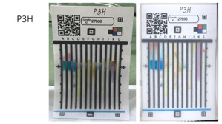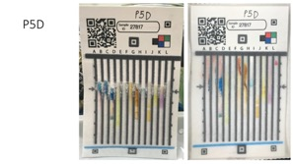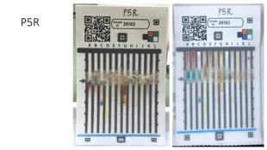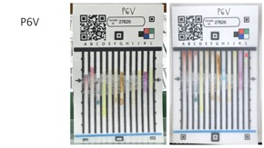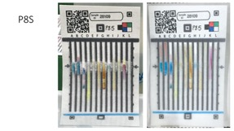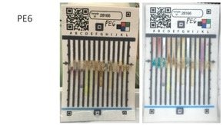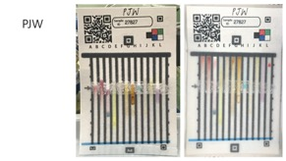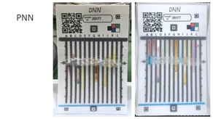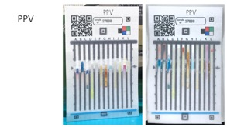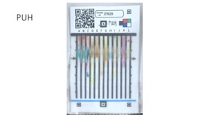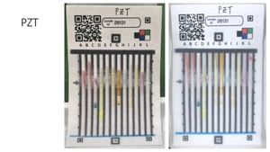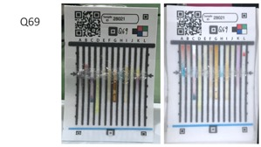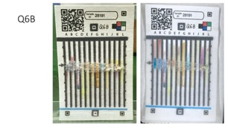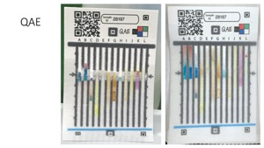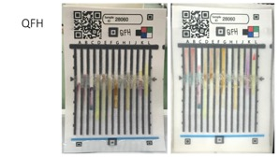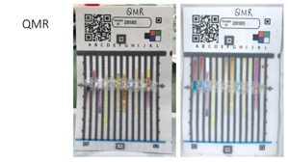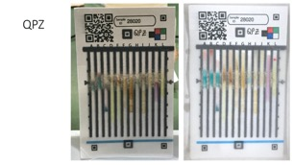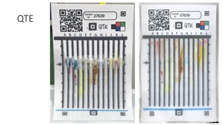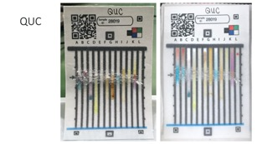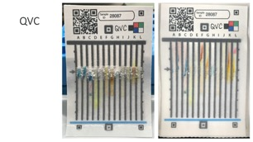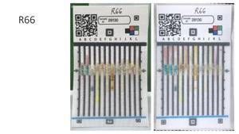

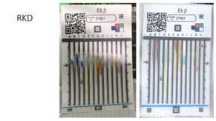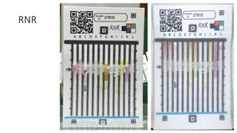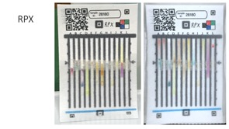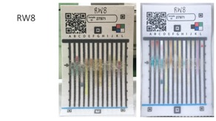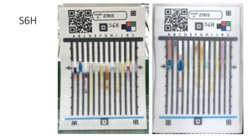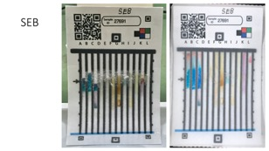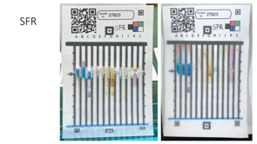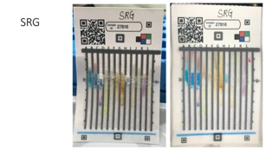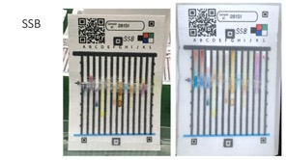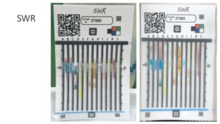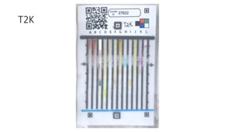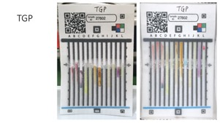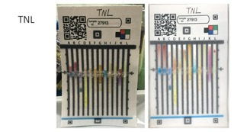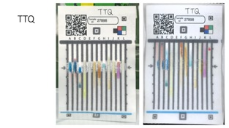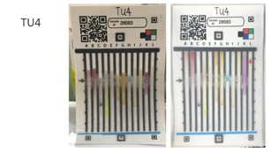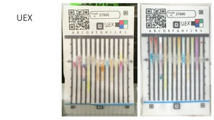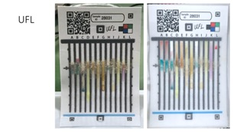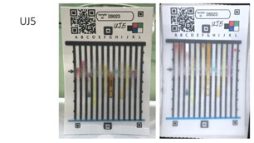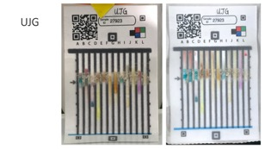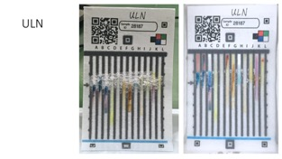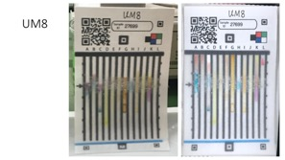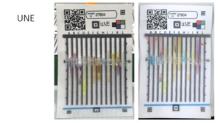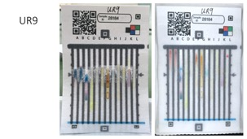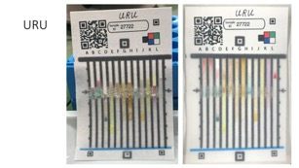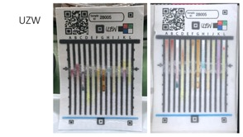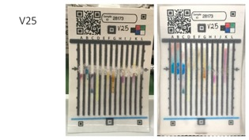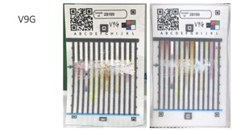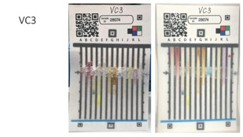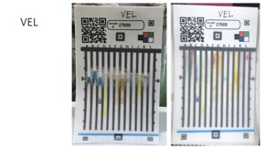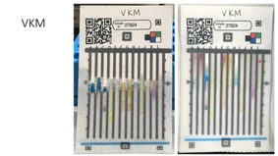
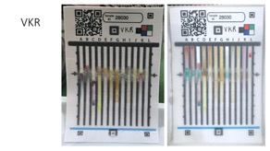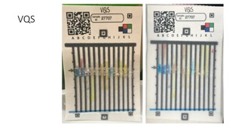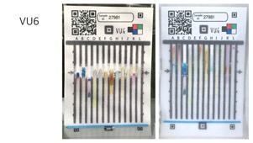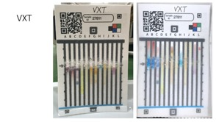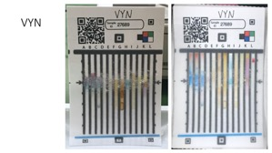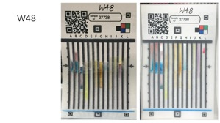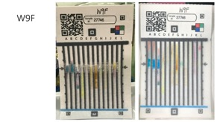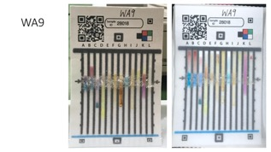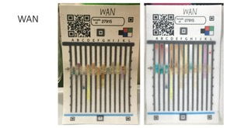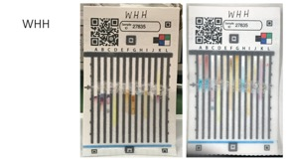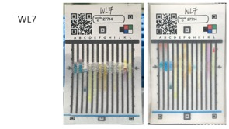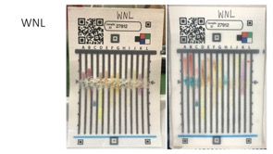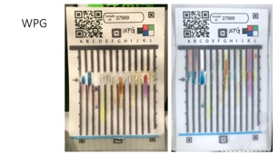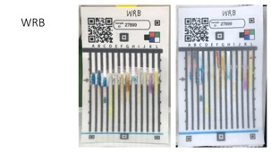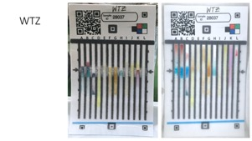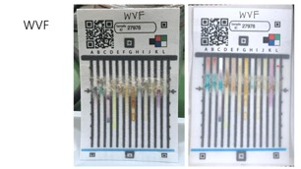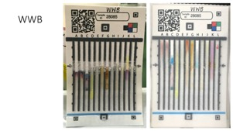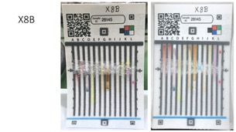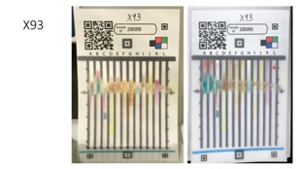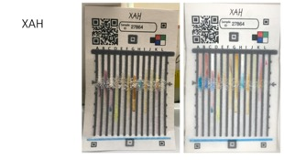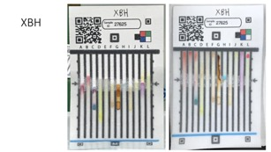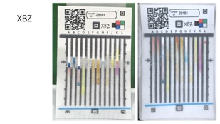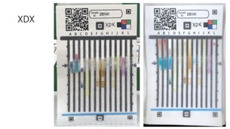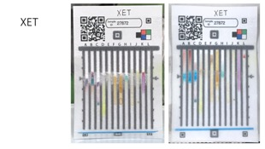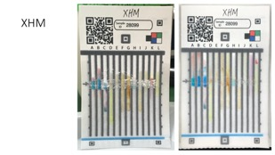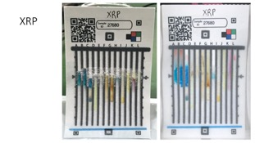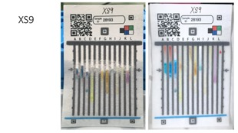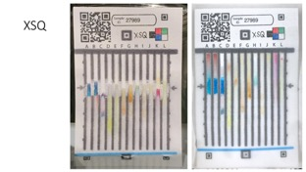
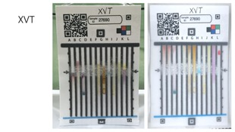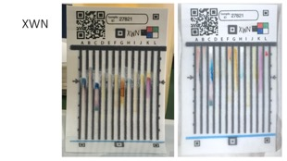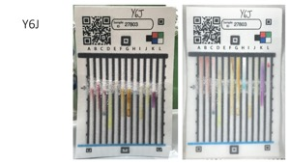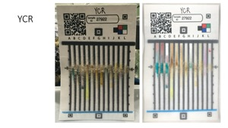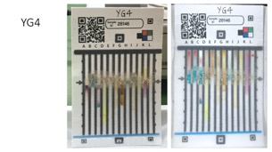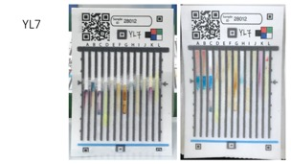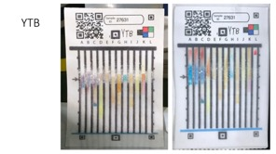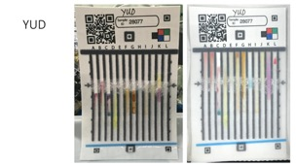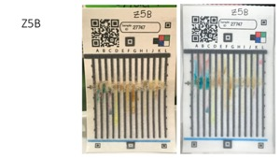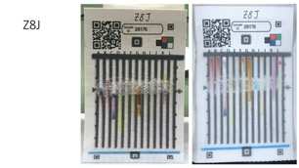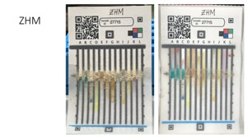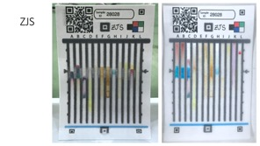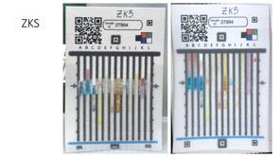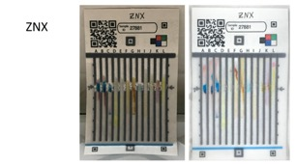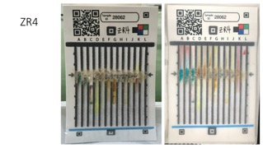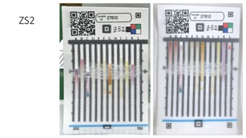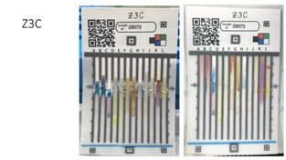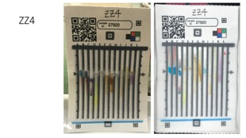

S8. T-Testing of Lanes A-C Inverted Blue Color Intensity
n=46 for each Cocaine and Heroin

Lane | Inverted Mean ($\overline{\text{x}})$ Pixel Value | Standard Deviation ($\text{)}$ | P Value (Two-Tailed)
Lane A Cocaine | 0.856 | 0.028 | 2.921 x 10⁻¹⁵
Lane A Heroin | 1.485 | 0.115 | 2.921 x 10⁻¹⁵
Lane B Cocaine | 0.739 | 0.020 | 1.469 x 10⁻²¹
Lane B Heroin | 1.460 | 0.056 | 1.469 x 10⁻²¹
Lane C Cocaine | 0.665 | 0.039 | 1.072 x 10⁻²⁰
Lane C Heroin | 1.368 | 0.044 | 1.072 x 10⁻²⁰
Lanes A-C Cocaine | 0.771 | 0.029 | 2.437 x 10⁻⁵³
Lanes A-C Heroin | 1.440 | 0.074 | 2.437 x 10⁻⁵³

S9. Heroin Standard idPAD

20uL of a 1mg/mL Heroin in methanol standard (Cerilliant, Lot: FE06151603, Exp: 11/2021) was applied to the idPAD. Lane D (right) and Lane E (left) test for phenols. Both lanes had faint reactivity by turning orange/red when exposed to the heroin standard.

Blank idPAD Heroin Std. idPAD
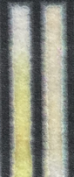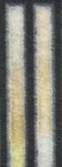
D E
D E

S10. Additional Color Bar Codes

S11. Characteristic Curves of Blinded Samples

The characteristic curves below display the blinded sample identifications split up by drug and researcher. For each drug and dilution (100% heroin, 50% heroin/50% lactose, etc.) a correct sample ID=1, a wrong ID=0, and a close ID= 0.5 (only done for Cocaine HCl vs Crack Cocaine). The results were averaged and plotted on the y-axis with the x-axis indicating increasing concentration/percentage of controlled substance. These plots clearly show that the majority of false negative identifications occurred when the sample contained only 25% drug. Analysts 1 and 2 were expert readers with Analyst 3 as the novice.

S12. Grading of Adulterant, Cutting Agent and Drug Samples

Sample Code | Actual Identity | Analyst 1: Drug Present? | Analyst 1: If so, which? | Analyst 2: Drug Present? | Analyst 2: If so, which?
7MB | 1,2,4,5-benzenetetra | no |  | No
4BJ | 2-aminothiazole | no |  | No
PTW | 4-4-Dipyridil | no |  | No
3UP | 4-aminobenzonitrile | no |  | No
9ZG | 7,7,8,8-Tetracyanoquinodimethane | no |  | No
2RQ | Acetaminophen | no |  | No
NTA | Acetaminophen Hydrocodone | no |  | Yes | Meth
7JW | Alizarian Compuxone | no |  | No
2UW | Azithromycin | no |  | No
N7D | Carbonyldimidazole | no |  | No
HJM | Carboxybenzaldehyde | no |  | No
8EB | Chloramphenicol | no |  | No
UVW | Chloranil | no |  | No
EP6 | Chloranilic Acid | no |  | No
YLK | Ciprofloxacin | no |  | No
KVZ | Clonazepam | no |  | No
39R | Cocaine | yes | Cocaine | Yes | Cocaine
9PE | Cocaine | yes | Cocaine | Yes | Cocaine
AWM | Cocaine | yes | Cocaine | Yes | Cocaine
DPP | Cocaine | yes | Cocaine | Yes | Cocaine
EWY | Cocaine | yes | Cocaine | Yes | Cocaine
NCQ | Cocaine | yes | Cocaine | Yes | Cocaine
RYD | Cocaine | yes | Cocaine | Yes | Cocaine
T9H | Cocaine | yes | Cocaine | Yes | Cocaine
WAQ | Cocaine | yes | Cocaine | Yes | Cocaine
YJN | Cocaine | yes | Cocaine | Yes | Cocaine
RDG | D-Amphetamine | no |  | No
QQ8 | Dexamethason | no |  | No
W4U | Dichlorophenolindophenol | no |  | No
DQH | diethylphenyl benzamide | no |  | No
TA3 | DimethylaminoCinnamaldehyde | no |  | No
YA7 | Enalapril | no |  | No
LB8 | Epinephrine | no |  | No
7PP | Erythromycin | no |  | No
PBQ | Ethambutol | no |  | No
G6V | Furosemide | no |  | No
GG7 | Gabapentin | no |  | No
GPC | Glycine | no |  | No
473 | Heroin | yes | Heroin | Yes | Heroin
4P9 | Heroin | yes | Heroin | Yes | Heroin
7EA | Heroin | yes | Heroin | Yes | Heroin
8KD | Heroin | yes | Heroin | Yes | Heroin
AEM | Heroin | yes | Heroin | Yes | Heroin
BWR | Heroin | yes | Heroin | Yes | Heroin
FXN | Heroin | yes | Heroin | Yes | Heroin
JYX | Heroin | yes | Heroin | Yes | Heroin
LFY | Heroin | yes | Heroin | Yes | Heroin
PHT | Heroin | yes | Heroin | Yes | Heroin
K9X | Hydantoin | no |  | No
7WY | Hydroquinone | no |  | No
7RW | Imidazole | no |  | No
6BW | Isatin | no |  | No
4V8 | Mebendazole | no |  | No
49X | Meth | yes | Meth | Yes | Meth
84C | Meth | yes | Meth | Yes | Meth
BHB | Meth | yes | Meth | Yes | Meth
CBB | Meth | yes | Meth | Yes | Meth
JA6 | Meth | yes | Meth | Yes | Meth
PBV | Meth | yes | Meth | Yes | Meth
QYP | Meth | yes | Meth | Yes | Meth
UUK | Meth | yes | Meth | Yes | Meth
V9P | Meth | yes | Meth | Yes | Meth
WY9 | Meth | yes | Meth | Yes | Meth
YUF | Meth | yes | Meth | Yes | Meth
299 | Metronidazole | no |  | No
8QC | Morphine | no |  | No
D9Z | Ninhydrin | no |  | No
WRV | NQS | no |  | No
NLV | O-Phenonthymine | no |  | No
QM2 | Orcinol | no |  | No
D6W | Penicillin G | no |  | No
CN9 | Percocet | no |  | Yes | Meth
U7P | Phenoxazine | no |  | No
WD7 | Phthalamide Potassium | no |  | No
2OO | Procaine | no |  | No
R7X | Pyrazinamide | no |  | No
VYF | Pyrazole | no |  | No
V2D | Quinine | no |  | No
XPA | Quinine Sulfate | no |  | No
DYC | Rizatriptan Benzoagte | no |  | No
MAL | Safranin O | no |  | No
CGZ | Sodium Citrate Dihydrate | no |  | No
LHQ | Sodium Tetraphenyl Boroate | no |  | No
QQZ | Sulfadozine | no |  | No
KDC | Sulfamethoxazole | no |  | No
47Z | Sulfanilamine | no |  | No
AVP | Syringaldazin | no |  | No
BXF | Tetrahydroxy-1,4-quinone hydrate | no |  | No
92V | Tetraphyltgium Disulfide | no |  | No
XPU | Tramadol | no |  | Yes | Cocaine
BG3 | Triphenylphosphine | no |  | No
BL4 | Uridine | no |  | No
8LK | Vanillin | no |  | No
KDB | Water | no |  | No
TDV | Water | no |  | No
LQD | Xanax | no |  | No

S13. Adulterant, Cutting Agent, and Drug idPAD Images

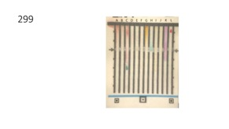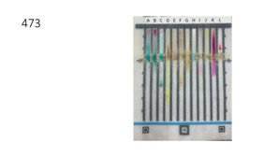
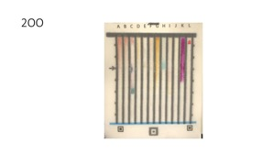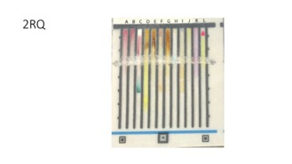

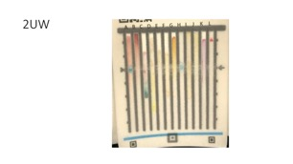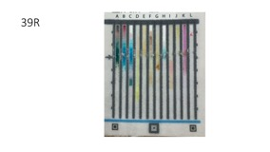

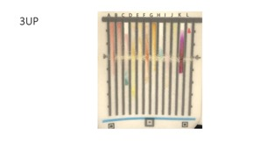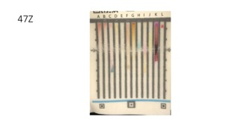

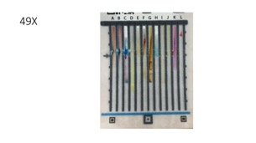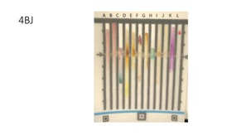
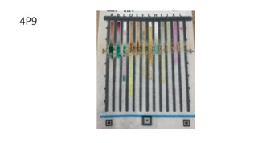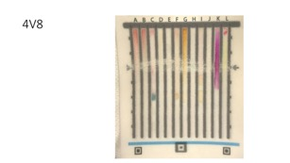

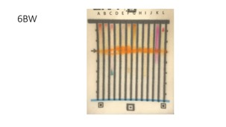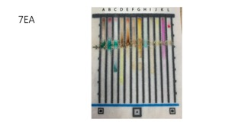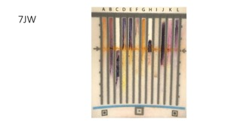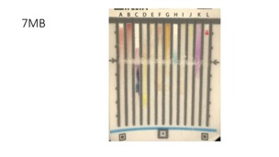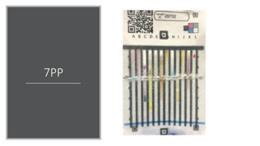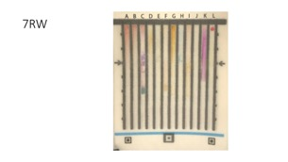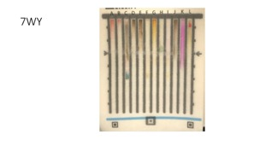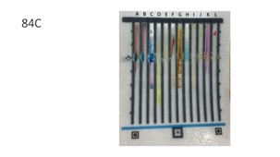

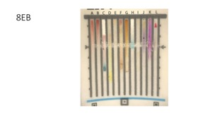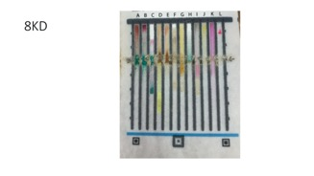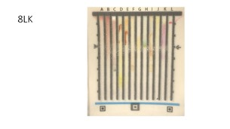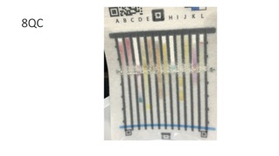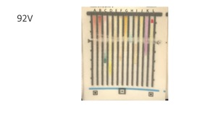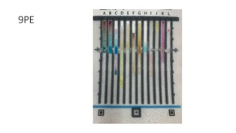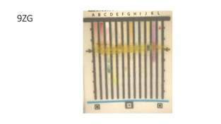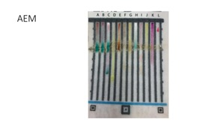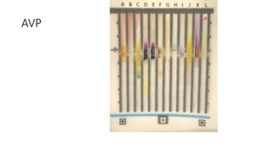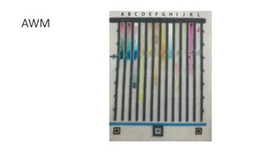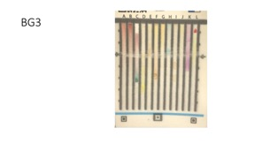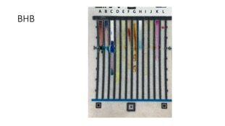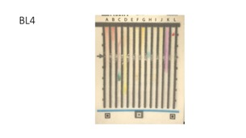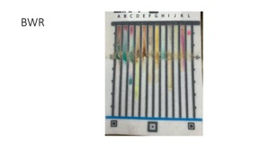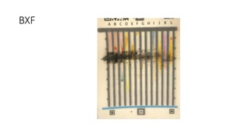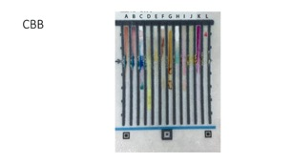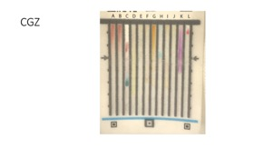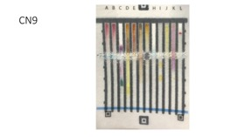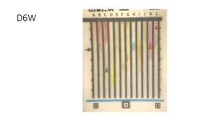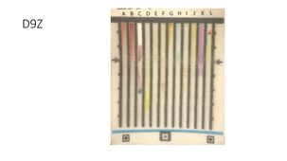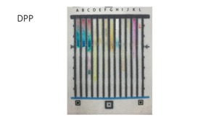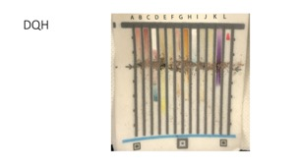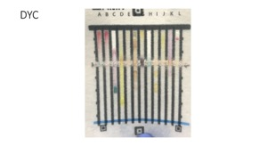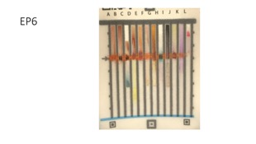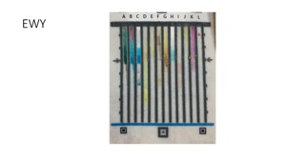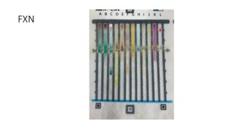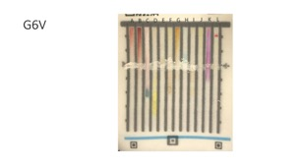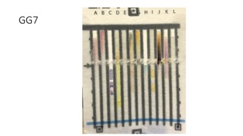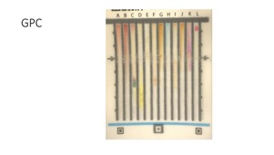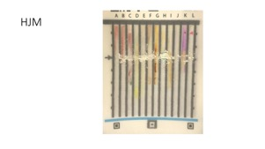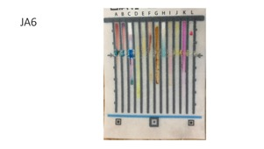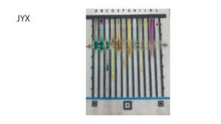

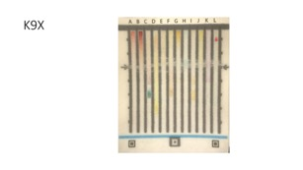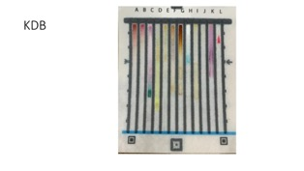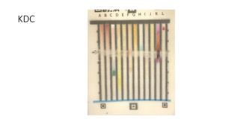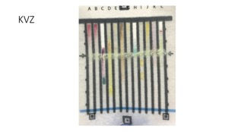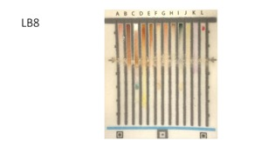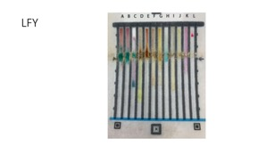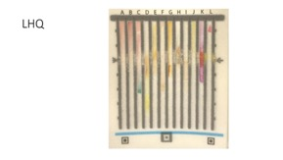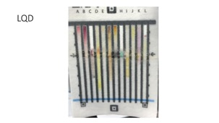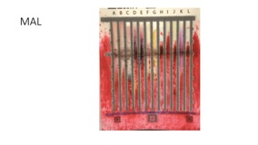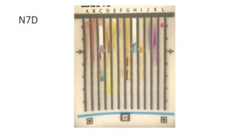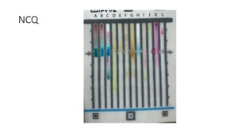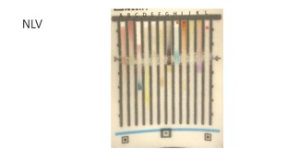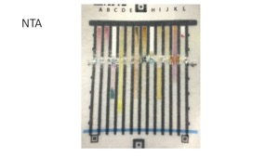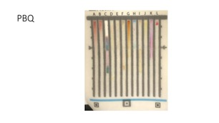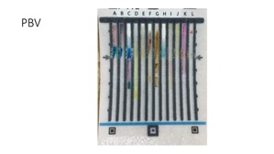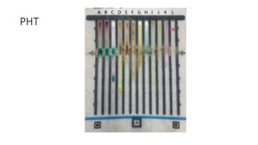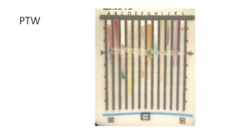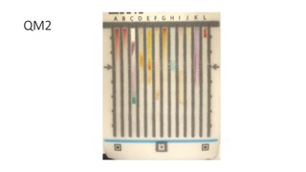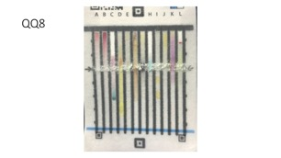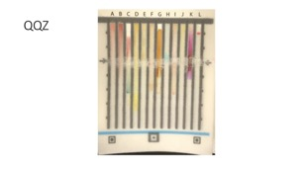
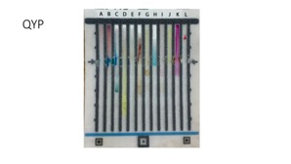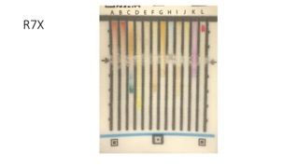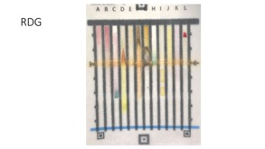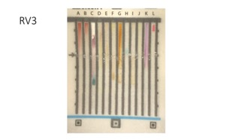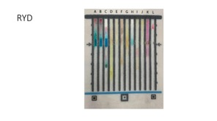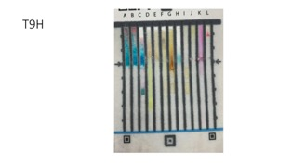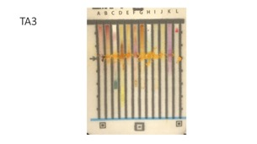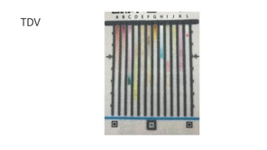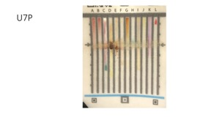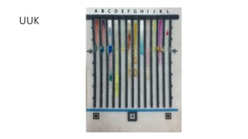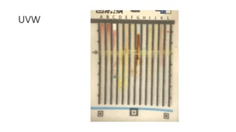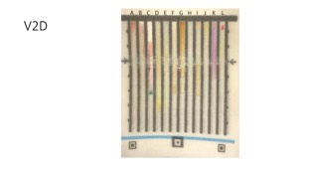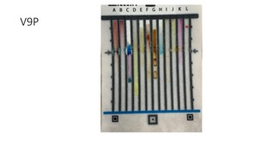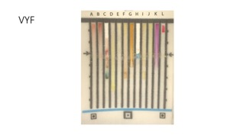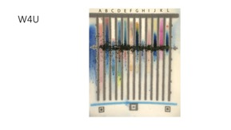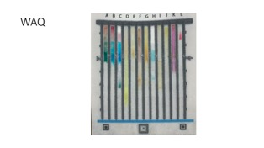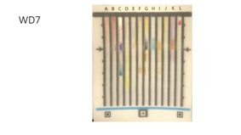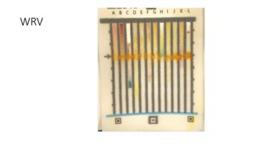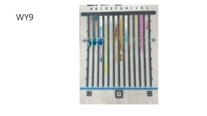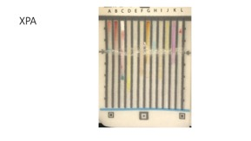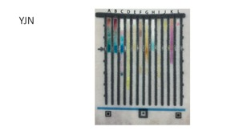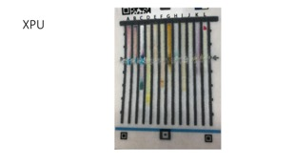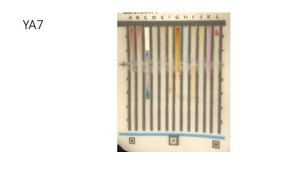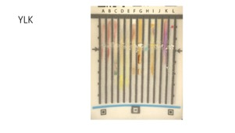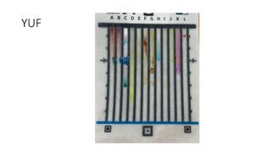

S14. Stability Testing

Lane | Chemical Test | Analyte Used | 1 Week | 1 Month | 3 Months
A | Acidic Co(SCN)₂ | Ciprofloxacin | Hot: PASS | Hot: PASS | Hot: PASS
A | Acidic Co(SCN)₂ | Ciprofloxacin | Lab Temp: PASS | Lab Temp: PASS | Lab Temp: PASS
A | Acidic Co(SCN)₂ | Ciprofloxacin | Cold: PASS | Cold: PASS | Cold: PASS
B | Neutral Co(SCN₎₂ | Diethylcarbamazine Citrate | Hot: PASS | Hot: PASS | Hot: PASS
B | Neutral Co(SCN₎₂ | Diethylcarbamazine Citrate | Lab Temp: PASS | Lab Temp: PASS | Lab Temp: PASS
B | Neutral Co(SCN₎₂ | Diethylcarbamazine Citrate | Cold: PASS | Cold: PASS | Cold: PASS
C | Basic Co(SCN)₂ | Ciprofloxacin | Hot: PASS | Hot: FAIL | Hot: FAIL
C | Basic Co(SCN)₂ | Ciprofloxacin | Lab Temp: PASS | Lab Temp: PASS | Lab Temp: PASS
C | Basic Co(SCN)₂ | Ciprofloxacin | Cold: PASS | Cold: PASS | Cold: PASS
D | P-Nitroaniline | 50% Amoxicillin/50% Starch | Hot: PASS | Hot: PASS | Hot: PASS
D | P-Nitroaniline | 50% Amoxicillin/50% Starch | Lab Temp: PASS | Lab Temp: PASS | Lab Temp: PASS
D | P-Nitroaniline | 50% Amoxicillin/50% Starch | Cold: PASS | Cold: PASS | Cold: PASS
E | Sulfanilamide | 50% Amoxicillin/50% Starch | Hot: PASS | Hot: PASS | Hot: PASS
E | Sulfanilamide | 50% Amoxicillin/50% Starch | Lab Temp: PASS | Lab Temp: PASS | Lab Temp: PASS
E | Sulfanilamide | 50% Amoxicillin/50% Starch | Cold: PASS | Cold: PASS | Cold: PASS
F | Naphthoquinone Sulfonate | Ciprofloxacin | Hot: PASS | Hot: PASS | Hot: PASS
F | Naphthoquinone Sulfonate | Ciprofloxacin | Lab Temp: PASS | Lab Temp: PASS | Lab Temp: PASS
F | Naphthoquinone Sulfonate | Ciprofloxacin | Cold: PASS | Cold: PASS | Cold: PASS
G | Starch | 50% Amoxicillin/50% Starch | Hot: PASS | Hot: PASS | Hot: PASS
G | Starch | 50% Amoxicillin/50% Starch | Lab Temp: PASS | Lab Temp: PASS | Lab Temp: PASS
G | Starch | 50% Amoxicillin/50% Starch | Cold: PASS | Cold: PASS | Cold: PASS
H | Ethambutol | 50% Amoxicillin/50% Starch | Hot: PASS | Hot: FAIL | Hot: FAIL
H | Ethambutol | 50% Amoxicillin/50% Starch | Lab Temp: PASS | Lab Temp: PASS | Lab Temp: PASS
H | Ethambutol | 50% Amoxicillin/50% Starch | Cold: PASS | Cold: PASS | Cold: PASS
I | FeCl₃ | Epinephrine | Hot: PASS | Hot: PASS | Hot: PASS
I | FeCl₃ | Epinephrine | Lab Temp: PASS | Lab Temp: PASS | Lab Temp: PASS
I | FeCl₃ | Epinephrine | Cold: PASS | Cold: PASS | Cold: PASS
J | Ninhydrin | 50% Amoxicillin/50% Starch | Hot: PASS | Hot: PASS | Hot: PASS
J | Ninhydrin | 50% Amoxicillin/50% Starch | Lab Temp: PASS | Lab Temp: PASS | Lab Temp: PASS
J | Ninhydrin | 50% Amoxicillin/50% Starch | Cold: PASS | Cold: PASS | Cold: PASS
K | Dimethylamino-cinnamaldehyde | Indole | Hot: PASS | Hot: PASS | Hot: PASS
K | Dimethylamino-cinnamaldehyde | Indole | Lab Temp: PASS | Lab Temp: PASS | Lab Temp: PASS
K | Dimethylamino-cinnamaldehyde | Indole | Cold: PASS | Cold: PASS | Cold: PASS
L | Timer | Water | Hot: PASS | Hot: PASS | Hot: PASS
L | Timer | Water | Lab Temp: PASS | Lab Temp: PASS | Lab Temp: PASS
L | Timer | Water | Cold: PASS | Cold: PASS | Cold: PASS

