CREATING A DATA MODEL DESIGN of a COMPANY

E-R Diagram
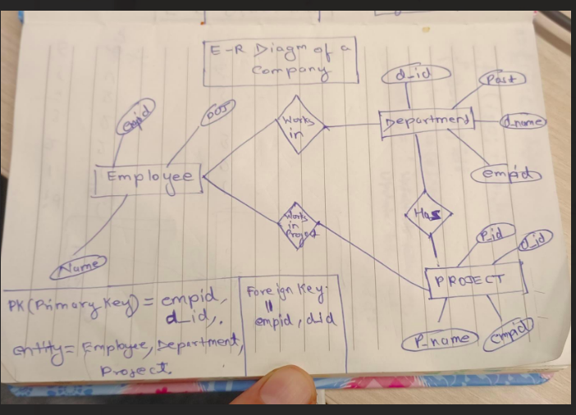

n

Data model design = E-R diagram

Data rules which shows the representation in E-R diagram -:

1- entity =

2- Attribute =

3- Relationship =

4- one to one -

5- one to many -

Description
1- PRIMARY KEY – empid, d_id.
2- ENTITIES – Employee , Department and Project .
3- FOREIGN KEY – empid ,d_id .
4- one to one relationship – Department project

5 – one to Many relationship - Department
Employee
Project

POPULATING THE DATA IN MY SQL DATABASE

Reasons to use Mysql Database-:

a- open source and compatible .
b- fast and reliable .
c- Scalability.

* Creating three tables Employee,Department and Project with their description ..
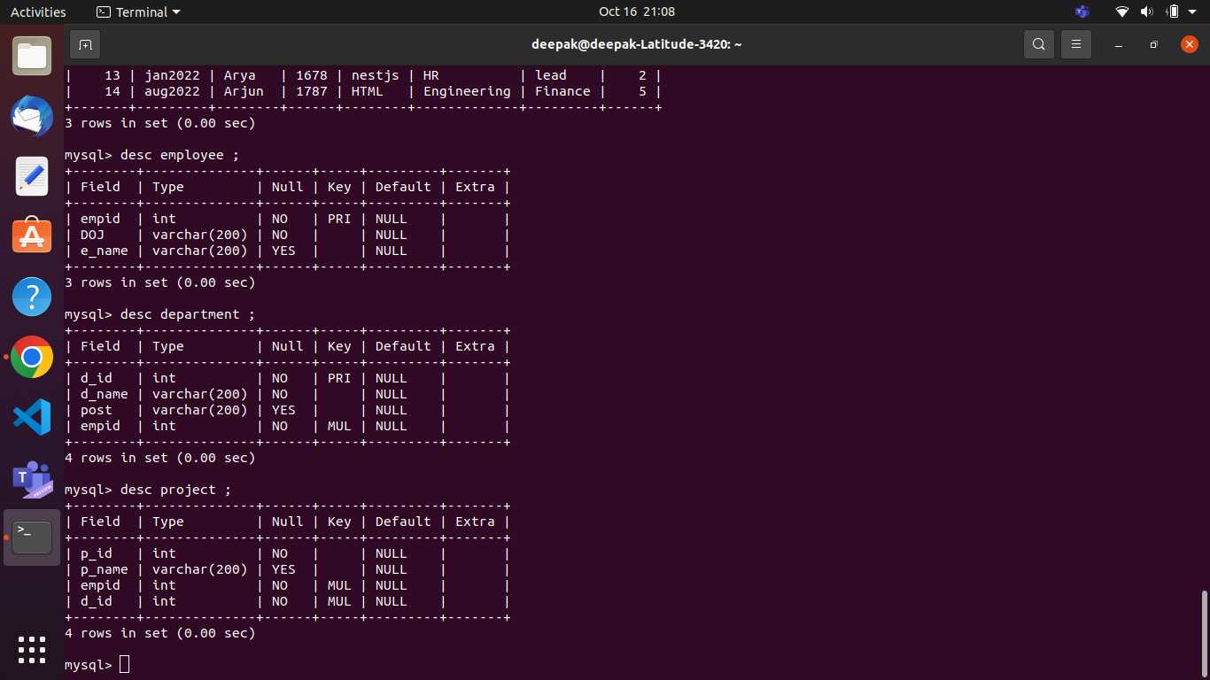

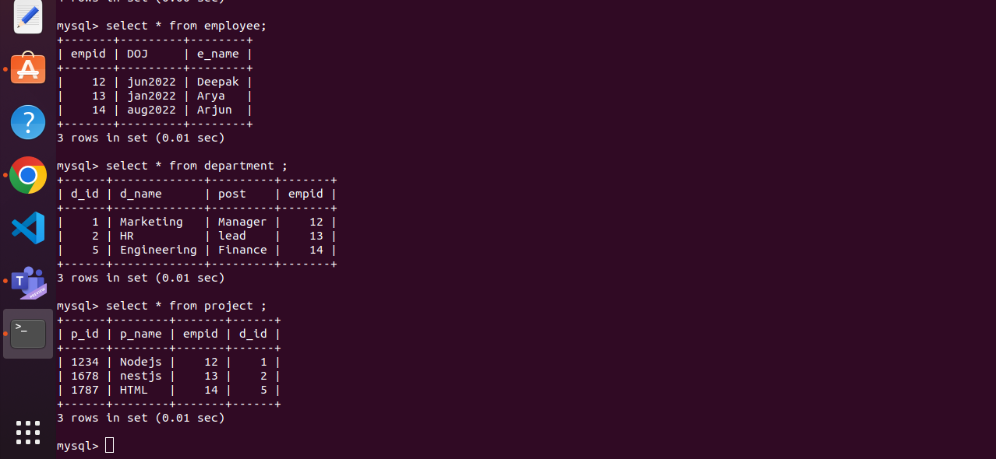
* After inserting their values..

* Joining three tables Employee , Department and project through inner join ..

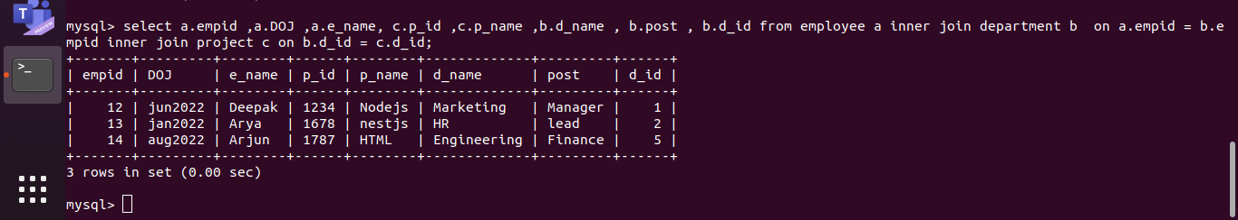
*

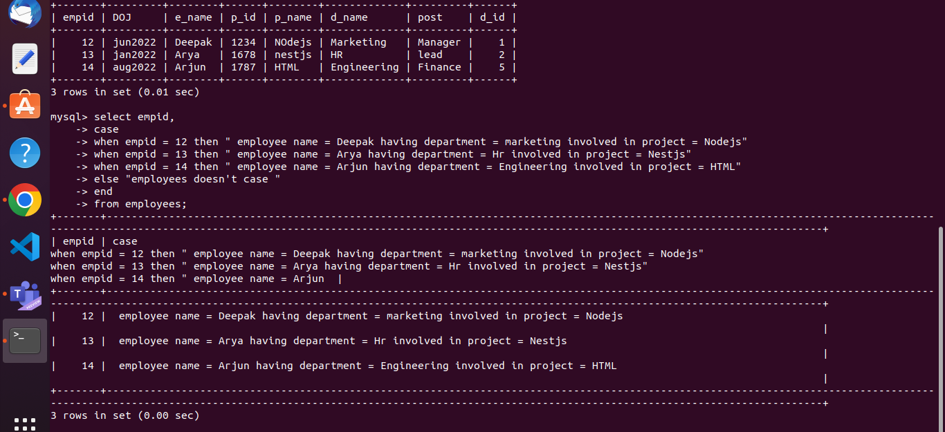
* Below mention Various use cases..

