SUPPLY UNDER GST – SCHEDULE 2

- Transfer of title of moveable goods = supply of goods(SOG)
- Transfer of right to use of moveable goods = supply of service(SOS)
- transfer of title/ sell of land and building = outside of GST laws(NA)
- transfer of right to use(let out, lease, hire, license) of L&B = SOS
- treatment/process on material of another person (JOB WORK) = SOS
- Transfer of title of business assets = SOG
- Business assets Put to use for another person/ transfer of right to use = SOS
- Renting of immoveable property = SOS
- Sale of Building
  - If whole consideration paid After Receiving completion certificate = GST-NA
  - If whole/part of consideration paid before Receiving completion certificate = SOS
- Temporary transfer/ permitting to use any IPR (Patent copyright know how etc) = SOS
- Development, design, programming, customization, adaptation, upgradation, enhancement, implementation of IT software = SOS
- Agreement and receive consideration for
  - Do an act = SOS
  - Not do an act = SOS
  - To tolerate an act = SOS
- Works contract Related to construction, Repair, Renovation (THRKADARI) = SOS
- Restaurant service = SOS
- Business Assets deemed to supply on day Immediately preceding the day a taxable person under GST ceases to be a taxable person.
  - Exception In following cases Deemed supply not Applicable
    - Business transfer As Going Concern to another person
    - Business is carried on by legal/personal representative

VALUE OF SUPPLY

- IF Question gives rate of gst and int/late fee/penalty charged
  - Always assume int/late fee/penalty amount is inclusive GST
  - You have to exclude GST from such payments
- Else if gate not give then assume
  - It is exclusive of gst

Ex - if late fee = 5900, gst rate = 18%
Therefore late fee = (5900*100)/118 = 5000

TIME OF SUPPLY

Sale of goods on continuous basis- 12(2), section 31 due date calculation
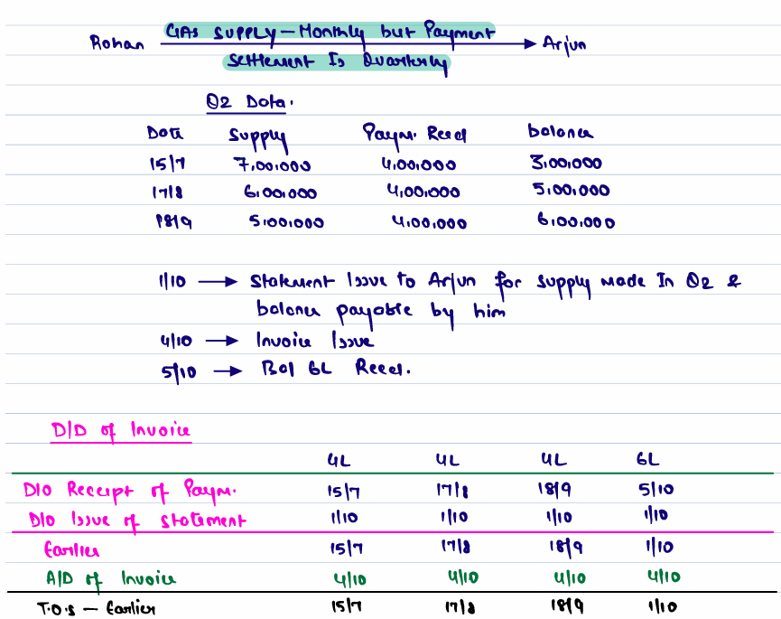

PLACE OF SUPPLY

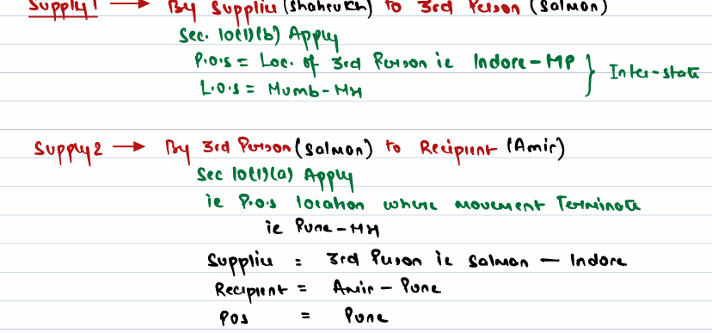
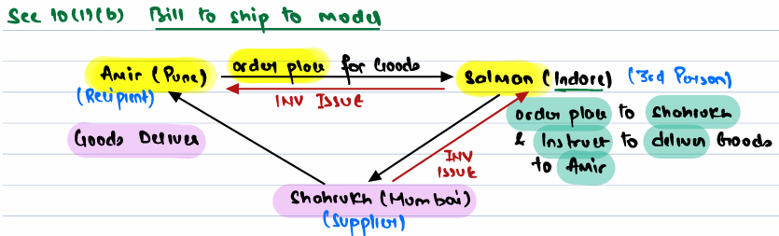
Section 12(9)
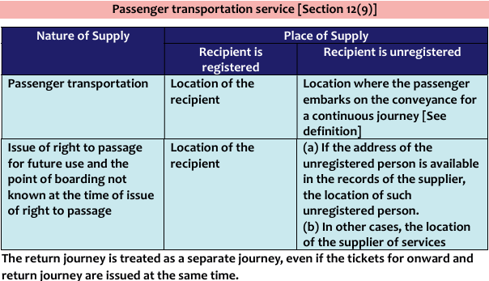

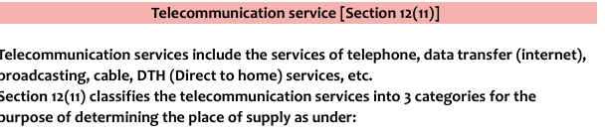
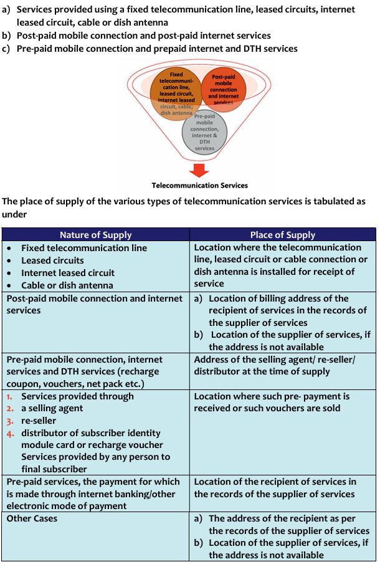

Input tax credit
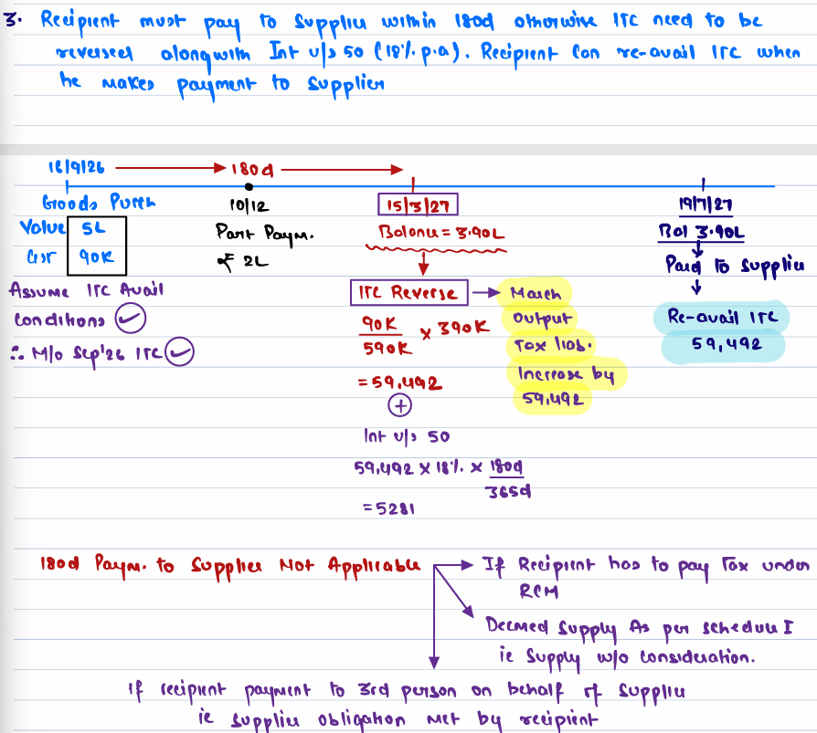
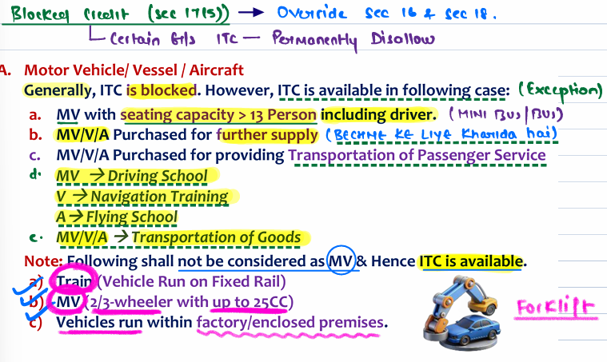
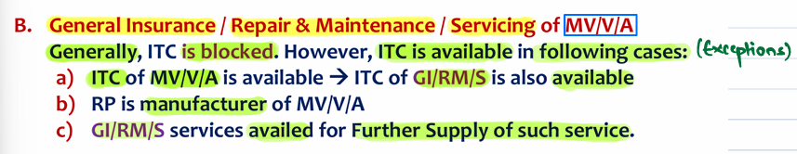
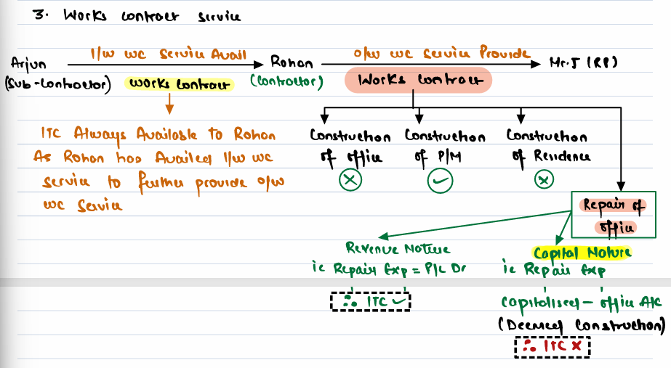
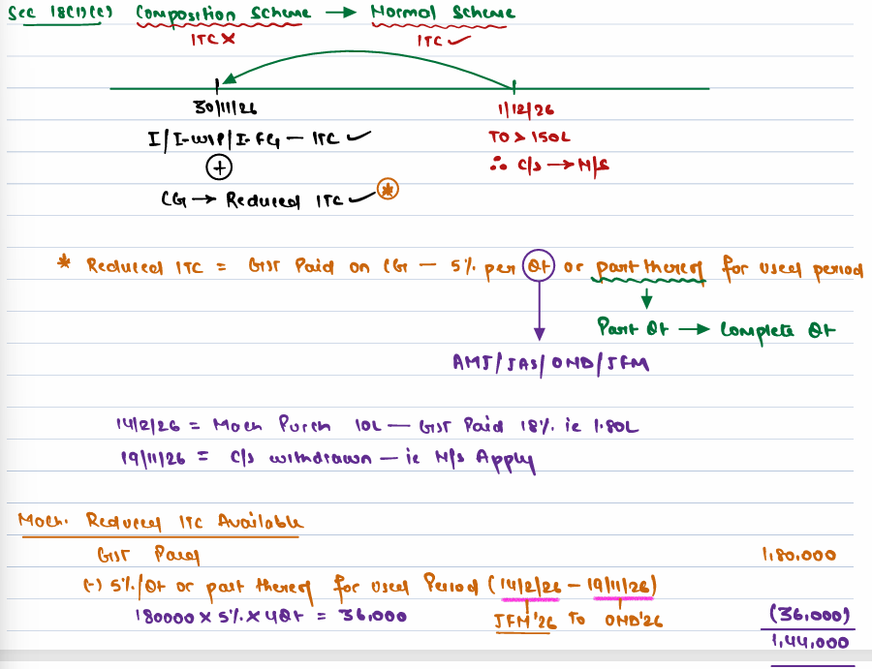
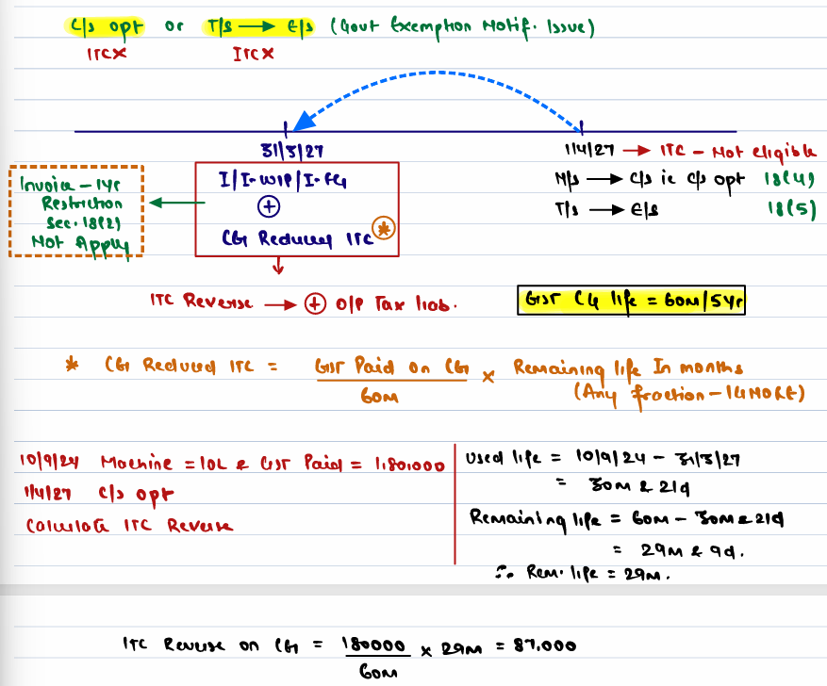
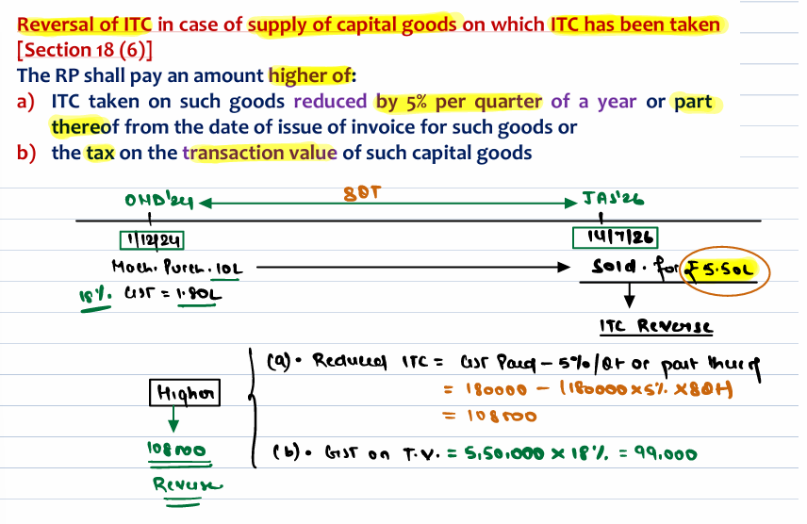

Clarification on availability of ITC in respect of warranty replacement of parts and repair services during warranty period

Issue 1: There are cases where the original equipment manufacturer offers warranty for the goods supplied by him to the customer and provides replacement of goods or its parts and/ or repair services to the customer during the warranty period, without separately charging any consideration at the time of such replacement/ repair services. Whether in such cases, the manufacturer is required to reverse the input tax credit in respect of such replacement of goods or its parts, as the case may be or supply of repair services as part of warranty, in respect of which no additional consideration is charged from the customer?

Clarification: When a manufacturer provides warranty services (e.g., replacement of goods or parts and/or repair services) without additional charges during the warranty period, the cost of these services is already included in the value of the original supply. Such warranty services are not treated as exempt supplies, and the manufacturer is not required to reverse Input Tax Credit (ITC) on the goods or services used for providing these warranty services.

Issue 2: Where the distributor provides replacement of parts to the customer as part of warranty on behalf of the manufacturer, whether the distributor would be required to reverse the ITC in respect of such replacement of parts? There are four scenarios for replacement of goods or parts under warranty:

Case (a) Distributor Replaces Parts Using Own Stock or Purchases from a Third Party:
• Distributor charges the manufacturer for the parts via a tax invoice.
• GST is payable by the distributor on this supply, and the manufacturer can claim ITC.
• No ITC reversal is required for the distributor.

Example: Distributor XYZ replaces a part worth ₹10,000 (from its stock or third party) and charges the manufacturer ABC Ltd. via a tax invoice. GST of ₹1,800 is paid by XYZ, and ABC Ltd. claims ITC.

Case (b) Manufacturer Provides Parts to Distributor for Warranty Replacement:
• Manufacturer supplies parts to the distributor for warranty replacement without charging any consideration.
• No GST is payable, and no ITC reversal is required by the manufacturer.

Example: Distributor XYZ requests parts from the manufacturer ABC Ltd., who sends them without charging any consideration. No GST applies, and ABC Ltd. doesn’t reverse ITC.
Case (c) Distributor Uses Manufacturer's Supplied Stock and Manufacturer Issues a Credit Note:
• Distributor replaces parts from prior supplies by the manufacturer.
• Manufacturer issues a credit note and adjusts tax liability as per Section 34(2) of the CGST Act, 2017, provided the distributor reverses ITC on the replaced parts.

Example: Distributor XYZ replaces a part worth ₹5,000 from previous supplies received from ABC Ltd., and ABC issues a credit note for the same. Tax liability is adjusted if XYZ reverses ITC on the part.

Case (d) Manufacturer Replenishes Distributor's Stock Without Consideration:
• Distributor replaces parts using his own stock and requests replenishment from the manufacturer.
• Manufacturer replenishes parts via a delivery challan without charging consideration. • No GST is payable, and no ITC reversal is required by the manufacturer.

Example: Distributor XYZ replaces a part from its own stock and requests replenishment from ABC Ltd., who provides the part worth ₹7,000 via delivery challan without charging consideration. No GST applies, and ABC Ltd. doesn’t reverse ITC.

Issue 3: Where the distributor provides repair service, in addition to replacement of parts or otherwise, to the customer without any consideration, as part of warranty, on behalf of the manufacturer but charges the manufacturer for such repair services either by way of issue of tax invoice or a debit note, whether ITC is available on such activity?

Clarification: When a distributor provides repair services to the customer as part of the warranty, without charging the customer, but charges the manufacturer for these services through a tax invoice or debit note, it constitutes a supply of service. The manufacturer, as the recipient of the service, is liable to pay GST on this supply. Furthermore, the manufacturer is eligible to claim Input Tax Credit (ITC) on the GST paid for these repair services, subject to the conditions specified in the CGST Act, 2017.
