REGISTRATION UNDER GST

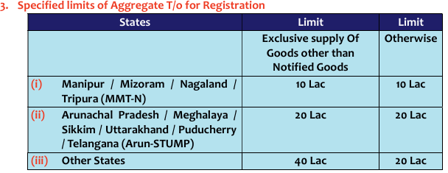
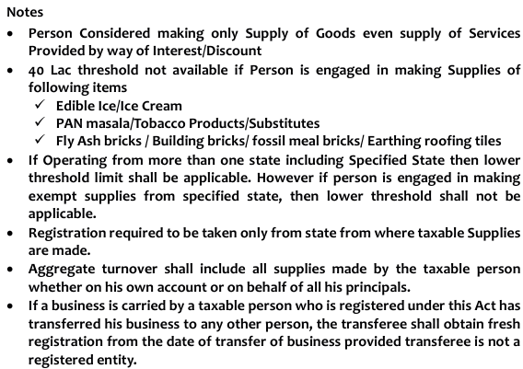

Section 25 Registration Procedure

- Person who is liable for registration u/s 22 or u/s 24 shall apply for registration within 30 days from the date he becomes liable for registration.
- CTP/NRTP shall apply for registration at least 5 days prior to commencement of business.
- Registration is to be taken state wise i.e. there is no centralized registration under GST.
- Within a state an entity having different branches can have single registration wherein it can declare once place as principal place of business and other branches as Additional place of business.
- A person having multiple places of business within a state or UT can apply for separate registration for each such place of business.
- Person having separate registration from same PAN shall be treated as Distinct Person for each such registration.
- If one unit in SEZ & another in non SEZ area in Same state then Separate Registration is Required.
- Person may opt to get voluntarily register even not liable as per section 22 or 24.
- PAN is mandatory for having the registration under GST except NRTP can get passport based Registration.
- Effective date of registration:
  - If applied for registration within 30 days of being liable for registration
    - date of being liable for registration is Effective date of registration
  - if applied for registration after 30
    - date on which certificate of registration granted
  - voluntary registration
    - date on which certificate of registration granted
- Unique Identification Number (might come for standalone question for 4 marks)
  - Who shall apply: • Specialized Agency of UN or any financial institution of UN • Consulate • Embassies
  - Purpose- To obtain refund of tax paid on Supplies of GIS supplied to them
  - Note: • It is Centralized number not state wise • UIN Holder not a registered person, hence not a taxable person.
- Temporary Registration In a search, survey, enquiry, inspection or any other proceedings of the act, Proper officer finds that a person is liable for registration but failed to apply for registration, then such officer may register the person on temporary basis. Such person shall either:
  - Submit an application for registration within 90 days from the date of grant of temporary registration, or
  - File an appeal against such temporary registration.
- In case (b), if the Appellate Authority upholds the liability to registration, application for registration shall be submitted within 30 days from the date of issuance of such order of the Appellate Authority. GSTIN thereafter granted shall be effective from the date of order of the proper officer granting temporary registration.

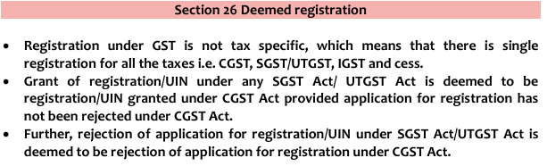

q. who needs to authenticate and not authenticate Aadhar?
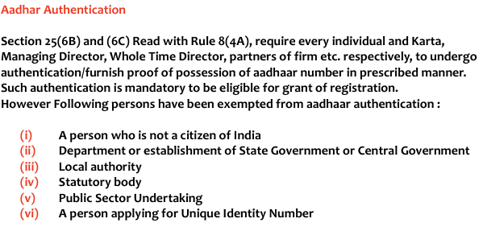
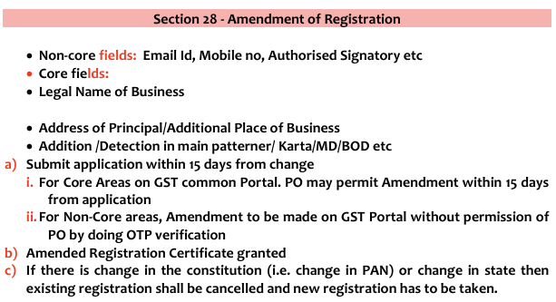
If the proper officer fails to take any action,- (a) within a period of 15 working days from the date of submission of the application, or
(b) within a period of 7 working days from the date of the receipt of the reply to the show cause notice, the certificate of registration shall stand amended to the extent applied for and the amended certificate.

Section 29 Cancellation of Registration
- Voluntary Cancellation (By registered Person)
Circumstance to cancel Registration (Apply within 30 days)
a) Business Discontinued / Transferred / Armed Granted / Merger / Demerger / Disposal / Death of properties
b) Change in Constitution of Business
c) No Longer liable to register u/s 22 or 24 d) Optout of voluntary Registration.
- Circumstance when PO cancel Registration: =>(important)
  - If contravened following Provisions:
    - Mismatch of GSTR-1/1A & GSTR-3B
    - Mismatch of GSTR-2B & GSTR-3B
    - Doesn’t conduct Business from Registered place.
    - Violate Provision of anti-Profiteering
    - Doesn’t Provide Bank A/c details within time
    - Issue Invoice / Bill without supply of Goods & Services
    - Avail ITC in Violence of Act
    - Violates rule 86 B (Maximum ITC allowed 99%)
  - Registration obtained by Means of Fraud/wilful misstatement/supersession of facts
  - Voluntary Registration person not commenced business within 6 months from Registration
  - Not File return by composition supplier beyond 3 months from due date.
  - Not file return by normal supplier
    - Monthly Return - For continuous 6 months
    - Quarterly return - For 2 tax periods.
- Suspension of registration [First proviso to section 29(1) and second proviso to section 29(2) read with rule 21A] A.
  - Suspension During Cancellation Proceedings:
    - • If a registered person applies for cancellation, their registration will be suspended from:
      - The date of submission of the cancellation request, OR
      - The date from which cancellation is sought, whichever is later.
    - • If cancellation is initiated by the department (Suo-moto), the proper officer decides the suspension date.
  - Suspension Due to Discrepancies or Non-Compliance:
    - • Registration can be suspended if there are major mismatches between:
      - GSTR-1/1A vs. GSTR-3B OR GSTR-2B vs. GSTR-3B, indicating violations.
      - Non-compliance with Rule 10A (failure to furnish bank details after registration).
    - • The taxpayer will be notified electronically or via email and given 30 days to explain why registration should not be cancelled.
    - • No refund under Section 54 will be granted during the suspension period.
  - Restrictions During Suspension:
    - • The taxpayer cannot make taxable supplies during suspension i.e. No tax invoice can be issued, and no tax can be charged during this period.
    - • The taxpayer is not required to file GST returns
  - Revocation of Suspension:
    - • Suspension automatically ends when the cancellation proceedings conclude.
    - • Revocation is effective from the date the suspension started.
    - • The proper officer can revoke suspension anytime during cancellation proceedings if deemed necessary.
  - If registration was suspended due to non-filing of GST returns, suspension will end once all pending returns are filed.
  - If registration was suspended due to non-compliance with Rule 10A, suspension will be revoked upon compliance.
  - Effect of Suspension Revocation: Once suspension is revoked,
    - Revised tax invoices (Section 31(3)(a)) must be issued for supplies made during suspension.
    - First return (Section 40) provisions will apply for supplies made during this period.
- Amount payable on cancellation of registration [Section 29(5) & (6)]
  - Effective Date & Payment of Dues:
    - • The cancellation of registration will be effective from the date decided by the proper officer and mentioned in the cancellation order.
    - • The officer may direct the taxpayer to pay any outstanding tax, interest, or penalty, including the amount payable under Section 29(5).
  - Payable amount under section 29(5) Reversal of ITC on Inputs: The taxpayer must debit their electronic credit/cash ledger by the higher of:
    - ITC on inputs (proportionate to the invoices where ITC was claimed).
    - Output tax payable on such goods.
  - Reversal of ITC on Capital Goods & Machinery: The taxpayer must reverse ITC on capital goods or plant & machinery, whichever is higher of:
    - ITC calculated on the remaining useful life (assuming a 5-year life) as per Rule 44.
    - Tax on the transaction value of such capital goods as per Section 15.
- Other Points
  - Even after cancellation, the taxpayer is still liable to pay any pending tax or dues for the period before cancellation. (Section 29(3))
  - If registration is cancelled under the SGST/UTGST Act, it is automatically cancelled under the CGST Act as well. (Section 29(4))
  - The taxpayer will be notified via SMS and email once registration is cancelled. The cancellation order will be sent to the primary authorized signatory through email and SMS.
  - The taxpayer cannot file returns for periods after cancellation. However, they can still submit returns for the period before cancellation, when registration was active.

Revocation of cancellation of registration Section 30/Rule 23

- Application for Revocation:
• If a proper officer cancels a GST registration Suo-motu, the taxpayer can apply for revocation within 90 days from the date of the cancellation order.
• This period can be extended by the Commissioner or an authorized officer (not below the rank of Additional/Joint Commissioner) for up to 180 more days (i.e., 90 days + 180 days).
• If cancellation was due to non-filing of returns, the taxpayer must first file all pending returns and clear dues before applying for revocation.
- Approval of Revocation: If the proper officer is satisfied, he will approve the revocation request within 30 days of receiving the application and communicate the decision to the applicant.
- Rejection of Revocation:
• If the officer intends to reject the revocation request, he must first issue a Show Cause Notice (SCN) to the applicant.
• The applicant must submit a reply within 7 working days of receiving the SCN.
• The proper officer must then dispose of the application (approve/reject) within 30 days of receiving the applicant's response.
- Filing of Pending Returns After Revocation: Once cancellation is revoked, the taxpayer must file all pending returns (from the effective cancellation date to the date of revocation order) within 30 days of the revocation order.
- Deemed Revocation Under CGST Act: If cancellation is revoked under the SGST Act / UTGST Act, it is automatically deemed revoked under the CGST Act.

