Exdion EyeQ Endorsement Request
- Under Endorsement Management, replace the text Configure policy endorsements and modifications with Request for policy change request form
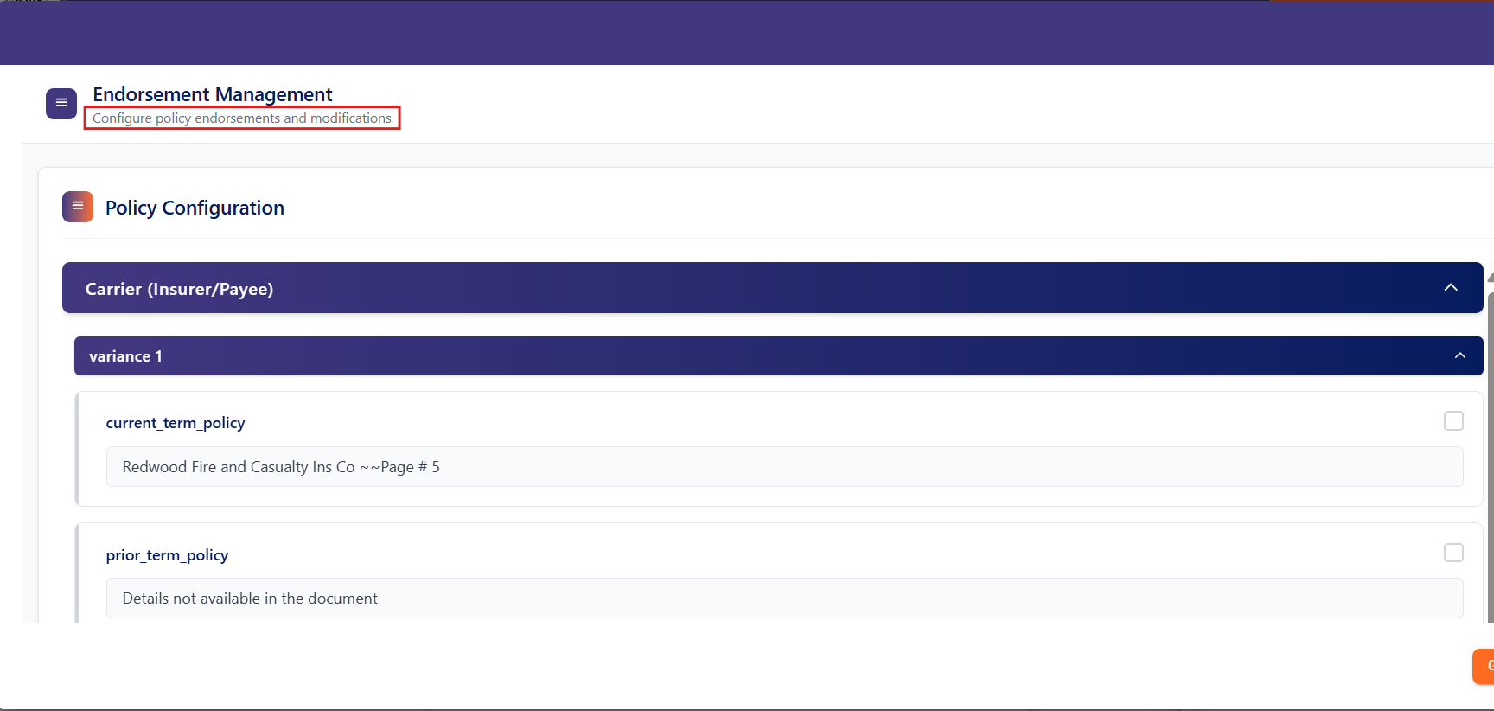
- Replace Policy configuration with the below Instruction.
Instruction:
Select the checkbox next to each variance to automatically update the details in the endorsement change request form.

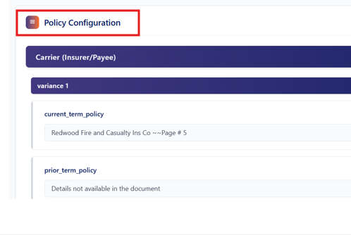

- Replace Policy Editor with Change Request Form Editor
- Broker information needs to be updated in the policy change request

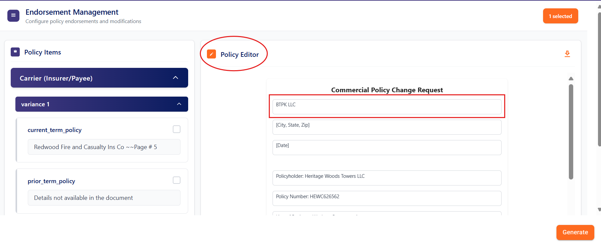
Change Request Form Editor
Broker Name instead of Named Insured
- A popup is required when clicked on ‘Generate’. Refer to the video attached in the email.

