Payroll Management System

Project Report

1/1/2022

RTD Enterprises Limited

*By -🡪*

*Tinu – 4920140*

*Rupesh – 4920130*

*Deepak - 4920108*

**Acknowledgment :**

We have taken a lot of effort into this project. However, completing this project would not have been possible without the support and guidance of a lot of individuals. We would like to extend our sincere thanks to all of them.

We are highly indebted to Dr. Archana for their guidance and supervision. We would like to thank her for providing the necessary information and resources for this project.

We would like to express our gratitude towards our parents & our friends for their kind co-operation and encouragement which helped us a lot in completing this project.

Our thanks and appreciations also goes to our class-mates in developing the project. Thank you to all the people who have willingly helped us out with their abilities.

**Introduction :**

Our project titled “Payroll Management System” is a simple system to calculate the salary of the employees of a given institute by collecting just their codes , Names and Designations.

This system asks the users to enter the data i.e. employee name and then their employee codes followed by their designations and then automatically calculates the salary of those employees based on the values provided to the system imlicitly by the programmers which cannot be altered by any normal people .It can only be altered by a technician or a programmer who can understand the code easily.

So in this way the salary data is less prone to errors as it doesn’t have any interference from any of the users and it will calculate the salary on the basis of values provided by the Progrmmer or Developer at the time of coding according to the designation of the employees.

**Working of our Project :**

Working logic of our project is very simple and easy . First the system asks the user to select an option from the givel list of choices which includes adding new data ,viewing receipt and viewing data of all the employees.

This system first asks the user to enter the details of the employee like name , employee code and designation of the employee . Then it stores the data in an ‘oll.dat’ file and then according to the format of output required it copies the data in structure variables and then print those data on console window as per the formatting requirements.

A detailed and step – by - step description of working of this system is given in the user manual section along with pictures of a trial run for a better clarification and understanding of working of payroll management system to the users.

**User Manual Section :**

* **Starting of Project :**

First copy the source code file in “c:\turbo\bin” folder and then open turbo c++ and in turbo c++ open the file and start executing it . On executing a small intro animation that tells about the developersof this project will show up like the one shown in the below picture :

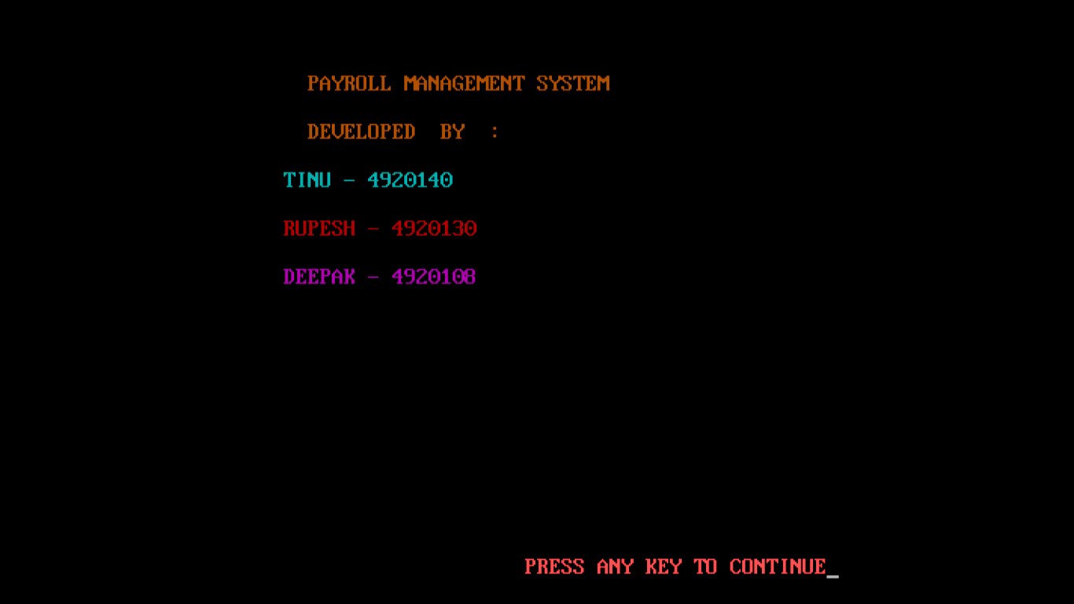

When the animation gets finished the console will ask you to press any key to continue to the introduction window . On pressing any key , the program will take you to the introduction window.

* **Intro Window :**

After animation comes the intro window that prints a specific message for users saying “WELCOME TO PAYROLL MANAGEMENT SYSTEM”,”PRESS ANY KEY TO CONTINUE” just as shown in the below picture :

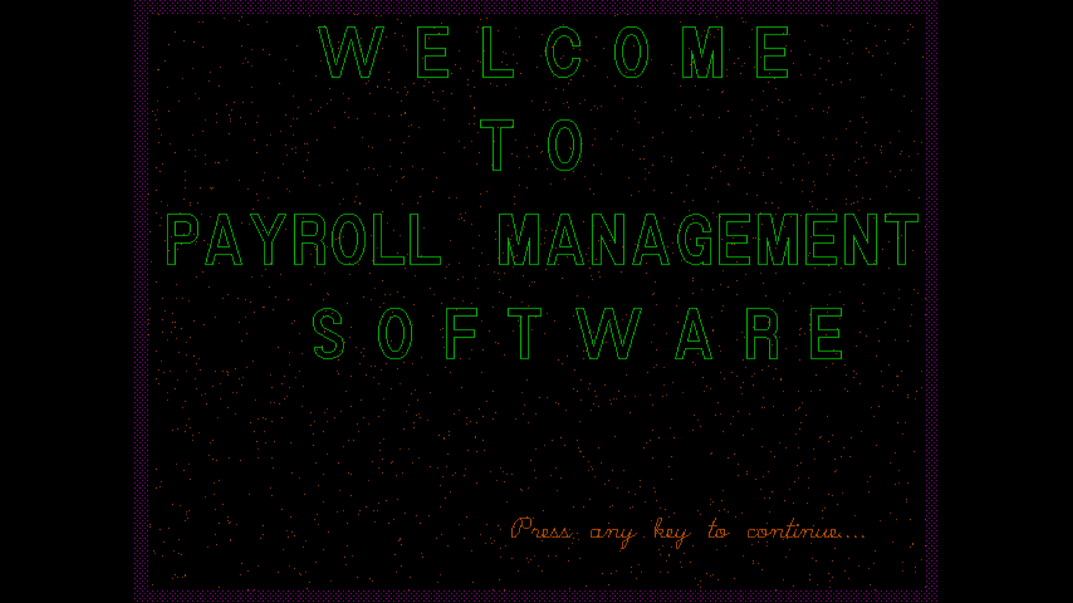

When the user presses any key on this window he is taken to a new window called main menu window.

* **Main Menu :**

After the intro window , a new window will appear called main menu window which contains various choices as shown in the picture below :

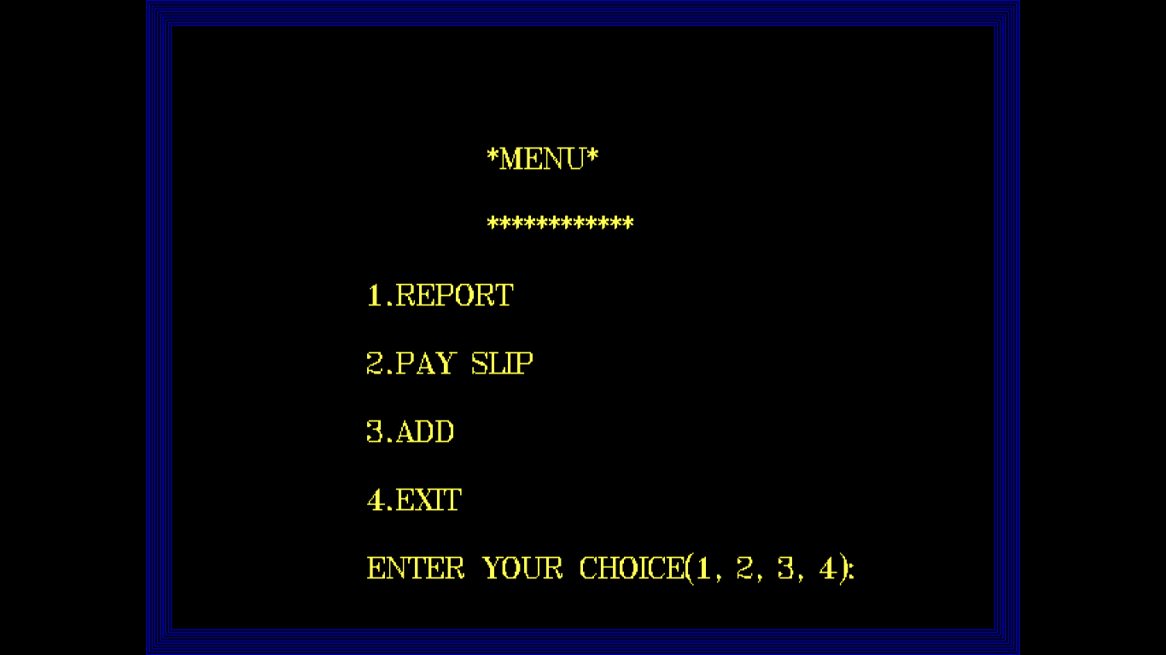

The report option is for viewing all the employees and pay slip option is used for viewing pay slip of a specific person , the third option is used for adding new employee details . The fourth option is used for terminating our program.

The pictures of all three features is shown below

* **Report Option :**

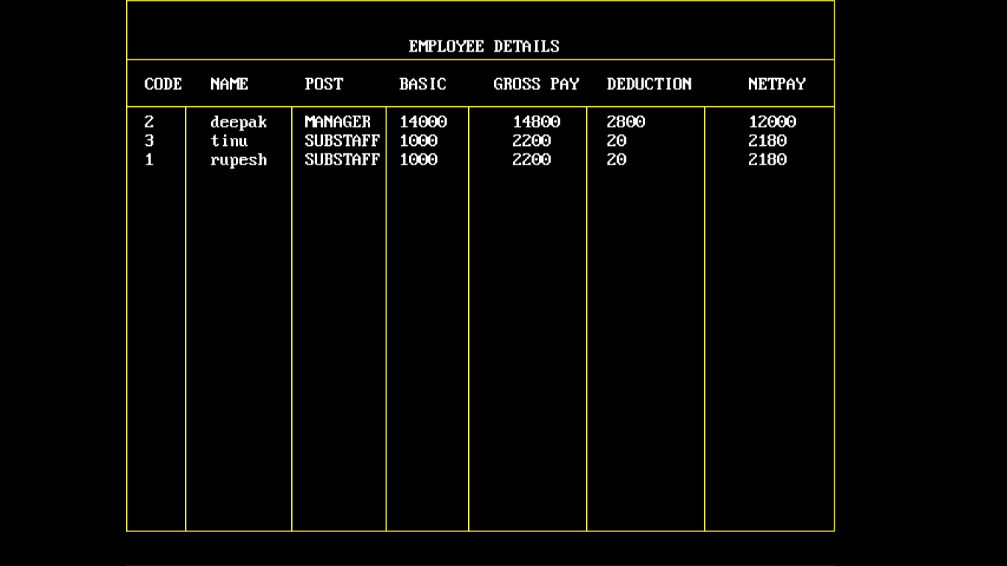

* **Pay Slip Option :**

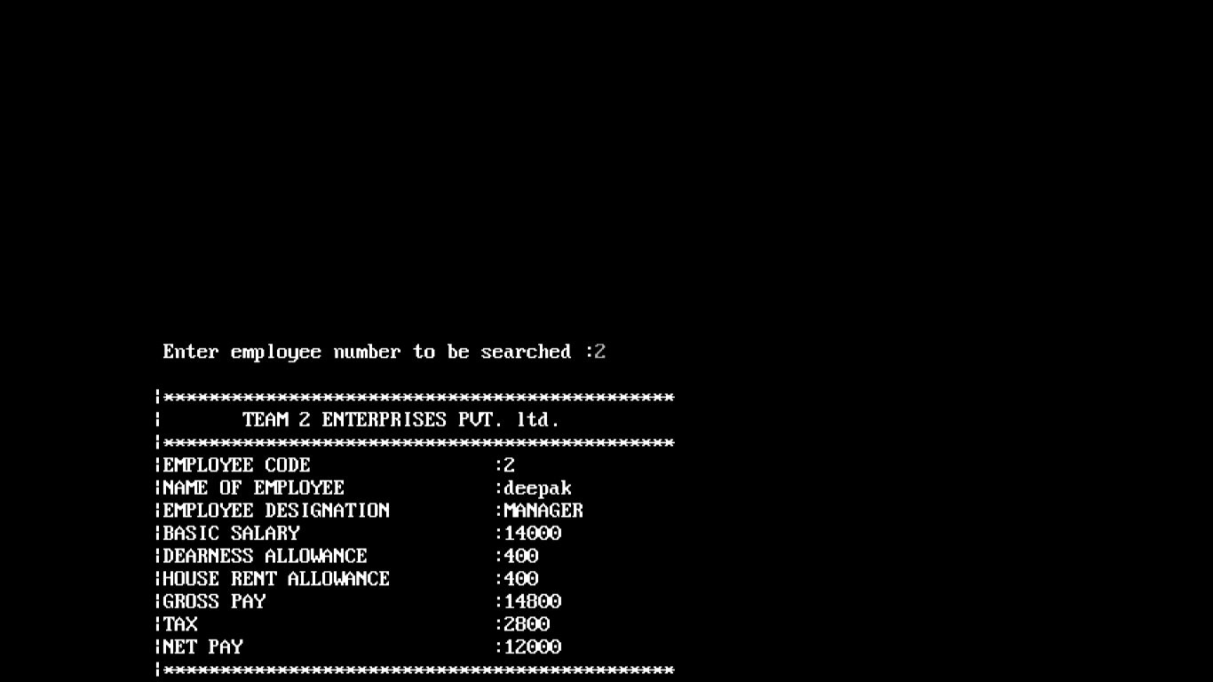

* **Add Data Option :**

