1. Go to Jenkins dashboard
2. Create the job with the name mave_war_creation of getting maven project from github and packaging the file into war then archive the artifact war file.
3. Create the job by selecting freestyle project.
4. 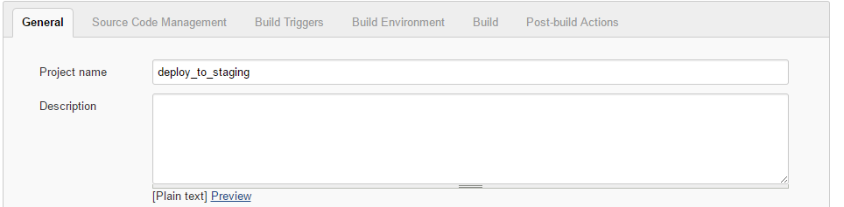
5. 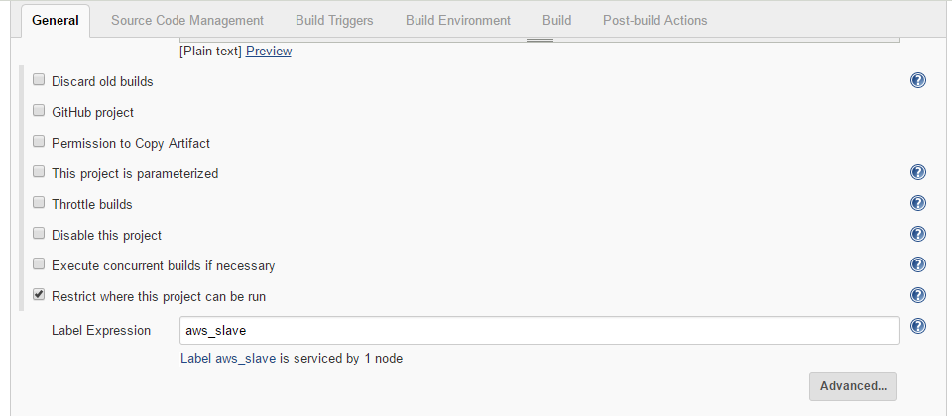You can restrict the project where it should be run by selecting the slave server
6. In Build section choose Copy artifacts from another project 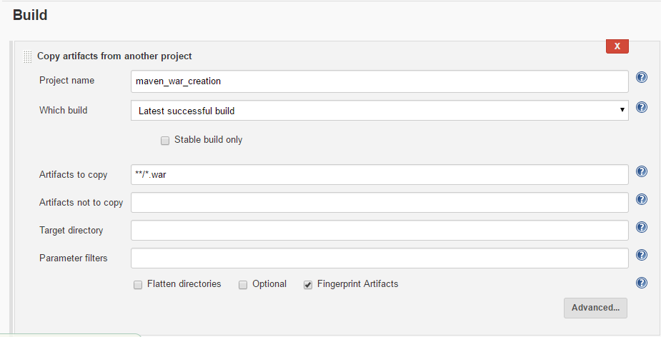 and select the maven_war_creation project from which war file need to be copied, write the war file location in artifact to copy like **/*.war
7. In Post Build section choose Deploy war/ear to Container

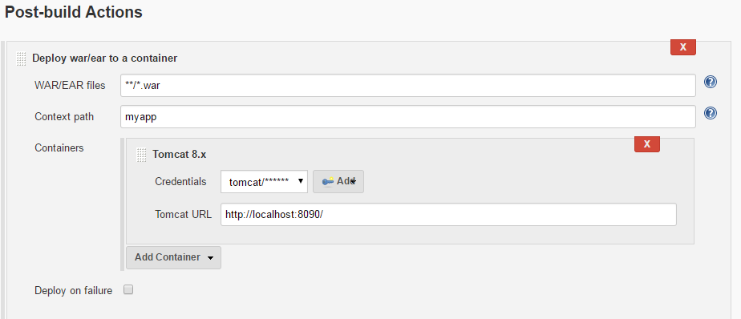 Write the war file location, enter the context path by which you can access the application. Now choose the tomcat 8.x and add the credential, it will be the same credential which you have created in tomcat-users.xml ie tomcat or Jenkins and then enter the tomcat url

<http://localhost:8090> or 8080

1. Save it.
2. Now we have to create trigger in maven_war_creation in Post build section choose build other projects

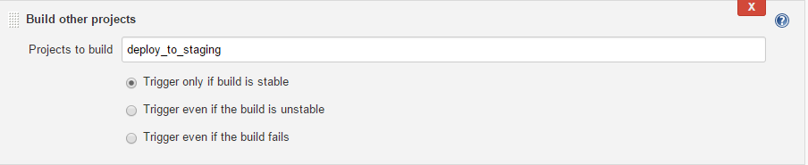

1. Save it.
2. Now trigger the build for project maven_war_creation.
3. Check the output by going http://slave:8090/myapp