**Instructions for downloading MySQL workbench**

1. Navigate to <https://dev.mysql.com/downloads/workbench/>
2. Select your operating system (Mac/Windows) and click **Download**. Example below is for MacOS:

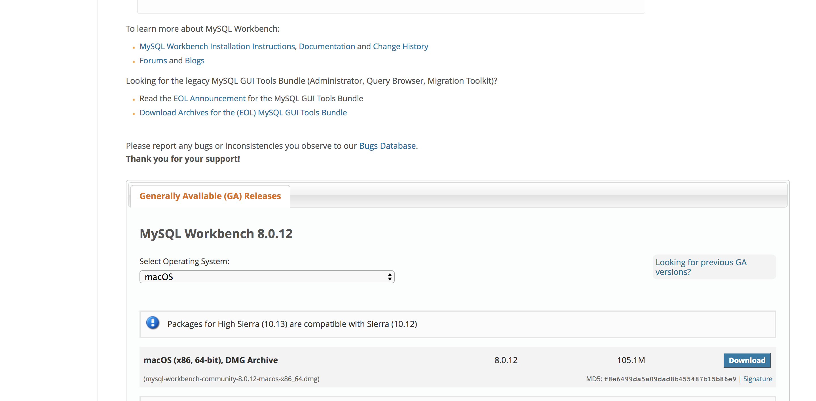

1. You will be prompted to either login to Oracle Web account or sign up for one, ignore both and click on the following the link below in blue **No thanks, just start my download:**

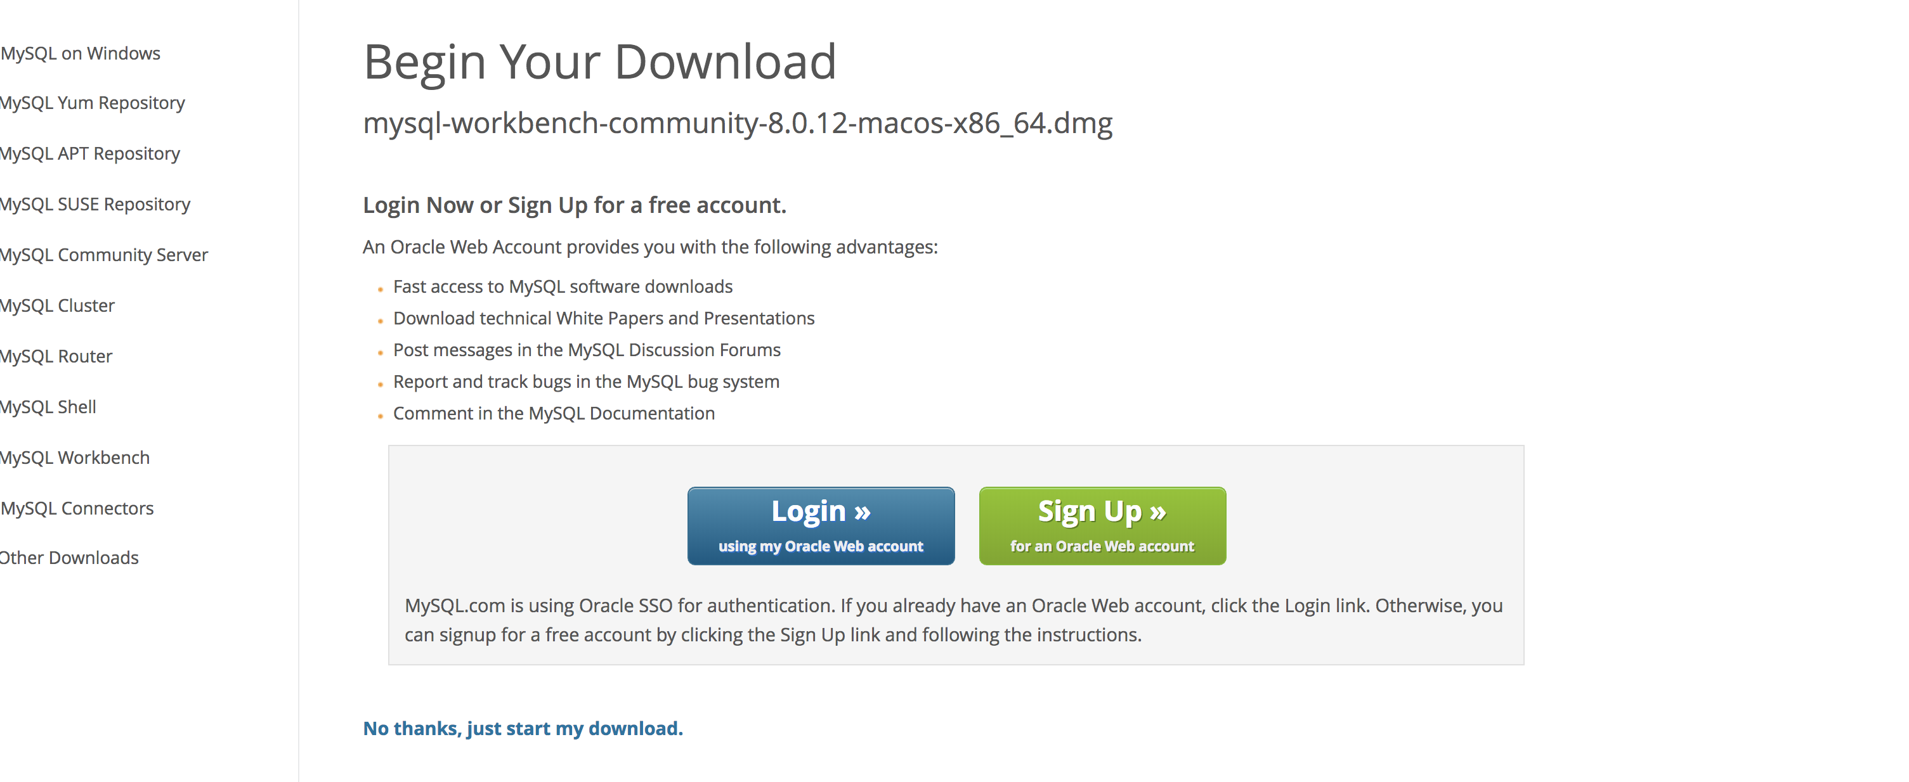

1. After the download completes, click on the dmg file as it will prompt the installer to start the download process:

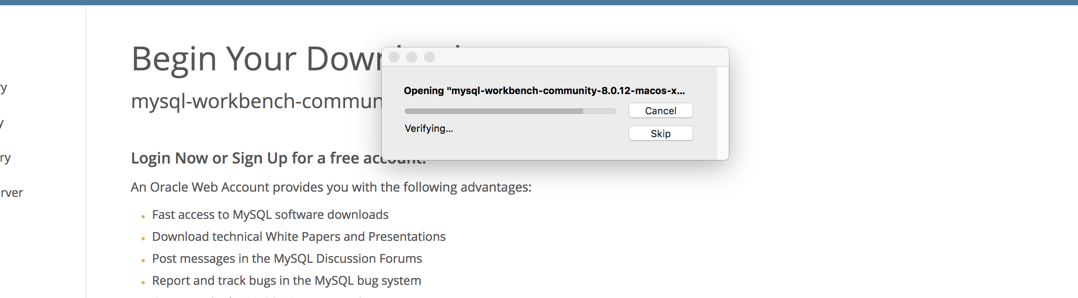

1. Move MySQL Workbench to your Applications folder:

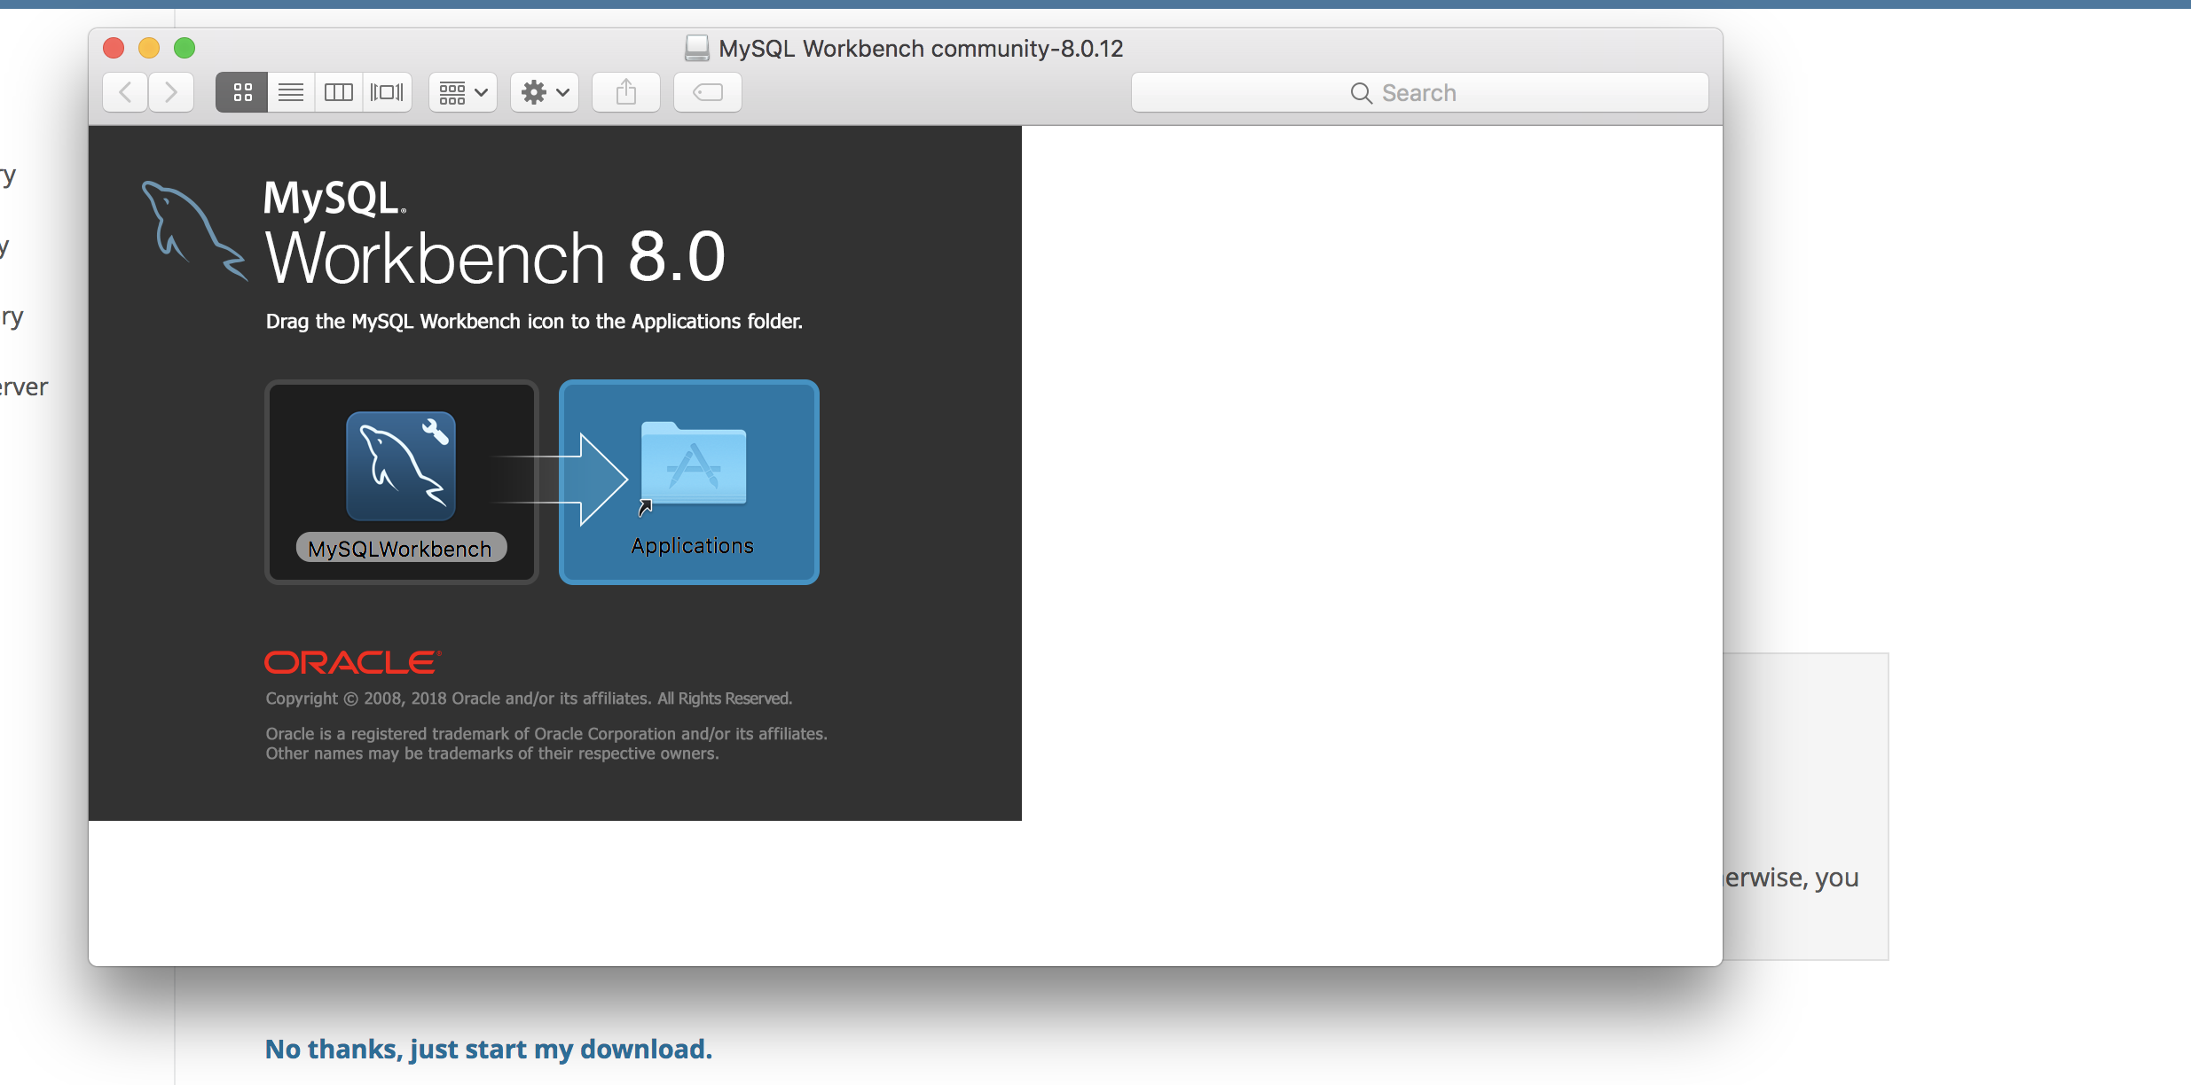

1. You will now see MySQLWorkbench in your applications folder:

