PRODUCT INVENTORY MANAGEMENT SYSTEM

A Mini project report

BACHELOR OF COMPUTER SCIENCE
(2024 – 2027)

Submitted by

DEEPA KALA S DURGASRI N
222408411 222408415

BHUVANESWARI E KAMALI PS
222408408 222408424

Under the Guidance of
Mrs. V. THILAGAVATHY M.Sc., M.Phil.
Assistant Professor
Department of Computer Science



SOKA IKEDA COLLEGE OF ARTS AND SCIENCE FOR WOMEN,
MADHANANGKUPPAM, CHENNAI – 600 099.
Affiliated to the University of Madras, Chepauk, Chennai 600 005.

ABSTRACT (Backend Product Inventory Management System):
- Purpose
  - The system is designed to manage, monitor, and control product inventory for businesses such as retail stores, warehouses, and e-commerce platforms.
  - Aims to reduce human error, optimize stock levels, and improve operational efficiency.
- Technology Stack
  - Node.js: Provides a scalable and efficient server-side runtime for handling concurrent requests.
  - Express.js: Simplifies routing, middleware integration, and RESTful API development.
  - MongoDB: Serves as a NoSQL database to store product data, inventory levels, and transaction history efficiently.
- Core Functionalities
  - Product Management: Add, update, and delete product information including name, category, price, and SKU.
  - Stock Tracking: Monitor current stock levels in real-time to prevent overstocking or stockouts.
  - Transaction Handling: Record inbound and outbound product movements for accurate inventory tracking.
  - Reporting & Analytics: Generate reports on stock levels, low-stock alerts, and product trends.
- Advantages
  - Automation: Reduces manual effort in tracking inventory.
  - Scalability: Supports businesses of varying sizes due to the flexible Node.js and MongoDB architecture.
  - Data Integrity: Maintains accurate and up-to-date inventory records.
  - Accessibility: Backend APIs allow integration with front-end applications or third-party platforms.
- Target Users
  - Retail store managers, warehouse supervisors, e-commerce administrators, and business analysts who require real-time inventory insights.
- Outcome
  - Improves decision-making, operational efficiency, and resource management by providing reliable inventory data.
  - Enhances the overall supply chain management process through centralized backend control.

CHAPTER | CONTENT | PAGE NO
1 | PROJECT OVERVIEW | 2
2 | PROJECT INSTRUCTION | 2
3 | PRE-REQUISITES | 3
4 | PROJECT ARCHITECTURE | 4
5 | TECHNICAL ARCHITECTURE | 4
6 | ER DIAGRAM | 5
7 | ROLES AND RESPONSIBILITY | 6
8 | BACKEND DEVELOPMENT | 9
9 | AUTH CONTROLLER | 10
10 | PRODUCT CONTROLLER | 11
11 | AUTH MIDDLEWARE (PRODUCT) | 12
12 | DATABASE CONFIGURATION AND SETUP | 13
13 | PROJECT EXECUTION | 15
14 | CONCLUSION | 19

PROJECT OVERVIEW:
A Backend Product Inventory Management System is a backend-focused web application developed using Node.js, Express.js, and MongoDB server-side application designed to manage, track, and control product stock efficiently for businesses such as retail stores, warehouses, or e-commerce platforms.

KEY OBJECTIVES:
- Maintain accurate stock records
- Automate inventory updates
- Reduce manual errors
- Improve order processing
- Provide real-time reports
- Ensure data security
- Support business growth
TARGET USERS:
- Admin – Manages products, users, and system settings
- Inventory Manager – Tracks stock levels and updates inventory
- Warehouse Staff – Handles stock entry and product movement
- Sales Staff – Processes orders and checks product availability
- Business Owner / Management – Views reports and monitors performance
PROJECT INSTRUCTIONS:
- Set up backend framework & database
- Design tables for products, users, orders, stock
- Create APIs for CRUD, stock updates, and orders
- Implement authentication & role-based access
- Add business logic: stock tracking, alerts, logging
- Test APIs for accuracy and errors
- Document endpoints and database
- Deploy backend to server/cloud
KNOWLEDGE REQUIREMENTS:
- JavaScript (ES6+) Concepts
- Node.js & Express.js REST API Development
- MongoDB & Mongoose
- JSON Web Token (JWT) Authentication
- Middleware Architecture
- API Testing with Postman

PRE-REQUISITES:
Software | Purpose
Node.js | JavaScript runtime for backend
MongoDB | Database storage
npm | Package manager
VS Code | Development environment

Project Thumbnail:

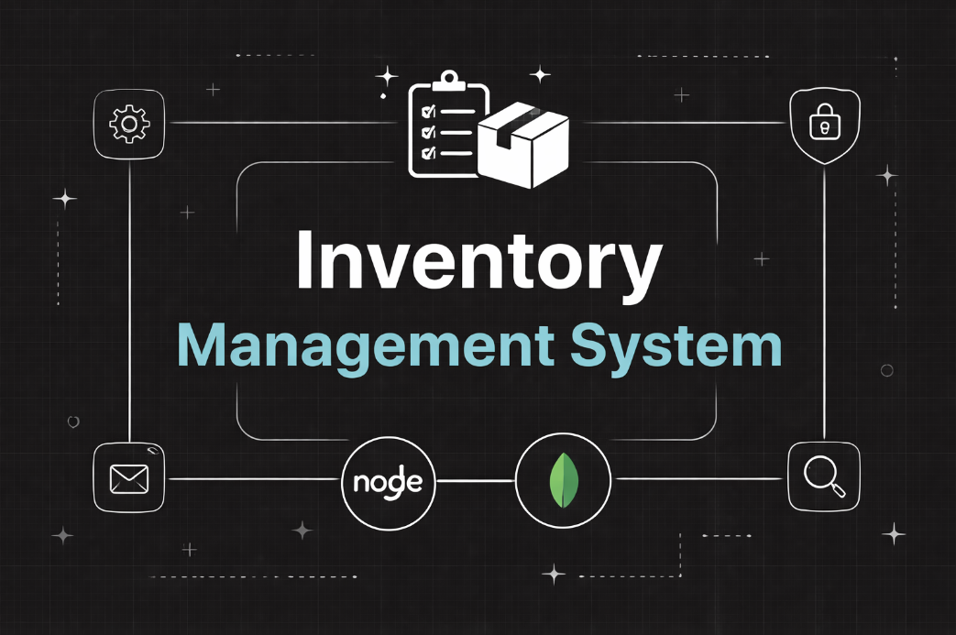

PROJECT ARCHITECTURE :

High-level architecture diagram illustrating the three-tier backend structure.

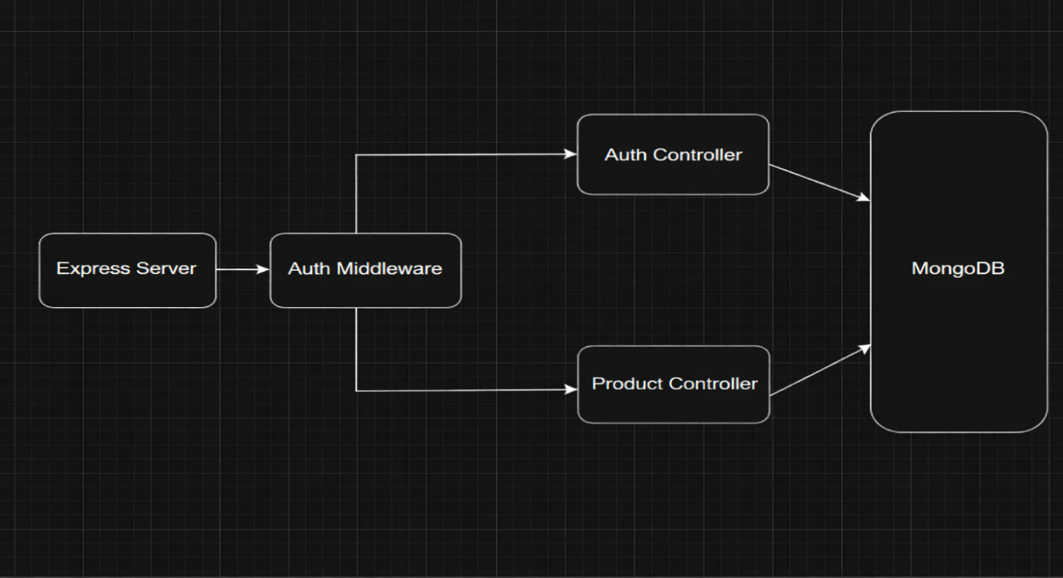
Node.js + Express Backend
• RESTful API architecture
• JWT authentication middleware
• MVC pattern (Models, Controllers, Routes)
• Input validation and error handling
MongoDB Database
• Document-based NoSQL storage
• Mongoose ODM for schema modeling
• Two collections: Users and Contacts
• Indexed fields for optimized queries
TECHNICAL ARCHITECTURE:
- Presentation Layer – REST API endpoints built using Express.js
- Application Layer – Business logic handled in service/controllers (built on Node.js)
- Routing Layer – Modular route management for different resources
- Middleware Layer – Authentication, authorization, logging, validation, and error handling
- Configuration Layer – Environment variables & centralized config management

DATABASE ARCHITECTURE (MongoDB)
Users Collection:
• _id
• name
• email
• password (hashed)
• timestamps
Products Collection:
• _id
• userId (reference to user)
• name
• price
• quantity
• description
• timestamps
Relationship: One User → Many Products
Indexes:
• email (unique)
• userId
• product name
ER Diagram:
ER diagram showing User → Product relationship:

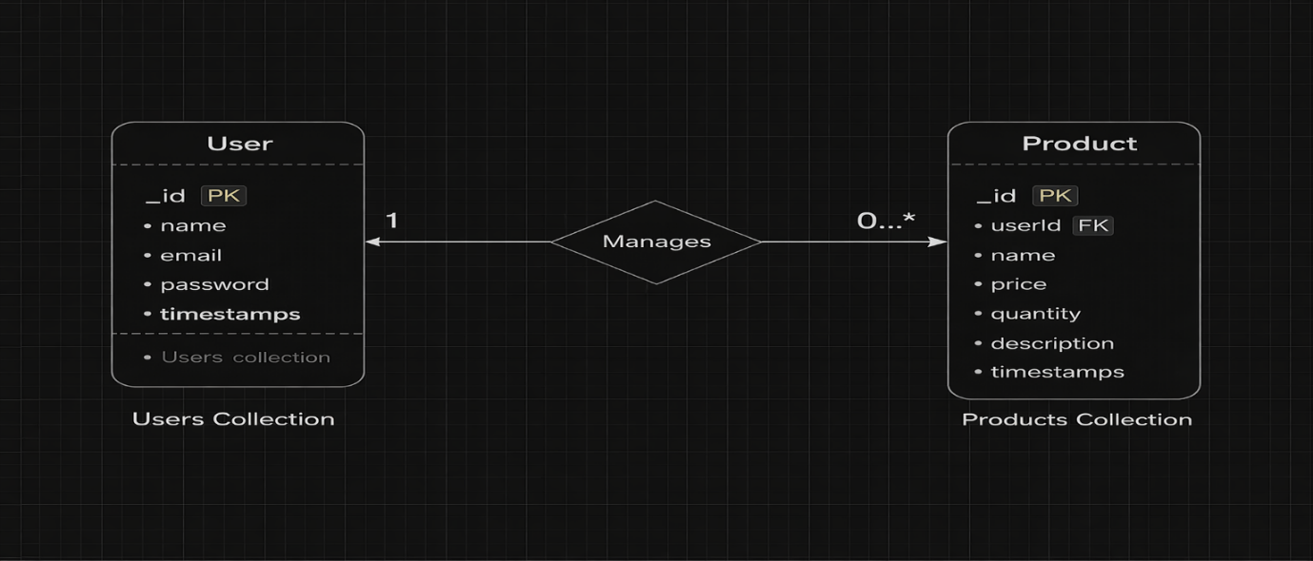

Features:

Core Features
S.No | Feature | Description
1 | User Authentication | JWT-based register and login system
2 | Product CRUD | Add, view, update and delete products
3 | Private Data Access | Users access only their own products
4 | Product Search | Search products by name
5 | Secure API | Middleware protected routes

ROLES AND RESPONSIBILITY:
User:
- Registration: A user signs up by providing details to create a new account in the system.
- Login: A user enters credentials to access their account securely.
- Add Product: A user creates a new product by submitting its details to the system.
- Edit Product: A user updates the details of an existing product they own.
- Delete Product: A user removes one of their products from the system.
- Search Product: A user looks for products by name, category, or other filters.
User flow:
- Registration – User signs up by providing required details.
- Login – User enters credentials to access the system.
- Authentication – System verifies JWT token for secure access.
- Profile Management – User views or updates their profile information.
- Add Product – User creates a new product with details.
- Edit/Delete Product – User updates or removes their own products.
- Search/View Products – User browses or searches products in the system.
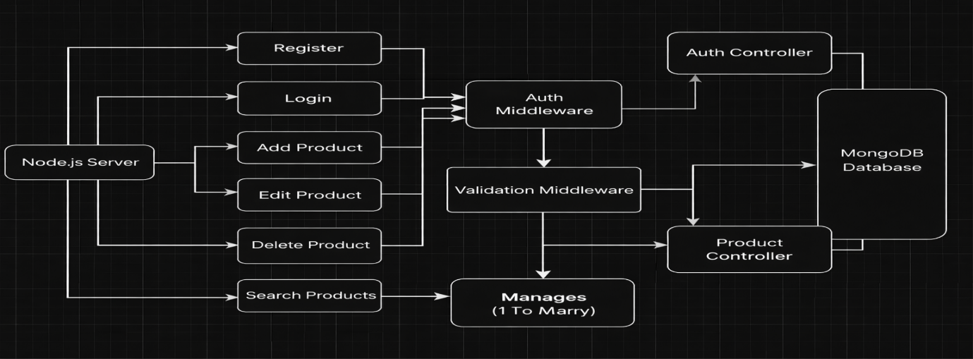
Project Setup and Configuration

Folder Structure

server/
│
├── node_modules/
├── src/
│ ├── controllers/
│ ├── db/
│ ├── middlewares/
│ ├── models/
│ ├── routes/
│ └── server.js
│
├── .env
├── .gitignore
├── package-lock.json
└── package.json

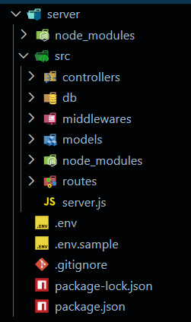
Initialize Node.js Project:
Open terminal inside the server folder and run:
npm init -y
This creates the package.json file which manages project dependencies.

Install Required Packages:
Install backend dependencies:
npm install express mongoose cors dotenv jsonwebtoken bcryptjs

Package Purpose:
- express → Backend framework
- mongoose → MongoDB connection
- cors → Cross-origin requests
- dotenv → Environment variables
- jsonwebtoken → Authentication
- bcryptjs → Password hashing
Create Environment File:
Create a .env file in the root of the server folder.
Example:

PORT=5000
MONGO_URI=your_mongodb_connection_string
JWT_SECRET=your_secret_key

Backend Development

Setup Express Server:
Inside src/server.js, create the basic Express server.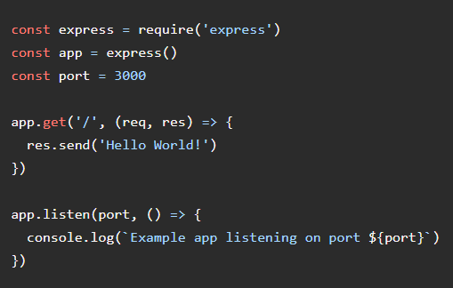

Create Controllers
Inside: src/controllers/
Create: auth.controller.js

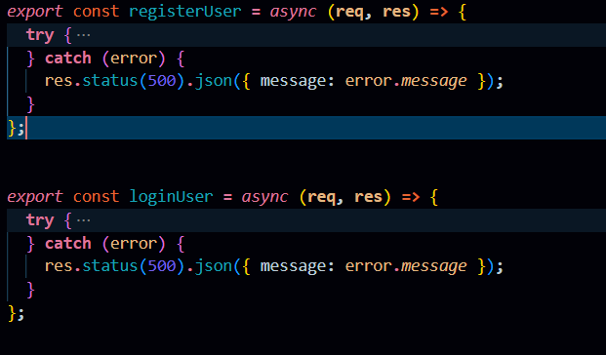

AUTH CONTROLLERS:
An Auth Controller manages user login, registration, and access control.
Main Responsibilities:
- User registration
- User login
- Token generation (usually JWT)
- Logout
- Password reset / change
- Role verification (Admin, Staff, etc.)
Main Functionalities:

- Handles user registration in the system.
- Verifies user login credentials (email/username and password).
- Generates authentication tokens (e.g., JWT) for secure access.
- Manages user logout and session control.
- Supports password reset or change functionality.
- Enforces role-based access (Admin, Staff, etc.).
- Provides current user information for authenticated users.
product.controller.js

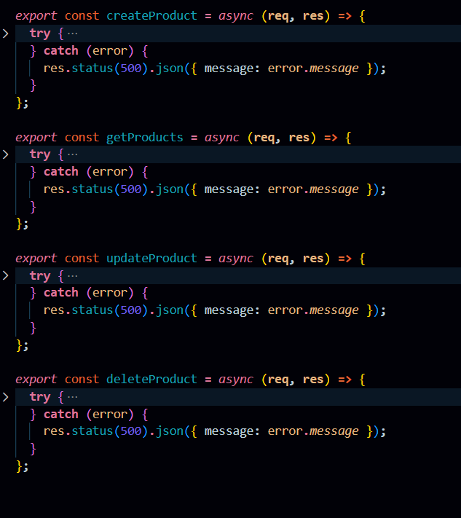

PRODUCT CONTROLLER:
The Product Controller handles all product inventory operations and contains the business logic for managing products linked to individual users.
Responsibilities:
- Manage all product-related operations in the inventory system.
- Handle communication between frontend, database, and business logic.
- Ensure data validation and proper product management.
Main Functionalities:
- Add Product – Create and store new product details.
- View Products – Retrieve and display product list.
- Update Product – Modify existing product information (price, stock, etc.).
- Delete Product – Remove products from the system.
- Search/Filter Products – Find products by name, category, or ID.
- Manage Stock Levels – Update product quantity in inventory.
.

Create Middleware
Inside: src/middlewares/

Create:auth.middleware.js
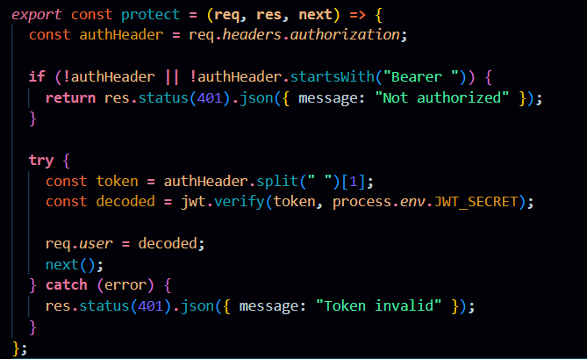

AUTH MIDDLEWARE (PROTECT):
Auth Middleware is a backend component that verifies whether a user is authenticated before allowing access to product-related routes. It checks the authentication token (such as JWT) in the request and ensures that only authorized users can perform actions like adding, updating, or deleting products in the inventory system.

Create Routes
Inside: src/routes/

Create:

auth.routes.js

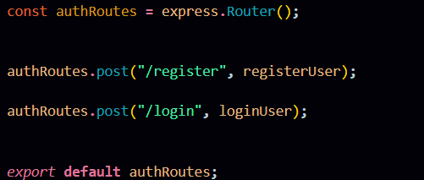

AUTH ROUTES:

Auth routes are the API endpoints that handle user authentication operations in the backend. They allow users to perform actions such as registration, login, logout, and password management, enabling secure access to the system. product.routes.js

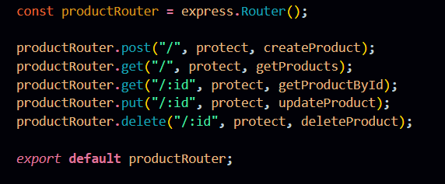

PRODUCT ROUTES:
Product routes are the API endpoints used to handle product-related operations in the backend of an inventory management system. They allow users to add, view, update, delete, and manage product details in the database.

Connect Routes to Server
Import all routes into server.js

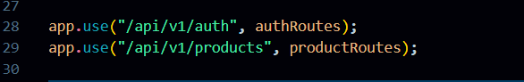
These route configurations connect the authentication and product APIs to the main Express server using versioned endpoints. The /api/v1/auth path handles all user authentication requests, while /api/v1/products manages product-related operations, helping maintain a structured and scalable API architecture.

Database Configuration and Setup
- Create MongoDB Atlas cluster
- Add connection string to .env
- Connect DB before API testing.
Database Connection:
Create a file inside: src/db/db.js
Purpose: Connect backend to MongoDB using mongoose.
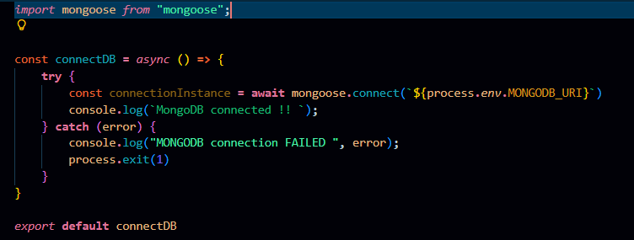

The connectDB function establishes a connection between the application and MongoDB using Mongoose and environment-based configuration. It ensures the server starts only after a successful database connection and logs an error message if the connection fails.

Create Models:
Inside src/models/ create:
- User.js
- Product.js

User Model:
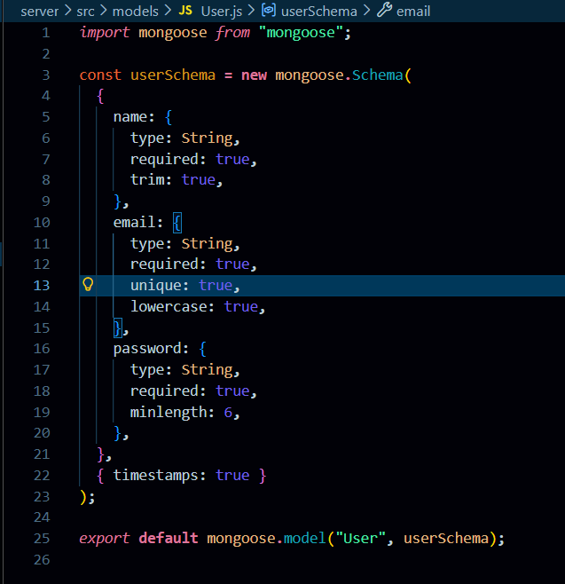
User Schema:
The User schema defines the structure for storing user details such as name, email, and hashed password in the database. It supports secure authentication and maintains timestamps for record tracking.
Product Model:

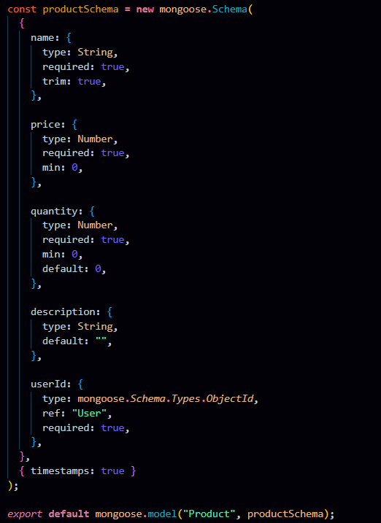
Product Schema:
The Product schema represents inventory items and includes fields like name, price, quantity, description, and a userId reference. It ensures each product is linked to its owner, enabling private data access and management.

Project Execution

Execution Steps
- Open terminal in server folder.
- Make sure you have a start script in the package.js file.
- Run:
npm start

- Console should display:
Server running on PORT
Database Connected

API Testing :
Use Thunder Client to test APIs:
Test APIs:
Register User:
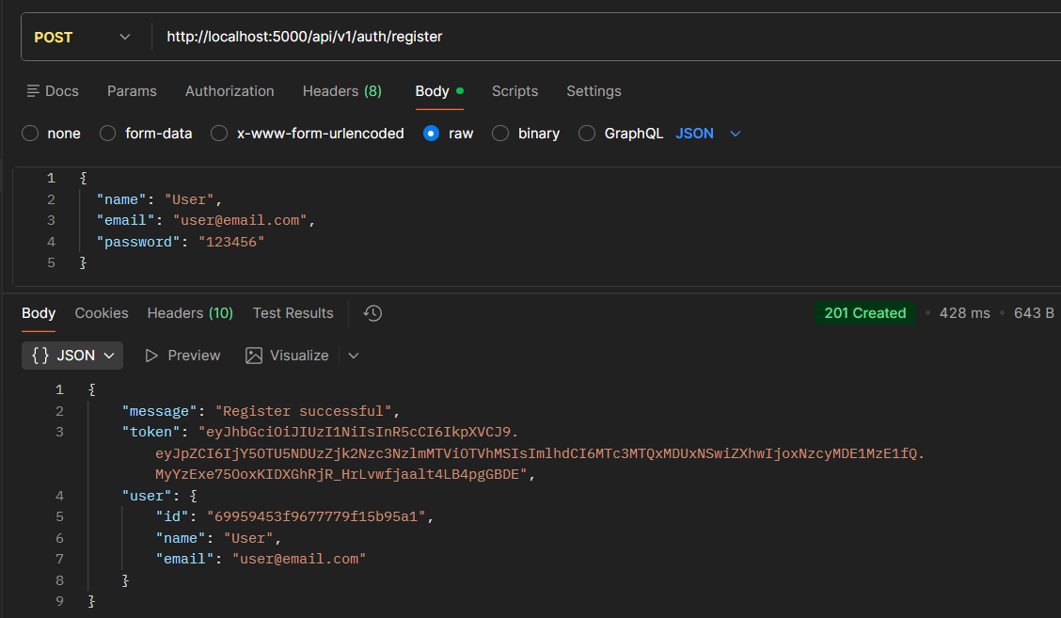
Register:
The register functionality allows new users to create an account by submitting their details, which are validated and securely stored with a hashed password. It ensures unique user creation before granting access to the system.
Login User
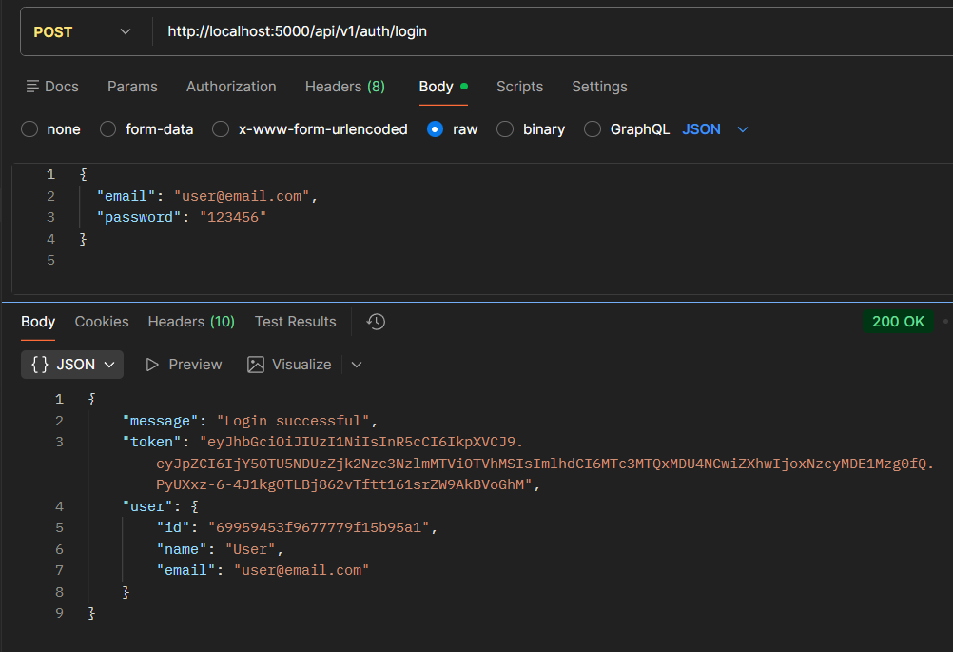

Login:
The login functionality verifies user credentials and generates a JWT token upon successful authentication. This token is used to access protected routes securely.
Create Product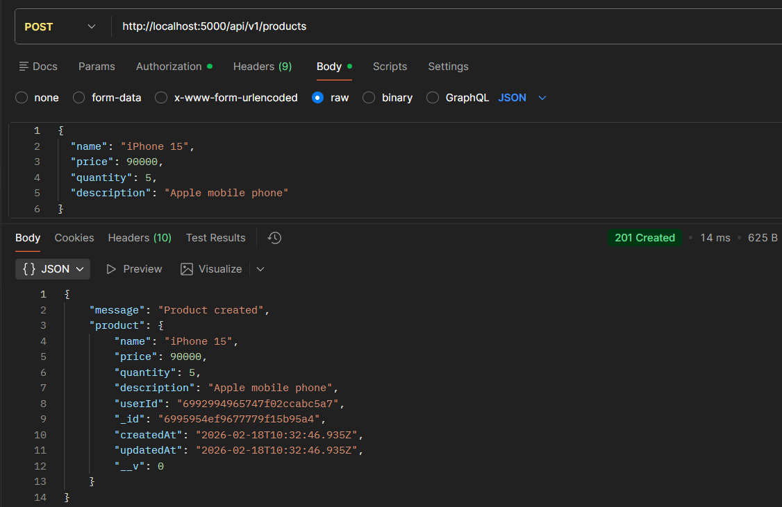

Create Product:
Allows an authenticated user to add a new product to their inventory by submitting product details. The product is saved with the user’s ID to maintain ownership.
Get all Products
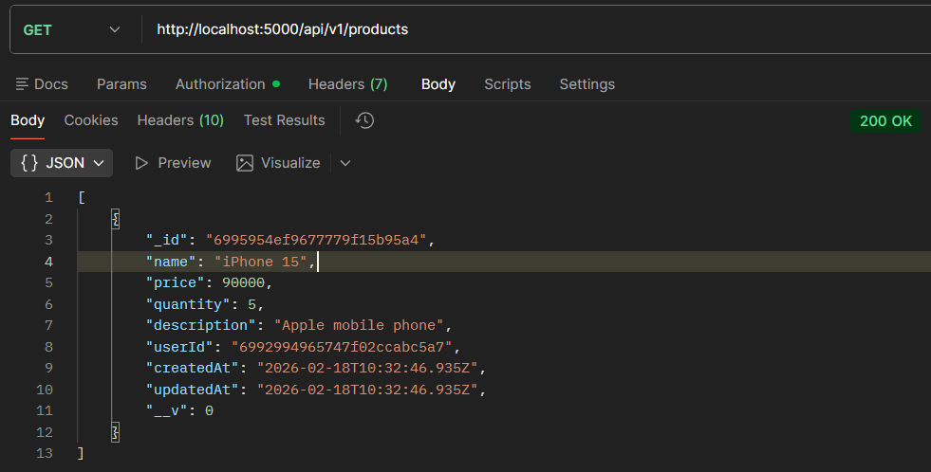
Get all Products:
Fetches all products that belong to the logged-in user. It ensures users can view only their own inventory data.
Update Product
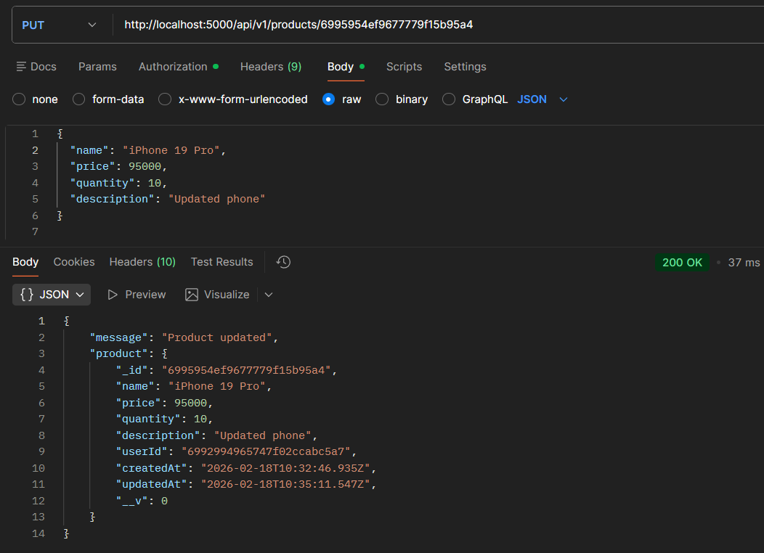

Update Product:
Enables users to modify existing product details such as name, price, or quantity. The system verifies ownership before allowing any updates.

Delete Product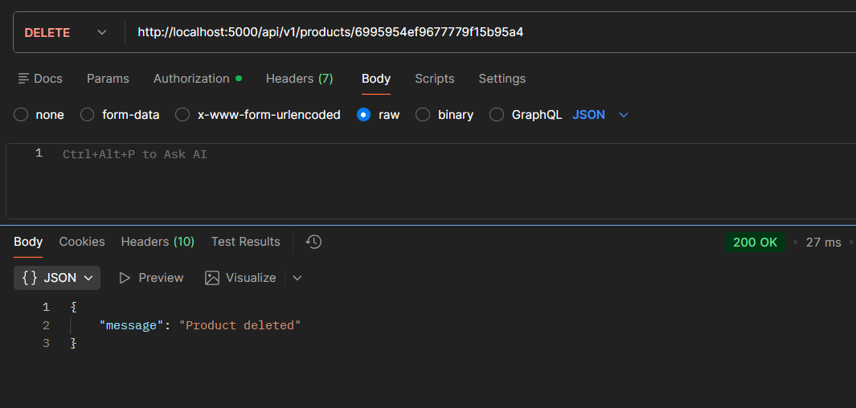

Delete Product:
Allows users to permanently remove a product from their inventory. The operation is protected to ensure only the product owner can delete it.

CONCLUSION:
The Product Inventory Management System is a secure and scalable backend application developed using Node.js, Express.js, and MongoDB. It provides RESTful APIs for managing product inventory with full CRUD functionality. The system implements JWT-based authentication to ensure that only authorized users can access and manage product data. Overall, the project demonstrates the effective use of backend technologies for building a reliable inventory management solution.

