**Use of This Project**

This project is a Retrieval-Augmented Generation (RAG)-based backend system, and its core purpose is to enable intelligent question-answering or document search over custom text data (like PDFs and TXT files) by combining:

* Text extraction & chunking
* Semantic embeddings
* Vector search in Pinecone or other vector DBs
* Metadata tracking in SQL/NoSQL
* FastAPI RESTful APIs Framework

**Real-World Use Cases**

### **1.** **Enterprise Document Search / Internal Knowledge Base**

**Problem:** Employees waste time searching through 100s of documents (PDFs, manuals, policies, etc.)

**Solution:** Upload all files → chunk & embed → store in vector DB → use RAG to ask natural-language questions and get precise answers.

Example: “What is the sick leave policy for employees in Nepal branch?”

### **2. Legal or Regulatory Document QA**

**Problem:** Lawyers need to search relevant sections from large legal texts.

**Solution:** Upload PDF contracts or legal rulings

* Ask: “Which clause discusses arbitration?”
* RAG system returns exact chunk from the document.

### **3. Medical Records Summarization or Querying**

**Problem:** Doctors or researchers want answers from research papers or patient histories.

**Solution:** Upload .txt or .pdf reports or journals

* Ask: “What treatment is suggested for gastric ulcers in elderly patients?”
  1. **Uploaded the file name as War.pfd**

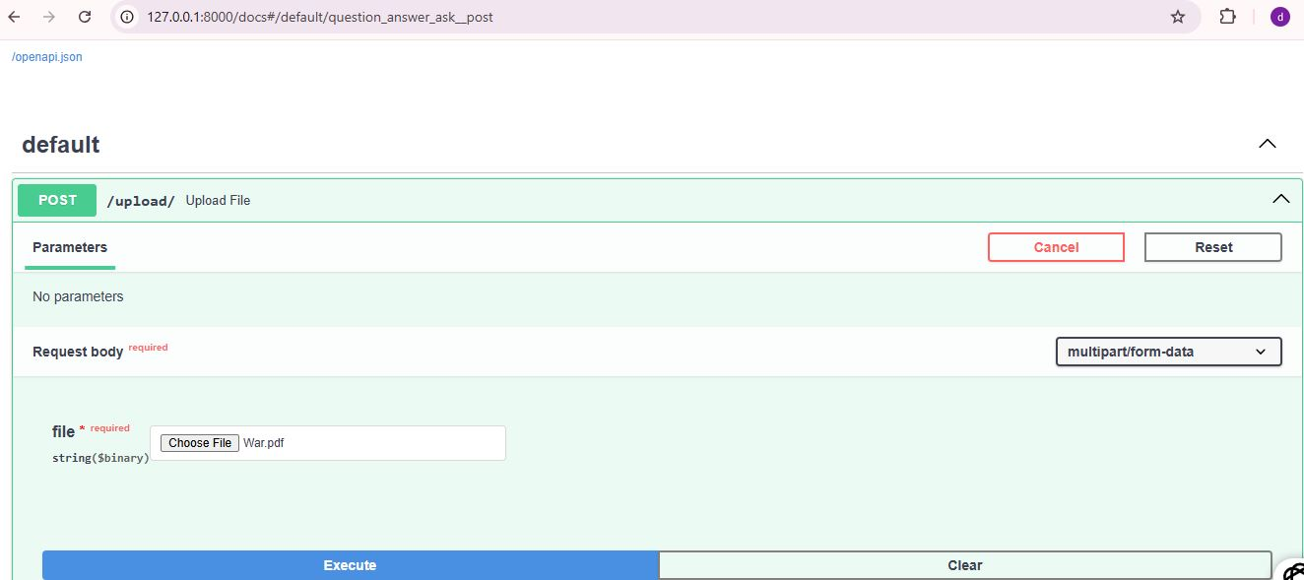

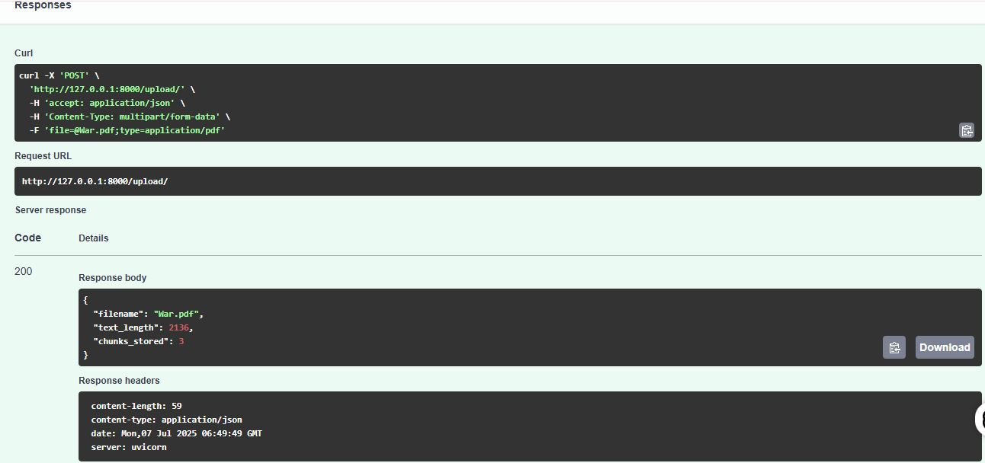

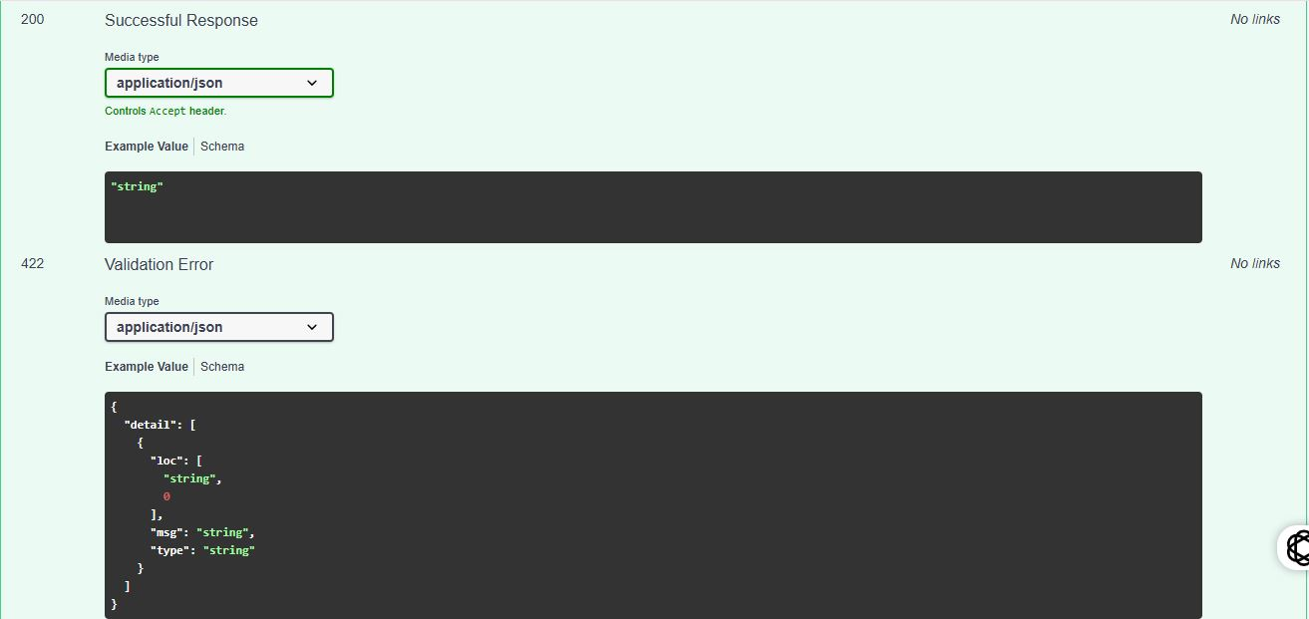

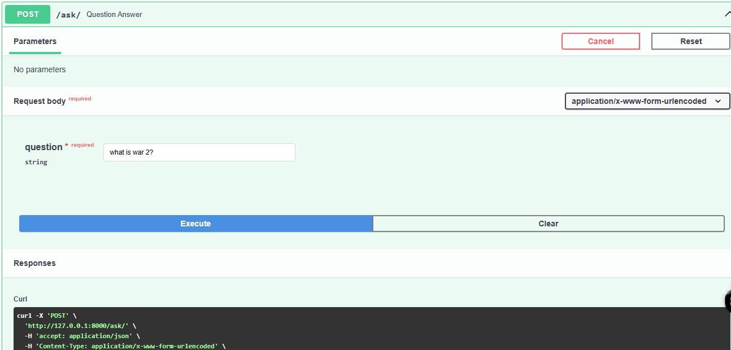

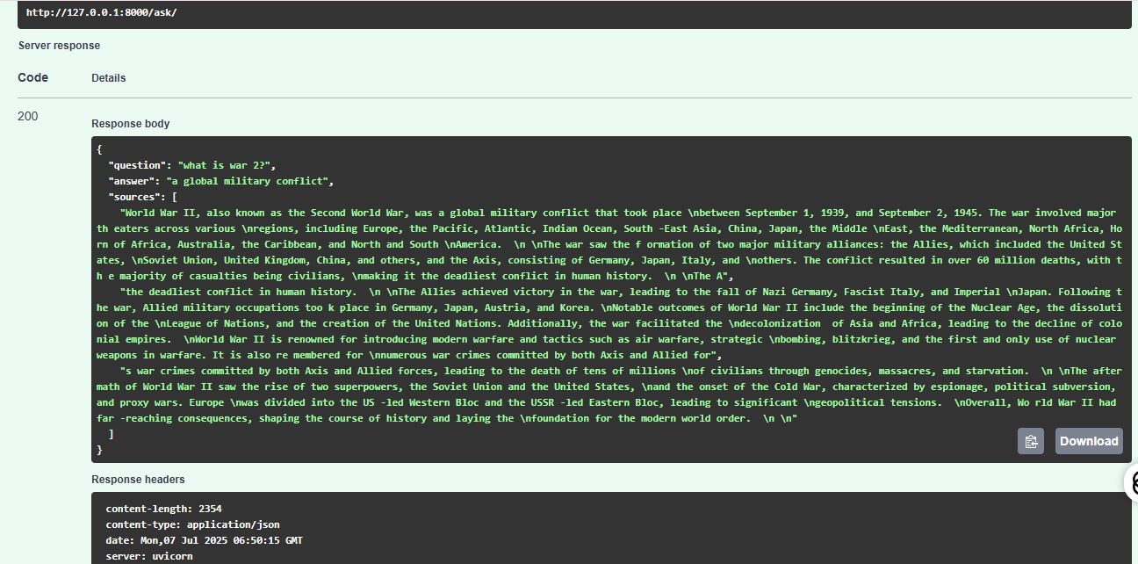

**2. Pinecone vector DB:**

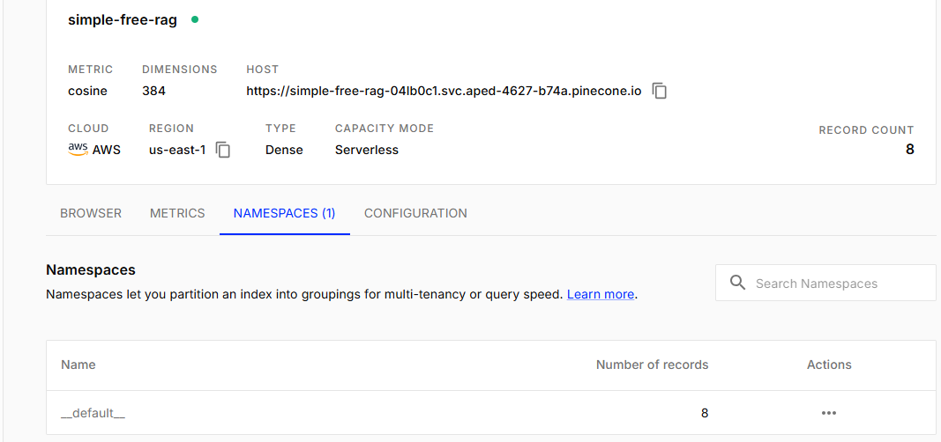

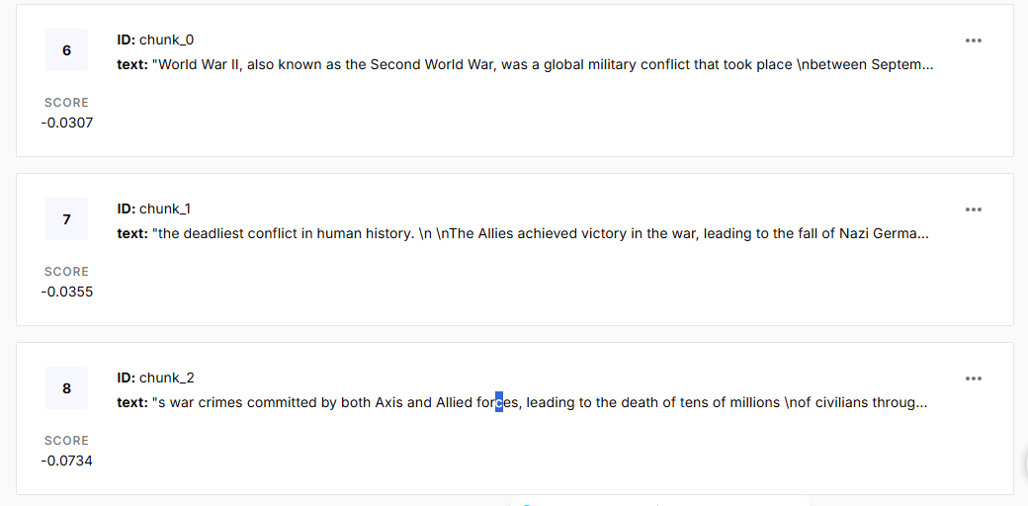

**3. Database part**

select *from chunks;

