PROPOSAL PACKAGE | DOCUMENT 03
Solution Architecture
High-level plan and low-level design for the AI Executive Intelligence Assistant, the CRM + Follow-up System, and the shared platform that connects them
Document | 03 of 15
Audience | Client CTO / IT, procurement, and the delivery team
Version | 1.0 (first-meeting edition)
Date | September 2026
Classification | Confidential - prepared for the client

Contents
1. Purpose and how to read this document 3
2. The requirement, restated precisely 3
2.1 System 1: AI Executive Intelligence Assistant 3
2.2 System 2: CRM + Follow-up System 3
2.3 Cross-cutting asks 4
3. High-level architecture 4
3.1 Why a shared platform layer 5
3.2 Shared platform components 5
3.3 System 1 at a glance 6
3.4 System 2 at a glance 7
3.5 Deployment and data residency 7
4. How the two systems connect at the top level 8
5. Plugging in real data later without rebuilding 8
6. High-level delivery plan 9
PART B: LOW-LEVEL DESIGN 11
7. Component design 11
7.1 Runtime components 11
7.2 Service boundaries and independence 11
8. Data model (low level) 12
8.1 Platform schema 12
8.2 Intelligence schema 12
8.3 CRM schema 13
9. Processing pipelines 13
9.1 Ingestion pipeline (System 1) 13
9.2 Answering pipeline (System 1) 14
9.3 Outreach approval workflow (System 2) 15
9.4 Reminders 15
10. Interfaces 15
10.1 REST API (selected endpoints) 15
10.2 Connectors 16
11. Environments, deployment and operations 16
12. Quality, evaluation and safety controls 17
12.1 Evaluation approach 17
12.2 Safety controls specific to the assistant 17
12.3 Safety controls specific to the CRM 17
13. Non-functional requirements summary 18

1. Purpose and how to read this document
This document has two halves. Part A (sections 2-6) is the high-level plan: what we build, why it is shaped this way, and how the two systems stay independent yet connected. It is written for executives and non-technical readers. Part B (sections 7-13) is the low-level design: components, data model, processing pipelines, interfaces, environments, and quality controls. It is written for the client's technical reviewers and for our delivery team, and it is the blueprint we will build from.
Design principles that govern every decision in this document:
1. Closed domain. The assistant answers only from documents the client has loaded. No open-internet answers.
2. Evidence first. Every answer cites document and page. No citation, no answer.
3. Human in control. No outbound message is sent without a named human approving it.
4. Configuration over code. Stages, categories, checklists, fields and connectors are configured, so real data plugs in later without a rebuild.
5. Portability. The client owns the code, the cloud accounts and the data; AI models are swappable behind a gateway.

2. The requirement, restated precisely

2.1 System 1: AI Executive Intelligence Assistant
# | Requirement (client wording) | What it means in engineering terms
R1 | Retrieve specific info from documents on request, controlled access, not open internet | Retrieval-augmented generation (RAG) over a private corpus, with per-user, per-document access control enforced before retrieval, and the model forbidden from using outside knowledge.
R2 | Flag contradictions where two documents state different figures, dates or terms for the same thing | A structured claims ledger: extract (entity, attribute, value, unit, date, source, page, quote) from every document, normalise, then compare like-for-like across documents; surface conflicts with both sources shown.
R3 | Track missing information: gaps where a decision needs a document or data point not yet provided | Configurable decision checklists (required evidence per decision type) matched against the ledger and document inventory; plus detection of references to documents that are not in the corpus (for example "see Annex B").
R4 | Answer management questions in plain language based only on the loaded document set | Grounded answer generation with citations, a second-pass grounding check that verifies each sentence is supported, and explicit refusal when evidence is absent.

2.2 System 2: CRM + Follow-up System
# | Requirement (client wording) | What it means in engineering terms
C1 | Three categories: investors; partners/counterparties; customers/members; GCC-specific relationship pipeline | Relationship records typed by category, each with its own configurable pipeline and stage set; a GCC pipeline template reflecting introduction, trust-building and regulatory steps.
C2 | Contact and relationship records with stage/status tracking | Organisation and Person entities, Relationship records with stage, owner, status, last touch, next action; full history of stage changes.
C3 | Follow-up scheduling and reminders | Follow-up tasks with due dates and owners; reminders to staff by email/Teams/in-app; overdue escalation.
C4 | Any outreach must go through human approval before sending; no fully automated outbound | Outreach Request workflow: draft, review queue, approve/reject with reason, send via connected mailbox under the approver's authority, immutable log. No scheduler may send.
C5 | Basic reporting: who has been contacted, stage, overdue | Dashboards and exportable reports: contacts touched by period, pipeline by stage and category, overdue follow-ups, dormant relationships, approval turnaround.

2.3 Cross-cutting asks
- Build approach and tools for each (section 3 and Document 06).
- Structure that accepts real data later without rebuild (section 5 and Document 07).
- Timeline to a working structure/demo (section 6 and Document 04).
- Cost or pricing model (Document 05 workbook and Document 14 draft statement of work).

3. High-level architecture
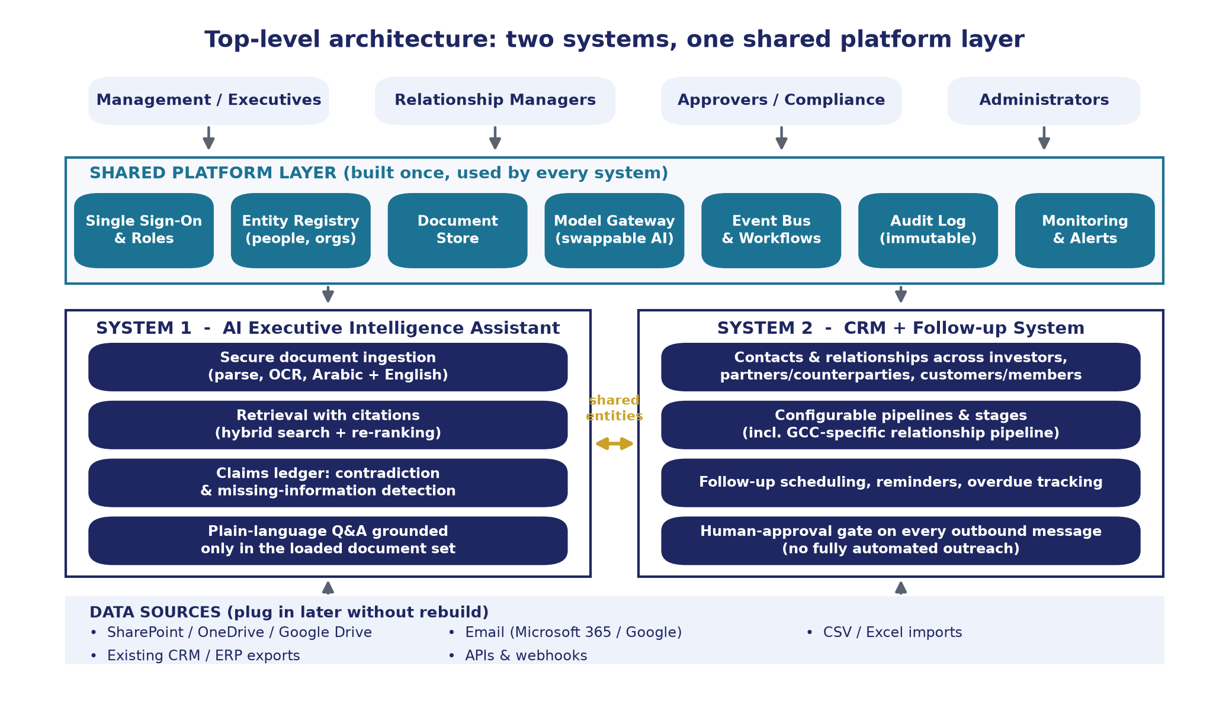
Figure 1. Top-level architecture: two systems on one shared platform layer

3.1 Why a shared platform layer
Both systems need the same seven things: who the user is and what they may see; a single list of organisations and people; somewhere to keep documents; a way to call AI models; a way to run workflows and reminders; a tamper-evident audit trail; and monitoring. Building these once avoids two identity systems, two contact lists and two audit logs. It also means a third or fourth system (for example a board-pack generator or a compliance tracker) can be added later on the same base.
Each product remains individually deployable and individually usable. The CRM works with the Executive Intelligence Assistant switched off, and vice versa. The connection is at the top level only: shared identity, shared entities, shared audit, and the ability for the assistant to read CRM attachments as documents and for the CRM to show relevant assistant findings on a relationship record.

3.2 Shared platform components
Component | Responsibility | Technology (pilot -> production)
Identity and access | Single sign-on, roles (executive, relationship manager, approver, analyst, admin), per-document and per-record permissions | Supabase Auth with OIDC -> Microsoft Entra ID / Okta; Keycloak if self-hosted
Entity registry | Master list of organisations and people with de-duplication and merge; used by both systems | PostgreSQL tables with matching rules
Document store | Original files, versions, checksums, classification tags, access-control lists | Supabase Storage -> S3 / Azure Blob in a GCC region, or on-premises object storage
Model gateway | One internal API for all AI calls; routes by policy (document classification, cost, residency); logs tokens and cost; swaps providers without code change | LiteLLM proxy (open source) in front of Anthropic API / AWS Bedrock / Microsoft Foundry / in-region vLLM
Workflow and events | Background jobs (ingestion, extraction, reminders), event bus so systems react to each other | PostgreSQL job queue -> Redis + workers; Temporal if workflows become complex
Audit log | Append-only record of every read, answer, approval and send, with hash chaining | PostgreSQL append-only table with periodic hash anchoring; export to SIEM at enterprise tier
Monitoring | Application metrics, AI tracing (prompts, retrieved passages, latencies, cost), alerting | Langfuse (open source LLM tracing), OpenTelemetry, Grafana / Sentry

3.3 System 1 at a glance
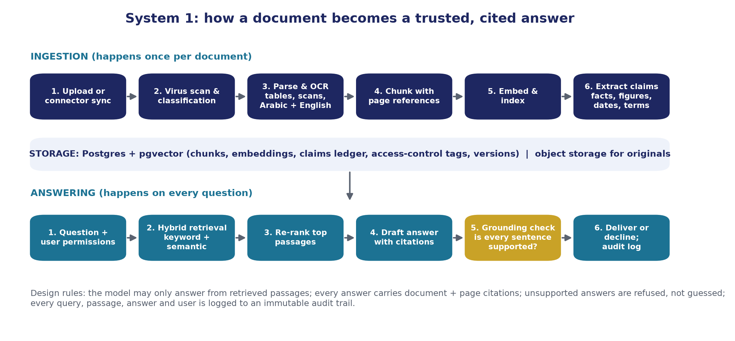
Figure 2. How a document becomes a trusted, cited answer
Two flows. Ingestion runs once per document version: scan, classify, parse (including OCR for scans, in Arabic and English), chunk with page references, embed and index, and extract claims into the ledger. Answering runs on every question: apply the user's permissions, retrieve by keyword and meaning, re-rank, draft an answer with citations, check grounding, and either deliver or decline. Everything is logged.
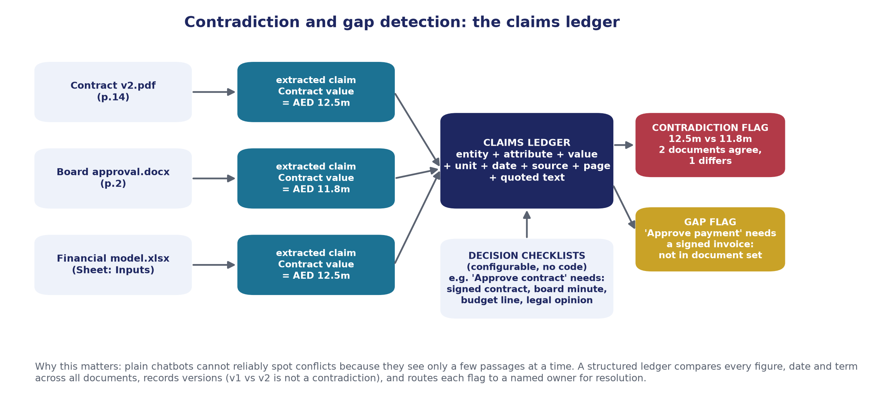
Figure 3. Contradiction and gap detection through the claims ledger
The claims ledger is the part that makes this more than a chatbot. Extraction turns prose into rows: "Contract value = AED 12.5m (Contract v2.pdf, p.14)". Comparison then finds the row from the board minute that says AED 11.8m. Decision checklists list what evidence each decision type needs and mark what is present, what is missing, and what is contradicted.

3.4 System 2 at a glance
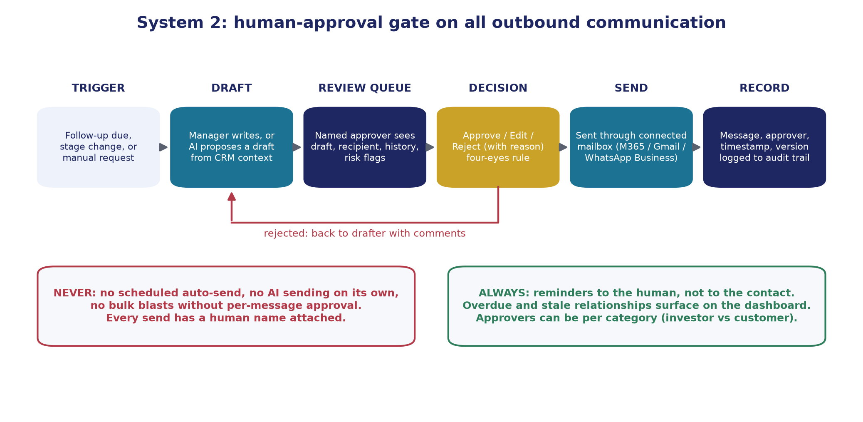
Figure 4. Human-approval gate on all outbound communication
The CRM is deliberately conventional in its records and pipelines, and deliberately strict in its outbound behaviour. Staff draft (optionally with AI assistance from the relationship's history), an approver reviews, and only then is the message sent through the organisation's own mailbox, so replies land where they always did. Reminders go to staff, never to contacts.

3.5 Deployment and data residency
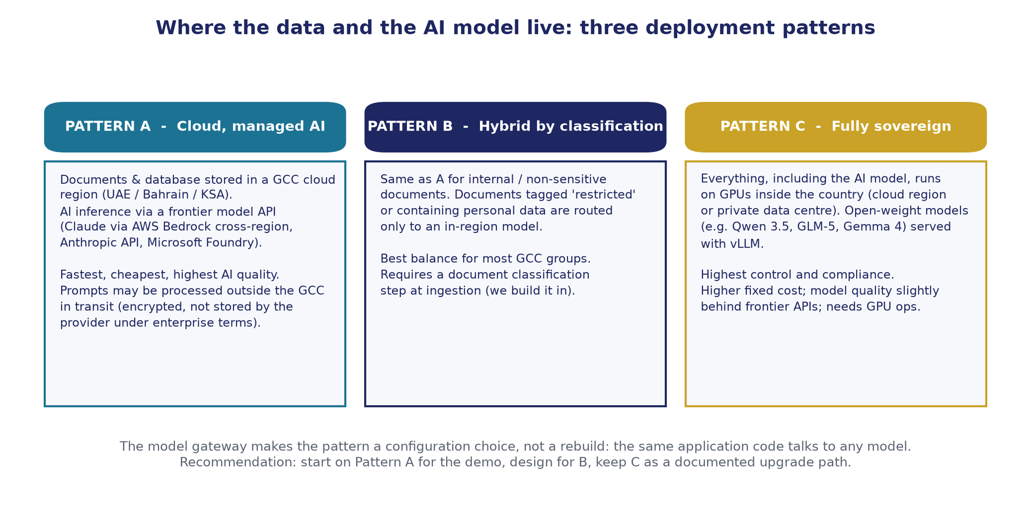
Figure 5. Three deployment patterns for data and model residency
The client will need to decide where data at rest and AI processing may take place. The architecture supports three patterns, selectable by configuration:
- Pattern A, cloud with managed AI. Data at rest in a GCC cloud region (for example AWS UAE me-central-1 or Bahrain me-south-1, Azure UAE North, Google Cloud Dammam). AI calls go to a frontier model provider. As of early 2026, Claude models are reachable from the AWS Middle East regions through Amazon Bedrock's global cross-region inference, which means prompts may be processed outside the region in transit under AWS encryption and enterprise terms. This is the fastest and cheapest pattern and gives the highest model quality.
- Pattern B, hybrid by classification. Same as A for internal and non-sensitive material; documents tagged restricted, or containing personal data, are routed by the model gateway only to an in-region model. Our recommended target state for most GCC groups.
- Pattern C, fully sovereign. All processing, including the model, runs on GPUs inside the country, either in a hyperscaler's local region or a private data centre, using open-weight models (for example Qwen 3.5, GLM-5, Gemma 4) served with vLLM. Highest control; higher fixed cost; model quality a step behind frontier APIs.
We recommend starting on Pattern A for the demo, designing for Pattern B, and keeping Pattern C as a documented upgrade path. The gateway makes this a configuration change, not a rebuild.

4. How the two systems connect at the top level
Connection | Behaviour
Shared identity | One login; roles apply across both systems; an approver in the CRM can be a read-only user in the assistant.
Shared entity registry | The "Al Futtaim Investment LLC" in a contract is the same organisation record as the investor in the pipeline. The assistant links claims to organisations; the CRM shows those claims on the relationship page.
Documents flow one way | Attachments added to a CRM interaction (a signed NDA, a term sheet) can be pushed into the assistant's corpus with the same access tags as the relationship.
Findings flow the other way | Contradictions or gaps that involve a counterparty appear as alerts on that relationship. Example: "The MoU date in the CRM (12 March) differs from the signed MoU (14 March)."
Shared audit | One tamper-evident trail. A regulator or internal auditor sees who asked what, who approved what, and what was sent, in one place.
Event bus | Stage changes, new documents, approvals and reminders are events; either system can subscribe. New automations do not require touching the other system's code.

5. Plugging in real data later without rebuilding
The client asked for a structure that accepts real data later. This is achieved by five design choices, detailed in Document 07:
- Schema-first data model with a JSON "custom fields" column on every core table, so new attributes are configuration, not migrations.
- Configuration-driven pipelines, stages, categories and decision checklists, editable by an administrator in the interface.
- Import templates (CSV/XLSX with column mapping and validation preview) for contacts, organisations, relationships and historical interactions.
- Connectors for SharePoint/OneDrive, Google Drive, Microsoft 365 and Gmail mailboxes, and an API with webhooks for anything else.
- Demo data is flagged, not baked in. Every demo record carries an "is_demo" marker; one administrative action removes all of it and leaves the configuration intact.
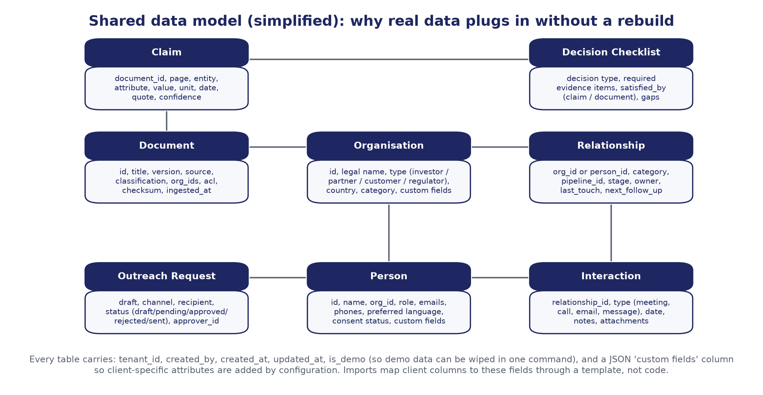
Figure 6. Shared data model (simplified)

6. High-level delivery plan
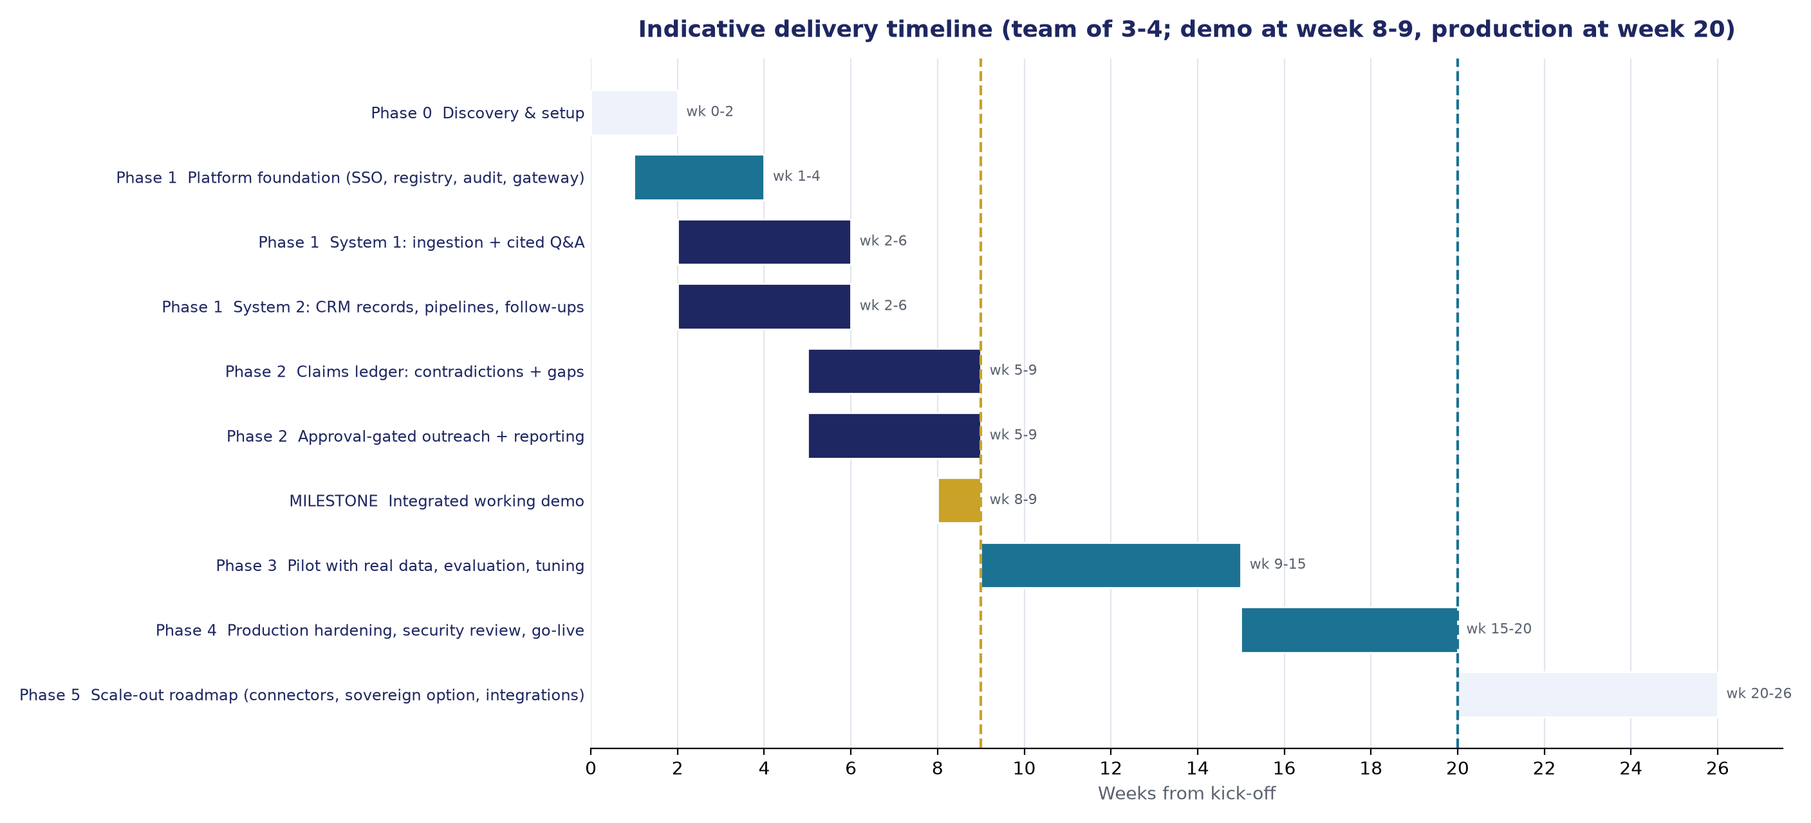
Figure 7. Indicative timeline
Phase | Weeks | Outcome
0 Discovery | 0-2 | Confirmed scope, jurisdictions, residency pattern, identity provider, sample documents, decision types, pipeline stages. Environments created in the client's cloud account.
1 Foundation and working structure | 1-6 | Platform layer live; System 1 ingests documents and answers with citations; System 2 has records, pipelines and follow-ups. Sample data loaded.
2 Verification layer and approval gate | 5-9 | Claims ledger with contradiction and gap detection; decision checklists; outreach approval queue; reports. Integrated working demo at week 8-9.
3 Pilot with real data | 9-15 | Real documents and contacts; evaluation against the agreed golden question set; tuning of extraction and retrieval; user training.
4 Production hardening | 15-20 | Security review, penetration test, backups and disaster recovery, runbooks, SLAs, go-live.
5 Scale-out | 20+ | Additional connectors, sovereign model option, ERP/DMS/board-portal integration, multi-entity tenancy.

The full plan with staffing, dependencies and acceptance criteria is in Document 04.

PART B: LOW-LEVEL DESIGN

7. Component design

7.1 Runtime components
Component | Language / runtime | Responsibilities and notes
Web application | Next.js (React, TypeScript) | Single sign-on, assistant chat and findings pages, CRM pages (contacts, pipeline board, follow-ups, approval queue, dashboards), administration (configuration, imports, connectors). Responsive; works in mobile browsers. Arabic right-to-left layout supported.
Core API | Node.js (TypeScript) | Business logic for CRM and platform: entities, relationships, tasks, outreach workflow, audit, configuration. Exposes REST endpoints and webhooks.
Intelligence service | Python (FastAPI) | Document ingestion, parsing and OCR orchestration, chunking, embedding, claims extraction, retrieval, answer generation, grounding check, contradiction and gap detection. Python is used because the document and AI tooling ecosystem is strongest there.
Workers | Python and Node | Background jobs: ingestion pipeline, scheduled extraction re-runs, reminder generation, connector syncs. Pull from a job queue; horizontally scalable.
Model gateway | LiteLLM (Python) | Single OpenAI-compatible endpoint for chat, embeddings and re-ranking; routes to configured providers; enforces per-classification routing, budgets, rate limits; logs usage.
Database | PostgreSQL 16 with pgvector | System of record for both systems; vectors and full-text indexes; row-level security.
Object storage | S3-compatible | Original documents and derived artefacts (page images, parsed text), versioned, encrypted.
Cache / queue | Redis | Job queue, rate-limit counters, short-lived session data. (Pilot uses a PostgreSQL-backed queue to avoid an extra service.)
Observability | Langfuse, OpenTelemetry, Grafana or Sentry | AI traces (prompt, retrieved chunks, answer, cost), application logs, metrics, alerts.

7.2 Service boundaries and independence
- The CRM depends only on the Core API, the database and the platform layer. It does not call the intelligence service except for optional draft suggestions, which are behind a feature flag.
- The assistant depends on the intelligence service, the model gateway, the database and the platform layer. It reads entity records from the Core API read model; it never writes CRM data.
- Each service has its own database schema (namespace) inside one PostgreSQL instance during pilot and can be split into separate databases at enterprise scale without code changes, because cross-schema access goes through APIs rather than joins.

8. Data model (low level)
All tables carry: id (UUID), tenant_id, created_at, created_by, updated_at, updated_by, is_demo, custom (JSONB). Soft-delete via deleted_at where retention rules require.

8.1 Platform schema
Table | Key columns
users | email, display_name, idp_subject, status, locale (en/ar), last_login_at
roles, user_roles | role code (executive, relationship_manager, approver, analyst, admin), scope (category or business unit)
organisations | legal_name, short_name, type (investor, partner, counterparty, customer, member, regulator, vendor), country, jurisdiction, registration_no, parent_id, aliases (text[]), classification
persons | full_name, full_name_ar, organisation_id, title, emails (jsonb), phones (jsonb), preferred_language, preferred_channel, consent_status, consent_source, consent_at
documents | title, source (upload, sharepoint, drive, email, crm), source_ref, version, supersedes_id, mime, size, checksum, classification (public, internal, confidential, restricted), acl (jsonb), organisation_ids (uuid[]), language(s), status (received, scanned, parsed, indexed, extracted, failed), ingested_at
audit_events | actor_id, action, object_type, object_id, details (jsonb), ip, user_agent, occurred_at, prev_hash, hash (append-only; hash chain anchored daily)
configuration | key, value (jsonb), version, changed_by, changed_at (pipelines, stages, categories, checklists, routing policies)
jobs | type, payload, status, attempts, run_after, locked_by, error

8.2 Intelligence schema
Table | Key columns
document_pages | document_id, page_no, text, text_ar, ocr_confidence, image_ref
chunks | document_id, page_start, page_end, section_path, text, token_count, embedding (vector), tsv (full-text), acl (copied from document for pre-filtering)
claims | document_id, page_no, entity_text, entity_org_id, attribute (normalised code, e.g. contract_value, effective_date, term_months, interest_rate, counterparty), value_raw, value_num, value_text, value_date, unit, currency, as_of_date, quote, confidence, extractor_model, extracted_at
claim_links | claim_id_a, claim_id_b, relation (agrees, conflicts, supersedes, unclear), delta, detected_at
findings | type (contradiction, gap, dangling_reference, stale), severity, title, description, claim_ids, document_ids, decision_id, owner_id, status (open, acknowledged, resolved, dismissed), resolution_note
decisions | type (approve_contract, release_payment, board_resolution, investor_commitment, custom), name, organisation_id, target_date, owner_id
checklist_templates, checklist_items | decision type; required evidence item (e.g. signed contract, board minute, budget line, legal opinion, KYC file); matching rule (document type tag, attribute presence, or manual)
queries | user_id, question, language, retrieved_chunk_ids, rerank_scores, answer, citations (jsonb), grounding_result, model, tokens_in, tokens_out, cost, latency_ms, feedback

8.3 CRM schema
Table | Key columns
pipelines | name, category (investor, partner, customer), stage list (ordered, with codes, SLA days, exit criteria), is_default
relationships | organisation_id or person_id, category, pipeline_id, stage_code, status (active, dormant, closed_won, closed_lost, on_hold), owner_id, secondary_owner_id, priority, source, introduced_by_person_id, last_touch_at, next_follow_up_at, health_score
stage_history | relationship_id, from_stage, to_stage, changed_by, changed_at, note
interactions | relationship_id, type (meeting, call, email_in, email_out, message, event, note), occurred_at, participants (uuid[]), summary, sentiment, attachments (document ids)
follow_ups | relationship_id, title, due_at, owner_id, status (open, done, snoozed, cancelled), reminder_policy, completed_at
outreach_requests | relationship_id, recipient_person_id, channel (email, whatsapp, sms, letter), subject, body, body_lang, drafted_by, draft_source (human, ai_assisted), status (draft, pending_approval, changes_requested, approved, rejected, sent, failed), approver_id, decided_at, decision_note, sent_at, provider_message_id, version
outreach_versions | outreach_request_id, version, body, edited_by, edited_at
approval_policies | category, min_approvers, approver_role, escalation_after_hours, restricted_recipient_rules

9. Processing pipelines

9.1 Ingestion pipeline (System 1)
- Receive. Upload via UI, or connector sync (SharePoint/OneDrive/Drive/mailbox). Compute checksum; if identical to an existing document, link rather than duplicate. Detect version relationships by filename pattern and metadata; administrator can confirm "supersedes".
- Scan and classify. Anti-malware scan (ClamAV or cloud-native). Classification by rule (source folder, filename) and by a lightweight model pass; administrator can override. Classification drives the model-routing policy.
- Parse. Digital PDFs, Word, Excel, PowerPoint and email via Docling (open source, runs locally, strong table extraction). Scanned pages via OCR with Arabic and English support (Azure AI Document Intelligence in the Azure UAE region, or Tesseract/PaddleOCR self-hosted for the sovereign pattern). Excel: each sheet is parsed into cell-level text with sheet and cell references so citations can point to "Sheet Inputs, cell C14".
- Chunk. Structure-aware chunking (headings, clauses, table rows) with 300-600 tokens per chunk and overlap; each chunk records page range and section path. Contract clauses are kept whole where possible.
- Embed and index. Multilingual embeddings (Voyage voyage-3.5 via API, or BGE-M3 self-hosted); stored in pgvector with an HNSW index. Full-text index built in parallel for exact terms, numbers and names.
- Extract claims. A structured-output prompt to the extraction model (Claude Sonnet 5 for cost, Claude Opus 5 for complex financial documents) returns claims as JSON validated against a schema. Values are normalised (currency to ISO code, numbers to base units, dates to ISO 8601, Arabic numerals handled). Each claim keeps the verbatim quote and page.
- Compare. For each new claim, find claims with the same normalised entity and attribute across other documents. Numeric: conflict if the difference exceeds a tolerance (configurable, default 0.5%). Dates: conflict if different, unless one document supersedes the other. Text terms: an LLM adjudication pass decides agrees / conflicts / unclear with a rationale. Conflicts become findings.
- Check gaps. Re-evaluate decision checklists that reference the affected organisations or decision types; update missing-evidence findings. Detect dangling references ("Annex B", "the schedule attached") with no matching document.
- Notify and audit. Owners of affected findings are notified; every step logs to audit with timings and model usage.

9.2 Answering pipeline (System 1)
- Authorise. Resolve the user's permitted document set (roles plus per-document ACLs). This filter is applied inside the retrieval query, never after.
- Understand the question. Detect language (Arabic or English); expand with synonyms and normalised entity names from the registry; identify if the question is about a figure, a date, a term, a status or a comparison.
- Retrieve. Hybrid retrieval: top 40 by vector similarity and top 40 by full-text match, fused (reciprocal rank fusion). If the question names an entity or attribute that exists in the claims ledger, ledger rows are added as high-priority evidence.
- Re-rank. A cross-encoder re-ranker (Voyage rerank-2.5 or self-hosted bge-reranker-v2-m3) orders the fused set; the top 8-12 passages go to the model.
- Generate. The answer model (Claude Opus 5 by default; Claude Sonnet 5 for routine lookups; in-region model under Pattern B/C when classification requires) receives the passages with document titles and pages, and a system instruction that forbids outside knowledge and requires a citation for each statement. Structured output returns the answer, a list of citations, and a confidence label.
- Ground. A second, independent pass checks each sentence of the answer against the cited passages and marks supported / partially supported / unsupported. Unsupported sentences are removed; if nothing remains, the assistant replies that the loaded documents do not contain the answer and lists the closest documents found.
- Attach findings. If any cited claim is part of an open contradiction, the answer shows the conflict inline ("Note: another document states a different value").
- Deliver and log. Answer, citations, retrieved passages, model, tokens, cost and latency are logged. Users can rate the answer; ratings feed the evaluation set.
Target latency: first token under 3 seconds, full answer under 15 seconds for typical questions.

9.3 Outreach approval workflow (System 2)
- Trigger: follow-up due, stage change, or manual "compose".
- Draft: the relationship manager writes the message, or requests an AI-assisted draft. The draft generator sees only the relationship history, the contact's language preference and approved templates; it cannot send.
- Submit: the draft enters the approval queue with recipient, channel, history summary, and automated risk flags (new recipient domain, restricted counterparty, missing consent, attachment classification).
- Decide: an approver (per approval policy: role, category, minimum approvers) approves, requests changes, or rejects with a reason. Four-eyes rule: drafter cannot approve their own message. Escalation after a configurable number of hours.
- Send: on approval, the message is sent through the connected mailbox or channel (Microsoft Graph send-as, Gmail API, WhatsApp Business Platform) using the approver's authority. The system has no scheduled send capability by design; approval and sending are the same human action.
- Record: full message, versions, approver, timestamps, provider message id and delivery status are written to the interaction history and the audit log. Replies received in the connected mailbox are attached to the relationship.

9.4 Reminders
A scheduled job evaluates follow-ups daily and hourly: due today, overdue, and stale relationships (no touch in N days per stage). Reminders go to staff via in-app notification, email digest, and optionally Microsoft Teams or Slack. Reminders never go to external contacts.

10. Interfaces

10.1 REST API (selected endpoints)
Endpoint | Purpose
POST /v1/documents ; GET /v1/documents/{id} ; POST /v1/documents/{id}/reindex | Upload, inspect, reprocess documents
POST /v1/ask | Ask a question; returns answer, citations, findings, trace id
GET /v1/findings ; PATCH /v1/findings/{id} | List and resolve contradictions and gaps
GET /v1/decisions/{id}/checklist | Evidence status for a decision
POST /v1/organisations ; POST /v1/persons ; POST /v1/relationships | Create records; bulk endpoints for imports
PATCH /v1/relationships/{id}/stage | Move stage with note; writes history
POST /v1/follow-ups ; PATCH /v1/follow-ups/{id} | Schedule and complete follow-ups
POST /v1/outreach ; POST /v1/outreach/{id}/submit ; POST /v1/outreach/{id}/decide | Draft, submit for approval, approve/reject
GET /v1/reports/pipeline ; /v1/reports/overdue ; /v1/reports/activity | Reporting data for dashboards and exports
POST /v1/imports ; GET /v1/imports/{id}/preview | Import with mapping and validation preview
Webhooks: document.indexed, finding.created, relationship.stage_changed, outreach.sent | Event notifications for integrations

All endpoints require a bearer token from the identity provider; service-to-service calls use short-lived signed tokens. Rate limits and request logging apply.

10.2 Connectors
Connector | Notes
SharePoint / OneDrive | Microsoft Graph, delta sync per library; permissions mirrored to document ACLs
Google Drive | Drive API changes feed; shared drives supported
Microsoft 365 mailbox | Graph: read selected folders for ingestion; send-as for approved outreach
Gmail / Google Workspace | Gmail API equivalent
WhatsApp Business Platform | Meta Cloud API; template messages; approval gate applies
CSV / XLSX import | Contacts, organisations, relationships, interactions, documents manifest
Generic API and webhooks | For ERP, existing CRM or document management system exports

11. Environments, deployment and operations
Aspect | Pilot (Tier 0-1) | Enterprise / sovereign (Tier 2-3)
Hosting | Vercel (web) + Supabase (PostgreSQL, storage, auth) or a single cloud account in a GCC region; containers for the intelligence service | Kubernetes or managed containers (AWS ECS/EKS, Azure AKS) in a GCC region or private data centre; GPU node pool for in-region models
Environments | dev, demo, pilot | dev, test, staging, production, plus disaster-recovery region
Infrastructure as code | Terraform from day one; the client's account, our automation | Terraform; policy-as-code; change approval
CI/CD | GitHub Actions: tests, security scans, container build, deploy | Same, plus signed images, manual production gate
Backups | Daily automated, 30-day retention | Point-in-time recovery, cross-region copies, quarterly restore tests
Availability target | Business hours, best effort | 99.9% monthly, defined RTO/RPO (for example 4 hours / 15 minutes)
Support | Email, next business day | Tiered SLA, on-call for severity 1

12. Quality, evaluation and safety controls

12.1 Evaluation approach
Large language models are probabilistic. The system is engineered so that errors are visible and measurable rather than hidden:
- Golden question set. During discovery we agree 100-200 real questions with known answers and source pages. Every release is scored on retrieval hit rate, citation accuracy, answer faithfulness and refusal correctness (refusing when the corpus genuinely lacks the answer).
- Claims extraction accuracy. A labelled sample of documents gives precision and recall for extracted figures, dates and terms; target precision above 95% for numeric fields at pilot exit.
- Contradiction detection. Seeded conflicts in the pilot corpus measure detection rate and false-positive rate; every flag shows both sources, so a false positive costs a minute, not a decision.
- Human feedback loop. Thumbs up/down and "wrong source" reports on every answer feed the evaluation set; findings resolved as "not a contradiction" tune tolerance rules.
- Regression gate. No release ships if the golden-set score drops.

12.2 Safety controls specific to the assistant
- System instruction forbids outside knowledge and requires citations; grounding check enforces it.
- Prompt-injection defence: document text is treated as data, never as instructions; retrieved passages are delimited and the model is told to ignore instructions inside them; high-risk phrases are flagged in ingestion.
- Per-user permission filter applied before retrieval; the model never sees passages the user may not read.
- No training on client data. Providers are used under enterprise terms with zero or limited retention where available; the self-hosted pattern removes third-party processing entirely.
- Rate limits, spend budgets and anomaly alerts on the model gateway.

12.3 Safety controls specific to the CRM
- No automated sending path exists in the code base; the send function requires an approval record signed by a different user than the drafter.
- Restricted-recipient rules (sanctioned or embargoed counterparties, regulators) block submission until a compliance role approves.
- Consent status is displayed on every contact; outreach to contacts without recorded consent raises a flag.
- Full message history is immutable; edits create versions.

13. Non-functional requirements summary
Requirement | Target
Languages | English and Arabic in interface, documents and answers; right-to-left layout
Document formats | PDF (digital and scanned), DOCX, XLSX, PPTX, EML/MSG, images (JPG/PNG scans)
Corpus size | Pilot: up to 5,000 documents / 150,000 pages; enterprise: millions of pages with the same architecture
Concurrency | Pilot: 25 concurrent users; enterprise: 500+ with horizontal scaling
Security | Encryption in transit (TLS 1.2+) and at rest (AES-256); SSO with MFA; RBAC and row-level security; audit hash chain; secrets in a managed vault; annual penetration test
Privacy | Data minimisation; consent tracking; retention and deletion policies; data subject request support; residency pattern per jurisdiction (Document 08)
Accessibility | WCAG 2.1 AA for the web application
Portability | Client owns repositories and cloud accounts; containerised services; no proprietary database features that block migration

