AUTOMATED PORT SCANNER WITH SERVICE DETECTION AND REPORTING DASHBOARD
Major Project Report
Prepared By: Deepak Kumar Bareth
Roll No: 6604295
Technology Stack: Python, Nmap, Masscan, Linux, Azure
VM
Project Type: Cyber Security & Network Monitoring

1. Introduction
The Automated Port Scanner with Service Detection and Reporting Dashboard project is designed to automate network reconnaissance and service discovery in enterprise environments. The system scans target hosts, identifies open ports, detects running services, and generates detailed reports through a centralized dashboard. This project improves security auditing, reduces manual effort, and provides administrators with better visibility into network exposure.

2. Objectives
- Automate port scanning and service detection.
- Identify active hosts and open ports in the network.
- Generate real-time security reports.
- Integrate Nmap and Masscan for faster scanning.
- Create a reporting dashboard for monitoring scan results.
- Improve vulnerability assessment and security monitoring.

3. System Requirements
Hardware Requirements:
- Minimum 4 GB RAM
- Dual Core Processor• Stable Internet Connection
Software Requirements:
- Ubuntu Linux 22.04
- Python 3.x
- Nmap
- Masscan
- Azure Virtual Machine
- HTML/CSS Dashboard

4. Architecture & Workflow
The project follows a multi-stage workflow. First, the scanner sends packets to target systems using Masscan and Nmap. Then service detection identifies protocols and applications running on discovered ports. The collected data is stored and displayed on a dashboard. Finally, reports are generated for analysis and auditing.

5. Implementation Details
Port Scanning: Nmap and Masscan are used to detect open ports and active hosts.
Service Detection: Service banners and version information are collected automatically.
Dashboard: Scan results are displayed through a centralized monitoring dashboard.
Reporting: Automated reports summarize detected ports, services, and system information.

6. Security Features
- Automated detection of exposed services.
- Faster network scanning with Masscan.
- Service version identification.
- Reporting and monitoring support.
- Improved visibility into network infrastructure.

7. Results & Observations
The system successfully scanned the Azure virtual machine environment and detected active ports and services. Nmap provided detailed service detection while Masscan enabled high-speed scanning. The generated reports improved monitoring efficiency and reduced manual network analysis time.

8. Future Enhancements
- Integration with SIEM tools.
- Real-time alert notifications.
- Web-based interactive dashboard.
- Vulnerability detection integration.
- Cloud-scale distributed scanning.

9. Conclusion
The Automated Port Scanner with Service Detection and Reporting Dashboard project demonstrates how automation can improve cyber security operations. By combining fast scanning tools with reporting mechanisms, the project provides an efficient solution for network auditing, service detection, and security monitoring in enterprise environments.

10. Project Screenshots
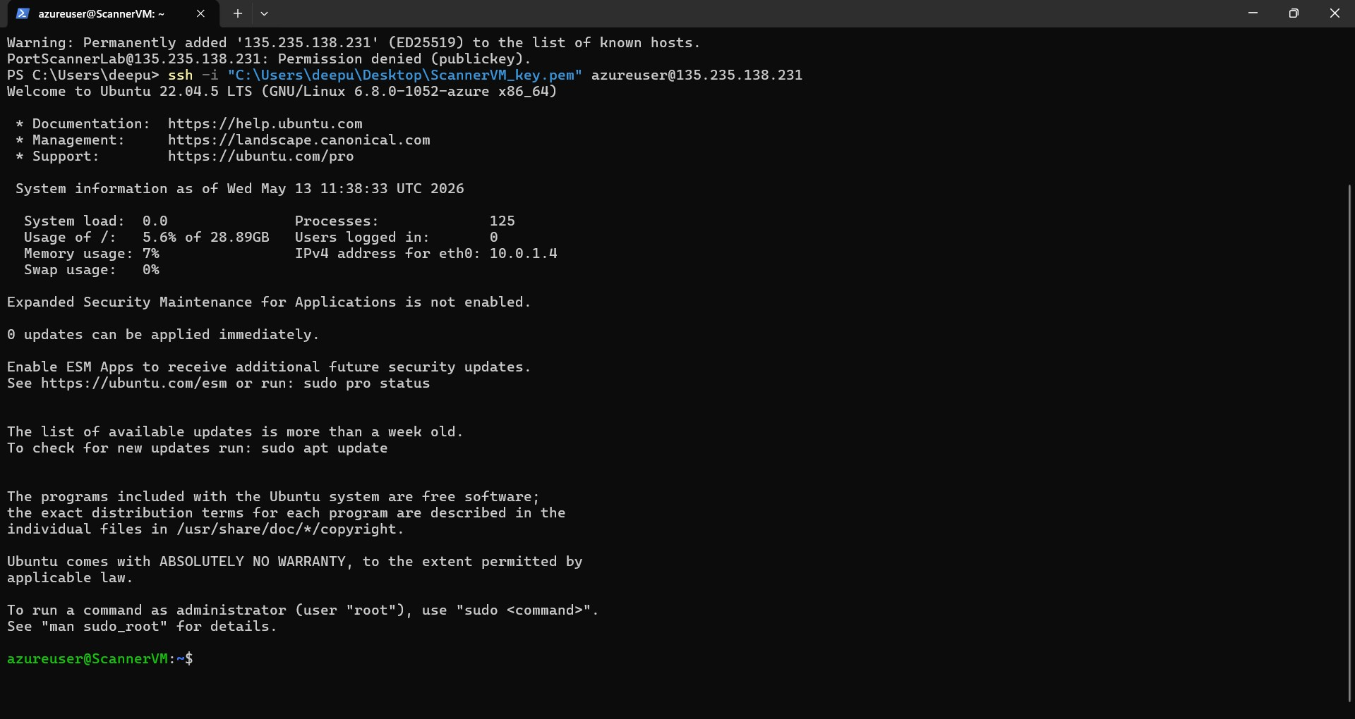
SSH Login to Azure Scanner VM
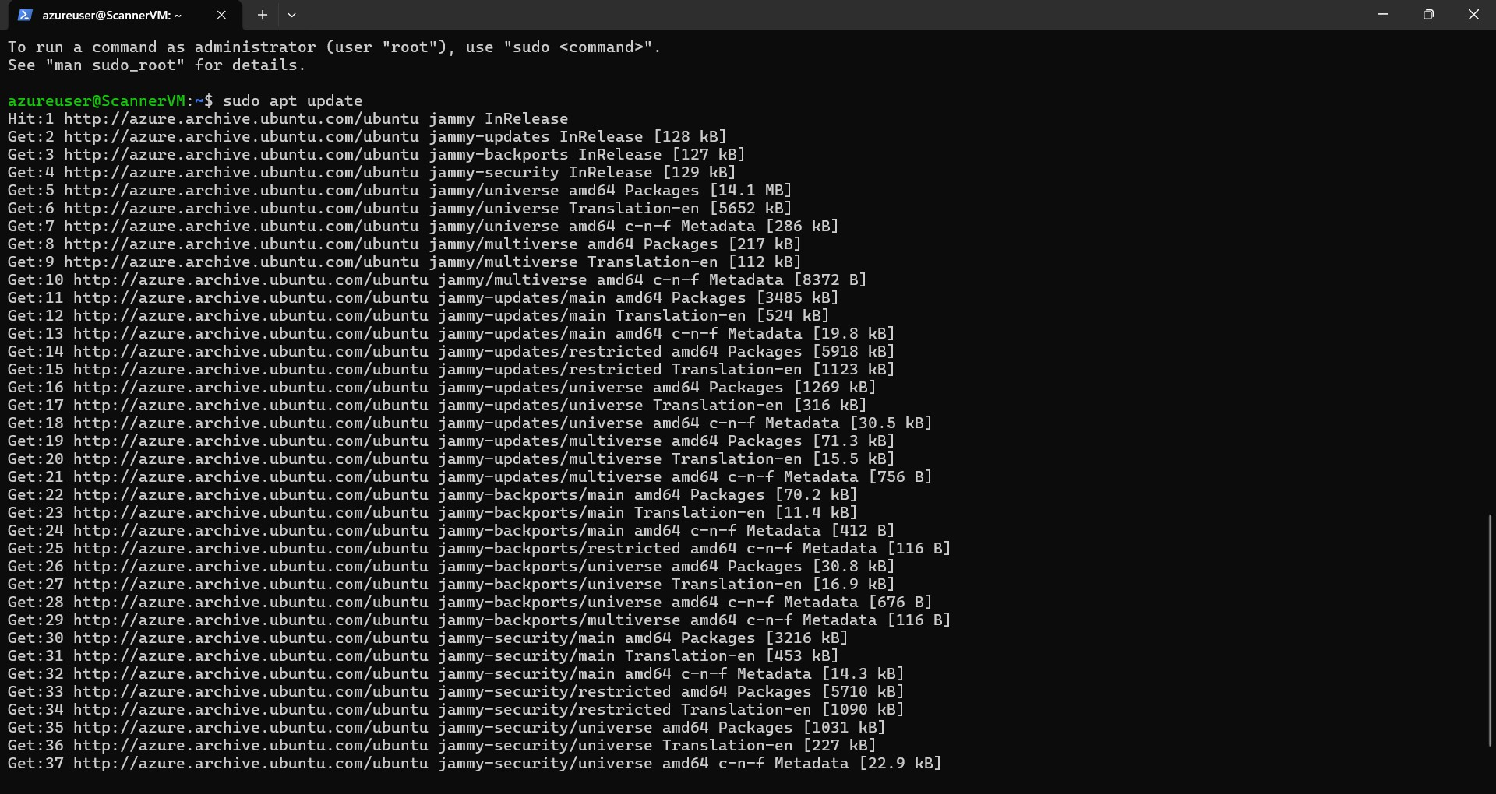
System Update and Package Installation
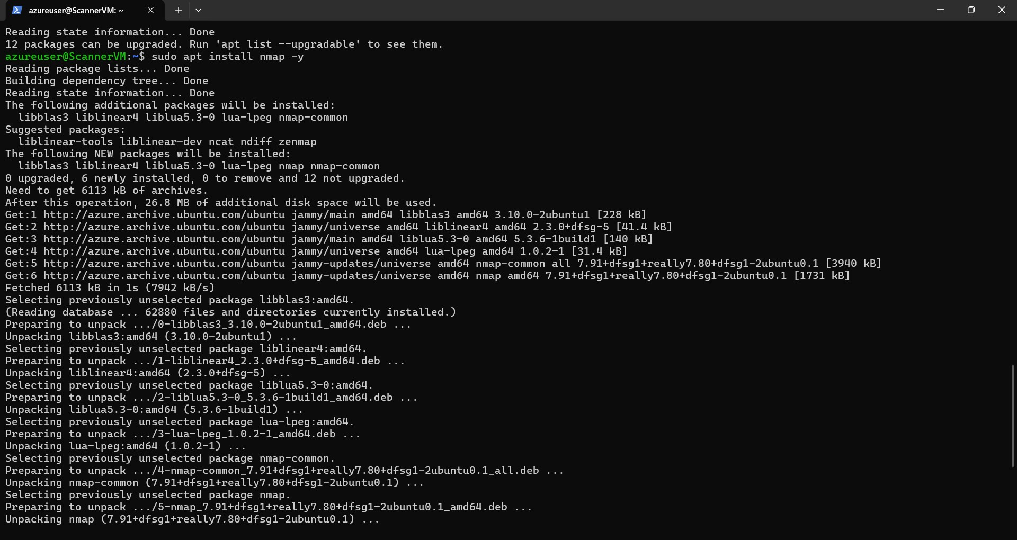
Nmap Installation and Configuration
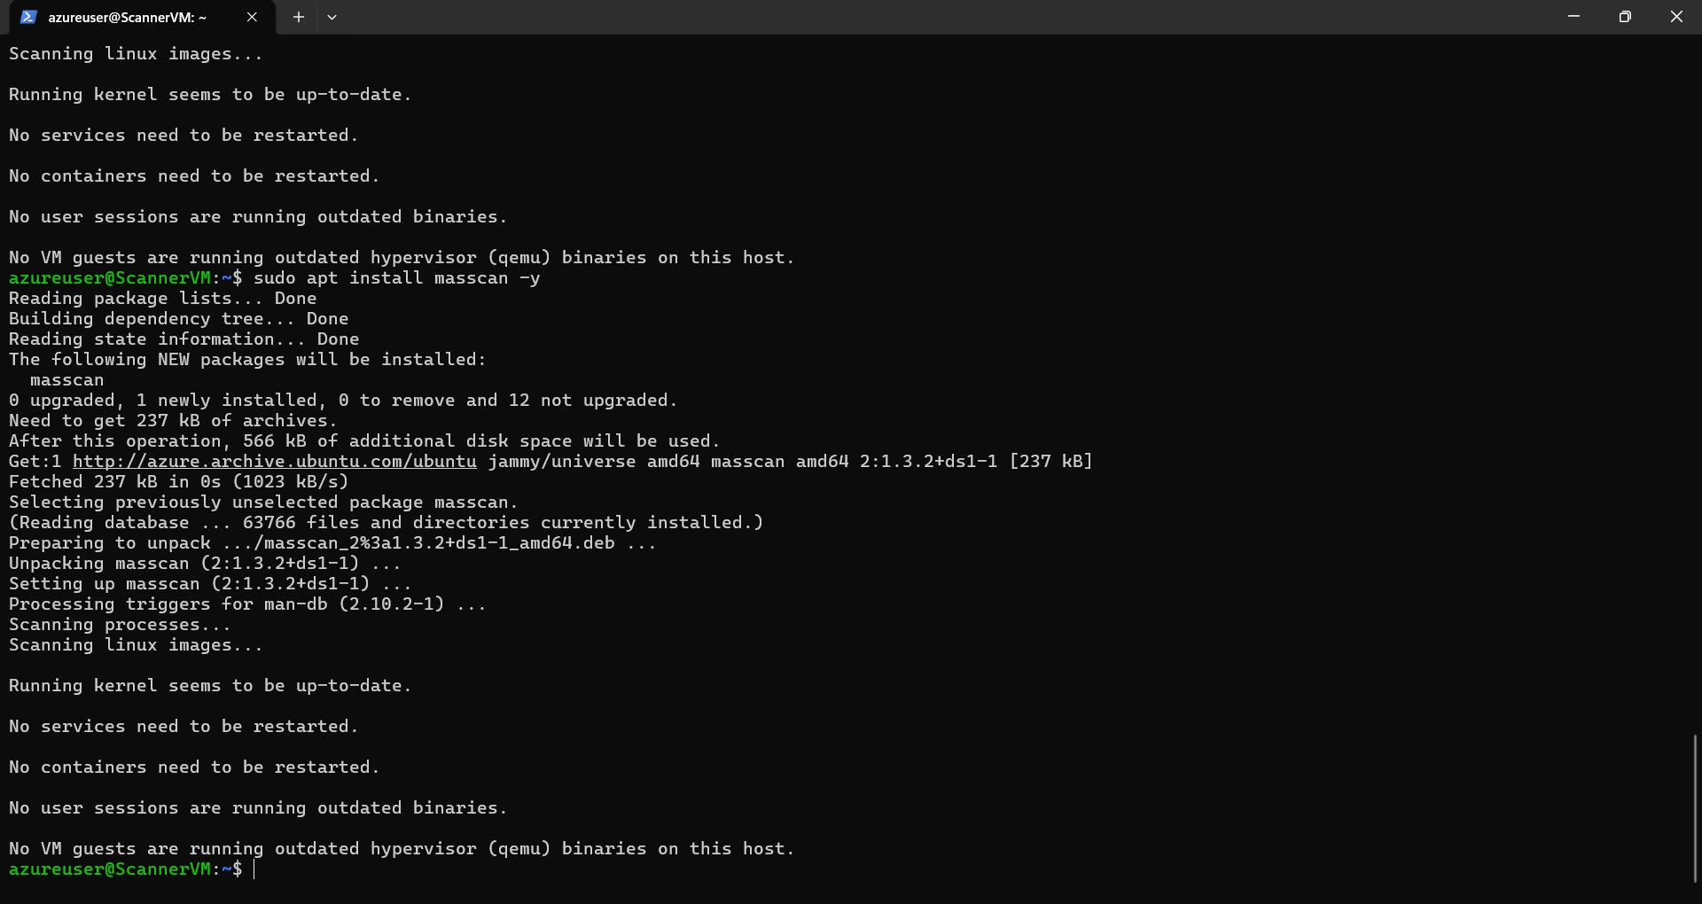
Masscan Installation and Setup

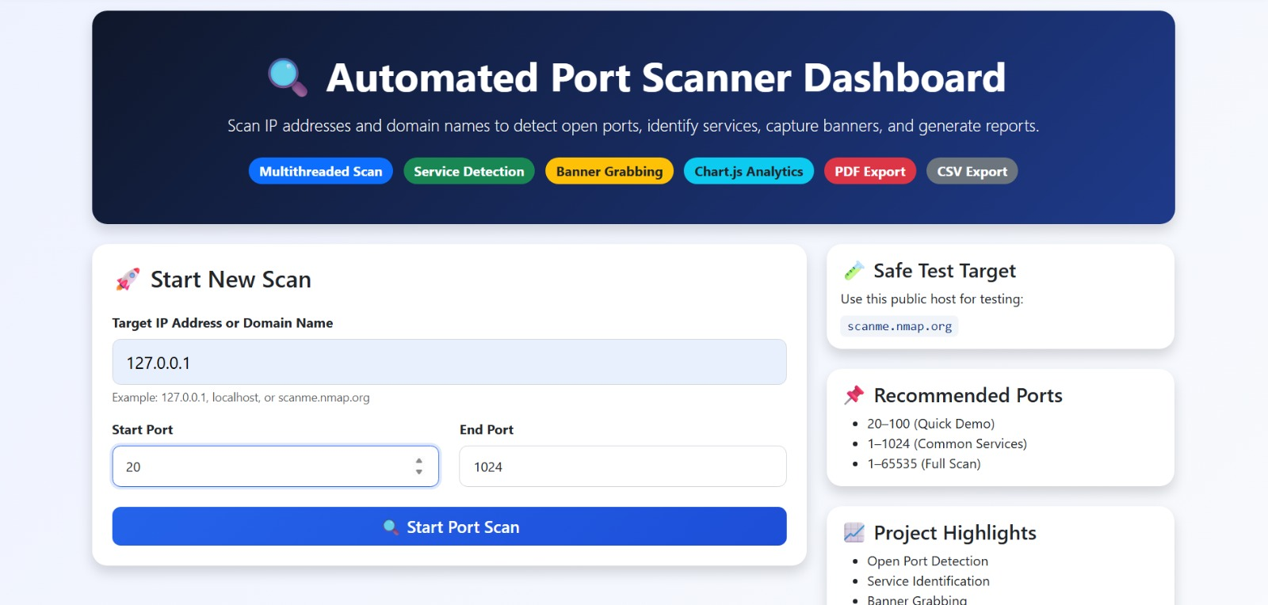

This screenshot shows the main dashboard of the Automated Port Scanner. Users can enter a target IP address or domain name, define port ranges, and start scanning. The dashboard also displays project highlights, safe test targets, and supported features.

Port Scan Result Visualization

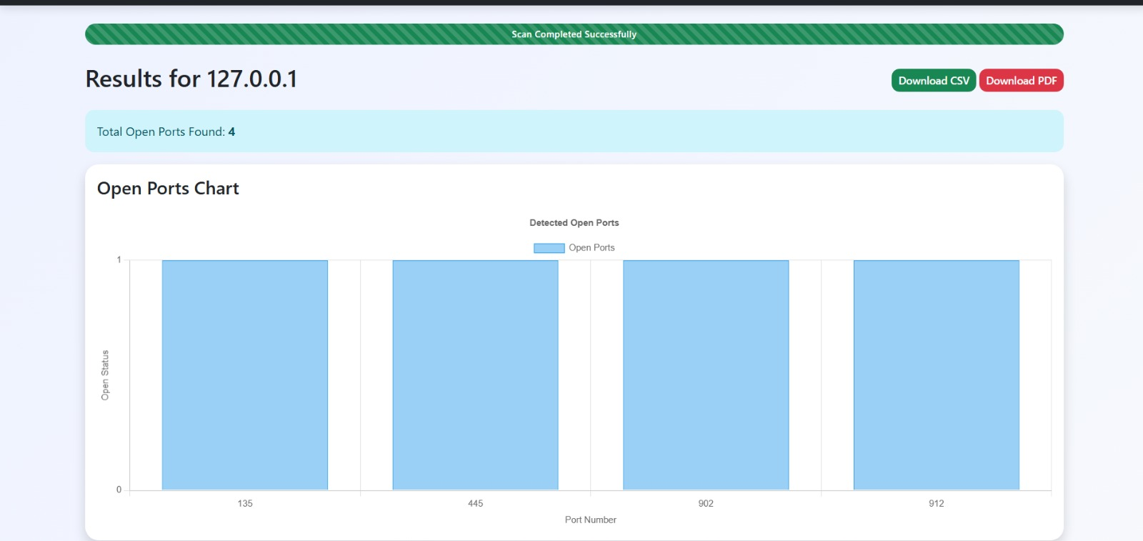

This screenshot displays the successful scan results generated by the system. Open ports are detected and visualized using charts for easier analysis. Users can also export reports in CSV and PDF formats.

11. References
- Nmap Official Documentation
- Masscan Documentation
- Ubuntu Linux Documentation
- Microsoft Azure Documentation
- Cyber Security & Network Scanning Research Papers

