<!DOCTYPE html>
<html lang="en">
<head>
<meta charset="UTF-8">
<meta name="viewport" content="width=device-width, initial-scale=1.0">
<title>Simple Calculator</title>
<style>
body {
font-family: Arial, sans-serif;
display: flex;
justify-content: center;
align-items: center;
height: 100vh;
background: #0a0303;
}
.calculator {
background: #308d60;
padding: 20px;
border-radius: 15px;
box-shadow: 0px 4px 10px rgba(0,0,0,0.1);
}
#result {
width: 100%;
height: 50px;
font-size: 1.5em;
text-align: right;
margin-bottom: 10px;
padding: 5px;
border: 1px solid #ccc;
border-radius: 5px;
}
.buttons {
display: grid;
grid-template-columns: repeat(4, 70px);
gap: 10px;
}

button {
height: 50px;
font-size: 1.2em;
border: none;
border-radius: 5px;
background: #0078d7;
color: white;
cursor: pointer;
transition: background 0.3s;
}
button:hover {
background: #5e7586;
}
.equal {
grid-column: span 1;
background: #7a7b54;
}
.equal:hover {
background: #1e7e34;
}
</style>
</head>
<body>
<div class="calculator">
<input type="text" placeholder="0" id="result" disabled>
<div class="buttons">
<button onclick="clearResult()">C</button>

<button onclick="appendValue('%')">%</button>
<button onclick="appendValue('.')">.</button>
<button onclick="appendValue('-')">-</button>

<button onclick="appendValue('7')">7</button>
<button onclick="appendValue('8')">8</button>
<button onclick="appendValue('9')">9</button>
<button onclick="appendValue('+')">+</button>

<button onclick="appendValue('4')">4</button>
<button onclick="appendValue('5')">5</button>
<button onclick="appendValue('6')">6</button>
<button onclick="appendValue('/')">/</button>

<button onclick="appendValue('1')">1</button>
<button onclick="appendValue('2')">2</button>
<button onclick="appendValue('3')">3</button>

<button onclick="appendValue('*')">*</button><br>
<button onclick="appendValue('0')">0</button>
<button onclick="calculate()" class="equal">=</button>
<button onclick="backspace()">&#x232B;</button>

</div>
</div>

<script>
function appendValue(value) {
document.getElementById("result").value += value;
}

function clearResult() {
document.getElementById("result").value = "";
}

function calculate() {
try {
document.getElementById("result").value =
eval(document.getElementById("result").value);
} catch {
document.getElementById("result").value = "Error";
}
}
</script>
</body>
</html>

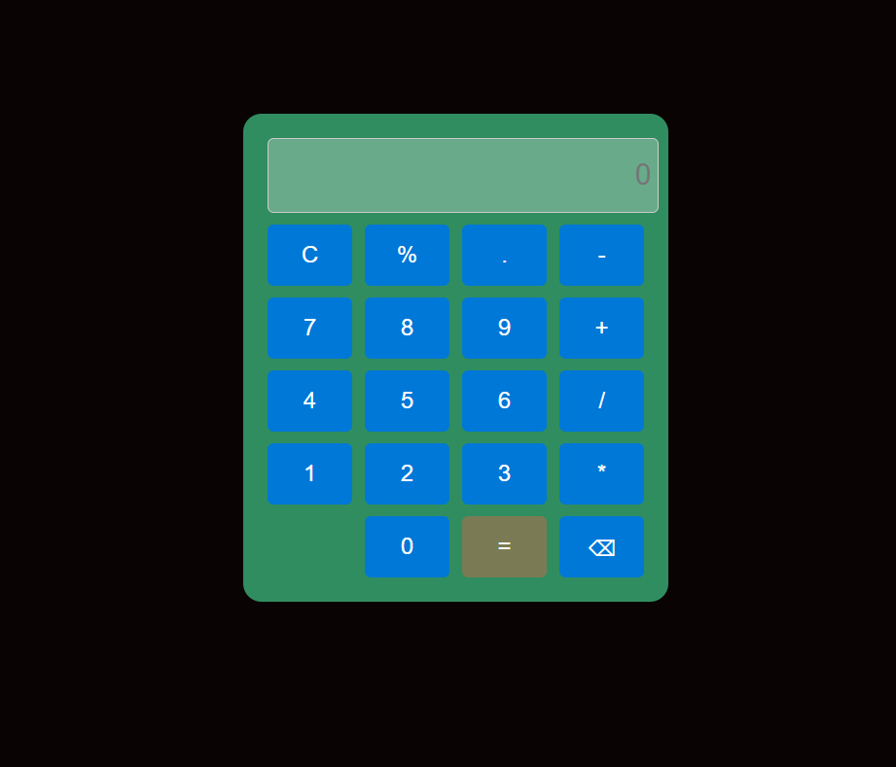

Fig1: Calculator

