# About C2P

DCMS distinctly defines **Stations** for specific purposes with each Station having it's own functionality. Two of theses stations are the Verification Station and AWL (Awaiting Locating).  As the cartons come from the Sewing Plant, it enters the Receiving station from where it passes on to the Verification station. After the verification process the Cartons are passed on to the AWL. Physically this process is carried out by placing the Cartons on a Conveyor Belt which transfers the cartons from the Receiving Station to AWL.

'Carton To Pallet' comes into the picture when the cartons are on the Conveyor belt.  Locating program accept the cartons which are on a pallet. So to locate the verified cartons which are on conveyor, they must be first put on some pallet. C2P has been deigned for this purpose.

It is the responsibility of ’Carton To Pallet' to place the cartons on the Pallet in a proper and orderly fashion and also update the information in the DCMS about the location of each carton and the contents of each Pallet.

The basic philosophy which is addressed in **Carton To Pallet (C2P)** is to place the cartons which have passed through the various stages from receiving to matching station on to a pallet from where they can be effectively picked and located by LOCprogram.

The main features of **Carton To Pallet**

* Aid in properly placing the Carton in an ordered fashion before they can be located in the warehouse on numbered locations.
* Giving latest information about the number of cartons which are ready to be placed in the numbered locations after passing through a rigorous check after the Carton is received.
* Transfer a carton from conveyor to a pallet.
* Transfer a carton from one Pallet to another.

## SYSTEM OVERVIEW

After the carton is received it is directed towards matching station. At matching station the contents of carton is checked for both quantity and quality. In case everything is matched then a Green dot is placed on the carton and carton is sent to the C2P (Carton to pallet), from where it is subsequently send in AWL area. In case there is any discrepancy or the carton is part of a promotional scheme, a Red or Yellow dot will be placed on carton at Matching station and carton will be directed towards Rework department for correction/re-pricing from where it is subsequently sent to  C2P station.

C2P can accept cartons against a pallet coming from any carton area. The expected carton area is rework area or MAT . If user scans any of the cartons which is coming from any other carton area except rework area then the user will get a warning from the system. If the user requests for continue then the carton is accepted otherwise the previous request is cancelled. The destination area for all accepted cartons is AWL. We are assuming that each carton should carry the green dot against it. If it is carrying yellow or red dot then the system will warn the user. If user request to continue then the system will change the red or yellow dot to the green dot.

## Locating a Carton on a Pallet

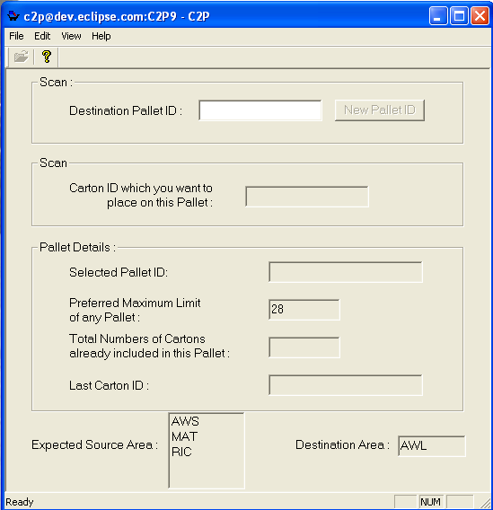

To  locate a carton on a pallet the user scans the Pallet ID first (  Destination Pallet ID  **)**.Based upon the scanned Pallet ID the system checks whether the Pallet has crossed it's maximum limit or not . If yes, it warns the user and asks whether he would still like to place the Carton on the Pallet. If the user says yes then the Carton will be placed on the scanned Pallet

.  User will scan the relevant carton ids which he wants to add in the above scanned pallet. Following changes are applied on the scanned cartons

1. Carton Id must exist in the SRC_CARTON table.
2. If any pallet is already associated with scanned carton id then the system will warn the user.
3. If user request to change the pallet already associated with the carton then the system will change the pallet with the existing one.
4. If carton exists without any pallet associated with it then the system will check whether the maximum limit of the pallet is reached or not. If it reaches the maximum limit then the user will get a warning message.
5. If user requests to continue then the system will add the carton to the list of cartons available in the pallet and total number of cartons will be increased by one.
6. The carton area of these scanned cartons will be changed to “AWL” (Awaiting Locating).
7. We are assuming that each carton should carry the green dot against it. If it is carrying yellow or red dot then the system will warn the user. If user request to continue then the system will change the red or yellow dot to green dot.

    If user wants to change the pallet then he can click the button ‘New Pallet’ and then scans a new pallet to change the working pallet.

# Version History:

**Changes in(Version 2.9):-**

According to this new changed version C2P will read and accept cartons from the areas shown in the Expected Source Area list box. By default the list will show all the source areas which are assigned to C2P module in table tab_module_area. User can override this default by using (Edit | Preferences...). Once user changes the area preferences for a session then C2P will accept cartons only from source area defined by preference for that session.  Once preference is set in a session then there is no option to reset area to the system defaults for that session. User would have to exit and re open the C2P program.

**Testing Log:**

**Version 2.9:-**

All test cases are tested by Pravin Awasthi on 10/10/06.

## Test cases (ECLIPSE SYSTEMS PVT. LTD.):

|  |  |  |  |
| --- | --- | --- | --- |
| **Program : C2P** |  | **Tested By :Deepak Bhatt** |  |
|  |  |  |  |
| **Test Cases** | **Expected Result** | **Actual Result** | **Status** |
| The destination pallet ID scanned by the user should start with P. | Pallet ID not starting with P should be discarded. | Whenpallet ID not starting with P was given to the program it gave error message as expected. | Working Properly. |
| Cartons to be placed in the pallet should exist in the database. | If the cartons do not exist in database the program should report error message. | An Error message displayed. | Working Properly. |
| Whenever the preferred maximum limit of the cartons to be placed in the pallet is crossed. | The program should give a warning message and reconfirm user action. | As Expected. | Working Properly. |
| If the user scans the carton already placed in the current pallet. | User should be given an error message. | As Expected. | Working Properly |
| When the program accepts a carton which is to be placed in the pallet. | The total no. of cartons should increase by one. | As Expected. | Working Properly. |
| If user wants to place a carton to current pallet which is a part of another pallet. | The user should get a warning message and his action should be reconfirmed. | As Expected. | Working Properly. |

**New test cases:**

(Added on 10/10/2006 By:- Mbisht)

|  |  |  |  |
| --- | --- | --- | --- |
| Scan a carton which is not from the areas sown in expected source areas. | The user should get a warning message. | As expected | Working Properly. |
|  |  |  |  |