Restock Carton By Ankit Sharma

# Executive Summary

This document describes the restock carton process. This document is meant for warehouse managers and supervisors who will be responsible for the restock carton function.

# Overview

Restock Carton process can be used to fill hungry locations as per need. Restock Carton module is used to open carton contents on a location. The SKU in carton must be assigned to the location where the carton is being restocked. We can restock carton of any area.

All the locations within the selected building where the SKU of carton can be restocked will be suggested to the user and user can restock carton on any of suggested location. If a carton contains multiple SKU restock puts carton in suspense as soon as it is restocked. If the carton contains more SKUs than capacity of location we allow restocking after confirmation from the user. The carton must not be empty and have order quality in order to be restocked. The pieces of SKU in carton must be in ratio of pieces per package of SKU and carton must have its SKU assigned to any location in order to be restocked.

Restock Carton Process

1. The restocker selects building where he/she wants to start restock.
2. The restocker scans a carton.
3. The program shows Style, Color, Dimension, size and pieces information of carton and also the locations to restock carton.
4. Program asks to scan UPC.
5. After scanning UPC the program suggests locations you can restock carton in any of these locations.
6. The user scans a location form suggested locations and the carton’s content are opened in that location.

# Flow Chart



# Detailed Restock Process

Following operations will be done after we scan a carton in Restock carton Application

1. The application checks if that carton actually exists or not, if carton doesn’t exist then checks if it is an opened carton and if carton is opened an error “Carton is already opened” displays else error “No such carton” displays .If that carton exists then, check for carton is non-empty or not.
2. If carton is empty the message “Carton is empty” will display and application stops processing on that carton. If carton is non-empty, then check for any work needed on carton.
3. If any work required on carton the message “Work needed on carton” will display and application stops processing on that carton. If carton do not need any work, then check for quality of carton.
4. If carton does not have order quality we display message “Carton must have order quality to restock” and stop working on that carton.
5. If carton have mixed SKUs the carton will be put in suspense.
6. If carton does not have mixed SKUs, then check for pieces of SKU in carton are in ratio of pieces per package of SKU.
7. If pieces in carton are not in ratio of pieces per package of SKU, then the message “Pieces of SKU in carton are not in ratio of pieces per package of carton” displays and stop working on that carton.
8. If pieces are in ratio of piece per package then, check if any location suggested to restock SKU in carton. If no location found to restock carton then, message “No location found to restock carton” displays and stop working on that carton. Else the user redirected to Scan UPC page showing carton’s SKU, pieces and location suggestions. The application asks user to scan UPC of SKU in carton.
9. If scanned UPC does not exist in carton an error message “UPC scanned does not match with UPC in carton” displays and carton sends to suspense.
10. If scanned UPC exists in carton we redirected to location suggestion page which displays locations, restock aisles and pieces required by a location and building.
11. If user scans a location that does not match with any of suggested location an error message “Scanned location did not match with suggested location” will display. If user scans a valid location then, check for pieces required by location are more than pieces in carton. If pieces required by location are more than pieces in carton the carton will get restocked and user will be redirected to Carton page. Else ask for confirmation scan and then, carton will get restocked and user will be redirected to Carton page.

# Restock UI

The Index page of Replenishment consist two links .We can restock cartons by clicking Restock Link

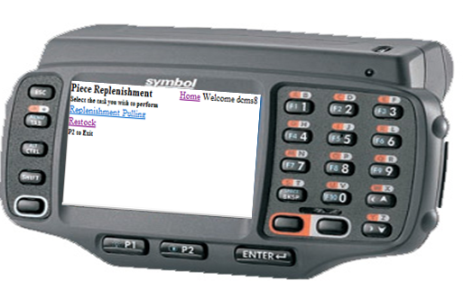

The home page of Restock application is Building page. This page asks you to select building. 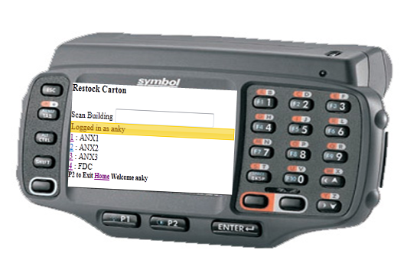

After selecting building we redirects to Carton page. This page asks you to scan carton.

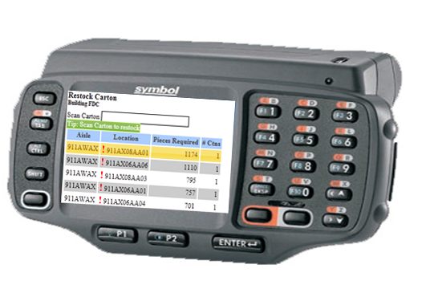

When you scan a carton we redirect to UPC page. On UPC page SKU we have SKU of carton 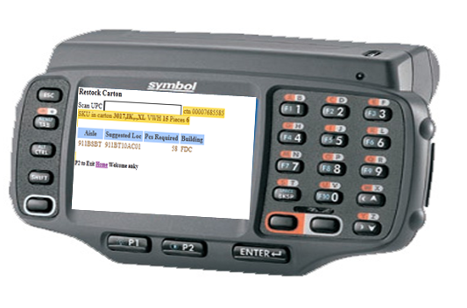

After scanning UPC we redirects to location page. 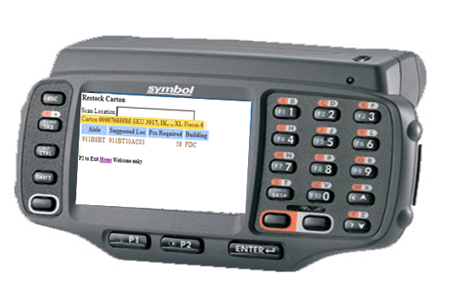

On location page we scan location where we want to restock. After scanning valid location the carton get restocked.

