**Practical 5**

**Aim:**

1. **Write a JavaScript function to find maximum of three numbers using if-else.**

**Description:**

<html>: The html tag represents the root of an HTML document.

<head>: The head element is a container for all the head elements.

<title>: The title tag is required in all HTML documents and it defines the title of the document.

<body>: The body tag defines the document's body.

<script>: The <script> tag is used to define a client-side script (JavaScript).

<form>: The <form> tag is used to create an HTML form for user input.

<h1><h6>: Headings are defined with the <h1> to <h6> tags.

Function: A JavaScript function is a block of code designed to perform a particular task.

If : Use if to specify a block of code to be executed, if a specified condition is true.

Else if: Use else if to specify a new condition to test, if the first condition is false.

Alert: used to give a warning message to the users.

**Code:**

<html>

<head>

<title>Submit Form</title>

</head>

<body>

<script>

function myfun()

{

var txt1 = document.getElementById("txt1").value;

var txt2 = document.getElementById("txt2").value;

var txt3 = document.getElementById("txt3").value;

if(txt1<txt2)

{

if(txt2<txt3)

{

document.getElementById("demo").innerHTML = txt3;

}

else

{

document.getElementById("demo").innerHTML = txt2;

}

}

else

{

document.getElementById("demo").innerHTML = txt1;

}

}

</script>

<fieldset style="width:200">

<legend>Find Maximum</legend>

Value 1 <input type="text" id="txt1"><br>

Value 2 <input type="text" id="txt2"><br>

Value 3 <input type="text" id="txt3"><br><br>

Maximum Value = <p id="demo"></p>

<button onclick="myfun()">Find Maximum</button>

</fieldset>

</body>

</html>

**Output:**

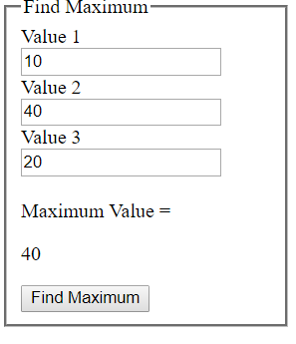

1. **Write a JavaScript to show use of alert, confirm and prompt boxes.**

**Code:**

<html>

<head>

<title>Practical - 5</title>

<script>

function myAlert()

{

alert("I am an alert box!");

}

function myConfirm()

{

var txt;

if (confirm("Press a button!") == true)

{

txt = "You pressed OK!";

}

else

{

txt = "You pressed Cancel!";

}

document.getElementById("demo1").innerHTML = txt;

}

function myPrompt()

{

var txt;

var person = prompt("Please enter your name:", "Rishi");

if (person == null || person == "")

{

txt = "User cancelled the prompt.";

}

else

{

txt = "Hello " + person + "! How are you today?";

}

document.getElementById("demo2").innerHTML = txt;

}

</script>

</head>

<body>

<h1>Alert Box</h1>

<button onclick="myAlert()">Try it</button>

<h1>Confirm Box</h1>

<button onclick="myConfirm()">Try it</button>

<p id="demo1">

<h1>Prompt Box</h1>

<button onclick="myPrompt()">Try it</button>

<p id="demo2">

</body>

</html>

**Output:**

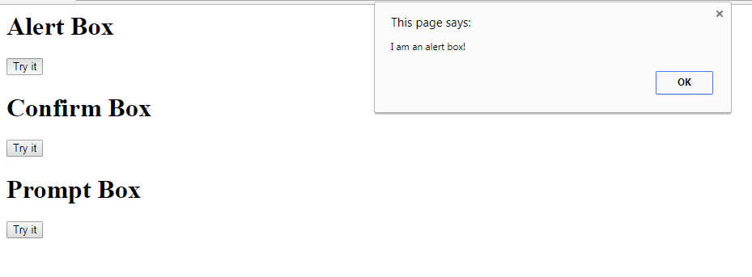

**Alert Box**

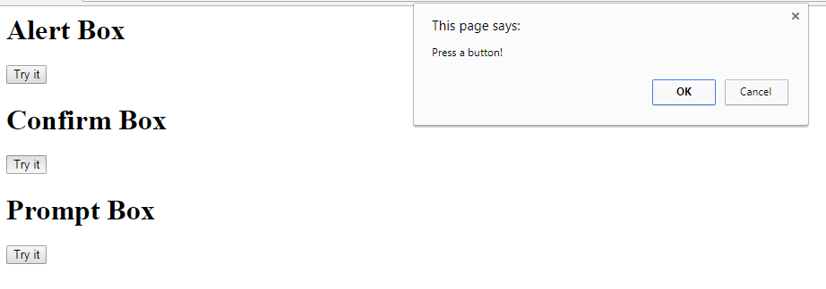

**Confirm Box**

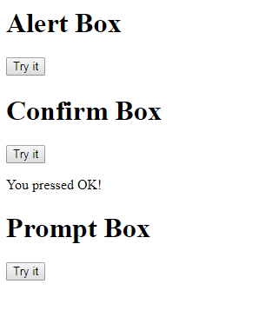 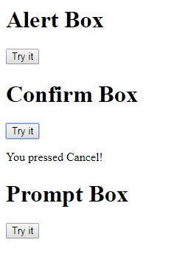

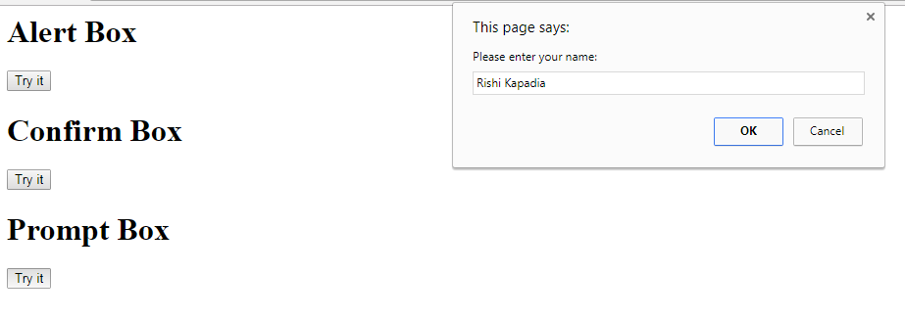

**Prompt Box**

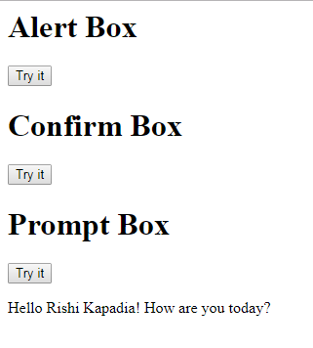 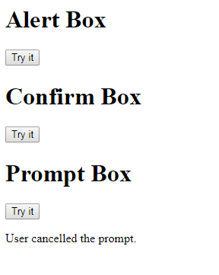

1. **Write a JavaScript to create a button and on click event on the button, a new window should open up in a new tab.**

**Code:**

<html>

<head>

<title>Open New Window</title>

<script>

function myFunction()

{

window.open("https://www.google.com");

}

</script>

</head>

<body>

<p>Click to Open a New Window.</p>

<button onclick="myFunction()">New Window</button>

</body>

</html>

**Output:**

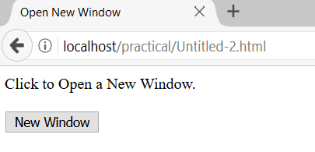

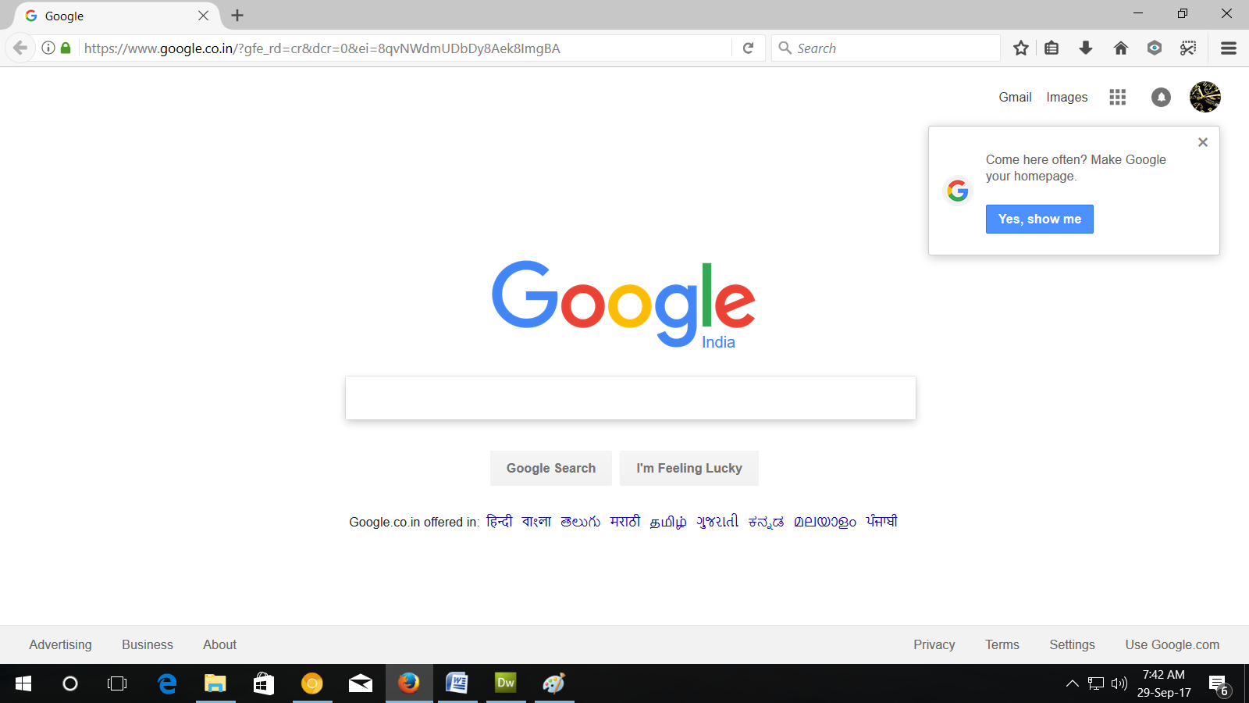

**Google Open in New Window**

**Practical 6**

**Aim: Write Implement image gallery using JavaScript.**

**Description:**

<html>: The html tag represents the root of an HTML document.

<head>: The head element is a container for all the head elements.

<title>: The title tag is required in all HTML documents and it defines the title of the document.

<body>: The body tag defines the document's body.

Function: A JavaScript function is a block of code designed to perform a particular task.

If : Use if to specify a block of code to be executed, if a specified condition is true.

**Code:**

<!DOCTYPE html>

<html>

<title>dainik</title>

<link rel="stylesheet" href="style.css">

<body>

<h2 class="center">Manual Slideshow</h2>

<div class="w3-content w3-display-container">

<img class="mySlides" src="1.jpg" style="width:50%">

<img class="mySlides" src="2.jpg" style="width:50%">

<img class="mySlides" src="3.jpg" style="width:50%">

<button class="left" onclick="plusDivs(-1)">&#10094;</button>

<button class="right" onclick="plusDivs(1)">&#10095;</button>

</div>

<script>

var slideIndex = 1;

showDivs(slideIndex);

function plusDivs(n) {

showDivs(slideIndex += n);

}

function showDivs(n) {

var i;

var x = document.getElementsByClassName("mySlides");

if (n > x.length) {slideIndex = 1}

if (n < 1) {slideIndex = x.length}

for (i = 0; i < x.length; i++) {

x[i].style.display = "none";

}

x[slideIndex-1].style.display = "block";

}

</script>

</body>

</html

**Output:**

