Async/Await

- async is a keyword that is used before a function to create a async function
- async function always returns a Promise
- Let’s say if you don’t return a Promise from an async function, then that function itself will wrap that value in a Promise and then will return it

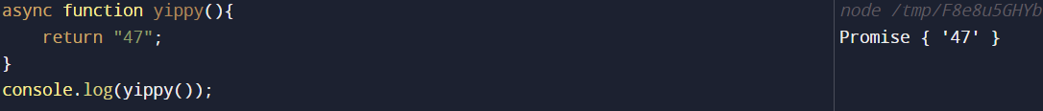

The word “async” before a function means that the function will always returns a Promise, and wraps non-Promises in it
In our code example too, you can see that yippy is an async function, and we are simply returning a string “47” from our function, but in consoled output we can see that, the output is Promise { ‘47’ }, cause async function always returns a Promise
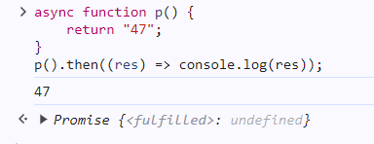
Our function above did not return a Promise, so it wraps the return value into a Promise and then returned it, and we have handled that Promise using then and consoled out the result
Now, lets introduce another terminology linked with async i.e await keyword
- Async/Await combo is used to handle Promises
- Before async/await we used to handle Promises by making use of then block
- We use the keyword await in front of the Promise inside the async function
- The keyword await makes JavaScript wait until Promise settles and returns its result
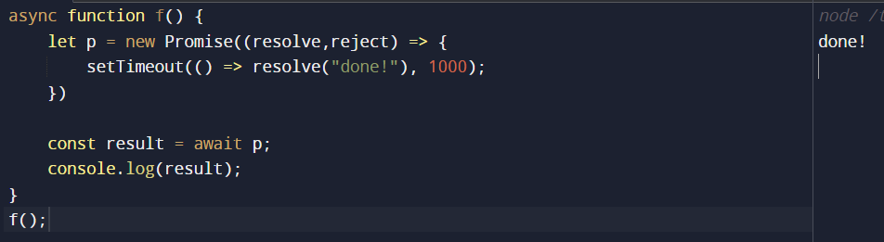

- await literally suspends the function execution until the promise settles, with result becoming its result
- In the meantime, JavaScript engine can do other jobs, execute scripts, handle events, etc

Now, let’s dive deep into the concepts,
First of all lets see an example where the Promise is handled with then/catch
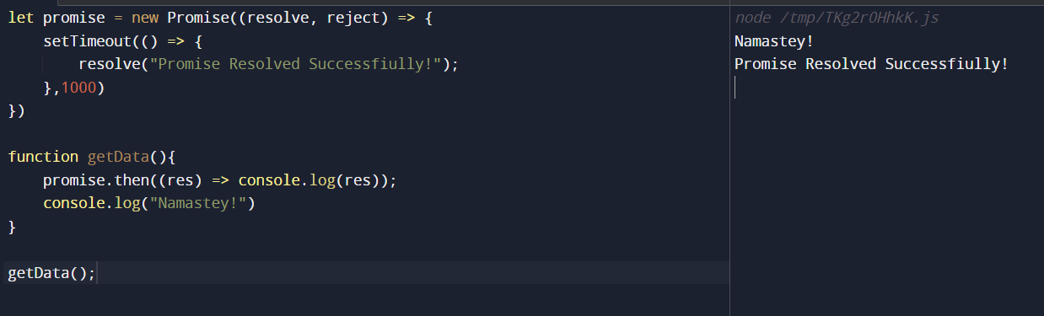
See, in our function getData, Namastey was consoled earlier then we got the result of Promise, cause promise is asynchronous so JS Engine continue to further execute the script and JS Engine did not wait for the promise to resolve

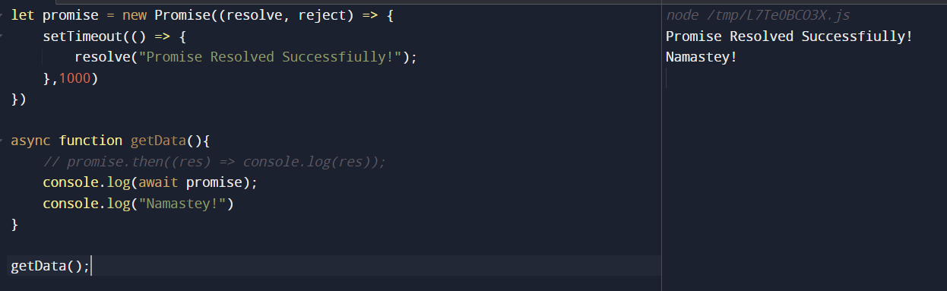
But see on the other hand, using async/await the async function was suspended as soon as the JS engine determines the Promise, hence further code did not run and we did not get the Namastey first here, JS Engine waited for the Promise to be resolved then it moved ahead in the function getData

Let us see another scenario ->
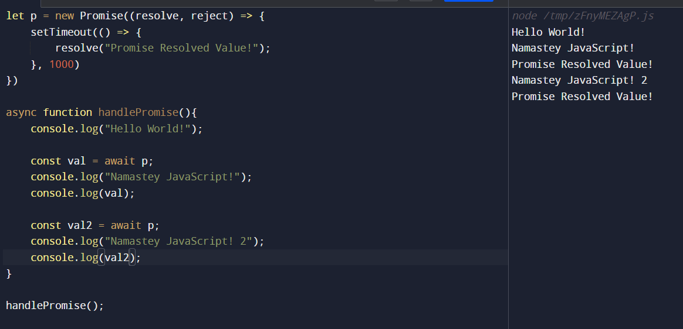
In the above code, as soon as the handlePromise runs, we get consoled output Hello World,
Then after 1 second, we get the remaining lines of console.
Another Example ->
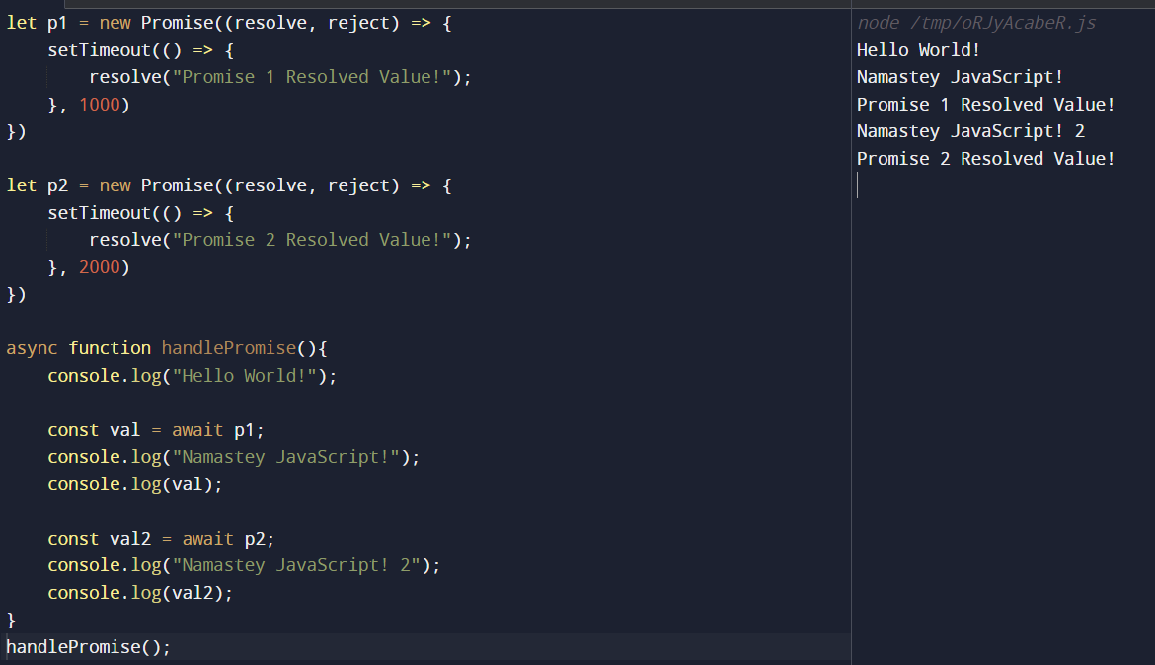
See in the above example,
- First and foremost, we get Hello World
- Then after one second, we get Namastey JavaScript and Promise 1 result
- Then after two seconds (counting from beginning, not after first promise’s result was consoled out), we get Namastey JavaScript 2 and Promise 2 result.
But see the example below now ->
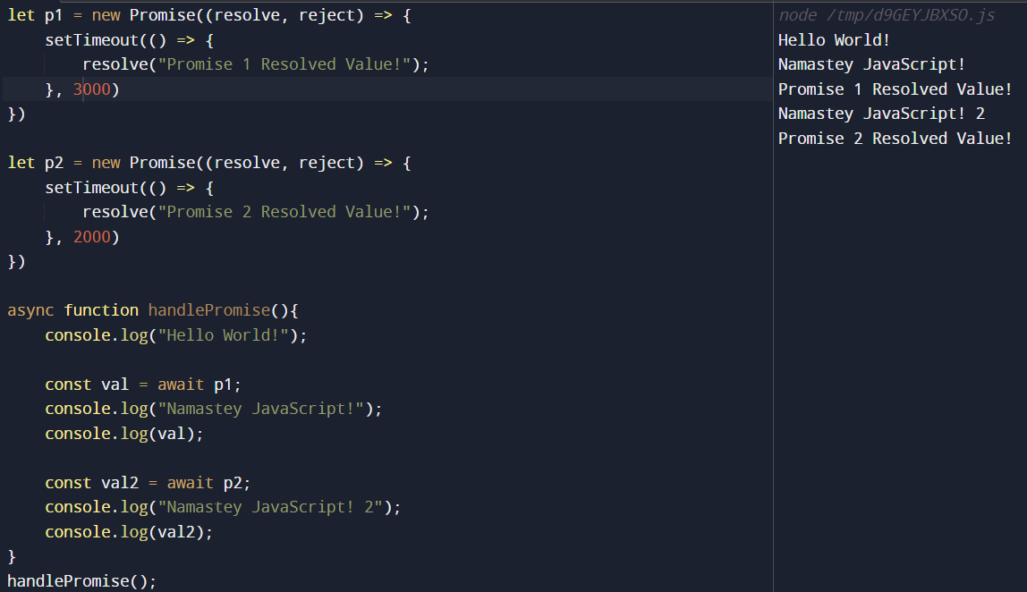
- See, here initially we get Hello World
- But then after 3 seconds of the beginning of executing the function, we get the remaining lines
- Cause function stopped at p1 and until it resolved, it did not move ahead

