CALL, APPLY, BIND

Call Method ->
- Call Method is used for function borrowing, kaise ?
  - Let’s assume we have two objects, name1 and name2

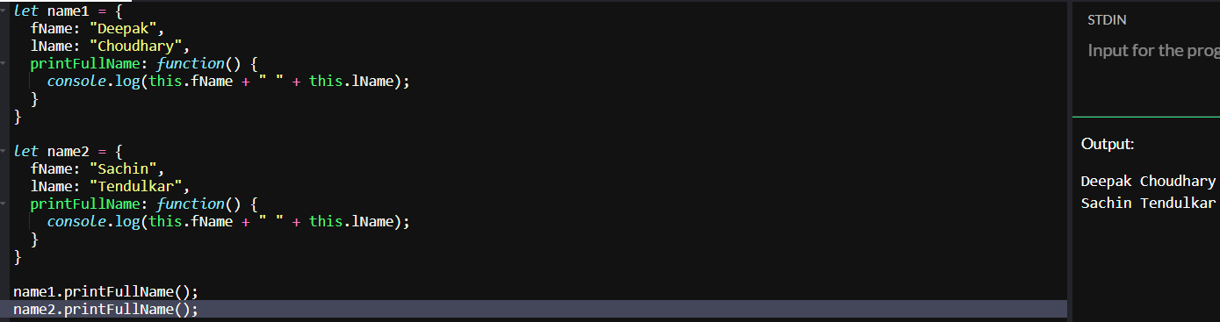
  - Here, we are using the same method printFullName in both the objects, so rather than using the same method in different objects and rewriting it again and again, we can borrow the method from one object in another object using call method
  - 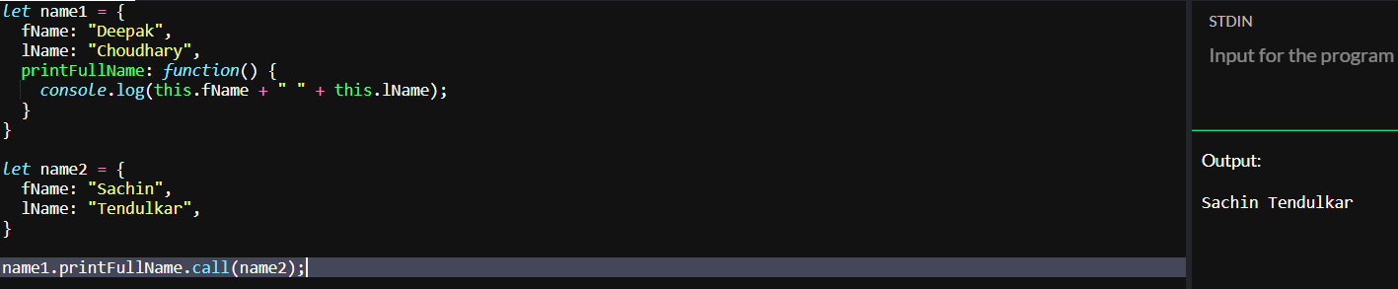
  - Or we can take the method out from the first object as well, and use that function generally as used in the below snap:
  - 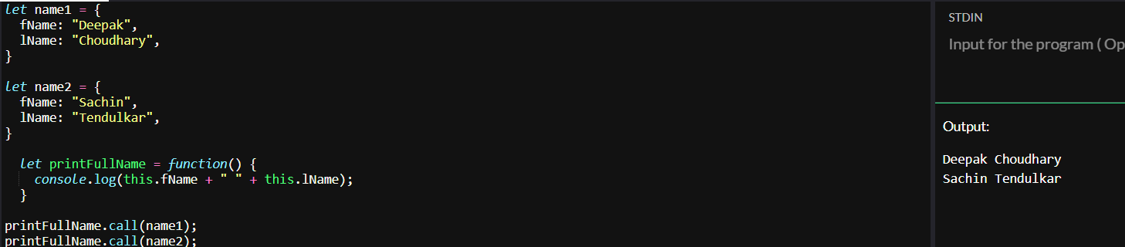

- What if we want to pass more parameters into the function, suppose we want to display hometown of the folks which is passed while call method as below:
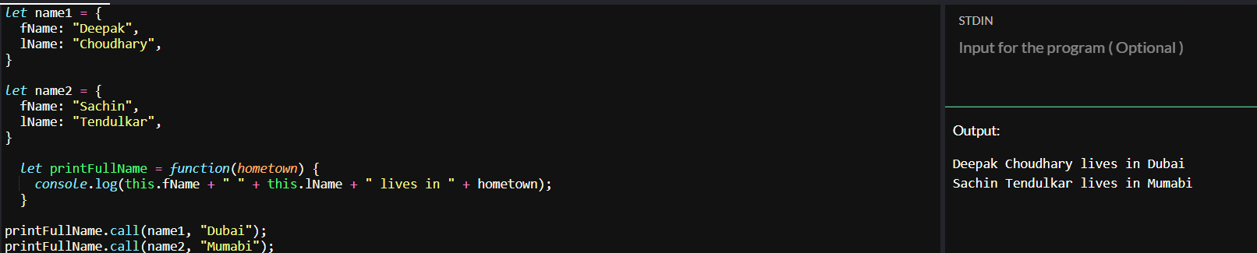
- Now what if we want to display state alongside hometown,
- 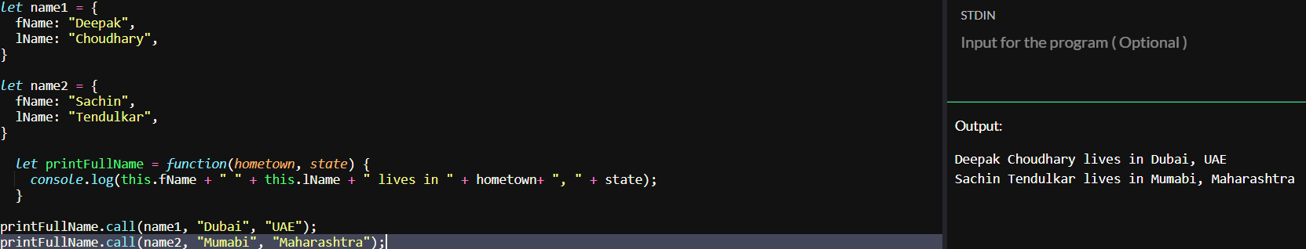

- The only difference between the call and apply method is the way we pass arguments

- 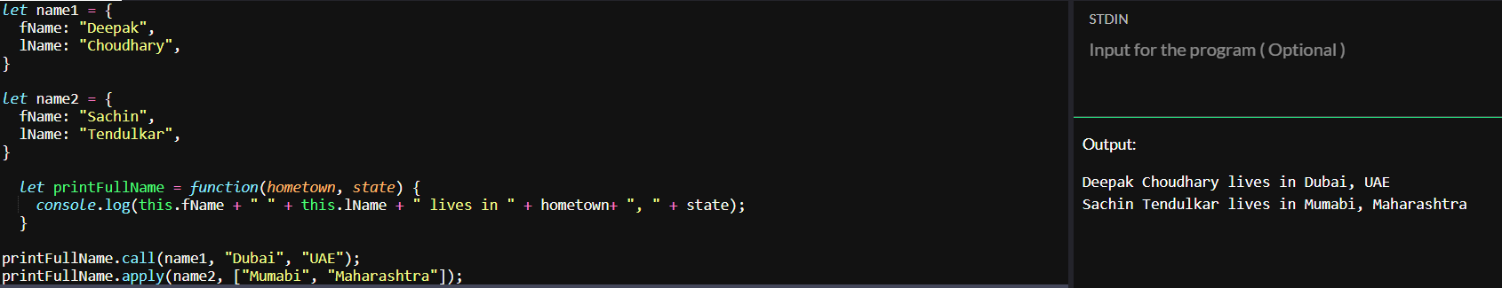

- So instead of passing arguments individually as in the call method, we rather pass arguments in an array in the apply method.

BIND Method ->
- Bind method looks exactly the same as the call method, but the instead of calling the method directly like printFullName.call(name), the bind method, binds the method i.e printFullname with the object and returns the copy of that method.
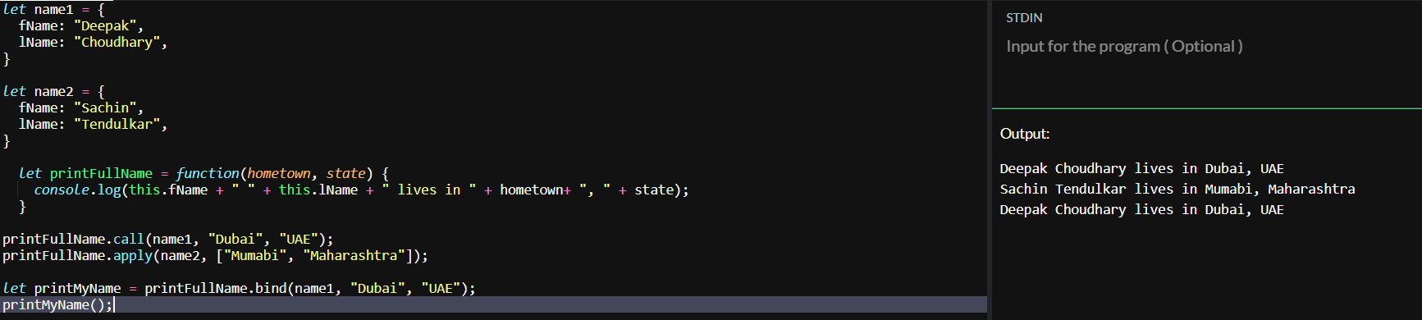
- Bind Method is just used to bind and keep a copy of that method and use it later
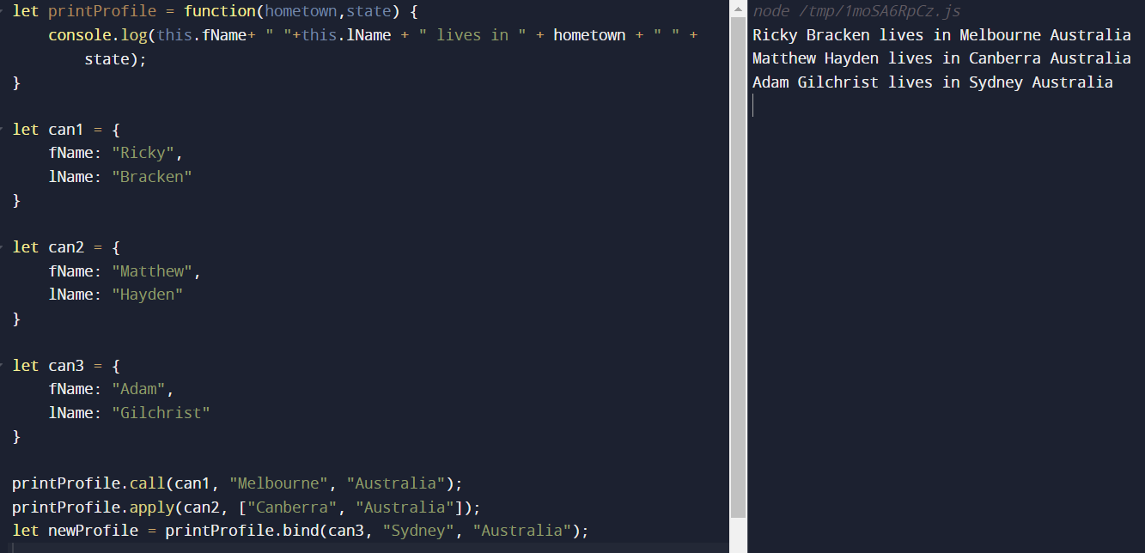
We can also bake arguments into functions using bind
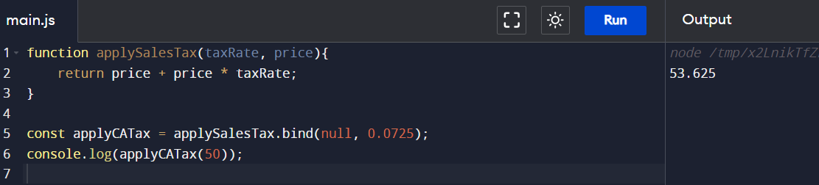
When you do not directly call functions and instead JavaScript calls them, a keyword this is created for you, like for ->
- Event Listeners
- Timers
- Callback functions(map, filter)
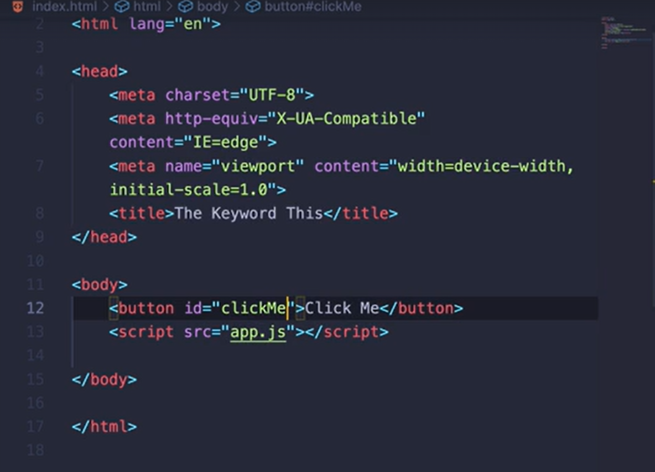
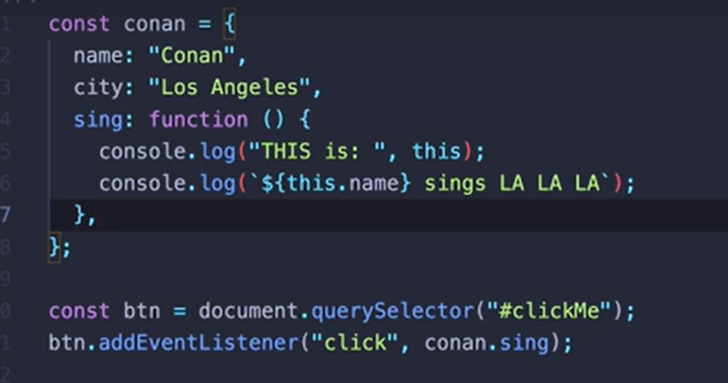
See here as soon as the button is clicked, we have attached an event listener to the button, and we are calling sing method of the conan object
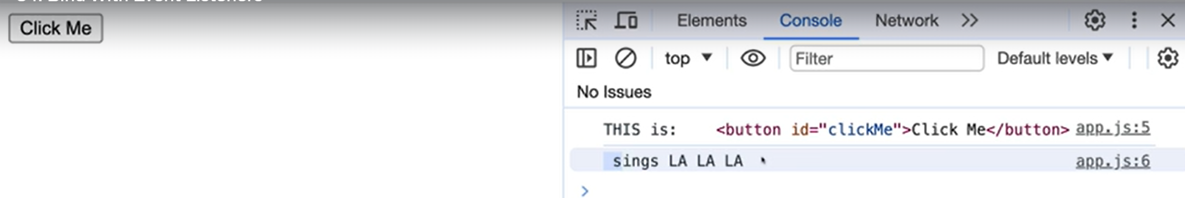
But see, in the output we have got only sings LA LA LA, and value of this is the button itself, i.e. in this case JavaScript decided the value of this, which is button
So, what can we do in this case? Simple we’ll use the bind
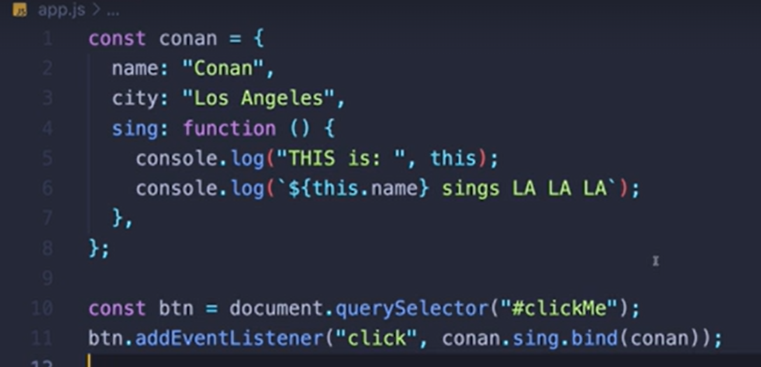
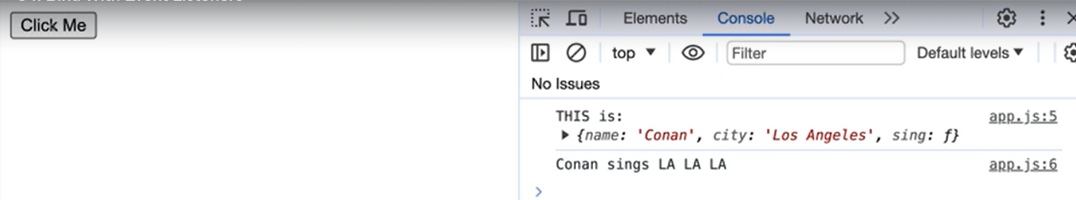
See, now we have gotten the expected output.
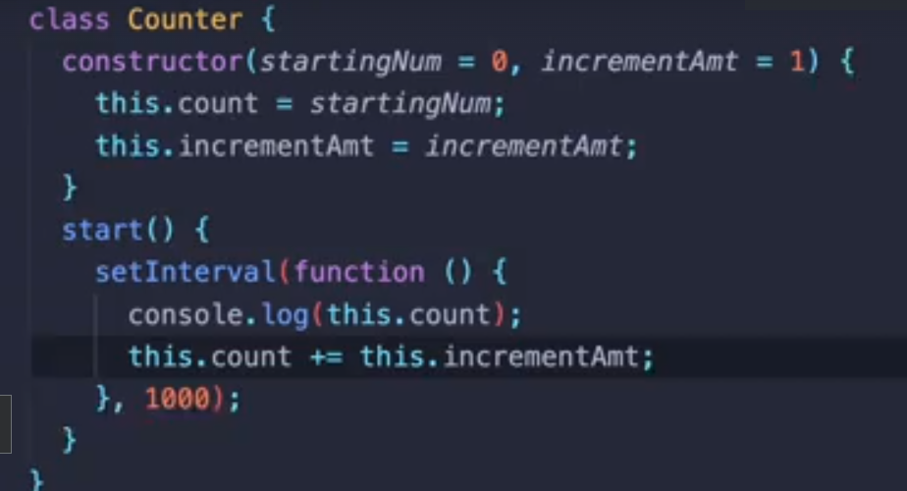
See in the above code excerpt, we have a class Counter, and a method start, we have called a setInterval in that method, which triggers after every one second
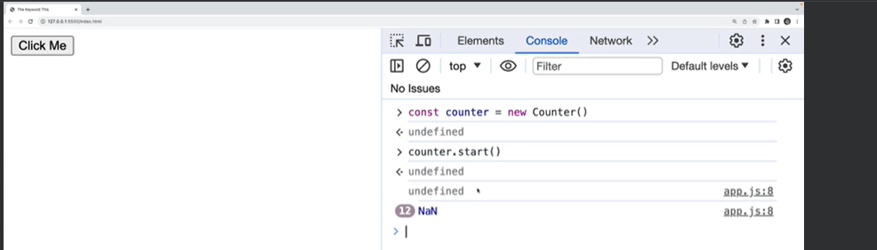
But see, it have given us NaN, to further check let us console the value of this,
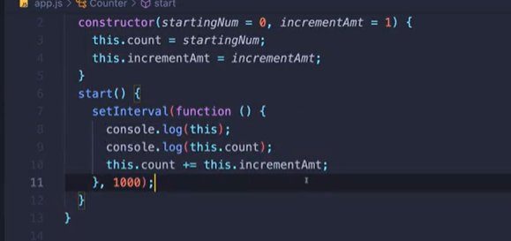
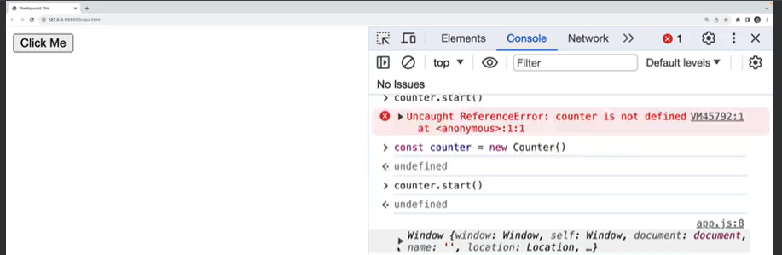
See the value of this is window object, but whyyyyyyy?
Cause when JS calls setInterval, it calls it on the window object, and that context is set for this as well, so what’s the solution
First Solution -> bind
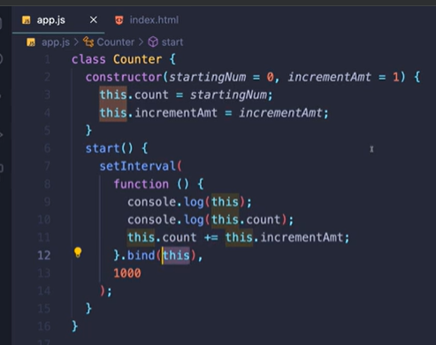

Second Solution -> use Arrow function inside setInterval
Q ESTIONS
1.

- In an online compiler
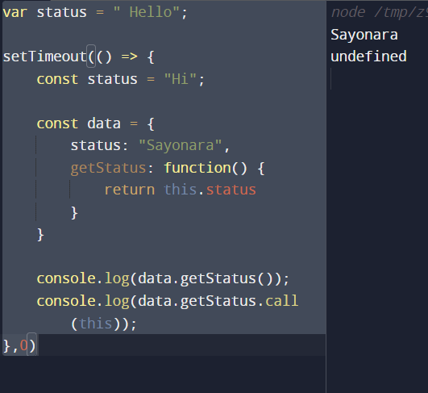

- In inspect terminal
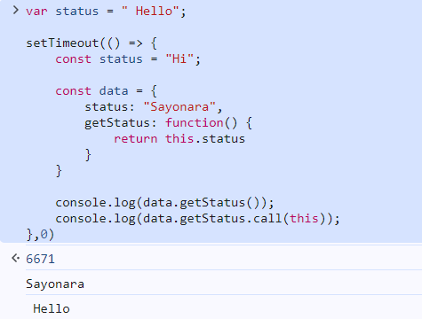
- It printed Hello cause this never points to a function, and in our case setTimeout is a function rather this will point to the context of the function, so what this will point to the global object, that’s why in inspect it printed Hello whereas in an online compiler it printed undefined

2.
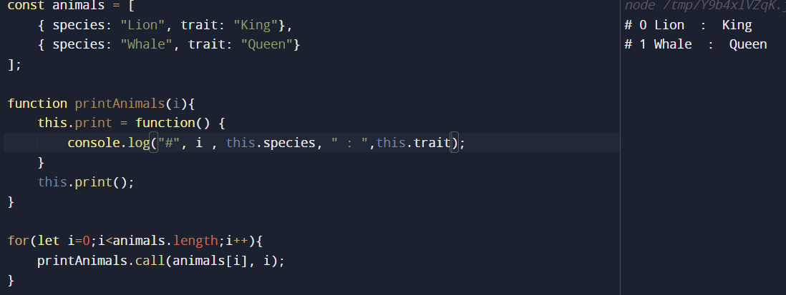
3. Append an array to another array using Apply
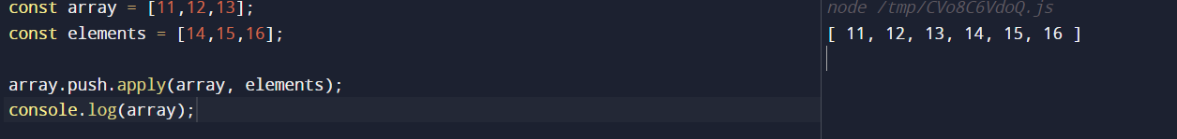
4. Find min/max number in an array
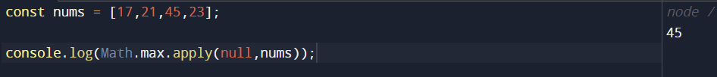
5.
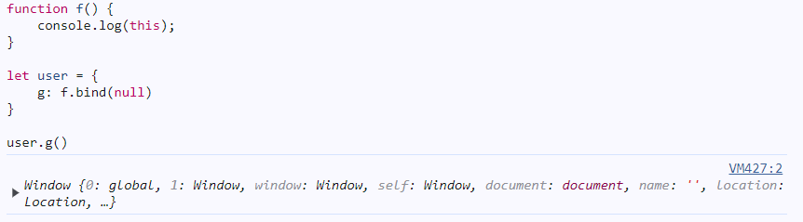
Explanation -> in bind function we have provided the context as null so even if we are calling that function in another object i.e. user the context is hard fixed and it will point to the window object
6. Bind Chaining Question
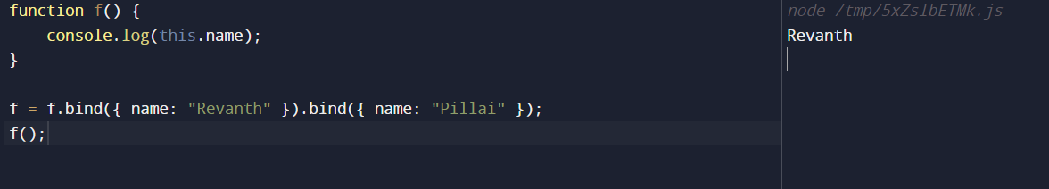
Explanation -> once a function is bound to a particular object, it will always be bound to that particular object, hence it consoled out Revanth

7. Fix line 17 of code to make it work
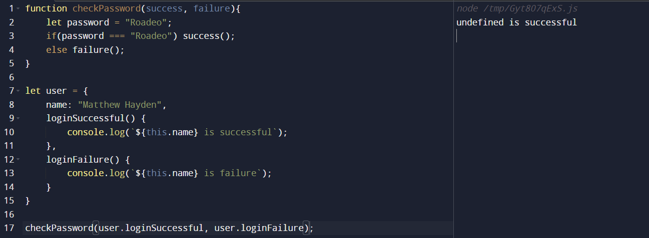

EXPLANATION: We are trying to execute the callbacks in the checkPassword function and the callbacks are trying to find the value of this in checkPassword itself, therefore it’s printing undefined, therefore we need to bind the user object to the callbacks to that they will remember the context
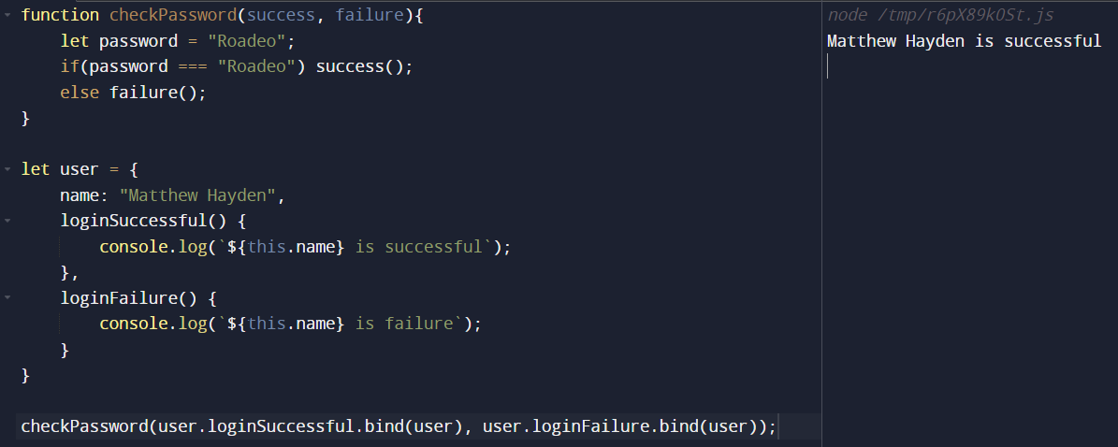
8. Explicit Binding with Arrow Functions
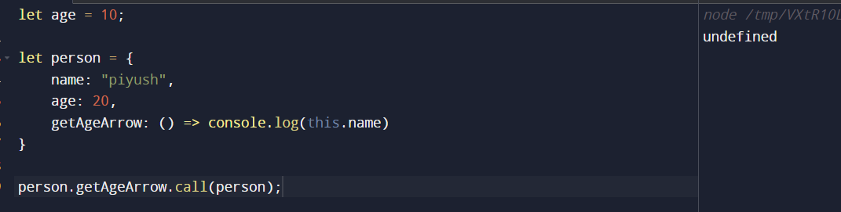
Exaplanation -> It does not matter if we do call, apply, bind with arrow functions, it takes the context from it’s parent and it does not have any parent in this case, hence it printed undefined
9. Polyfill for Call Method

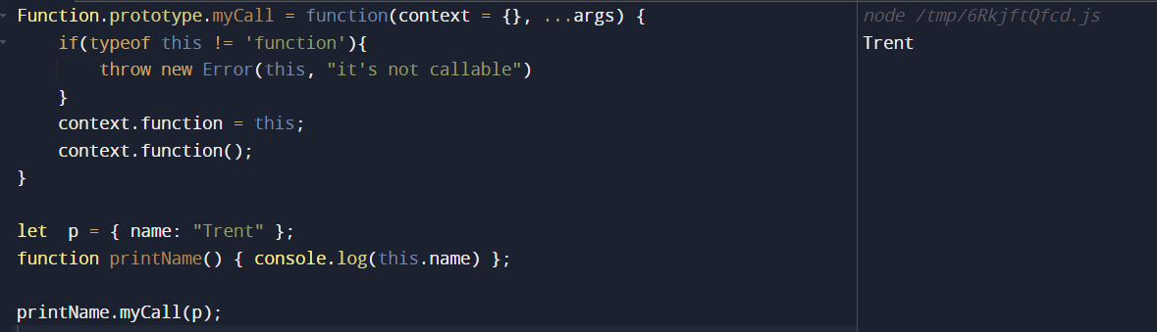
Explanation -> first and foremost, we verified whether the thing that we are calling this myCall on is an actual function or not, then we assigned this to the context.function and then called context.function with arguments as (…args)
10. Polyfill for Apply Method
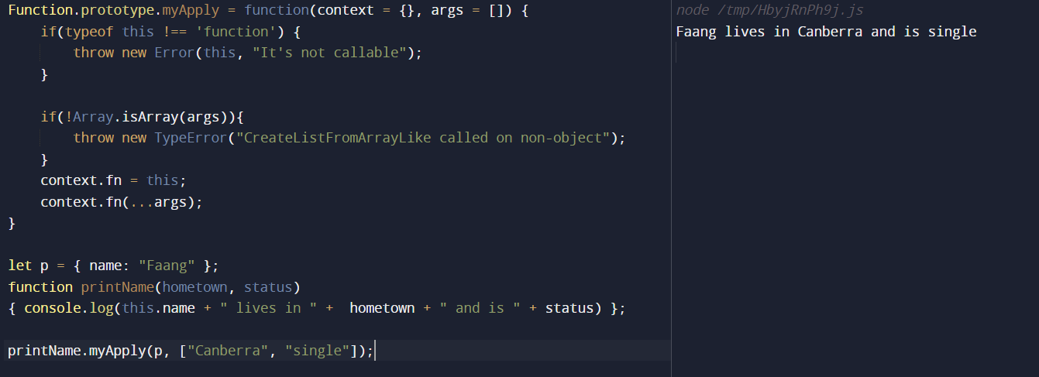
11. Polyfill for Bind Method
