CALLBACK FUNCTIONS

- As we already know, functions are first class citizens in JavaScript
- Means, you can take a function and pass it into another function
- And when you do so, the function that you passed into another function is known as Callback Function
- Callback Functions are very powerful in JavaScript, it gives us access to the asynchronous world in this synchronous single-threaded language
- Example ->

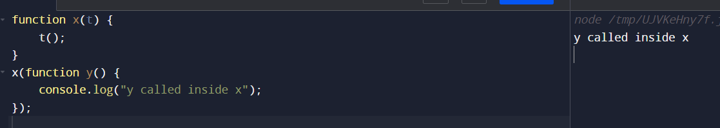
- Function y in the above program is the Callback Function
- But why function y is called the callback Function?
- Cause we pass the function y while calling function x, and we give the responsibility to function x that is can invoke y whenever it needs
- Use Case -> setTimeout function
SYNCHRONOUS SYTEMS

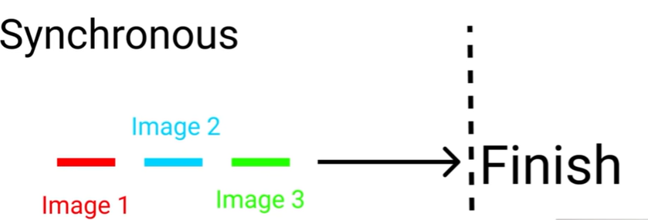

See, in the above image, all three candidates are trying to finish the race, but all three are racing in a single line, so they cannot overtake one another, hence, they have to run behind each other only, and from the image it’s clear that candidate 3 will win the race

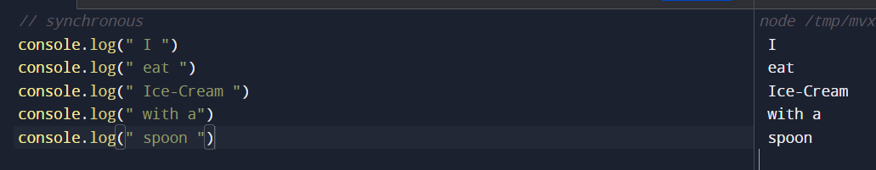
In the above code extract, the lines run one by one
Now, let us make the code asynchronous by inserting a setTimeout function,
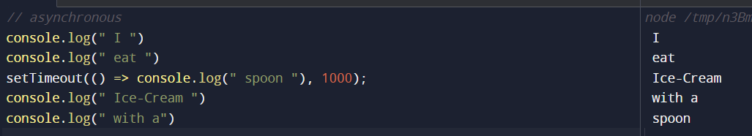
To understand the Callback Hell, let’s start an ice-cream business:-
Flow ->
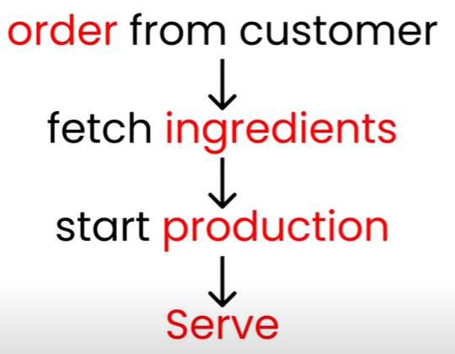
Let’s start with creating order and production functions ->
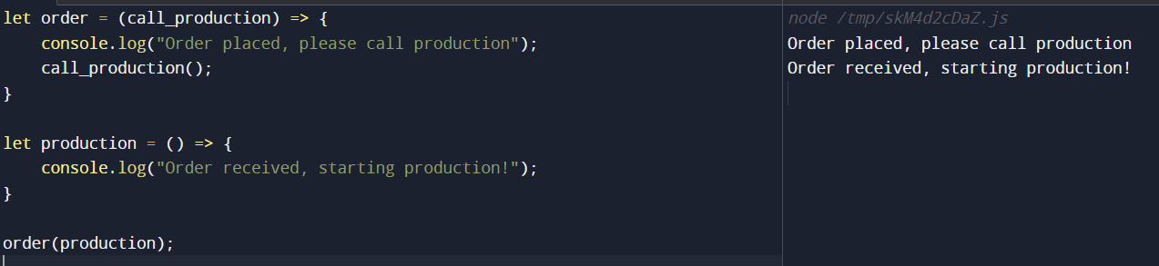
Now, let’s understand the relationship b/w the front and backend,
The front end is our kitchen
The back end is our Store Room
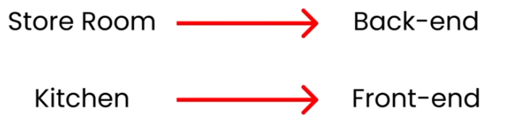
So, let’s create Stocks, which will store all our objects, i.e. fruits, liquids, toppings, etc,
And given below is the time frames for different activities,
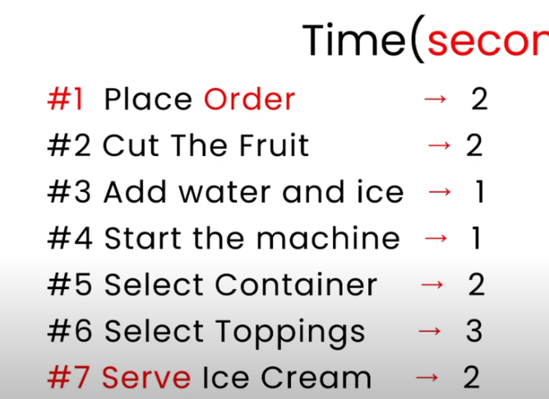

#1 -> Placed the order ->
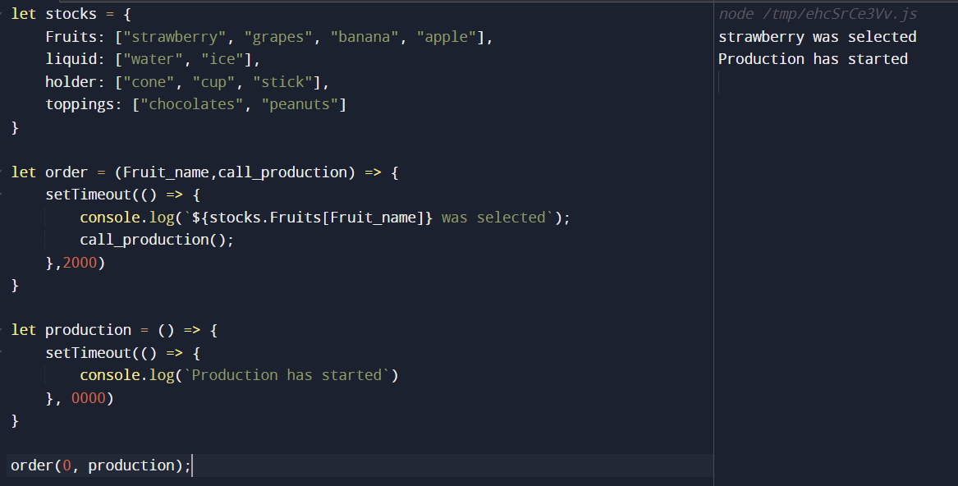
#2 -> Cut the Fruit ->
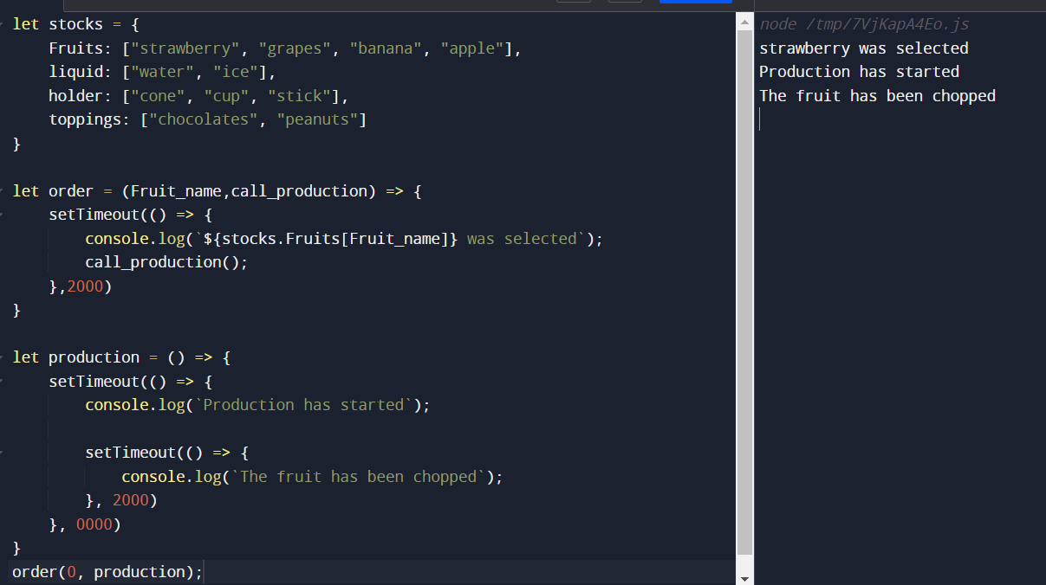
#3 -> Add Water and Ice ->
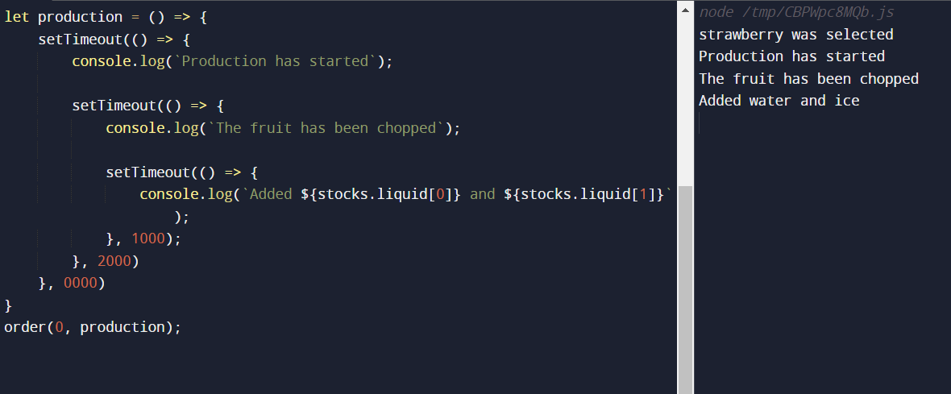
#4 -> Start the machine ->
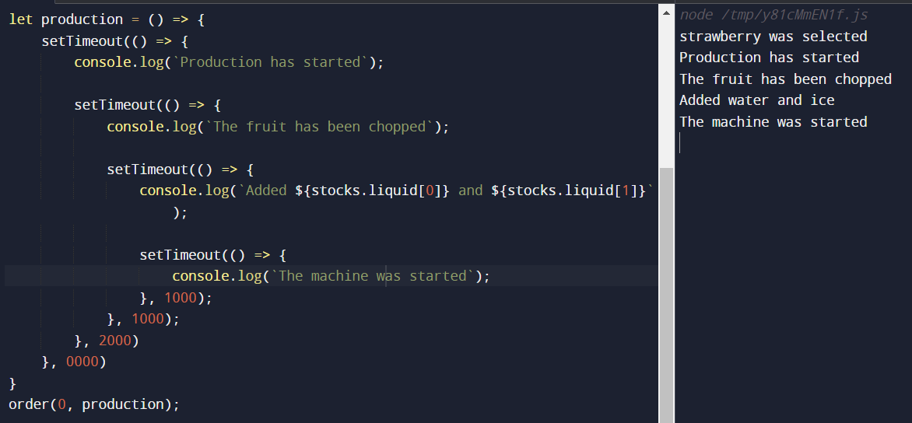
#5 -> Select Container (We are picking cone here) ->
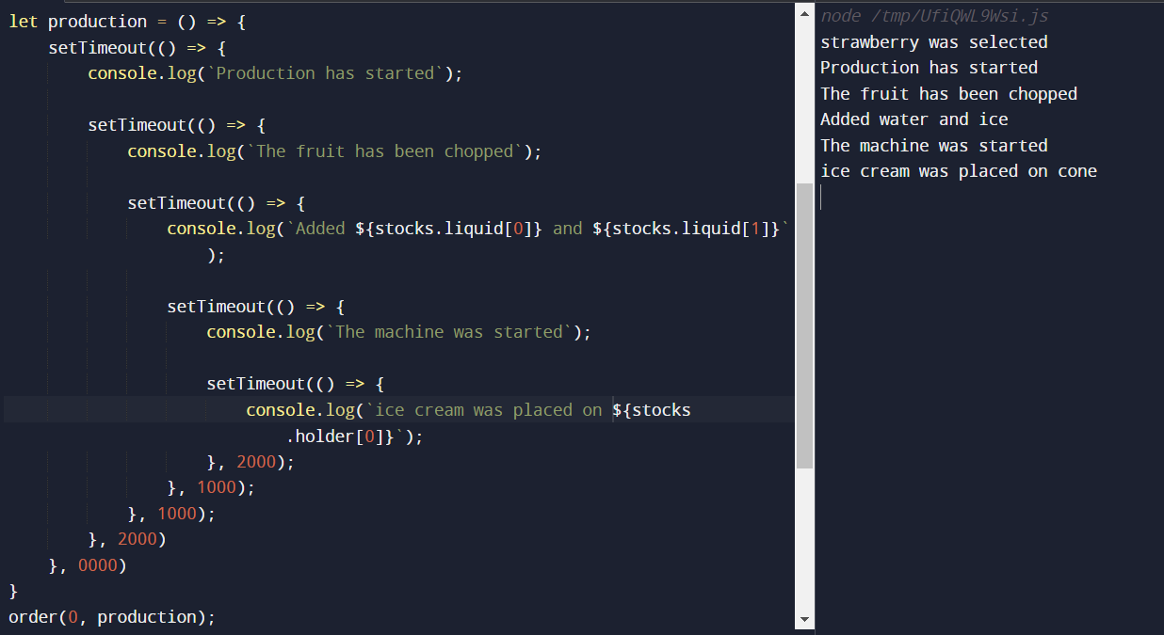
#6 -> Select Toppings ->
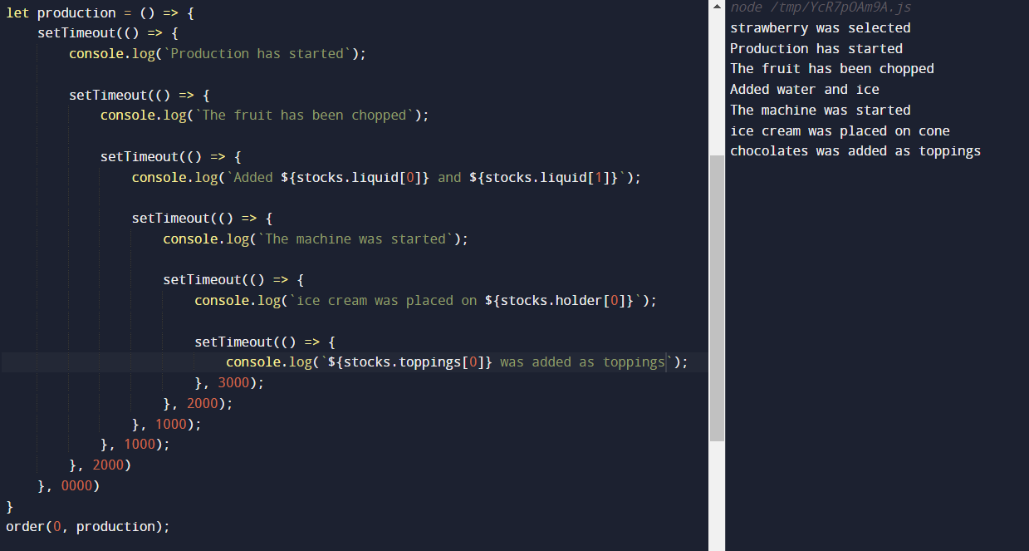
#7 -> Serve the Ice Cream ->
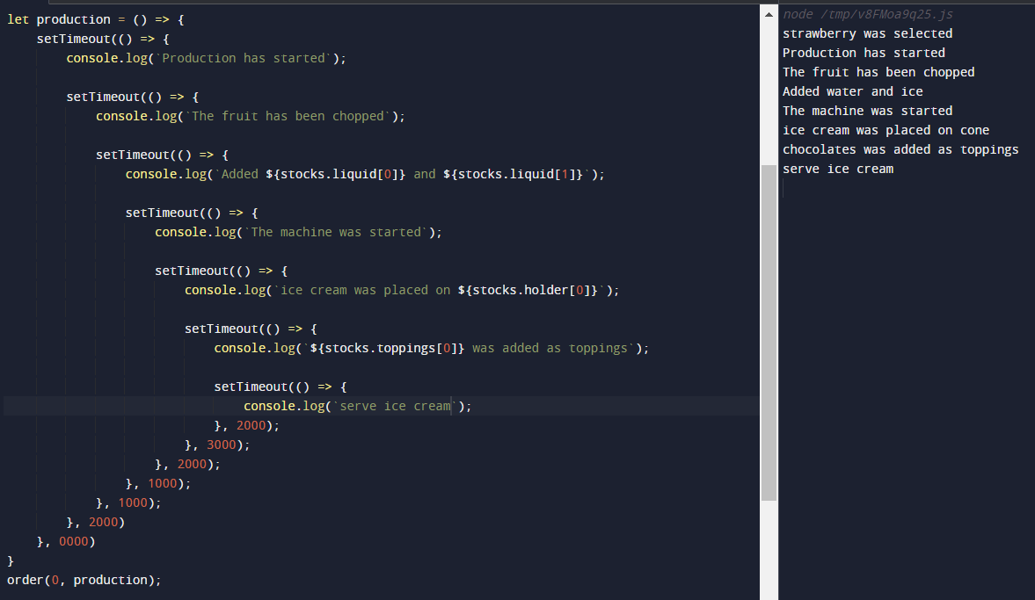

Finally, we have created a Callback Hell
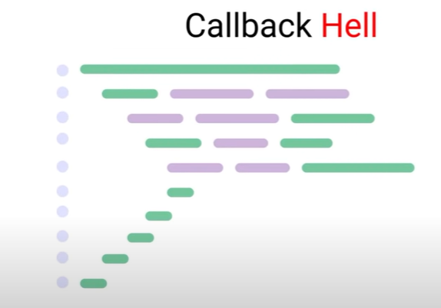
Our code too looks like this, so what is the solution to Callback Hell.
The solution is Promises
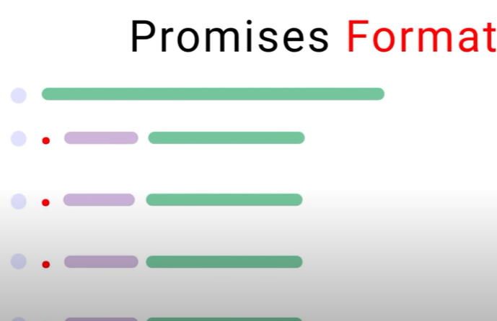
See the format of Promises, it looks very clean
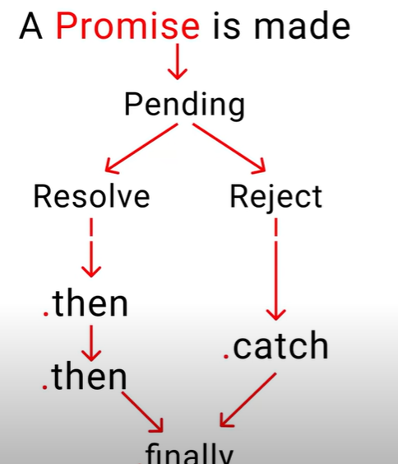
Promise Cycle
- Firstly, we make promise to our customers, i.e we promise that we are gonna serve you ice cream
- Now, this promise will have two parts, either this promise will get fulfilled or this promise will get rejected
- Suppose, the customer orders Mango ice cream, if we have mangoes in our stocks, the promise will be resolved, and code will enter the then chain, i.e. first do this, then this .. and so on, but if we don’t have mangoes in our stocks, then the promise will get rejected

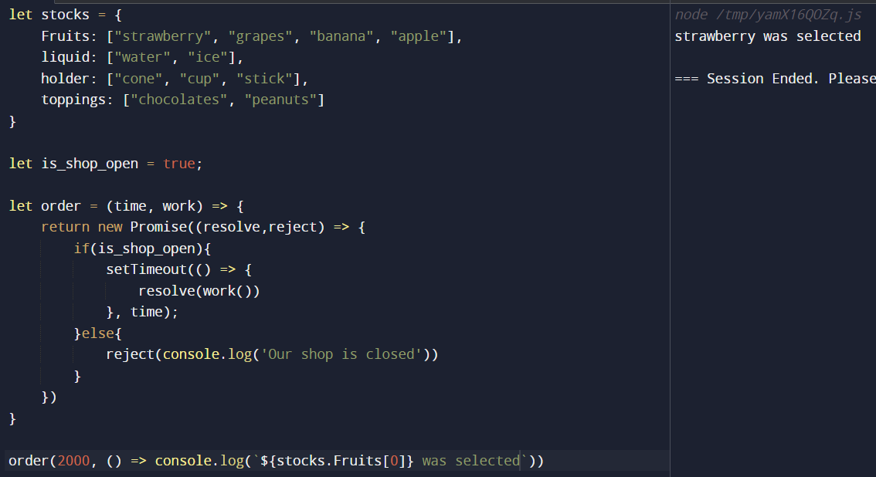
We checked whether the shop is open or closed, if the shop is open, we are resolving the Promise, and is the shop is closed we are rejecting the Promise
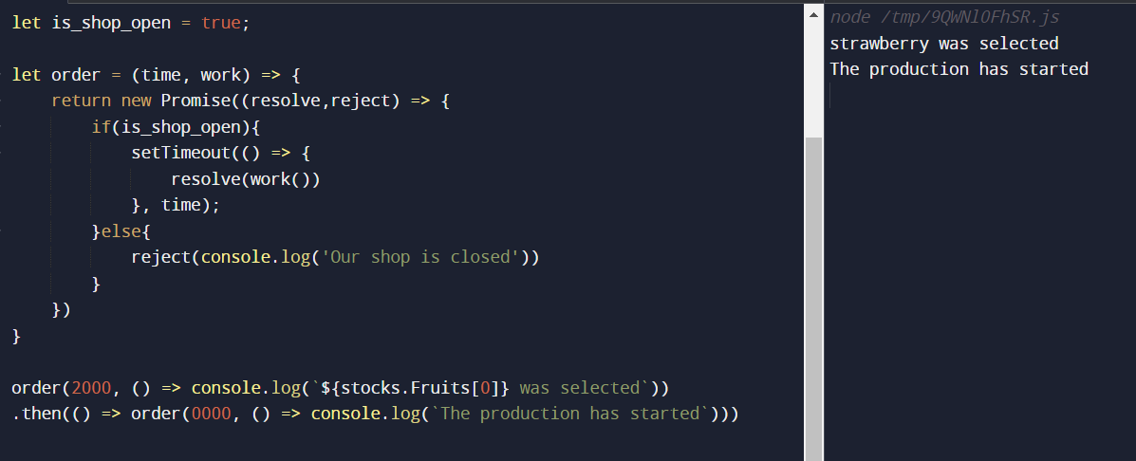
If the promise resolves, then we are chaining it with then, and calling the function order again which again will return a Promise,
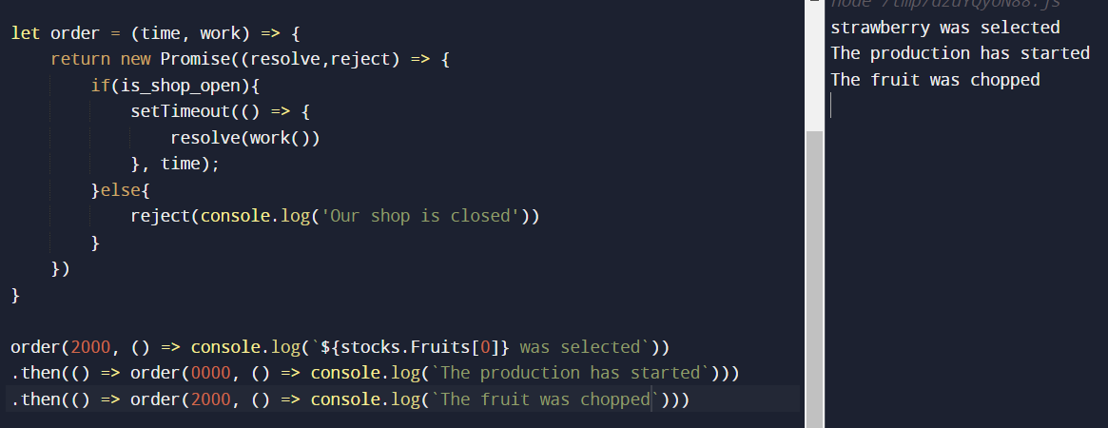
Now, we will add water and ice ->
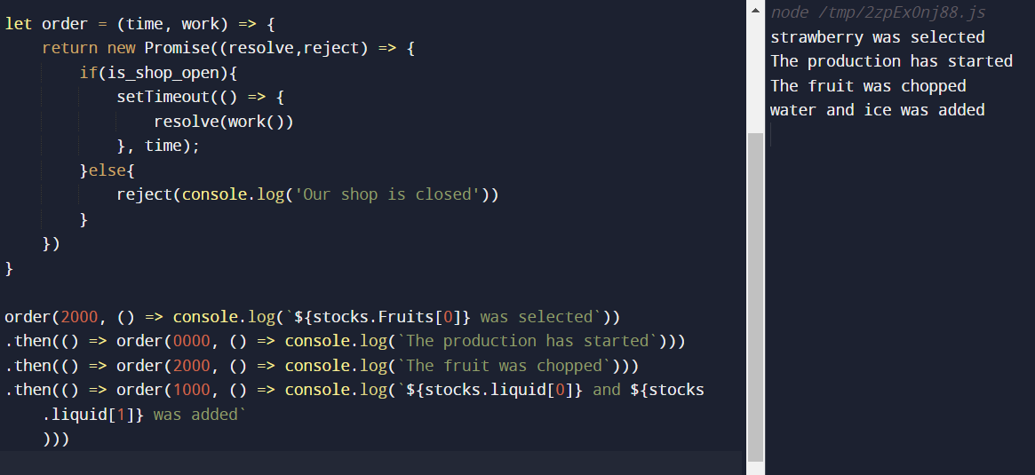
Now, we will start the machine ->
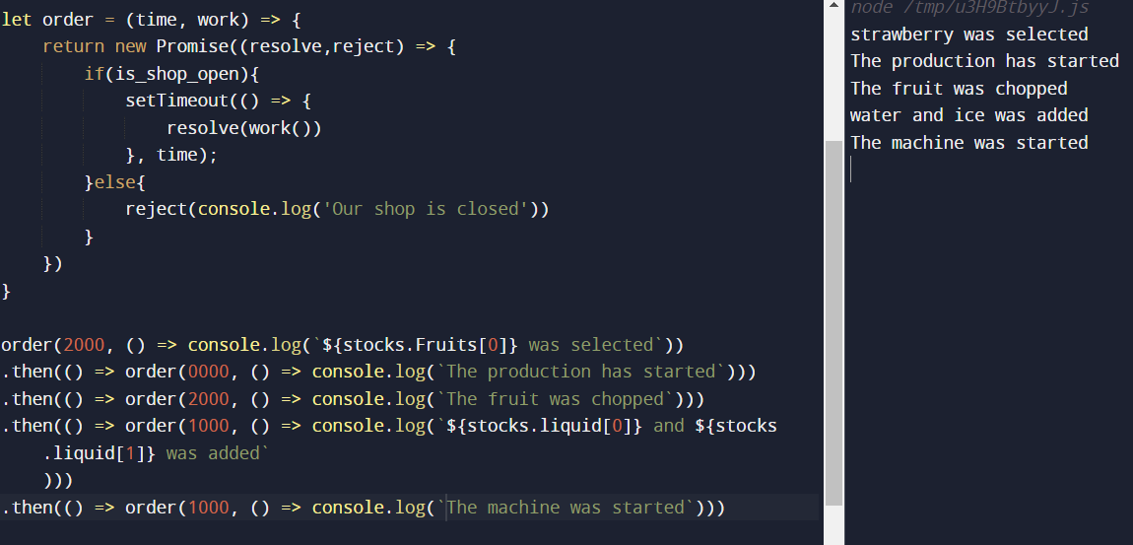

Now, we will select the container (We are selecting cone in this case) ->
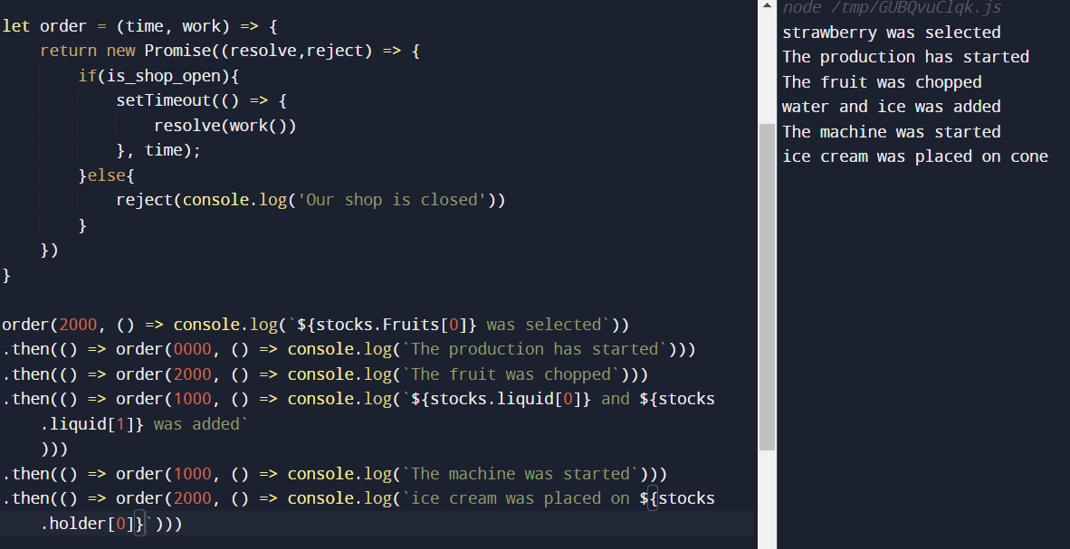
Now, we will select the toppings ->
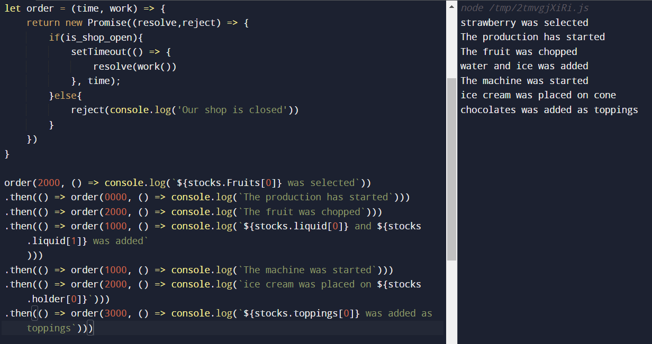
Now, lastly we will serve the ice cream ->
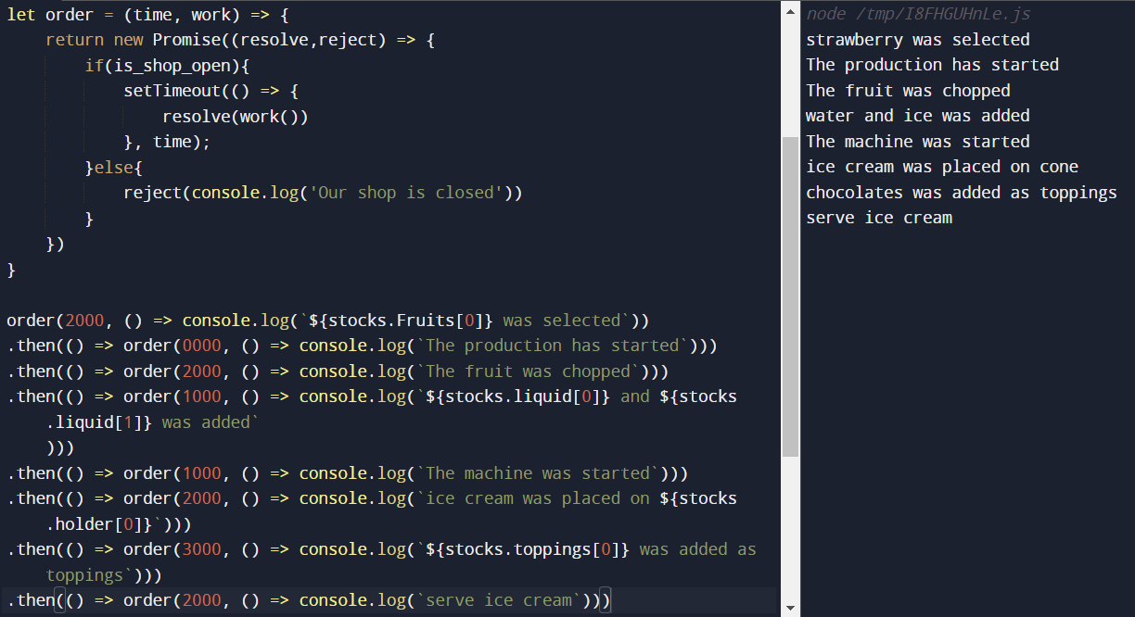

But, there’s one thing which is lacking in the above code, can you guess?
Yeaahh, where’s the error handling ?
If we don’t handle the error then what will happen, let’s check that,
Suppose we rejected our Promise by making variable is_shop_open to false
Then as we have not handled the rejection, the program will through UnhandledPromiseRejection Error ->
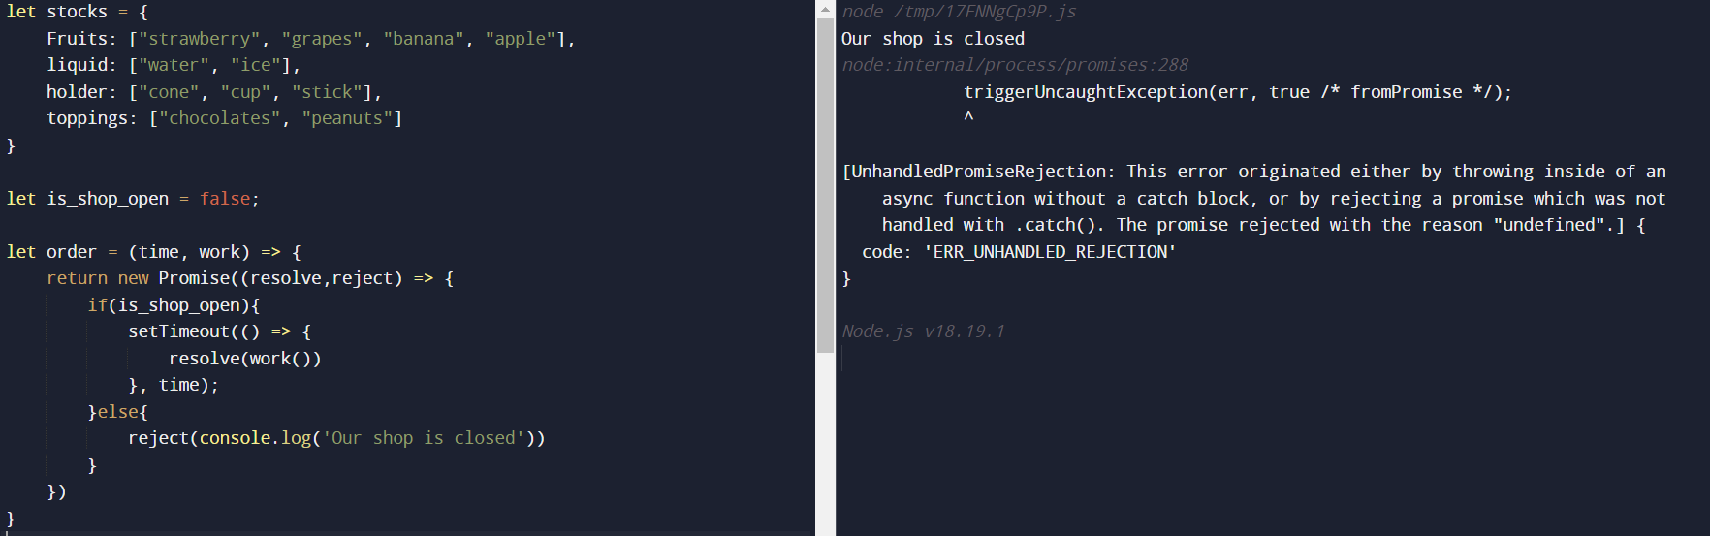
So, let’s handle the rejection by writing the catch block ->
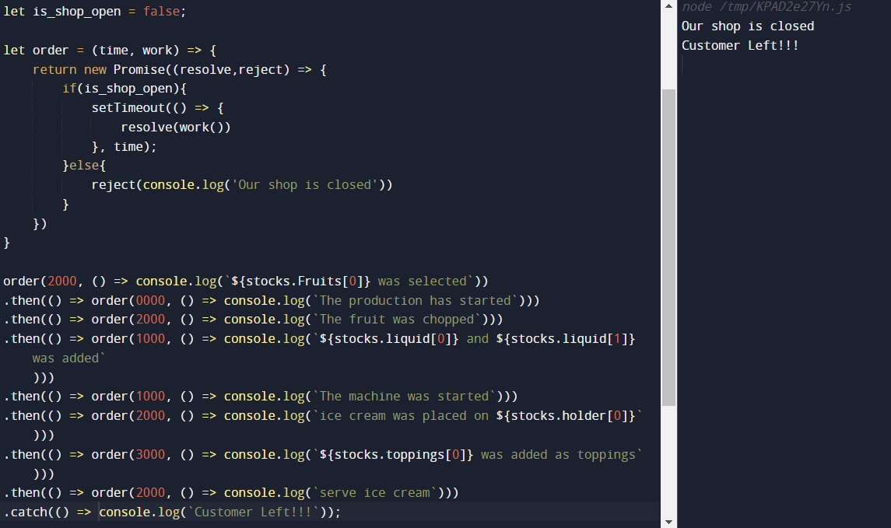
See, with the catch handler written, we did not get the error UnhandledPromiseRejection
Now, the last part i.e the finally handler,
It does not matter whether the Promise gets resolved or rejected, the finally block will run
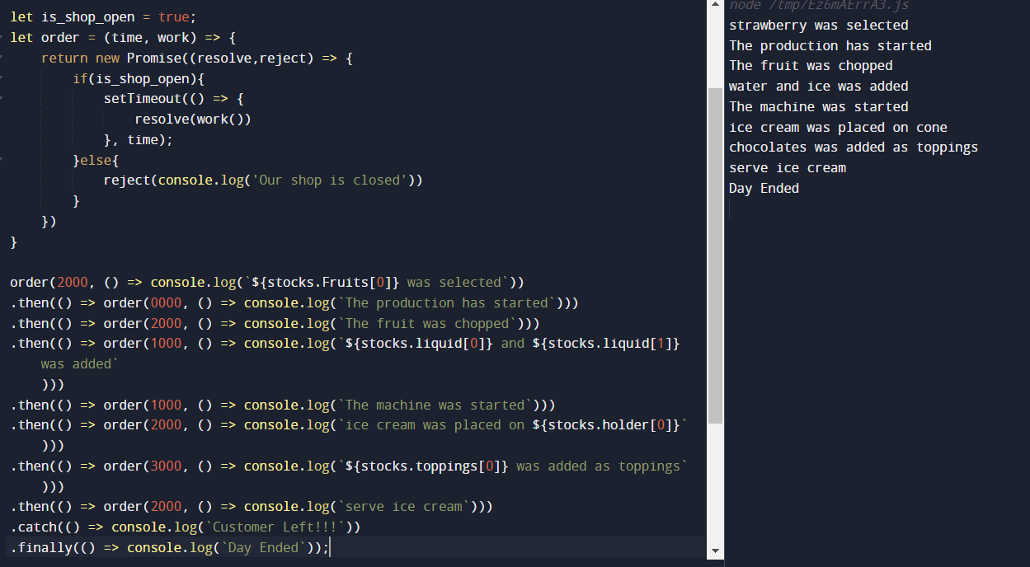
So, this was all related to Promises.

Let us jump into async/await then

