Debouncing

Simple si baat hai, let us assume humare pas ek input box hai, simple, or har keystroke par hum ek console krwa rhe hai,
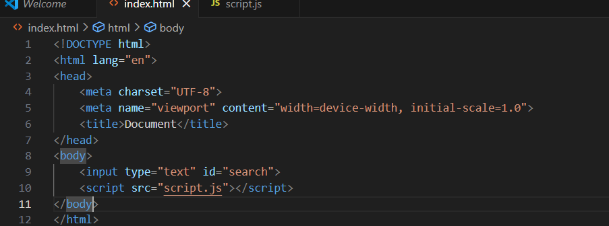
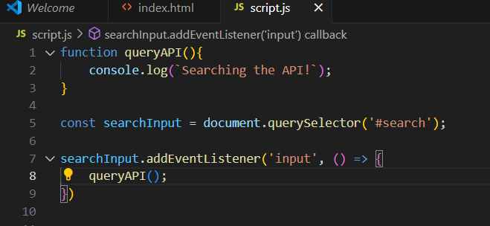
Dekho, in the above code excerpt, humne ek listener lgaya hua hai, jo ki har keystroke pr queryAPI call karega, which in turn will console Searching the API!
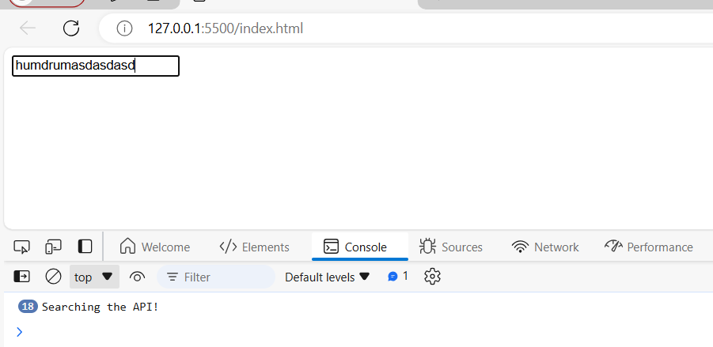
Now, see the output, jitni bar likh rhe hai utni bar function hit ho rha hai, but y overhead hai, hume thoda break lekr function ko hit krna hai taki function calling itne times nahi h o, islie hum debouncing ka use krege
Ab question is aap bologe ki bhai sidha setTimeout ka use krlo, to usko bhi dekh lete hai ->
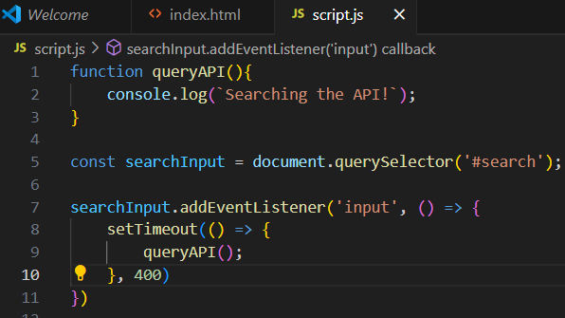
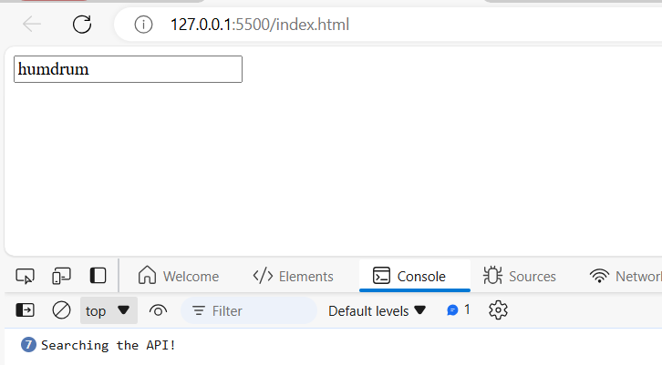
Dekho output, bhle setTimout delay kar rha hai, pr call utni bar hi ho rha hai function to ky kare,
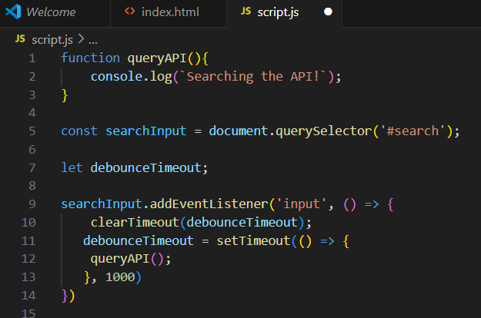
Ab dekho, is code me humne debouncing ki hai, but how?
See, we have declared a variable debounceTimeout, or jese hi keystroke press hoga hum clearTimeout kar rahe hai, ab humara time hai 1000ms agar use ne ek key dabayi to debounceTimeout me uska id store ho jaega, fir agar user ne 1000ms ke pehle hi dusri key dabadi to phla function jo 1000ms ke baad chlne wala tha wo chlega hi nh

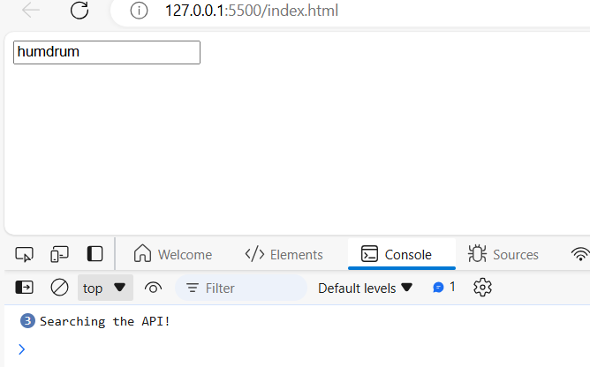
See the effect, ab km baar function call ho rha hai, and we have achieved this using debouncing
Ye to sahi kaam kiya ab question is what if humare pas bht saare functions hai jinme debouncing lagana hai, agr ese hi implement kie to humko same code bar bar use karna pdega
So we will rewrite the debounce functionality
On keystroke rather than calling queryAPI function directly, I will rather call it’s debounced version i.e debouncedQueryAPI
We will create a Higher Order Function named debounce that will accept a function as an argument and will return a fancy wrapped up version of that function
So, we can reuse that debounce function again and again without having to rewrite the above logic everywhere
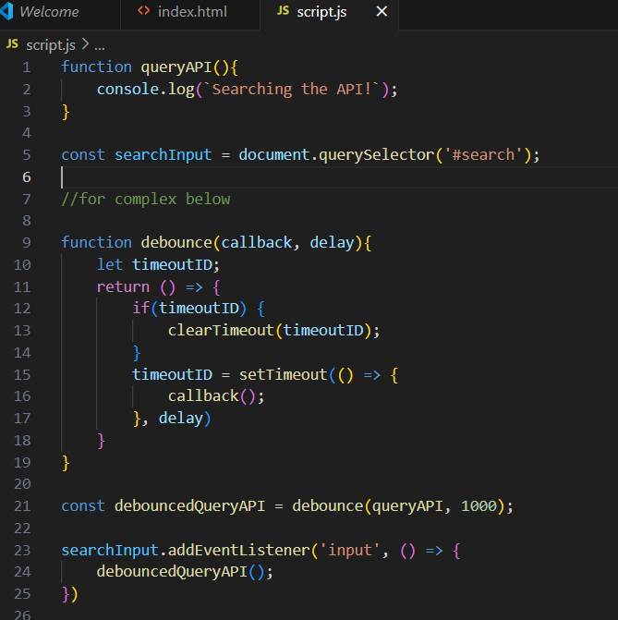
We are returning a new function from debounce which is a debounced version of the passed function, other logic remains the same
But now there is a problem in this code excerpt, what if queryAPI function receives an argument
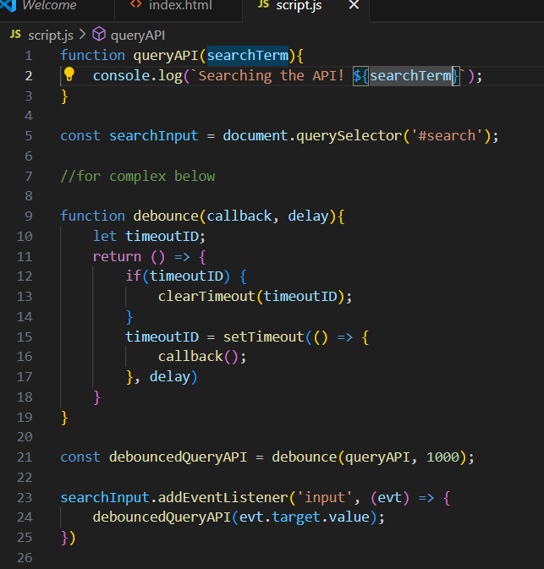
I have passed the event’s target value to the debouncedQueryAPI function but the output is not what we expected ->
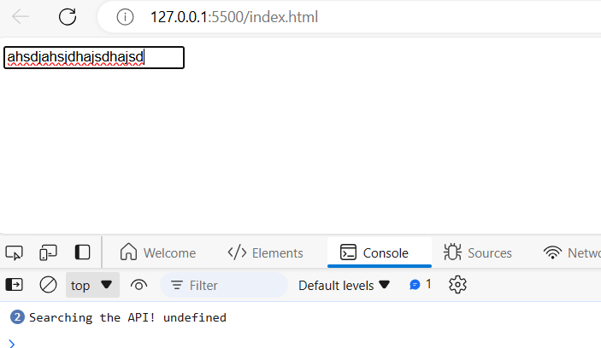
See the output is undefined, cause debounce function is eventually calling the callback function with no arguments, that’s why we are getting undefined
So, what we need to do is, the new function that is returned from the debounce function should receive any number of arguments

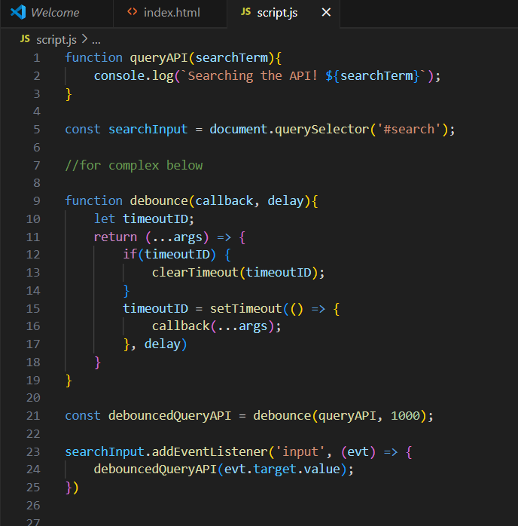
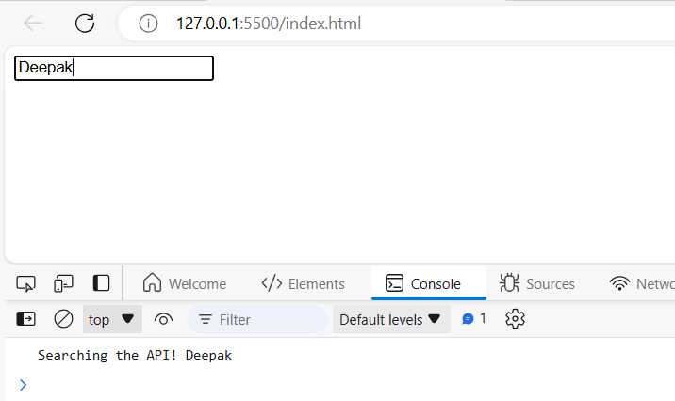
See now it worked

