FIRST CLASS FUNCTIONS

Let’s first understand what a function statement is:
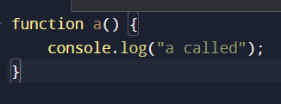
This way of creating a function is known as function statement.
Now, in JavaScript, you can assign a function to a variable also,
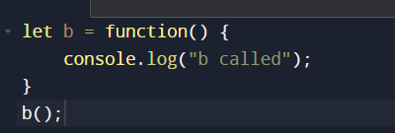
Function acts like a value in this case, and that’s where the crux is, when functions are treated like any other variable in a language are called First Class Functions

The ability to use functions as values, can be passed to another function, can be returned from a function is called First Class Functions

Difference between function statement and function exrpression ->
The difference b/w function statement and function declaration is hoisting,

Function statement when called before declaration ->

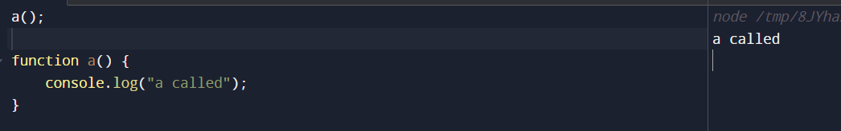

Function expression when called before declaration ->
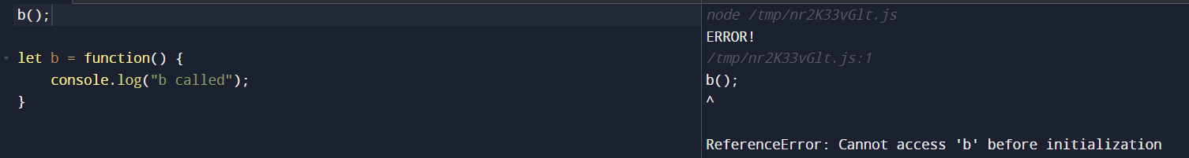
In function expression we got the error cause we have assigned an anonymous function to a variable and JavaScript is treating that function as a variable itself

- Anonymous functions are used in the place where functions are used as values
Named Function Expression
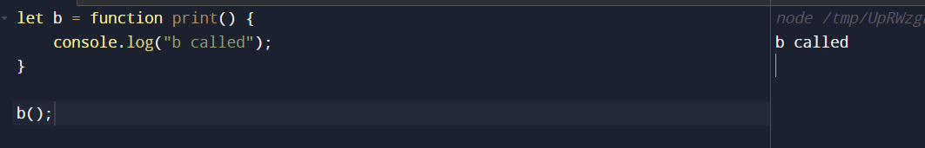
When we give name to the anonymous function in a function expression, it becomes Named Function Expression
Question ->
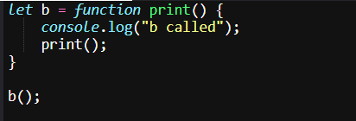
We are calling the named function inside the function body, what will be the output ->
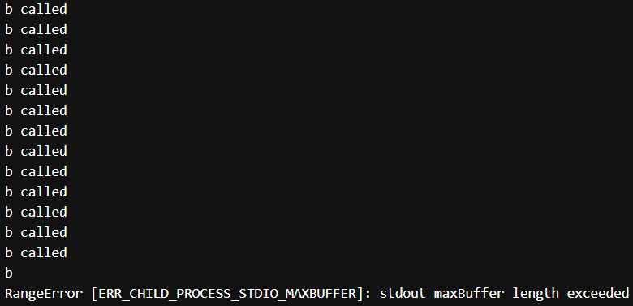
Buffer length exceeded, cause again and again print() will be called.

Parameters vs Arguments
Whenever you are creating a function, and declare some identifiers in the brackets (…), those are called parameters
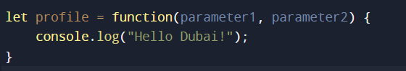
And, while calling the function the identifiers which we pass in the brackets (…) are called arguments


FIRST ORDER FUNCTIONS
In first order functions, we can’t pass functions as an argument and we can’t return function as well, so all in all,
first order function is a function that is not a higher order function,
A higher-order function is a function that takes one or more functions as arguments, or returns a function as its result.

