HIGHER ORDER FUNCTIONS

A function which takes another function as an argument, or returns a function from it, is known as Higher Order Function
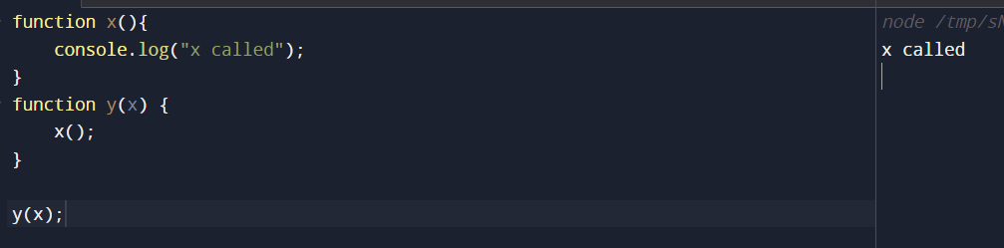
Here, y is the Higher Order Function and x is the Callback function

Suppose we want to calculate area of circles whose radii are provided in an array,
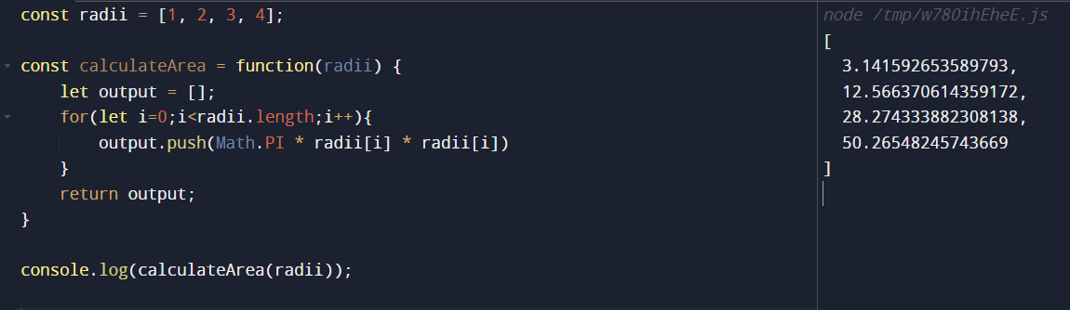

Now what if we also want to calculate circumference of circles whose radii are provided in an array, we will normally create another function,
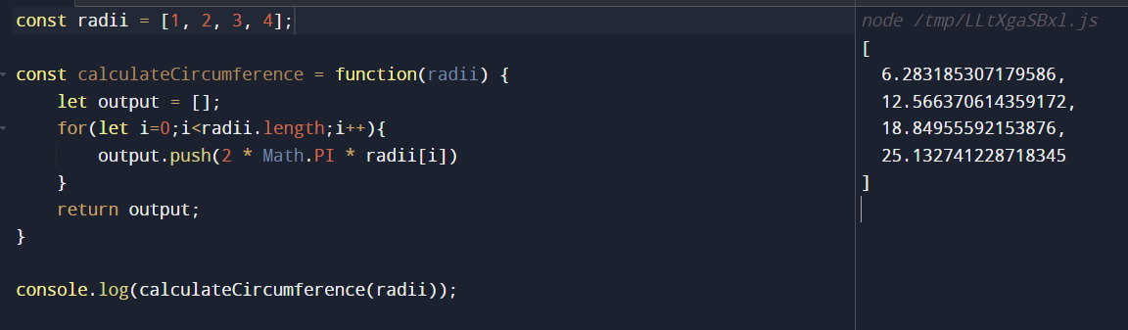
Now, what if we want to calculate diameter of circles whose radii are provided in an array, we will again copy paste the same code and change the formula
But this is not a good approach to follow, we are repeating code a lot here and in software Engineering we follow DRY approach i.e. Don’t Repeat Yourself
All the functions in our case are almost 90% the same, what changes is just the formulae logic, i.e. area of circle, circumference of circle, diameter of circle

So can we just extract the logic out i.e formulae calculating part
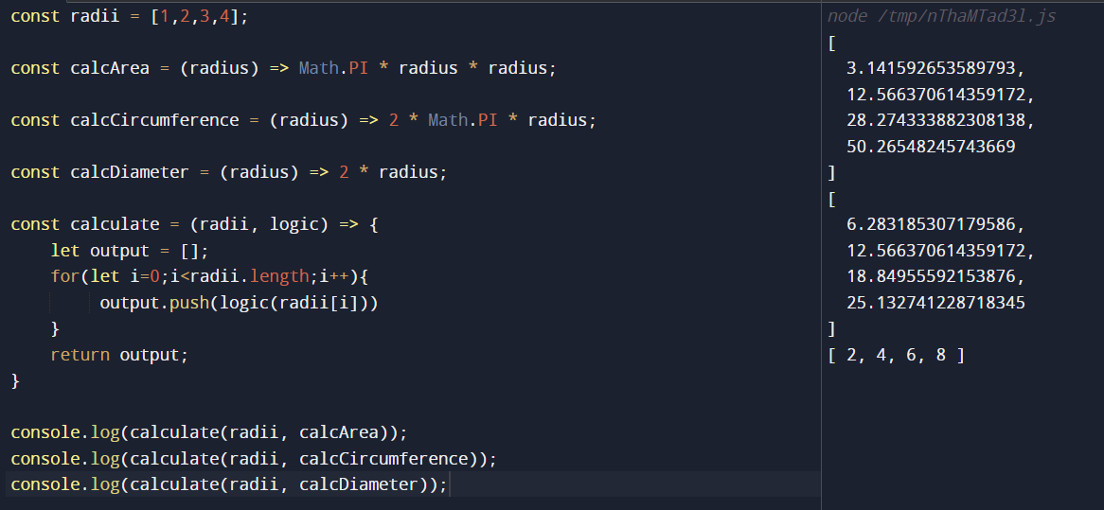
We have seen higher order function above, let’s just explore more,
What if we use map method to calculate the logic, see below:
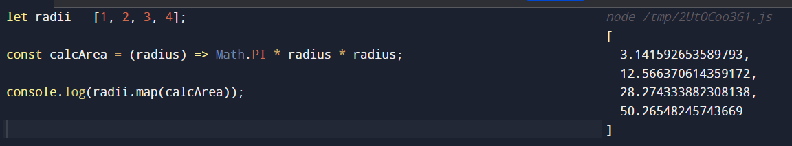
Let’s build calculate function such that it behaves like map,
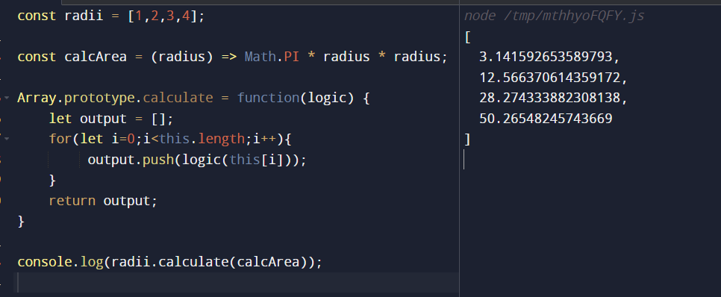

Unary Function -> allows you to pass only a single parameter to it.

