HISTORY API
History API provides access to browser’s session history through the history global object
- Manipulate the history with pushState()
- Perfect for Single Page Applications (SPAs)
To move back through history -> history.back()
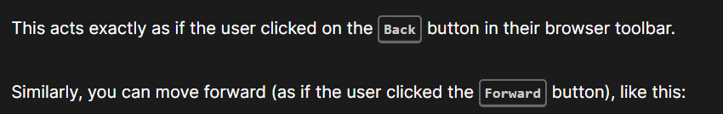
To move forward through history -> history.forward()
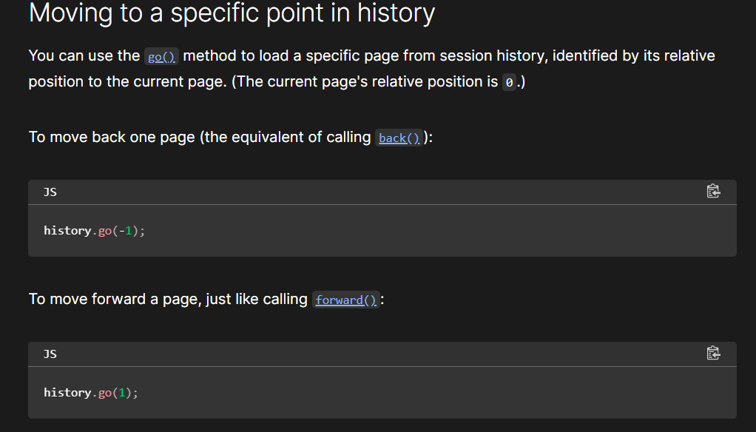

Whenever history is changed, the challenge is to find out about it. The pushState() method has been called. It is used to monitor alterations to the history of the browser. To monkey-patch window.history when the pushState() method is used.

Popstate event bhi pdh lena

