Lexical Environment
The term 'lexical' simply means 'source code' or in other words, 'relating to the text of a program'.
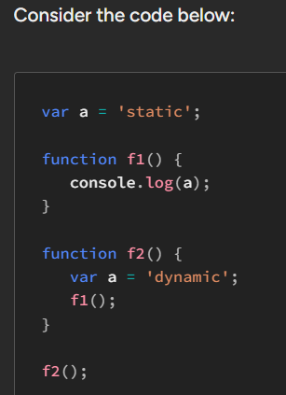
OUTPUT -> ‘static’
Cause , JS is not dynamically-scoped. It's rather lexically-scoped, also known as statically-scoped.
In this scoping system, in order to resolve a name inside a function, it's first searched in the local environment of the function and then in its lexical environment.
The lexical environment for a function f simply refers to the environment enclosing that function's definition in the source code.
Well, the JavaScript compiler reads the program's source code and determines the environment accessible to a given function based on its definition, when compiling it.
For instance, if a function f is defined in the global scope, its lexical environment (determined when compiling the function) is simply the global environment.
All the set of environments enclosing a function are collectively referred to as its lexical environment.
The lexical environment of a function can contain multiple environments.

The [[Scopes]] attribute in Chrome
every function holds an internal attribute [[Environment]] that simply contains the lexical environment of the function
This means that we could actually inspect the lexical environment of any given function f in Chrome by inspecting its [[Scopes]] attribute.
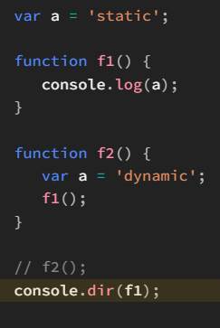
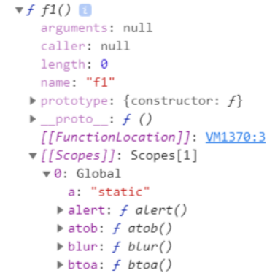
Let's review what happens when a is encountered in the function f1 above.
- The local environment of f1 is searched for the name a. Nothing is found here, likewise searching shifts to the lexical environment of f1.
- Within the lexical environment, represented via [[Scopes]], the name a is searched for in the first environment enclosing f1. In this case, that environment just turns out to be the global environment.
- Likewise, a is searched for in the global environment. As a match is found, bound to the value 'static', the a in f1 is resolved with 'static'.

Alright, moving on, let's make one simple change to the code above and then reconsider it. We'll encapsulate all of it inside an IIFE:
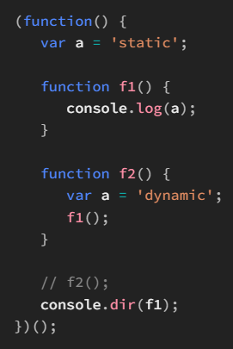
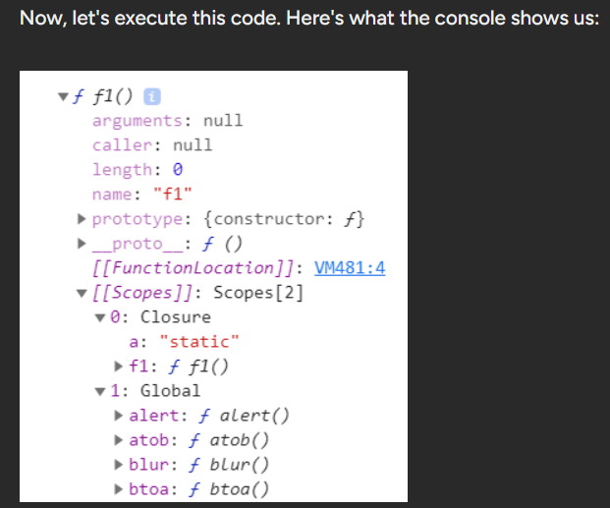
The [[Scopes]] attribute of f1 (and f2) contains two entries. The first one is for the first environment enclosing the definition of f1 i.e. the local environment of the IIFE, while the second one is the second environment enclosing f1 i.e. the global environment.

But, how come JavaScript is able to hold onto a local environment of a function once it exits'?
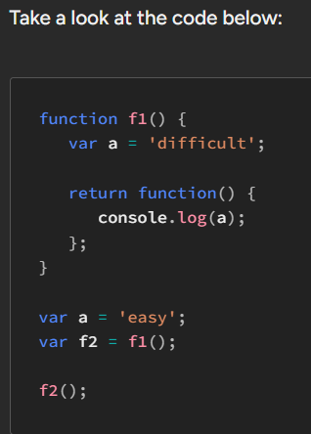
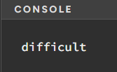
- Lexical environment of this anonymous function includes this local environment (of f1)
- At this point, since a value is returned from the function f1 which means that it has finished executing, the JavaScript engine has to delete its local environment. Now before the deletion, a quick search is conducted to find out whether any references exist to this environment. Since outside the local scope of the function f1, there indeed does exist a reference — in the [[Environment]] attribute of the returned function — the environment is kept on in memory. However, the other necessary procedures are performed as usual for e.g. clearing away the call stack frame for f1.
The most interesting thing to note over here is that the local environment of f1 is NOT deleted even when f1 exits (via the return keyword). This is because a reference to its local environment exists in the returned anonymous function.
The engine checks if there is at least one reference to the local environment of a function exiting, outside the function. If there is, the local environment is not garbage-collected
Functions returning other functions are perhaps one of the most common applications of closures in JavaScript programs. It's highly likely that once you start building complex programs, you'd use them too.

