NULL and UNDEFINED
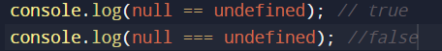
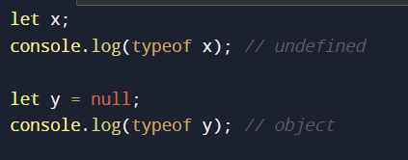

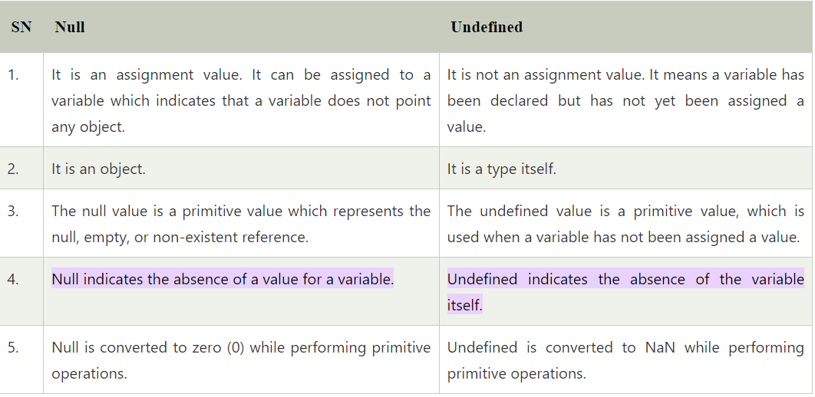
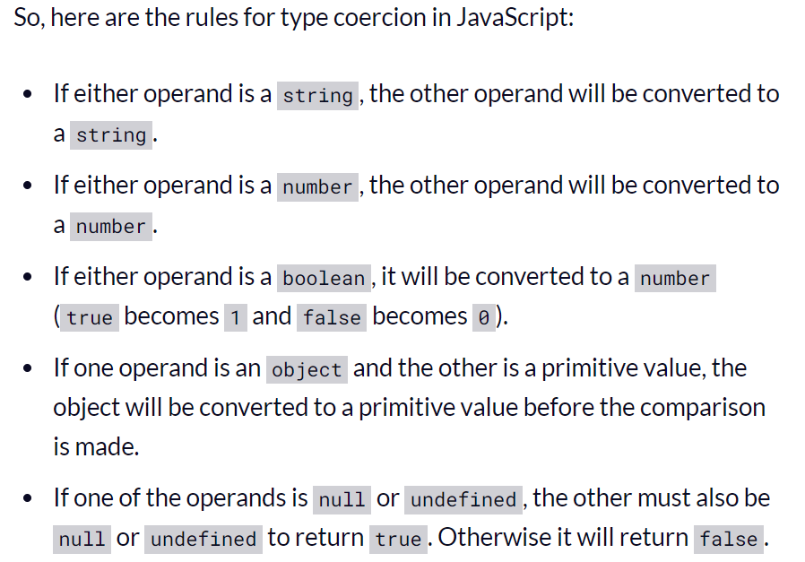

Example: console.log(true == ‘true’) //false
Explanation: the variable a (true) gets converted to a number before the comparison. So after comparison – where we're now comparing 1 and 'true' – we get false because the variables contain different values.

