Object Properties
# Property Flags and Descriptors
Object cannot store only a key:value pair but its more than that
Object ki ek property me value ke alawa teen aur attributes hote hain
- writable
- configurable (a Boolean specifying whether the property's attributes could be changed or the property be deleted via the delete keyword)
- enumerable (a boolean specifying whether the property shows up in for…in loop)
But how to know ki ek property pr ye kese set hue hai, usko pata krne ka bhi ek method hai
Object.getOwnPropertyDescriptors
Allows to query full information about a property
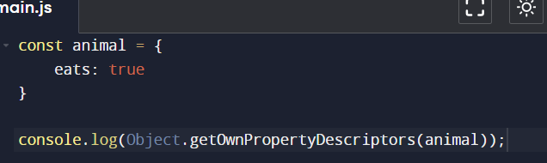
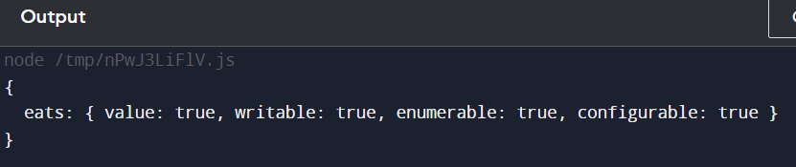
But agar kisi ek hi property ka info janna ho tab ->
We use Object.getOwnPropertyDescriptor
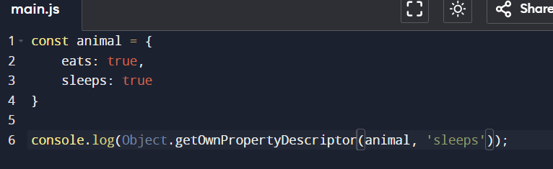
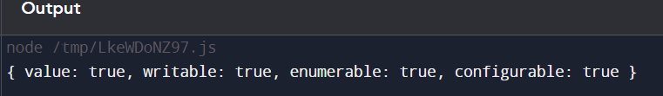
Now, how can we change these flags/attributes for that also, we have the below method ->
Object.defineProperty(obj, propertyName, descriptor)

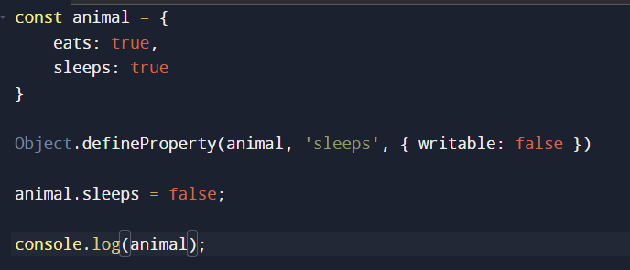
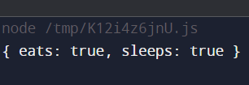
Cause we have set the writable attribute to false, hence the value was not modified
Object.defineProperty either adds a new property if property is not there, or modifies an existing property on an object and returns the object

Let us see one strange behaviour
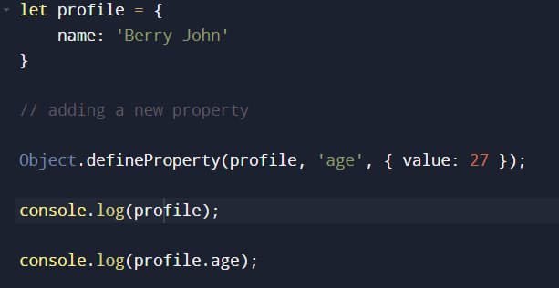
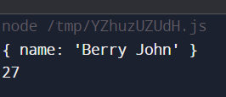
We were expecting the output to be { name: ‘Berry John’, age: 27 }, but we got a different one
Why?
Cause we should set enumerable to true, as its false by default
What does enumerable means?
That property will not be seen in the Object.keys() or for…in loop
*****Properties defined using Object.defineProperty or certain built-in objects are non-enumberable
Enumerability refers to whether a property can be iterated over or accessed using iteration methods
While ownership determines whether a property belongs to the object directly or is inherited from its prototype chain
Enumerable properties have their enumerable flag set to true by default and iteration methods such as, Object.keys(), Object.values(), Object.entries(), visit only enumerable properties
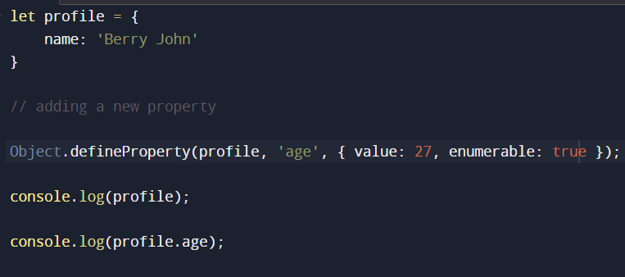
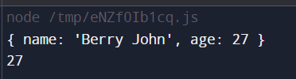
# How to make an object non-writable
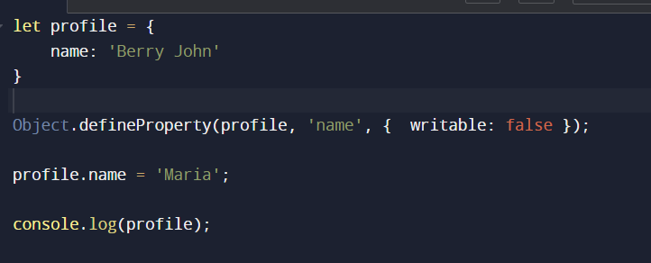
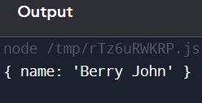
*****For new properties, we need to explicitly set what’s true
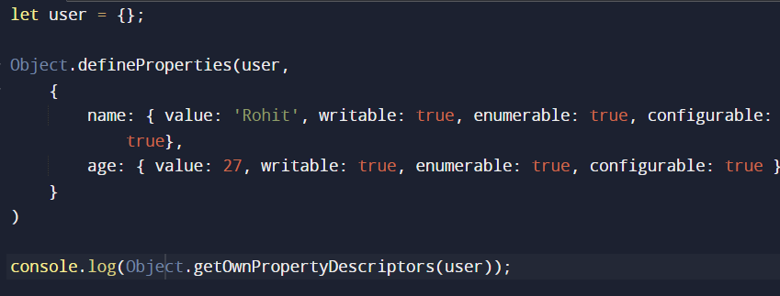
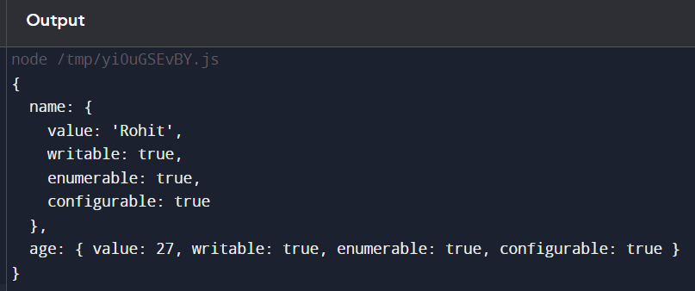

A non-configurable property cannot be deleted and its attributes cannot be modified
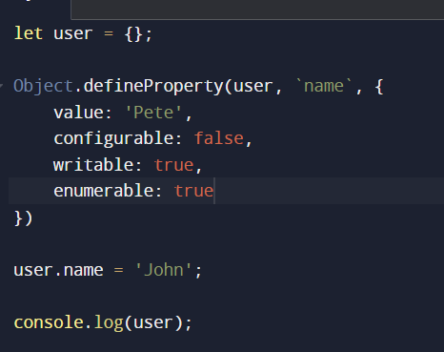
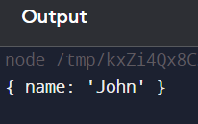
See we can modify the value, but if I try to delete the property, it won’t be deleted, as we have set the configurable attribute to false
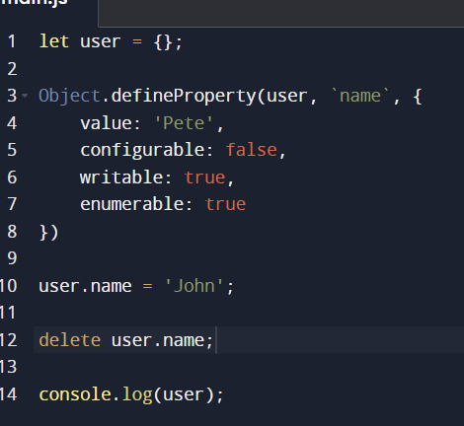
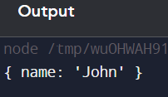
# Object.preventExtensions
Prevents new properties from ever being added to an object
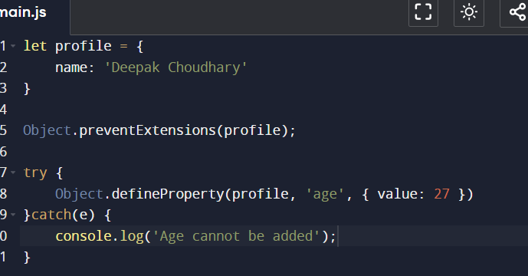
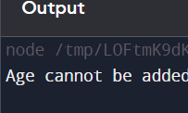
With Object.isExtensible() we can check whether the object is extensible or not
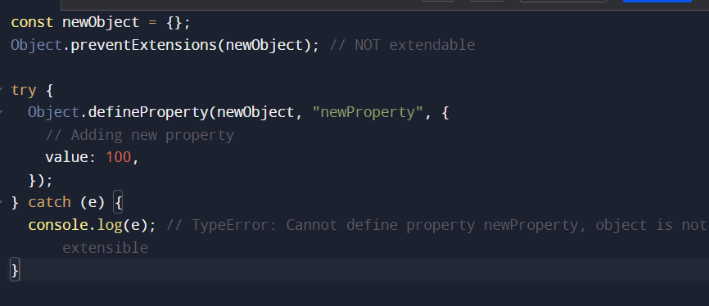
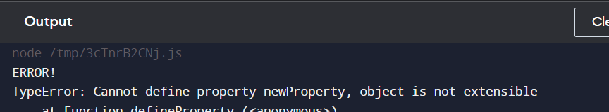

Object.seal() and Object.freeze() are used to control the mutability of objects, they both restrict modifications to an object
Object.seal()
Prevents addition and deletion of properties, while allowing modification of the existing ones
Sealed objects are still mutable, meaning you can change the values of the existing properties
However, you cannot add new or remove existing properties
The Object.isSealed() method can be used to check if an object is sealed
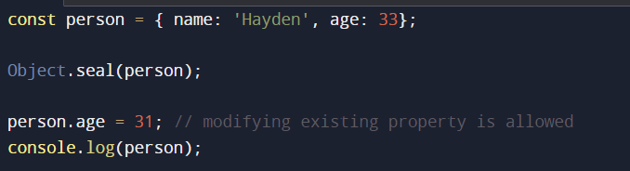
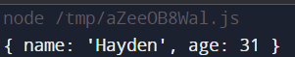




# Object.keys
The Object.keys() static method returns an array of a given object's own enumerable string-keyed property names.
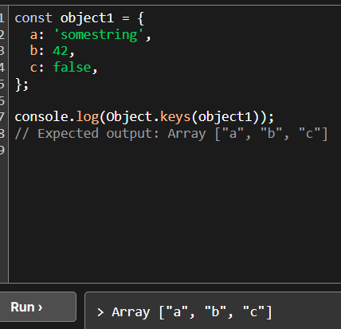
# Object.getOwnPropertyNames
See the difference between Object.keys and Object.getOwnPropertyNames is that keys will not take non-enumerable properties while Object.getOwnPropertyNames will take those too
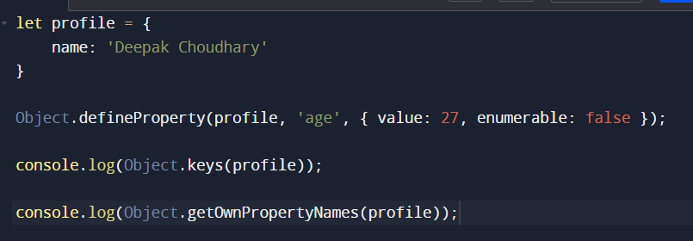
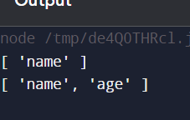

# Object.assign
Copies all enumerable own properties from one or more source objects to a target object, it returns the modified target object
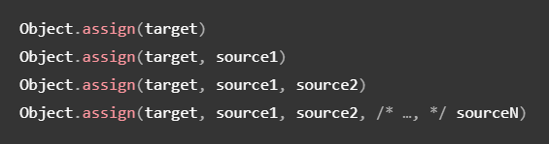
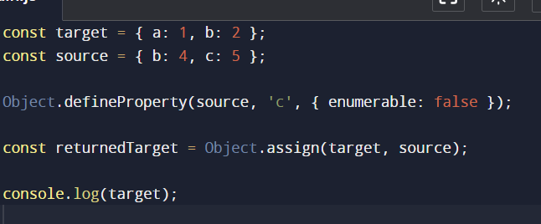
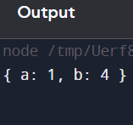
See, as we have set c property of object source as non-enumerable, so it did not get copied into the target object
As in our case value of property b is overwritten from source obj to target obj
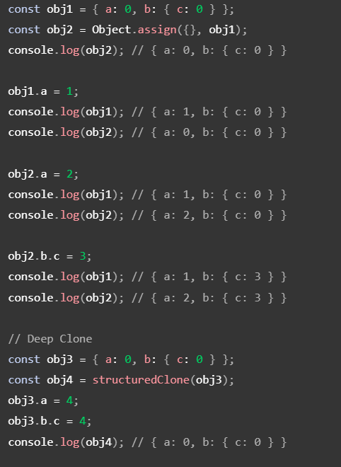

# Object.create
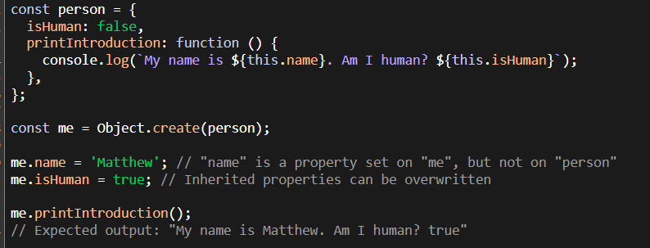
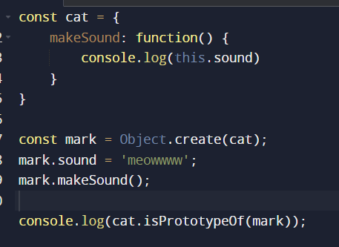

Object.create is more natural to the prototype model than the new keyword

# Object.prototype.hasOwnProperty
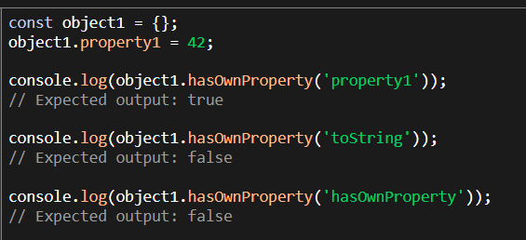
Ab isme do trike h hasOwnProperty ko call krne ke, ek to object1.hasOwnProperty jo humne dekha and the other one is `Object.prototype.hasOwnProperty.call`
Why do we need the second one?
If you accidentally override the `hasOwnProperty` method on your object, you might get unexpected results. To avoid this issue, you can use `Object.prototype.hasOwnProperty.call`
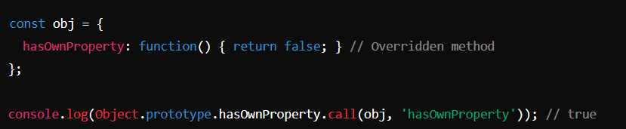
Using Object.prototype.hasOwnProperty.call is a safe way to ensure you're checking the actual hasOwnProperty method from Object.prototype

# Object.entries()
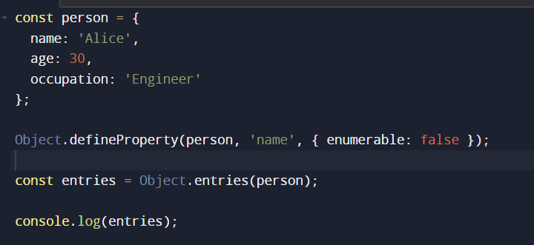
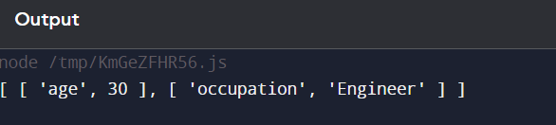
See we have made the name property’s enumerable property as false hence we could not see that in our output 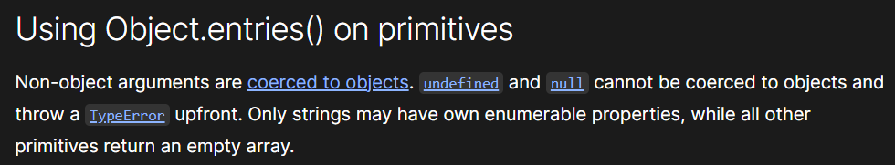
Non primitives are coerced to Objects
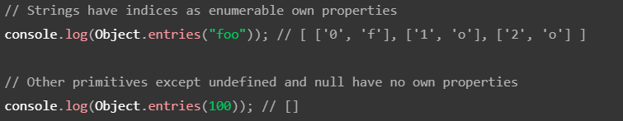

Additional Notes ->
- Let's also try redefining the property via the same Object.defineProperty() method and see whether it works or not:
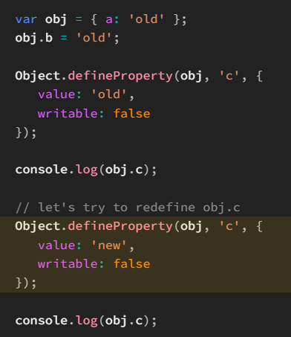
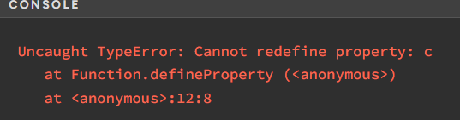
Actually the error thrown above is because of the internal [[Configurable]] attribute set to false, not because of [[Writable]] set to false
- omitting value in a data property descriptor results in [[Value]] being set to undefined
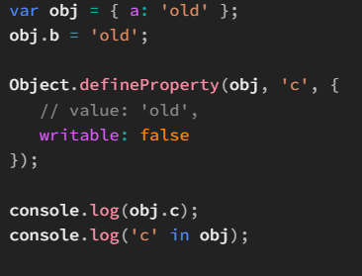
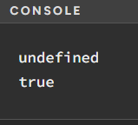

Attributes of accessor properties
Accessor properties use accessor functions to retrieve and set a given piece of data
Let's create an accessor property.
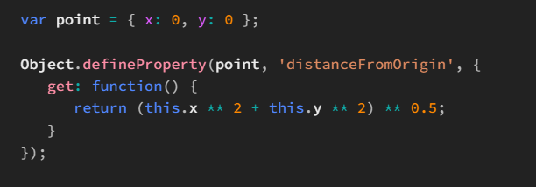
Now, let's retrieve this property:
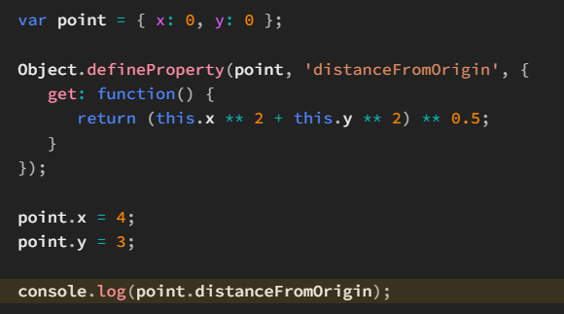

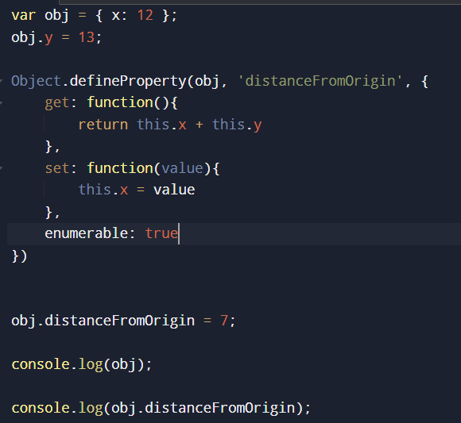
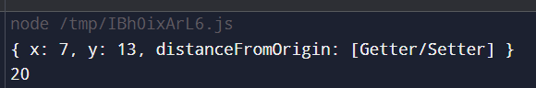

- The value of the [[Configurable]] attribute can't be changed to true for a non-configurable property:
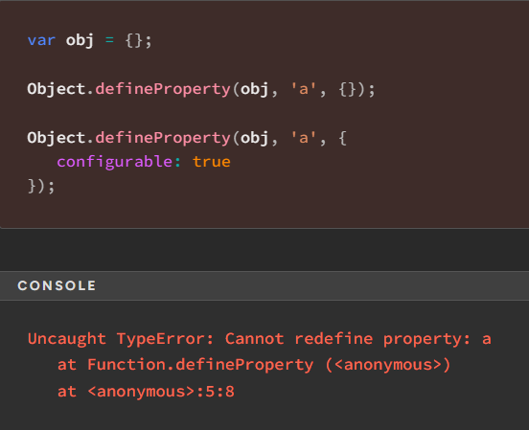

- the non-configurable nature of the property together with its writable nature does not disallow redefining it via another call to Object.defineProperty()

it's possible to change the value of a non-configurable property, i.e. change the value of its [[Value]] attribute, given that its [[Writable]] attribute is true
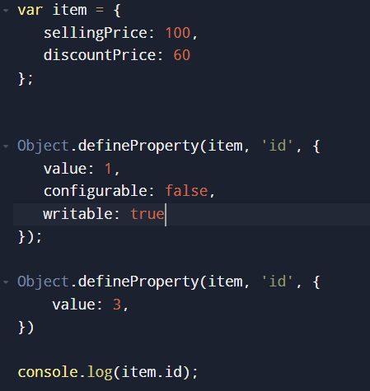
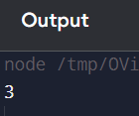

- we could even change the [[Writable]] attribute of a non-configurable property from true to false, but NOT the other way round.

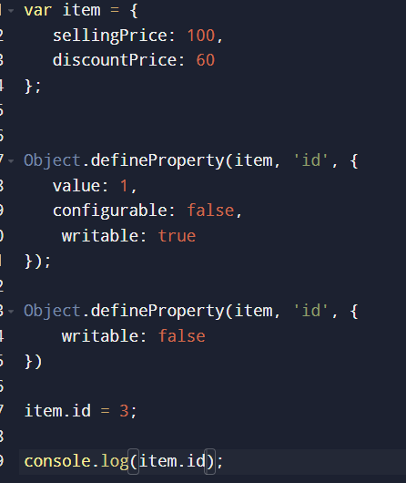
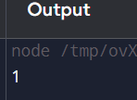
Other way around ->
