SCOPE
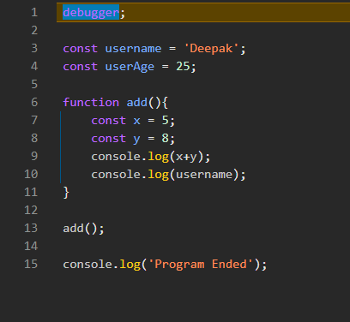
See when I ran the above program by applying debugger at the top, I got two scopes in the Scope tab,
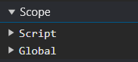
Script and Global
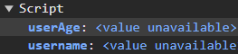
In Script scope, we have userAge and username
Actually script scope is also the global scope only, and script scope comes when we use the keywords const and let
and the variables created using the var keyword goes into the window object
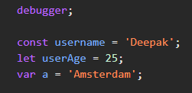
See, for the above code,
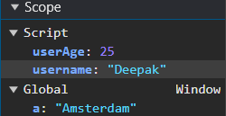
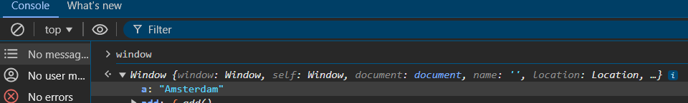
So therefore if we try to access window.a then we will get the output as Amsterdam, but on the other hand, if we try to access window.userAge or window.username, we will not get the expected output cause they are present in script scope

Ab jese hi humara function call hoga to ek or scope create hoga jo hoga local scope
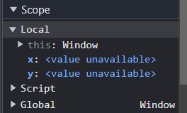
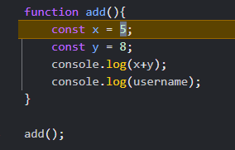
Now there is another scope called Module Scope

