Truthy/Falsy Values and Rules

***** The following values are always falsy in JavaScript ***********************
- false
- 0
- -0
- 0n
- ‘’, “”, `` (empty string)
- null
- nndefined
- NaN

Everything else is truthy, that includes ->
- ‘0’ (a string containing a single 0)
- ‘false’ (a string containing the text ‘false’)
- [ ] (an empty array)
- {} (an empty object)
- Function() {} (an empty function)

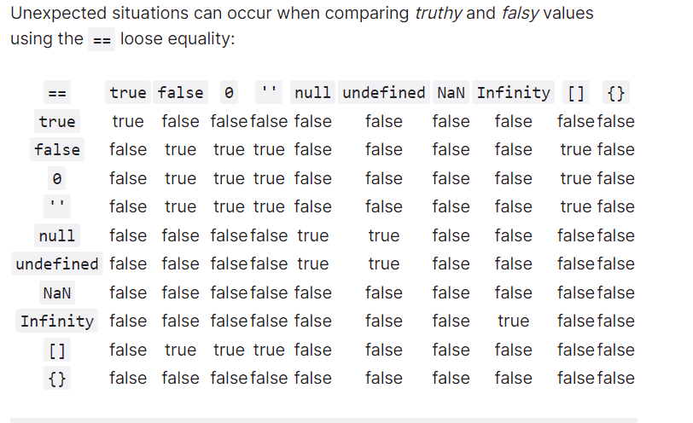
The rules ->
- False, zero and empty strings are all equivalent
- null and undefined are equivalent to themselves and each other but nothing else
- NaN is not equivalent to anything – including another NaN!
- Infinity is truthy – but cannot be compared to true or false
- An empty array is truthy – yet comparing with true is false and comparing with false is true
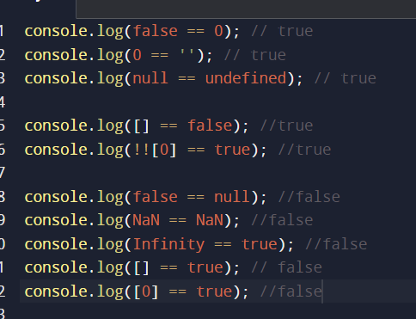

If you want to be certain that a false is generated only by false, 0 ,null, undefined, NaN, “”, use either a Boolean constructor or double negative !!
See above without double negative, same piece of code gave true, hence mark my words use !!(double negative)

