Fetch

A modern way to make network requests, replacing the older XMLHttpRequest
The fetch() method takes a mandatory argument, the path to the resource you want to fetch
After calling fetch, we get a Response object, but that does not contain the data yet, rather a readable stream, and then again we need to call a method to read from that stream
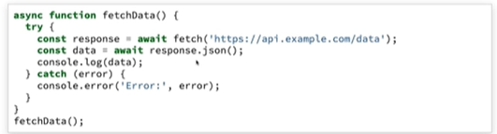
As the dummy API we’ve use returns the JSON data, hence we’ve used response.json() method
response.json() again returns a promise that will be resolved with data from that response

But what happens if there is a bad request, how does fetch handles it?
As we know in async/await, the way to handle error is to use the try/catch block ->
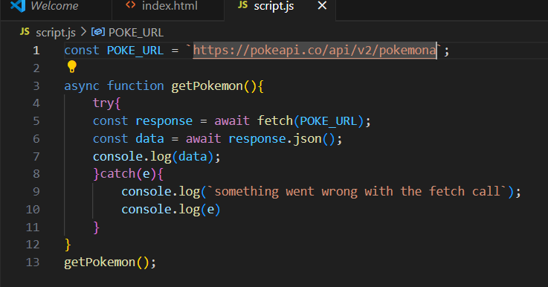
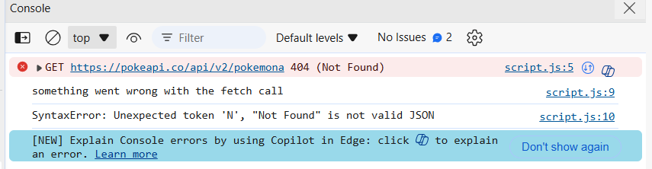
See, we’ve got the error as we changed the API itself, but the SyntaxError that we have got, what does it tell us?
It tells use that the fetch actually worked, but where does it go wrong, when we tried to parse the response as json
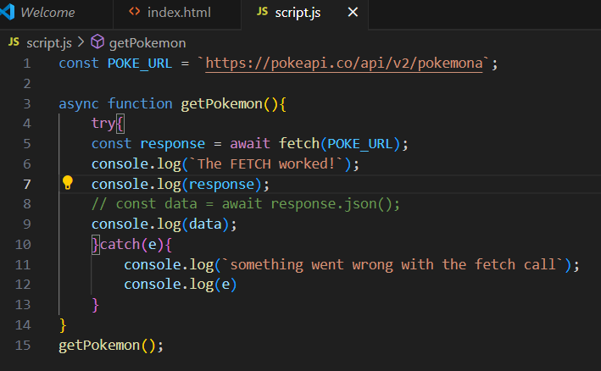
But, now we’ve removed the response.json() code and consoling the response itself, let’s see what happens ->
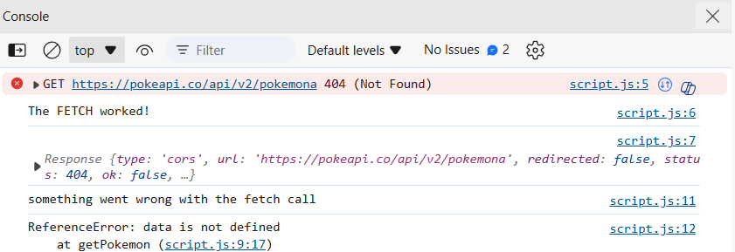
We’ve got the console as The FETCH worked even though we have requested a URL that does not exist
But fetch will not reject a promise if 404 is there or any negative status is there, fetch will only reject a promise if there is a Network error or cors error
So, how do we handle, if there’s a status code like 404 or so comes in as fetch won’t reject the promise, so for doing that we have a ok property on the fetch response object
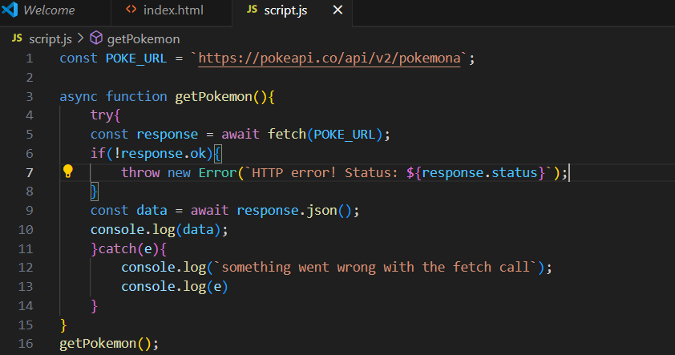
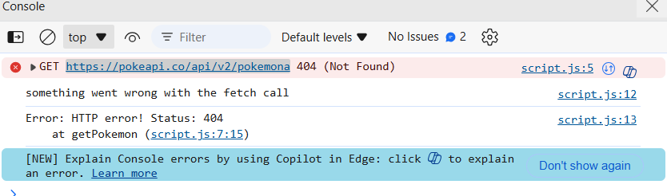

# SENDING REQUEST HEADERS WITH FETCH
Suppose we want to header a header {content-type: json}, how do we do that?
We have pass an object as a second property in fetch call, which will have a property called headers, which itself will also be an object
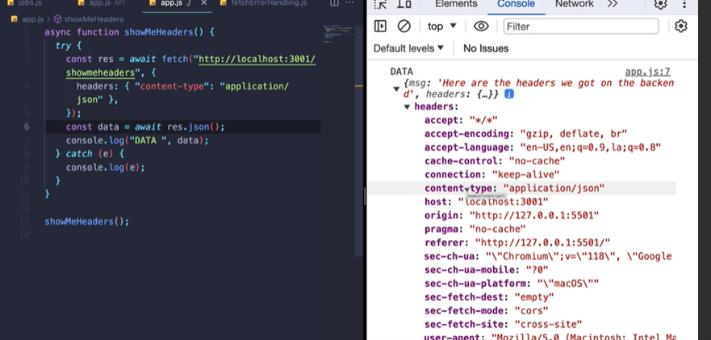

Another way to include headers in your request is to include Headers object
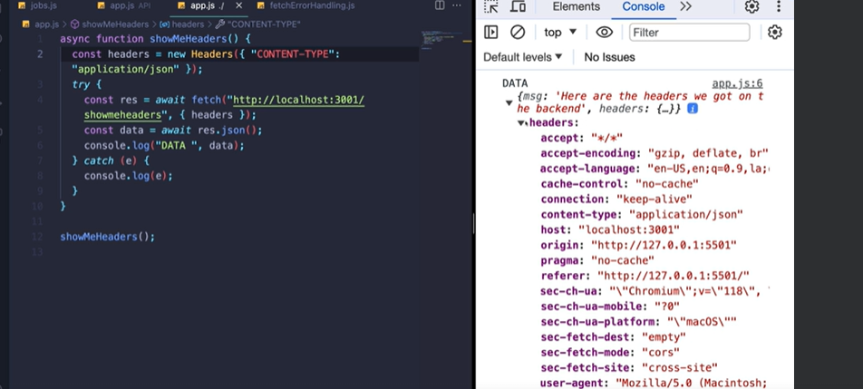
# POST requests with FETCH
So, in the second argument of fetch, where we had declared headers, we can also declare another property called method, and if the request is POST we’ve got to send the data and how to do that, simple one more property called body is there
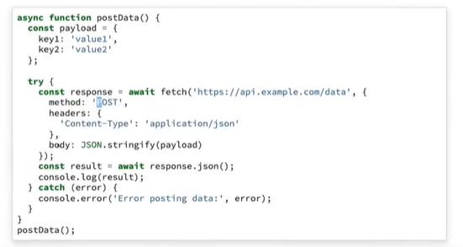
# Uploading files with fetch
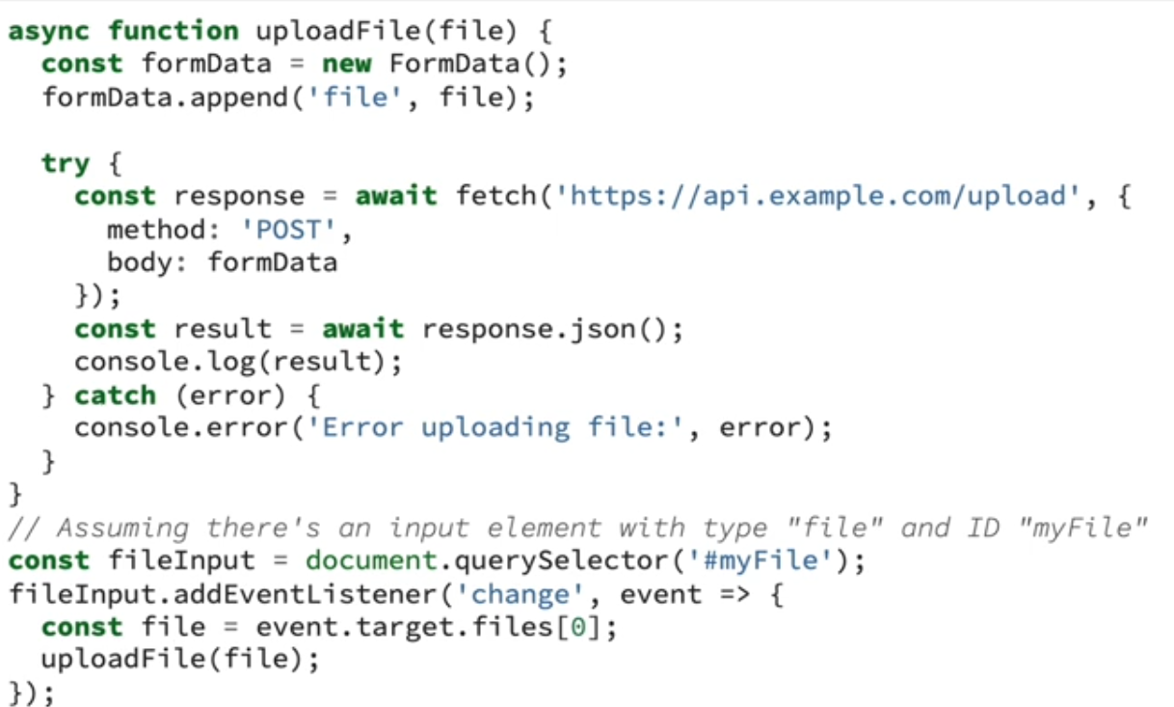
We have made a formdata object, and appended a file to that object and sent it

