setTimeout

- Global setTimeout methods sets a timer which executes a function or specified piece of code once the timer expires
- It returns a number which is the id of the timer, using this id with clearTimeout(id) will cancel the timer

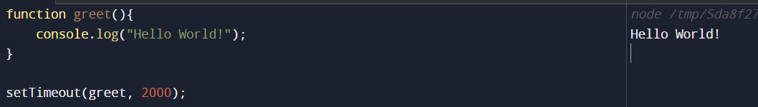
The output Hello World was printed after 2000 milliseconds or 2 seconds
Let’s see an example of clearTimeout, as we discussed in the 2nd point, we can stop the execution of a setTimeout function using clearTimeout
Closely analyze below given piece of code,
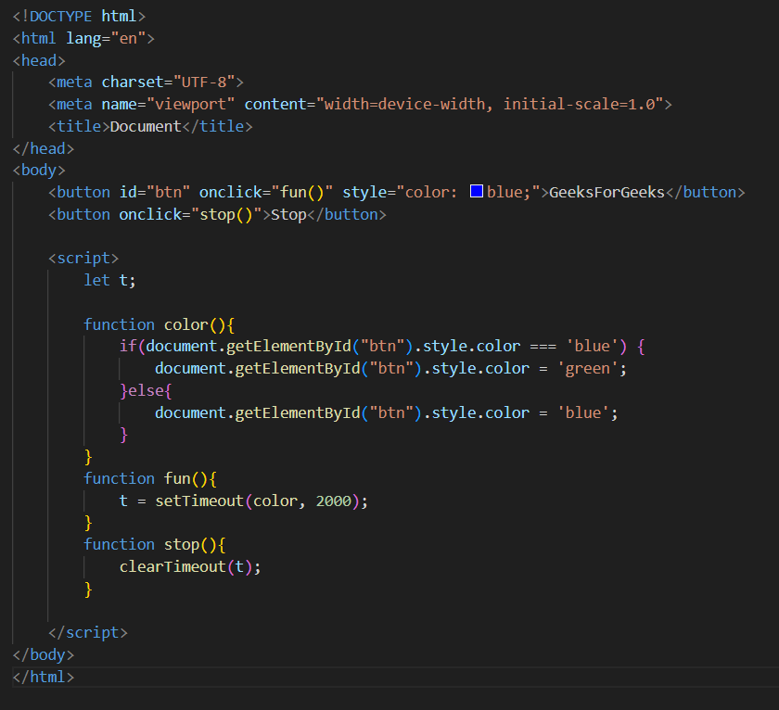
Looks like this in the browser –>
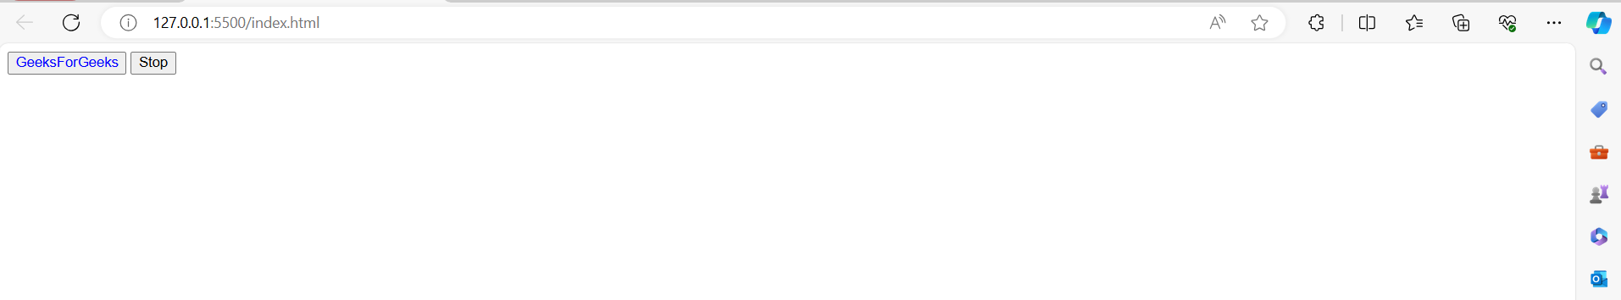

Now, the functionality is like that, if we click on the button the text “GeeksForGeeks” will change it’s color from blue to green and vice-versa, and the color change will happen with a delay of 2 seconds when we click on the button
Now, the question is what does stop function do, as we know it will take 2 seconds for the color of text to change, so if within those 2 seconds, if we click the stop button, then clearTimeout function will as we have called it in the stop function with the timer id of our setTimeout, and the setTimeout will stop its execution, i.e the text color will not take place

Now let us see the structure of the setTimeout function –>
- First parameter is the function you want to execute
- Second parameter is the milliseconds you pass
- Then comes additional parameters, lets understand these
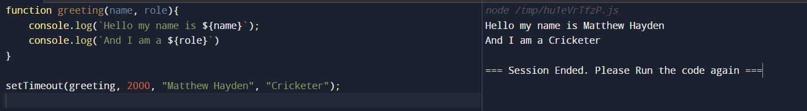
- Now, a thought might come, that why not pass the parameters directly to the function, cause
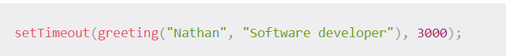
- If you pass like this, then JS will immediately execute the function without waiting, cause you are passing a function call and not a function reference

setInterval

- Used to repeatedly execute a function at specified intervals
- The setInterval() method continues calling the function until clearTimeout() is called or the window is closed

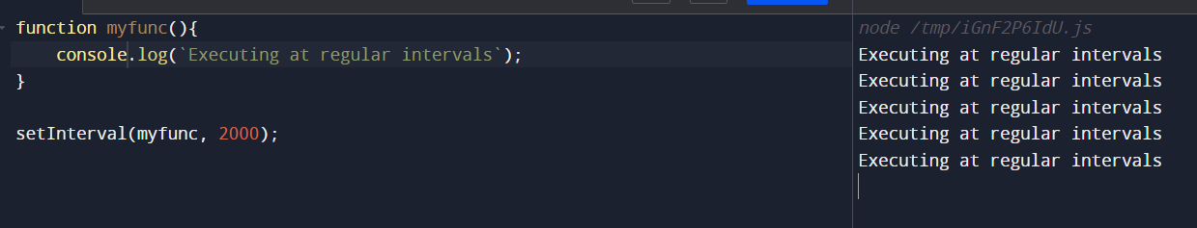
- Here, “Executing at regular intervals” will be printed after every 2 seconds

Let’s take a simple example of building a clock in JS ->
- HTML Code excerpt –
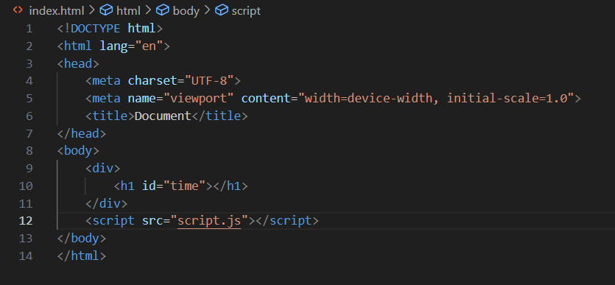
- JS code excerpt –
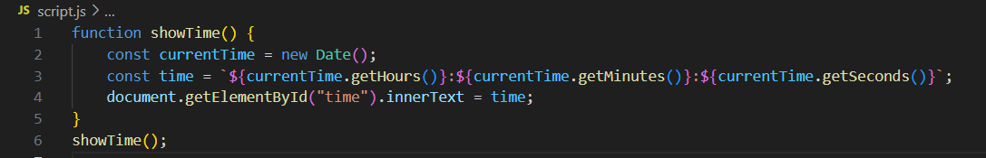

Now, what’s happening is, this function showTime, whenever we load our page, we will get to see the current time, that’s it,
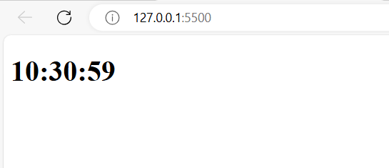

But our goal is to build a clock, which will tick every second, think now if we use setTimeout, it will run only once after n seconds, but we want our function to execute after every one second, hence we are gonna use setInterval API

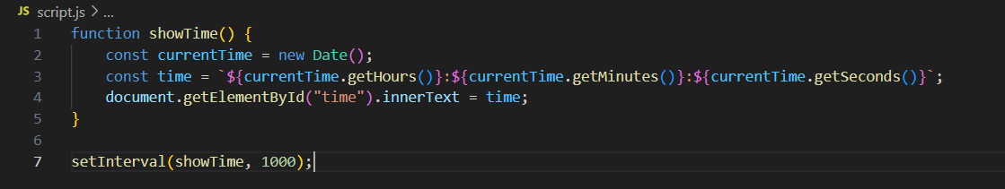
Now, our clock ticks every second.

