Critical Rendering Path (CRP)

The Critical Rendering Path is the sequence of steps the browser goes through to convert the HTML, CSS, and JavaScript into pixels on the screen.
Optimizing the critical render path improves render performance. The critical rendering path includes the Document Object Model (DOM), CSS Object Model (CSSOM), render tree and layout.

If the browser renders as soon as possible when it just has some HTML—but before it has any CSS or necessary JavaScript—then the page will momentarily look broken and change considerably for the final render. This is a worse experience than initially presenting a blank screen for a time until the browser has more of these resources needed for an initial render that offers a better user experience.

The browser needs to know what the minimum number of resources it should wait for in order to avoid presenting an obviously broken experience. On the other hand, the browser also shouldn't wait longer than necessary before presenting the user with some content. The sequence of steps the browser takes before performing that initial render is known as the critical rendering path.

The Critical Rendering Path
The rendering path involves the following steps:
- Constructing the Document Object Model (DOM) from the HTML.
- Constructing the CSS Object Model (CSSOM) from the CSS.
- Applying any JavaScript that alters the DOM or CSSOM.
- Constructing the render tree from the DOM and CSSOM.
- Perform style and layout operations on the page to see what elements fit where.
- Paint the pixels of the elements in memory.
- Composite the pixels if any of them overlap.
- Physically draw all the resulting pixels to screen.

The browser needs to wait for some critical resources to download before it can complete the initial render. These resources include:

- Part of the HTML.
- Render-blocking CSS in the <head> element.
- Render-blocking JavaScript in the <head> element.

Importantly, for the initial render, the browser will not typically wait for:

- All of the HTML.
- Fonts.
- Images.
- Non-render-blocking JavaScript outside of the <head> element (for example, <script> elements placed at the end of the HTML).
- Non-render-blocking CSS outside of the <head> element, or CSS with a media attribute value that does not apply to the current viewport.

Fonts and images are often regarded by the browser as content that to be filled in during subsequent page rerenders so they don't need to hold up the initial render. This can, however, mean that areas of blank space are left in the initial render while text is hidden waiting on fonts, or until images are available. Worse still is when sufficient space is not reserved for certain types of content—particularly when image dimensions are not provided in the HTML—the page's layout can shift when this content loads later on. This aspect of the user experience is measured by the Cumulative Layout Shift (CLS) metric.

Layout Shift
Layout shifts only occur when existing elements change their start position. If a new element is added to the DOM or an existing element changes size, it doesn't count as a layout shift—as long as the change doesn't cause other visible elements to change their start position.

Animations and Transitions
Animations and transitions, when done well, are a great way to update content on the page without surprising the user. Content that shifts abruptly and unexpectedly on the page almost always creates a bad user experience. But content that moves gradually and naturally from one position to the next can often help the user better understand what's going on, and guide them between state changes.

CSS transform property lets you animate elements without triggering layout shifts:
- Instead of changing the height and width properties, use transform: scale().
- To move elements around, avoid changing the top, right, bottom, or left properties and use transform: translate() instead.

To identify which resources are in the critical rendering path, you need to understand render-blocking and parser-blocking CSS and JavaScript.

Render Blocking Resources
Some resources are deemed so critical that the browser pauses page rendering until it has dealt with them. CSS falls into this category by default.
When a browser sees CSS—whether it's inline CSS in a <style> element, or an externally referenced resource specified by a <link rel=stylesheet href="..."> element—the browser avoids rendering any more content until it has completed downloading and processing that CSS.

A more recent innovation is the blocking=render attribute, added to Chrome 105. This allows developers to explicitly mark a <link>, <script> or <style> element as rendering-blocking until the element is processed, but still allowing the parser to continue processing the document in the meantime

Parser Blocking Resources
Parser-blocking resources are those that prevent the browser from looking for other work to do by continuing to parse the HTML.
JavaScript by default is parser-blocking (unless specifically marked as asynchronous or deferred), as JavaScript can change the DOM or the CSSOM upon its execution. Therefore, it's not possible for the browser to continue processing other resources until it knows the full impact of the requested JavaScript on a page's HTML. Synchronous JavaScript therefore blocks the parser.

Parser-blocking resources are effectively render-blocking as well. -all page content is blocked from being rendered.

Blocking the parser can have a huge performance cost - much more than just blocking rendering
For this reason, browsers will try to reduce this cost by using a secondary HTML parser known as the preload scanner to download upcoming resources while the primary HTML parser is blocked. While not as good as actually parsing the HTML, it does at least allow the networking functions in the browser to work ahead of the blocked parser, meaning it will be less likely to be blocked again in the future.

Optimize the critical rendering path

Optimizing the critical rendering path involves reducing the time to receive the HTML (represented by the Time to First Byte (TTFB) metric)

GENERAL HTML PERFORMANCE CONSIDERATIONS
Let’s first understand few key terms:
- TTFB (Time To First Byte)
- LCP (Largest Contentful Paint)
- FCP (First Contentful Paint)

Time To First Byte (TTFB)
Time between starting navigation to a page and when the first byte of response begins to arrive

TTFB is the sum of the following request phases(entire network journey) :
- Redirect time
- Service worker startup time (if applicable)
- DNS lookup
- Connection and TLS negotiation
- Request, up until the point at which the first byte of the response has arrived
The four core components of the Time to First Byte metric are:
- DNS lookup
- TCP connection
- SSL connection
- HTTP request time

Does TTFB include redirects?
Redirects are included in the Full TTFB measurement.
For example, if the initial server response consists of an HTTP redirect rather than HTML in the response body that the browser can display. The actual First Byte time is recorded when the second HTTP request returns an HTML document.
However, receiving the first byte often isn't sufficient as most pages have additional render-blocking resources that are loaded after the initial document request.

What is a good TTFB?
Google considers a Full TTFB of 800 milliseconds to be good. Values above 1.8 seconds are considered poor.

The First Contentful Paint (FCP) and Largest Contentful Paint (LCP) metrics measure when content actually becomes visible to the user.

HTTP requests TTFB
Every HTTP request that receives a response has a Time to First Byte.

First Contentful Paint (FCP)
The First Contentful Paint (FCP) page speed metric measures how long it takes for content to start appearing on a website.
Usually this means that text or an image is visible.
FCP is called a rendering milestone timing, because it measures a visual aspect of the page load process. When this rendering milestone is reached the visitor can tell that something is happening and that the page has started to load.
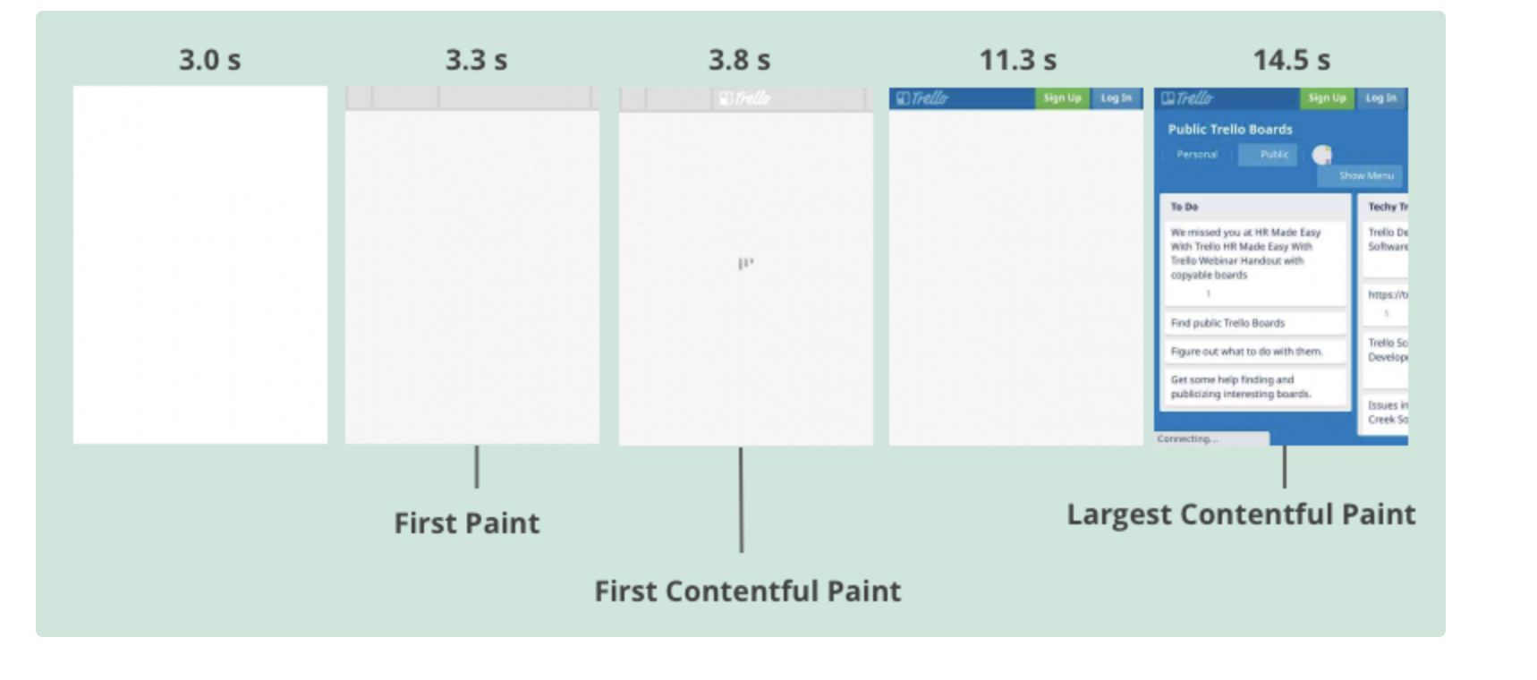

What is the First Paint?
The First Paint marks the time when the page first starts displaying something, even if that's not content. For example, a box with a background color might start to show, but the browser might still be loading the necessary web fonts to display the text content for that box.
The Largest Contentful Paint (LCP) marks the time when the largest content element on a page is rendered. That often means most of the page content is now visible to the user.

This diagram below shows the rendering progress of an example website:
- TTFB: The server has responded with the HTML document
- FCP: Some page content becomes visible
- LCP: The main image is displayed
- Visually Complete: The page is fully loaded and there are no more visual updates
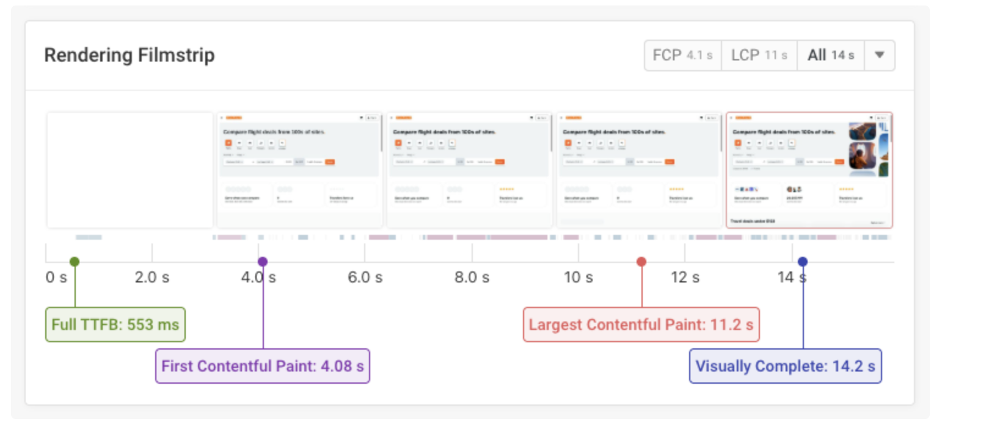

What is a good First Contentful Paint (FCP) score?

Websites should have an FCP of 1.8 seconds or less. If visitors on your website wait more than 3 seconds for any content then this is considered poor.

Is First Contentful Paint a Core Web Vitals metric?

First Contentful Paint is a web vital, but it is not one of the Core Web Vitals that impact Google rankings. However, FCP does represent a lower bound for the Largest Contentful Paint score, which is a Core Web Vital.

The three Core Web Vitals metrics are:
- Largest Contentful Paint (LCP)
- Cumulative Layout Shift (CLS)
- Interaction to Next Paint (INP)
How to improve First Contentful Paint
These are some concrete steps you can do to improve your website's FCP score:
- Improve Time to First Byte
- Optimize render-blocking stylesheets (studied above in CRP)
- Reduce render-blocking scripts
- Ensure web fonts don't delay text
- Check page content isn't hidden with CSS

Core Web Vitals
Key Metrics and Thresholds
- Largest Contentful Paint (LCP): Measures loading performance (how fast the largest image or text block renders). <= 2.5 seconds (ideal)

- Interaction to Next Paint (INP): Measures responsiveness (how quickly the page reacts to user inputs like clicks). <= 200 ms (ideal)

- Cumulative Layout Shift (CLS): Measures visual stability (how much elements move around unexpectedly). <= 0.1 seconds (ideal)
.

How To Measure And Optimize Largest Contentful Paint (LCP)

The Largest Contentful Paint (LCP) metric is a web performance indicator that measures how quickly the main content (biggest single content) of a website becomes visible to users. LCP marks the rendering milestone when visitors can see the largest page element.

What is a good Largest Contentful Paint?
For optimal user experience and search engine performance, websites should aim for an LCP of 2.5 seconds or less.

Measure And Optimize Interaction to Next Paint (INP)

Interaction to Next Paint (INP) is a website performance metric that measures how fast pages respond to user interactions (clicks or key presses).

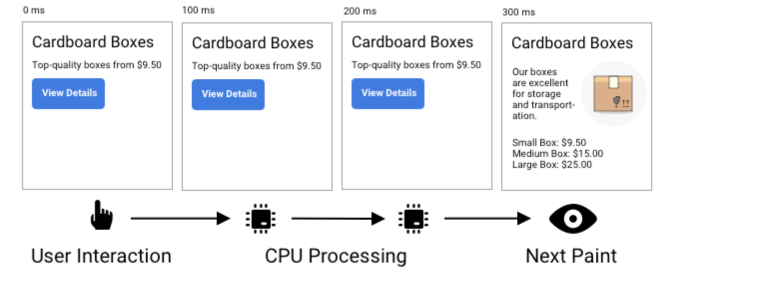

How is Interaction to Next Paint measured?

INP measures the responsiveness of your website by tracking the time between user input and UI updates. It can be subdivided into three contributing components:
- Input Delay: waiting for background tasks on the page that prevent the event handler from running
- Processing Time: running event handlers in JavaScript
- Presentation Delay: handling other queued up interactions, recalculating the page layout, and painting page content

How to debug, Replicate the interaction and record it with Chrome DevTools
Sometimes the real user script data already tells you what's slowing down your page. But the Chrome DevTools performance recording can provide much deeper insights.
Here's how to collect a performance profile:
- Right-click on the page and select Inspect to open the developer tools
- Switch to the Performance tab
- Open settings for the recording by clicking on the top right gear icon in the second row
- If you're on a fast device, enable CPU throttling by selecting 4x slowdown
- Click on Record in the Performance tab
- Perform the interaction you want to debug
- Click Stop and wait for the analysis to load
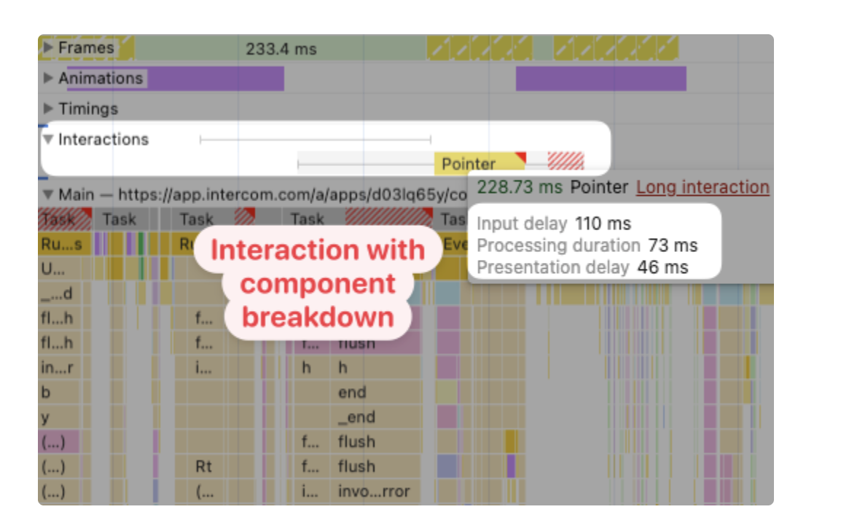

Measure And Optimize Cumulative Layout Shift (CLS)
Cumulative Layout Shift (CLS) is one of the three Core Web Vitals metrics that impact search result rankings in Google.
CLS is a measure of how user experience is impacted by unexpected layout shift. Ever clicked a button only to have it move at the last second? That's layout shift in action, created when content moves around on the page after the initial load

What is Cumulative Layout Shift?
The Cumulative Layout Shift metric measures visual stability. Your CLS score increases when page content moves around after being rendered.
Here's an example where an image appears at the top of the page after the website text has already been rendered. As a result, the text shifts down on the page.
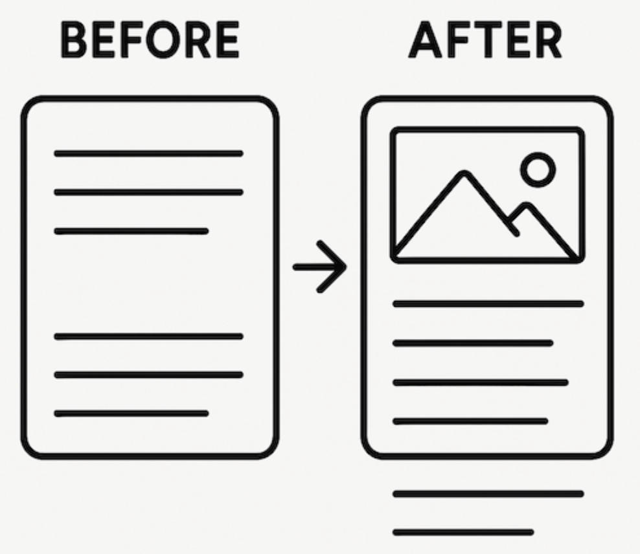

Cumulative Layout Shift Example
This filmstrip demonstrates content shift after initial render. The banner's load pushes the heading and article downward.
For this page the CLS value is 0.13.
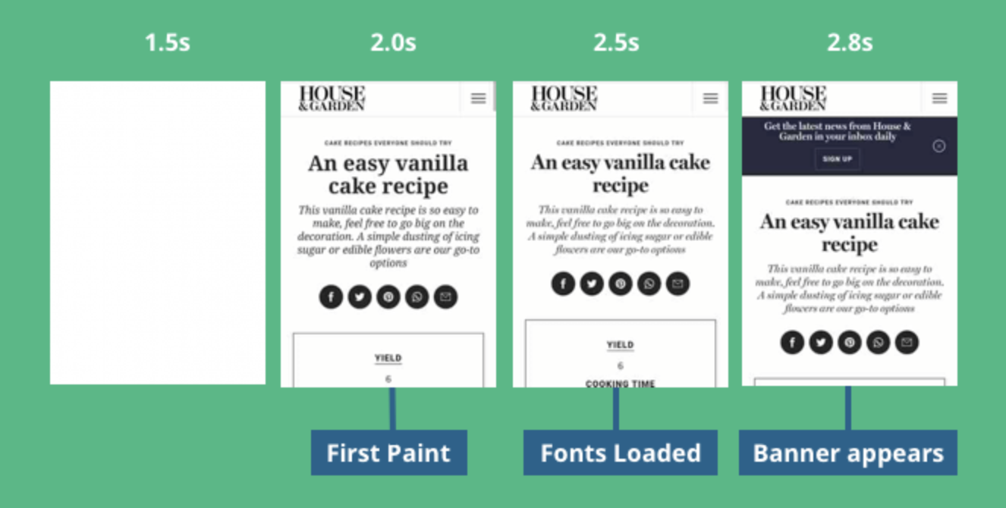
If you look closely there are actually two layout shifts on this page. The first one occurs after 2.5s when the web font loads, causing the title and description to re-render. After this, the description takes up a little less space, and the content below it shifts upward.

How is CLS calculated?
Individual layout shifts in a certain window time
Each individual layout shift is scored based on two components:
- the impact fraction measures how much of the screen area is impacted
- the distance fraction measures how far an element has moved
The final score is calculated by multiplying the two numbers.
A Cumulative Layout Shift score below 0.1 is considered good for user experience. Scores ranging from 0.1 to 0.25 are considered to need improvement, while scores above 0.25 are considered poor.
Cumulative Layout Shift determines 25% of the overall Lighthouse Performance score.

