JWT (JSON Web Token)

• JWT stands for JSON Web Token — a compact, URL-safe token format used to securely transmit information between parties as a JSON object.

It is widely used for stateless authentication and authorization because it is self-contained (carries user info and claims) and doesn’t require server-side session storage.

• It is commonly used for authentication and authorization in modern web applications.

Structure of a JWT
A JWT is a string made up of three parts separated by dots:



Header (xxxxx):
- Contains metadata about the token, including the type (JWT) and the signing algorithm (e.g., HS256).
- Example (encoded in Base64Url):

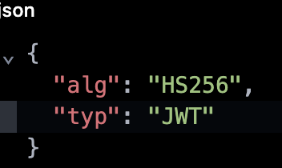
Payload (yyyyy):
- Contains claims or statements about the user and additional data.
- Common claims include:
  - sub: subject (usually the user ID)
  - iss: issuer
  - exp: expiration time (timestamp)
  - iat: issued at (timestamp)
  - Custom claims (e.g., roles, permissions)

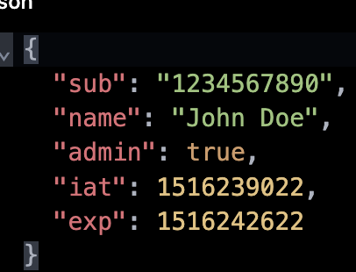

Signature (zzzzz):
- Created by taking the encoded header and payload, signing them with a secret key using the specified algorithm.
- This signature allows verification that the token was not tampered with.

How is JWT Used in Frontend?
Common Use Case: User Authentication
• User logs in:
- The frontend collects user credentials and sends them to the backend (usually via HTTPS POST).
• Backend authenticates and issues JWT:
- If credentials are valid, the backend produces a signed JWT containing user information and sends it back.
• Frontend stores JWT:
- The frontend stores the JWT, typically in:
  - Local Storage: window.localStorage
  - Session Storage: window.sessionStorage
  - HTTP-only Cookies: (more secure, but with some constraints)
Frontend sends JWT with requests:
- For subsequent API requests needing authentication, frontend attaches the JWT in the HTTP headers, typically as:
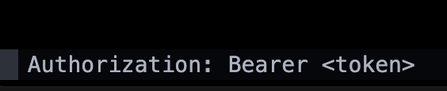
Backend verifies JWT on each request:
- The backend validates the signature and token claims, and if valid, processes the request.

Considerations for Handling JWT in Frontend

Storage Security
- LocalStorage/SessionStorage: Simple, but vulnerable to XSS attacks (malicious scripts can steal tokens).
- HTTP-only cookies: More secure from XSS but vulnerable to CSRF unless mitigated.
- Choose storage strategy based on your threat model.

Token Expiration and Refresh
- Tokens usually have expiration times (exp) to limit exposure if leaked.
- Frontends should handle token expiration gracefully:
  - Redirect to login on expired token.
  - Use refresh tokens (long-lived tokens) to obtain new JWTs without requiring re-login.

Avoid Storing Sensitive Data
- Don’t store sensitive info like passwords or excessive personal data in the JWT payload — even though it’s signed, it’s not encrypted and can be decoded by anyone who gets the token.

Decode JWT in Frontend
- Frontends can decode (but not verify) JWT payload using client libraries (e.g., jwt-decode in JavaScript) to read user roles or session info.

Handling Logout
- To log out, simply remove the JWT from storage and redirect the user.
- Backend-side token invalidation is harder with JWT unless you keep a blocklist or short expiration times.

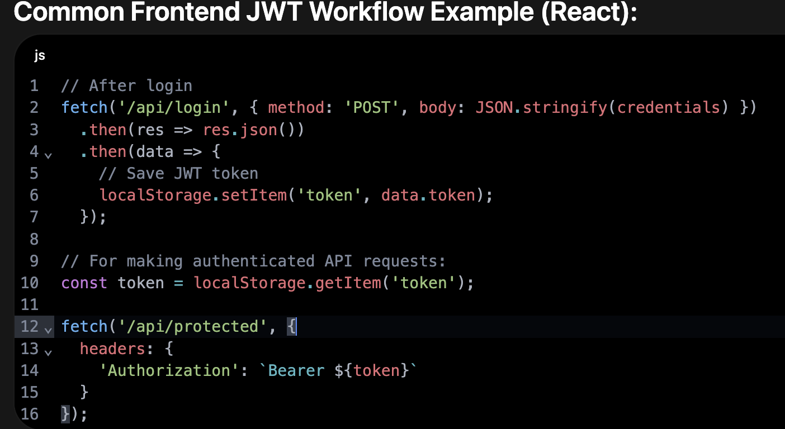

Common Interview Questions Around it

2. How does JWT authentication work from the frontend to backend?
Answer:
User logs in, frontend sends credentials to backend. Backend validates and sends back a signed JWT. Frontend stores the JWT and attaches it to subsequent API requests (usually in the Authorization header). Backend verifies the token on each request to authenticate the user.

3. Where is it safe to store JWT tokens on the client side? Discuss pros and cons.
Answer:
- localStorage: Easy to use but vulnerable to XSS attacks (scripts can steal tokens).
- sessionStorage: Similar risks as localStorage but cleared on tab close.
- HTTP-only cookies: More secure as they are inaccessible to JavaScript, reducing XSS risk but may be vulnerable to CSRF unless protected properly.
Best practice: Prefer HTTP-only secure cookies along with CSRF protections.

4. How do you attach JWT to API requests in a frontend application?
Answer:
Include the JWT in the HTTP Authorization header as a Bearer token:

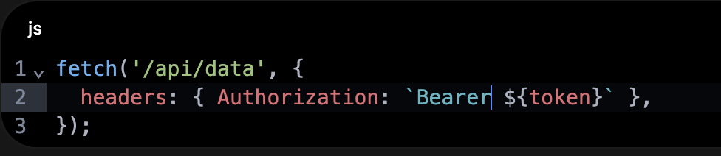

7. What is the difference between access tokens and refresh tokens? How do you handle them in frontend?
Answer:
- Access tokens: Short-lived tokens used to access protected resources.
- Refresh tokens: Long-lived tokens used to obtain new access tokens without re-authenticating.
Frontend stores access tokens (preferably in memory or secure storage) and refresh tokens securely (often HTTP-only cookies). When access token expires, the frontend uses the refresh token to request a new access token.
9. What is stateless authentication, and how does JWT support it?
Stateless authentication means the server does not keep session info — the client carries all needed info. JWT supports this by embedding user claims and info in the token itself, which the server can verify without storing session state.

10. How do you decode a JWT on the frontend, and why would you want to?
Answer:
You can decode JWT payload (Base64Url decode) using a library like jwt-decode. This lets the frontend read user info (e.g., roles) to customize UI. Important: decoding cannot verify authenticity or signature.

11. Can JWT tokens be tampered with or forged on the client? How can the backend prevent this?
Answer:
Clients can modify token content but cannot produce a valid signature without the secret/private key. The backend verifies the signature to detect tampering or forgery. If signature verification fails, the token is rejected.

15. Explain CSRF and how does JWT relate to it in frontend apps?
Answer:
CSRF (Cross-Site Request Forgery) tricks a user’s browser to send unwanted requests. If JWT is stored in cookies sent automatically by the browser, CSRF can be a risk. Mitigate by using SameSite cookies, CSRF tokens, or storing JWT in browser storage (with caution for XSS).

16. How can you refresh JWT tokens? Explain the workflow in frontend applications.
Answer:
Frontend uses the refresh token (usually stored securely) to request a new access token before or after expiration. The backend validates the refresh token and issues a new access token without asking the user to re-login.

19. How would you implement role-based access control (RBAC) in frontend using JWT?
Answer:
Include the user’s roles or permissions in the JWT payload. Decode the token on the frontend, then conditionally render or restrict UI components/routes based on the user’s roles

What is Role-Based Access Control (RBAC)?
- RBAC is a method of restricting access to parts of an application or system based on the roles assigned to authenticated users.
- Roles represent groups of permissions (e.g., "admin", "editor", "user") that govern what a user can see or do.
- RBAC improves security by enforcing the principle of least privilege — users can only access resources necessary for their role.

Using JWT for RBAC

How roles fit into JWT
- The JWT payload can include custom claims that represent the user’s roles or permissions.
- Example JWT payload with roles claim:
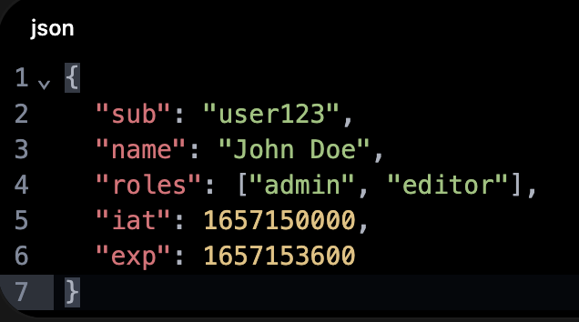
Roles are included at authentication time by the backend service generating the token.

How RBAC Works in the Frontend with JWT
- User logs in, frontend receives JWT containing roles.
- Frontend decodes the JWT to extract user roles using a library like jwt-decode.
- Based on the extracted roles, the frontend:
  - Controls access to routes/pages (e.g., only admins can access admin dashboard).
  - Shows or hides UI components (e.g., show admin buttons only to admin role).
  - Enables or disables actions (e.g., only editor role can edit content).
- On API requests, the JWT with embedded roles is sent to the backend, which can perform server-side authorization check to enforce the role permissions securely.

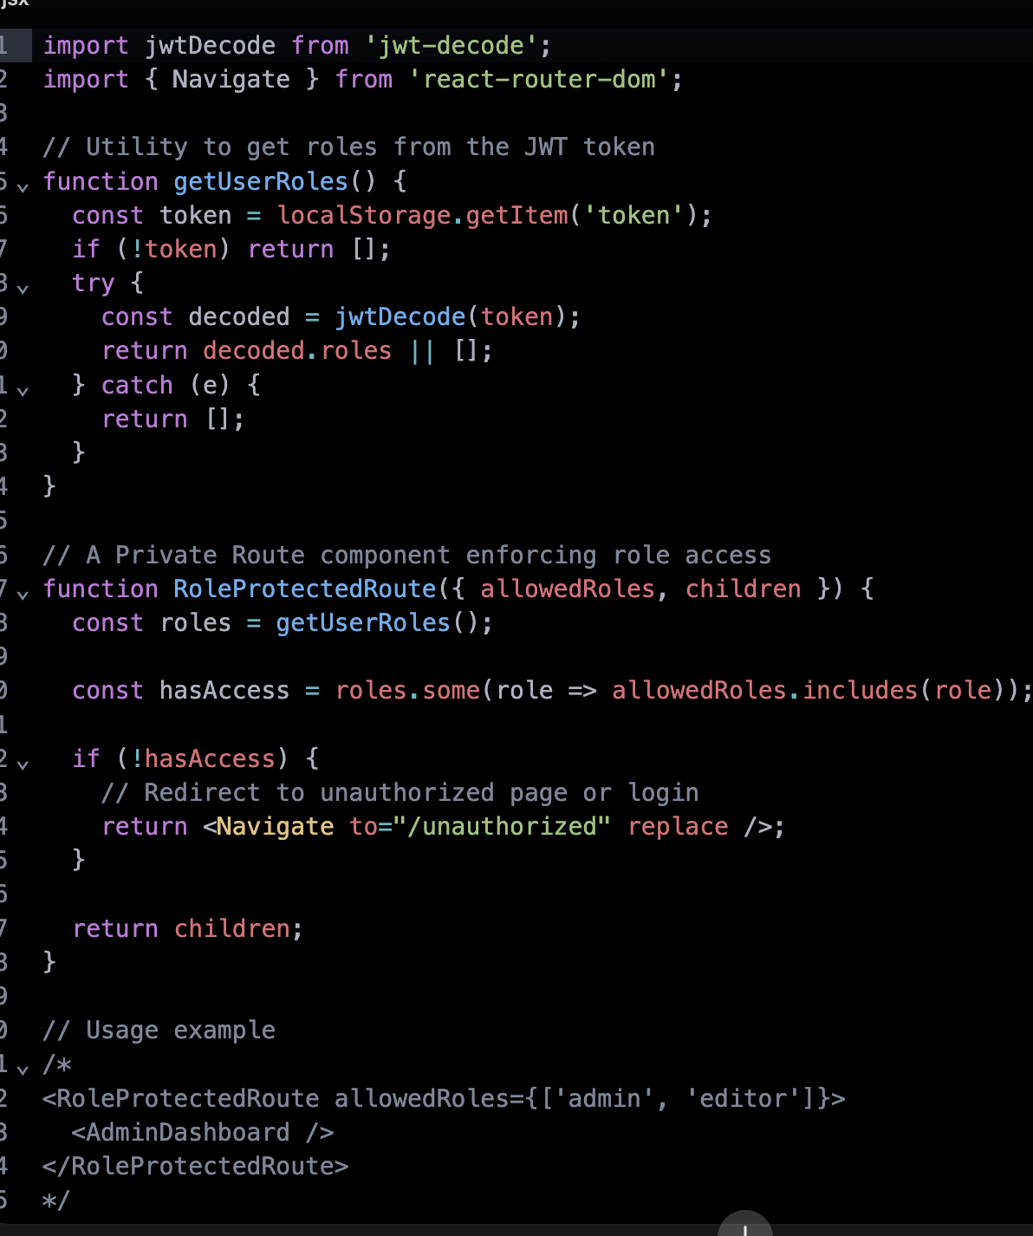

Best Practices for Role-Based Access Tokens
- Minimal Roles: Only include necessary role information in the token to reduce payload size and leak risk.
- Short Expiry: Use short expiration (exp claim) for access tokens to limit misuse.
- Server-side Authorization: Always verify roles and permissions on backend for sensitive operations.
- Immutable Tokens: JWTs are usually immutable once issued; changing user roles requires re-issuing a new token.
- Clear Role Naming: Use consistent, meaningful role names and document their permissions clearly.
- Frontend as UI gatekeeper: Remember, frontend RBAC is primarily for UX — backend should enforce all security.

Advantages of Using JWT for RBAC
- Stateless: Roles included in token, reducing API calls to fetch user permissions repeatedly.
- Efficient: Frontend can quickly tailor UI based on roles decoded from JWT.
- Portable: The token is sent with each request, so all components have access to necessary auth details.

How does the backend validate JWT tokens without storing them?
One key benefit of JWT-based authentication is that it’s stateless. That means the backend does not need to store tokens in a database or session store to validate them. Instead, backend validates JWTs by verifying their signature and claims.

What the backend validates in a JWT:

1. Signature
- JWT is signed by the issuer (usually the backend or authentication server) using a secret key (in symmetric signing like HMAC) or a private key (in asymmetric signing like RSA or ECDSA).
- When receiving a JWT, backend:
  - Extracts the header and payload.
  - Uses the signing algorithm and the secret/public key to verify that the signature matches the contents.
- If the signature doesn't match, it means the token is tampered with or forged and is rejected immediately.

2. Claims
Common claims validated include:
- exp (Expiration time): Check if token is expired.
- nbf (Not before): Ensure token is valid after a certain time.
- iat (Issued at): Sometimes used to check token creation time.
- aud (Audience): Verify that token is intended for this backend/service.
- iss (Issuer): Confirm the token was issued by the trusted authority.
- Custom claims (e.g., user id, roles) may be validated against expectations.

Complete Backend Validation Flow:
- Extract JWT from the HTTP header (usually Authorization: Bearer <token>).
- Decode the token without trusting it yet.
- Verify the signature using the secret/public key.
- If signature is valid, verify claims (expiration, issuer, audience).
- If all checks pass, accept the token and proceed.
- Optionally, use claims (like sub user id) to fetch any additional user info if necessary, but this is application-dependent.
- If any check fails, reject the token and respond with 401 Unauthorized.

Why no server storage needed?
- Because the token carries all information required for authentication and authorization inside a cryptographically signed payload, the backend just needs to verify the signature and claims.

